Accessibility ID Report — selectFlightFlightInfo_ios
Tarih: 31.03.2026 00:29 | Platform: IOS

Element ID | Page | Type | Label / Text | Value | Accessibility ID | Status | New Status
selectFlightFlightInfo_ios_element_1 | Select Departure Flight | Other | Bottom Sheet |  |  | ID Yok | ID Eklenecek (Waiting Dev)
selectFlightFlightInfo_ios_element_2 | Select Departure Flight | Other | Flight Info |  |  | ID Yok | ID Eklenecek (Waiting Dev)
selectFlightFlightInfo_ios_element_3 | Select Departure Flight | Other |  |  |  | ID Yok | ID Eklenecek (Waiting Dev)
selectFlightFlightInfo_ios_element_4 | Select Departure Flight | Other | Log in |  |  | ID Yok | ID Eklenecek (Waiting Dev)
selectFlightFlightInfo_ios_element_5 | Select Departure Flight | Other | Flight Schedule |  |  | ID Yok | ID Eklenecek (Waiting Dev)
selectFlightFlightInfo_ios_element_6 | Select Departure Flight | Other | Flight Status |  |  | ID Yok | ID Eklenecek (Waiting Dev)
selectFlightFlightInfo_ios_element_7 | Select Departure Flight | Other | Feedback |  |  | ID Yok | ID Eklenecek (Waiting Dev)
selectFlightFlightInfo_ios_element_8 | Select Departure Flight | Other | Notifications |  |  | ID Yok | ID Eklenecek (Waiting Dev)
selectFlightFlightInfo_ios_element_9 | Select Departure Flight | Other | Gift Card |  |  | ID Yok | ID Eklenecek (Waiting Dev)
selectFlightFlightInfo_ios_element_10 | Select Departure Flight | Other | Settings |  |  | ID Yok | ID Eklenecek (Waiting Dev)
selectFlightFlightInfo_ios_element_11 | Select Departure Flight | Other | Contact us |  |  | ID Yok | ID Eklenecek (Waiting Dev)
selectFlightFlightInfo_ios_element_12 | Select Departure Flight | Other |  |  |  | ID Yok | ID Eklenecek (Waiting Dev)
selectFlightFlightInfo_ios_element_13 | Select Departure Flight | Other | 31 , Mar, Tue, Search |  |  | ID Yok | ID Eklenecek (Waiting Dev)
selectFlightFlightInfo_ios_element_14 | Select Departure Flight | Other | 01 , Apr, Wed, Search |  |  | ID Yok | ID Eklenecek (Waiting Dev)
selectFlightFlightInfo_ios_element_15 | Select Departure Flight | Other | 02 , Apr, Thu, Search |  |  | ID Yok | ID Eklenecek (Waiting Dev)
selectFlightFlightInfo_ios_element_16 | Select Departure Flight | Other | 03 , Apr, Fri, Search |  |  | ID Yok | ID Eklenecek (Waiting Dev)
selectFlightFlightInfo_ios_element_17 | Select Departure Flight | Other | 04 , Apr, Sat, Search |  |  | ID Yok | ID Eklenecek (Waiting Dev)
selectFlightFlightInfo_ios_element_18 | Select Departure Flight | Other | 05 , Apr, Sun, Search |  |  | ID Yok | ID Eklenecek (Waiting Dev)
selectFlightFlightInfo_ios_element_19 | Select Departure Flight | Other | 06 , Apr, Mon, NO FLIGHT |  |  | ID Yok | ID Eklenecek (Waiting Dev)
selectFlightFlightInfo_ios_element_20 | Select Departure Flight | Other | 07 , Apr, Tue, 60EUR |  |  | ID Yok | ID Eklenecek (Waiting Dev)
selectFlightFlightInfo_ios_element_21 | Select Departure Flight | Other | 08 , Apr, Wed, NO FLIGHT |  |  | ID Yok | ID Eklenecek (Waiting Dev)
selectFlightFlightInfo_ios_element_22 | Select Departure Flight | Other | 09 , Apr, Thu, NO FLIGHT |  |  | ID Yok | ID Eklenecek (Waiting Dev)
selectFlightFlightInfo_ios_element_23 | Select Departure Flight | Other | 10 , Apr, Fri, 60EUR |  |  | ID Yok | ID Eklenecek (Waiting Dev)
selectFlightFlightInfo_ios_element_24 | Select Departure Flight | Other | 11 , Apr, Sat, NO FLIGHT |  |  | ID Yok | ID Eklenecek (Waiting Dev)
selectFlightFlightInfo_ios_element_25 | Select Departure Flight | Other | 12 , Apr, Sun, 60EUR |  |  | ID Yok | ID Eklenecek (Waiting Dev)
selectFlightFlightInfo_ios_element_26 | Select Departure Flight | Other | 13 , Apr, Mon, NO FLIGHT |  |  | ID Yok | ID Eklenecek (Waiting Dev)
selectFlightFlightInfo_ios_element_27 | Select Departure Flight | Other | 14 , Apr, Tue, Search |  |  | ID Yok | ID Eklenecek (Waiting Dev)
selectFlightFlightInfo_ios_element_28 | Select Departure Flight | Other | 15 , Apr, Wed, Search |  |  | ID Yok | ID Eklenecek (Waiting Dev)
selectFlightFlightInfo_ios_element_29 | Select Departure Flight | Other | 16 , Apr, Thu, Search |  |  | ID Yok | ID Eklenecek (Waiting Dev)
selectFlightFlightInfo_ios_element_30 | Select Departure Flight | Other | 17 , Apr, Fri, Search |  |  | ID Yok | ID Eklenecek (Waiting Dev)
selectFlightFlightInfo_ios_element_31 | Select Departure Flight | Other | 18 , Apr, Sat, Search |  |  | ID Yok | ID Eklenecek (Waiting Dev)
selectFlightFlightInfo_ios_element_32 | Select Departure Flight | Other | 19 , Apr, Sun, Search |  |  | ID Yok | ID Eklenecek (Waiting Dev)
selectFlightFlightInfo_ios_element_33 | Select Departure Flight | Other | 20 , Apr, Mon, Search |  |  | ID Yok | ID Eklenecek (Waiting Dev)
selectFlightFlightInfo_ios_element_34 | Select Departure Flight | Other | Executive Economy |  | avail_selection_switch_item | Duplicate | ID Eklenecek (Waiting Dev)
selectFlightFlightInfo_ios_element_35 | Select Departure Flight | Other | Economy |  | avail_selection_switch_item | Duplicate | ID Eklenecek (Waiting Dev)
selectFlightFlightInfo_ios_element_36 | Select Departure Flight | Other | Business |  | avail_selection_switch_item | Duplicate | ID Eklenecek (Waiting Dev)
selectFlightFlightInfo_ios_element_37 | Select Departure Flight | Other | Select |  | avail_selection_select_button | ID Var
selectFlightFlightInfo_ios_element_38 | Select Departure Flight | Other | EUR |  | avail_selection_currency_picker | ID Var
selectFlightFlightInfo_ios_element_39 | Select Departure Flight | Other |  |  | avail_selection_calendar_picker | ID Var
selectFlightFlightInfo_ios_element_40 | Select Departure Flight | Other | 21:00, 22:45, 1h 45min, PK 340, Direct, 60.28EUR |  | avail_selection_flight_item_direct | ID Var

📸 Ekran Görüntüsü
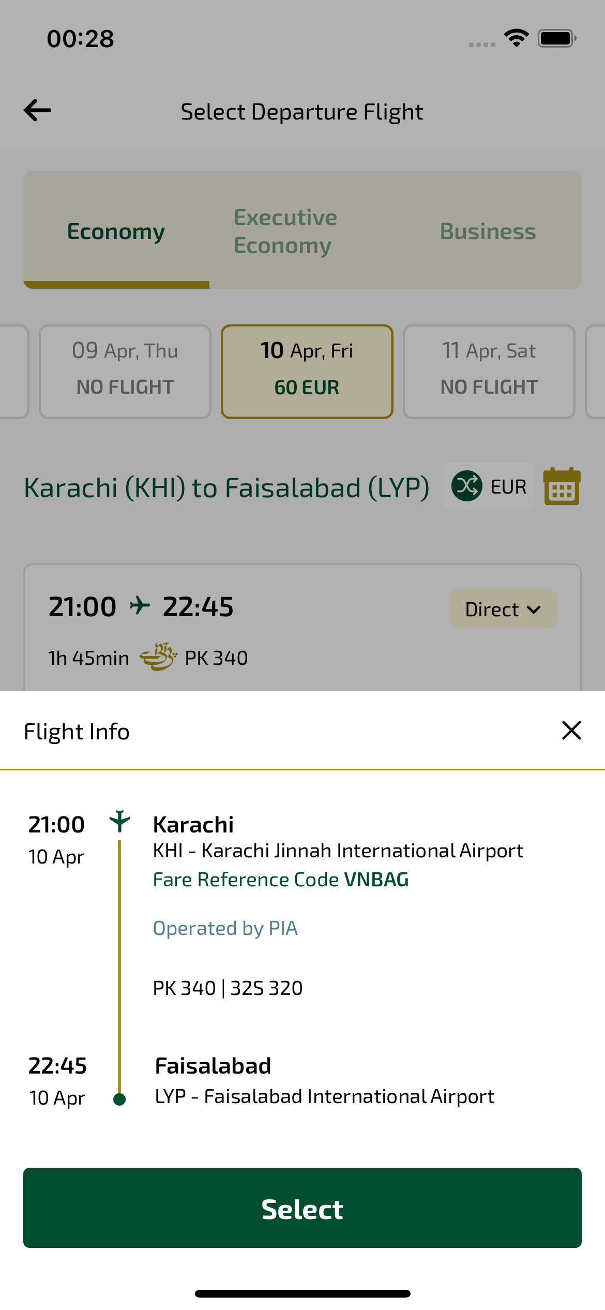
selectFlightFlightInfo_ios sayfası ekran görüntüsü

