Accessibility ID Report — signupForm_ios
Tarih: 30.03.2026 23:51 | Platform: IOS

Element ID | Page | Type | Label / Text | Value | Accessibility ID | Status | New Status
signupForm_ios_element_1 | Sign up | Other |  |  |  | ID Yok | ID Eklenecek (Waiting Dev)
signupForm_ios_element_2 | Sign up | Other | Log in |  |  | ID Yok | ID Eklenecek (Waiting Dev)
signupForm_ios_element_3 | Sign up | Other | Flight Schedule |  |  | ID Yok | ID Eklenecek (Waiting Dev)
signupForm_ios_element_4 | Sign up | Other | Flight Status |  |  | ID Yok | ID Eklenecek (Waiting Dev)
signupForm_ios_element_5 | Sign up | Other | Feedback |  |  | ID Yok | ID Eklenecek (Waiting Dev)
signupForm_ios_element_6 | Sign up | Other | Notifications |  |  | ID Yok | ID Eklenecek (Waiting Dev)
signupForm_ios_element_7 | Sign up | Other | Gift Card |  |  | ID Yok | ID Eklenecek (Waiting Dev)
signupForm_ios_element_8 | Sign up | Other | Settings |  |  | ID Yok | ID Eklenecek (Waiting Dev)
signupForm_ios_element_9 | Sign up | Other | Contact us |  |  | ID Yok | ID Eklenecek (Waiting Dev)
signupForm_ios_element_10 | Sign up | Other |  |  |  | ID Yok | ID Eklenecek (Waiting Dev)
signupForm_ios_element_11 | Sign up | Other | Sign up |  |  | ID Yok | ID Eklenecek (Waiting Dev)
signupForm_ios_element_12 | Sign up | Other | I want to be informed through SMS. |  |  | ID Yok | ID Eklenecek (Waiting Dev)
signupForm_ios_element_13 | Sign up | Other | I want to be informed through E-mail. |  |  | ID Yok | ID Eklenecek (Waiting Dev)
signupForm_ios_element_14 | Sign up | Other | I accept the Awards* +Plus Membership Rules and Conditions |  |  | ID Yok | ID Eklenecek (Waiting Dev)
signupForm_ios_element_15 | Sign up | Other | E-mail |  |  | ID Yok | ID Eklenecek (Waiting Dev)
signupForm_ios_element_16 | Sign up | Other | Add |  |  | ID Yok | ID Eklenecek (Waiting Dev)
signupForm_ios_element_17 | Sign up | Other | Phone |  |  | ID Yok | ID Eklenecek (Waiting Dev)
signupForm_ios_element_18 | Sign up | Other | Add |  |  | ID Yok | ID Eklenecek (Waiting Dev)
signupForm_ios_element_19 | Sign up | Other | Address |  |  | ID Yok | ID Eklenecek (Waiting Dev)
signupForm_ios_element_20 | Sign up | Other | Add |  |  | ID Yok | ID Eklenecek (Waiting Dev)
signupForm_ios_element_21 | Sign up | Other | Male |  |  | ID Yok | ID Eklenecek (Waiting Dev)
signupForm_ios_element_22 | Sign up | Other | Female |  |  | ID Yok | ID Eklenecek (Waiting Dev)
signupForm_ios_element_23 | Sign up | Other | Preferred |  |  | ID Yok | ID Eklenecek (Waiting Dev)
signupForm_ios_element_24 | Sign up | Other | Preferred |  |  | ID Yok | ID Eklenecek (Waiting Dev)
signupForm_ios_element_25 | Sign up | Other | Preferred |  |  | ID Yok | ID Eklenecek (Waiting Dev)
signupForm_ios_element_26 | Sign up | TextField | Enter | Enter | undefinedgivenName | Undefined ID | ID Eklenecek (Waiting Dev)
signupForm_ios_element_27 | Sign up | TextField | Surname | Surname | undefinedsurname | Undefined ID | ID Eklenecek (Waiting Dev)
signupForm_ios_element_28 | Sign up | TextField | Enter | Enter | undefinedpassportNumber | Undefined ID | ID Eklenecek (Waiting Dev)
signupForm_ios_element_29 | Sign up | TextField | Enter | Enter | undefinedemailList.0.email | Undefined ID | ID Eklenecek (Waiting Dev)
signupForm_ios_element_30 | Sign up | TextField | Enter | Enter | undefinedaddressList.0.apartmentNo | Undefined ID | ID Eklenecek (Waiting Dev)
signupForm_ios_element_31 | Sign up | TextField | Enter | Enter | undefinedaddressList.0.streetNo | Undefined ID | ID Eklenecek (Waiting Dev)
signupForm_ios_element_32 | Sign up | TextField | Enter | Enter | undefinedaddressList.0.area | Undefined ID | ID Eklenecek (Waiting Dev)
signupForm_ios_element_33 | Sign up | TextField | Enter | Enter | undefinedaddressList.0.postalCode | Undefined ID | ID Eklenecek (Waiting Dev)
signupForm_ios_element_34 | Sign up | TextField | Phone number | Phone number | undefinedphoneNumberList.0.phoneNumber | Undefined ID | ID Eklenecek (Waiting Dev)
signupForm_ios_element_35 | Sign up | SecureTextField | Enter | Enter | undefinedpassword | Undefined ID | ID Eklenecek (Waiting Dev)
signupForm_ios_element_36 | Sign up | SecureTextField | Enter | Enter | undefinedreTypePassword | Undefined ID | ID Eklenecek (Waiting Dev)
signupForm_ios_element_37 | Sign up | SecureTextField | Enter | Enter | undefinedivrPassword | Undefined ID | ID Eklenecek (Waiting Dev)
signupForm_ios_element_38 | Sign up | SecureTextField | Enter | Enter | undefinedreTypeIvrPassword | Undefined ID | ID Eklenecek (Waiting Dev)
signupForm_ios_element_39 | Sign up | Other |  |  | undefinedlanguage | Undefined ID | ID Eklenecek (Waiting Dev)
signupForm_ios_element_40 | Sign up | Other | Enter |  | undefinedtitle | Undefined ID | ID Eklenecek (Waiting Dev)
signupForm_ios_element_41 | Sign up | Other | Date of Birth*, Select |  | undefinedbirthDate | Undefined ID | ID Eklenecek (Waiting Dev)
signupForm_ios_element_42 | Sign up | Other | Nationality*, Enter |  | undefinednationality | Undefined ID | ID Eklenecek (Waiting Dev)
signupForm_ios_element_43 | Sign up | Other |  |  | undefinedemailList.0.emailUseType | Undefined ID | ID Eklenecek (Waiting Dev)
signupForm_ios_element_44 | Sign up | Other |  |  | undefinedphoneNumberList.0.phoneNumberUseType | Undefined ID | ID Eklenecek (Waiting Dev)
signupForm_ios_element_45 | Sign up | Other |  |  | undefinedaddressList.0.addressUseType | Undefined ID | ID Eklenecek (Waiting Dev)
signupForm_ios_element_46 | Sign up | Other | Country of Residence*, Select |  | undefinedaddressList.0.country | Undefined ID | ID Eklenecek (Waiting Dev)
signupForm_ios_element_47 | Sign up | Other | City, Select |  | undefinedaddressList.0.city | Undefined ID | ID Eklenecek (Waiting Dev)
signupForm_ios_element_48 | Sign up | Other | State, Select |  | undefinedaddressList.0.state | Undefined ID | ID Eklenecek (Waiting Dev)
signupForm_ios_element_49 | Sign up | Other |  |  | undefinedphoneNumberList.0.phoneNumber | Undefined ID | ID Eklenecek (Waiting Dev)

📸 Ekran Görüntüsü
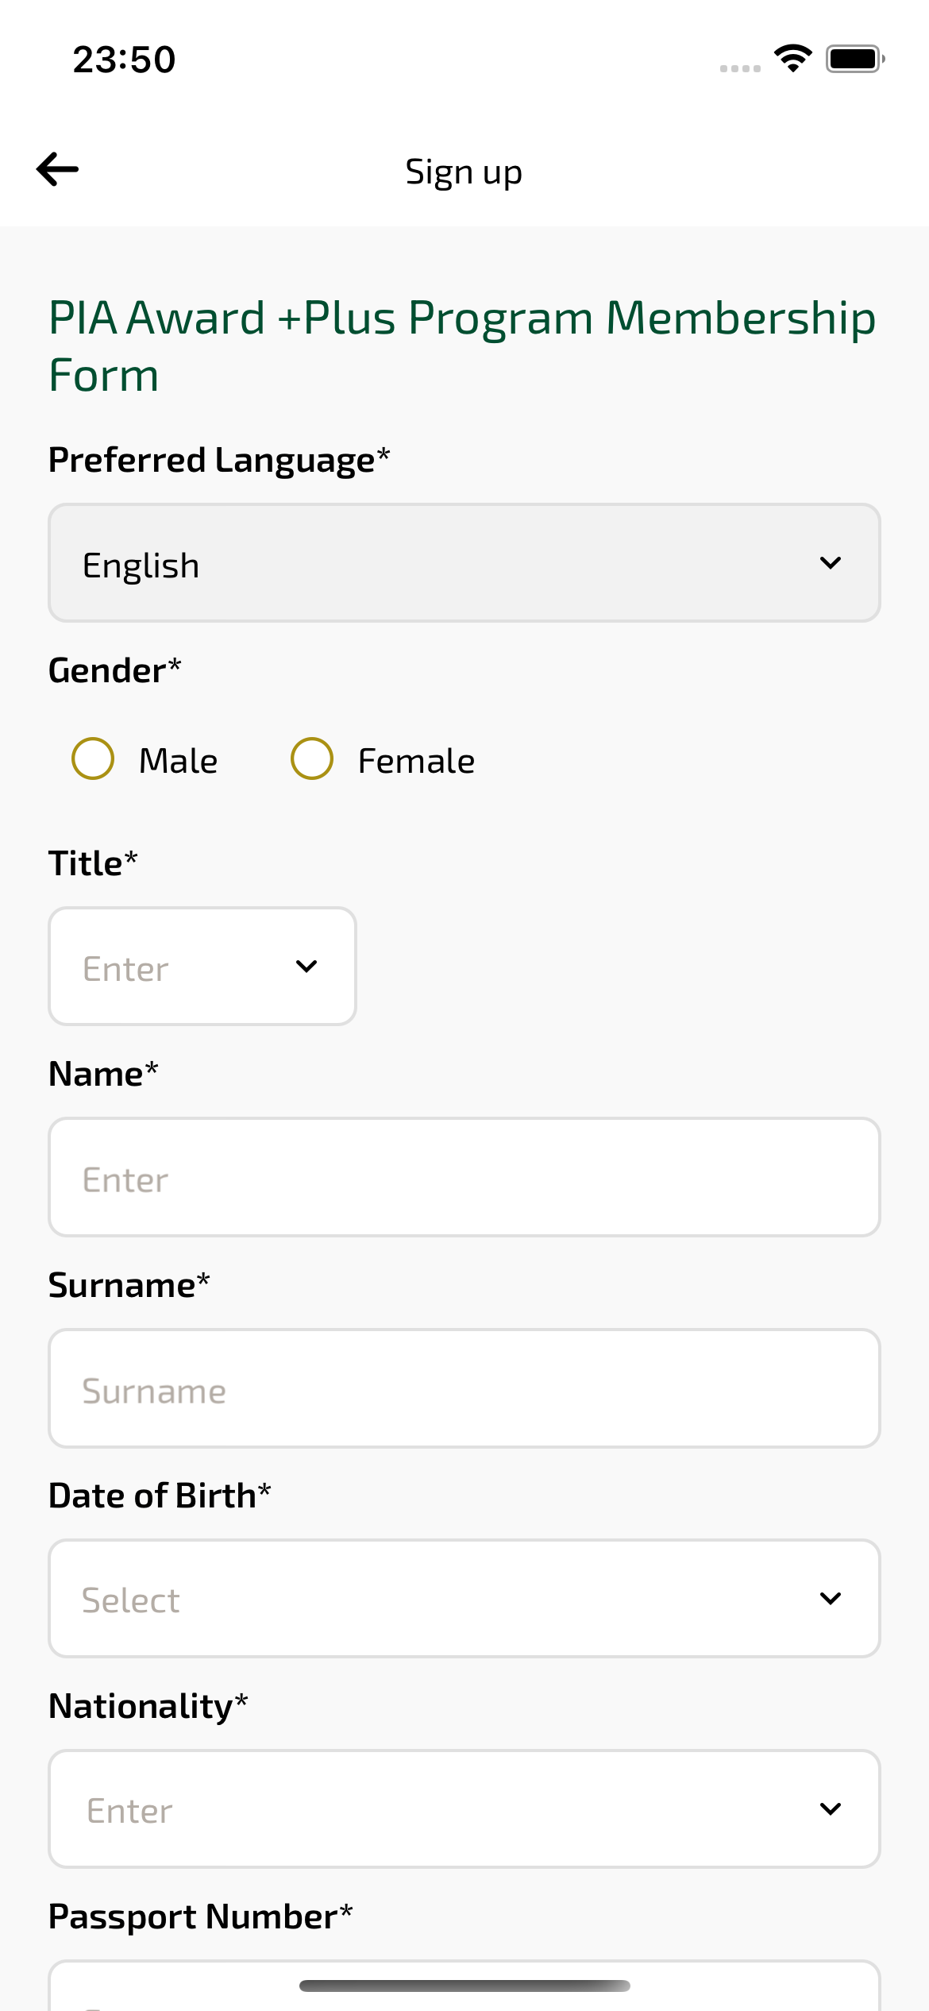
signupForm_ios sayfası ekran görüntüsü

