Accessibility ID Report — ssrList_ios
Tarih: 31.03.2026 00:54 | Platform: IOS

Element ID | Page | Type | Label / Text | Value | Accessibility ID | Status | New Status
ssrList_ios_element_1 | Additional Services | Other |  |  |  | ID Yok | ID Eklenecek (Waiting Dev)
ssrList_ios_element_2 | Additional Services | Other | Log in |  |  | ID Yok | ID Eklenecek (Waiting Dev)
ssrList_ios_element_3 | Additional Services | Other | Flight Schedule |  |  | ID Yok | ID Eklenecek (Waiting Dev)
ssrList_ios_element_4 | Additional Services | Other | Flight Status |  |  | ID Yok | ID Eklenecek (Waiting Dev)
ssrList_ios_element_5 | Additional Services | Other | Feedback |  |  | ID Yok | ID Eklenecek (Waiting Dev)
ssrList_ios_element_6 | Additional Services | Other | Notifications |  |  | ID Yok | ID Eklenecek (Waiting Dev)
ssrList_ios_element_7 | Additional Services | Other | Gift Card |  |  | ID Yok | ID Eklenecek (Waiting Dev)
ssrList_ios_element_8 | Additional Services | Other | Settings |  |  | ID Yok | ID Eklenecek (Waiting Dev)
ssrList_ios_element_9 | Additional Services | Other | Contact us |  |  | ID Yok | ID Eklenecek (Waiting Dev)
ssrList_ios_element_10 | Additional Services | Other | Total , 187.15EUR |  |  | ID Yok | ID Eklenecek (Waiting Dev)
ssrList_ios_element_11 | Additional Services | Other |  |  | ssr_navigator_back_button | ID Var
ssrList_ios_element_12 | Additional Services | Other | Continue |  | ssr_navigator_continue_button | ID Var
ssrList_ios_element_13 | Additional Services | Other | Seat Selection, 4A |  | ssr_navigator_ssr_item_SEAT | ID Var
ssrList_ios_element_14 | Additional Services | Other | Extra Baggage Selection, Baggage +5kg x1 |  | ssr_navigator_ssr_item_BAG | ID Var

📸 Ekran Görüntüsü
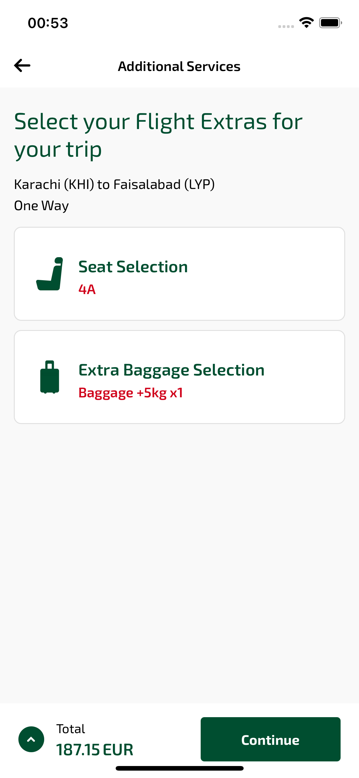
ssrList_ios sayfası ekran görüntüsü

