Accessibility ID Report — upcomingFlightsHaveFlight
Tarih: 31.03.2026 14:50 | Platform: iOS

Element ID | Page | Type | Label / Text | Value | Accessibility ID | Status | New Status
upcomingFlightsHaveFlight_element_1 | Welcome, | Button | HOME, tab, 1 of 5 |  |  | ID Yok | ID Eklenecek (Waiting Dev)
upcomingFlightsHaveFlight_element_2 | Welcome, | Button | AVAILABILITY_SEARCH, tab, 2 of 5 |  |  | ID Yok | ID Eklenecek (Waiting Dev)
upcomingFlightsHaveFlight_element_3 | Welcome, | Button | MY_TRIPS_INITIAL, tab, 3 of 5 | 1 |  | ID Yok | ID Eklenecek (Waiting Dev)
upcomingFlightsHaveFlight_element_4 | Welcome, | Button | CHECKIN, tab, 4 of 5 |  |  | ID Yok | ID Eklenecek (Waiting Dev)
upcomingFlightsHaveFlight_element_5 | Welcome, | Button | LOYALTY, tab, 5 of 5 |  |  | ID Yok | ID Eklenecek (Waiting Dev)
upcomingFlightsHaveFlight_element_6 | Welcome, | Other |  |  |  | ID Yok | ID Eklenecek (Waiting Dev)
upcomingFlightsHaveFlight_element_7 | Welcome, | Other | Find a Flight |  |  | ID Yok | ID Eklenecek (Waiting Dev)
upcomingFlightsHaveFlight_element_8 | Welcome, | Other | Upcoming |  |  | ID Yok | ID Eklenecek (Waiting Dev)
upcomingFlightsHaveFlight_element_9 | Welcome, | Other | Past |  |  | ID Yok | ID Eklenecek (Waiting Dev)
upcomingFlightsHaveFlight_element_10 | Welcome, | Other | Test Operational Notice For Testing In UAT1 Test Operational Notice For Testing In UAT2 |  |  | ID Yok | ID Eklenecek (Waiting Dev)
upcomingFlightsHaveFlight_element_11 | Welcome, | Other | Information for Credit Card Holders |  |  | ID Yok | ID Eklenecek (Waiting Dev)
upcomingFlightsHaveFlight_element_12 | Welcome, | Other | Long Lon Long Operational Notice One Two |  |  | ID Yok | ID Eklenecek (Waiting Dev)
upcomingFlightsHaveFlight_element_13 | Welcome, | Other | Karachi, to , Faisalabad, 03 Apr, ⬤, 21:00 - 22:45, 1 Adult, PNR No: 9DRZUD |  |  | ID Yok | ID Eklenecek (Waiting Dev)
upcomingFlightsHaveFlight_element_14 | Welcome, | Other | Karachi, to , Jeddah, 02 Apr, ⬤, 22:25 - 01:00, 1 Adult, PNR No: 9DRQ12 |  |  | ID Yok | ID Eklenecek (Waiting Dev)

📸 Ekran Görüntüsü
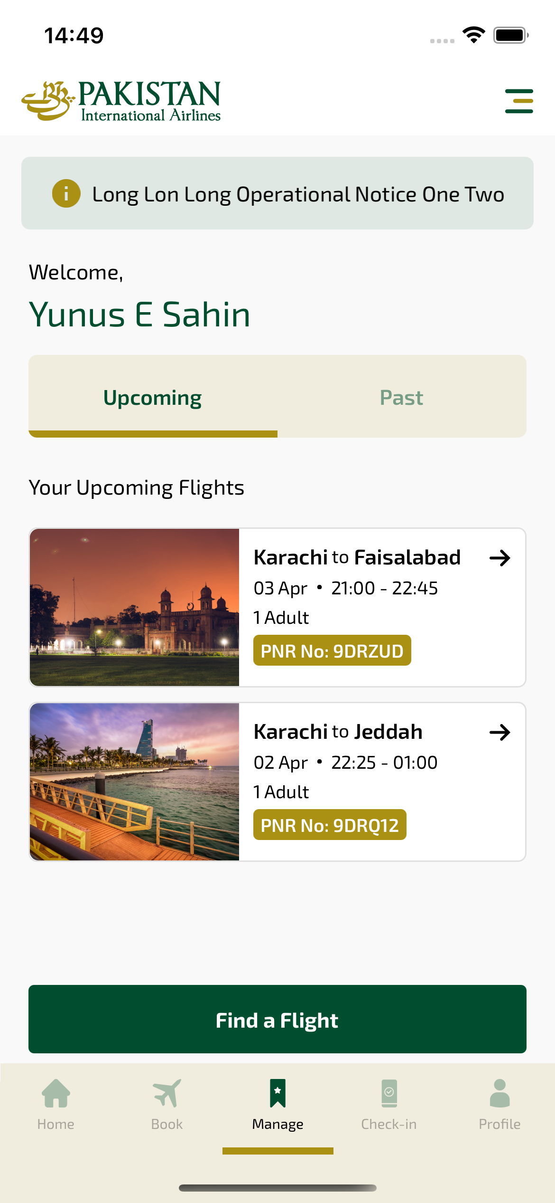
upcomingFlightsHaveFlight sayfası ekran görüntüsü

