Accessibility ID Report — yourFlight_ios
Tarih: 31.03.2026 00:30 | Platform: IOS

Element ID | Page | Type | Label / Text | Value | Accessibility ID | Status | New Status
yourFlight_ios_element_1 | Your Route | Other |  |  |  | ID Yok | ID Eklenecek (Waiting Dev)
yourFlight_ios_element_2 | Your Route | Other | Log in |  |  | ID Yok | ID Eklenecek (Waiting Dev)
yourFlight_ios_element_3 | Your Route | Other | Flight Schedule |  |  | ID Yok | ID Eklenecek (Waiting Dev)
yourFlight_ios_element_4 | Your Route | Other | Flight Status |  |  | ID Yok | ID Eklenecek (Waiting Dev)
yourFlight_ios_element_5 | Your Route | Other | Feedback |  |  | ID Yok | ID Eklenecek (Waiting Dev)
yourFlight_ios_element_6 | Your Route | Other | Notifications |  |  | ID Yok | ID Eklenecek (Waiting Dev)
yourFlight_ios_element_7 | Your Route | Other | Gift Card |  |  | ID Yok | ID Eklenecek (Waiting Dev)
yourFlight_ios_element_8 | Your Route | Other | Settings |  |  | ID Yok | ID Eklenecek (Waiting Dev)
yourFlight_ios_element_9 | Your Route | Other | Contact us |  |  | ID Yok | ID Eklenecek (Waiting Dev)
yourFlight_ios_element_10 | Your Route | Other |  |  |  | ID Yok | ID Eklenecek (Waiting Dev)
yourFlight_ios_element_11 | Your Route | Other | Total , 179.59EUR |  |  | ID Yok | ID Eklenecek (Waiting Dev)
yourFlight_ios_element_12 | Your Route | Other | Karachi (KHI) to Faisalabad (LYP), Fri, 10 Apr - 21:00, 1h 45min - PK 340, ECONOMY, Direct |  |  | ID Yok | ID Eklenecek (Waiting Dev)
yourFlight_ios_element_13 | Your Route | Other | Continue |  | your_route_continue_button | ID Var

📸 Ekran Görüntüsü
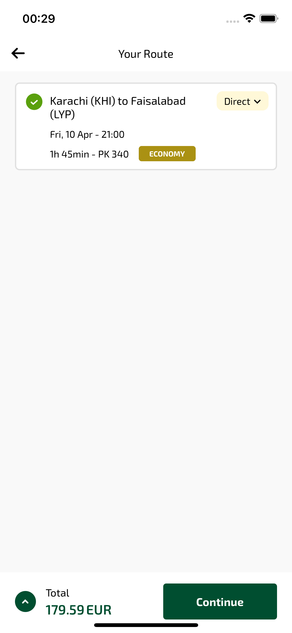
yourFlight_ios sayfası ekran görüntüsü

