Accessibility Report — 1_search
Tarih: 30.03.2026 13:11 | Platform: ANDROID

Page | Type | Label / Text | Value | Resource ID | Status
MainActivity | View | Home |  |  | ID Yok
MainActivity | View | Book |  |  | ID Yok
MainActivity | View | Manage |  |  | ID Yok
MainActivity | View | Check-in |  |  | ID Yok
MainActivity | View | Profile |  |  | ID Yok
MainActivity | ViewGroup | Information for Credit Card Holders |  |  | ID Yok
MainActivity | ViewGroup | One Way |  | avail_selection_switch_item | Duplicate
MainActivity | ViewGroup | Round Trip |  | avail_selection_switch_item | Duplicate
MainActivity | ViewGroup | Multi City |  | avail_selection_switch_item | Duplicate
MainActivity | ViewGroup | Passengers, 1 Adult |  | avail_search_pax_count_card | Duplicate
MainActivity | ViewGroup | Class, Economy |  | avail_search_pax_count_card | Duplicate
MainActivity | ViewGroup |  |  | avail_search_header | ID Var
MainActivity | ViewGroup |  |  | __CAROUSEL_ITEM_2__ | ID Var
MainActivity | ViewGroup | Departure, Select |  | avail_search_dep_port_card | ID Var
MainActivity | ViewGroup | Arrival, Select |  | avail_search_arr_port_card | ID Var
MainActivity | ViewGroup | Departure Date, Select |  | avail_search_dep_date_card | ID Var
MainActivity | FrameLayout |  |  | content | ID Var
MainActivity | LinearLayout |  |  | action_bar_root | ID Var

📸 Ekran Görüntüsü
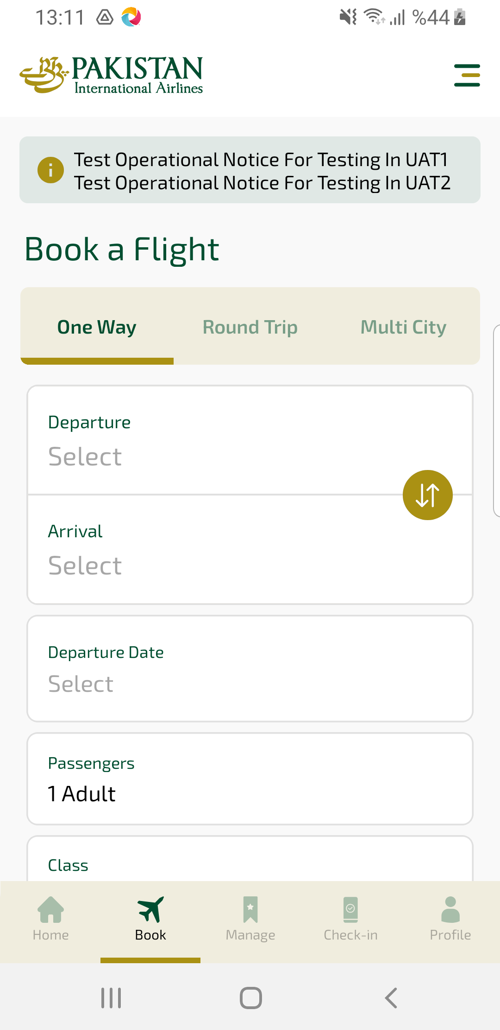
1_search sayfası ekran görüntüsü

