Accessibility Report — 2_search
Tarih: 30.03.2026 13:13 | Platform: ANDROID

Page | Type | Label / Text | Value | Resource ID | Status
MainActivity | View | Home |  |  | ID Yok
MainActivity | View | Book |  |  | ID Yok
MainActivity | View | Manage |  |  | ID Yok
MainActivity | View | Check-in |  |  | ID Yok
MainActivity | View | Profile |  |  | ID Yok
MainActivity | ViewGroup | Test Operational Notice For Testing In UAT1 Test Operational Notice For Testing In UAT2 |  |  | ID Yok
MainActivity | ViewGroup | One Way |  | avail_selection_switch_item | Duplicate
MainActivity | ViewGroup | Round Trip |  | avail_selection_switch_item | Duplicate
MainActivity | ViewGroup | Multi City |  | avail_selection_switch_item | Duplicate
MainActivity | ViewGroup | Passengers, 2 Adult, , 1 Child, , 1 Infant |  | avail_search_pax_count_card | Duplicate
MainActivity | ViewGroup | Class, Economy |  | avail_search_pax_count_card | Duplicate
MainActivity | View |  |  | navigationBarBackground | ID Var
MainActivity | ViewGroup |  |  | avail_search_header | ID Var
MainActivity | ViewGroup |  |  | __CAROUSEL_ITEM_1__ | ID Var
MainActivity | ViewGroup | Departure, Aalborg - Aalborg Lufthavn Airport(AAL) |  | avail_search_dep_port_card | ID Var
MainActivity | ViewGroup | Arrival, Islamabad - Islamabad International Airport(ISB) |  | avail_search_arr_port_card | ID Var
MainActivity | ViewGroup | Departure Date, Tue, 31 Mar |  | avail_search_dep_date_card | ID Var
MainActivity | ViewGroup |  |  | pax_count_picker_header | ID Var
MainActivity | ViewGroup |  |  | pax_count_picker_dec_button_ADLT | ID Var
MainActivity | ViewGroup |  |  | pax_count_picker_inc_button_ADLT | ID Var
MainActivity | ViewGroup |  |  | pax_count_picker_dec_button_CHLD | ID Var
MainActivity | ViewGroup |  |  | pax_count_picker_inc_button_CHLD | ID Var
MainActivity | ViewGroup |  |  | pax_count_picker_dec_button_INFT | ID Var
MainActivity | ViewGroup |  |  | pax_count_picker_inc_button_INFT | ID Var
MainActivity | ViewGroup | Done |  | pax_count_picker_done_button | ID Var
MainActivity | FrameLayout |  |  | content | ID Var
MainActivity | LinearLayout |  |  | action_bar_root | ID Var

📸 Ekran Görüntüsü
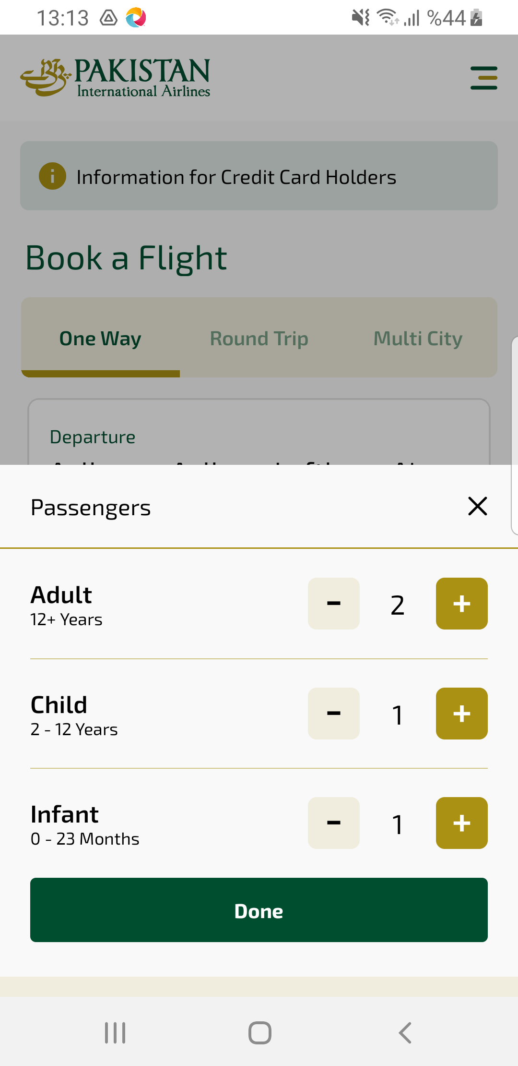
2_search sayfası ekran görüntüsü

