Generation Prompt and Required Figures
Machine Learning Classification: SVM, Naive Bayes, and Logistic Regression
Create a concise and professional 3-minute presentation about the machine learning classification component of an XMUM Freshman FAQ Chatbot.
The presentation should focus only on the classification part, especially the comparison between Naive Bayes, Logistic Regression, and Linear SVM. Use the real project results below instead of invented numbers.
Project context:
This project is a hybrid FAQ chatbot for XMUM freshman enquiries. The chatbot first handles simple rule-based intents such as greetings, thanks, goodbye, help, and identity. For real FAQ questions, it uses machine learning classification to predict the user's question category before retrieving or selecting an answer.
Dataset:
- Number of target categories: 8
- Categories:
1. Campus life: 193 samples
2. Accommodation & Living: 94 samples
3. Academic Affairs: 71 samples
4. Registration & Orientation: 64 samples
5. Transportation: 53 samples
6. Finance & Fees: 52 samples
7. Campus Services: 52 samples
8. University Platforms & IT Support: 43 samples
Text preprocessing:
- Lowercasing
- Removing punctuation and special symbols
- Tokenization
- Stopword removal
- Simple stemming
- For Logistic Regression and Linear SVM, text is converted using TF-IDF with unigram and bigram features, maximum 2000 features, and sublinear TF scaling.
- Naive Bayes uses a custom word-count probabilistic implementation with Laplace smoothing.
Models compared:
1. Naive Bayes
2. Logistic Regression
3. Linear SVM
Model evaluation method:
The models are evaluated through a supervised text classification workflow. First, the FAQ dataset is split into training and testing data using an 80/20 stratified split, so each category is represented in both sets. Each model is trained on the training set and then tested on unseen test questions.
The main evaluation metrics are:
- Accuracy: the percentage of all test questions classified correctly.
- Precision: among the questions predicted as a category, how many are actually correct.
- Recall: among the real questions in a category, how many are successfully found by the model.
- F1-score: the balance between precision and recall.
- Macro F1: the average F1-score across all categories, treating each category equally.
Macro F1 is especially important because the dataset is imbalanced. For example, Campus life has many more samples than University Platforms & IT Support. If we only use accuracy, the model may look good by performing well on large categories, while still performing poorly on smaller categories.
We also compare:
- Per-class precision, recall, and F1-score to see which categories are easier or harder.
- Train-test accuracy gap to check possible overfitting.
- 5-fold cross-validation macro F1 to estimate performance stability across different splits.
- Training time to compare efficiency.
Real evaluation results:
| Model | Test Accuracy | Macro F1 | Train Accuracy | Train Macro F1 | Train-Test Accuracy Gap | 5-Fold CV Macro F1 | Training Time |
|---|---:|---:|---:|---:|---:|---:|---:|
| Naive Bayes | 0.7280 | 0.6428 | 0.9577 | 0.9442 | 0.2297 | 0.7182 +/- 0.0485 | 0.0034s |
| Logistic Regression | 0.7440 | 0.6905 | 0.9960 | 0.9961 | 0.2520 | 0.7668 +/- 0.0466 | 0.3393s |
| Linear SVM | 0.7680 | 0.7186 | 0.9799 | 0.9763 | 0.2119 | 0.7213 +/- 0.0318 | 0.1341s |
Main finding:
On the held-out test set, Linear SVM achieved the best performance with 0.7680 accuracy and 0.7186 macro F1. It also had the smallest train-test accuracy gap among the three models, suggesting relatively better generalization on this split. Logistic Regression had the highest 5-fold CV macro F1, but it also showed the largest train-test gap. Naive Bayes was the fastest model but had the lowest macro F1.
Important per-class Linear SVM results:
| Category | Precision | Recall | F1-score | Support |
|---|---:|---:|---:|---:|
| Academic Affairs | 0.8571 | 0.8571 | 0.8571 | 14 |
| Accommodation & Living | 0.7500 | 0.7895 | 0.7692 | 19 |
| Campus Services | 0.3571 | 0.5000 | 0.4167 | 10 |
| Campus life | 0.8780 | 0.9231 | 0.9000 | 39 |
| Finance & Fees | 0.7500 | 0.6000 | 0.6667 | 10 |
| Registration & Orientation | 1.0000 | 0.6923 | 0.8182 | 13 |
| Transportation | 0.6667 | 0.7273 | 0.6957 | 11 |
| University Platforms & IT Support | 0.7143 | 0.5556 | 0.6250 | 9 |
Presentation requirements:
- Create 6 slides.
- Total speaking time should be about 3 minutes.
- Use a clean academic style suitable for a university project presentation.
- Keep text concise, but include speaker notes for each slide.
- Use blue, white, grey, and one contrasting highlight color.
- Every slide must include the following footer in the bottom-right corner:
HUANG YUHAN
TCM2409003
- Do not overcrowd slides.
- Use charts and tables where appropriate.
- Make the presentation easy to explain orally.
Slide 1: Title
Title: Machine Learning Classification
Subtitle: Comparing Naive Bayes, Logistic Regression, and Linear SVM
Visual: simple chatbot or text classification icon.
Speaker note:
Briefly introduce that this part focuses on how the chatbot classifies freshman questions into FAQ categories using machine learning.
Slide 2: Role of Classification in the Chatbot
Show the pipeline:
User Question -> Text Preprocessing -> ML Classification -> Predicted Category -> FAQ Retrieval / Response
Explain that simple conversational inputs are handled by rule-based intent detection, while real FAQ queries are routed to ML classification.
Use the eight target categories as small labels around the classifier block:
Academic Affairs, Accommodation & Living, Campus Services, Campus life, Finance & Fees, Registration & Orientation, Transportation, University Platforms & IT Support.
Speaker note:
Explain that classification helps the chatbot understand the topic of a freshman's question before selecting the most relevant answer.
Slide 3: Training Pipeline
Show training steps:
Naive Bayes:
NB:
Data -> Preprocessing -> Word Counts -> Naive Bayes Training -> Prediction

LG:
Data -> Preprocessing -> TF-IDF Features -> Logistic Regression Training -> Prediction

SVM:
Data -> Preprocessing -> TF-IDF Features -> Linear SVM Training -> Prediction
Mention that TF-IDF unigram and bigram features are used for Logistic Regression and Linear SVM, while Naive Bayes uses word-frequency counts from the preprocessed text with Laplace smoothing.
Slide 4: Evaluation Method and Models Compared
Show the category distribution chart.
Point out that the dataset is imbalanced. Campus life has the most samples, while IT Support has the fewest. This is why macro F1 is important.
Explain how the models are evaluated:
- Use a stratified 80/20 train-test split.
- Train each classifier on the training data.
- Test each classifier on unseen test questions.
- Compare accuracy, precision, recall, and macro F1.
- Use train-test gap and 5-fold cross-validation macro F1 to check generalization and stability.
Then create a comparison table:
| Model | Main Idea | Strength | Limitation |
|---|---|---|---|
| Naive Bayes | Uses word probabilities and class priors | Very fast and simple | Lower macro F1, assumes word independence |
| Logistic Regression | Learns class probabilities from TF-IDF features | Strong baseline and interpretable | Highest train-test gap in this result |
| Linear SVM | Finds strong linear decision boundaries for text features | Best test accuracy and macro F1 | Less transparent than Naive Bayes |

Speaker note:
Explain that accuracy shows overall correctness, while macro F1 is more suitable for this project because each category should matter, even when category sizes are unequal.
Slide 5: Performance Comparison
Use a grouped bar chart comparing Test Accuracy and Macro F1:
Naive Bayes: Accuracy 0.7280, Macro F1 0.6428
Logistic Regression: Accuracy 0.7440, Macro F1 0.6905
Linear SVM: Accuracy 0.7680, Macro F1 0.7186
Add a small table or callout:
Best test-set model: Linear SVM
Accuracy: 0.7680
Macro F1: 0.7186
Smallest train-test accuracy gap: 0.2119
Also mention:
Naive Bayes was fastest: 0.0034s
Logistic Regression had highest 5-fold CV macro F1: 0.7668 +/- 0.0466
Linear SVM had the best held-out test result.
Speaker note:
Explain that Linear SVM performs best on the test set. Macro F1 is especially important because the categories are imbalanced. Logistic Regression performs well in cross-validation but shows a larger train-test gap, while Naive Bayes is efficient but less accurate.
Slide 6: Conclusion and Insights
Summarize:
- Linear SVM achieved the best held-out test performance: 0.7680 accuracy and 0.7186 macro F1.
- Campus life and Academic Affairs performed strongly.
- Campus Services and IT Support were more challenging, likely because of fewer samples and overlapping wording.
- Future improvement: add more balanced training data, tune model parameters, and improve category-specific examples.
Final sentence:
"Overall, Linear SVM is the most suitable classifier for the current chatbot because it gives the best balance between test accuracy, macro F1, and generalization."
Speaker note:
End by saying that classification improves the chatbot's ability to route freshman questions to the correct topic and support more accurate responses.

Figures to Insert

ML Classification Pipeline
Use this on Slide 2 to explain how a user question moves from preprocessing to category prediction.
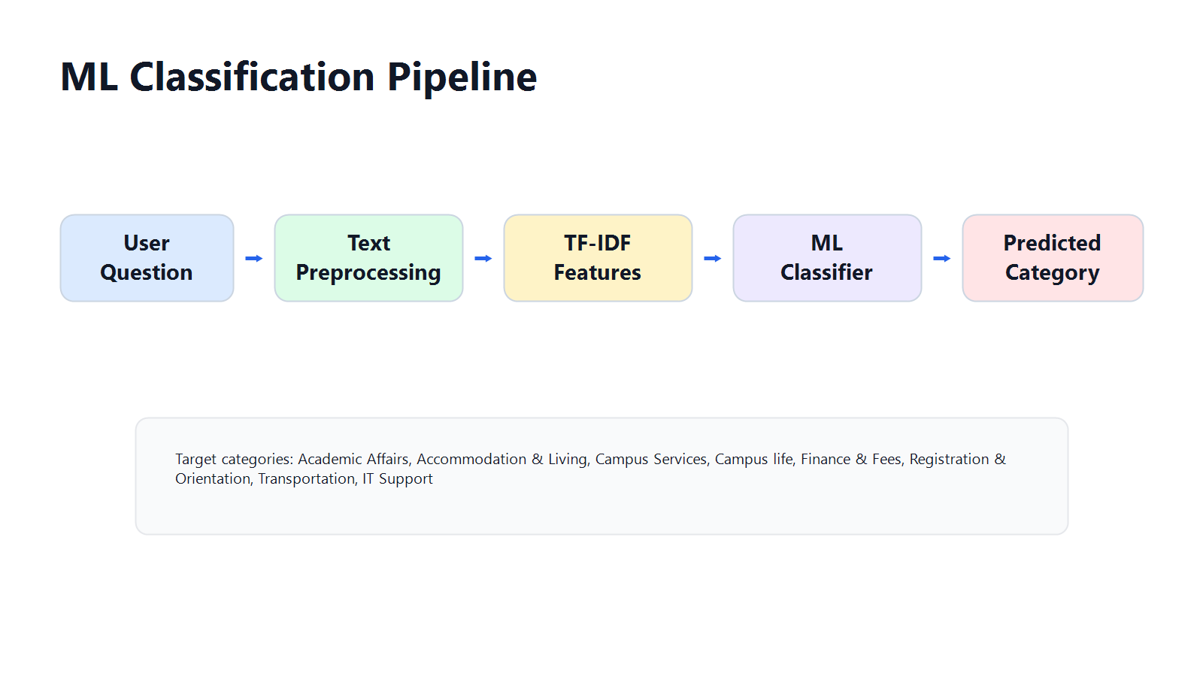
01_ml_classification_pipeline_clean.png

Dataset Category Distribution
Use this on Slide 4 to show class imbalance and justify using macro F1.
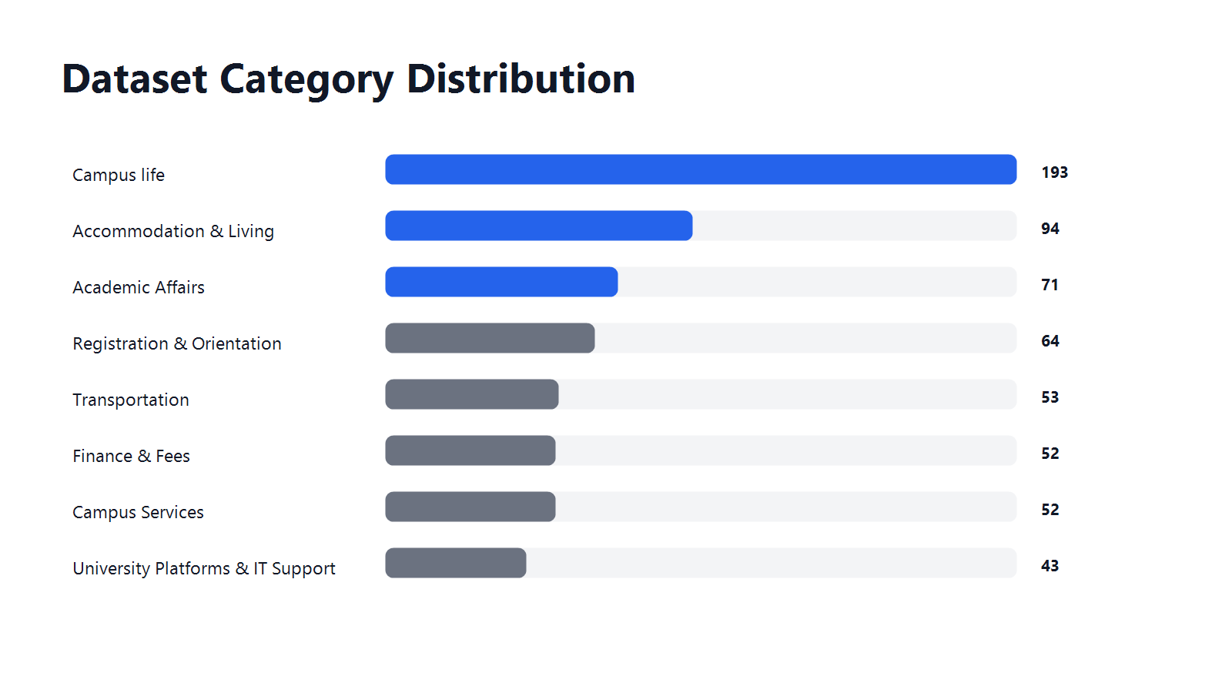
02_category_distribution_clean.png

Model Performance Comparison
Use this on Slide 5 as the main evidence that Linear SVM performs best on the held-out test set.
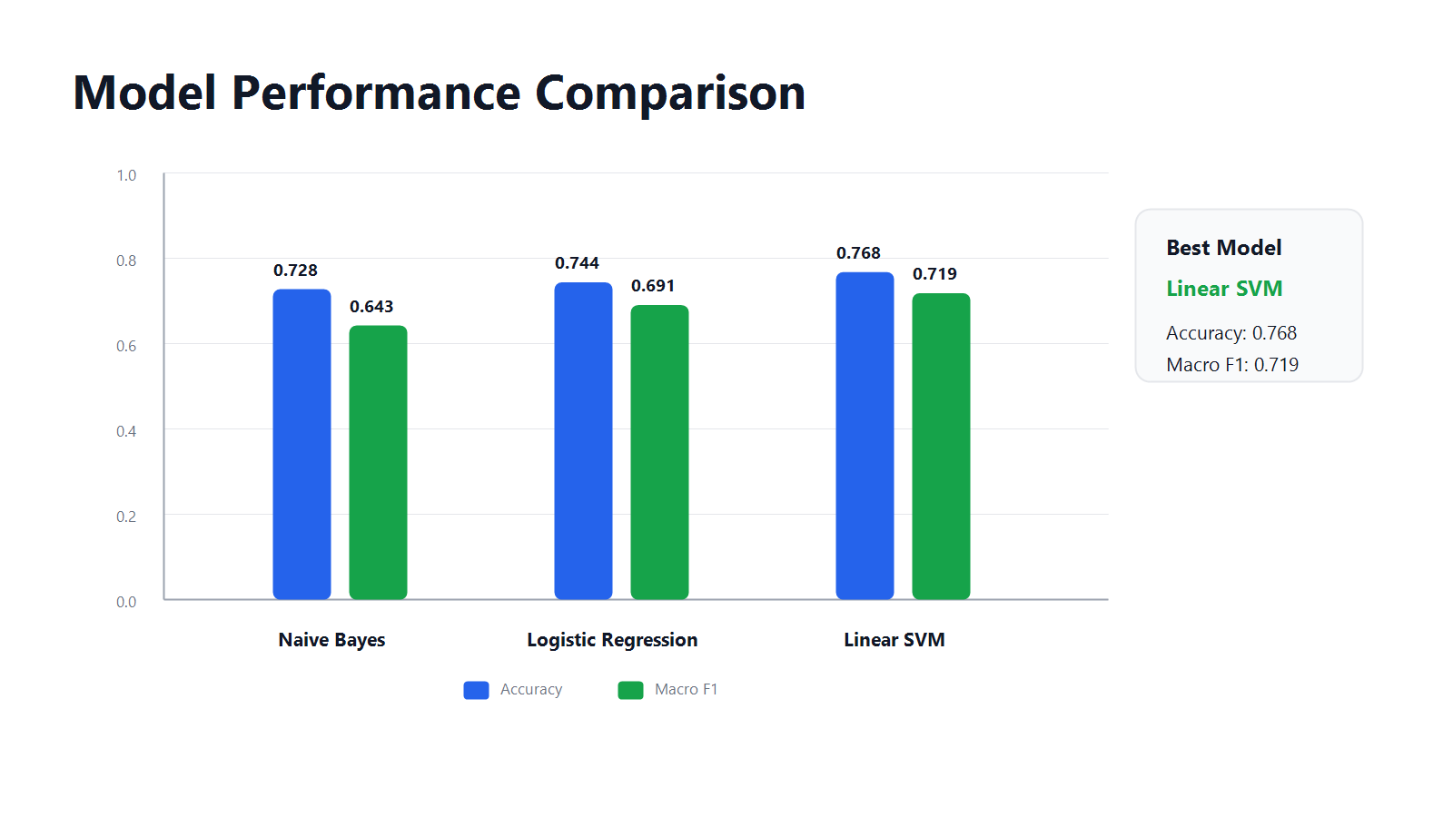
03_model_performance_comparison_clean.png

Linear SVM Per-Class Results
Use this on Slide 6 or as a backup figure to explain which categories are strong or weak.
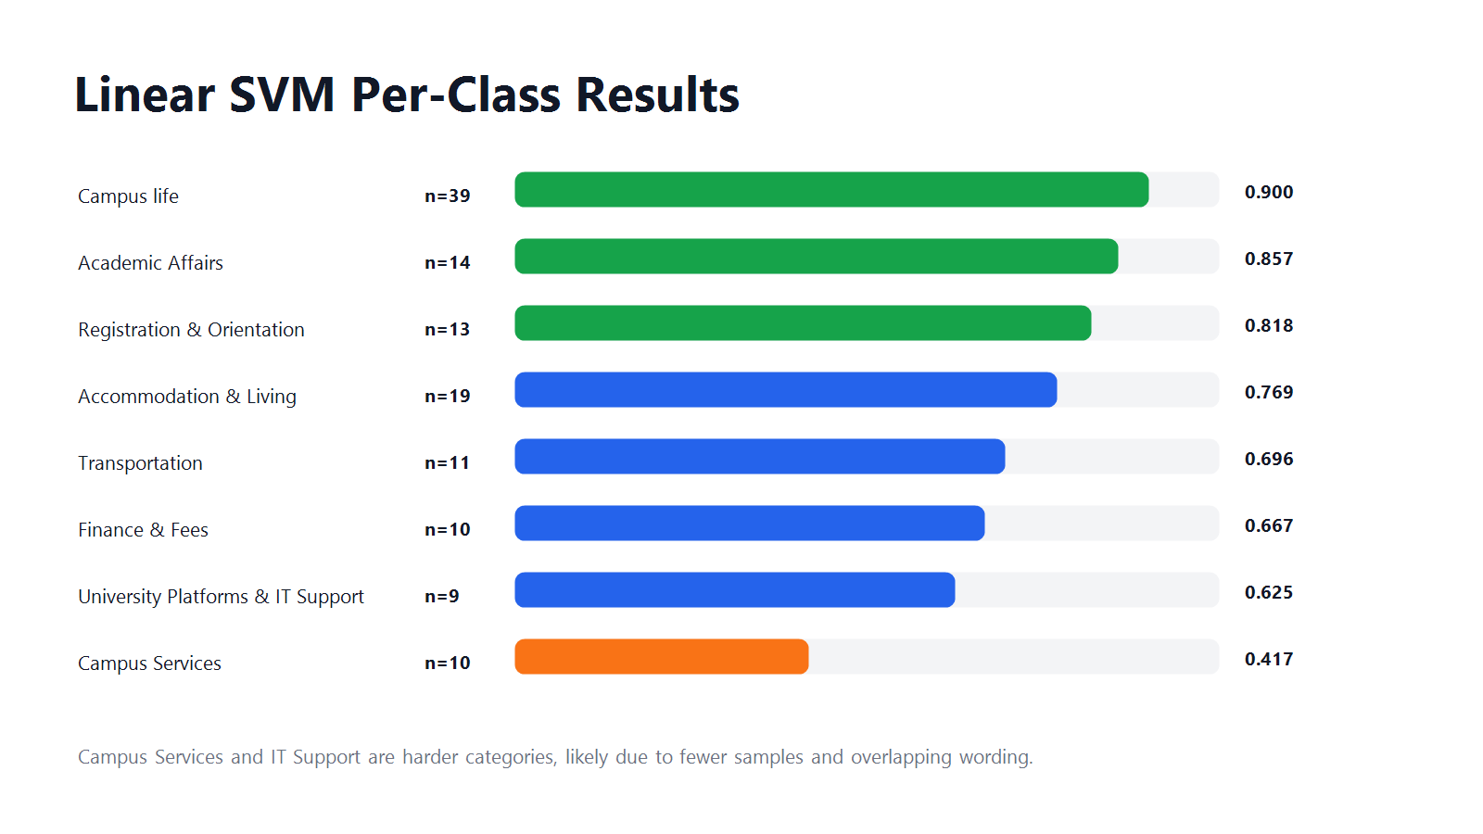
04_linear_svm_per_class_f1_clean.png

Recommended Figure Placement
- Slide 2: ML Classification Pipeline
- Slide 4: Dataset Category Distribution
- Slide 5: Model Performance Comparison
- Slide 6 or backup slide: Linear SVM Per-Class Results

