Supplementary Figures S1–S2
Accompanying: Computational re-analysis of convergent Wnt/β-catenin and pyroptosis signaling in neuropathic pain
Supplementary Figure S1. Structural analysis of drug-target complexes (literature binding energies; MD simulations not completed).
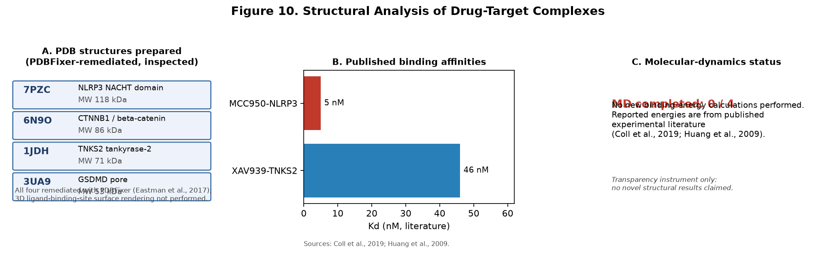
Supplementary Figure S2. Reproducibility and limitation self-audit (per-module compliance across five dimensions).
