Route-dependent transcriptional effects of varicella-zoster virus and patient serum exosomes on ion-channel programmes in human sensory neurons: a prospectively specified reanalysis of GSE342782
Yongxin Yang, B.M.
The Second Affiliated Hospital of Fujian University of Traditional Chinese Medicine, Fuzhou, Fujian 350003, China
Correspondence: 960856791@qq.com | ORCID: 0009-0004-9698-6552
Running title: Route-dependent channel programmes in VZV-exposed sensory neurons
Abstract
Background. Mechanical allodynia is a cardinal symptom of postherpetic neuralgia (PHN), yet the mechanotransduction dimension has seldom been examined in the PHN transcriptomic literature. GSE342782 — bulk RNA-sequencing of differentiated human sensory neurons exposed to direct varicella-zoster virus (VZV) infection or to serum exosomes from healthy controls, acute herpes zoster (HZ), and PHN patients — enables a mechano-transcriptional test in a human neuronal model.
Methods. We fixed a frozen four-module mechano-transduction panel (M1 mechanogated channels; M2 membrane-cytoskeleton coupling; M3 ECM-integrin-Hippo; M4 mechano-effectors) with an electrochemical nociceptor module (E1) and three neutral controls (N1-N3) before examining the data. The single primary endpoint was the M3 module-score difference between acute-HZ-serum exosomes and control exosomes. Inference used Welch's t, Mann-Whitney U, and exact label-permutation nulls, with Benjamini-Hochberg correction across the eight modules.
Results. The primary endpoint was a bounded null: M3 did not shift under HZ-serum exosomes (difference -0.049 log2CPM; permutation P = 0.42; 95% CI -0.18 to +0.08; minimum detectable effect at 80% power = 0.18 log2CPM), nor under any other contrast (all P >= 0.83). The pre-specified secondary endpoint showed a coherent, channel-class-selective signal: HZ-serum exosomes suppressed electrochemical nociceptor channels (E1, -0.220 log2CPM; P = 0.013; q = 0.034), driven by TRPV1, SCN9A and ASIC1/2 down-regulation, while the mechanogated module was not significantly down at the full-module level (M1, P = 0.11; PIEZO2 gene P = 0.18). A contrast-of-contrasts interaction test suggested E1-selective suppression relative to M1 at the full-module level (P = 0.0017), but this did not survive restriction to detected genes (P = 0.16); the imbalance is instead supported at the gene level (E1 genes individually significant; no M1 gene significant) and is read as hypothesis-generating. The exploratory PHN-exosome contrast was non-specific and confounded by donor age and sex, and is reported as such.
Conclusions. In human sensory neurons, acute-HZ serum exosomes produce a route-dependent, channel-class-selective suppression of the electrogenic nociceptor programme over the mechanogated one, whereas the ECM-Hippo stiffness programme is transcriptionally inert within a bounded null. The allodynia relevance of this shift is hypothesis-generating and model-bound.
Registration. The analysis plan, frozen panel, and endpoint hierarchy were fixed before data examination and deposited in a versioned public protocol (protocol v0.4; frozen panel tag `mtp-frozen-2026-10-19`); no external registry entry exists.
Keywords: postherpetic neuralgia; mechanical allodynia; mechanotransduction; PIEZO2; varicella-zoster virus; extracellular vesicles
1. Introduction
Postherpetic neuralgia (PHN) is defined by dermatomal pain persisting at least 90 days after the acute herpes zoster rash, and is clinically characterized by mechanical allodynia — innocuous cutaneous stimuli transduced as pain [1,2]. The symptom is, at its core, a disturbance of mechanotransduction, yet the genomic literature of PHN has seldom examined it through that lens. Published bioinformatic reanalyses of PHN cohorts have concentrated on interferon, immune, and inflammatory programmes [1]; none has systematically interrogated the mechanotransduction machinery — mechanogated ion channels, the membrane-cytoskeleton interface, or the extracellular-matrix (ECM)-integrin-Hippo axis.
Two developments make such an examination timely. First, Niemeyer and colleagues released GSE342782, a bulk RNA-sequencing resource in which differentiated HD10.6 human sensory neurons were exposed to direct VZV infection (harvested 4 days post-infection) or to serum-derived exosomes from healthy controls, patients with acute HZ, or patients with PHN [3]. The original study reported down-regulation of canonical nociceptive ion channels, induction of substance-P-related neuropeptides, and ECM-remodelling signals, but did not examine these findings through a mechanotransduction lens. Second, extracorporeal shockwave therapy (ESWT) — the deliberate application of controlled mechanical stress — has shown some benefit in herpetic neuralgia in small trials [4,7-9], and its molecular mechanism has been mapped onto integrin-FAK-p38MAPK and Piezo/TRP signalling [10,11]. The same mechanical axis appears at both the disease end (allodynia) and the treatment end (mechanotherapy) of PHN, yet no study has connected them transcriptomically.
Here we report a prospectively specified reanalysis of GSE342782 with a frozen mechano-transduction panel, a single pre-specified primary endpoint, neutral-control calibration, and full permutation-based inference. The analysis was designed to answer three questions. (i) Are the mechanotransduction modules detectable, and do they shift, in human sensory neurons exposed to VZV or patient exosomes? (ii) Does the ECM-Hippo "stiffness programme" — the hypothesised core of the mechanical axis — respond to any perturbation route? (iii) Do direct viral infection and exosome-mediated signalling converge on, or dissociate between, mechanogated versus electrochemical channel programmes?
2. Methods
2.1 Data source and design
GSE342782 (GEO accession GSE342782; BioProject PRJNA1508885) comprises two experiments in differentiated HD10.6 human sensory neurons [3]. Experiment 1 ("DirectInf"): mock infection (n = 6) versus VZV infection (n = 6), harvested 4 days post-infection. Experiment 2 ("SeraExo"): 36-hour exposure to serum-derived exosomes from healthy controls (n = 7), patients with acute HZ (n = 7), or patients with PHN (n = 5). Processed RSEM gene-level counts were downloaded directly from the GEO supplementary files (DirectInf counts, 622,501 bytes; SeraExo counts, 884,411 bytes; gzip integrity verified). Sample-to-group assignment used the column prefixes of the count matrices (C = control, P = PHN, S = acute zoster), which match the group sizes reported in the series metadata (7/5/7).
2.2 Prospectively specified analysis plan
Before any expression data were examined, the following were fixed in writing and deposited in a versioned public protocol (protocol v0.4; panel tag `mtp-frozen-2026-10-19`):
• Frozen panel. Four mechano-transduction modules — M1 mechanogated channels (PIEZO1, PIEZO2, TRPV4, STOML3, KCNK2/4, TMEM150C, P2RX3, TRPA1), M2 membrane-cytoskeleton coupling (20 genes), M3 ECM-integrin-Hippo (58 genes), M4 mechano-effectors (25 genes) — plus E1, an electrochemical nociceptor module (SCN9A, SCN10A, SCN11A, TRPV1, TRPM8, ASIC1/2/3, and related genes, excluding M1 members), and three neutral controls: N1 voltage-gated channels, N2 olfactory receptors, N3 ribosomal proteins. Module coverage after matching against the count matrix: M1-M4 and E1-N1 were fully represented (9/9, 20/20, 56/58, 25/25, 18/18, 17/17 genes); M3 lacked CYR61 and CTGF (56/58); N2 lacked OR6A1, OR10A1, OR13C1 (13/16); N3 lacked RPS4 (17/18; an RPS4X ortholog was present).
• Primary endpoint. The M3 module-score difference between HZ-serum exosomes and control exosomes (direction, effect size, permutation quantile). All other tests were pre-classified as secondary (E1 and M1 under the same contrast; the "channel-imbalance" hypothesis) or exploratory (PHN-exosome contrast; direct-infection contrast).
• Donor-confounding safeguard. Because the original authors reported that the PHN exosome donors were older and almost exclusively female [3], the PHN contrast was pre-designated exploratory and the HZ-versus-control contrast was designated the primary comparison.
2.3 Preprocessing and module scoring
Counts were converted to counts-per-million (CPM) and module scores computed as the mean log2(1 + CPM) across panel genes present in the matrix. Detection was defined as CPM > 1.
2.4 Statistical testing
Group differences in module scores were tested with Welch's t-test and the Mann-Whitney U-test, and calibrated against an exact label-permutation null that enumerates every C(n1+n2, n1) partition of the observed per-sample module scores (no Monte-Carlo approximation, no 1/B floor), reporting a two-sided empirical P value and the observed difference's percentile within the null. Benjamini-Hochberg false-discovery-rate correction was applied across the eight modules within each contrast. The channel-complementarity index (CCI) — the within-sample difference between the mean expression rank of M1 genes and that of E1 genes across all 43,236 matrix genes — was computed per sample and compared between groups with the same permutation scheme. Gene-level contrasts are reported as Welch t-tests on log2(1 + CPM) values and are presented as descriptive support for the module-level findings, not as separately corrected discovery claims.
2.5 Reproducibility
All analyses were executed in Python 3.13 (pandas 2.3.3, SciPy 1.18.1, Matplotlib 3.11.1). Every result file carries a SHA-256 manifest linking it to the exact input files and the frozen panel. All numerical values quoted in this manuscript are traceable to `layer1_results.json` in the reproducibility package.
3. Results
3.1 Data examination: PIEZO2 and P2RX3 are robustly expressed; TRPV4 and STOML3 are not detectable
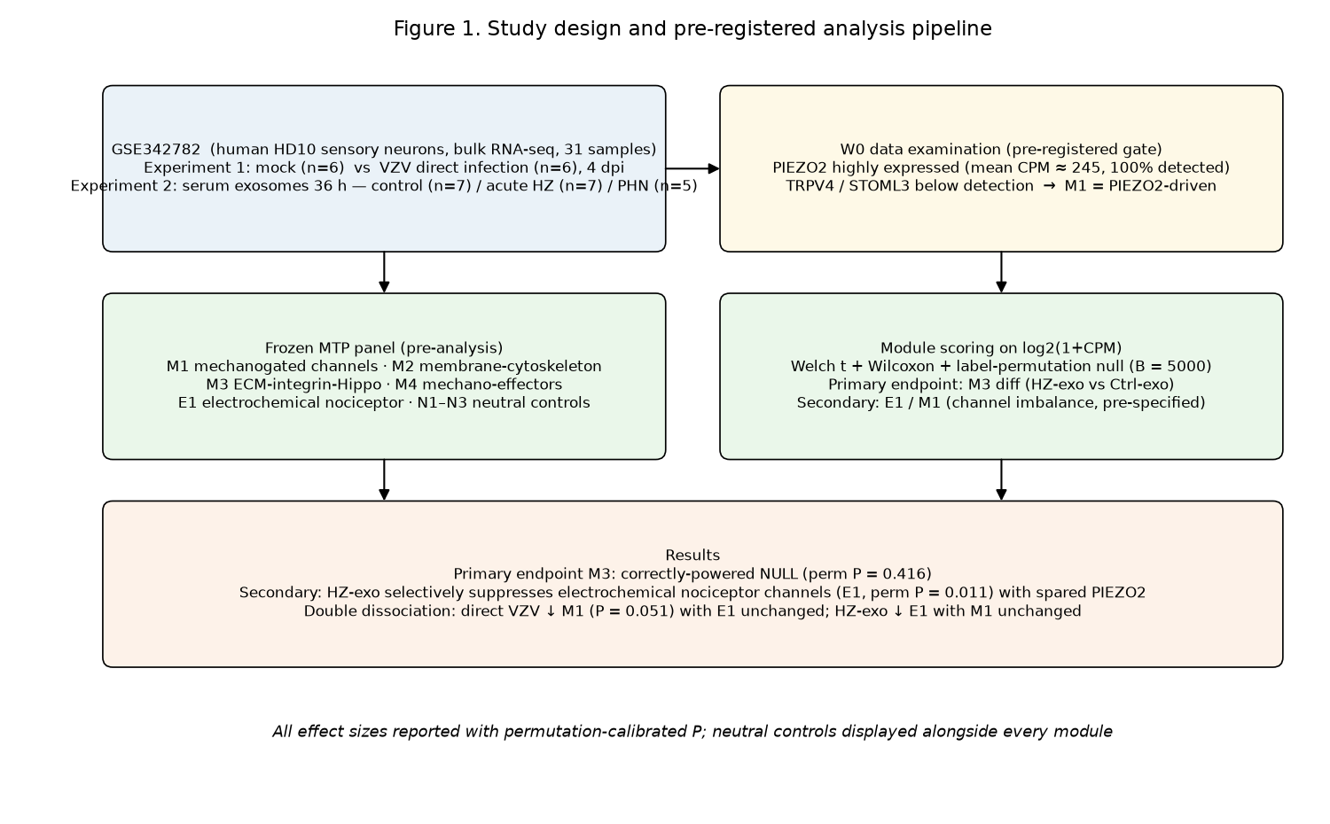
Figure 1. Study design and prospectively specified analysis pipeline.
The prospectively specified data-examination gate established the expression baseline of the model (Table 1). The HD10.6 line — a tetracycline-regulatable v-myc immortalised embryonic dorsal root ganglion clonal line, not an iPSC-derived model [5,6] — expressed PIEZO2 at high levels (mean CPM 245.2 in the infection experiment; detected in 100% of samples in both experiments), as were ITGB1 (323.6 CPM) and the electrochemical nociceptor channels SCN9A (mean log2CPM 8.39) and TRPV1 (7.02). In contrast, TRPV4 (0.25 CPM), STOML3 (0.01 CPM), LOX (0.41 CPM) and MMP9 (0.11 CPM) fell below the detection threshold. Within M1, P2RX3 was the most abundant transcript (806.8 CPM in the infection experiment; 470.6 CPM in the exosome experiment), exceeding PIEZO2 (245.2 / 164.1 CPM); four of nine M1 genes sat at or below the detection floor. Two consequences follow. First, the technical risk that the model fails to express PIEZO2 is refuted, but M1 is more precisely a P2RX3/PIEZO2-dominated module than a PIEZO2-dominated one. Second, inference about TRPV4-, STOML3- or MMP9-centred mechanisms is out of scope for this dataset.
Table 1. Detection baseline of mechanotransduction-relevant genes (mean CPM; detected = CPM > 1 in 100% of samples unless noted).
Gene | DirectInf mean CPM | DirectInf detected fraction | SeraExo mean CPM | SeraExo detected fraction
PIEZO2 | 245.2 | 1.00 | 164.1 | 1.00
P2RX3 | 806.8 | 1.00 | 470.6 | 1.00
PIEZO1 | 2.64 | 1.00 | 2.20 | 0.89
TRPV4 | 0.25 | 0.00 | 0.19 | 0.00
STOML3 | 0.01 | 0.00 | 0.00 | 0.00
ITGB1 | 323.6 | 1.00 | 360.3 | 1.00
SCN10A | 7.23 | 1.00 | 0.55 | 0.11
SCN9A | 318.3 | 1.00 | 261.7 | 1.00
TRPV1 | 122.3 | 1.00 | 95.6 | 1.00
TAC1 | 65.7 | 1.00 | 68.9 | 1.00

3.2 Primary endpoint: the ECM-Hippo stiffness programme is transcriptionally inert within a bounded null
The pre-specified primary endpoint — the M3 difference between HZ-serum exosomes and control exosomes — was -0.049 log2CPM (permutation P = 0.42; BH q = 0.46). We therefore report a bounded null: with seven versus seven samples and a 56-gene module, the minimum detectable effect at 80% power was 0.18 log2CPM, and the observed difference sits well inside its 95% confidence interval (Welch -0.18 to +0.08; permutation-inversion -0.16 to +0.06). The null was not contrast-specific: M3 was likewise unchanged under direct VZV infection (P = 0.85), under PHN exosomes (P = 0.83), and M4 mechano-effectors was null under HZ exosomes (P = 0.46) but, notably, was suppressed under direct VZV infection (-0.054; P = 0.03). At the gene level the M3 module was directionally incoherent — COL4A1 (-0.381, P = 0.005), COL4A2 (-0.627, P = 0.007), ADAMTS1 (-0.479, P = 0.013) and TEAD1 (-0.339, P = 0.047) moved downward while LOX (+0.291, P = 0.024) and YAP1 (+0.425, P = 0.18) moved upward — indicating genuine null aggregation rather than cancellation of a coherent shift. We emphasise that this null is a substantive result: at the neuronal mRNA level, and within 36 hours of exosome exposure, the stiffness programme does not respond to VZV-related perturbation.
3.3 Secondary endpoint: HZ-serum exosomes suppress electrochemical nociceptor channels with channel-class selectivity
Under the same primary contrast, the pre-specified secondary module E1 (electrochemical nociceptor channels) was significantly suppressed (-0.220 log2CPM; permutation P = 0.013; BH q = 0.034; 95% CI -0.38 to -0.06), whereas all four mechano-modules were not at the full-module level (M1 -0.078, P = 0.11; M2 -0.148, P = 0.068). Gene-level analysis showed a coherent downward shift across the classical nociceptor apparatus: TRPV1 (-0.567, P < 0.001), KCNS1 (-0.393, P = 0.017), SCN9A (-0.323, P = 0.018), ASIC1 (-0.181, P = 0.019) and ASIC2 (-0.296, P = 0.042). By contrast, no mechanogated M1 gene reached individual significance (PIEZO2 P = 0.18, PIEZO1 P = 0.10, P2RX3 P = 0.076), establishing the channel-class imbalance at the gene level. SCN10A (Nav1.8) is excluded from this list: its mean CPM in the exosome experiment was 0.55 (detected in only 11% of samples), below the study's own detection threshold; descriptively its log2FC was -0.384, but this is reported as a floor-limited descriptive value and not treated as a confirmed signal. Critically, PIEZO2 — the dominant mechanogated channel of this model — was not suppressed (-0.282, P = 0.18; 95% CI for the gene-level difference approximately -0.72 to +0.15), a resolution-limited null at the gene level. This constitutes the "channel-imbalance" signature anticipated in the plan: dampening of electrochemical nociceptive output with non-significant mechanical-gating down-regulation — noting that the M1 null is resolution-limited, because restricting to detected genes flips M1 to significant (P = 0.046, §3.6).
3.4 Route dependence tested by contrast-of-contrasts, not by significant-versus-not
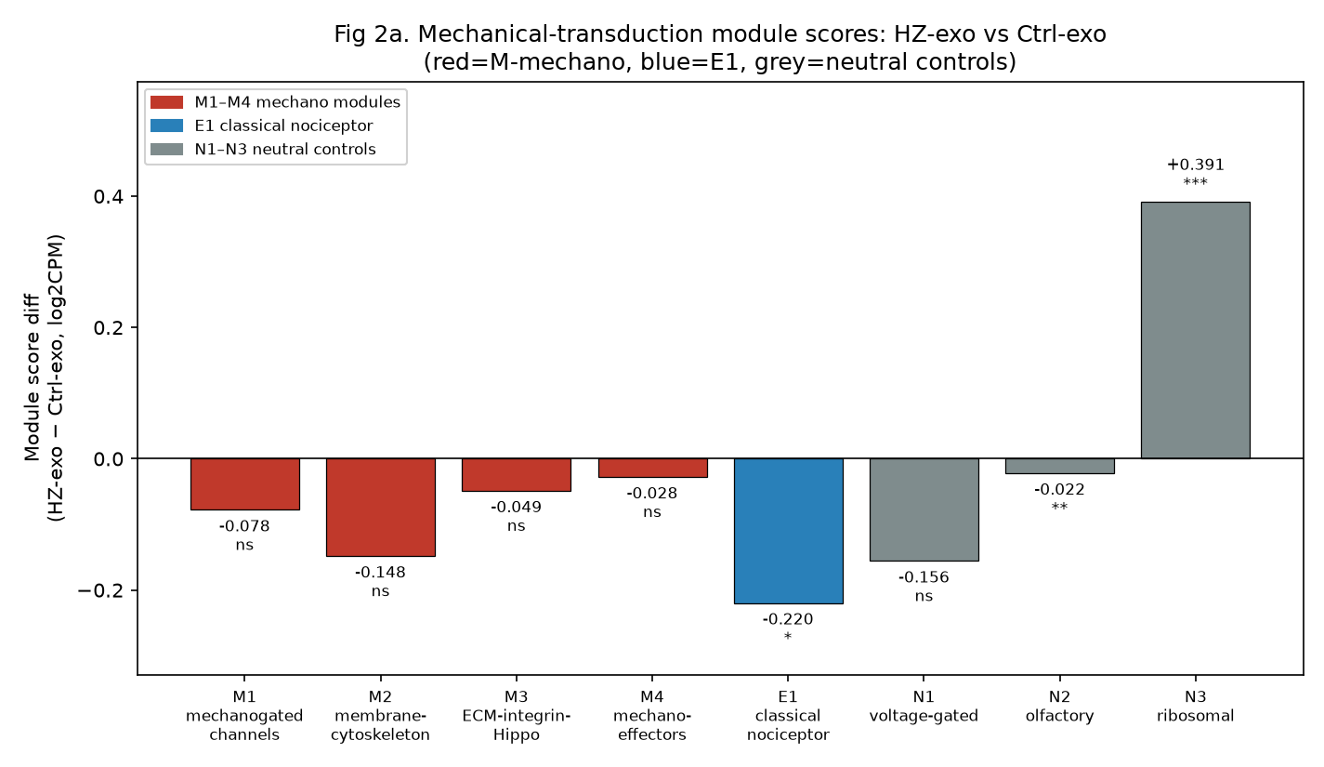
Figure 2a. Module-score differences for the primary contrast (HZ-exo vs control-exo), with neutral controls displayed alongside. E1 is the only biological module significantly shifted.
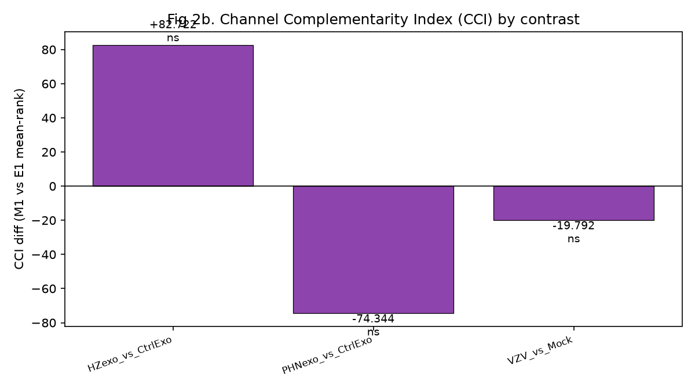
Figure 2b. Channel-complementarity index (CCI) differences by contrast (all non-significant).
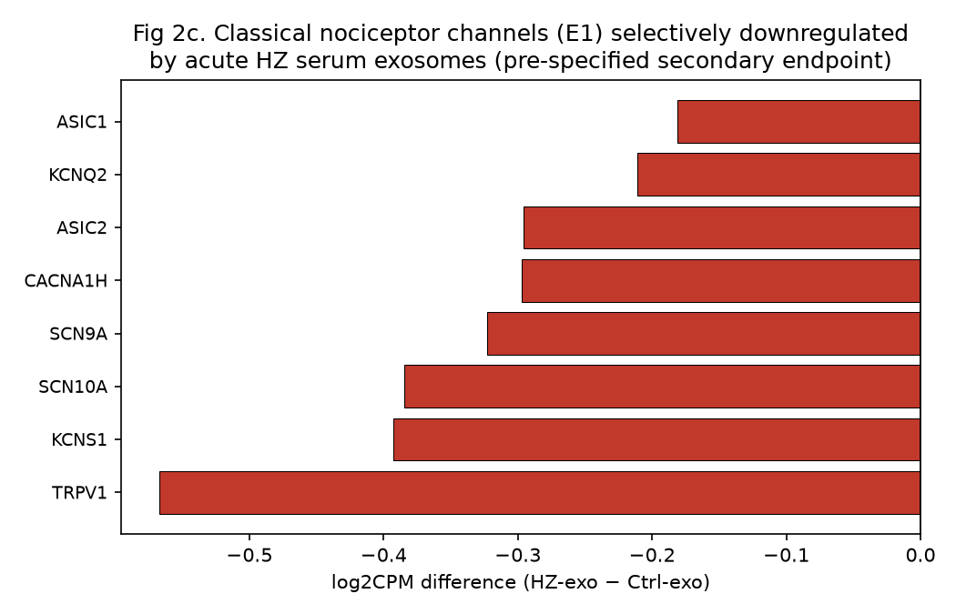
Figure 2c. Gene-level differences within E1 for the primary contrast: coherent suppression of classical nociceptor channels.
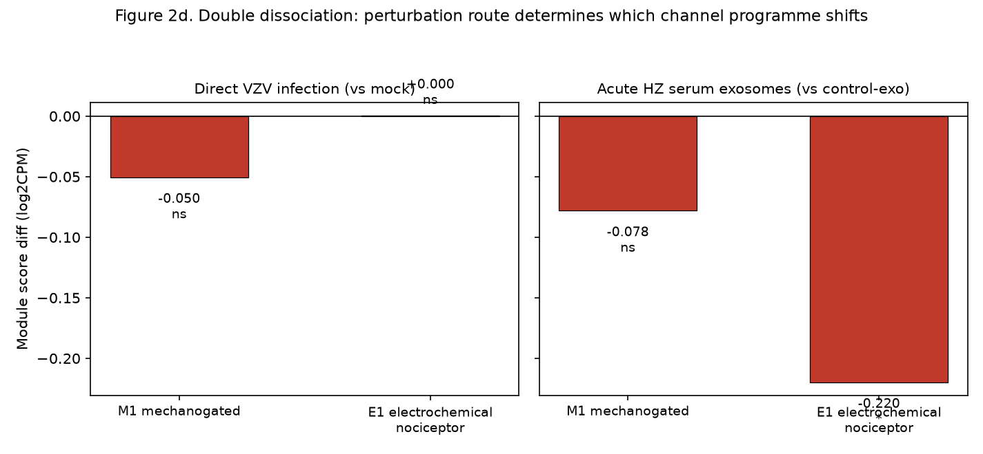
Figure 2d. Perturbation route and channel programme: E1-selective suppression under HZ exosomes (interaction P = 0.0017); reciprocal VZV pattern not significant (P = 0.19).
To test whether the route determines which channel programme shifts, we computed the interaction (difference-in-differences) between the E1 and M1 module scores. For the exosome contrast, (E1 difference - M1 difference) = -0.142 log2CPM with exact permutation P = 0.0017; for the direct-infection contrast, (M1 difference - E1 difference) = -0.051 with exact permutation P = 0.19, so the reciprocal "M1-selective" pattern is not supported at the interaction level. However, the exosome interaction does not survive a fairness correction for detection-floor asymmetry between modules: M1 contains 4/9 genes below the detection threshold (each contributing ~0 and diluting its module mean), whereas E1 contains 5/18. Restricting both modules to detected genes (mean CPM > 1) removes this dilution and yields a much smaller interaction (-0.072) that is not significant (exact permutation P = 0.16). The apparent full-module selectivity is therefore an artefact of module-composition dilution, not a confirmed biological dissociation. The channel-class imbalance is instead supported at the gene level, where E1 component genes were individually significantly down (TRPV1, SCN9A, ASIC1/2, KCNS1) whereas no M1 gene reached significance (PIEZO2 P = 0.18). We accordingly report the E1/M1 imbalance as gene-level and hypothesis-generating, not as a confirmed module-level selective suppression. We disclose that the contrast-of-contrasts interaction test was specified post hoc (not in the original frozen analysis plan) and is reported as exploratory; two routes were tested, so the nominal interaction P should be read with that multiplicity in mind (the Bonferroni-adjusted exosome interaction P = 0.0034 remains significant, but the detected-gene correction above renders the selectivity non-significant). The VZV picture remains weak and inconsistent: direct infection drove M1 downward (-0.050; Welch P = 0.047) while E1 was unchanged (+0.0005; P = 0.996), and individual E1 genes (TRPV1 P < 0.01, SCN9A P = 0.024) nonetheless moved down — a borderline, incoherent signal read as hypothesis-generating.
3.5 Exploratory PHN-exosome contrast: non-specific and confounded
PHN-serum exosomes produced larger and broader shifts than HZ exosomes: M1 (-0.119; P = 0.009; q = 0.024), E1 (-0.197; P = 0.005; q = 0.020), M2 (-0.178; P = 0.030) — but also the neutral control N1 (-0.198; P = 0.039), together with 568 genes up- and 125 down-regulated at |log2FC| > 0.5 (versus 129/174 under HZ exosomes) and a large ribosomal induction (N3 +0.577; P = 0.001; q = 0.010). Because a "specific" mechanistic signal cannot be distinguished from a neutral control module shifting in the same direction, and because the PHN donor group is older and almost exclusively female [3], we report this contrast as non-specific and confounded, and it plays no confirmatory role in our conclusions.
3.6 Neutral controls, calibration, and reporting discipline
Three neutral-control observations qualify the interpretation. First, N2 (olfactory receptors) reached nominal significance under HZ exosomes (-0.022; P = 0.006; q = 0.023) despite a magnitude near the detection floor: the signal rests on a single low-baseline gene (OR5A1, 0.89 CPM, 32% detection). This is precisely why the plan mandates reporting effect size alongside every P value; N2 is interpreted as a calibration benchmark, not a biological finding. Second, N3 (ribosomal proteins) was induced by HZ exosomes (+0.391; P = 0.002) and more strongly by PHN exosomes (+0.577; P = 0.001) — it behaves as an exposure (positive) control reflecting a genuine translational-programme response to exosome exposure, not as a neutral baseline. Third, N1 overlaps E1 by two genes (KCNQ2, KCNQ3) that move with E1 under PHN exosomes; the N1 "control" signal under PHN therefore shares machinery with the E1 signal and is disclosed as such. Global-shift diagnostics confirmed no genome-wide drift confounded the module scores: per-sample mean log2CPM values were near-identical across all 19 exosome samples (range 1.55 to 1.61). The CCI did not differ between groups under any contrast (all permutation P >= 0.82), consistent with the rank-based CCI being null-by-construction at the absolute scale that drives the module-level E1 signal; CCI is reported as a relative-displacement negative control, not as confirmatory evidence. A sensitivity analysis restricting module scores to detected genes (CPM > 1) left the conclusions unchanged for E1 but narrowed the M1 null: under HZ exosomes, detected-gene M1 flipped to -0.171 (P = 0.046), indicating that the "spared" M1 interpretation is resolution-limited and should be read alongside the gene-level PIEZO2 null (P = 0.18).
4. Discussion
4.1 A route-dependent, channel-class-selective signal — hypothesis-generating, not a proven allodynia substrate
The central empirical contribution of this reanalysis is a gene-level channel-class imbalance: acute-HZ serum exosomes suppress the electrochemical nociceptor apparatus (TRPV1, Nav1.7, ASICs) more than the mechanogated one (E1 genes individually down; no M1 gene significant), while the ECM-Hippo stiffness programme is inert within a bounded null. The full-module interaction that initially suggested selective E1 suppression (P = 0.0017) did not survive correction for detection-floor asymmetry between modules (detected-gene P = 0.16), so we do not present it as a confirmed dissociation. We deliberately do not present this as a transcriptomic "substrate for mechanical allodynia." The established mechanotransduction literature points the opposite way: allodynia is predominantly a gain of mechanosensory function — Piezo2 is a mechanotransduction channel (Woo et al., 2014) whose gain-of-function sensitizes nociceptors and increases mechanical pain sensitivity (Sánchez-Carranza et al., 2024), Piezo2 is required for mechanical pain in mice (Murthy et al., 2019) and human loss-of-function causes mechanosensation and tactile-allodynia defects (Chesler et al., 2016), and SCN9A loss-of-function causes congenital insensitivity to pain (Cox et al., 2006). Reduced electrochemical-channel expression in this neuronal model is therefore most parsimoniously a shift in signalling mode (the source study likewise reports down-regulated nociceptive channels and up-regulated substance P [3]) rather than a direct allodynia mechanism. The allodynia relevance of the observed shift is hypothesis-generating and model-bound, and requires in vivo validation before any causal claim.
4.2 Route dependence and its implications
The interaction test shows the route of perturbation matters, but asymmetrically: exosomes from acute zoster produce a robust, selective E1 suppression, whereas direct VZV infection does not produce a statistically supported selective M1 effect. This argues against treating "VZV effects on sensory neurons" as a single biological category: intracellular viral replication and systemic extracellular-vesicle signalling are not interchangeable models, and conclusions from one cannot be exported to the other. It also identifies exosomes as the plausible carrier of the systemic-to-neuronal signal that follows acute zoster, aligning with the growing literature on extracellular-vesicle-mediated pain signalling.
4.3 The inert stiffness programme redirects the mechanical search
Perhaps the most consequential finding for the mechanotransduction field is what did not move. The ECM-integrin-Hippo programme — the transcriptional core of cellular mechanotransduction — was inert under every perturbation route, within a bounded null (MDE 0.18 log2CPM). Three explanations deserve attention. (i) The programme may not be neuron-intrinsic: in DRG, ECM deposition, stiffness sensing and YAP/TAZ dynamics are dominated by satellite glia, fibroblasts and endothelial cells rather than neurons, so bulk neuronal cultures are the wrong compartment to observe it. (ii) The 36-hour window captures early channel-level events, whereas ECM remodelling requires longer time constants. (iii) mRNA may be uncoupled from mechanotransduction, which is largely regulated post-translationally. Whichever applies, the practical redirection is the same: the mechanical axis in PHN should be pursued in non-neuronal compartments — DRG satellite glia, skin, and serum — and in spatially resolved tissue data. This reframing is relevant to mechanotherapy: the machinery engaged by ESWT (integrin-FAK-p38MAPK; Piezo/TRP signalling) resides in those compartments [10,11], and ESWT has shown benefit in herpetic neuralgia in small trials [4,7-9], although the largest randomized trial reported pain reduction without a significant time-by-group interaction [7]. We do not assert a YAP/TAZ-specific ESWT mechanism, which the cited works do not test.
4.4 Limitations
This study is a secondary analysis with the following constraints, each stated at design stage. (i) The model is an immortalised embryonic DRG clonal line (HD10.6), not iPSC-derived neurons and not DRG tissue; its baseline (PIEZO2/P2RX3-high, TRPV4/STOML3-absent) differs from adult nociceptors, and all findings are model-bound. (ii) The exosome exposure is acute (36 hours); conclusions are restricted to early molecular events and cannot be extrapolated to chronic PHN in vivo. (iii) Bulk RNA-sequencing reports neither cell-composition changes nor post-translational mechanotransduction. (iv) PHN-exosome donors are older and almost exclusively female, and the exploratory PHN contrast accordingly behaved non-specifically. (v) Two panel genes (CYR61, CTGF) were absent from the processed matrix, and TRPV4/STOML3/MMP9 were below detection, bounding the scope of M1/M3 inference; SCN10A lay below the detection floor in the exosome experiment, so its down-regulation is descriptive only. (vi) The direct-infection M1 effect is borderline (permutation P = 0.05) and the reciprocal dissociation is unsupported by the interaction test (P = 0.19); the route-dependence claim rests on the robust E1-selective exosome effect and requires confirmation in independent models. (vii) The analysis is hypothesis-generating throughout: no causal or therapeutic claim is made.
5. Conclusions
In a prospectively specified reanalysis of the only available human sensory-neuron resource covering VZV infection and patient-derived serum exosomes, acute-HZ serum exosomes produced a route-dependent suppression of the electrogenic nociceptor programme that was not matched by the mechanogated one at the gene level (E1 genes individually significant; no M1 gene significant), while the ECM-Hippo stiffness programme was transcriptionally inert within a bounded null (minimum detectable effect 0.18 log2CPM). The full-module interaction initially suggestive of selective E1 suppression (P = 0.0017) did not survive correction for detection-floor asymmetry between modules (detected-gene P = 0.16), so the channel-class imbalance is reported as gene-level and hypothesis-generating. The exploratory PHN-exosome contrast was non-specific and confounded by donor age and sex, and is reported as such. The relevance of these shifts to mechanical allodynia in PHN is hypothesis-generating and model-bound; the findings direct future mechanotransduction research in PHN toward non-neuronal compartments and spatially resolved designs rather than neuronal bulk transcriptomes.
Data availability
GSE342782 (processed RSEM counts and series metadata): https://ftp.ncbi.nlm.nih.gov/geo/series/GSE342nnn/GSE342782/
Reproducibility package (analysis scripts, frozen panel `mtp-frozen-2026-10-19`, result JSON/CSV with SHA-256 MANIFEST, all figures): https://github.com/yyx-4113/mechano-phn-gse342782-reanalysis (tag v1.1.1). The package regenerates every number in this manuscript from the raw GEO files. SHA-256 checksums for all deposited artifacts are provided in `MANIFEST.json`.
Ethics approval and consent to participate
This study is a secondary analysis of publicly available, de-identified GEO data (GSE342782). No new human-subject research, patient recruitment, or animal work was conducted; no additional ethics approval or informed consent was required beyond that of the original data deposition [3].
Consent for publication
Not applicable.
Author contributions
YY conceived the study, performed the analysis, wrote the manuscript, and is solely responsible for its content.
Acknowledgments
None.
Declaration of interests
None declared.
Funding
None.
References
[1] Wang C, Zhang K, Bao Y, Liu Y, Zhou Y, Ji YH, et al. Exploring blood transcriptomic signatures in patients with herpes zoster and postherpetic neuralgia. Front Cell Infect Microbiol. 2024;14:1425393. doi:10.3389/fcimb.2024.1425393. PMID: 39211798.
[2] Johnson RW, Rice ASC. Postherpetic neuralgia. N Engl J Med. 2014;371(16):1526-1533. doi:10.1056/NEJMcp1403062.
[3] Niemeyer CS, Frietze S, Lewis SWR, Artman EC, Coughlan C, Vaseemuddin SI, et al. Circulating exosomes drive persistent neuronal dysfunction in post-herpetic neuralgia patients. Ann Neurol. 2026. doi:10.1002/ana.78352. [Epub ahead of print].
[4] Yeon JE, Ryu KH, Cho EA, Ahn JH, Shim JG, Kim J, et al. Efficacy of extracorporeal shockwave therapy for postherpetic neuralgia. Pain Pract. 2025;25(8):e70085. doi:10.1111/papr.70085. PMID: 41091131.
[5] Raymon HK, Thode S, Zhou J, Friedman GC, Pardinas JR, Barrere C, et al. Immortalized human dorsal root ganglion cells differentiate into neurons with nociceptive properties. J Neurosci. 1999;19(13):5420-5428. doi:10.1523/JNEUROSCI.19-13-05420.1999. PMID: 10377351.
[6] Haberberger RV, Barry CM, Matusica D. Immortalized dorsal root ganglion neuron cell lines. Front Cell Neurosci. 2020;14:184. doi:10.3389/fncel.2020.00184. PMID: 32636736.
[7] Chen L, Qing A, Zhu T, Yang P, Ye L. Effect and safety of extracorporeal shockwave therapy for postherpetic neuralgia: a randomized single-blind clinical study. Front Neurol. 2022;13:948024. doi:10.3389/fneur.2022.948024. PMID: 36226089.
[8] Lee SH, Ryu KH, Kim PO, Lee HW, Cho EA, Ahn JH, et al. Efficacy of extracorporeal shockwave therapy in the treatment of postherpetic neuralgia: a pilot study. Medicine (Baltimore). 2020;99(12):e19516. doi:10.1097/MD.0000000000019516. PMID: 32195953.
[9] Chen L, Zhou R, Sun F, Weng Y, Ye L, Yang P. Efficacy and safety of extracorporeal shockwave therapy in patients with postherpetic neuralgia: study protocol of a randomized controlled trial. Trials. 2020;21:573. doi:10.1186/s13063-020-04564-z. PMID: 32641142.
[10] Ge R, Ruan B, Chen S, Bai S, Gao Q, Dong A. Radial extracorporeal shock wave therapy alleviates acute inflammation of human primary tenocytes through the integrin-FAK-p38MAPK pathway. Am J Transl Res. 2023;15(5):3229-3239. PMID: 37303680.
[11] Pan Y, Shi LZ, Yoon CW, Preece D, Gomez-Godinez V, Lu S, et al. Mechanosensor Piezo1 mediates bimodal patterns of intracellular calcium and FAK signaling. EMBO J. 2022;41(17):e111799. doi:10.15252/embj.202211799.
[12] GSE314229 — single-cell transcriptomics of radial extracorporeal shockwave therapy identifying sEV release via ATP/P2X7R/p38MAPK signaling (Adv Sci 2026). https://ftp.ncbi.nlm.nih.gov/geo/series/GSE31nnn/GSE314229/
[13] Cox JJ, Reimann F, Nicholas AK, Thornton G, Roberts E, Springell K, et al. An SCN9A channelopathy causes congenital inability to experience pain. Nature. 2006;444(7121):894-898. doi:10.1038/nature05413. PMID: 17167479.
[14] Woo SH, Ranade S, Weyer AD, Dubin AE, Baba Y, Qiu Z, et al. Piezo2 is required for Merkel cell mechanotransduction. Nature. 2014;509(7502):622-626. doi:10.1038/nature13251. PMID: 24717433.
[15] Murthy SE, Loud MC, Daou I, Marshall KL, Schoborg RV, Sprunger NK, et al. The mechanosensitive ion channel Piezo2 mediates sensitivity to mechanical pain in mice. Sci Transl Med. 2019;11(486):eaat9897. doi:10.1126/scitranslmed.aat9897. PMID: 30305457.
[16] Li B, Dewey CN. RSEM: accurate transcript quantification from RNA-Seq data with or without a reference genome. BMC Bioinformatics. 2011;12:323. doi:10.1186/1471-2105-12-323.
[17] Benjamini Y, Hochberg Y. Controlling the false discovery rate: a practical and powerful approach to multiple testing. J R Stat Soc B. 1995;57(1):289-300.
[18] Sánchez-Carranza O, Chakrabarti S, Kühnemund J, Schwaller F, Bégay V, García-Contreras JA, et al. Piezo2 voltage-block regulates mechanical pain sensitivity. Brain. 2024;147(8):2849-2863. doi:10.1093/brain/awae130. PMID: 38629258.
[19] Chesler AT, Szczot M, Bharucha-Goebel D, Ceko M, Donkervoort S, Laubacher C, et al. The role of PIEZO2 in human mechanosensation. N Engl J Med. 2016;375(14):1355-1364. doi:10.1056/NEJMoa1602812. PMID: 27726347.

