Prediction of intraoperative hypotension exposure from data available at anaesthesia induction: development and internal validation in MOVER/SIS with an external transportability check in VitalDB
Yongxin Yang¹ ORCID 0009-0004-9698-6552
¹ Department of Anesthesiology, The Second Affiliated Hospital of Fujian University of Traditional Chinese Medicine, Fuzhou, Fujian 350003, China
Correspondence: Yongxin Yang, 960856791@qq.com

Abstract
Background: Intraoperative hypotension is associated with kidney and myocardial injury. Machine-learning performance estimates vary widely. We developed and internally validated a model predicting hypotensive exposure (at least 30% of recorded post-anchor mean arterial pressure readings below 65 mmHg) over the remainder of surgery from data available at the anaesthesia induction anchor, and examined its transportability in an external cohort.
Methods: Retrospective cohort from MOVER/SIS. Of 19,114 screened records, 16,861 adult cases had a valid anchor (first intubation event, 82.0%; otherwise surgery start, 18.0%). The primary outcome required ≥10 mean arterial pressure (MAP) measurements after the anchor with ≥30% below 65 mmHg. Predictors were truncated at the anchor; four models were fitted (baseline, full logistic, XGBoost, LightGBM). Validation used patient-level (primary) and temporal (secondary) splits; the unchanged MOVER core model was also applied to the VitalDB arterial cohort (n = 3,735; anchor adapted from intubation to operation start; no refitting) as a transportability check. AUPRC was the primary metric; AUROC and Brier score were secondary; 95% confidence intervals came from 1,000 bootstrap resamples; isotonic calibration and decision curve analysis were performed.
Results: The outcome occurred in 2,622 of 16,861 cases (15.55%). XGBoost achieved AUPRC 0.347 (95% CI 0.309–0.387) and AUROC 0.722 (0.697–0.745) on the patient-level split, versus 0.233 (baseline), 0.301 (full logistic) and 0.338 (LightGBM); on the temporal split it achieved 0.339 (0.291–0.395) and 0.733 (0.703–0.762). Isotonic recalibration improved the Brier score from 0.191 to 0.119. Subgroup AUPRC tracked stratum prevalence; pre-anchor mean MAP was the dominant predictor. Externally (VitalDB, prevalence 5.73%), the unchanged model retained discrimination (AUROC 0.744, 95% CI 0.705–0.778; AUPRC 0.158, 0.126–0.202) but probabilities were uncalibrated; the 53-feature internal AUROC was 0.698–0.710, confirming transportability rather than like-for-like validation.
Conclusions: An anchor-based model using routinely recorded pre-induction data achieved modest but non-null discrimination for intraoperative hypotensive exposure and was well calibrated. An external transportability check in VitalDB supported transfer of ranking but not of absolute probabilities, requiring local recalibration before clinical use.
Keywords: intraoperative hypotension; machine learning; clinical prediction model; mean arterial pressure; perioperative medicine; calibration; TRIPOD

Background
Intraoperative hypotension is common and consistently associated with organ injury. Salmasi and colleagues showed that MAP below an absolute threshold of 65 mmHg was progressively related to both myocardial and kidney injury after non-cardiac surgery, that prolonged exposure increased the odds at any given threshold, and that absolute thresholds discriminated as well as relative thresholds derived from preoperative pressure [1]. These conclusions have since been reinforced by a systematic review of intraoperative hypotension and adverse postoperative outcomes [16] and by a perioperative consensus that recommends keeping intraoperative mean arterial pressure at or above 60 mmHg in at-risk patients [17], and by further work linking intraoperative mean arterial pressure to outcomes [15]. These findings shifted attention from the lowest recorded value towards the cumulative burden of hypotensive exposure.
That shift created a demand for anticipation. Commercial indices derived from arterial waveforms, most notably the machine-learning Hypotension Prediction Index [19], have been evaluated in randomised trials [2,3], and a growing literature applies machine learning to routinely recorded vital signs. Two features of this literature motivate the present study.
First, reported performance is extremely heterogeneous, in part because the prediction task differs between studies. Some predict whether hypotension will occur within the next 5–15 minutes (a monitoring problem, addressed intraoperatively), whereas others stratify a patient's risk before or at the start of the hypotensive exposure (a triage problem, addressed at induction). These tasks are not interchangeable: the second admits fewer, coarser predictors and cannot exploit the impending event's own precursors.
Second, some reported performances are difficult to reconcile with the information content of the data. Applying gradient-boosted trees to the same public resource used here, a recent preprint reported near-perfect discrimination for short-horizon prediction (AUROC 0.973, accuracy 0.942) [4]. In the component of that resource analysed here, non-invasive MAP is recorded in 19.89% of vital-sign rows (about one in five) and 96.2% of non-empty recording segments are isolated single minutes. Under such sparsity, discrimination of that magnitude is difficult to attribute to physiological signal. A cross-centre evaluation reached a closely related conclusion, showing that apparent advantage of deep-learning models over simple threshold rules largely disappears once cases already hypotensive at the prediction origin are excluded and the grey zone is retained [5], and a scoping review of perioperative artificial intelligence found external validation and bias-resistant evaluation to be uncommon [6].
We therefore set out to develop and internally validate a model for intraoperative hypotensive exposure over the remainder of surgery, using only information available at the anaesthesia induction anchor, to examine its transportability in an independent external cohort, and to report it under an explicit leakage audit, with calibration and decision-analytic evaluation, and with an honest account of what the recording density of the source data permits.

Methods

Study design and data source
This is a retrospective cohort study reported in accordance with TRIPOD+AI [7]; it corresponds to TRIPOD type 2b (development with internal and external validation), with the qualification that the external step is a transportability check rather than a like-for-like validation, because the external anchor, endpoint definition and recording density differ from the development cohort. The development data source was MOVER (Medical Informatics Operating Room Vitals and Events Repository), University of California Irvine, distributed through the UCI Machine Learning Repository [8]. The extraction analysed here is the surgical information system (SIS) component, comprising nine linked tables: patient information, procedure events, vitals, observations (invasive monitoring), ventilator settings, medication, laboratories, intake/output, and a case-level procedure description. Access required a signed data use agreement; all data were pre-existing and de-identified. No patients were recruited and no intervention was performed.

Cohort
Records were screened and excluded as follows (Figure 1): 8 records with implausible operating room (OR) windows (4 with non-positive duration, 4 exceeding 1,440 minutes; maximum observed 3,156,668 minutes, indicating corrupt timestamps); 1,632 records with fewer than 60 vital-sign observations inside the OR window; and 371 records of patients younger than 18 years. This left 17,103 cases. A further 242 cases were excluded because no valid prediction anchor could be determined (anchor falling outside the OR window), yielding an analysis cohort of 16,861 cases contributing 3,379,173 OR-window vital-sign observations. Median OR duration was 167 minutes.

Prediction anchor
The prediction anchor was the first recorded Intubation event (n = 13,834; 82.0%). Where no intubation event existed, Surgery start was used as a proxy (n = 3,027; 18.0%). The anchor occurred a median of 15 minutes (IQR 11–24) after OR start. The observation window after the anchor had a median duration of 147 minutes (5th–95th percentile 49–440).

Outcome
The primary outcome (D1) adopts the absolute MAP threshold (<65 mmHg) of Salmasi et al. [1] but operationalises burden as the proportion of recorded post-anchor MAP readings below threshold: at least 10 readings, of which at least 30% below 65 mmHg. Because non-invasive pressure is recorded intermittently rather than continuously, this is a proportion of recorded readings, not a cumulative time below threshold; the number of low readings required for a positive label therefore varies with recording density (3 to 77 readings across cases; median 9). The ≥10-measurement and ≥30%-below rule is our operational choice rather than a literal transcription of that report. Cases with fewer than 10 post-anchor measurements were classified as negative by construction; this applied to 1,496 cases (8.9%): 1,332 with 1–9 readings and 164 with no post-anchor MAP recording at all, because the definition deliberately requires a minimum amount of evidence before a burden can be asserted. A sensitivity analysis restricted to the 15,365 evaluable cases is reported in the Results.
Because the choice of hypotension definition materially changes apparent performance, 14 candidate definitions were computed for every case and are reported in full (Table 2; their prevalence is shown in Figure 2). They comprise sustained-grid definitions (consecutive minutes below threshold on a one-minute grid, with missing minutes counted as interruption), point-burst definitions (a minimum number of low readings within a rolling window), exposure-fraction definitions, any-below definitions, two SpO₂ desaturation definitions included as a coverage comparison, and one measured-only definition retained solely to quantify how much sustained-event definitions are inflated when gaps are ignored.

Candidate predictors and leakage control
Two hundred and six candidate predictors were constructed across 13 domains: anchor characteristics (3), demographics (6), surgical group (14), anaesthesia technique (12), non-invasive blood pressure (36), derived non-invasive indices (6), quality-assurance counters (2), invasive monitoring (32), ventilation and inhaled agents (47), medication (26), derived medication indices (2), laboratories (12) and fluid/bleeding (8).
Every domain was truncated at the anchor such that no information dated after the prediction origin could enter the model. Physiological and device domains were additionally restricted to the 15 minutes preceding the anchor; laboratories used the last value before the anchor; medication and fluid records were restricted to those started before the anchor. The integrity of this truncation was verified programmatically and reported as a leakage audit (Table 3): across all seven time-stamped domains the maximum interval between any used observation and the anchor was 0.00 minutes, and no record had an unparseable timestamp. One boundary detail deserves statement: the physiological windows are closed at the anchor ([anchor−15, anchor]), so a MAP reading recorded exactly at the anchor minute belongs to both the feature window and the outcome window ([anchor, OR end]). Sensitivity analyses that exclude the anchor minute from the feature window, and separately from the outcome window, are reported in the Results; neither changed the conclusions.
Surgical group was assigned from the free-text procedure description by keyword mapping into 12 surgical categories plus a no-surgery category, with a controlled fuzzy fallback (edit distance ≤1, identical initial, minimum length 7 characters). The residual "other" category contained 348 cases (2.1%).
Anthropometric variables required cleaning. Height and weight in the source contained unit-entry errors (observed height as low as 2 cm, weight as high as 839 kg), which propagated to body mass index values as extreme as 2.2 × 10⁵ kg/m². Values outside adult plausible ranges (height 100–220 cm; weight 25–300 kg; BMI 10–80 kg/m²) were set to missing rather than imputed: 37 heights, 18 weights and 6 BMI values were affected, leaving BMI computable for 16,699 cases (99.0%).

Model development
Four models were pre-specified. A baseline logistic model used age, sex and BMI only, to quantify how much the full predictor set adds. A full logistic model used all predictors after median imputation with missingness indicators and standardisation, with balanced class weighting; the imputer was fitted within each training fold only, so no test-set information entered preprocessing. XGBoost (300 trees, depth 4, learning rate 0.05, subsample 0.8, column sampling 0.8, minimum child weight 10, L2 penalty 1.0, class-weight scaling) and LightGBM (300 trees, 15 leaves, learning rate 0.05, subsample 0.8, column sampling 0.8, minimum 20 samples per leaf, L2 penalty 1.0, balanced class weighting) used native handling of missing values and required no imputation. Hyperparameters were fixed a priori on clinical-iterative grounds rather than by external tuning; with 335 logistic parameters against 2,097 training events (events per variable ≈6.3, below the commonly cited 10-events-per-parameter heuristic [20]), the full logistic model is expected to be over-fitted and is reported as a comparator rather than a deployable model.

External validation cohort
As a transportability check rather than a like-for-like external validation, the MOVER core model was applied unchanged to VitalDB [18], an independent public database of high-fidelity vital signs from surgical patients at a single tertiary centre (Seoul National University Hospital, Republic of Korea), accessed through its public application programming interface without authentication. A transparency limitation must be stated at the outset: VitalDB records no intubation event, so the prediction anchor was adapted from the MOVER intubation (induction) anchor to the operation start time (opstart), which occurs after induction and intubation. The external "pre-anchor" 15-minute window therefore captures early-intraoperative rather than pre-induction physiology, a different phase from the development window. The outcome D1 was computed by the same rule over [opstart, opend]; because VitalDB samples arterial pressure far more densely than the intermittent non-invasive readings in MOVER, the same proportion-based rule implies a much larger absolute hypotensive exposure for a positive external label (at the median recording density, about 1,300 hypotensive samples, or some 44 cumulative minutes below 65 mmHg, versus 9 readings in MOVER), so the external endpoint is not equivalent to the development endpoint and part of the prevalence gap between cohorts is definitional rather than case-mix; a sensitivity analysis on a common one-minute-grid, absolute-time definition is reported in the Results. Of 6,388 VitalDB cases with recorded vital signs, 3,735 had an arterial MAP track (Solar8000/ART_MBP or EV1000/ART_MBP) together with valid operation timing and formed the external cohort. Predictors were restricted to the 53-feature transportable subset: demographic and anthropometric variables; pre-anchor 15-minute summary statistics of six vital signs (MAP, SBP, DBP, HR, a heart-rate variability proxy and SpO₂); the fraction of pre-anchor MAP readings below 65 and 55 mmHg; and three MOVER-specific contextual features: the anchor-to-OR-start interval, an indicator that the anchor was an intubation event, and a calendar-year indicator. The latter two are not derivable from VitalDB and were set to zero; the anchor-to-OR-start interval was re-derived under the opstart anchor (opstart minus case start, in minutes), so its meaning necessarily differs from the development cohort, where it is the OR-start-to-intubation interval, a residual source of transportability error. For transparency we note that the transported model was fitted on the full MOVER cohort (all 16,861 cases), whereas the internal comparators in Table 7 were fitted on the 80% training split of the patient-level split; the external model is therefore not disadvantaged by a smaller training set, but neither is it directly comparable to the held-out internal estimates. The MOVER core model (53 features, seed 12,345) was applied without any external refitting or recalibration; performance was summarised by AUPRC (primary), AUROC and Brier score, with 95% confidence intervals from 1,000 bootstrap resamples. Calibration was assessed descriptively and was not updated on the external data.

Validation and performance
The primary validation was a patient-level split: a randomly selected 80% (n = 13,488) for training and 20% (n = 3,373; 525 outcome-positive) for testing, with no patient appearing in both. A secondary temporal split used cases before 2018 for training (n = 15,043) and cases from 2018 for testing (n = 1,818; 291 outcome-positive), to detect calendar-time drift.
Because the outcome is moderately imbalanced (15.55%), AUPRC was the primary metric; a model with no skill attains AUPRC equal to the prevalence. AUROC and Brier score were secondary. Confidence intervals came from 1,000 bootstrap resamples of the test set. Calibration was assessed and, for the primary model, improved by isotonic regression fitted on out-of-fold predictions from a 5-fold cross-validation within the training data, then applied unchanged to the test set. Calibration slope and intercept were reported on both the probability scale (linear-probability model) and the log-odds scale (logistic recalibration), in keeping with current guidance on calibration assessment [21]. Decision curve analysis quantified net benefit across threshold probabilities.
Predictor importance was reported as XGBoost gain. Because gain reflects the fitted model rather than an inferential quantity, it is presented descriptively.

Software and reproducibility
Analyses used Python 3.13 with pandas 2.3.3, scikit-learn 1.9.0 [9], XGBoost 3.4.1 [10] and LightGBM 4.7.0 [11]. The random seed was fixed at 12,345. Every headline number reported in this manuscript is generated from a result file by the analysis pipeline and is traceable through an audit trail (Additional file 1) that records, for each quantity, its value, the producing artefact and the command that reproduces it; a small number of descriptive statistics (for example the interquartile ranges of recording density) are produced by the same scripts and are listed in the trail with their source artefact but without a dedicated reproduce command.

Results

Cohort
The 16,861 analysed cases had a median age of 54 years (IQR 39–66) and were almost evenly split by sex (Table 1). Median BMI was 26.6 kg/m² (IQR 23.1–30.9). The most common surgical groups were gastrointestinal (29.2%), neurosurgical (15.0%) and orthopaedic (14.3%). The primary outcome occurred in 2,622 cases (15.55%). Compared with outcome-negative cases, outcome-positive cases were younger (median 48 vs 55 years), had lower BMI (25.4 vs 26.8 kg/m²) and, most prominently, lower pre-anchor mean MAP (79.5 vs 89.0 mmHg) and lower pre-anchor minimum MAP (72 vs 81 mmHg).
Table 1. Characteristics of the analysis cohort (n = 16,861).
Characteristic | Value
Age, years (median, IQR) | 54 (39–66)
Male sex, n (%) | 8,355 (49.6)
Female sex, n (%) | 8,502 (50.4)
Sex unknown, n (%) | 4 (<0.1)
Height, cm (median, IQR) | 167 (160–175)
Weight, kg (median, IQR) | 76 (63–90)
Body mass index, kg/m² (median, IQR) | 26.6 (23.1–30.9)
Anchor = Intubation, n (%) | 13,834 (82.0)
Anchor = Surgery start (proxy), n (%) | 3,027 (18.0)
Anchor after OR start, min (median, IQR) | 15 (11–24)
Post-anchor window, min (median, 5th–95th) | 147 (49–440)
Pre-anchor MAP readings in 15-min window (median, IQR) | 3 (2–4)
Pre-anchor mean MAP, mmHg (median, IQR) | 87.7 (77.7–98.5)
Invasive arterial monitoring available, n (%) | 2,503 (14.8)
Ventilation data available, n (%) | 4,852 (28.8)
Pre-anchor laboratory results, n (%) | 76 (0.45)
Pre-anchor fluid/intake-output records, n (%) | 2,794 (16.6)
Surgical group: gastrointestinal, n (%) | 4,916 (29.2)
Surgical group: neurosurgical | 2,530 (15.0)
Surgical group: orthopaedic | 2,407 (14.3)
Surgical group: urological | 1,541 (9.1)
Surgical group: plastic | 1,318 (7.8)
Surgical group: vascular | 1,049 (6.2)
Surgical group: gynaecological | 992 (5.9)
Surgical group: thoracic | 958 (5.7)
Surgical group: ear, nose and throat | 418 (2.5)
Surgical group: other | 348 (2.1)
Surgical group: ophthalmic | 201 (1.2)
Surgical group: cardiac | 177 (1.0)
Surgical group: no surgery recorded | 6 (<0.1)
Primary outcome D1, n (%) | 2,622 (15.55%)

Outcome definition sensitivity
The 14 candidate definitions span a very wide prevalence range (Table 2), which is the principal reason that performances reported across studies are not comparable. Strict sustained-grid definitions at 55 mmHg identified 15 to 54 cases (0.09–0.32%), far too few for modelling, whereas any-below definitions identified up to 11,091 cases (65.8%). The primary definition D1 occupies an intermediate position with adequate event count for model development.
Table 2. Prevalence of 14 candidate outcome definitions (n = 16,861), post-anchor window.
ID | Type | Signal | Threshold | Parameters | n | %
O1 | sustained grid | MAP | 55 | 5 min, no gaps | 15 | 0.09
O2 | sustained grid | MAP | 55 | 5 min, 1-min gaps allowed | 54 | 0.32
O3 | sustained grid | MAP | 55 | 10 min, 1-min gaps allowed | 2 | 0.01
O4 | sustained grid | MAP | 65 | 10 min, 1-min gaps allowed | 27 | 0.16
S1 | measured-only grid | MAP | 65 | 10 min (known to overestimate) | 1,214 | 7.20
B1 | point burst | MAP | 65 | ≥3 readings within 30 min | 7,240 | 42.94
B2 | point burst | MAP | 65 | ≥5 readings within 60 min | 5,192 | 30.79
B3 | point burst | MAP | 55 | ≥3 readings within 30 min | 1,159 | 6.87
D1 | exposure fraction | MAP | 65 | ≥10 readings and ≥30% below | 2,622 | 15.55
D2 | exposure fraction | MAP | 55 | ≥10 readings and ≥30% below | 91 | 0.54
E1 | any below | MAP | 55 | — | 3,770 | 22.36
E2 | any below | MAP | 65 | — | 11,091 | 65.78
O5 | sustained grid | SpO₂ | 90 | 2 min, no gaps | 1,292 | 7.66
O6 | sustained grid | SpO₂ | 92 | 5 min, no gaps | 572 | 3.39

S1 is retained solely to show the magnitude of inflation produced by ignoring recording gaps; O5 and O6 are desaturation outcomes shown for coverage comparison and are not hypotension definitions.

Predictor availability and recording density
Predictor availability was markedly unequal across domains (Table 3). Demographic, surgical, anchor and medication domains were essentially complete. By contrast, invasive arterial monitoring was available for 2,503 cases (14.8%), ventilation data for 4,852 (28.8%), fluid records for 2,794 (16.6%) and pre-anchor laboratory results for 76 (0.45%). Within the non-invasive blood pressure domain, 16,036 cases (95.1%) had at least one reading in the 15-minute pre-anchor window, but the median number of MAP readings in that window was 3 (IQR 2–4).
Across the whole cohort, non-invasive MAP was recorded in 19.89% of case-minutes (systolic 19.99%, diastolic 19.95%), whereas heart rate and pulse rate were recorded in 94.8% and 95.9% and oxygen saturation in 96.1%. Of 637,188 non-empty MAP recording segments, 96.2% consisted of a single minute; the median segment length was 1 minute. Per case, the median number of MAP measurements over the OR window was 33 (5th–95th percentile 12–90).
Table 3. Leakage audit and coverage by predictor domain.
Domain | Predictors | Cases with data | Coverage (%) | Max interval to anchor (min)
Anchor characteristics | 3 | 16,861 | 100.0 | 0.00
Demographics | 6 | — | 99.7 | n/a (static)
Surgical group | 14 | 16,861 | 100.0 | n/a (static)
Anaesthesia technique | 12 | 16,563 | 98.2 | 0.00
Medication (pre-anchor) | 26 | 16,573 | 98.3 | 0.00
Non-invasive blood pressure | 36 | 16,036 | 95.1 | 0.00
Derived non-invasive indices | 6 | — | 89.8 | 0.00
Quality-assurance counters | 2 | — | 99.6 | 0.00
Ventilation and inhaled agents | 47 | 4,852 | 28.8 | 0.00
Invasive monitoring | 32 | 2,503 | 14.8 | 0.00
Fluid and bleeding | 8 | 2,794 | 16.6 | 0.00
Laboratories | 12 | 76 | 0.45 | 0.00

All seven time-stamped domains passed the audit (maximum interval 0.00 minutes; zero records with unparseable timestamps).

Model performance
On the primary patient-level split, XGBoost gave the highest AUPRC at 0.347 (95% CI 0.309–0.387), which is 2.23 times the prevalence of 0.1555 expected under no skill (Table 4). LightGBM was similar on AUROC (0.721 vs 0.722) but slightly lower on AUPRC. The full logistic model reached AUPRC 0.301, and the age/sex/BMI baseline 0.233, indicating that the additional predictors contribute meaningfully beyond basic demographics while the absolute gain remains moderate. Figure 3 shows the precision–recall and receiver operating characteristic curves for all four models.
Results on the temporal split were closely similar (XGBoost AUPRC 0.339, AUROC 0.733), indicating no material calendar-time drift.
Table 4. Model performance on the patient-level (primary) and temporal (secondary) splits.
Split | Model | n train | n test | Events in test | AUPRC (95% CI) | AUROC (95% CI) | Brier
Patient | Baseline logistic (age, sex, BMI) | 13,488 | 3,373 | 525 | 0.233 (0.205–0.267) | 0.624 (0.596–0.650) | 0.239
Patient | Full logistic | 13,488 | 3,373 | 525 | 0.301 (0.269–0.339) | 0.706 (0.681–0.728) | 0.216
Patient | XGBoost | 13,488 | 3,373 | 525 | 0.347 (0.309–0.387) | 0.722 (0.697–0.745) | 0.191
Patient | LightGBM | 13,488 | 3,373 | 525 | 0.338 (0.299–0.377) | 0.721 (0.697–0.743) | 0.183
Temporal | Baseline logistic | 15,043 | 1,818 | 291 | 0.243 (0.209–0.288) | 0.609 (0.574–0.646) | 0.239
Temporal | Full logistic | 15,043 | 1,818 | 291 | 0.336 (0.289–0.394) | 0.726 (0.694–0.758) | 0.226
Temporal | XGBoost | 15,043 | 1,818 | 291 | 0.339 (0.291–0.395) | 0.733 (0.703–0.762) | 0.194
Temporal | LightGBM | 15,043 | 1,818 | 291 | 0.336 (0.289–0.390) | 0.731 (0.702–0.761) | 0.188

AUPRC under no skill equals the prevalence (0.1555). Brier scores are for uncalibrated predictions.

Calibration and clinical usefulness
For XGBoost on the patient-level split, the uncalibrated Brier score was 0.191, which exceeds the no-information Brier score of 0.131 (prevalence × (1 − prevalence)); this indicates meaningful miscalibration for which recalibration was required rather than cosmetic. Out-of-fold isotonic recalibration reduced the Brier score to 0.119, with a calibration slope of 0.909 and an intercept of 0.008 on the probability scale (linear-probability model); the logit-scale recalibration slope and intercept are reported alongside. On the temporal split the Brier score improved from 0.194 to 0.122, with slope 0.934 and intercept 0.006 on the probability scale. In both cases the probability-scale slope below 1 indicates that the uncalibrated predictions were slightly over-dispersed, which isotonic recalibration corrected.
In decision curve analysis, the calibrated model's net benefit exceeded that of the "treat none" strategy from the lowest evaluated threshold up to 0.58 on the patient-level split and up to 0.45 on the temporal split; on the temporal split it then turned negative between 0.46 and 0.65 and returned briefly to positive only between 0.66 and 0.73, where the net benefit was nonetheless negligible (≤0.0006), as it was at the top of the patient-level range (0.0001 at 0.58). The "treat all" strategy had a small positive net benefit at the lowest evaluated thresholds (≈0.06 at threshold 0.10) but became strongly negative at higher thresholds (≈−2.1 at 0.73), so it offers no advantage over the model. The absolute net benefit at the decision-relevant thresholds was small (0.078 and 0.085 at threshold 0.10; 0.051 and 0.058 at threshold 0.15, close to the outcome prevalence), so the clinical usefulness shown by the curve is modest. In a benchmark against a logistic model using the pre-anchor mean MAP alone, the full model's incremental net benefit was 0.013 at both thresholds 0.10 and 0.15 (Figure 4).

Subgroup performance
Raw subgroup AUPRC varied across strata (Table 5): it was higher in women than men, declined with age, and was highest in underweight patients. However, subgroup AUPRC tracks stratum outcome prevalence closely: across the nine strata the rank correlation between full-cohort stratum prevalence and patient-level subgroup AUPRC was strong (Spearman ρ = 0.88, p = 0.002). Normalising AUPRC by stratum prevalence (the no-skill AUPRC for that stratum) compressed the age gradient to ratios of 1.89, 2.28 and 1.82 across increasing age bands and reversed the sex ordering (men 2.17 vs women 2.07); on the temporal split the normalised ratios were similarly uniform (1.88–2.14 by age band; women 2.14 vs men 1.93). The raw subgroup differences therefore largely reflect stratum base rates rather than differential model skill, and no subgroup-specific claim is made. The underweight stratum is the clearest exception and is explicitly unstable: its raw AUPRC of 0.616 rests on 10 outcome events among 98 patient-level test-set cases (512 cases, 95 events in the full cohort), and the corresponding ratio of 3.32 is inflated by the same small numbers; on the temporal split the AUPRC fell to 0.382.
Table 5. AUPRC of XGBoost by subgroup (held-out test set), with stratum prevalence and the AUPRC-to-prevalence ratio (lift over the no-skill baseline).
Subgroup | n (test) | Stratum prevalence, % (full cohort) | Patient AUPRC | AUPRC / prevalence | Temporal AUPRC | AUPRC / prevalence
Men | 1,689 | 13.80 | 0.299 | 2.17 | 0.267 | 1.93
Women | 1,684 | 17.27 | 0.357 | 2.07 | 0.370 | 2.14
Age < 50 years | 1,402 | 20.09 | 0.380 | 1.89 | 0.377 | 1.88
Age 50–64 years | 1,044 | 14.26 | 0.324 | 2.28 | 0.305 | 2.14
Age ≥ 65 years | 927 | 10.22 | 0.186 | 1.82 | 0.194 | 1.90
BMI < 18.5 kg/m² | 98 | 18.55 | 0.616 | 3.32 | 0.382 | 2.06
BMI 18.5–24.9 kg/m² | 1,202 | 18.76 | 0.392 | 2.09 | 0.354 | 1.89
BMI 25–29.9 kg/m² | 1,064 | 14.55 | 0.286 | 1.96 | 0.306 | 2.10
BMI ≥ 30 kg/m² | 977 | 12.45 | 0.257 | 2.07 | 0.330 | 2.65

n denotes the number of cases in the held-out test set on which each subgroup AUPRC was computed (patient-level split: 3,373; temporal split: 1,818). Stratum prevalence is the D1 prevalence of the stratum in the full analysis cohort (n = 16,861), which estimates the stratum base rate more stably than the smaller held-out sets; under no skill the AUPRC of a stratum equals its prevalence, so the ratio is the lift over that baseline. Subgroup AUPRCs are exploratory given the reduced event counts within strata: for example, the underweight stratum comprised 98 patient-level test-set cases with 10 events (512 cases with 95 events in the full cohort). Thirty-two test-set cases had missing BMI and contribute to no BMI stratum.

Predictor importance
Pre-anchor arterial pressure dominated (Table 6). Mean MAP had a gain roughly 2.3 times that of the next predictor. The remaining informative predictors were the maximum pre-anchor MAP, whether the anchor was an intubation event, the elapsed time from OR start to the anchor, the fraction of pre-anchor readings already below 65 mmHg, surgical group, and diastolic and invasive arterial pressure summaries. Figure 5 shows the 25 highest-gain predictors.
Table 6. Ten highest-gain predictors, XGBoost (patient-level split).
Rank | Predictor | Domain | Gain
1 | Mean pre-anchor MAP | Non-invasive blood pressure | 175.5
2 | Maximum pre-anchor MAP | Non-invasive blood pressure | 75.2
3 | Anchor is intubation | Anchor | 72.2
4 | Intubation event recorded | Anaesthesia technique | 69.1
5 | Interval from OR start to anchor | Anchor | 64.1
6 | Fraction of pre-anchor readings below 65 mmHg | Non-invasive blood pressure | 52.9
7 | Gastrointestinal surgical group | Surgical group | 48.6
8 | Mean pre-anchor diastolic pressure | Non-invasive blood pressure | 45.0
9 | Minimum invasive diastolic pressure | Invasive monitoring | 44.7
10 | Mean invasive MAP | Invasive monitoring | 43.2

External transportability check
The MOVER core model was applied without refitting to the VitalDB arterial cohort of 3,735 eligible cases (of 6,388 VitalDB cases with recorded vital signs, those with valid operation timing and an arterial MAP track), of which 214 (5.73%) met the D1 outcome (Table 7); a further 214 cases with fewer than 10 post-anchor MAP measurements were classified D1-negative by construction under the same rule as the development cohort, so the conditional prevalence among adequately monitored external cases was 6.1% (214 of 3,521). Discrimination transferred: the external AUROC was 0.744 (95% CI 0.705–0.778), numerically above the internal patient-level value of 0.698 and the temporal value of 0.710 for the same 53-feature model, although the confidence intervals overlap (0.705–0.778 vs 0.673–0.723 and 0.679–0.740), so the difference should be read as consistency rather than superiority. The external AUPRC of 0.158 (0.126–0.202) exceeded the external prevalence by a factor of 2.8, a larger relative lift than the 2.1-fold internal value for that model. The lower absolute AUPRC reflects the much lower external prevalence (5.73% vs 15.55%) rather than a loss of ranking ability. Absolute probabilities did not transfer: the mean predicted risk was 0.36 against an observed prevalence of 0.057 (external Brier score 0.176), indicating that the model would require local recalibration before the predicted probabilities could be used directly. These results are summarised in Figure 6 and Table 7.
Table 7. External transportability check of the MOVER core model (53 features) in VitalDB versus internal performance of the same model in MOVER/SIS.
Dataset | Split | n | Events | Prevalence (%) | AUPRC (95% CI) | AUROC (95% CI) | Brier
MOVER/SIS (development) | Patient | 3,373 | 525 | 15.55 | 0.321 (0.284–0.362) | 0.698 (0.673–0.723) | 0.198
MOVER/SIS (development) | Temporal | 1,818 | 291 | 16.01 | 0.314 (0.269–0.365) | 0.710 (0.679–0.740) | 0.199
VitalDB (external) | — | 3,735 | 214 | 5.73 | 0.158 (0.126–0.202) | 0.744 (0.705–0.778) | 0.176

Internal values are for the identical 53-feature transportable model; the development manuscript headline (AUPRC 0.347, AUROC 0.722) is for the full 206-feature model. The external cohort had no refitting or recalibration.

Sensitivity analyses
We tested the main findings against eight perturbations; the results are in Table 8.
S1 – Restricted evaluable cohort. Excluding the 1,496 negative-by-construction (NBC) cases left 15,365 cases with at least 10 post-anchor MAP measurements (conditional prevalence 17.06%). On this subset XGBoost reached AUPRC 0.401 (95% CI 0.358–0.444) and AUROC 0.735 (0.710–0.757) on the patient-level split and AUPRC 0.367 (0.318–0.425) and AUROC 0.739 (0.709–0.769) on the temporal split – higher than the full-cohort values, confirming that the apparent precision gain reflects removal of the NBC cases rather than stronger physiological signal.
S2 – Half-open anchor window. Repeating the main analysis with the anchor minute excluded from the feature window (strict `<anchor`) gave patient-level AUPRC 0.342 (0.302–0.380) and AUROC 0.715 (0.690–0.737) and temporal AUPRC 0.334 (0.286–0.388) and AUROC 0.723 (0.693–0.753), essentially unchanged from the closed-window main results, so inclusion of the anchor minute does not drive the findings.
S3 – Externally re-derived time-based labels. Recomputing the external D1 outcome on VitalDB on a common one-minute grid with absolute-time thresholds (already-transported 53-feature model, unrefitted) yielded AUROC 0.744 (0.705–0.778) and AUPRC 0.158 (0.126–0.202) under the sampling-based definition (D1_samples, prevalence 5.73%) – numerically consistent with the development-label external value, which indicates that the transportability signal is not an artefact of the development label rule.
S4 – External recalibration. Fitting a logistic recalibration to the transported predictions on VitalDB (logit-scale slope 0.77, intercept -2.61; calibration-in-the-large 0.30) shifted the mean predicted risk from 0.36 towards the observed prevalence of 0.057 and improved the Brier score, showing that local recalibration restores probability accuracy.
S5 – External funnel. Of 6,388 VitalDB cases with recorded vitals, 3,735 had a valid arterial MAP track and operation timing; 214 had zero post-anchor MAP and were negative by construction, coinciding exactly with the 214 D1-positive cases (disclosed for transparency).
S6 – Physiological-feature subset. Restricting the transported model to the 39 physiological value-domain features (dropping cadence counters and the frozen context features) gave external AUROC 0.713 (0.670–0.750) and AUPRC 0.151 (0.119–0.196) – only marginally below the 53-feature value, so the dropped features contributed little.
S7 – Anchor-minute label overlap. In the primary design both windows are closed at the anchor (the feature window `[anchor-15, anchor]` and the label window `[anchor, OR_end]` share the anchor minute); 99.0% of cases have a MAP reading exactly at the anchor. Re-deriving labels with the strictly open label window `(anchor, OR_end]` flipped only 62 positive to negative and 35 negative to positive (net -27; prevalence 15.39% vs 15.55%), confirming the anchor minute belongs to the feature side and its shared inclusion does not materially affect labels.
S8 – Case-minute recording rate. The fraction of surgical minutes with at least one recorded MAP (case-minute recording rate) was 19.6%, corroborating the 19.89% row-level MAP density and the sparse-sampling limitation in Limitation 9.
Table 8. Sensitivity analyses of the MOVER/SIS hypotension model (XGBoost unless noted).
Analysis | Split | n | Prevalence (%) | AUPRC (95% CI) | AUROC (95% CI)
S1 Restricted cohort | Patient | 15,365 | 17.06 | 0.401 (0.358–0.444) | 0.735 (0.710–0.757)
S1 Restricted cohort | Temporal | 15,365 | 17.06 | 0.367 (0.318–0.425) | 0.739 (0.709–0.769)
S2 Half-open window | Patient | 16,861 | 15.55 | 0.342 (0.302–0.380) | 0.715 (0.690–0.737)
S2 Half-open window | Temporal | 16,861 | 15.55 | 0.334 (0.286–0.388) | 0.723 (0.693–0.753)
S3 External labels (D1_samples) | - | 3,735 | 5.73 | 0.158 (0.126–0.202) | 0.744 (0.705–0.778)
S6 Physiological subset (external) | - | 3,735 | 5.73 | 0.151 (0.119–0.196) | 0.713 (0.670–0.750)

Discussion

Principal findings
In a cohort of 16,861 adult surgical cases, a gradient-boosted model using only information available at the induction anchor achieved an AUPRC of 0.347 and an AUROC of 0.722 for intraoperative hypotensive exposure over the remainder of surgery, with closely similar performance under temporal validation and good calibration after isotonic recalibration. Discrimination was therefore approximately 2.2-fold (2.23×) better than the no-skill baseline on the precision–recall scale (modest, but clearly not null), and the decision curve showed the model's net benefit over both default strategies was positive across most of the evaluated threshold range but very small in absolute terms (below 0.01 at the decision-relevant thresholds of 0.10–0.30, and at most 9.9×10⁻⁵ at 0.58 on the patient-level split); on the temporal split net benefit was positive up to 0.45, then negative except for a narrow interval between 0.66 and 0.73, where its magnitude is negligible. The decision-relevant region is therefore thresholds near to moderately above the outcome prevalence (roughly 0.10–0.30), where the calibrated probabilities could support a vasopressor-readiness or enhanced-monitoring decision; the specific operating point remains a clinical judgement to be informed by external validation rather than settled here.

Interpretation
The dominance of pre-anchor mean MAP is the single most informative result, and it should be read carefully. Its most straightforward interpretation is that patients who are already relatively hypotensive at induction are likely to remain so, which is clinically sensible and actionable: it identifies a group in whom vigilance, arterial cannulation and vasopressor readiness are justified early. Its more cautionary interpretation is that the model is, to a substantial degree, an extrapolation of the current pressure rather than a discovery of new physiology. That distinction matters, because a model whose information content is largely the present blood pressure adds little to what an anaesthetist already sees, and it is precisely the setting in which selection bias can inflate apparent performance [5].
This interpretation is consistent with the stratified findings. Raw AUPRC declined with age and was higher in women, but both patterns tracked stratum outcome prevalence rather than differential model skill: normalising by stratum prevalence reversed the sex ordering and compressed the age gradient (Table 5). The patterns remain compatible with the model tracking pre-anchor pressure levels, whose distribution and prognostic weight differ across these strata, rather than with the model identifying age- or sex-specific vulnerability.

Relation to previous work
Our results stand in marked contrast to the near-perfect discrimination recently reported on the same public resource [4]. We do not question that analysis directly, since the details necessary to reproduce it are not available to us; we raise it as a methodological hazard rather than a claim about any specific report. Two facts are open to any reader. First, in the component analysed here, non-invasive arterial pressure is recorded in fewer than one in five case-minutes and almost all recorded segments are isolated single minutes, so the physiological trajectory available to any model is extremely coarse. Second, an independent external evaluation on the same resource reported an AUROC of 0.696 for a deliberately simple three-variable additive model under a selection-bias-resistant protocol [12], and a cross-centre evaluation attributed inflated performance to selection effects rather than to genuine generalisability [5]; our AUROC of 0.722 is consistent in magnitude with the former. We note that the same external analysis reported that the dynamics of arterial pressure, not only its current value, carry incremental predictive information for hypotension [12]. Our recording density (median 3 MAP readings in the 15-minute pre-anchor window) is too sparse to characterise such dynamics, so our model necessarily leans on the static pre-anchor level; this is a limitation of the source data rather than evidence against the dynamics signal. Other investigators have developed machine-learning models for intraoperative risk from comparable operating-room resources, including models developed on MOVER itself [13] and external-validation studies in related surgical populations [14]. We now provide such an external transportability check ourselves, in VitalDB, an independent resource with a different recording architecture; the model's ranking ability transferred (external AUROC 0.744, in the same range as and overlapping the confidence interval of the internal 0.698–0.710 for the same 53-feature model) while absolute probabilities did not and would require local recalibration, a finding that strengthens rather than weakens the caution above. Performance of the order of 0.97 would still require near-separation of the classes, which is difficult to reconcile with the recording density reported here, and we flag the possibility of label–feature window overlap or of counting as predictable those cases already below threshold at the prediction origin. We regard these as general methodological hazards in perioperative prediction rather than criticisms specific to one report, and we note that external validation and bias-resistant evaluation remain uncommon in this literature [6].

Implications
Four implications follow. First, the definition of the outcome should be stated with the same prominence as the performance metric: across our 14 candidate definitions the prevalence ranged from 0.01% to 65.8%, and no performance figure is interpretable without it. Second, exposure-fraction outcomes are feasible on sparse data in a way that sustained-duration outcomes are not. Sustained definitions at conventional thresholds identified fewer than 60 cases here, which is a structural constraint on what can be modelled with non-invasive recordings. Third, anchor-based prediction addresses a different clinical question from short-horizon prediction, and the two should not be benchmarked against each other as though they were the same task. Fourth, the model's information content is dominated by the pre-anchor arterial pressure: in a decision-curve benchmark against a logistic model using the pre-anchor mean MAP alone, the full model added only 0.013 net benefit at threshold 0.15, and the MAP-only model alone achieved an AUPRC of 0.284 versus 0.347 for the full model. The incremental value of the full model is therefore modest; its contribution lies in calibrated risk stratification and in pooling the pre-anchor MAP with a small number of ancillary signals, rather than in revealing hidden physiology.

Limitations
1. External validation was performed as a transportability check with necessary adaptations and shows transfer of discrimination but not of calibration. The model was validated externally in VitalDB without refitting or recalibrating, but three adaptations limit how the result should be read. First, because VitalDB records no intubation event, the anchor was adapted from induction (intubation) to operation start (opstart), which occurs after induction; the external pre-anchor window therefore captures early-intraoperative rather than pre-induction physiology, a different phase from the development window. Second, the one MOVER-specific timing feature that could be re-derived under the opstart anchor, the interval from operation start to the prediction anchor, necessarily changes meaning between cohorts (OR-start-to-intubation in MOVER, case-start-to -operation-start in VitalDB) and is a residual source of transportability error. Third, the external cohort was restricted to 3,735 of 6,388 VitalDB cases with valid operation timing and an arterial MAP track, introducing selection we could not characterise fully, and a further 214 external cases were classified D1-negative by construction for having fewer than 10 post-anchor MAP measurements. The external cohort also had a substantially lower outcome prevalence (5.73% vs 15.55%) and a different recording architecture (continuous arterial pressure rather than intermittent non-invasive measurement), so the external AUPRC cannot be compared directly with the internal value; the external AUROC (0.744) indicates that ranking transferred, although its confidence interval overlaps the internal interval. Predicted probabilities were not calibrated to the external cohort (mean predicted risk 0.36 vs observed 0.057), so the external result supports deployment readiness of the discrimination but not of the probabilities. 2. Severe sparsity of non-invasive blood pressure. Median 3 readings in the 15-minute pre-anchor window; 96.2% of recording segments are single minutes. This caps achievable performance and makes any sustained-duration definition effectively unmeasurable. 3. No preoperative baseline. Fewer than 1% of cases had any MAP recording in the 30 minutes before OR start, so relative-threshold definitions could not be computed. This is a property of the source data, not a design choice. 4. No physiological severity or outcome linkage. ASA physical status was not available, and the database contains no postoperative outcomes, so the model could not be linked to acute kidney injury, myocardial injury or mortality. The endpoint is a surrogate. 5. Anchor proxy and spectrum bias. In 18.0% of cases the anchor was Surgery start rather than intubation, because no intubation event was recorded. This is not merely a labelling nuisance: the anchor source was among the strongest predictors (anchor is intubation ranked third by gain), so the proxy cohort (cases without a recorded intubation, which may systematically differ, for example monitored anaesthesia care or non-intubated procedures) introduces spectrum bias that the model can exploit but that may not transfer. 6. Unequal domain coverage. Invasive monitoring, ventilation, laboratory and fluid domains were available for 14.8%, 28.8%, 0.45% and 16.6% of cases respectively, so the model is driven largely by demographics, surgical group, anaesthetic events and non-invasive pressure. 7. Structural exclusions and spectrum bias. 1,496 cases (8.9%) had fewer than 10 post-anchor measurements and were classified as negative by construction: 1,332 with 1–9 readings and 164 with no post-anchor MAP recording at all. This is a spectrum effect: the excluded cases are exactly those with the sparsest monitoring, and they are therefore not missing at random. A visible proxy supports the mechanism: 42.9% of the excluded cases had a Surgery-start anchor versus 18.0% overall, and the anchor-source indicator is among the strongest predictors, so the model can score these cases low for reasons unrelated to physiology. The conditional prevalence among cases with at least 10 measurements was 17.1% (2,622 of 15,365); a sensitivity analysis restricted to those 15,365 evaluable cases is reported in the Results and shows that XGBoost discrimination improved to AUPRC 0.401 (95% CI 0.358–0.444) and AUROC 0.735 (0.710–0.757) – an apparent gain driven by removal of the negative-by-construction cases rather than by added physiological signal. Anthropometric cleaning set 37 heights, 18 weights and 6 BMI values to missing. 8. Single author, no preregistration. The analysis protocol was fixed before modelling but was not publicly registered. Predictor importance is descriptive and should not be read as inference. 9. Outcome-label validity under sparse sampling. D1 is an exposure-fraction definition that treats each recorded MAP as representative of the true intraoperative pressure; under the observed 19.89% row-level recording density (case-minute MAP recording rate 19.6%), with 96.2% of non-null segments consisting of isolated single minutes, recorded MAP is not a random sample of the surgical period. Cases monitored only during stable intervals could be under-counted as burden-free, so the reported prevalence and performance may be sensitive to which minutes were recorded. We state this as a structural limitation of deriving burden from intermittent non-invasive measurement rather than continuous arterial pressure. 10. External discrimination may be inflated by recording density. VitalDB records continuous arterial pressure, which both defines the outcome and supplies the MAP predictors far more densely and cleanly than the intermittent non-invasive measurement in MOVER/SIS; blood-pressure autocorrelation under dense sampling can inflate apparent ranking discrimination relative to the development cohort. The external AUROC of 0.744 should therefore be read as evidence that ranking transferred under a denser measurement regime, not as evidence of intrinsically better discrimination than the development cohort. 11. The model largely reflects the present blood pressure. The dominant predictor is the pre-anchor MAP level, and the next strongest predictors are the maximum pre-anchor MAP and the fraction of pre-anchor readings already below 65 mmHg. The model therefore largely extrapolates the patient's current pressure rather than discovering independent risk, and adds limited information beyond what a clinician reading the bedside monitor already has; a decision-curve benchmark against a MAP-only logistic model showed the full model's incremental net benefit was only 0.013 at threshold 0.15 (Figure 4). 12. Anchor placement is imprecise for a minority of cases. The Intubation anchor occurred a median of 15 minutes after OR start, but the distribution has a long right tail: 325 cases had an anchor more than 60 minutes after OR start (maximum 751 minutes, about 12.5 hours), so for those cases the "pre-anchor" window describes mid- or post-operative physiology rather than induction. In addition, a small number of clinically implausible events were recorded before the anchor (four extubations, one cardiopulmonary resuscitation and three head-frame applications, at lags up to 2,853 minutes), which we retained rather than silently deleted; they affect the pre-anchor event counters only. 13. The transported feature set includes features with no external support. Four of the 53 transported features are recording-cadence counters whose VitalDB values lie far outside the MOVER range (median MAP-reading count 450 versus 3; minutes since last MAP reading 0.02 versus 1.0), and one contextual feature (anchor is intubation) is frozen at zero in VitalDB. A sensitivity analysis restricting the transported model to the 39 physiological value-domain features is reported in the Results; the external discrimination under that restriction was AUROC 0.713 (95% CI 0.670–0.750) and AUPRC 0.151 (0.119–0.196) – only marginally below the 53-feature shipped value (0.744/0.158), which indicates that the dropped recording-cadence and context features contributed little. 14. The external outcome is not the development outcome. Because VitalDB samples arterial pressure far more densely, the same proportion-based rule implies a much larger absolute exposure for a positive external label (about 44 cumulative minutes below 65 mmHg at the median recording density versus 9 readings in MOVER), so the external prevalence of 5.73% is not directly comparable with the internal 15.55%. A sensitivity analysis re-deriving the external labels on a common one-minute grid with absolute-time thresholds is reported in the Results and showed the transported model still discriminated comparably (D1_samples: AUROC 0.744, AUPRC 0.158), which indicates that the transportability signal is not an artefact of the development label definition.

What this study adds
Beyond the modest absolute performance, this study contributes five elements that are under-reported in perioperative hypotension prediction and that hold independently of the discrimination achieved.
1. A quantitative leakage audit on a public operating-room resource. All seven time-stamped predictor domains were truncated at the prediction origin with no used record postdating its anchor (maximum interval 0.00 minutes; no unparseable timestamps), and the one residual boundary overlap, a MAP reading recorded exactly at the anchor minute that belongs to both the feature and the outcome window, is quantified and shown not to change the conclusions. Such audits are uncommon yet essential wherever near-perfect discrimination has been claimed on sparse data, and they convert an unverifiable "cannot be reproduced" concern into a reported, auditable fact. 2. A 14-definition outcome sensitivity analysis. Apparent performance is shown to be largely an artefact of the chosen hypotension definition (prevalence spanning 0.01%–65.8%), and sustained-duration definitions are effectively unmeasurable under the observed recording density (median 3 MAP readings in the pre-anchor window; 96.2% of segments a single minute). This gives future work on the same and similar resources a principled basis for choosing an evaluable endpoint. 3. A transparent accounting of spectrum bias. The 1,496 cases (8.9%) excluded by construction because of sparse monitoring are reported alongside the conditional prevalence among evaluable cases (17.1%, 2,622 of 15,365), quantifying how monitoring density shapes both the endpoint and the apparent signal rather than hiding it behind a single cohort prevalence. 4. An honest MAP-only benchmark. Against a logistic model using the pre-anchor mean MAP alone, the full model's incremental net benefit was only 0.013 at decision thresholds 0.10–0.15; this reframes the result as a calibrated risk-stratification aid anchored on the pre-induction pressure rather than a discovery of new physiology, and supplies future work with a realistic baseline on this resource. 5. An honest external transportability check on an independent resource. In VitalDB the model was applied unchanged with its anchor adapted to operation start; discrimination transferred (AUROC 0.744, in the same range as and overlapping the confidence interval of the internal 0.698–0.710 for the same feature set) while calibration did not, isolating exactly what does and does not generalise and supplying a concrete deployment requirement (local recalibration on the deployment cohort's own anchor and recording regime) rather than an abstract "needs external validation" caveat. The differing endpoint definitions, recording densities and feature-space support between the two cohorts are quantified rather than glossed over.

Conclusions
Using only data available at the anaesthesia induction anchor, a gradient-boosted model achieved modest but non-null discrimination (AUPRC 0.347, AUROC 0.722) for intraoperative hypotensive exposure, reproduced under temporal validation and well calibrated after isotonic recalibration. In an independent external cohort (VitalDB, n = 3,735) the same model retained discrimination (AUROC 0.744) without refitting. This is a transportability check rather than a like-for-like validation, because the external anchor (operation start) postdates induction and the external outcome is defined on denser arterial sampling. Absolute probabilities were not calibrated to that cohort and would require local updating. Most of the predictive information resided in the pre-anchor arterial pressure level, suggesting that such models primarily identify patients who are already relatively hypotensive at induction rather than anticipating new events. We recommend that future work on this and similar resources prioritise local recalibration on the deployment cohort's own anchor and recording regime, explicit reporting of the outcome definition and its prevalence, and routine quantification of recording density, and that claims of near-perfect discrimination on sparse non-invasive data be treated with corresponding caution.

List of abbreviations
ASA, American Society of Anesthesiologists; AUROC, area under the receiver operating characteristic curve; AUPRC, area under the precision–recall curve; BMI, body mass index; IQR, interquartile range; MAP, mean arterial pressure; MOVER, Medical Informatics Operating Room Vitals and Events Repository; OR, operating room; SIS, surgical information system; SpO₂, peripheral oxygen saturation; TRIPOD, Transparent Reporting of a multivariable prediction model for Individual Prognosis Or Diagnosis; VitalDB, Vital Signs Database.

Declarations
Ethics approval and consent to participate. This study analysed a pre-existing, de-identified database (MOVER, University of California Irvine) accessed under a signed data use agreement. No patients were recruited, no intervention was performed, and no identifiable information was accessed. Under the policy of the Institutional Review Board of The Second Affiliated Hospital of Fujian University of Traditional Chinese Medicine, retrospective research that uses exclusively pre-existing de-identified data obtained under a data use agreement is exempt from prospective ethical review and from individual consent; the study was conducted under this exemption and no approval number is reported. All procedures were conducted in accordance with the Declaration of Helsinki.
Consent for publication. Not applicable.
Availability of data and materials. The development cohort was drawn from MOVER (University of California Irvine), which is available to qualified researchers upon signature of a data use agreement (https://mover.ics.uci.edu/; UCI Machine Learning Repository, https://doi.org/10.24432/C5VS5G). The external cohort was drawn from VitalDB (https://vitaldb.net/), which is publicly accessible upon free registration and is described in Lee et al. (2022), doi:10.1038/s41597-022-01411-5. Patient-level data are not redistributed by the author, as the MOVER data use agreement does not permit this. All analysis code, the configuration file, the audit trail, and the aggregate result files from which every number in this manuscript is generated are available at https://github.com/yyx-4113/mover-sis-ioh-prediction/releases/tag/v1.0.1 (v1.0.1 reproduction package), together with a manifest of file checksums (MANIFEST.csv). Patient-level derived files (per-case feature matrix and outcome labels) are regenerable from the MOVER source under the data use agreement by running the provided pipeline (scripts/run_all.py).
Competing interests. The author declares no competing interests.
Funding. This research received no grant or monetary support from any funding agency in the public, commercial or not-for-profit sectors.
Authors' contributions. YY conceived the study, designed and implemented the data pipeline, performed all analyses, interpreted the results, and wrote and approved the manuscript. YY is the sole author.
Acknowledgements. The author thanks the University of California Irvine for making the MOVER resource available under a data use agreement.
Authors' information. Yongxin Yang, Department of Anesthesiology, The Second Affiliated Hospital of Fujian University of Traditional Chinese Medicine, Fuzhou, China. ORCID 0009-0004-9698-6552.
Use of artificial intelligence. A large-language-model assistant was used to support code writing, debugging and manuscript drafting. All study design decisions, all reported results, and the final text were reviewed and are the sole responsibility of the author. The assistant is not an author.

References
1. Salmasi V, Maheshwari K, Yang D, Mascha EJ, Singh A, Sessler DI, et al. Relationship between intraoperative hypotension, defined by either reduction from baseline or absolute thresholds, and acute kidney and myocardial injury after noncardiac surgery: a retrospective cohort analysis. Anesthesiology. 2017;126(1):47–65. doi:10.1097/ALN.0000000000001432. 2. Wijnberge M, Geerts BF, Hol L, Lemmers N, Mulder MP, Berge P, et al. Effect of a machine learning-derived early warning system for intraoperative hypotension vs standard care on depth and duration of intraoperative hypotension during elective noncardiac surgery: the HYPE randomized clinical trial. JAMA. 2020;323(11):1052–1060. doi:10.1001/jama.2020.0592. 3. Maheshwari K, Shimada T, Yang D, Khanna S, Cywinski JB, Irefin SA, et al. Hypotension prediction index for prevention of hypotension during moderate- to high-risk noncardiac surgery. Anesthesiology. 2020;133(6):1214–1222. doi:10.1097/ALN.0000000000003557. 4. Alrantisi KMM. Predicting intraoperative hypotension using machine learning: a comprehensive analysis of the MOVER dataset. Preprints.org. 2026. doi:10.20944/preprints202603.1373.v1. 5. Chaari N, Winski G, Hallbäck M, Lundström N, Björne H, Jacobsson M. Towards reliable prediction of intraoperative hypotension: a cross-center evaluation of deep learning-based and MAP-derived methods. J Clin Monit Comput. 2026;40(1):43–57. doi:10.1007/s10877-025-01357-0. 6. Hernández Rincón EH, Salcedo Garrido G, Tovar Acosta N, Ramírez Urueña JA. Artificial intelligence for predicting perioperative anaesthetic complications and supporting clinical decision-making: a scoping review. J Clin Monit Comput. 2026. doi:10.1007/s10877-026-01449-5. 7. Collins GS, Moons KGM, Dhiman P, et al. TRIPOD+AI statement: updated guidance for reporting clinical prediction models that use regression or machine learning methods. BMJ. 2024;385:e078378. doi:10.1136/bmj-2023-078378. 8. MOVER (Medical Informatics Operating Room Vitals and Events Repository). UCI Machine Learning Repository. doi:10.24432/C5VS5G. 9. Pedregosa F, Varoquaux G, Gramfort A, et al. Scikit-learn: machine learning in Python. J Mach Learn Res. 2011;12:2825–2830. 10. Chen T, Guestrin C. XGBoost: a scalable tree boosting system. In: Proceedings of the 22nd ACM SIGKDD International Conference on Knowledge Discovery and Data Mining. 2016:785–794. doi:10.1145/2939672.2939785. 11. Ke G, Meng Q, Finley T, et al. LightGBM: a highly efficient gradient boosting decision tree. In: Advances in Neural Information Processing Systems 30. 2017:3146–3154. 12. Oyarzun R. The dynamics of arterial pressure itself predict intraoperative hypotension beyond its current value: an interpretable additive model validated in 3,069 external patients under a selection-bias-resistant protocol. medRxiv. 2026. doi:10.1101/2026.08.26.26361468. 13. Chiu C, Braehler MR, Donovan AL, Butte AJ, Pirracchio R, Bishara AM. Development of a machine learning-derived model to predict unplanned ICU admissions after major non-cardiac surgery. BMC Anesthesiol. 2025;25:351. doi:10.1186/s12871-025-03195-8. 14. Cheun H, Ahn JH, Park JW, et al. Development and external validation of a machine learning model for predicting severe immediate postoperative complications in adults undergoing cardiac surgery. BMC Anesthesiol. 2026;26:334. doi:10.1186/s12871-026-03841-9. 15. Walsh M, Devereaux PJ, Garg AX, et al. Relationship between intraoperative mean arterial pressure and clinical outcomes after noncardiac surgery: toward an empirical definition of hypotension. Anesthesiology. 2013;119(3):507–515. doi:10.1097/ALN.0b013e3182a10e26. 16. Sun LY, Wijeysundera DN, Tait GA, Beattie WS. Association of intraoperative hypotension with acute kidney injury after elective noncardiac surgery. Anesthesiology. 2015;123(3):515–523. doi:10.1097/ALN.0000000000000765. 17. Saugel B, Fletcher N, Gan TJ, Grocott MPW, Myles PS, Sessler DI, et al. PeriOperative Quality Initiative (POQI) international consensus statement on perioperative arterial pressure management. Br J Anaesth. 2024;133(2):264–276. doi:10.1016/j.bja.2024.04.046. 18. Lee HC, Park Y, Yoon SB, Yang SM, Park D, Jung CW. VitalDB, a high-fidelity multi-parameter vital signs database in surgical patients. Sci Data. 2022 Jun 8;9(1):279. doi:10.1038/s41597-022-01411-5. PMID: 35676300; PMCID: PMC9178032. 19. Hatib F, Jian Z, Buddi S, Lee C, Settels J, Sibert K, et al. Machine-learning algorithm to predict hypotension based on high-fidelity arterial pressure waveform analysis. Anesthesiology. 2018;129(4):663–674. doi:10.1097/ALN.0000000000002300. PMID: 29894315. 20. Riley RD, Ensor J, Snell KIE, Harrell FE Jr, Martin GP, Reitsma JB, et al. Calculating the sample size required for developing a clinical prediction model. BMJ. 2020 Mar 18;368:m441. doi:10.1136/bmj.m441. PMID: 32184264. 21. Van Calster B, McLernon DJ, van Smeden M, Wynants L, Steyerberg EW; Topic Group 'Evaluating diagnostic tests and prediction models' of the STRATOS initiative. Calibration: the Achilles heel of predictive analytics. BMC Med. 2019 Dec 16;17(1):230. doi:10.1186/s12916-019-1466-7. PMID: 31842878; PMCID: PMC6912996.

Figure legends
Figure 1. Cohort construction. Flow from 19,114 screened records to the 16,861 analysed cases,
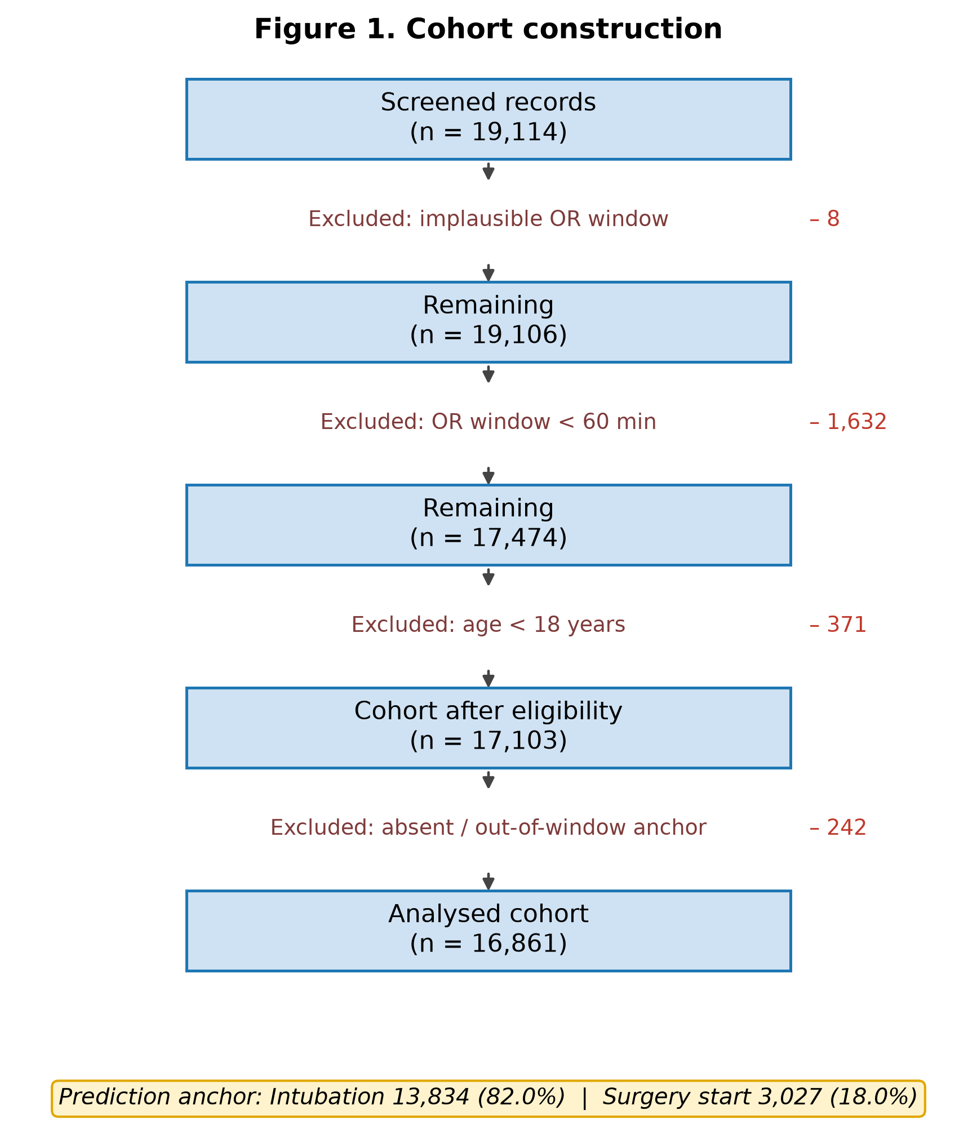
showing exclusions for implausible operating room window (n = 8), fewer than 60 recorded vital-sign observations within the operating-room window (n = 1,632), age below 18 years (n = 371) and absent or out-of-window prediction anchor (n = 242).
Figure 2. Prevalence of the 14 candidate outcome definitions. Definitions ordered by prevalence,
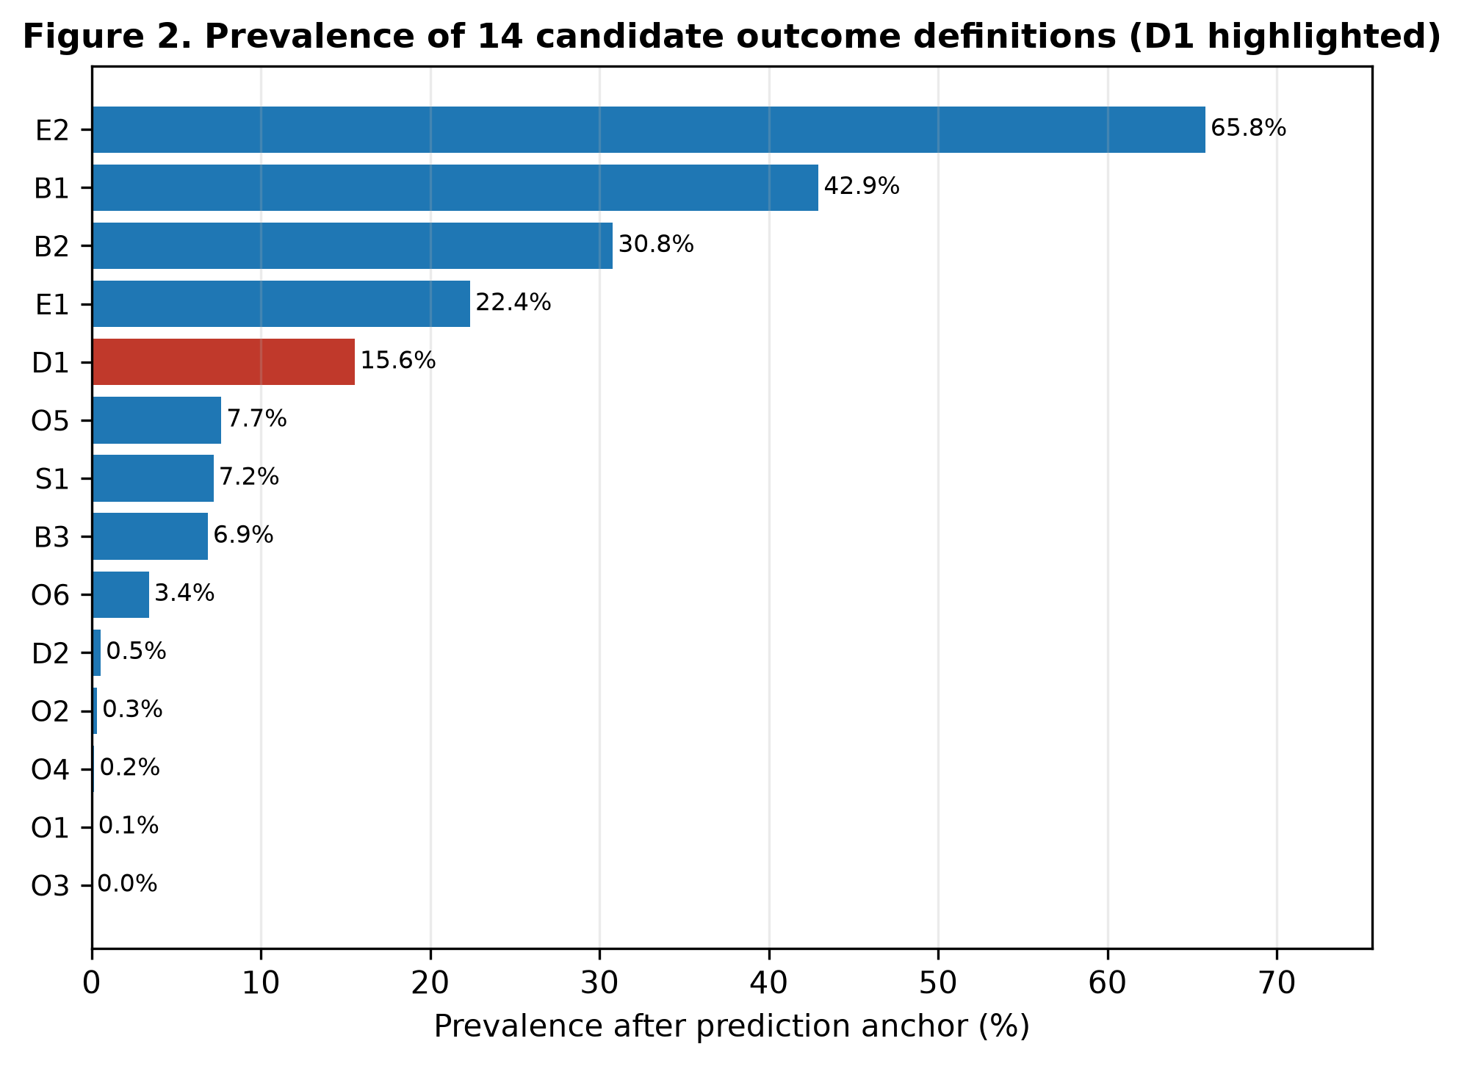
with the primary definition D1 marked.
Figure 3. Model performance. Precision–recall and receiver operating characteristic curves for
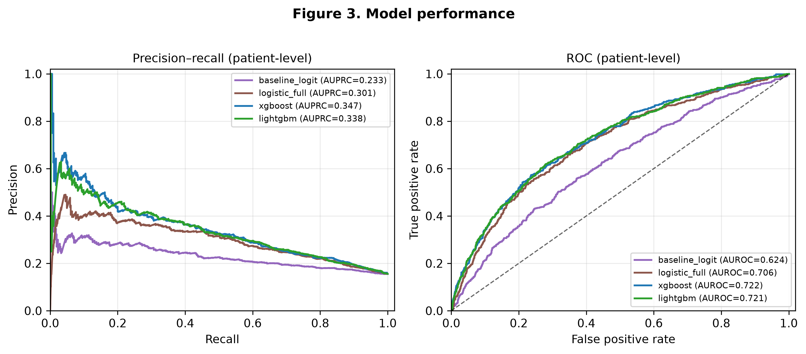
all four models on the patient-level split.
Figure 4. Calibration and decision curve analysis. Calibration plot before and after out-of-fold
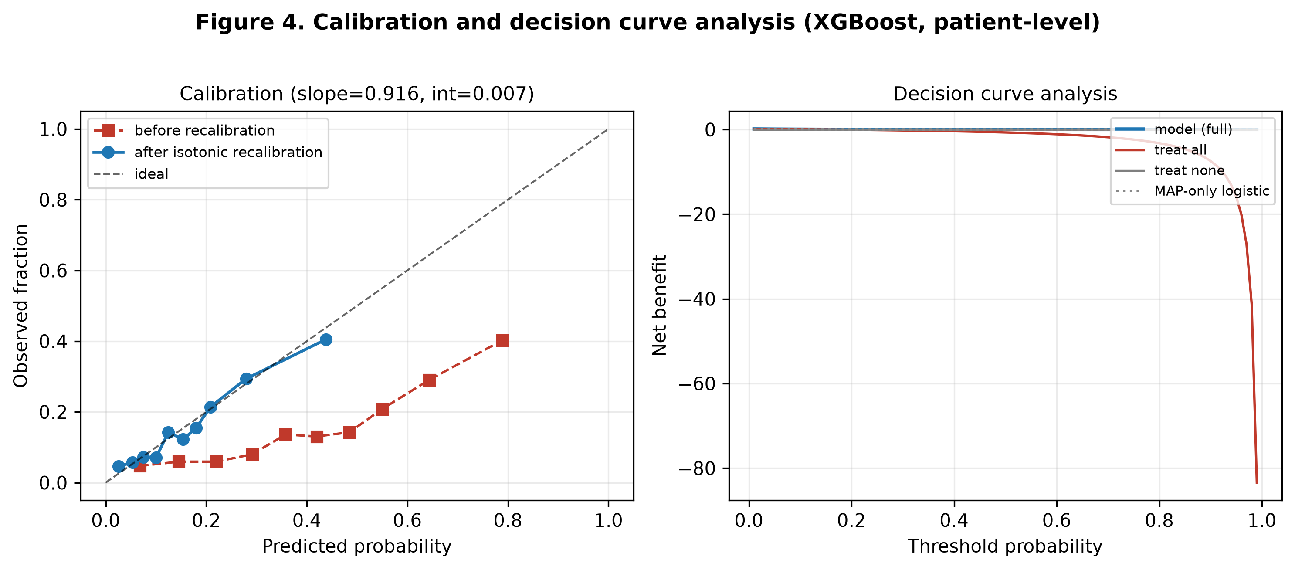
isotonic recalibration, and net benefit across threshold probabilities for XGBoost, a MAP-only logistic benchmark, treat all and treat none.
Figure 5. Predictor importance. Twenty-five highest-gain predictors from XGBoost.
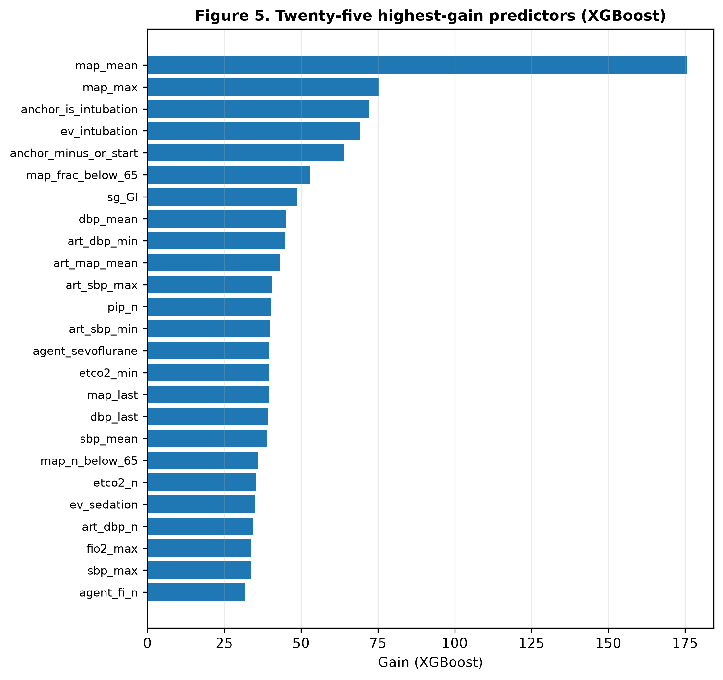
Figure 6. External transportability check in VitalDB. Receiver operating characteristic
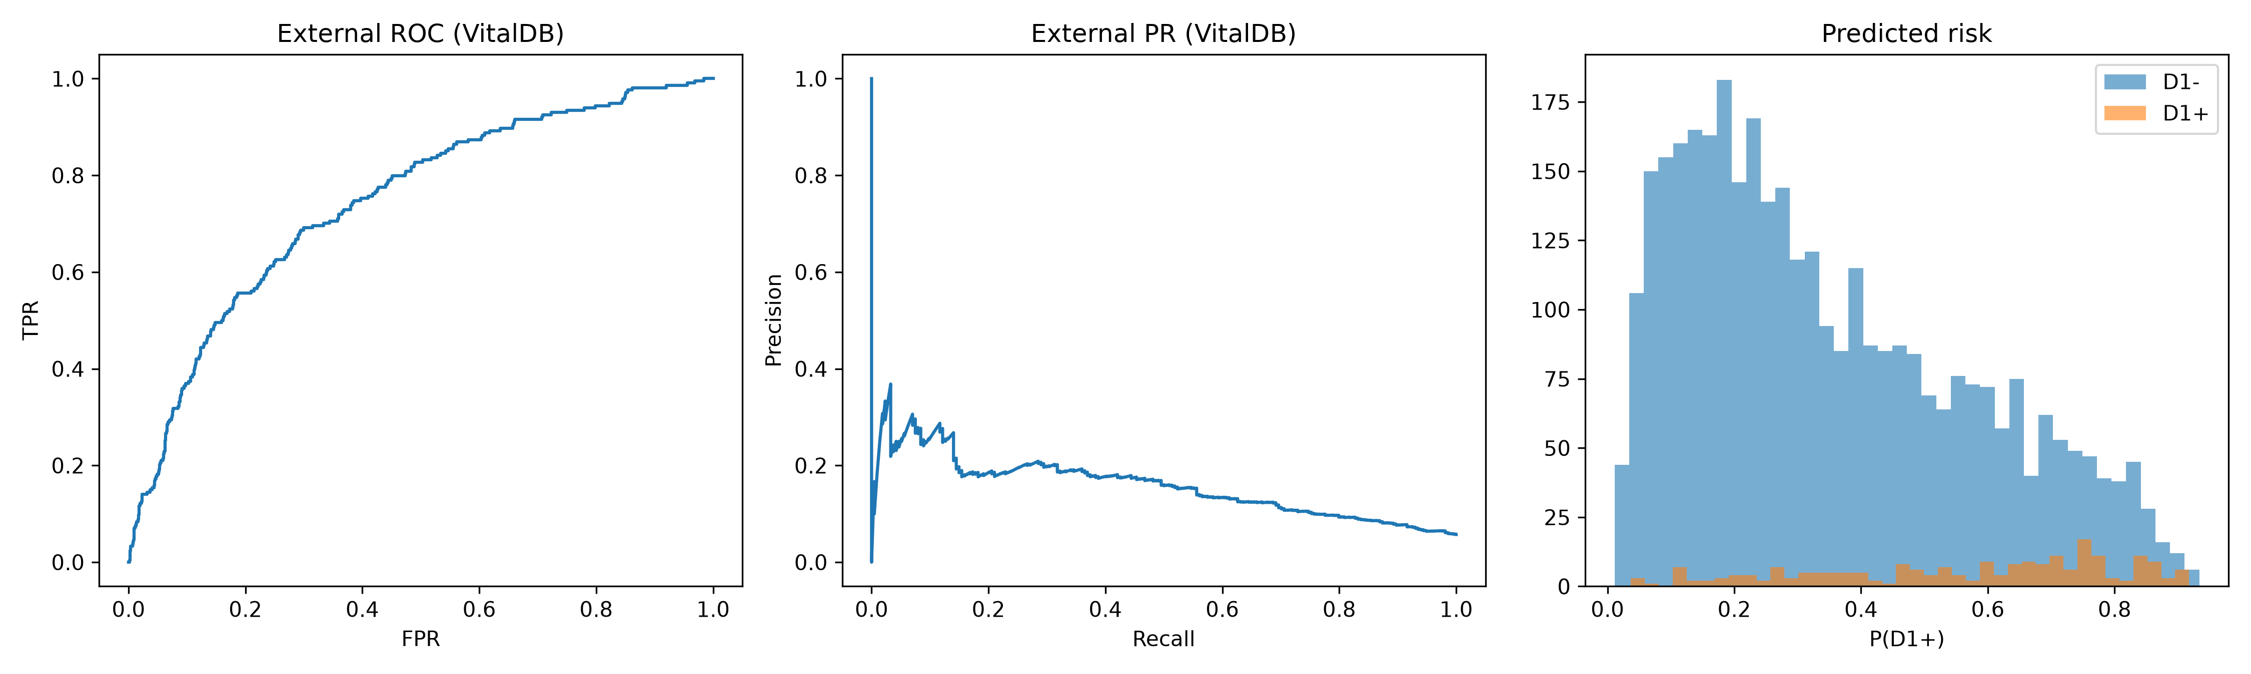
(left), precision–recall (centre) and predicted-risk distribution (right) for the MOVER core model applied unchanged to the VitalDB arterial cohort (n = 3,735; outcome prevalence 5.73%).

Additional files
Additional file 1. Audit trail: every number reported in this manuscript, its producing result file, and the command that reproduces it (CSV).
Additional file 2. TRIPOD+AI (2024) reporting checklist, with each item mapped to the relevant manuscript section or result file.

