Graphical Abstract
Domain-Specific versus Dense Knowledge Graphs for
Gene Perturbation Prediction: A Multi-Split Ablation Benchmark

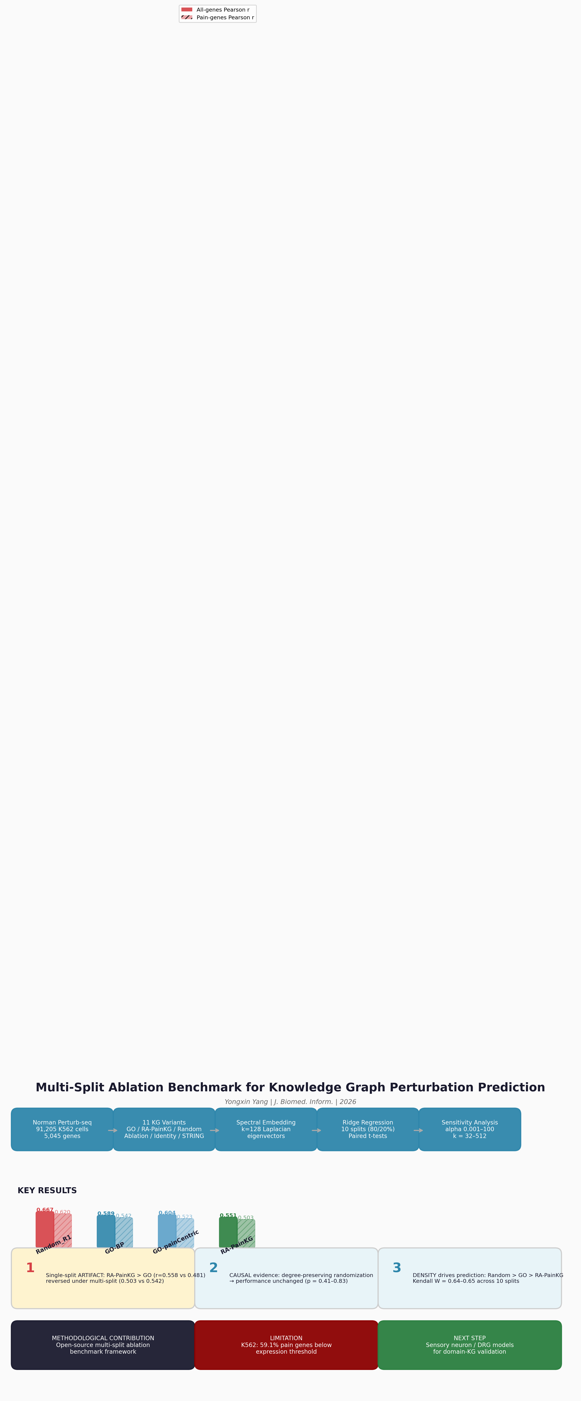

Figure: Multi-split ablation benchmark framework for knowledge graph evaluation.
Single-split artifact documented, causal evidence via degree-preserving randomization,
open-source benchmark with paired statistics and sensitivity analyses.

