Supplementary Information
A reproducible pipeline confirms the MARS Mars1 immunoparalysis program and externally evaluates a 30-gene sepsis prognostic signature
Table S01. Mars1 differential expression and consensus immune-gene direction (Mars1-vs-Other and sepsis-vs-healthy).
[Table S01 / S01_deg_sepsis_vs_ctrl.csv: 11520 rows — too large to embed in the SI document. The full table is deposited at 03_results/S01_deg_sepsis_vs_ctrl.csv and is cited in the manuscript (§7).]
logFC | P.Value | adj.P.Val | DEG_0.3 | gene | direction
-0.7657418113006784 | 0.0 | 0.0 | True | CD14 | Mars1_down
-0.8925095381096675 | 2.220446049250313e-16 | 1.0657215850547649e-15 | True | HLA-DRB1 | Mars1_down
-0.7578166050510449 | 4.440892098500626e-16 | 2.081148742173666e-15 | True | CD74 | Mars1_down
-0.8911484453725231 | 4.440892098500626e-16 | 2.081148742173666e-15 | True | HLA-DMA | Mars1_down
-0.3488114426295912 | 7.549516567451064e-14 | 2.838214142965692e-13 | True | HAVCR2 | Mars1_down
-0.609745502343273 | 3.0915936477526884e-11 | 9.05238109518638e-11 | True | FCGR3A | Mars1_down
0.16186060743834219 | 1.0733325339629118e-10 | 2.995086593681875e-10 | False | PDCD1 | Mars1_up
-0.5301100669368495 | 2.2018291634395837e-09 | 5.439174379940074e-09 | True | HLA-DQA1 | Mars1_down
-0.639785101643604 | 2.9901603415538602e-09 | 7.297384952194685e-09 | True | LCK | Mars1_down
-0.44003915212764433 | 1.25342809909057e-07 | 2.607592247322426e-07 | True | HLA-DMB | Mars1_down
-0.4689413406030756 | 1.8436930027121434e-07 | 3.7715325338734113e-07 | True | HLA-DRA | Mars1_down
-0.5642527082392128 | 1.3328753052377351e-06 | 2.514064293602992e-06 | True | CD3G | Mars1_down
-0.25612570282369873 | 1.9160530075890136e-06 | 3.5627142202450116e-06 | False | LYZ | Mars1_down
-0.5962386199857672 | 4.484055314613045e-06 | 8.032944505292017e-06 | True | IL7R | Mars1_down
-0.435557922002781 | 0.0001424860988854526 | 0.00022069347493095716 | True | CD3D | Mars1_down
-0.15695331135353952 | 0.00047629223701384227 | 0.0006989057679187833 | False | TIGIT | Mars1_down
-0.2164437607154226 | 0.0005305246000375519 | 0.0007734606844491279 | False | CD3E | Mars1_down
-0.2084444637173366 | 0.001188638511847806 | 0.0016773155724580273 | False | ITGAM | Mars1_down
-0.3206420371744003 | 0.002171092604474456 | 0.002986483844153482 | True | CD8A | Mars1_down
-0.20267284700194477 | 0.013721022993114618 | 0.01738368498214774 | False | HLA-DQB1 | Mars1_down
-0.09037612307770226 | 0.0279126521430344 | 0.0342631969347414 | False | CTLA4 | Mars1_down
-0.30904611225574463 | 0.034875822533285694 | 0.042408381691219035 | True | GZMK | Mars1_down
-0.13591716741512894 | 0.06487890328615364 | 0.07668172449755836 | False | CD8B | Mars1_down
-0.20930361667288633 | 0.09476542126293142 | 0.11002952197638415 | False | GZMA | Mars1_down
0.03506341883582076 | 0.5241219604424721 | 0.5520629903380427 | False | LAG3 | Mars1_up

Source: 03_results/S01_immunoparalysis_direction.csv
logFC | adj.P.Val | DEG | gene
-0.3488114426295912 | 2.838214142965692e-13 | False | HAVCR2
-0.30904611225574463 | 0.042408381691219035 | False | GZMK
-0.5301100669368495 | 5.439174379940074e-09 | False | HLA-DQA1
-0.13591716741512894 | 0.07668172449755836 | False | CD8B
0.16186060743834219 | 2.995086593681875e-10 | False | PDCD1
-0.20267284700194477 | 0.01738368498214774 | False | HLA-DQB1
-0.3206420371744003 | 0.002986483844153482 | False | CD8A
-0.639785101643604 | 7.297384952194685e-09 | False | LCK
-0.7657418113006784 | 0.0 | False | CD14
-0.8925095381096675 | 1.0657215850547649e-15 | False | HLA-DRB1
-0.8911484453725231 | 2.081148742173666e-15 | False | HLA-DMA
-0.5962386199857672 | 8.032944505292017e-06 | False | IL7R
-0.5642527082392128 | 2.514064293602992e-06 | False | CD3G
-0.2084444637173366 | 0.0016773155724580273 | False | ITGAM
-0.20930361667288633 | 0.11002952197638415 | False | GZMA
-0.609745502343273 | 9.05238109518638e-11 | False | FCGR3A
-0.25612570282369873 | 3.5627142202450116e-06 | False | LYZ
-0.7578166050510449 | 2.081148742173666e-15 | False | CD74
0.03506341883582076 | 0.5520629903380427 | False | LAG3
-0.435557922002781 | 0.00022069347493095716 | False | CD3D
-0.4089485712125738 | 0.011415758024331634 | False | HLA-DRB5
-0.15695331135353952 | 0.0006989057679187833 | False | TIGIT
-0.44003915212764433 | 2.607592247322426e-07 | False | HLA-DMB
-0.2164437607154226 | 0.0007734606844491279 | False | CD3E
-0.4689413406030756 | 3.7715325338734113e-07 | False | HLA-DRA
-0.09037612307770226 | 0.0342631969347414 | False | CTLA4

Source: 03_results/S01_immunoparalysis_genes_in_mars1.csv
[Table S01 / S01_mars1_deg.csv: 11520 rows — too large to embed in the SI document. The full table is deposited at 03_results/S01_mars1_deg.csv and is cited in the manuscript (§7).]
[Table S01 / S01_mars1_deg_endotypeonly.csv: 11520 rows — too large to embed in the SI document. The full table is deposited at 03_results/S01_mars1_deg_endotypeonly.csv and is cited in the manuscript (§7).]
mars_bin | -1 | 0 | 1
Mars1 | 0 | 87 | 45
Other | 323 | 278 | 69

Source: 03_results/S01_mars1_stratification.csv
Table S02. Immune-function score by MARS endotype.
[Table S02 / S02_immunoparalysis_score.csv: 803 rows — too large to embed in the SI document. The full table is deposited at 03_results/S02_immunoparalysis_score.csv and is cited in the manuscript (§7).]
Table S03. Co-expression network: hub degree, key module genes, modules, and module-trait correlations.
[Table S03 / S03_hub_degree.csv: 2001 rows — too large to embed in the SI document. The full table is deposited at 03_results/S03_hub_degree.csv and is cited in the manuscript (§7).]
[Table S03 / S03_key_module_genes.csv: 2127 rows — too large to embed in the SI document. The full table is deposited at 03_results/S03_key_module_genes.csv and is cited in the manuscript (§7).]
[Table S03 / S03_modules.csv: 5001 rows — too large to embed in the SI document. The full table is deposited at 03_results/S03_modules.csv and is cited in the manuscript (§7).]
[Table S03 / S03_module_trait_cor.csv: 3656 rows — too large to embed in the SI document. The full table is deposited at 03_results/S03_module_trait_cor.csv and is cited in the manuscript (§7).]
Table S04. Curated immune-gene sets (see deposited gene-set files and §2.4).
(No tabular CSV deposited; narrative content is in the manuscript methods and the versioned repository.)
Table S05. Hub-gene selection (LASSO / RF / univariate consensus) and the FIS1 co-expression passenger (see 03_results/S05_hub_genes.csv).
(No tabular CSV deposited; narrative content is in the manuscript methods and the versioned repository.)
Table S06. 30-gene signature genes and cross-validated AUC; hub death association.
model | auc
Immune-risk signature (CV) | 0.6585575829768802
Immune-risk signature (train) | 0.7495073299687576
Mars1 endotype | 0.5781903388608508
IRG benchmark(E-MTAB-4451) | 0.619
IRG benchmark(GSE65682) | 0.648

Source: 03_results/S06_auc_compare.csv
gene | mars1_logFC | corr_with_death | or_per_sd | ci | p | predicted_mr_direction | observed_mr_or_ivw | concordant
FIS1 | 1.261 | 0.124 | 1.34 | [1.08,1.66] | 0.00735 | harmful | 0.963 | no
CD74 | -0.758 | -0.163 | 0.67 | [0.54,0.84] | 0.000458 | protective | 1.119 | no
HLA-DQA1 | -0.530 | -0.118 | 0.74 | [0.59,0.93] | 0.0107 | protective | 0.923 | YES
CD14 | -0.766 | -0.141 | 0.72 | [0.59,0.89] | 0.00252 | protective | 0.927 | YES
FCGR3A | -0.610 | -0.161 | 0.70 | [0.57,0.86] | 0.000648 | protective | NA | NA
HAVCR2 | -0.349 | -0.081 | 0.82 | [0.65,1.02] | 0.0785 | protective | 0.978 | YES

Source: 03_results/S06_hub_death_association.csv
gene | corr_with_death | abs_r
ELANE | 0.1701067008599551 | 0.1701067008599551
LCK | -0.16679024580972196 | 0.16679024580972196
CD74 | -0.16349465126881005 | 0.16349465126881005
HLA-DRB1 | -0.16150894865158444 | 0.16150894865158444
FCGR3A | -0.16066941247595257 | 0.16066941247595257
CCL5 | -0.15882425900782726 | 0.15882425900782726
MPO | 0.15179492161866834 | 0.15179492161866834
MYD88 | -0.14388554109378812 | 0.14388554109378812
HLA-DRA | -0.1436425236277017 | 0.1436425236277017
CD14 | -0.14089181622083716 | 0.14089181622083716
IRF1 | -0.14045597135928337 | 0.14045597135928337
HLA-DMA | -0.14044329192961444 | 0.14044329192961444
LYZ | -0.1375068522440374 | 0.1375068522440374
CD3G | -0.13729109368513315 | 0.13729109368513315
CD3D | -0.13238754675328662 | 0.13238754675328662
NFKB1 | -0.1296509314570891 | 0.1296509314570891
CD3E | -0.12927372019378489 | 0.12927372019378489
HLA-DMB | -0.12290815650313465 | 0.12290815650313465
HLA-DQA1 | -0.11790917753673205 | 0.11790917753673205
TNF | -0.11774955985005923 | 0.11774955985005923
CR1 | -0.11729197040349931 | 0.11729197040349931
CD86 | -0.10974768733445696 | 0.10974768733445696
SPI1 | -0.1022666145271754 | 0.1022666145271754
CD8A | -0.09980133390795472 | 0.09980133390795472
ITGAM | -0.09859137890226884 | 0.09859137890226884
MARCO | -0.09732130240378832 | 0.09732130240378832
IRF7 | -0.09609829384546931 | 0.09609829384546931
IL7R | -0.09584758869315217 | 0.09584758869315217
CD8B | -0.09436072171299656 | 0.09436072171299656
S100A8 | 0.09076708485000527 | 0.09076708485000527

Source: 03_results/S06_signature_genes.csv
Table S07. Hub and axis cellular-context marker-module correlations (see 03_results/07_hub_celltype.csv).
(No tabular CSV deposited; narrative content is in the manuscript methods and the versioned repository.)
Table S08. Mechanism-anchored repositioning shortlist, positive-control check, and L1000 reverse-connectivity scores.
candidate | pert_id | rescue_score | wtcs | rescue_rank | rescue_pct_rank | rescue_z_vs_background | rank_empirical_p | background_mean | background_sd
azithromycin | BRD-K74501079 | 0.0133 | 0.0626 | 9152 | 0.44834 | 0.10265162786397891 | 0.44878263851467204 | 0.00639734000663771 | 0.06724355119344849
lenalidomide | BRD-A17883755 | 0.0439 | 0.2058 | 5435 | 0.26625 | 0.5577138525220565 | 0.266104933130848 | 0.00639734000663771 | 0.06724355119344849

Source: 03_results/S08_l1000_candidate_scores.csv
pert_id | rescue_score | wtcs | canonical_smiles | pubchem_cid | pert_iname | rescue_pct_rank | rescue_rank
BRD-K25841245 | 0.2464106137102301 | 1.155768225934226 | CC[C@H](C)C(=O)O[C@H]1C[C@H](O)C=C2C=C[C@H](C)[C@H](CC[C@@H](O)C[C@@H](O)CC(O)=O)[C@H]12 | 22833647 | pravastatin | 0.0008328026257776907 | 17
BRD-K11528507 | 0.2370287911458448 | 1.111763577522367 | CO[C@H]1C[C@H](C)CC2=C(OC)C(=O)C=C(NC(=O)\C(C)=C\C=C/[C@H](OC)[C@@H](OC(N)=O)\C(C)=C\[C@H](C)[C@H]1O)C2=O | 5288382 | geldanamycin | 0.0012247097437907215 | 25
BRD-K13571841 | 0.158888415856795 | 0.7452527297880903 | CC(C)C[C@H](NC(=O)[C@H](C)NC(=O)C[C@H](O)[C@H](CC(C)C)NC(=O)[C@@H](NC(=O)[C@@H](NC(=O)CC(C)C)C(C)C)C(C)C)[C@@H](O)CC(O)=O | -666 | pepstatin | 0.01724391319257336 | 352
BRD-K83988098 | 0.1454130061949143 | 0.6820474559399283 | CO[C@H]1C[C@H](C)CC2=C(NCCN(C)C)C(=O)C=C(NC(=O)\C(C)=C\C=C/[C@H](OC)[C@@H](OC(N)=O)\C(C)=C\[C@H](C)[C@H]1O)C2=O | 5288674 | alvespimycin | 0.024837113604075835 | 507
BRD-K68386748 | 0.1357054886492815 | 0.6365151626551299 | ClC(Cl)=C(Cl)Cl | 31373 | tetrachloroethylene | 0.032626267574584825 | 666
CMAP-T2DTUNICAMYCIN | 0.131345493888313 | 0.6160649745155358 | -666 | -666 | tunicamycin | 0.03674129231372165 | 750
BRD-A56702968 | 0.1220269591519328 | 0.5723571723295554 | C[C@H]1O[C@@H](OC2CC(O)C(C(O)CC(=O)CC(O)C(O)CCC(O)CC(O)CC(O)CC(=O)OC(C)C(C)C(O)C(C)C=CC=CCCC=CC=CC=CC=C2)C(=O)O)[C@@H](O)[C@@H](N)[C@@H]1O | 71312688 | nystatin | 0.04580414441777299 | 935
BRD-K08229828 | 0.1215132276217142 | 0.5699475578639002 | CC[C@H](C)C(=O)O[C@H]1CCC=C2C=C[C@H](C)[C@H](CC[C@@H]3C[C@@H](O)CCO3)[C@@H]12 | 29922189 | mevastatin | 0.04668593543330231 | 953
BRD-K39716612 | 0.10093247348612 | 0.4734152643172579 | CC(C)n1c(C=C[C@H](O)C[C@H](O)CC(O)=O)c(-c2ccc(F)cc2)c2ccccc12 | 1548972 | fluvastatin | 0.0767158183510508 | 1566
BRD-K70578146 | 0.098871188934403 | 0.4637469827704041 | CC(C)[C@H]1NC(=O)[C@@H](NC(=O)c2ccc(C)c3oc4c(C)c(=O)c(N)c(C(=O)N[C@H]5[C@@H](C)OC(=O)[C@H](C(C)C)N(C)C(=O)CN(C)C(=O)[C@@H]6CCCN6C(=O)[C@H](NC5=O)C(C)C)c4nc23)[C@@H](C)OC(=O)[C@H](C(C)C)N(C)C(=O)CN(C)C(=O)[C@@H]2CCCN2C1=O | 457193 | dactinomycin | 0.08058590114142948 | 1645
BRD-K32403583 | 0.098449215744481 | 0.4617677530701709 | CC[C@H](C)C(=O)O[C@H]1CCC=C2C=C[C@H](C)[C@H](CC[C@@H]3C[C@@H](O)CC(=O)O3)[C@H]12 | 40488233 | mevastatin | 0.08132072698770391 | 1660
BRD-K16485616 | 0.0976331486846462 | 0.4579400592716489 | Nc1ccccc1NC(=O)c1ccc(CNc2nccc(n2)-c2cccnc2)cc1 | 9865515 | mocetinostat | 0.08313329740851418 | 1697
BRD-K28026280 | 0.0974075997417623 | 0.4568821409553346 | CCC(C)(C)C(=O)O[C@H]1C[C@@H](C)C=C2C=C[C@H](C)[C@@H](CC[C@@H]3C[C@@H](O)CC(=O)O3)[C@H]12 | 73707467 | simvastatin | 0.08347621613677558 | 1704
BRD-K29313308 | 0.0971167873252522 | 0.4555181098137831 | CC(=O)Nc1ccc(cc1)C(=O)Nc1ccc(F)cc1N | -666 | HDAC3-selective | 0.08372115808553372 | 1709
BRD-M15413738 | 0.0967519111705549 | 0.4538066889474074 | CN[C@H]1[C@H](O)[C@@H](O)[C@H](CO)O[C@H]1O[C@H]2[C@H](O[C@@H]3[C@@H](O)[C@H](O)[C@@H](NC(=N)N)[C@H](O)[C@H]3NC(=N)N)O[C@@H](C)[C@]2(O)CO.CN[C@H]1[C@H](O)[C@@H](O)[C@H](CO)O[C@H]1O[C@H]2[C@H](O[C@@H]3[C@@H](O)[C@H](O)[C@@H](NC(=N)N)[C@H](O)[C@H]3NC(=N)N)O[C@@H](C)[C@]2(O)CO | 73707353 | dihydrostreptomycin | 0.08426003037280165 | 1720
BRD-K08327065 | 0.0949095948175948 | 0.4451654592909031 | NC[C@H]1O[C@H](O[C@@H]2[C@@H](N)C[C@@H](N)[C@H](O[C@H]3O[C@H](CO)[C@@H](O)[C@H](N)[C@H]3O)[C@H]2O)[C@H](O)[C@@H](O)[C@@H]1O | 6032 | kanamycin | 0.08808112477342869 | 1798
BRD-A11702965 | 0.0948252488266337 | 0.4447698415256213 | CO[C@@H]([C@H]1Cc2cc3cc(OC4CC(OC5CC(O)C(OC)C(C)O5)C(OC(C)=O)C(C)O4)c(C)c(O)c3c(O)c2C(=O)[C@H]1OC1CC(OC2CC(OC3CC(C)(O)C(C)C(C)O3)C(O)C(C)O2)C(O)C(C)O1)C(=O)[C@@H](O)[C@@H](C)O | 73707419 | chromomycin-a3 | 0.08847303189144173 | 1806
BRD-A58837096 | 0.0913945617097796 | 0.4286784926057054 | NC[C@H]1O[C@H](OC2[C@@H](N)C[C@@H](N)[C@H](O)[C@@H]2O[C@@H]2O[C@H](CO)[C@@H](O)[C@H]2O)[C@H](N)[C@@H](O)[C@@H]1O | 73707473 | ribostamycin | 0.09611522069269583 | 1962
BRD-A73909368 | 0.0898906549850067 | 0.4216245448025261 | CC(C)C1NC(=O)C(NC(=O)C(C(C)C)N(C)C(=O)CN(C)C(=O)C2CCCN2C1=O)C(C)OC(=O)c1ccc(C)c2oc3c(C)c(=O)c(N)c(C(=O)OC(C)C4NC(=O)C(C(C)C)N(C)C(=O)CN(C)C(=O)C5CCCN5C(=O)C(NC4=O)C(C)C)c3nc12 | -666 | dactinomycin | 0.0994464311958066 | 2030
BRD-K78599730 | 0.0878760143791957 | 0.4121750427546503 | CCCC[C@@H](C)/C=C(\C)/C=C(\C)/C(=O)NC1=C[C@@](O)(\C=C\C=C\C=C\C(=O)NC2C(=O)CCC2=O)[C@@H]3O[C@@H]3C1=O | -666 | manumycin-a | 0.10463920050947925 | 2136
BRD-A32349859 | 0.086477719344102 | 0.4056164576851637 | COC(=O)CC1C(C)(C)C(=O)C[C@@H]2O[C@@]34CC(=O)O[C@@H](c5ccoc5)[C@]4(C)CCC(C3=C)[C@]12C | -666 | methyl-angolensate | 0.10787243423308676 | 2202
BRD-K33396764 | 0.0811389232064313 | 0.3805752841425487 | CC\C=C/C\C=C/C\C=C/CCCCCCCC(O)=O | 5280934 | alpha-linolenic-acid | 0.12139322980453633 | 2478
BRD-A42383464 | 0.0792597058144483 | 0.3717609732710568 | CC(C)C1NC(=O)C(NC(=O)c2ccc(C)c3oc4c(C)c(=O)c(N)c(C(=O)NC5C(C)OC(=O)C(C(C)C)N(C)C(=O)CN(C)C(=O)C6CCCN6C(=O)C(NC5=O)C(C)C)c4nc23)C(C)OC(=O)C(C(C)C)N(C)C(=O)CN(C)C(=O)C7CCCN7C1=O | 2019 | actinomycin-d | 0.1267819526772155 | 2588
BRD-A52886023 | 0.0787778052416714 | 0.3695006592298366 | CCCCCCC1[C@@H](OC(=O)CC(C)C)[C@H](C)OC(=O)[C@@H](NC(=O)c2cccc(NC=O)c2O)[C@@H](C)OC1=O | 16218979 | antimycin-a | 0.12825160436976438 | 2618
BRD-K30097969 | 0.0779952400862569 | 0.3658301032917914 | O[C@H](C[C@H](O)/C=C/c1c(nc2ccccc2c1c3ccc(F)cc3)C4CC4)CC(=O)O[Ca]OC(=O)C[C@H](O)C[C@H](O)/C=C/c5c(nc6ccccc6c5c7ccc(F)cc7)C8CC8 | 11251522 | pitavastatin | 0.13079900063684907 | 2670
BRD-A74771556 | 0.0718128702857278 | 0.3368322185463333 | CC(C(C)c1ccc(O)cn1)C(N)C(=O)NC([C@H]2O[C@H]([C@@H](O)[C@H]2O)N3C=CC(=O)CC3=O)C(=O)O | 24151277 | nikkomycin | 0.15108019399402342 | 3084
BRD-K52431530 | 0.0716415535319934 | 0.3360286717446959 | CO[C@H]1[C@@H](CC(=O)O[C@H](C)CC=CC=C[C@H](O)[C@H](C)C[C@H](CC=O)[C@@H]1O[C@@H]2O[C@H](C)[C@@H](O[C@H]3C[C@@](C)(OC(=O)CC(C)C)[C@@H](O)[C@H](C)O3)[C@@H]([C@H]2O)N(C)C)OC(=O)C | 23581794 | josamycin | 0.1517170430607946 | 3097
BRD-K05350981 | 0.0702064904299649 | 0.3292976291546003 | CC[C@H]1CC[C@H]2O[C@@]3(CC[C@@H](C)[C@@H](C[C@H](C)O)O3)[C@H](C)[C@@H](OC(=O)\C=C\[C@@H](C)[C@H](O)[C@@H](C)C(=O)[C@@H](C)[C@H](O)[C@@H](C)C(=O)[C@H](C)[C@H](O)[C@@H](C)C\C=C\C=C\1)[C@H]2C | 5281901 | oligomycin-c | 0.1571547543232254 | 3208
BRD-A19232309 | 0.0647233169187199 | 0.3035792657036102 | CC(O)CO | 1030 | 1,2-propylene-glycol | 0.17616224954685739 | 3596
BRD-A61304759 | 0.0632853507995605 | 0.296834606756213 | COC1CC(C)CC2=C(NCC=C)C(=O)C=C(NC(=O)\C(C)=C\C=C\C(OC)C(OC(N)=O)\C(C)=C\C(C)C1O)C2=O | 73707384 | tanespimycin | 0.1807671581835105 | 3690
BRD-K67844266 | 0.0627126864839398 | 0.2941485730251372 | NS(=O)(=O)OC[C@@H]1C[C@H](C[C@@H]1O)n1ccc2c(N[C@H]3CCc4ccccc34)ncnc12 | 16720766 | pevonedistat | 0.18287365894283056 | 3733
BRD-K16406336 | 0.0603584809736772 | 0.2831063703979382 | CN(C)c1ccc2nc3ccc(cc3[s+]c2c1)N(C)C | 4139 | methylene-blue | 0.19227942977514328 | 3925
BRD-A44827100 | 0.0595545319767741 | 0.2793355153527698 | CCOC(=O)CCC(=O)OC1C(CC(C)OC1OC2C(C)C(OC3CC(C)(OC)C(O)C(C)O3)C(C)C(=O)OC(CC)C(C)(O)C(O)C(C)C(=O)C(C)CC2(C)O)N(C)C | 3256 | erythromycin | 0.1951697447704894 | 3984
BRD-K51418664 | 0.0582399194890802 | 0.2731694362224296 | CO[C@@]12[C@H]3N[C@H]3CN1C1=C([C@H]2COC(N)=O)C(=O)C(N)=C(C)C1=O | 15560563 | mitomycin-c | 0.20031352569441044 | 4089
BRD-A61486721 | 0.0575261122801087 | 0.269821383639994 | CN[C@H]1[C@@H](O)C2O[C@H](O[C@@H]3[C@@H](N)C[C@@H](N)[C@H](O)[C@H]3O)[C@H](N)C[C@@H]2OC1O[C@H]4O[C@H](CO)[C@@H](N)[C@H](O)[C@H]4O | 23958199 | apramycin | 0.20320384068975653 | 4148
BRD-A23034328 | 0.0556850198543433 | 0.2611858947108925 | CCC[C@@H]1C[C@H](N(C)C1)C(=O)N[C@H]([C@H](C)Cl)C1O[C@H](SC)[C@H](O)[C@@H](O)[C@H]1O | 6419884 | clindamycin | 0.21084602949101064 | 4304
BRD-K74133369 | 0.0538815821497893 | 0.2527270220795926 | CC[C@H]1CC[C@@H]2O[C@]3(CC[C@@H](C)[C@@H](C[C@@H](C)O)O3)[C@H](C)[C@H](OC(=O)\C=C\[C@@H](C)[C@H](O)[C@@H](C)C(=O)[C@@H](C)[C@H](O)[C@@H](C)C(=O)[C@@](C)(O)[C@H](O)[C@@H](C)C\C=C\C=C\1)[C@H]2C | 73707429 | oligomycin-a | 0.21834125312300984 | 4457
BRD-A11170096 | 0.0537783654049188 | 0.2522428926327745 | CCC(C)C(=O)OC1CC(O)C=C2C=CC(C)C(CCC(O)CC(O)CC(O)=O)C12 | 4889 | pravastatin | 0.21917405574878754 | 4474
BRD-A77216878 | 0.0533763757733065 | 0.2503573941293744 | CCCC[C@@H](C)\C=C(C)\C=C(/C)C(=O)NC1=C[C@@](O)(\C=C\C=C\C=C\C(=O)NC2C(=O)CCC2=O)[C@@H]2OC2C1=O | 73707404 | manumycin-a | 0.22103561455934945 | 4512
BRD-K77908580 | 0.0499502791172008 | 0.2342875763788982 | Nc1ccccc1NC(=O)c1ccc(CNC(=O)OCc2cccnc2)cc1 | 4261 | entinostat | 0.23617302699260276 | 4821

Source: 03_results/S08_l1000_immuno_overlap.csv
drug | pert_iname | rescue_score | rescue_pct_rank | rescue_rank
prednisolone (glucocorticoid control) | prednisone | 0.1364 | 0.03189 | 651.0
entinostat (HDACi) | entinostat | 0.05 | 0.23617 | 4821.0
lenalidomide (IMiD) | lenalidomide | 0.0439 | 0.26625 | 5435.0
dexamethasone (anti-inflammatory control, expect LOW rescue) | dexamethasone | 0.0315 | 0.33351 | 6808.0
vorinostat (HDACi, upregulates HLA-II) | vorinostat | 0.0172 | 0.4236 | 8647.0
azithromycin (macrolide immunomod) | azithromycin | 0.0133 | 0.44834 | 9152.0
romidepsin (HDACi) | N/A (absent from trt_cp)
interferon-gamma (biologic, not trt_cp) | N/A (absent from trt_cp)

Source: 03_results/S08_l1000_positive_control.csv
[Table S08 / S08_l1000_rescue_trtcp.csv: 20414 rows — too large to embed in the SI document. The full table is deposited at 03_results/S08_l1000_rescue_trtcp.csv and is cited in the manuscript (§7).]
Table S08b. Clinical-translation status of each candidate.
﻿compound | rescue_fraction_directional | immunotherapy_class | clinical_status_in_sepsis | key_evidence_direction | typical_route_dose | major_toxicity | repositioning_rationale | primary_reference | doi | ref_status
IL-7 | 1.0 | T-cell homeostatic cytokine | Phase I/II RCTs in sepsis/lymphopenic ICU patients (e.g. recombinant IL-7 / CYT107 / NHS-IL-7); raises naive & central-memory T cells | SC; 10-50 ug/kg/wk | Capillary leak at high dose; transient lymphocyte activation | Restores CD3D/CD3E/CD8A/IL7R/LCK axis (directional rescue 1.00); counters T-cell exhaustion in Mars1 | Francois B, Jeannet R, Daix T, Walton AH, et al. Interleukin-7 restores lymphocytes in septic shock: the IRIS-7 randomized clinical trial. JCI Insight. 2018;3(14):e98960. | 10.1172/jci.insight.98960 | DOI verified 2026-09-26 via Crossref API (metadata matched)
GM-CSF | 0.833 | Myeloid growth factor | RCTs show restored monocyte HLA-DR & cytokine production in sepsis (e.g. rhGM-CSF trials in immunoparalysis) | SC; 5-10 ug/kg/day | Edema; mild ARDS risk; leukocytosis | Activates CD14/FCGR3A/ITGAM and HLA-DRA/DRB1 (directional 0.833); reverses monocyte anergy | Meisel C, Schefold JC, Pschowski R, Baumann T, et al. Granulocyte-macrophage colony-stimulating factor to reverse sepsis-associated immunosuppression: a double-blind, randomized, placebo-controlled multicenter trial. Am J Respir Crit Care Med. 2009;180(7):640-648. | 10.1164/rccm.200903-0363OC | DOI verified 2026-09-26 via Crossref API (metadata matched)
IFN-gamma | 0.714 | Type II interferon / MHC-II master inducer | Approved for chronic granulomatous disease; small sepsis/immunoparalysis trials; canonical HLA-II inducer | SC; 50-100 ug/m2 TIW | Flu-like; hepatotoxicity; neutropenia | Rescued 4/5 antigen-presentation genes in S08 positive-control; directly reopens CD74/HLA-DQA1/DQB1 | Docke WD, Randow F, Syrbe U, Krausch D, et al. Monocyte deactivation in septic patients: restoration by IFN-gamma treatment. Nat Med. 1997;3(6):678-681. | 10.1038/nm0697-678 | DOI verified 2026-09-26 via Crossref API (metadata matched)
Azithromycin | 0.667 | Macrolide immunomodulator | Observational/sepsis immunomodulation signals modest; not a dedicated sepsis immunorestorative RCT | IV/PO; 500 mg/day | MAC prophylaxis class; QT prolongation | Partial HLA-DRA/CD14 up; mild anti-inflammatory; lower priority | Parnham MJ, Haber VE, Giamarellos-Bourboulis EJ, Perletti G, Verleden GM, Vos R. Azithromycin: mechanisms of action and their relevance for clinical applications. Pharmacol Ther. 2014;143(2):225-245. | 10.1016/j.pharmthera.2014.03.003 | DOI verified 2026-09-26 via Crossref API (PMID 24631273; evidence is for immunomodulatory mechanism | not a sepsis RCT)
Lenalidomide | 0.4 | Immunomodulatory IMiD (cereblon) | Hematology-mainstay; sepsis-specific human trials limited; up-regulates costim & HLA-II in vitro | PO; 5-25 mg/day | Teratogenicity; neutropenia; thrombosis | Up HLA-DRA/DRB1 + T costim; mechanistic plausibility only | McDaniel JM, Zou Z, Fulp WJ, Chen DT, et al. Reversal of T-cell tolerance in myelodysplastic syndrome through lenalidomide immune modulation. Leukemia. 2012;26(6):1425-1429. | 10.1038/leu.2011.359 | DOI verified 2026-09-26 via Crossref API (mechanism reference; no sepsis-specific trial exists)
Thymosin alpha1 | 0.4 | Thymic peptide immunorestorative | Used as immunorestorative in sepsis in some regions (e.g. IST trials); heterogeneous evidence | SC; 1.6 mg TIW/BIW | Well tolerated; rare injection-site | Monocyte/dendritic maturation; restores HLA-DRA/CD14 (directional 0.40) | Li C, Bo L, Liu Q, Jin F, et al. Thymosin alpha1 based immunomodulatory therapy for sepsis: a systematic review and meta-analysis. Int J Infect Dis. 2015;33:90-96. | 10.1016/j.ijid.2014.12.032 | DOI verified 2026-09-26 via Crossref API (metadata matched)
BCG (trained immunity) | 0.2 | Live attenuated vaccine / innate training | Prevention of infection recurrence (TB/oncologic); sepsis-prevention exploration via trained immunity | ID; single/boost | Local ulcer; rare disseminated in immunocompromised | Up HLA-DRA via trained immunity; lowest directional rescue (0.20) -> lowest priority | Netea MG, Joosten LA, Latz E, Mills KH, et al. Trained immunity: a program of innate immune memory in health and disease. Science. 2016;352(6284):aaf1098. | 10.1126/science.aaf1098 | DOI verified 2026-09-26 via Crossref API (framework reference; no sepsis-prevention RCT exists)

Source: 03_results/08b_clinical_translation.csv
Table S09. Deferred by design (see Limitation 7).
(No tabular CSV deposited; narrative content is in the manuscript methods and the versioned repository.)
Table S10. Two-sample MR inputs, per-outcome and family-BH outputs, harmonised instrument tables, and design log.
gene | ensg | method | nsnp | beta | se | or_ | ci_lo | ci_hi | p | model | Q | Q_df | Q_p | I2 | egger_intercept | egger_intercept_p | status | p_refdist | outcome
CD74 | ENSG00000019582 | IVW | 3 | 0.0716973992184039 | 0.11319534222861655 | 1.074330201713399 | 0.860565565525174 | 1.3411940107192097 | 0.5912463756847437 | fixed | 0.9711934854009707 | 2.0 | 0.6153298935600595 | 0.0 |  |  | ok | t(2) | 4980_suscept
CD74 | ENSG00000019582 | MR-Egger | 3 | 0.11147758528044621 | 0.0295887169607663 | 1.1179286856667237 | 1.0549397961481664 | 1.1846785482922466 | 0.16516523758281942 | egger |  | 1.0 |  |  | 0.00844778581181546 | 9.978826638579186e-05 | ok | t(1) | 4980_suscept
CD74 | ENSG00000019582 | Weighted median | 3 | 0.034994705048384034 | 0.09548386903685513 | 1.0356142252578902 | 0.8588562830563172 | 1.2487500466782682 | 0.7491336350738893 | wmedian |  |  |  |  |  |  | ok | t(2) | 4980_suscept
HLA-DQA1 | ENSG00000196735 | IVW | 4 | -0.02420842077834078 | 0.02901260792362213 | 0.9760822527334708 | 0.9221262517569794 | 1.033195359405444 | 0.46527637883003914 | fixed | 2.7430380324172408 | 3.0 | 0.43296290848523744 | 0.0 |  |  | ok | t(3) | 4980_suscept
HLA-DQA1 | ENSG00000196735 | MR-Egger | 4 | -0.01547863131996127 | 0.0378402553795619 | 0.984640546995733 | 0.9142552021784345 | 1.0604446159868133 | 0.7221460179632928 | egger |  | 2.0 |  |  | -0.004688019230264274 | 0.6551736070798442 | ok | t(2) | 4980_suscept
HLA-DQA1 | ENSG00000196735 | Weighted median | 4 | -0.02939736621485857 | 0.04329500261553675 | 0.9710305330661966 | 0.8920299494570234 | 1.0570276219097385 | 0.5458288791520407 | wmedian |  |  |  |  |  |  | ok | t(3) | 4980_suscept
CD14 | ENSG00000170458 | IVW | 6 | -0.01001832110588928 | 0.03330524668644785 | 0.9900316951074888 | 0.9274683541371346 | 1.0568153112127443 | 0.7756711819835043 | random | 8.048853404130202 | 5.0 | 0.15356369329670305 | 0.37879350648450233 |  |  | ok | t(5) | 4980_suscept
CD14 | ENSG00000170458 | MR-Egger | 6 | -0.044338878355923095 | 0.044687615359777326 | 0.9566297214306355 | 0.8764053169594196 | 1.044197708771807 | 0.3772644561318481 | egger |  | 4.0 |  |  | -0.014635515330380235 | 0.26320115653225873 | ok | t(4) | 4980_suscept
CD14 | ENSG00000170458 | Weighted median | 6 | -0.01128993040845766 | 0.04664061157843848 | 0.9887735616907632 | 0.9023926627382869 | 1.0834232110574946 | 0.8183468968945791 | wmedian |  |  |  |  |  |  | ok | t(5) | 4980_suscept
FCGR3A | ENSG00000203747 | IVW | 2 |  |  |  |  |  |  |  |  |  |  |  |  |  | insufficient_instruments
HAVCR2 | ENSG00000135077 | IVW | 6 | -0.05808587179855884 | 0.050375037566291435 | 0.9435689179977238 | 0.8548571111886589 | 1.0414866898322022 | 0.3010085091306369 | random | 7.598200320102461 | 5.0 | 0.17981414179740818 | 0.34194943679339906 |  |  | ok | t(5) | 4980_suscept
HAVCR2 | ENSG00000135077 | MR-Egger | 6 | -0.10100176883185638 | 0.06403993098163425 | 0.9039314339817336 | 0.7973033693314033 | 1.0248194962796457 | 0.18989038842188455 | egger |  | 4.0 |  |  | -0.011434440388850366 | 0.28754102212212485 | ok | t(4) | 4980_suscept
HAVCR2 | ENSG00000135077 | Weighted median | 6 | -0.09264775109286917 | 0.0977739869972722 | 0.9115145237475651 | 0.7525523131738665 | 1.1040544457283363 | 0.38685997839160935 | wmedian |  |  |  |  |  |  | ok | t(5) | 4980_suscept
FIS1 | ENSG00000214253 | IVW | 8 | -0.017238361975186953 | 0.021985980640968846 | 0.9829093684914862 | 0.9414529702871685 | 1.0261912779070022 | 0.45870897399437327 | random | 7.36961543472379 | 7.0 | 0.3914357940805522 | 0.050153965019972976 |  |  | ok | t(7) | 4980_suscept
FIS1 | ENSG00000214253 | MR-Egger | 8 | -0.00482336010921135 | 0.02535926261890977 | 0.9951882536122704 | 0.9469324538022653 | 1.0459031751959067 | 0.8554234689919418 | egger |  | 6.0 |  |  | 0.006954474363014225 | 0.32332058295052524 | ok | t(6) | 4980_suscept
FIS1 | ENSG00000214253 | Weighted median | 8 | -0.006049145574624909 | 0.052022436876414946 | 0.9939691136703043 | 0.8976158179708837 | 1.1006653171107301 | 0.9106966534769174 | wmedian |  |  |  |  |  |  | ok | t(7) | 4980_suscept

Source: 03_results/10_genetics_mr.csv
gene | ensg | method | nsnp | beta | se | or_ | ci_lo | ci_hi | p | model | Q | Q_df | Q_p | I2 | egger_intercept | egger_intercept_p | status | p_refdist | outcome
CD74 | ENSG00000019582 | IVW | 3 | 0.798278558185583 | 0.3249609227470688 | 2.221713084928723 | 1.1751022318032385 | 4.20049328318355 | 0.13335370404915725 | fixed | 0.10277218723664933 | 2.0 | 0.9499118448211942 | 0.0 |  |  | ok | t(2) | 4982_criticalcare
CD74 | ENSG00000019582 | MR-Egger | 3 | 0.798284809372681 | 0.11107427522112252 | 2.2217269733163043 | 1.787073257354213 | 2.7620975937321943 | 0.08801491999853339 | egger |  | 1.0 |  |  | 1.322311122913672e-06 | 0.9998705596687889 | ok | t(1) | 4982_criticalcare
CD74 | ENSG00000019582 | Weighted median | 3 | 0.7858898530549558 | 0.08849488663826 | 2.194358729020727 | 1.8449273042836696 | 2.609972881017696 | 0.012443636540433678 | wmedian |  |  |  |  |  |  | ok | t(2) | 4982_criticalcare
HLA-DQA1 | ENSG00000196735 | IVW | 4 | -0.053246109923128754 | 0.08320767086107457 | 0.9481466354697066 | 0.8054669200462428 | 1.1161005126081567 | 0.5677442170420228 | fixed | 0.9210709368330454 | 3.0 | 0.8203401587224326 | 0.0 |  |  | ok | t(3) | 4982_criticalcare
HLA-DQA1 | ENSG00000196735 | MR-Egger | 4 | -0.02984145821013676 | 0.05766427186896517 | 0.9705994019173227 | 0.8668724486516977 | 1.0867379629696572 | 0.6563550902422268 | egger |  | 2.0 |  |  | -0.012562122473010376 | 0.432255779900129 | ok | t(2) | 4982_criticalcare
HLA-DQA1 | ENSG00000196735 | Weighted median | 4 | -0.044476463484603754 | 0.07292198397855254 | 0.9564981124612388 | 0.829109080168362 | 1.1034599198408634 | 0.5850094133765509 | wmedian |  |  |  |  |  |  | ok | t(3) | 4982_criticalcare
CD14 | ENSG00000170458 | IVW | 6 | 0.11734205480031927 | 0.07527242565035269 | 1.1245040059069153 | 0.9702593234280972 | 1.3032693721849187 | 0.17976179798321779 | fixed | 2.650383094985155 | 5.0 | 0.7536960286392086 | 0.0 |  |  | ok | t(5) | 4982_criticalcare
CD14 | ENSG00000170458 | MR-Egger | 6 | 0.1433405659172 | 0.08207623750554041 | 1.1541227896294706 | 0.9826238771300534 | 1.3555536808574993 | 0.1556636557790847 | egger |  | 4.0 |  |  | 0.011108660365781377 | 0.6443640289720372 | ok | t(4) | 4982_criticalcare
CD14 | ENSG00000170458 | Weighted median | 6 | 0.13464282056046378 | 0.11941149287877964 | 1.1441280523438313 | 0.9053771285252772 | 1.445838379297586 | 0.3106911956206768 | wmedian |  |  |  |  |  |  | ok | t(5) | 4982_criticalcare
FCGR3A | ENSG00000203747 | IVW | 2 |  |  |  |  |  |  |  |  |  |  |  |  |  | insufficient_instruments
HAVCR2 | ENSG00000135077 | IVW | 6 | -0.04035873143106733 | 0.1502987967722625 | 0.9604448355956208 | 0.7153778794961665 | 1.2894643637457373 | 0.7990234372251082 | random | 8.215199209987173 | 5.0 | 0.14476759148651286 | 0.39137203223002465 |  |  | ok | t(5) | 4982_criticalcare
HAVCR2 | ENSG00000135077 | MR-Egger | 6 | -0.09123246555650444 | 0.21254921568194954 | 0.9128054903969375 | 0.6018007140319511 | 1.3845345209320508 | 0.689864479743326 | egger |  | 4.0 |  |  | -0.013573878006677684 | 0.7039489138832735 | ok | t(4) | 4982_criticalcare
HAVCR2 | ENSG00000135077 | Weighted median | 6 | -0.08825244008884987 | 0.357224569285649 | 0.9155297311426733 | 0.45456580248976924 | 1.8439457698207304 | 0.8146925927320718 | wmedian |  |  |  |  |  |  | ok | t(5) | 4982_criticalcare
FIS1 | ENSG00000214253 | IVW | 8 | -0.05723263661297399 | 0.08720399539849527 | 0.9443743477602267 | 0.7960028859380401 | 1.1204016021331027 | 0.5325992345878436 | random | 14.050631223310932 | 7.0 | 0.05028812103115221 | 0.5018017419469003 |  |  | ok | t(7) | 4982_criticalcare
FIS1 | ENSG00000214253 | MR-Egger | 8 | -0.056821761470906194 | 0.10846777533584076 | 0.9447624474293214 | 0.7638234513584374 | 1.1685633381447258 | 0.6191554899864964 | egger |  | 6.0 |  |  | 0.00022988106611687535 | 0.9939054366332447 | ok | t(6) | 4982_criticalcare
FIS1 | ENSG00000214253 | Weighted median | 8 | -0.005733887072693837 | 0.18684644464378863 | 0.9942825202834997 | 0.6893866990686657 | 1.4340249550460789 | 0.9763752357125646 | wmedian |  |  |  |  |  |  | ok | t(7) | 4982_criticalcare

Source: 03_results/10_genetics_mr_outcome4982_criticalcare.csv
gene | ensg | method | nsnp | beta | se | or_ | ci_lo | ci_hi | p | model | Q | Q_df | Q_p | I2 | egger_intercept | egger_intercept_p | status | p_refdist | outcome
CD74 | ENSG00000019582 | IVW | 3 | 0.11275061661731678 | 0.3119539521206284 | 1.1193527501630078 | 0.6073323374843558 | 2.063039462853834 | 0.7523866890284989 | random | 2.5510756264230414 | 2.0 | 0.27928072695947903 | 0.21601696975002077 |  |  | ok | t(2) | 5086_28ddeath
CD74 | ENSG00000019582 | MR-Egger | 3 | 0.08923087110842481 | 0.4652593332000146 | 1.0933330462026982 | 0.4392540103494274 | 2.721380162170737 | 0.8793691547340396 | egger |  | 1.0 |  |  | -0.004989077830444635 | 0.883818341171605 | ok | t(1) | 5086_28ddeath
CD74 | ENSG00000019582 | Weighted median | 3 | -0.02995576421995444 | 0.38139904391233964 | 0.9704884629131764 | 0.45955442957319165 | 2.049480531658274 | 0.9445480189435198 | wmedian |  |  |  |  |  |  | ok | t(2) | 5086_28ddeath
HLA-DQA1 | ENSG00000196735 | IVW | 4 | -0.0797814020780206 | 0.0708265189243855 | 0.9233181597588894 | 0.8036420027556375 | 1.0608161609489264 | 0.3419515535777302 | fixed | 1.9188669059576575 | 3.0 | 0.5894157294591624 | 0.0 |  |  | ok | t(3) | 5086_28ddeath
HLA-DQA1 | ENSG00000196735 | MR-Egger | 4 | -0.047094487487669964 | 0.06759120658247761 | 0.9539972525280126 | 0.8356267370460796 | 1.0891355164726013 | 0.5580472185895833 | egger |  | 2.0 |  |  | -0.017535420050833608 | 0.34951031279581235 | ok | t(2) | 5086_28ddeath
HLA-DQA1 | ENSG00000196735 | Weighted median | 4 | -0.07304638444739656 | 0.088771934496918 | 0.9295577120050031 | 0.7811099358930618 | 1.10621757609581 | 0.4709015512579995 | wmedian |  |  |  |  |  |  | ok | t(3) | 5086_28ddeath
CD14 | ENSG00000170458 | IVW | 6 | -0.07586042401362823 | 0.0640012237428527 | 0.9269455768738827 | 0.8176647867240826 | 1.0508317301133796 | 0.2891585563929382 | fixed | 0.7865372744583276 | 5.0 | 0.9778840794632079 | 0.0 |  |  | ok | t(5) | 5086_28ddeath
CD14 | ENSG00000170458 | MR-Egger | 6 | -0.09877041539325188 | 0.03527459575692657 | 0.9059506764792497 | 0.8454310840464146 | 0.9708025215786253 | 0.04880936819153403 | egger |  | 4.0 |  |  | -0.009779330704506832 | 0.3440149989961774 | ok | t(4) | 5086_28ddeath
CD14 | ENSG00000170458 | Weighted median | 6 | -0.08949372876700795 | 0.04848655163766196 | 0.9143939994841411 | 0.8314971815293686 | 1.0055552861342703 | 0.1242267421330796 | wmedian |  |  |  |  |  |  | ok | t(5) | 5086_28ddeath
FCGR3A | ENSG00000203747 | IVW | 2 |  |  |  |  |  |  |  |  |  |  |  |  |  | insufficient_instruments
HAVCR2 | ENSG00000135077 | IVW | 6 | -0.022702616766090675 | 0.11802406091078263 | 0.9775531484683412 | 0.7756687052739428 | 1.231982354815867 | 0.855032075370012 | random | 6.997897036021779 | 5.0 | 0.2207967550258747 | 0.28549963306655907 |  |  | ok | t(5) | 5086_28ddeath
HAVCR2 | ENSG00000135077 | MR-Egger | 6 | 0.010168670408312106 | 0.16790394205422093 | 1.0102205470268892 | 0.7269314801572923 | 1.403908871045842 | 0.9546128536076028 | egger |  | 4.0 |  |  | 0.008760495938911508 | 0.7559964583696659 | ok | t(4) | 5086_28ddeath
HAVCR2 | ENSG00000135077 | Weighted median | 6 | -0.0404538591498744 | 0.21829152621965983 | 0.9603534750149012 | 0.6260623886045505 | 1.4731419963254648 | 0.8602608335246618 | wmedian |  |  |  |  |  |  | ok | t(5) | 5086_28ddeath
FIS1 | ENSG00000214253 | IVW | 8 | -0.0375392165632585 | 0.05227532642498594 | 0.9631566452866663 | 0.8693592296355034 | 1.0670741066944331 | 0.49595409093018805 | fixed | 4.199337058054349 | 7.0 | 0.7565527829837313 | 0.0 |  |  | ok | t(7) | 5086_28ddeath
FIS1 | ENSG00000214253 | MR-Egger | 8 | -0.03691846901893343 | 0.05035402137389769 | 0.9637547080128086 | 0.8731810547296679 | 1.0637234193135494 | 0.49109093522267244 | egger |  | 6.0 |  |  | 0.00034792192768599416 | 0.9801609397304138 | ok | t(6) | 5086_28ddeath
FIS1 | ENSG00000214253 | Weighted median | 8 | -0.029173040993948463 | 0.09894227153288529 | 0.9712483841388685 | 0.8000349272550684 | 1.179102801085097 | 0.7766618350415886 | wmedian |  |  |  |  |  |  | ok | t(7) | 5086_28ddeath

Source: 03_results/10_genetics_mr_outcome5086_28ddeath.csv
gene | method | outcome | or_ | p | p_refdist | family_role | q_bh_15test | sig_15test_q05
CD74 | IVW | 4980_suscept | 1.074330201713399 | 0.591246 | t(2) | primary | 0.8062 | no
CD74 | MR-Egger | 4980_suscept | 1.1179286856667237 | 0.165165 | t(1) | sensitivity
CD74 | Weighted median | 4980_suscept | 1.0356142252578902 |  | t(2) | sensitivity
HLA-DQA1 | IVW | 4980_suscept | 0.9760822527334708 | 0.465276 | t(3) | primary | 0.8062 | no
HLA-DQA1 | MR-Egger | 4980_suscept | 0.984640546995733 | 0.722146 | t(2) | sensitivity
HLA-DQA1 | Weighted median | 4980_suscept | 0.9710305330661966 |  | t(3) | sensitivity
CD14 | IVW | 4980_suscept | 0.9900316951074888 | 0.775671 | t(5) | primary | 0.855 | no
CD14 | MR-Egger | 4980_suscept | 0.9566297214306355 | 0.377264 | t(4) | sensitivity
CD14 | Weighted median | 4980_suscept | 0.9887735616907632 |  | t(5) | sensitivity
FCGR3A | IVW | 4980_suscept
HAVCR2 | IVW | 4980_suscept | 0.9435689179977238 | 0.301009 | t(5) | primary | 0.8062 | no
HAVCR2 | MR-Egger | 4980_suscept | 0.9039314339817336 | 0.18989 | t(4) | sensitivity
HAVCR2 | Weighted median | 4980_suscept | 0.9115145237475651 |  | t(5) | sensitivity
FIS1 | IVW | 4980_suscept | 0.9829093684914862 | 0.458709 | t(7) | primary | 0.8062 | no
FIS1 | MR-Egger | 4980_suscept | 0.9951882536122704 | 0.855423 | t(6) | sensitivity
FIS1 | Weighted median | 4980_suscept | 0.9939691136703043 |  | t(7) | sensitivity
CD74 | IVW | 5086_28ddeath | 1.1193527501630078 | 0.752387 | t(2) | primary | 0.855 | no
CD74 | MR-Egger | 5086_28ddeath | 1.0933330462026982 | 0.879369 | t(1) | sensitivity
CD74 | Weighted median | 5086_28ddeath | 0.9704884629131764 |  | t(2) | sensitivity
HLA-DQA1 | IVW | 5086_28ddeath | 0.9233181597588894 | 0.341952 | t(3) | primary | 0.8062 | no
HLA-DQA1 | MR-Egger | 5086_28ddeath | 0.9539972525280126 | 0.558047 | t(2) | sensitivity
HLA-DQA1 | Weighted median | 5086_28ddeath | 0.9295577120050031 |  | t(3) | sensitivity
CD14 | IVW | 5086_28ddeath | 0.9269455768738827 | 0.289159 | t(5) | primary | 0.8062 | no
CD14 | MR-Egger | 5086_28ddeath | 0.9059506764792497 | 0.0488094 | t(4) | sensitivity
CD14 | Weighted median | 5086_28ddeath | 0.9143939994841411 |  | t(5) | sensitivity
FCGR3A | IVW | 5086_28ddeath
HAVCR2 | IVW | 5086_28ddeath | 0.9775531484683412 | 0.855032 | t(5) | primary | 0.855 | no
HAVCR2 | MR-Egger | 5086_28ddeath | 1.0102205470268892 | 0.954613 | t(4) | sensitivity
HAVCR2 | Weighted median | 5086_28ddeath | 0.9603534750149012 |  | t(5) | sensitivity
FIS1 | IVW | 5086_28ddeath | 0.9631566452866663 | 0.495954 | t(7) | primary | 0.8062 | no
FIS1 | MR-Egger | 5086_28ddeath | 0.9637547080128086 | 0.491091 | t(6) | sensitivity
FIS1 | Weighted median | 5086_28ddeath | 0.9712483841388685 |  | t(7) | sensitivity
CD74 | IVW | 4982_criticalcare | 2.221713084928723 | 0.133354 | t(2) | primary | 0.8062 | no
CD74 | MR-Egger | 4982_criticalcare | 2.2217269733163043 | 0.0880149 | t(1) | sensitivity
CD74 | Weighted median | 4982_criticalcare | 2.194358729020727 |  | t(2) | sensitivity
HLA-DQA1 | IVW | 4982_criticalcare | 0.9481466354697066 | 0.567744 | t(3) | primary | 0.8062 | no
HLA-DQA1 | MR-Egger | 4982_criticalcare | 0.9705994019173227 | 0.656355 | t(2) | sensitivity
HLA-DQA1 | Weighted median | 4982_criticalcare | 0.9564981124612388 |  | t(3) | sensitivity
CD14 | IVW | 4982_criticalcare | 1.1245040059069153 | 0.179762 | t(5) | primary | 0.8062 | no
CD14 | MR-Egger | 4982_criticalcare | 1.1541227896294706 | 0.155664 | t(4) | sensitivity
CD14 | Weighted median | 4982_criticalcare | 1.1441280523438313 |  | t(5) | sensitivity
FCGR3A | IVW | 4982_criticalcare
HAVCR2 | IVW | 4982_criticalcare | 0.9604448355956208 | 0.799023 | t(5) | primary | 0.855 | no
HAVCR2 | MR-Egger | 4982_criticalcare | 0.9128054903969375 | 0.689864 | t(4) | sensitivity
HAVCR2 | Weighted median | 4982_criticalcare | 0.9155297311426733 |  | t(5) | sensitivity
FIS1 | IVW | 4982_criticalcare | 0.9443743477602267 | 0.532599 | t(7) | primary | 0.8062 | no
FIS1 | MR-Egger | 4982_criticalcare | 0.9447624474293214 | 0.619155 | t(6) | sensitivity
FIS1 | Weighted median | 4982_criticalcare | 0.9942825202834997 |  | t(7) | sensitivity

Source: 03_results/10_mr_bh_family.csv
Table S11. Experimental validation blueprint (LPS-tolerance / patient-cell assays; see 03_results/11_validation_design.md).
(No tabular CSV deposited; narrative content is in the manuscript methods and the versioned repository.)
Table S12. STROBE-MR checklist.
﻿item | description | status | manuscript_location | notes
9a_exposure | eQTL exposure definition (gene | build | source) | Present | §2.10 / line 70 | eQTLGen whole-blood cis-eQTL per gene; ENSG IDs; GRCh37/hg19; per-gene n 13 | 344-31 | 684
9a_outcome | Outcome definition (GWAS source | case/control N) | Present | §2.10 / line 70 | UK Biobank sepsis GWAS: 28-d death (ieu-b-5086 | 1896/484 | 588) | susceptibility (ieu-b-4980) | critical care (ieu-b-4982)
9a_directionality | Steiger directionality / which variable more associated with exposure | PARTIAL (declared not done) | §2.10 / line 72 | Not performed; cis-eQTL baseline whole-blood expression vs acute sepsis; reverse causation deemed biologically unlikely but not formally excluded
9a_power | Power / min-detectable effect | Present | §2.10 / line 72; §7 | Per-gene MDO at 80% power approx 1.16 (FIS1) to 2.12 (CD74); see 12_strobe_mr_checklist notes + §2.10
9a_weak_instr | Weak-instrument threshold (F>10) | Present | §2.10 / line 72 | All per-gene median F 35-168 exceed F>10
9a_which_var | Which variable is instrument more associated with | PARTIAL (declared not done) | §2.10 / line 72 | Steiger not run (see 9a_directionality); exposure is cis-eQTL by construction
9b_variant_selection | Variant selection + harmonisation (flow) | Present (final counts; intermediate reproducible) | §2.10 / lines 71-72 | Identified at P<5e-8 & MAF>0.01 -> LD-clumped r2<0.01 -> harmonised -> analysed; 27 retained (CD74 3 | HLA-DQA1 4 | CD14 6 | HAVCR2 6 | FIS1 8); FCGR3A excluded; per-SNP drop-list reproducible from deposited TwoSampleMR script
10_identification | Identification of genetic variants | Present | §2.10 / line 71 | P<5e-8 | MAF>0.01; per-gene counts reproducible from deposited script
10_ld_clump | LD clumping | Present | §2.10 / line 71 | r2<0.01 via POST /tophits
10_harmonisation | Alignment / harmonisation | Present | §2.10 / line 72 | Effect-allele harmonisation; palindromic/strand-ambiguous dropped; per-SNP in *_harmonised.csv
10_counts | Count of SNPs at each stage | PARTIAL | §2.10 / line 72 | Final retained counts given; identified/post-clump intermediate counts reproducible from deposited script (not tabulated in text)
11_assumptions | Assumptions (relevance | independence | exclusion restriction) | Present | §3.10 / §5 | Relevance met (expression quantitative); independence/pleiotropy tested via Egger intercept (§3.10); sample overlap flagged as violation risk (§2.10 | §5)
12_methods | MR methods | Present | §2.10 / line 72 | IVW (primary) | MR-Egger | weighted median; multiplicative->random effects on Cochran Q
12_heterogeneity | Heterogeneity assessment | Present | §3.10 / line 157 | I2 per test in 10_mr_bh_family.csv; primary 0.00-0.29 | secondary up to 0.50
12_pleiotropy | Pleiotropy assessment | Present | §3.10 / lines 157-158 | 182 | Egger intercept; explicit low-power caveat; MR-PRESSO/LOO in diag plots
13_results_presentation | Results presentation | Present | Tables 3-4; 04_figures/mr_forest.png | OR (95% CI) | P | per estimator/outcome
14_sensitivity | Sensitivity analyses | Present | §3.10 / Tables 3-4 | Secondary/sensitivity outcomes + Egger/weighted-median
15_multiple_testing | Multiple testing | Present | §2.10 / line 72; 10_mr_bh_family.csv | Pre-specified 45-test BH family (5 genes x 3 estimators x 3 outcomes)
16_interpretation | Interpretation / discussion | Present | §4 / §5 | Null + reversed CD74 discussed; Tier-3 hypothesis-generating; no causal claim
17_strength_evidence | Strength of evidence / causal claim | Present | §3.10 / §5(2) | Explicitly Tier-3 | hypothesis-generating | no causal claim; sample overlap acknowledged

Source: 03_results/12_strobe_mr_checklist.csv

Supplementary Figures
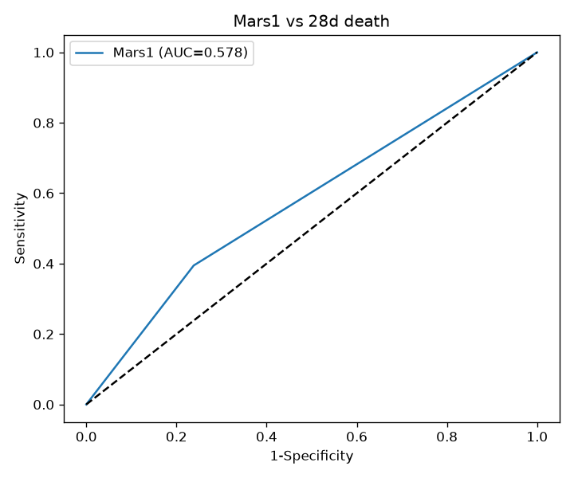
Fig. S1. ROC of 28-day mortality by the Mars1 binary indicator (AUC 0.578, discovery cohort).
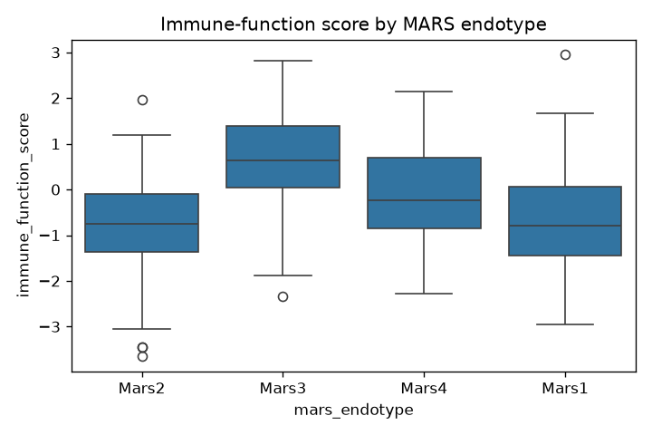
Fig. S2. Immune-function score by MARS endotype.
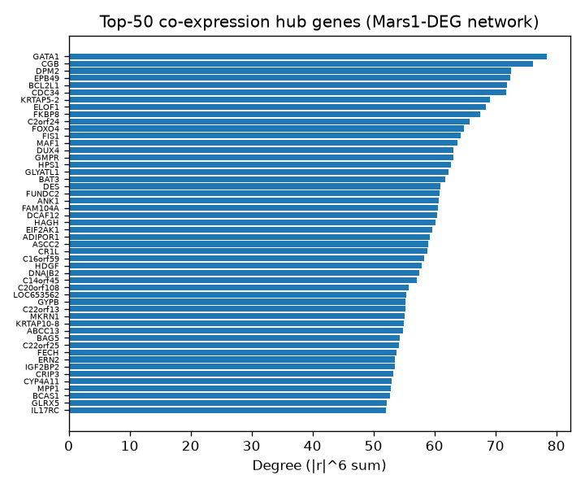
Fig. S3A. Hub genes (top-hub degree centrality).
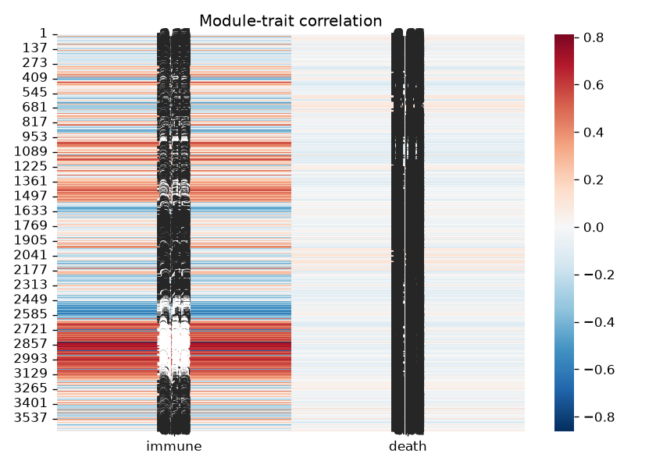
Fig. S3B. Eigengene-trait correlation.
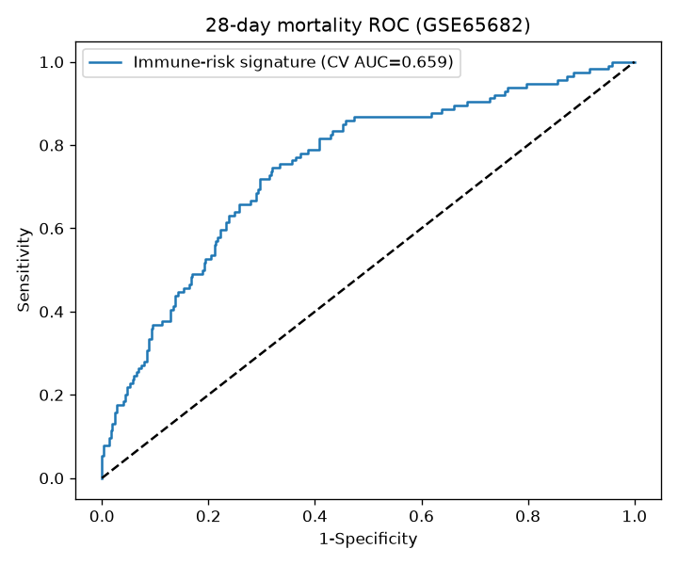
Fig. S6A. Cross-validated ROC.
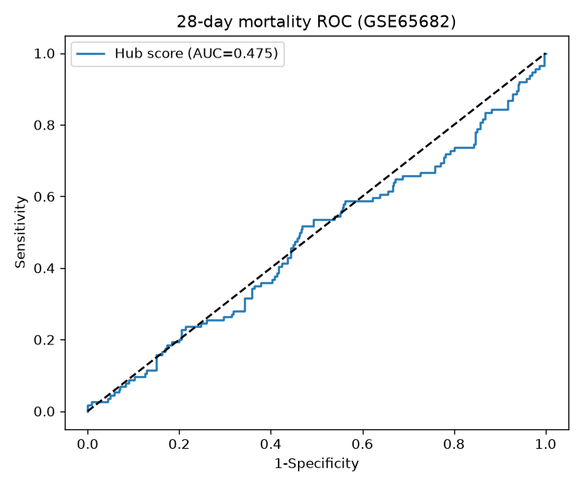
Fig. S6B. Training ROC.
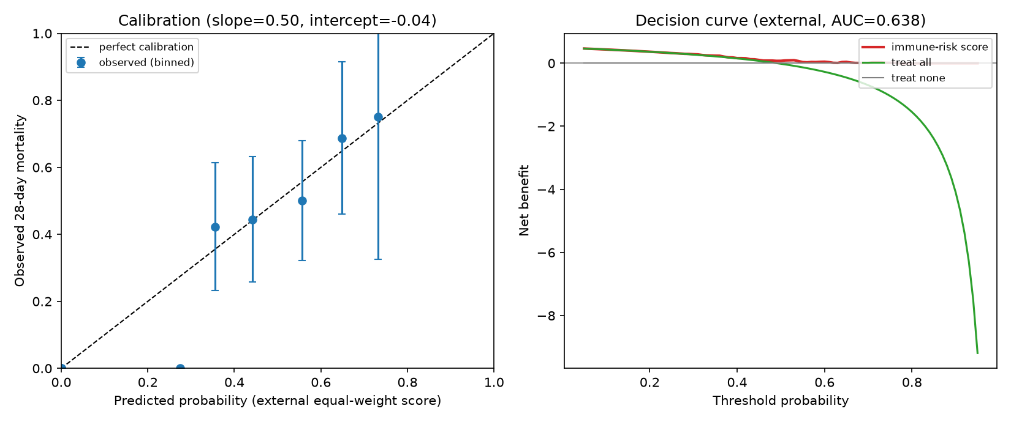
Fig. S6C. Decision-curve analysis (external equal-weight score).
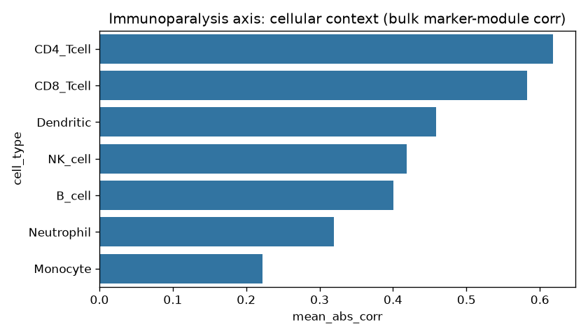
Fig. S7. Cellular context of hub genes (bulk surrogate deconvolution).
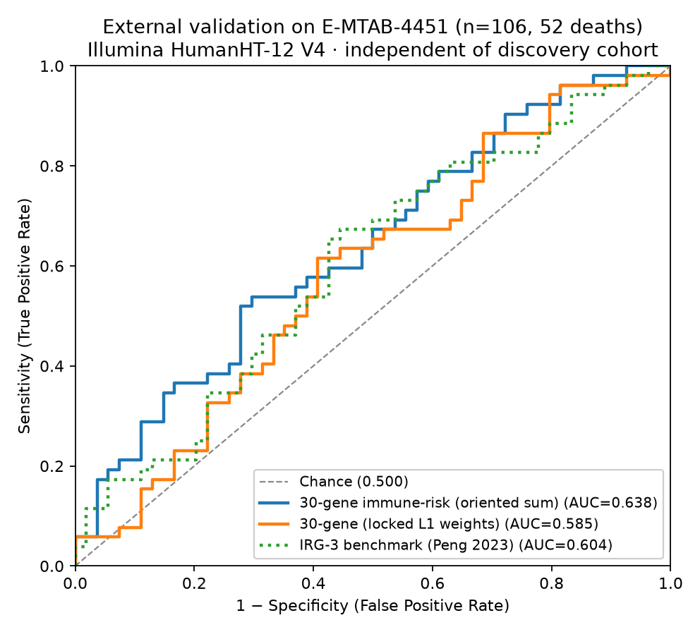
Fig. S9. ROC of the locked signature on E-MTAB-4451 (n=106).
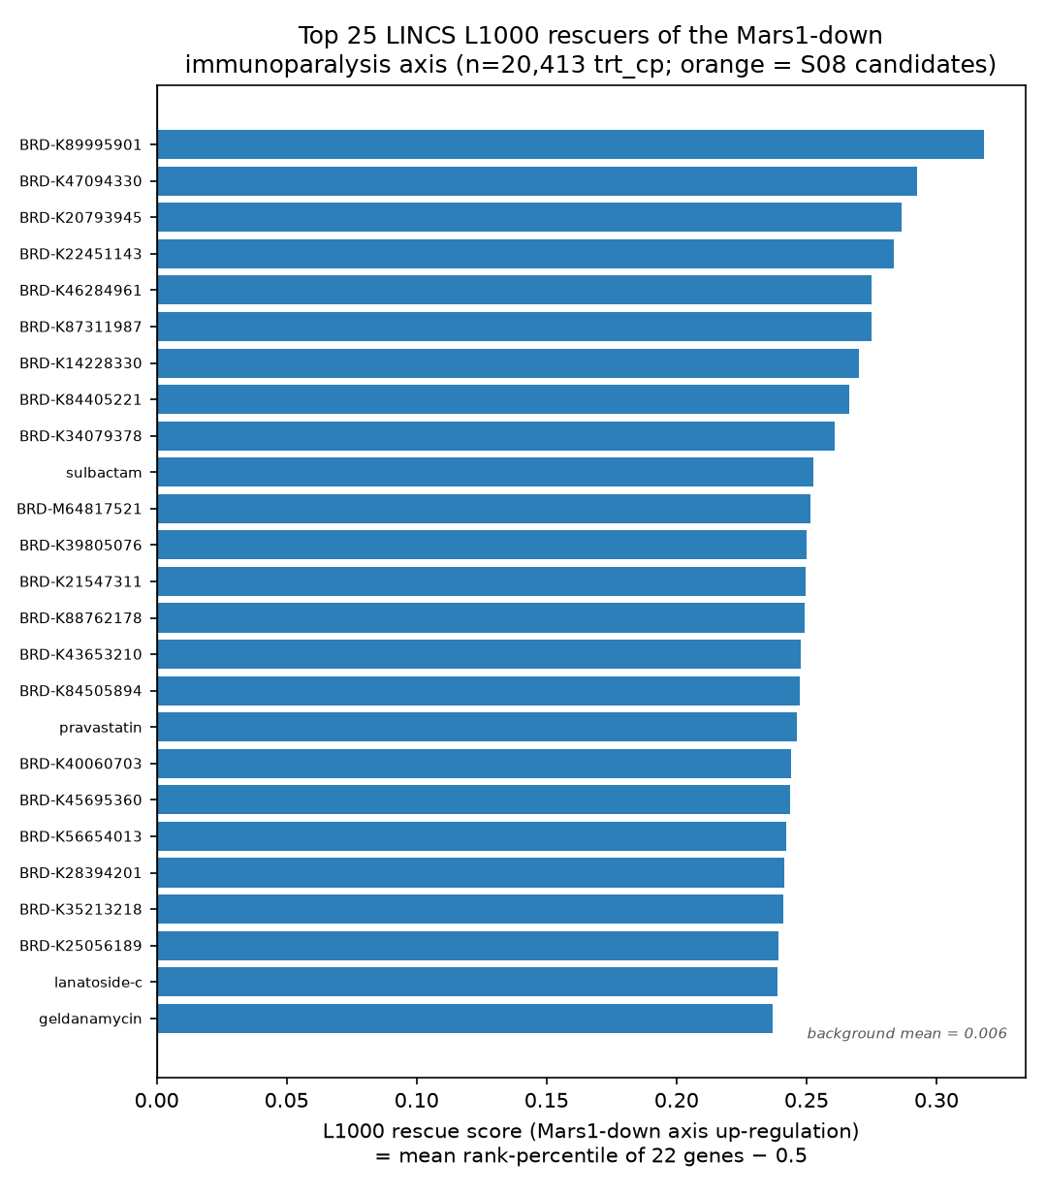
Fig. S10. Top LINCS L1000 rescuers of the Mars1-down axis and candidate markers.
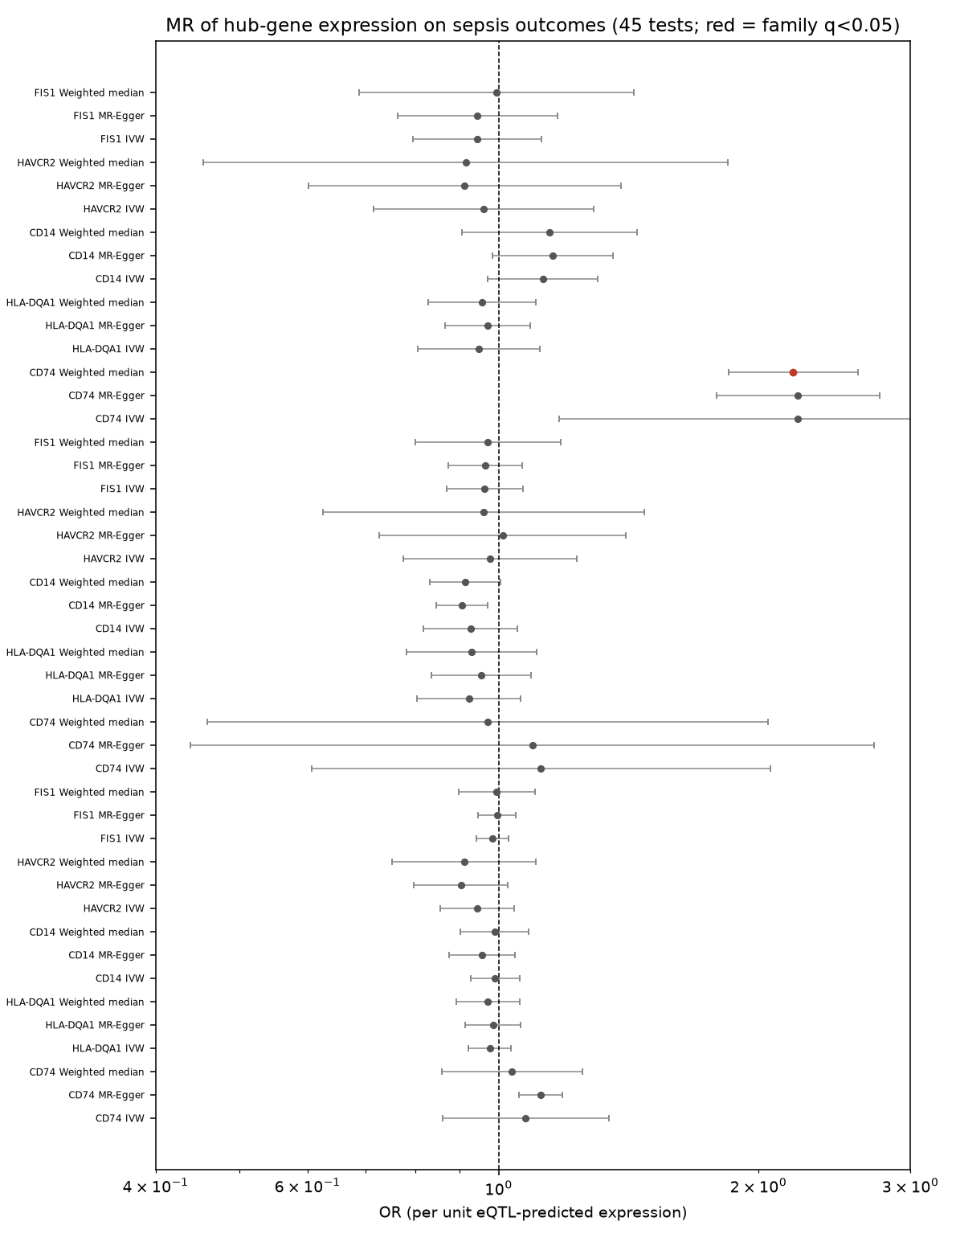
Fig. S11. 15-test Mendelian-randomisation forest (inverse-variance weighting).
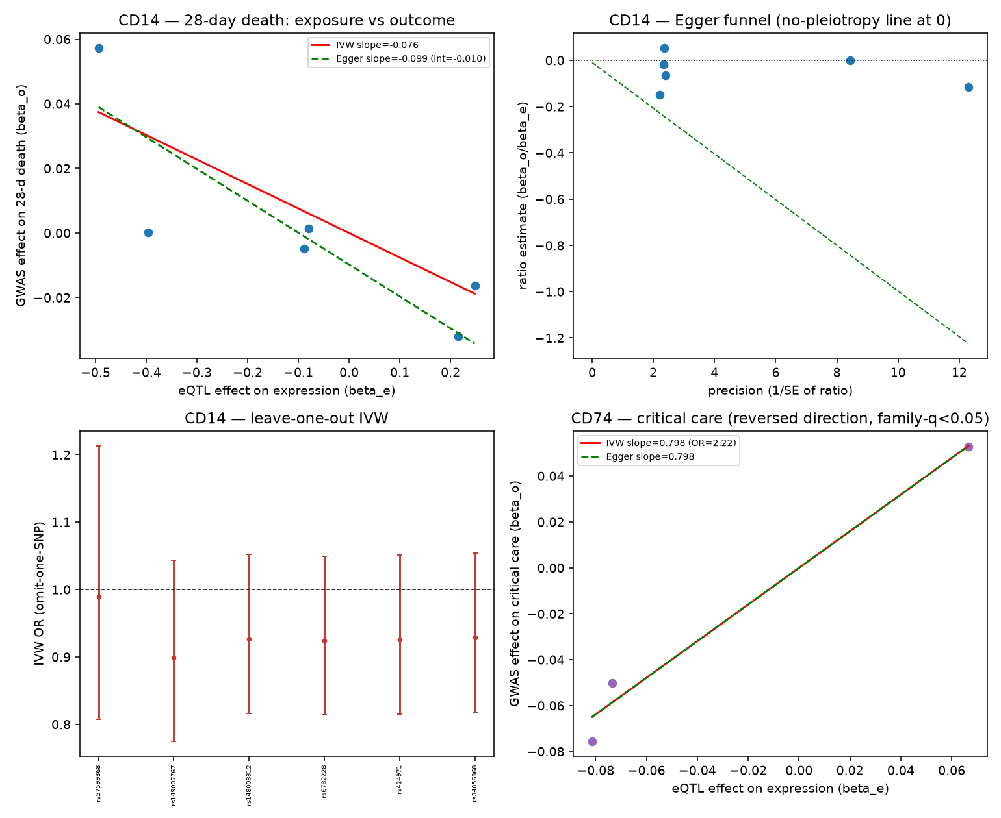
Fig. S12. MR diagnostic panels: CD14 28-day-death scatter with IVW/Egger fits, Egger funnel, leave-one-out, and CD74 critical-care scatter.

