Supplementary Information
This document contains supplementary figures and tables accompanying the manuscript:
"Single-Cell Transcriptomic Analysis of Sleep Deprivation Reveals Pomc as a Central Regulatory Hub and Predicts Downstream Transcriptional Consequences of Its Loss"

Supplementary Figures
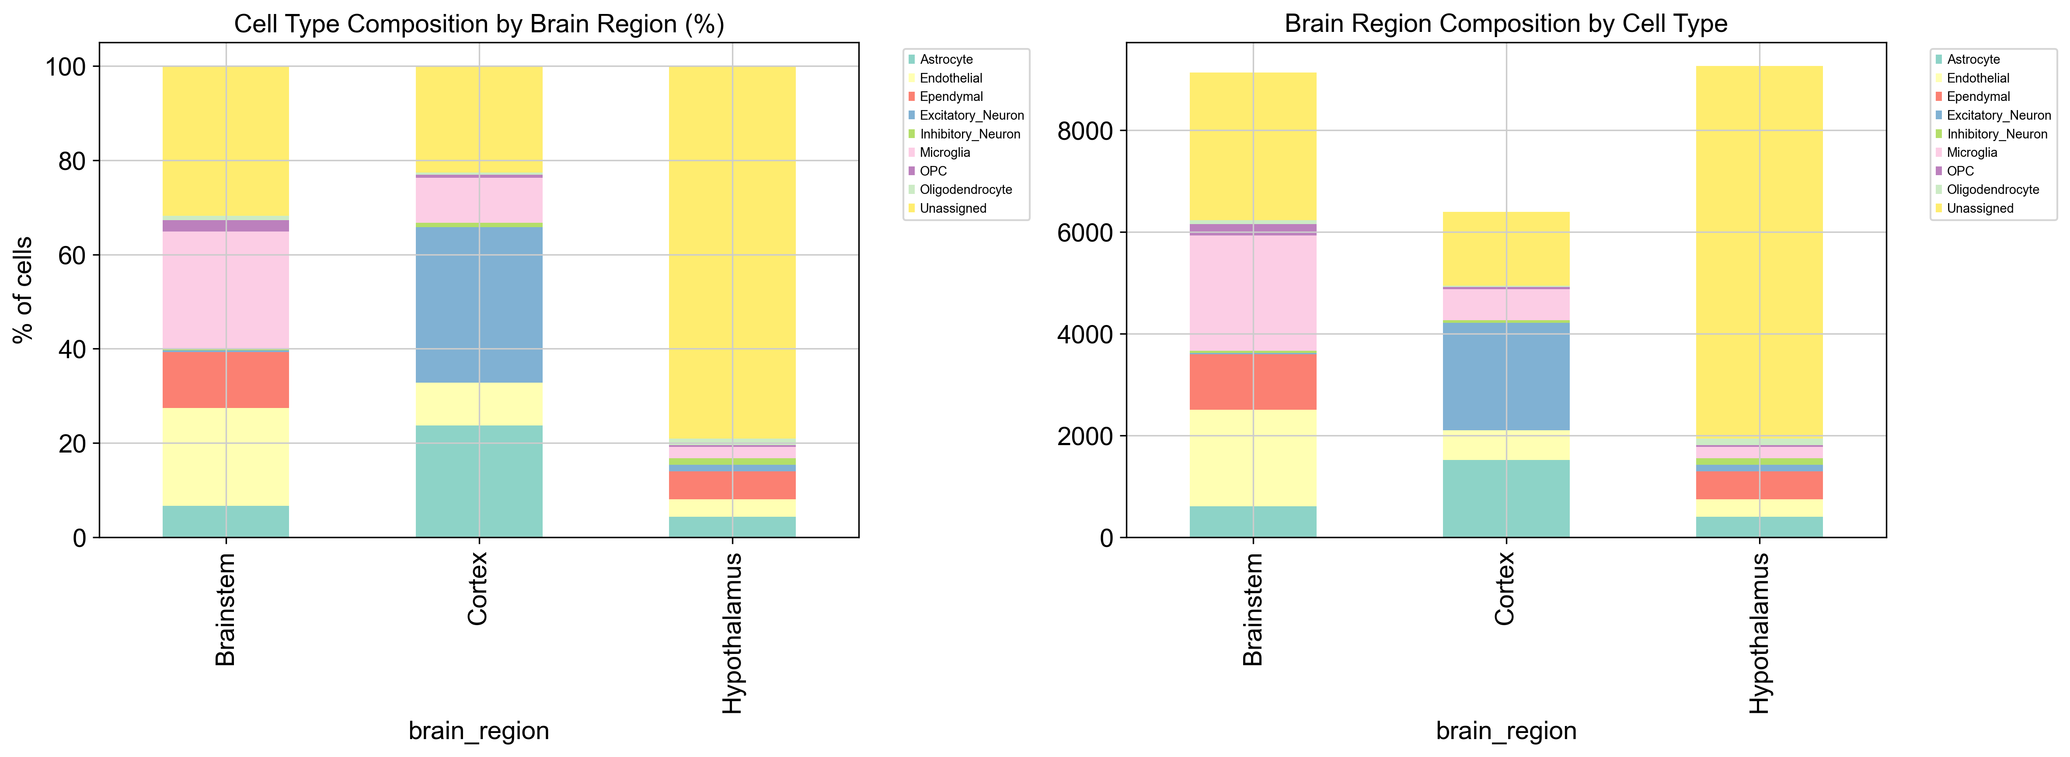
Figure S1. Cell type composition across brain regions and conditions.
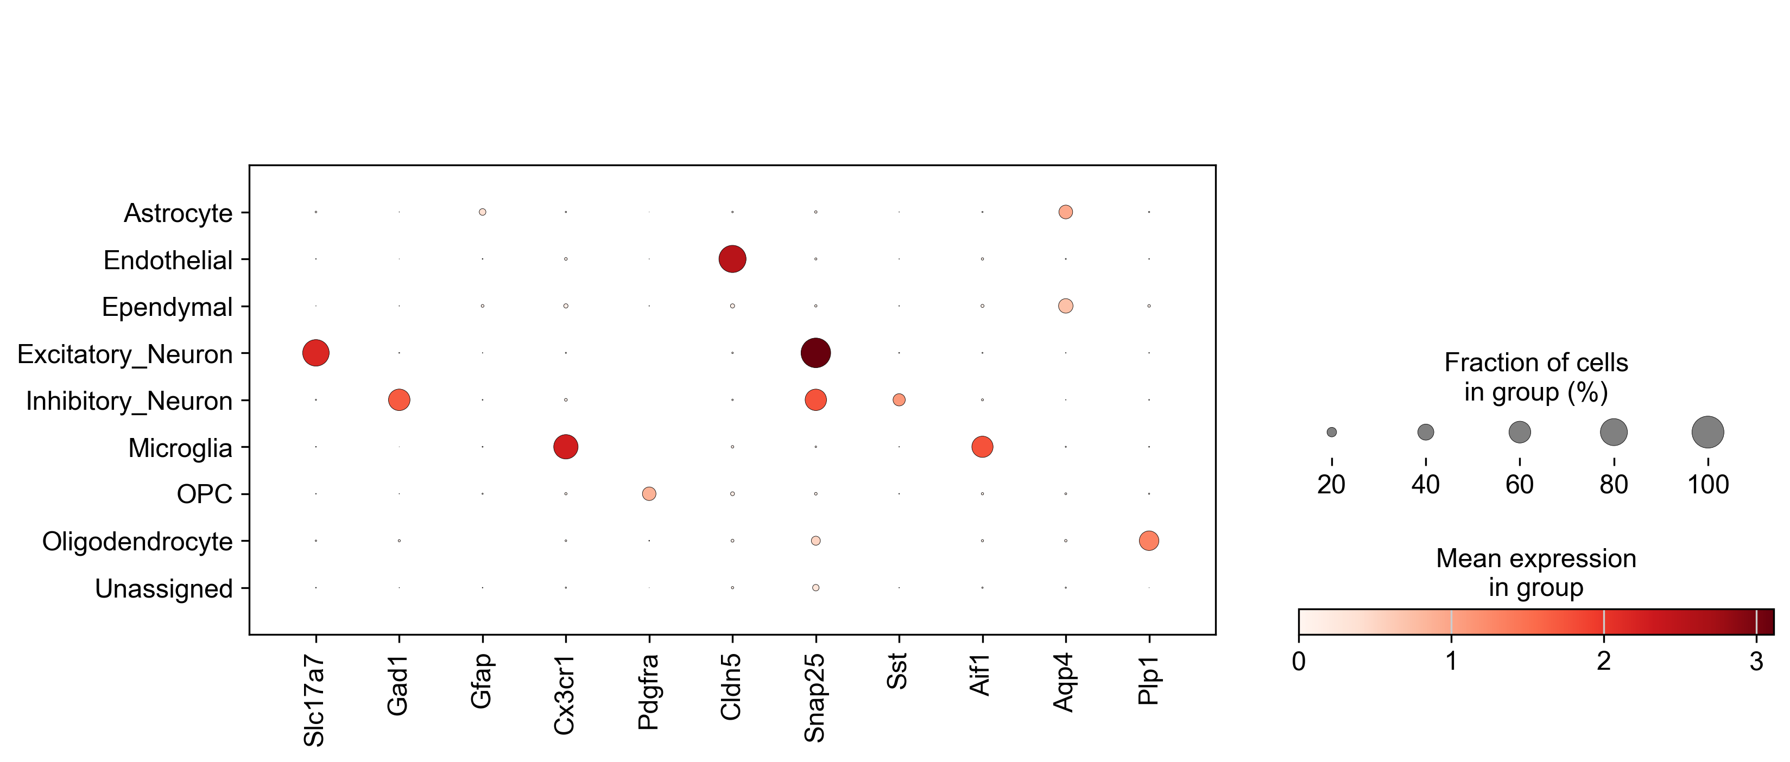
Figure S2. Marker gene dotplot for cell type annotation.
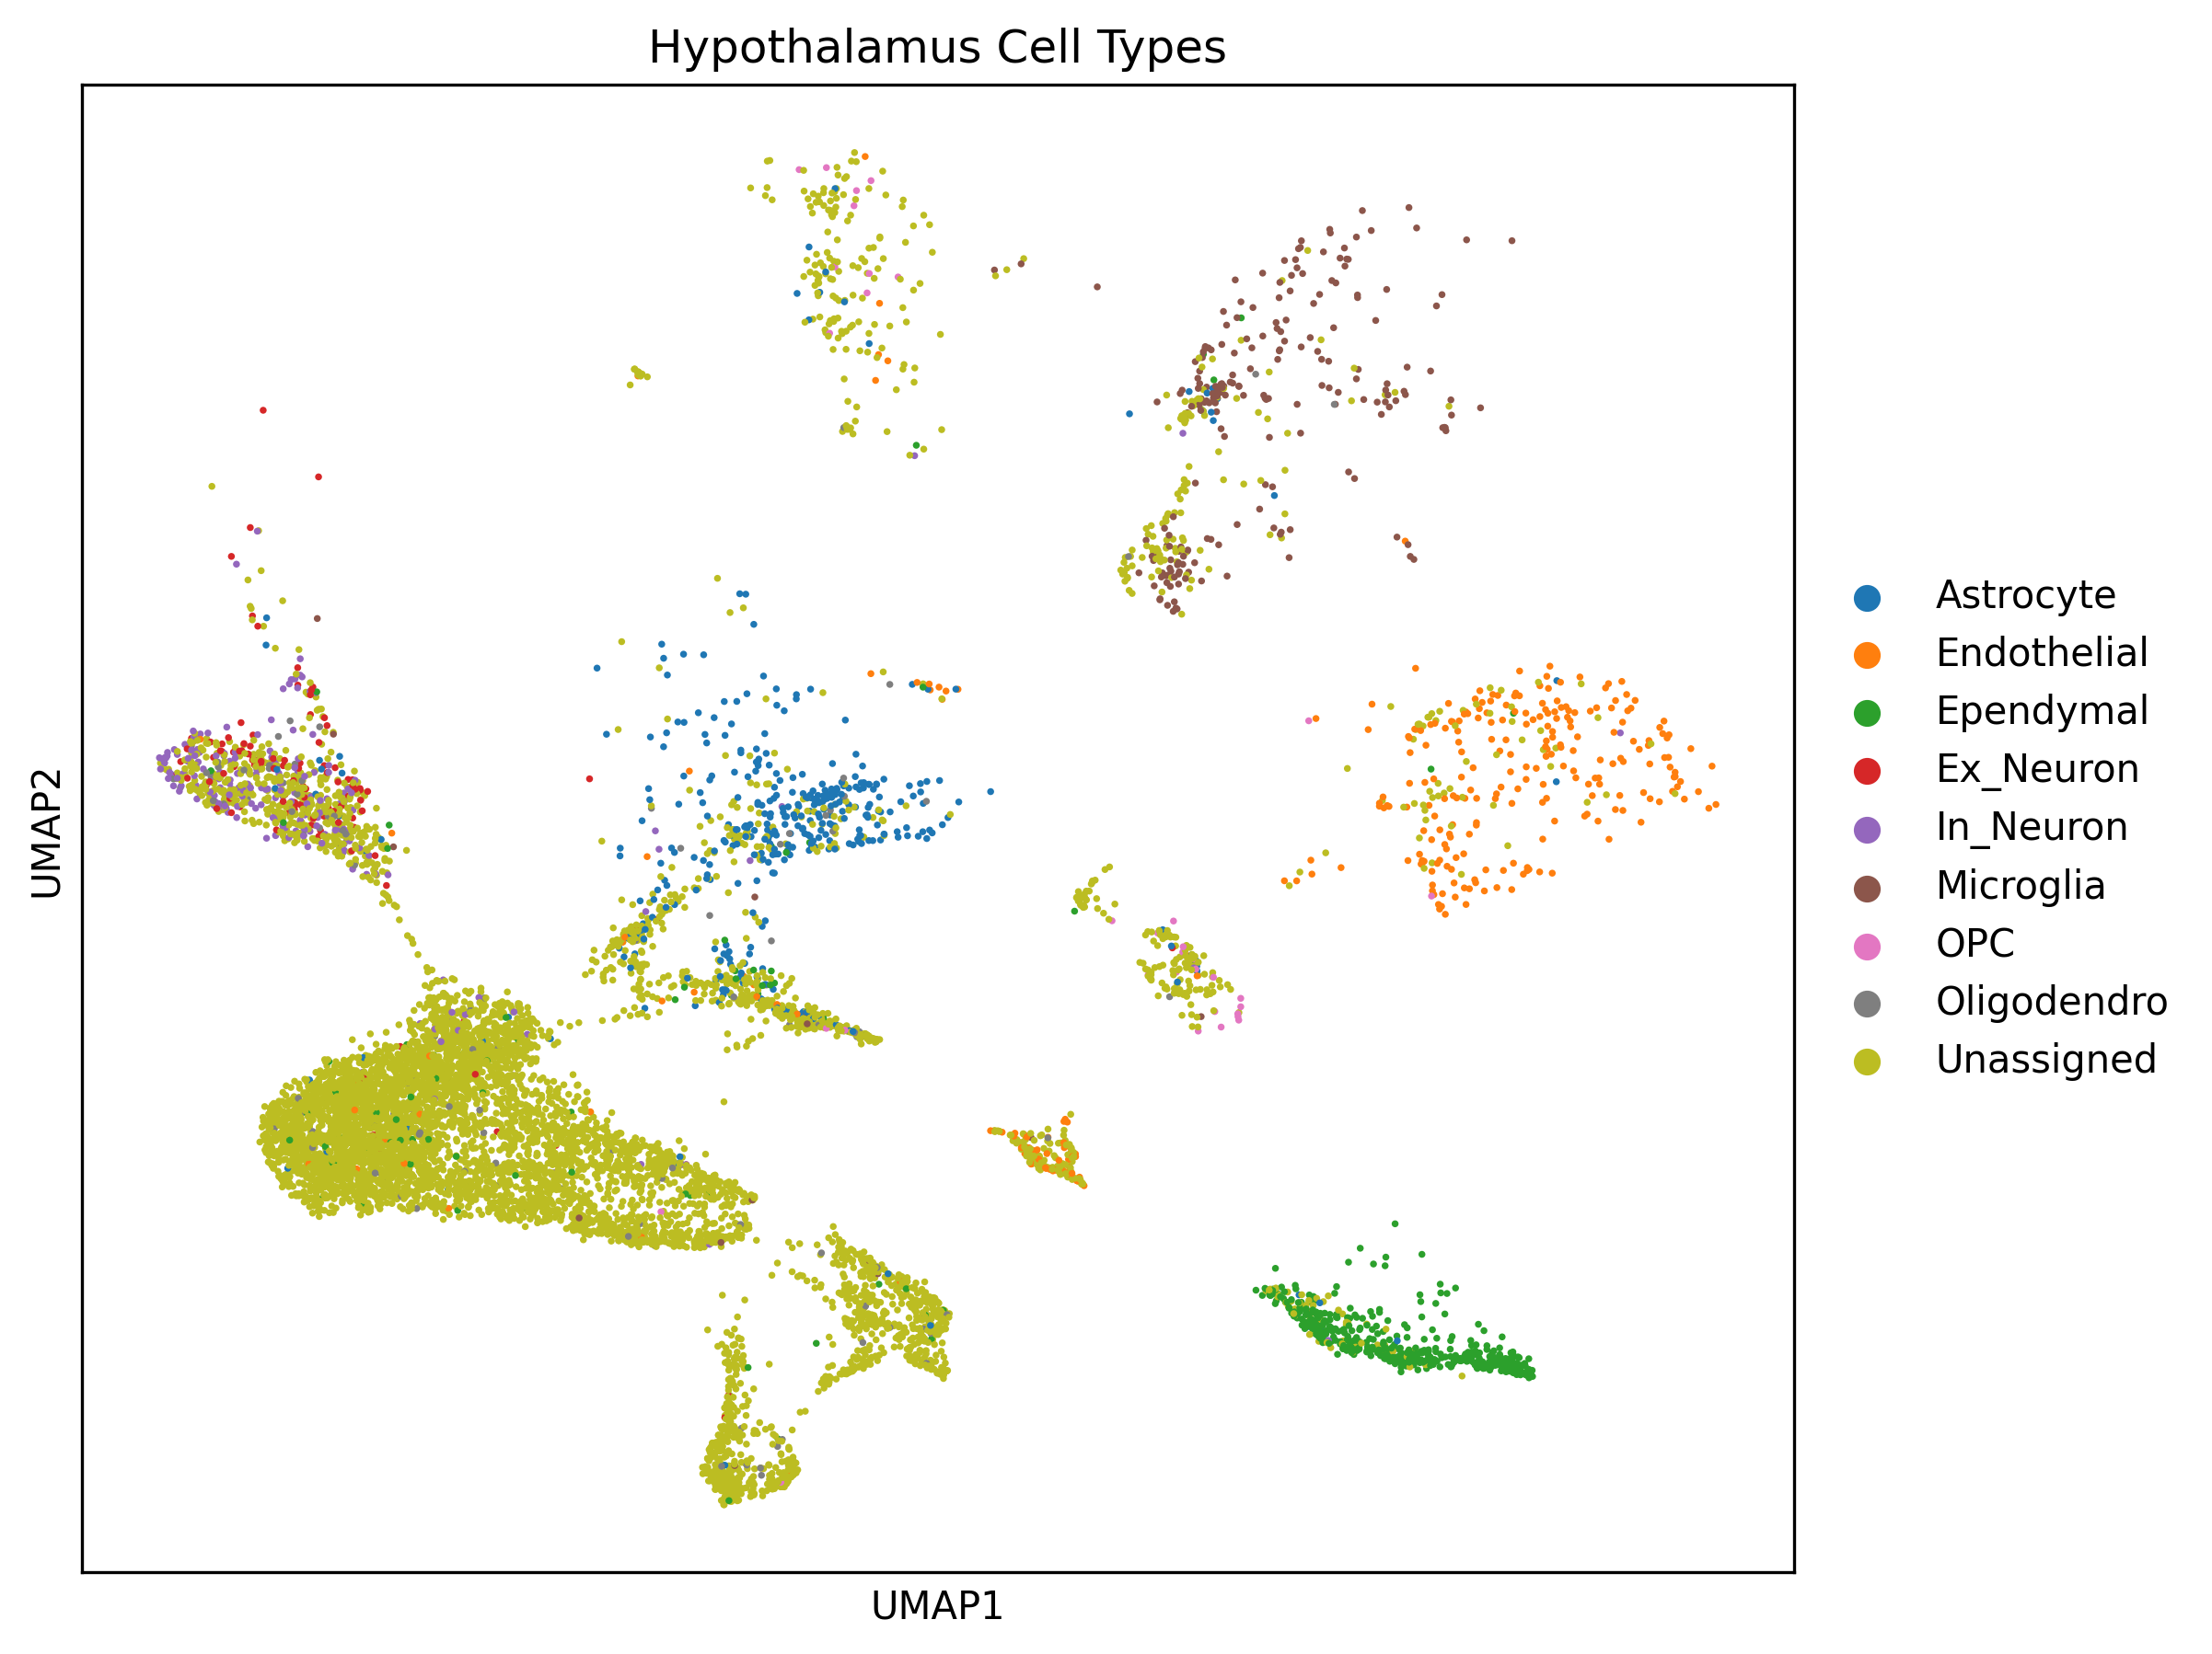
Figure S3. Hypothalamus UMAP with cluster annotations.
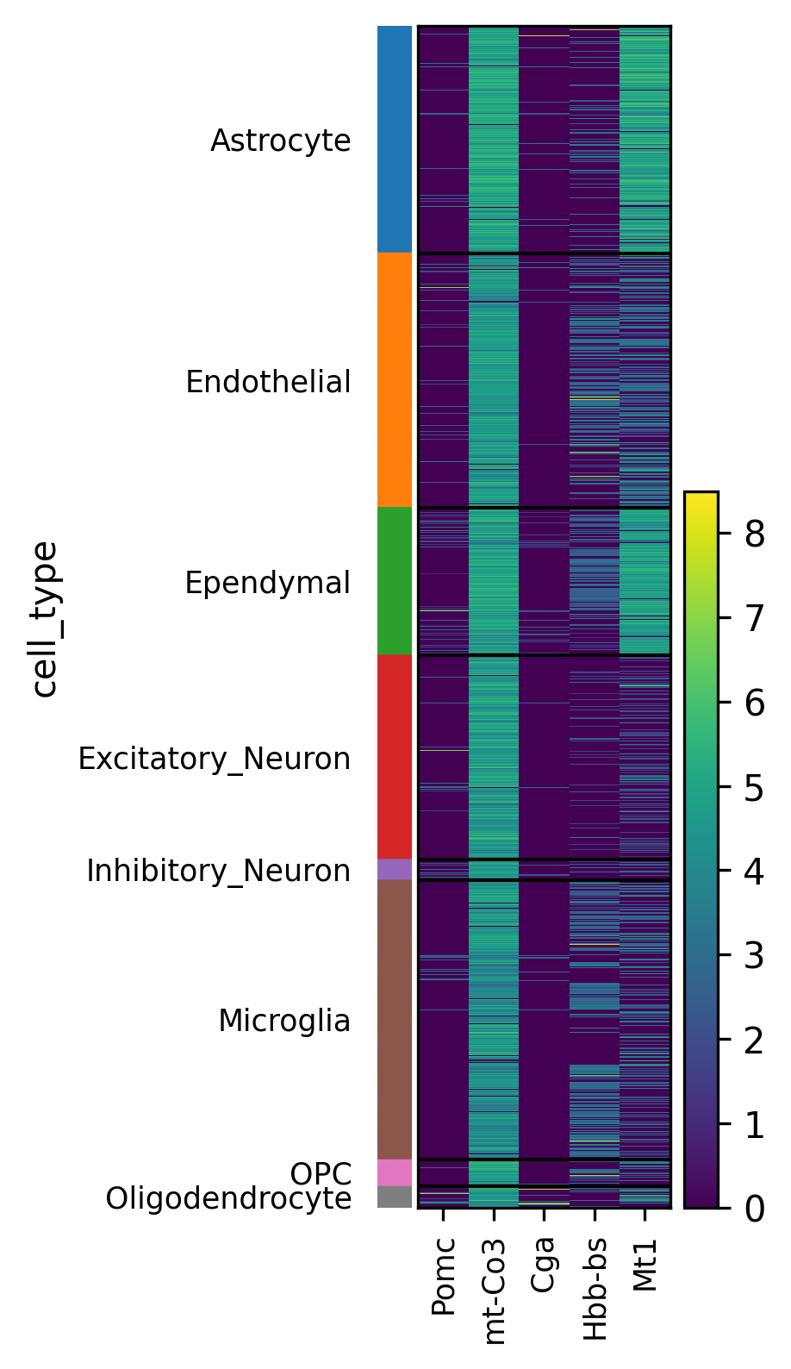
Figure S4. Heatmap of top DEGs across all brain regions and conditions.
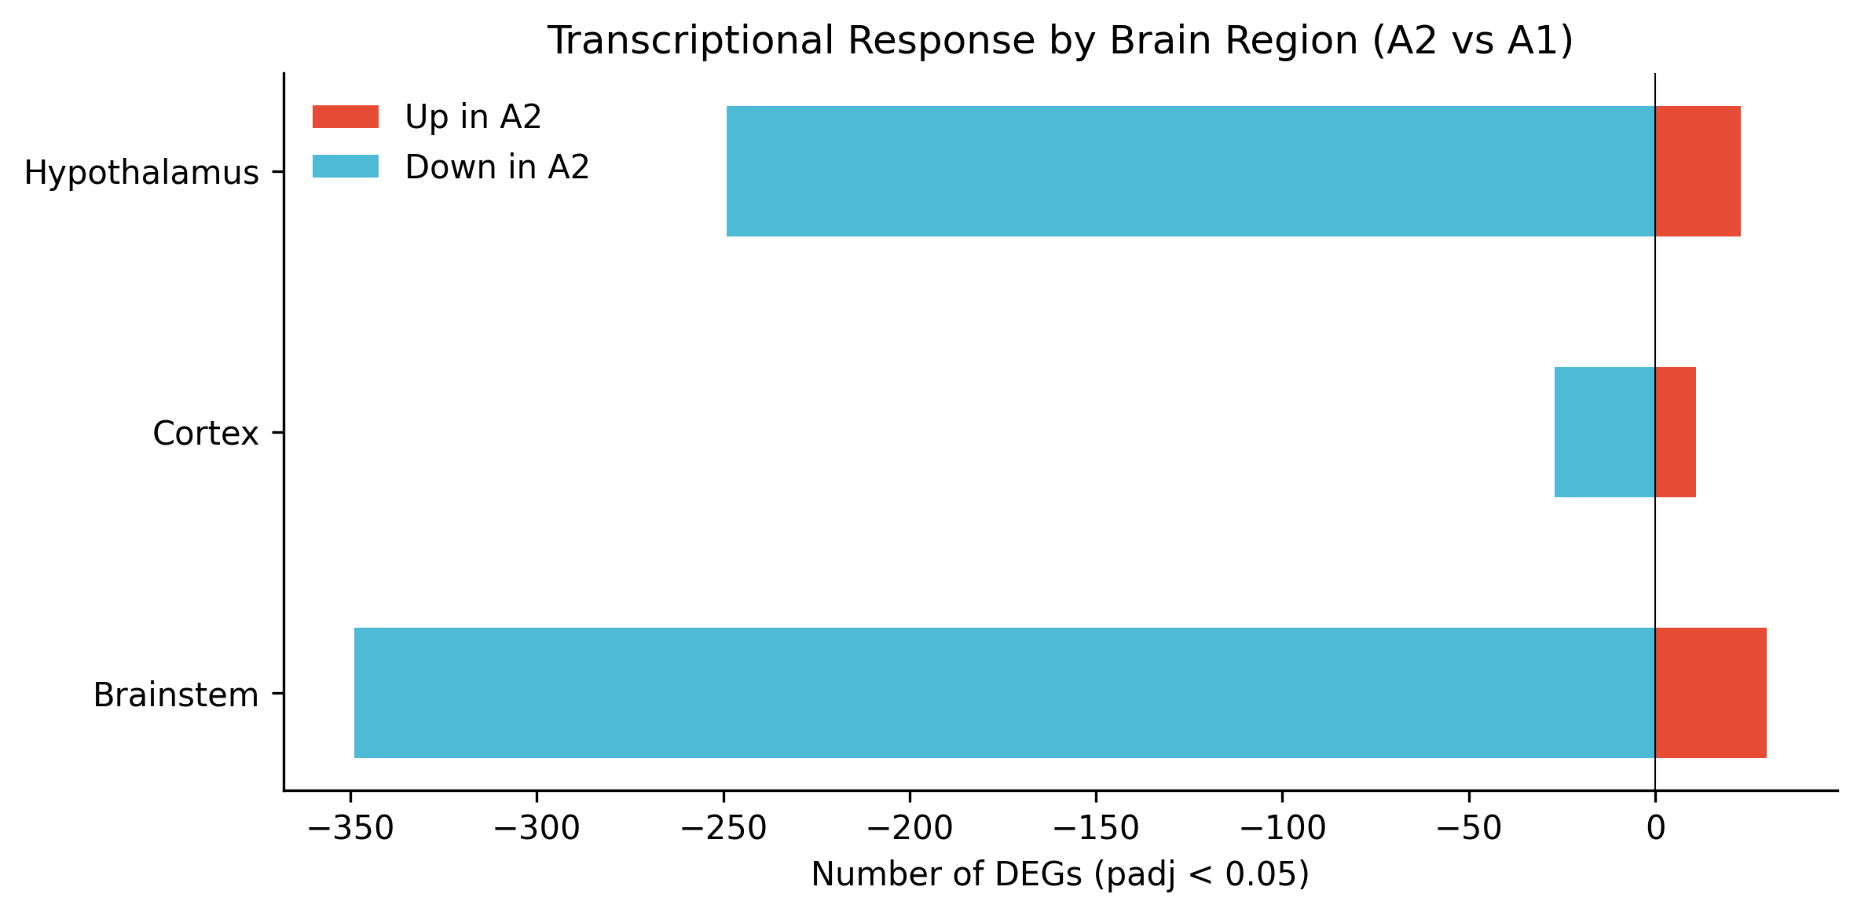
Figure S5. Differential expression response comparison by brain region.
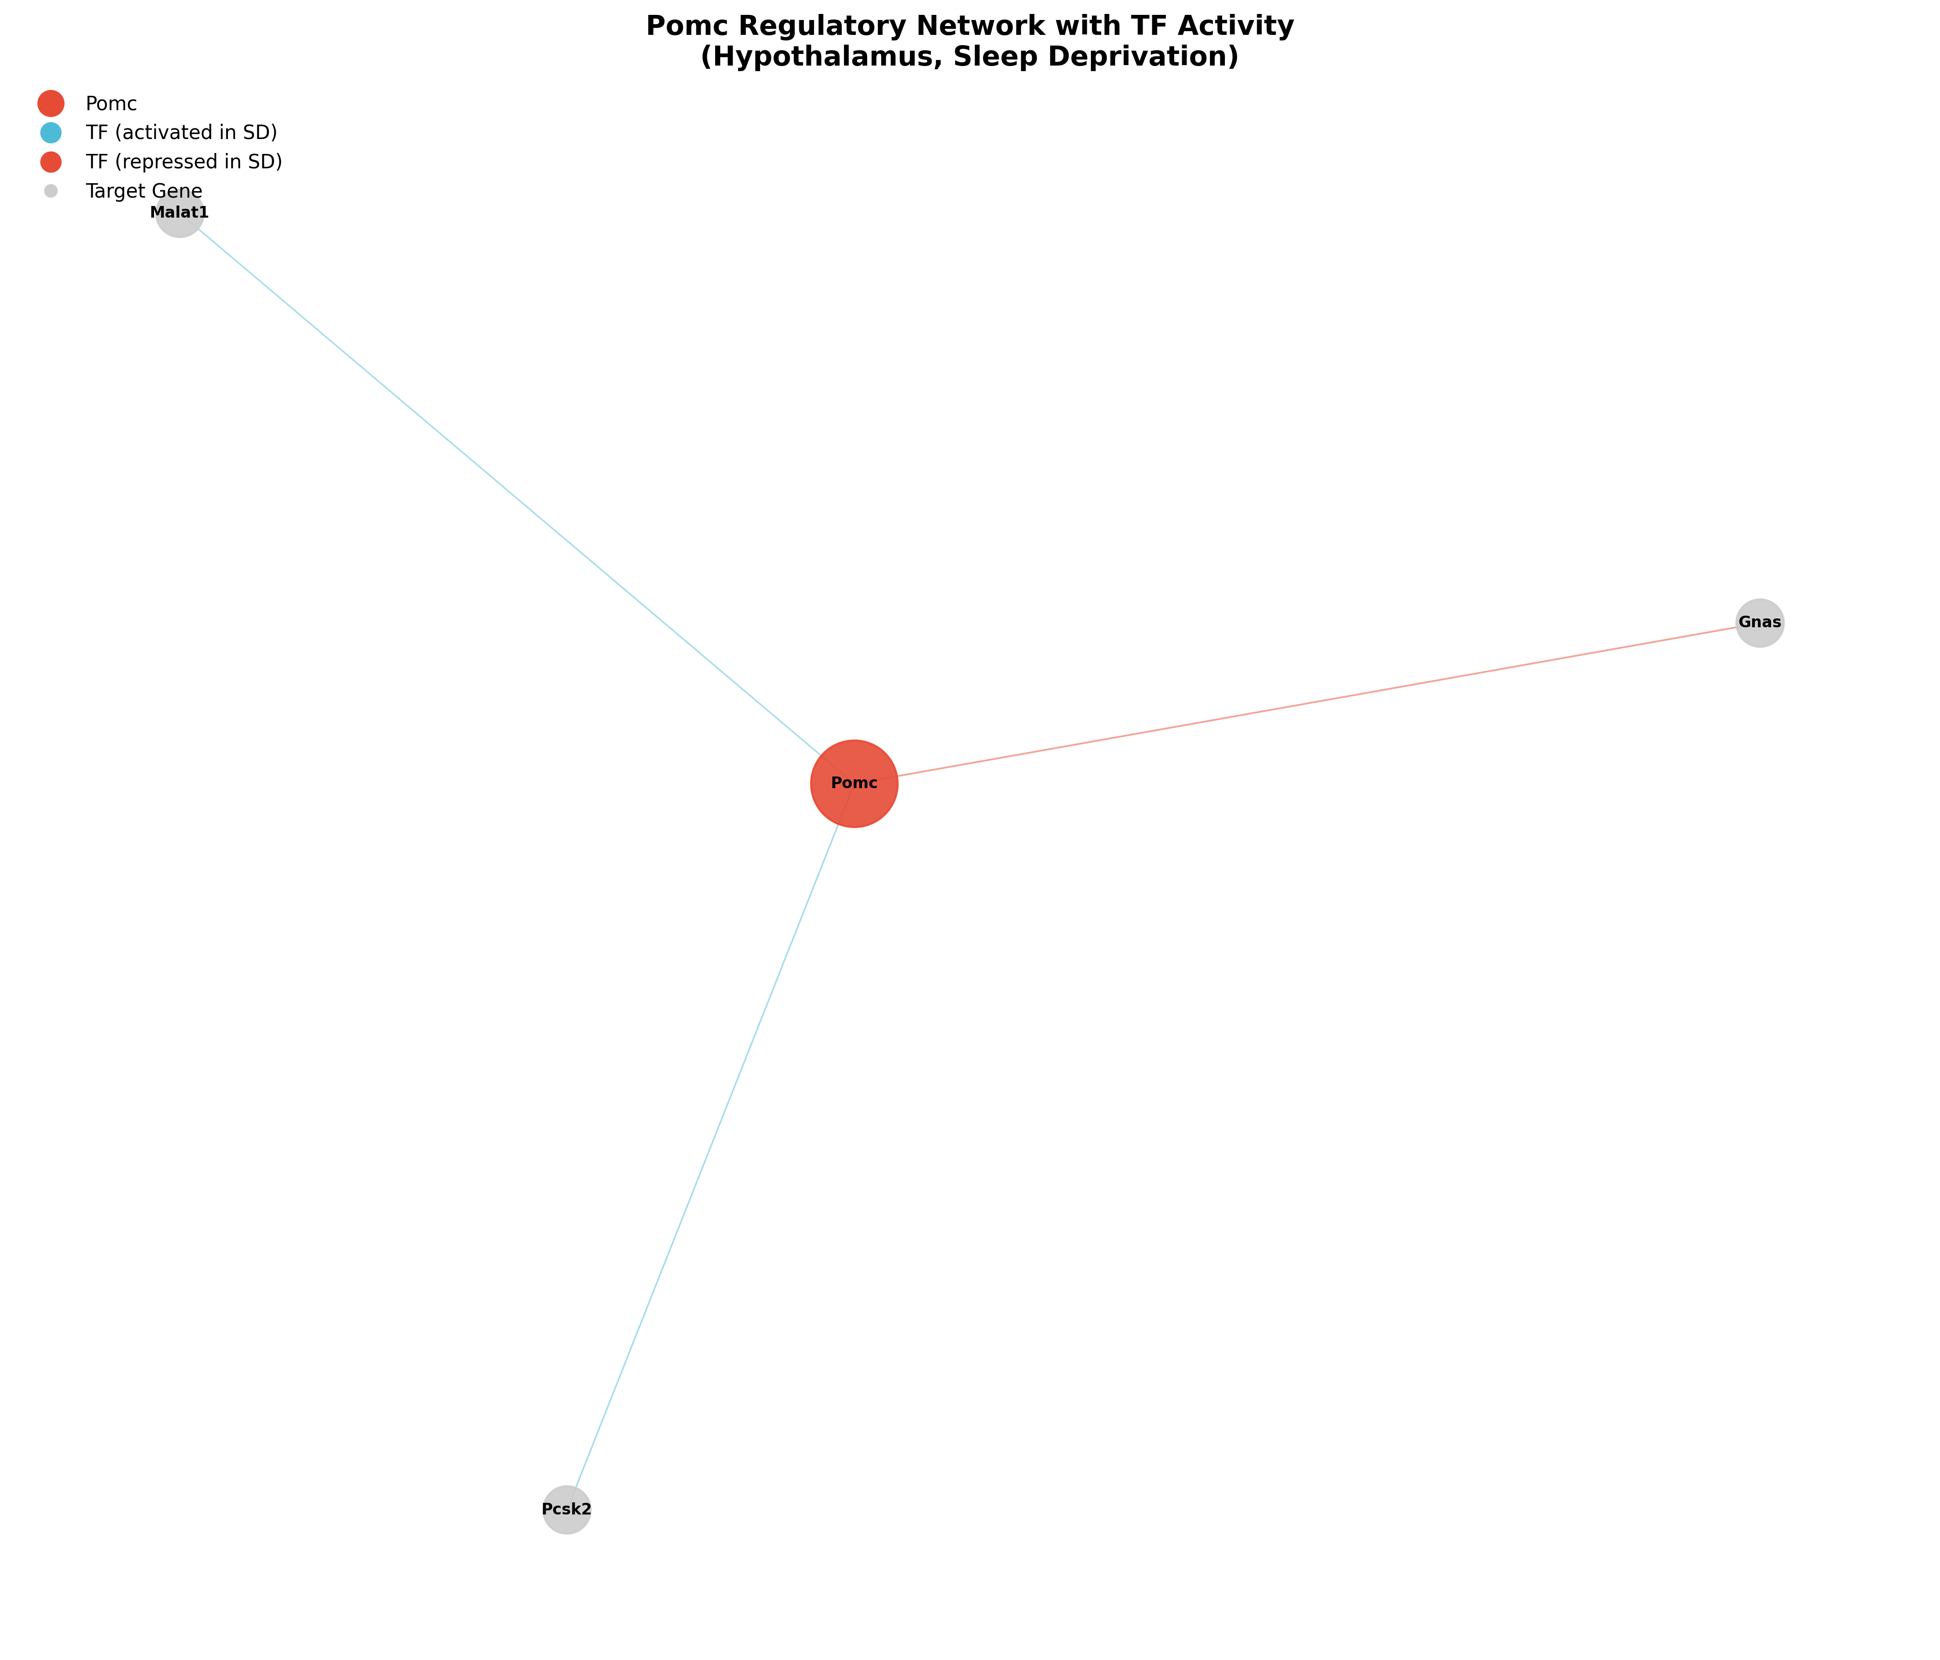
Figure S6. TF activity regulatory network around Pomc.
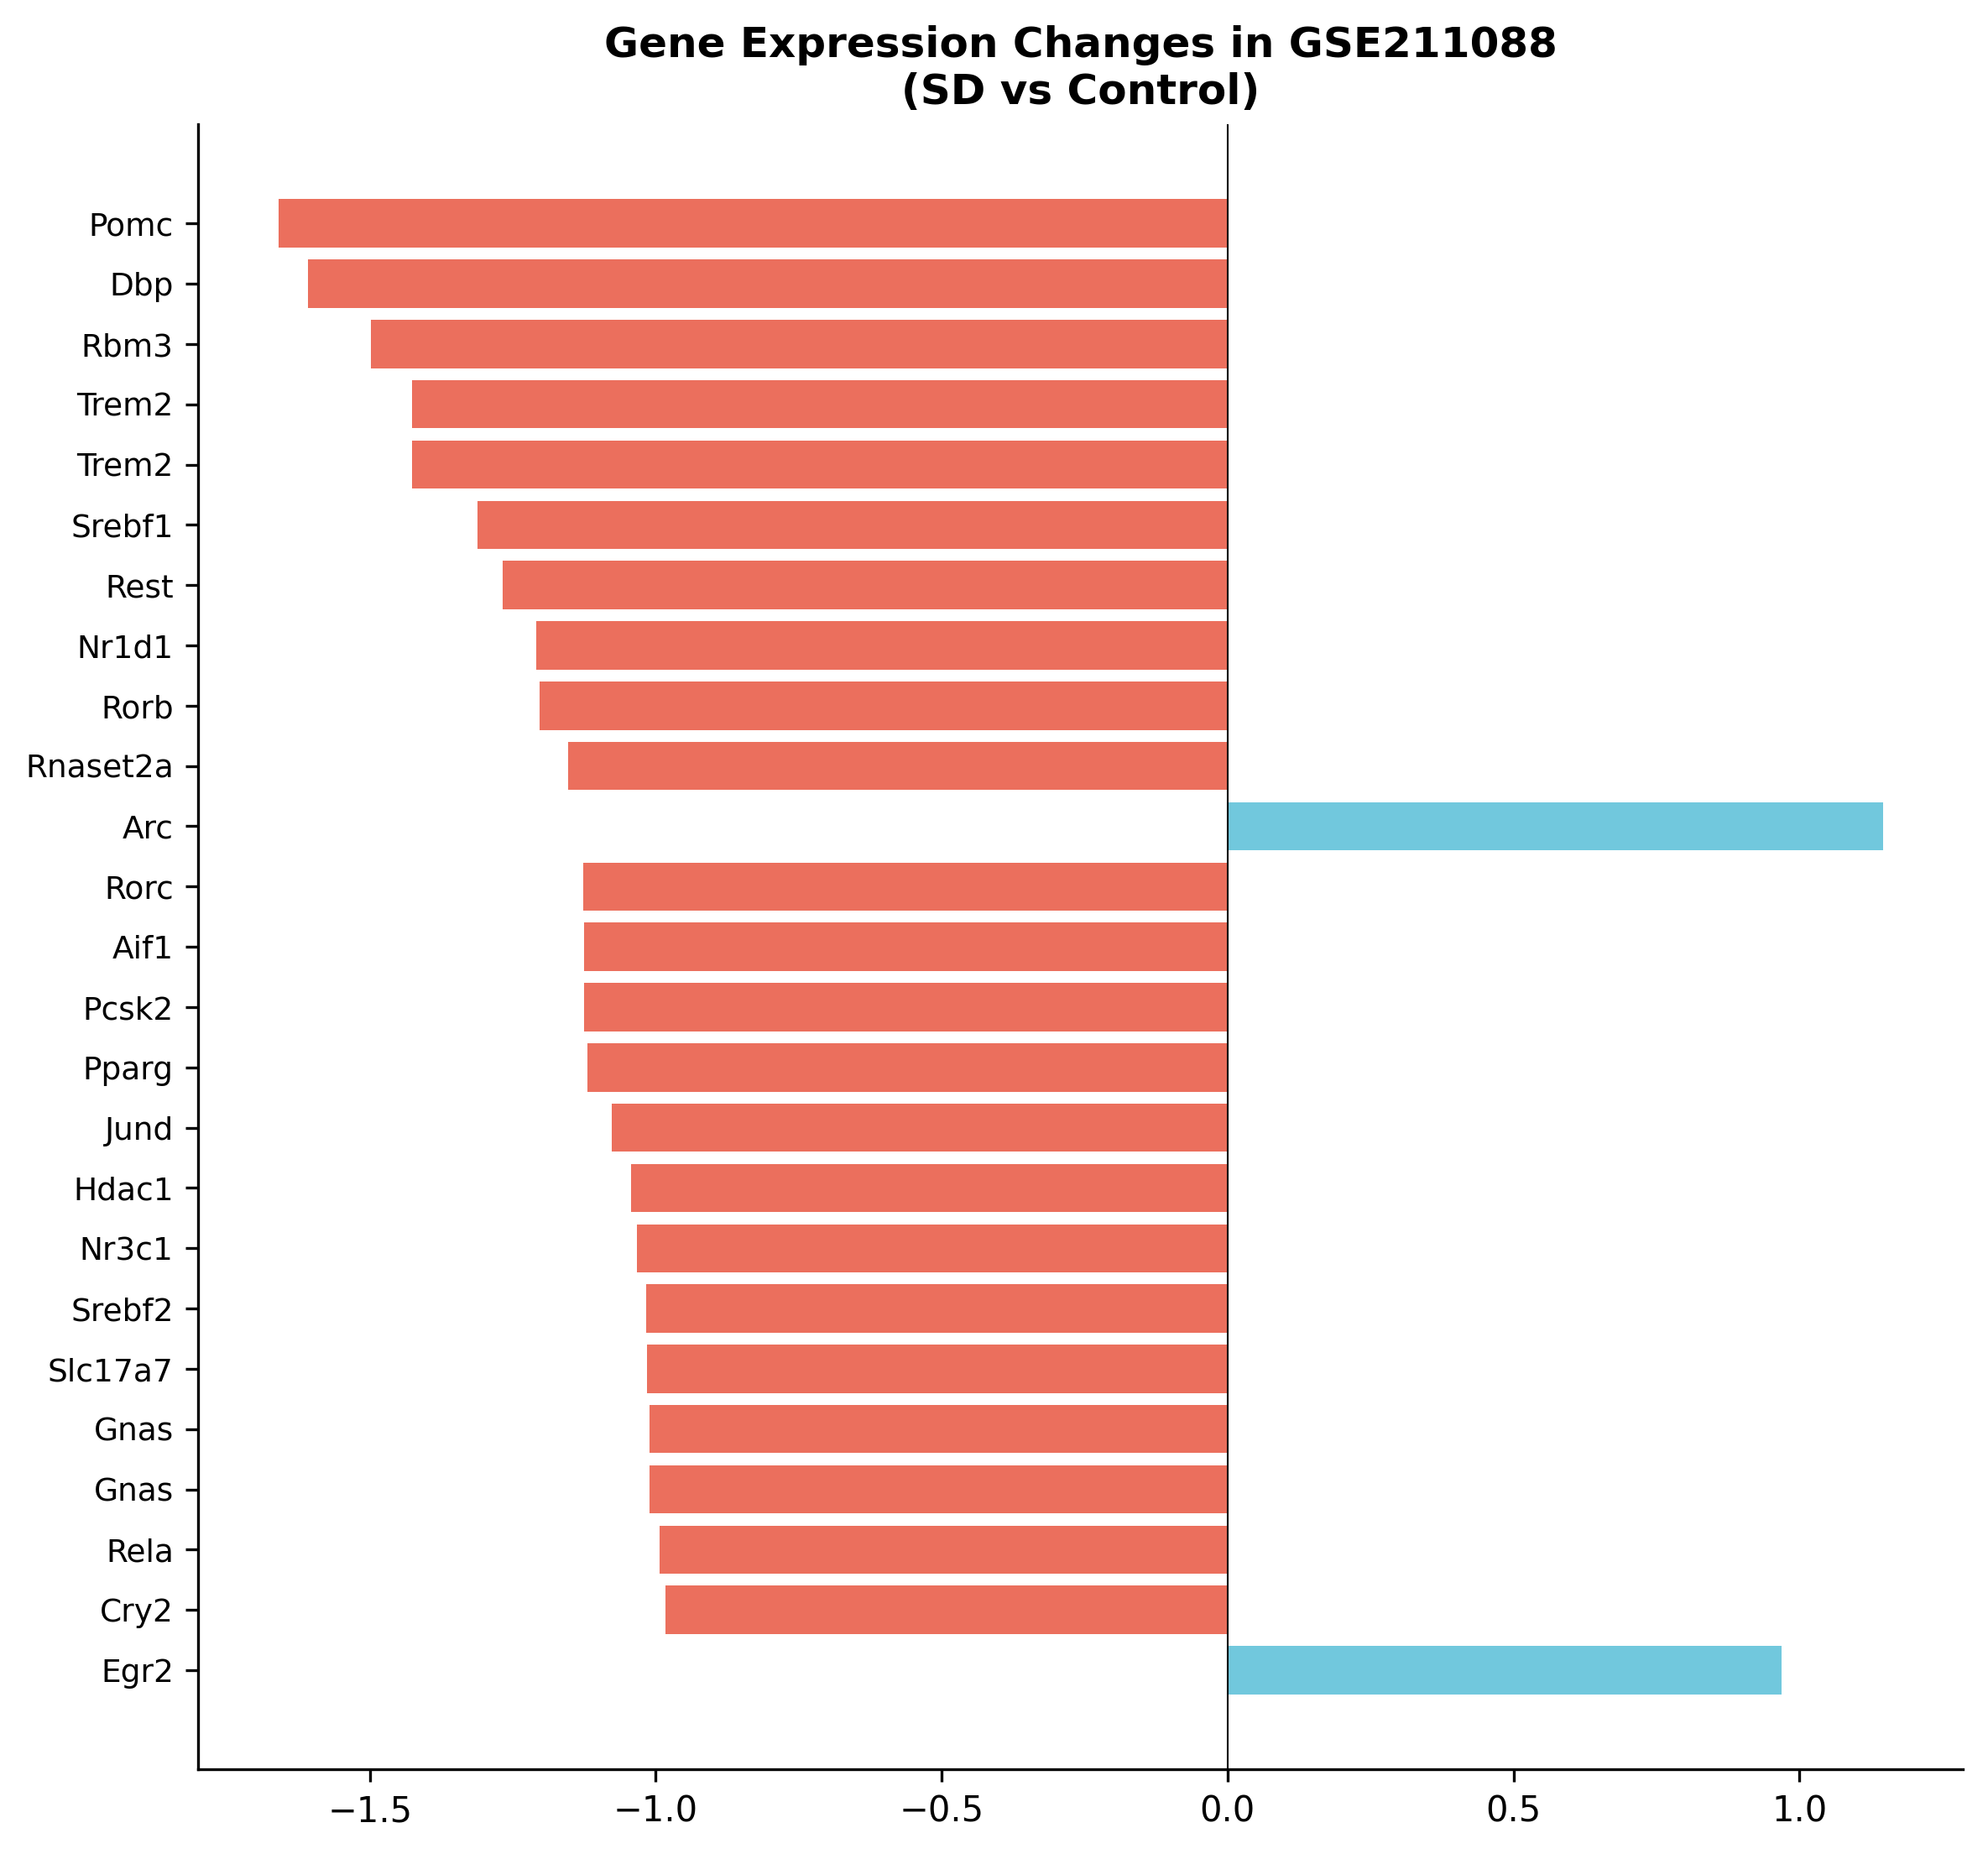
Figure S7. Key gene expression in GSE211088 validation dataset.
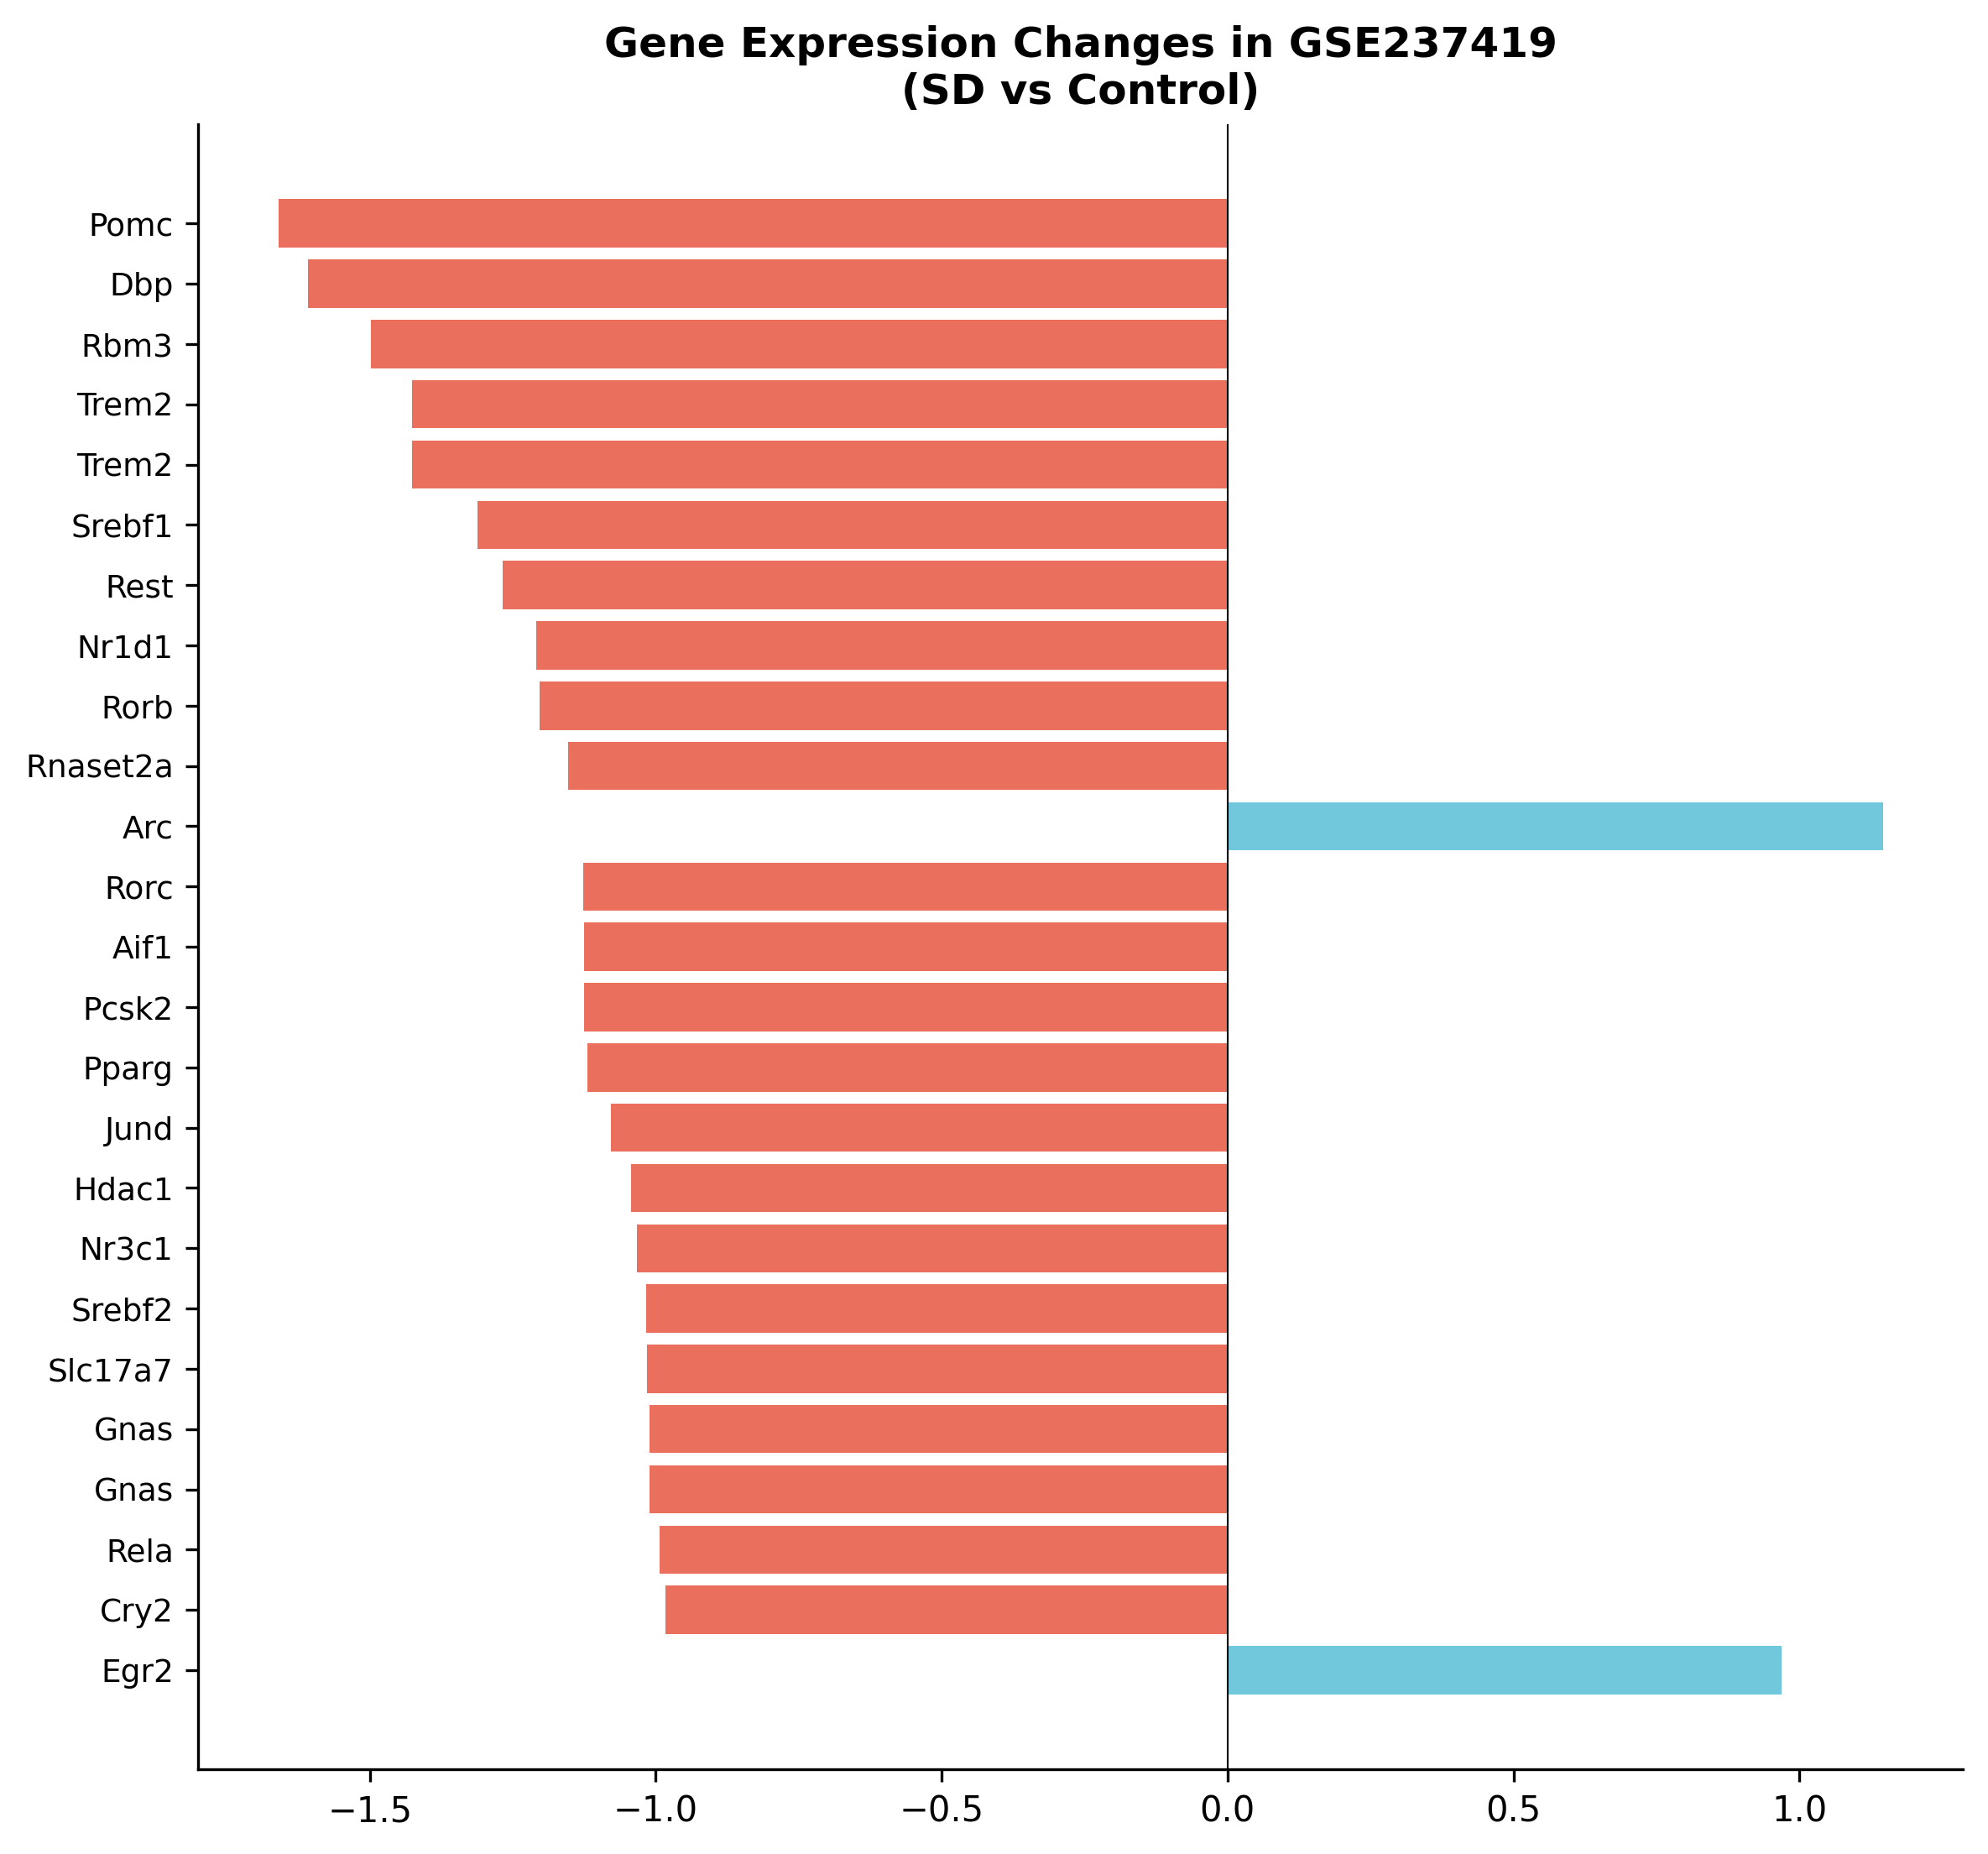
Figure S8. Key gene expression in GSE237419 validation dataset.
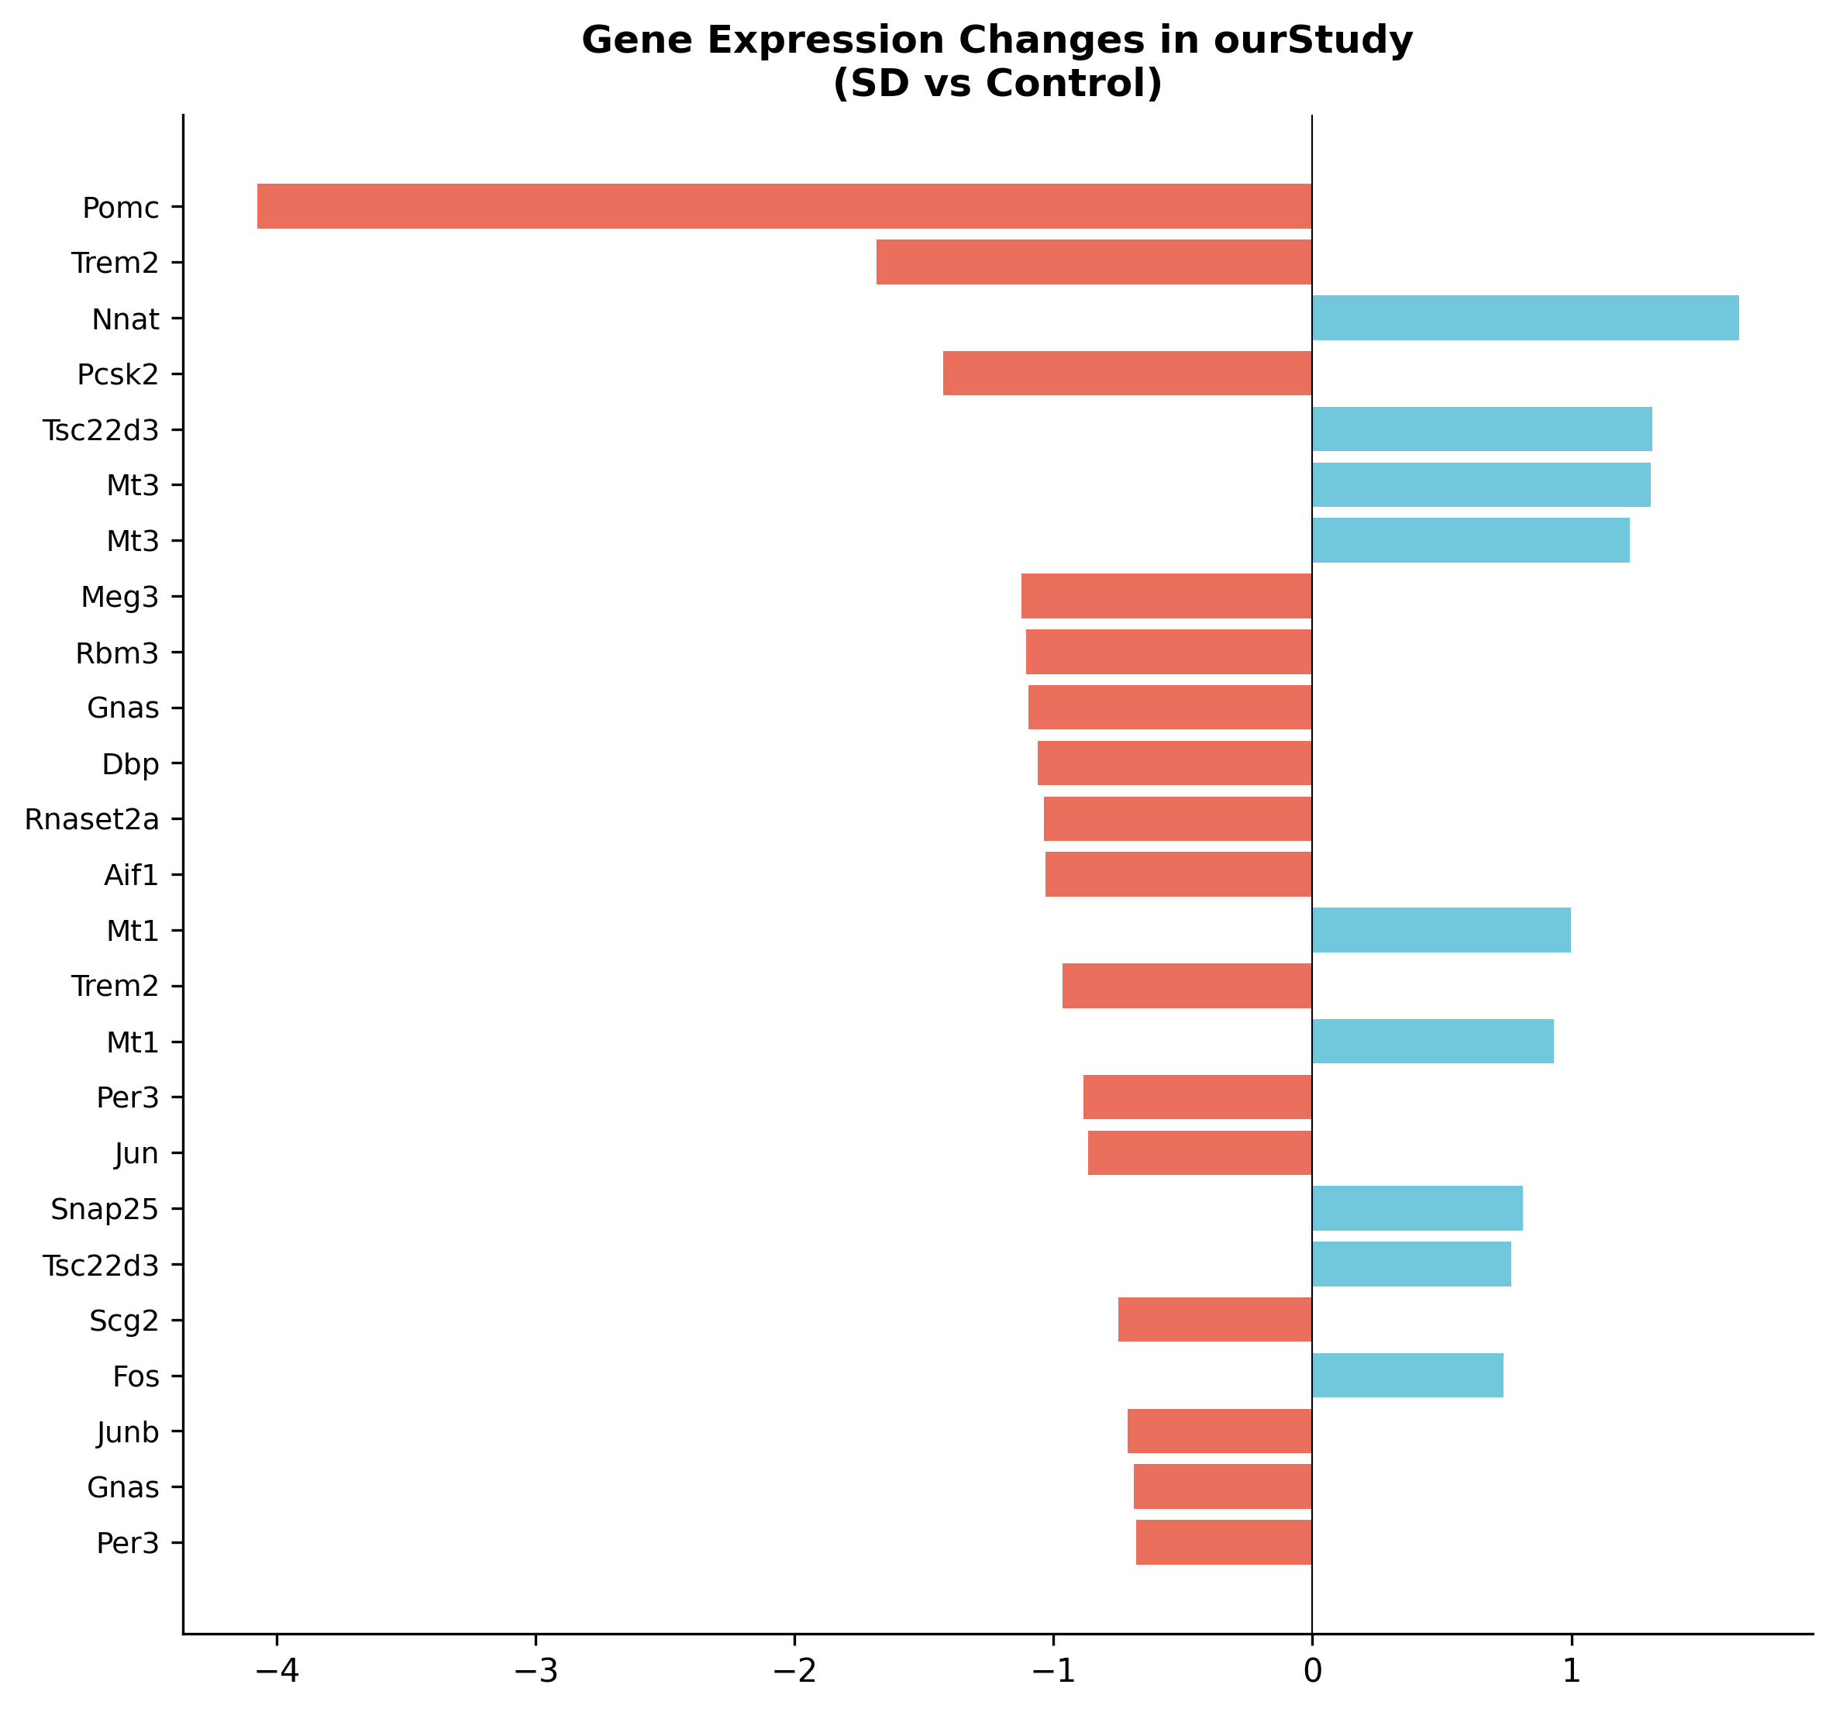
Figure S9. Key gene expression in our study (GSE137665 hypothalamus).

Supplementary Tables
Tables S1-S13 are also provided as machine-readable CSV files in the supplementary_tables/ folder.
Table S1. Top 10 differentially expressed genes: Hypothalamus (A2 vs A1).
names | scores | logfoldchanges | pvals | pvals_adj | brain_region
Pomc | -27.11 | -4.075 | 6.926e-162 | 1.289e-157 | Hypothalamus
Malat1 | -14.81 | -0.5278 | 1.339e-49 | 1.246e-45 | Hypothalamus
Cga | -14.63 | -1.958 | 1.877e-48 | 1.165e-44 | Hypothalamus
Meg3 | -14.04 | -1.123 | 9.085e-45 | 4.227e-41 | Hypothalamus
Gnas | -13.74 | -1.098 | 6.14e-43 | 2.286e-39 | Hypothalamus
Apoe | 12.46 | 1.287 | 1.272e-35 | 3.946e-32 | Hypothalamus
Mt1 | 10.94 | 0.9322 | 7.603e-28 | 2.022e-24 | Hypothalamus
mt-Atp6 | 10.62 | 0.3154 | 2.41e-26 | 5.606e-23 | Hypothalamus
Ccnd2 | -10.58 | -1.176 | 3.535e-26 | 7.311e-23 | Hypothalamus
Atp5e | -10.51 | -0.9984 | 7.503e-26 | 1.397e-22 | Hypothalamus

Table S2. Top 10 differentially expressed genes: Brainstem (A2 vs A1).
names | scores | logfoldchanges | pvals | pvals_adj | brain_region
mt-Co3 | 18.12 | 0.4594 | 2.047e-73 | 3.811e-69 | Brainstem
Hbb-bs | -13.87 | -0.8744 | 9.936e-44 | 9.246e-40 | Brainstem
Rsrp1 | -13.76 | -1.119 | 4.249e-43 | 2.636e-39 | Brainstem
Itm2b | -13.57 | -0.772 | 6.134e-42 | 2.854e-38 | Brainstem
H2-D1 | -13.01 | -1.233 | 1.041e-38 | 3.875e-35 | Brainstem
Malat1 | 12.26 | 0.403 | 1.49e-34 | 4.623e-31 | Brainstem
Mt1 | 11.58 | 0.9975 | 5.061e-31 | 1.346e-27 | Brainstem
B2m | -11.19 | -0.8994 | 4.64e-29 | 1.08e-25 | Brainstem
Nnat | 11.08 | 1.647 | 1.615e-28 | 3.339e-25 | Brainstem
Bsg | -10.57 | -0.8795 | 4.175e-26 | 7.77e-23 | Brainstem

Table S3. Top 10 differentially expressed genes: Cortex (A2 vs A1).
names | scores | logfoldchanges | pvals | pvals_adj | brain_region
Cst3 | -9.216 | -0.924 | 3.091e-20 | 5.754e-16 | Cortex
Tsc22d3 | 7.067 | 1.313 | 1.58e-12 | 1.47e-08 | Cortex
Rps29 | -6.99 | -0.6415 | 2.752e-12 | 1.707e-08 | Cortex
Calm1 | 6.594 | 0.6646 | 4.274e-11 | 1.989e-07 | Cortex
C1qc | -6.519 | -1.444 | 7.071e-11 | 2.632e-07 | Cortex
C1qb | -6.338 | -1.308 | 2.33e-10 | 7.229e-07 | Cortex
C1qa | -6.155 | -1.343 | 7.508e-10 | 1.996e-06 | Cortex
mt-Co1 | -5.98 | -0.2638 | 2.228e-09 | 5.184e-06 | Cortex
Camk2n1 | 5.935 | 0.6938 | 2.943e-09 | 6.087e-06 | Cortex
Malat1 | -5.819 | -0.2402 | 5.903e-09 | 1.099e-05 | Cortex

Table S4. Pomc co-expression results (top 20 genes by Spearman |r|).
gene | spearman_r | pvalue | padj
Gnas | 0.3002 | 4.202e-192 | 2.1e-188
Pcsk2 | 0.2685 | 1.294e-152 | 6.467e-149
Malat1 | 0.254 | 2.885e-136 | 1.442e-132
Pde10a | 0.25 | 7.318e-132 | 3.658e-128
Ly6h | 0.2452 | 9.13e-127 | 4.564e-123
Ccdc109b | 0.2451 | 1.02e-126 | 5.098e-123
Rpl41 | 0.2288 | 3.411e-110 | 1.705e-106
Pcsk1n | 0.228 | 1.927e-109 | 9.633e-106
Resp18 | 0.2264 | 7.462e-108 | 3.73e-104
Meg3 | 0.2177 | 1.063e-99 | 5.311e-96
Ccnd2 | 0.2172 | 3.285e-99 | 1.642e-95
Cidea | 0.2124 | 6.49e-95 | 3.244e-91
Obsl1 | 0.2051 | 1.754e-88 | 8.769e-85
Rps28 | 0.2033 | 5.664e-87 | 2.831e-83
Atpif1 | 0.1994 | 1.212e-83 | 6.059e-80
Atp5e | 0.1922 | 1.072e-77 | 5.36e-74
Etv1 | 0.1896 | 1.143e-75 | 5.715e-72
Scg2 | 0.1863 | 4.72e-73 | 2.359e-69
Bex2 | 0.1845 | 1.087e-71 | 5.433e-68
Wbp5 | 0.1843 | 1.556e-71 | 7.779e-68

Table S5. Transcription factors in Pomc co-expression network (|r| > 0.3).
gene | spearman_r | pvalue | padj

Table S6. In silico Pomc knockout prediction results.
gene | correlation | predicted_log2FC | direction | is_TF
Gnas | 0.3002 | -0.5216 | Down | False
Pcsk2 | 0.2685 | -0.4665 | Down | False
Malat1 | 0.254 | -0.4414 | Down | False
Pde10a | 0.25 | -0.4343 | Down | False
Ly6h | 0.2452 | -0.426 | Down | False
Ccdc109b | 0.2451 | -0.4259 | Down | False
Rpl41 | 0.2288 | -0.3975 | Down | False
Pcsk1n | 0.228 | -0.3961 | Down | False
Resp18 | 0.2264 | -0.3933 | Down | False
Meg3 | 0.2177 | -0.3782 | Down | False
Ccnd2 | 0.2172 | -0.3773 | Down | False
Cidea | 0.2124 | -0.3691 | Down | False
Obsl1 | 0.2051 | -0.3564 | Down | False
Rps28 | 0.2033 | -0.3533 | Down | False
Atpif1 | 0.1994 | -0.3465 | Down | False
Atp5e | 0.1922 | -0.3339 | Down | False
Etv1 | 0.1896 | -0.3295 | Down | False
Scg2 | 0.1863 | -0.3237 | Down | False
Bex2 | 0.1845 | -0.3206 | Down | False
Wbp5 | 0.1843 | -0.3203 | Down | False

Table S7. Machine learning consensus biomarkers.
gene | in_LASSO | in_RF | in_SVM | is_TF
Dbp | True | True | True | False
Nr3c1 | True | True | True | False
Pomc | True | True | True | False
Rbm3 | True | True | True | False
Rnaset2a | True | True | True | False
Tsc22d3 | True | True | True | False

Table S8. External validation: cross-dataset log2FC comparison.
gene | log2FC_GSE211088 | padj_GSE211088 | log2FC_GSE237419 | pval_GSE237419 | log2FC_ourStudy | padj_ourStudy | brain_region | r_with_Pomc
Aif1 | -1.126 | 1 | -1.126 | 0.001737 | -1.03 | 2.083e-10 | Brainstem | nan
Arc | 1.146 | 1 | 1.146 | 0.002584 | nan | nan | nan | 0.05102
Bdnf | -0.3719 | 1 | -0.3719 | 0.01467 | nan | nan | nan | nan
Bmal1 | -0.6454 | 1 | -0.6454 | 0.01682 | nan | nan | nan | nan
Cidea | -0.8437 | 1 | -0.8437 | 0.009612 | nan | nan | nan | 0.2124
Clock | -0.5575 | 1 | -0.5575 | 0.03755 | nan | nan | nan | 0.03466
Crem | -0.4302 | 1 | -0.4302 | 0.03396 | nan | nan | nan | 0.1353
Cry1 | -0.5468 | 1 | -0.5468 | 0.01096 | nan | nan | nan | nan
Cry2 | -0.9824 | 1 | -0.9824 | 0.002184 | nan | nan | nan | 0.009009
Ctcf | -0.7665 | 1 | -0.7665 | 0.006493 | nan | nan | nan | 0.03218
Dbp | -1.608 | 1 | -1.608 | 0.000216 | -1.059 | 9.872e-11 | Brainstem | 0.007341
Egr1 | -0.2976 | 1 | -0.2976 | 0.04412 | nan | nan | nan | 0.0789
Egr2 | 0.9687 | 1 | 0.9687 | 0.006252 | nan | nan | nan | nan
Egr3 | -0.1596 | 1 | -0.1595 | 0.3387 | nan | nan | nan | nan
Fos | 0.3459 | 1 | 0.3459 | 0.1794 | 0.7386 | 0.03357 | Hypothalamus | 0.07369
Fosb | 0.3196 | 1 | 0.3196 | 0.01698 | nan | nan | nan | 0.0316
Foxo1 | -0.7548 | 1 | -0.7548 | 0.008783 | nan | nan | nan | 0.03283
Foxo3 | -0.9298 | 1 | -0.9298 | 0.008768 | nan | nan | nan | 0.02513
Gad1 | -0.8864 | 1 | -0.8864 | 0.006396 | nan | nan | nan | nan
Gad2 | -0.7556 | 1 | -0.7556 | 0.003345 | nan | nan | nan | -0.006548

Table S9. Differential transcription factor activity (all TFs).
TF | mean_A1 | mean_A2 | mean_A3 | activity_log2FC | pvalue | regulon_size | padj
Pomc | 2.965 | 2.541 | 3.079 | -0.2222 | 3.207e-84 | 3 | 2.79e-82
Sox9 | 0.2012 | 0.2879 | 0.2197 | 0.5168 | 1.74e-18 | 50 | 1.514e-16
Klf4 | 0.2402 | 0.4148 | 0.22 | 0.7878 | 1.623e-08 | 1 | 1.412e-06
Jund | 0.2722 | 0.43 | 0.4525 | 0.6597 | 2.629e-08 | 1 | 2.287e-06
Ar | 0.1682 | 0.1028 | 0.1815 | -0.7099 | 4.474e-08 | 4 | 3.892e-06
Tsc22d3 | 0.3554 | 0.4023 | 0.3386 | 0.1787 | 1.028e-06 | 5 | 8.944e-05
Nr5a1 | 0.2129 | 0.1154 | 0.2328 | -0.8831 | 5.466e-06 | 3 | 0.0004755
Sox2 | 0.1956 | 0.2144 | 0.1991 | 0.1326 | 9.477e-06 | 29 | 0.0008245
Dbp | 0.3774 | 0.4406 | 0.3911 | 0.2232 | 1.134e-05 | 3 | 0.0009865
Crem | 0 | 0 | 0 | 0 | 1 | 0 | 1
Ctcf | 0 | 0 | 0 | 0 | 1 | 0 | 1
Cry2 | 0 | 0 | 0 | 0 | 1 | 0 | 1
Cux1 | 0 | 0 | 0 | 0 | 1 | 0 | 1
Cry1 | 0 | 0 | 0 | 0 | 1 | 0 | 1
Bcl11b | 0 | 0 | 0 | 0 | 1 | 0 | 1

Table S10. TF regulon definitions (|r| > 0.25, p < 0.01).
TF | target | weight
Ar | Cyp2f2 | 0.3017
Ar | Lcn2 | 0.3016
Ar | Rbpms | 0.2584
Ar | Igfbp5 | 0.2563
Atf3 | Fos | 0.3214
Atf3 | Jun | 0.3106
Atf3 | Zfp36 | 0.2939
Atf3 | Egr1 | 0.2851
Atf3 | Fosb | 0.281
Atf3 | Junb | 0.2798
Atf3 | Btg2 | 0.2663
Atf3 | Socs3 | 0.2603
Atf3 | Ier2 | 0.2575
Atf3 | Arc | 0.2536
Atf3 | Gadd45g | 0.2521

Table S11. Gradient boosting regression (GRNBoost2-equivalent) regulatory links.
TF | target | importance
Egr1 | Sox10 | 0.9752
Scg2 | Cga | 0.8612
Pomc | Pcsk2 | 0.7661
Apoe | Mt3 | 0.7348
Fos | Junb | 0.6142
Apoe | Meg3 | 0.6039
Junb | Fos | 0.5944
Fos | Jun | 0.5511
Per1 | Nr5a2 | 0.5261
Pcsk2 | Pomc | 0.5095
Mecp2 | Neurod2 | 0.5052
Pomc | Malat1 | 0.4823
Ctcf | Lhx6 | 0.4682
Ctcf | Fezf2 | 0.4588
Apoe | Mt1 | 0.4587

Table S12. GBR-informed in silico Pomc knockout prediction.
gene | correlation_with_Pomc | predicted_log2FC | direction | propagated_effect | grnboost2_importance | combined_score
Gnas | 0.3002 | -0.5216 | Downregulated | -0.1117 | 0.2063 | 0.3229
Pcsk2 | 0.2685 | -0.4665 | Downregulated | -0.1408 | 0.7661 | 0.5288
Malat1 | 0.254 | -0.4414 | Downregulated | -0.1335 | 0.4823 | 0.4055
Ccnd2 | 0.2172 | -0.3773 | Downregulated | -0.1113 | 0.362 | 0.3261
Scg2 | 0.1863 | -0.3237 | Downregulated | -0.1006 | 0.1293 | 0.2103
Apoe | -0.1714 | 0.2977 | Upregulated | 0.09377 | 0.08348 | 0.1799
Junb | 0.1603 | -0.2785 | Downregulated | -0.06895 | 0.1443 | 0.1886
Rorb | 0.1406 | -0.2442 | Downregulated | -0.1143 | 0.2522 | 0.2307
Crem | 0.1353 | -0.2351 | Downregulated | -0.1003 | 0.2694 | 0.2297
Nr4a2 | 0.09722 | -0.1689 | Downregulated | -0.09777 | 0.1932 | 0.1726
Homer1 | 0.08289 | -0.144 | Downregulated | -0.09925 | 0.1663 | 0.1525
Neurod1 | 0.07611 | -0.1322 | Downregulated | -0.1002 | 0.1095 | 0.1258
Fos | 0.07369 | -0.128 | Downregulated | -0.05278 | 0.01147 | 0.07154
Tsc22d3 | -0.0734 | 0.1275 | Upregulated | 0.06396 | 0.03092 | 0.08231
Pparg | 0.02327 | -0.04043 | Unchanged | -0.07003 | 0.1829 | 0.1088

