Regional medullary redox indices and exploratory RT-qPCR findings in rats with atlantoaxial joint disorder
Xiangying Yuan¹, Bin Yang², Zongbao He¹, Youkui Lv², Zijian Wu¹
1 School of Acupuncture and Tuina, Anhui University of Chinese Medicine, Hefei, Anhui 230012, China
2 Department of Rehabilitation and Physiotherapy, Anhui Provincial Corps Hospital, Hefei, Anhui 230041, China
Corresponding authors
Zijian Wu, School of Acupuncture and Tuina, Anhui University of Chinese Medicine, Hefei, Anhui 230012, China; email: wuzijian@ahtcm.edu.cn
Youkui Lv, Department of Rehabilitation and Physiotherapy, Anhui Provincial Corps Hospital, Hefei, Anhui 230041, China; email: lvyk126@126.com
Article type: Short Communication
Short title: Medullary redox changes in atlantoaxial joint disorder

Summary
We examined regional medullary redox indices and exploratory Nox1/Nox4-targeted RT-qPCR estimates in male Wistar rats with atlantoaxial joint disorder. Sham/model rats were sampled at week 4; restoration rats underwent implant removal at week 4 and sampling at week 8. Six records per group were reported to represent different rats. In tissue containing the rostral ventrolateral medulla (RVLM) and adjacent medulla, week-4 model rats had lower SOD activity and higher MDA than sham rats. Auxiliary fluorescence and normalized Nox1/Nox4-targeted assay estimates were higher, with assay ratios of 1.46/2.90. Later restoration observations were generally closer to sham values. Unverified assay specificity, missing identity-linked records and ethics documents, unmatched sampling times, absent second-surgery controls and omission of postoperative analgesia limit interpretation. These observations do not establish gene-expression changes, RVLM-specific mechanisms or an implant-removal effect.
Key words: Atlantoaxial joint disorder; Ventrolateral medulla; Oxidative stress; NADPH oxidase; RT-qPCR

A metallic implant in the rat atlantoaxial joint produces misalignment and blood-pressure elevation [1]. Oxidative stress is implicated in hypertension [2]; the rostral ventrolateral medulla (RVLM) regulates blood pressure [3], and experimental studies link regional redox disturbances to cardiovascular regulation [4,5]. We examined regional biochemical indices and exploratory Nox1/Nox4-targeted RT-qPCR estimates. Blood-pressure observations were shared with a related Ang II/AT1-R report [6], whereas the present biochemical and targeted RT-qPCR observations were not reported there.
The investigators reported approval of the 60-rat parent experiment by the Animal Ethics Committee of Anhui University of Chinese Medicine (AHUCM-rats-2022032), covering induction, implant removal and terminal sampling. The approval letter and approved protocol were unavailable for retrospective verification. Clean-grade male Wistar rats (approximately 12 weeks, 250 g) were individually housed; full husbandry details are in Supplementary Methods. Animals were randomized to sham operation (10) or model induction (50). Nine of 50 modeled rats died (18%; six intraoperatively, three postoperatively); all sham rats survived. Seven survivors lost implants, leaving 34 with retained implants. Successfully modeled rats were randomized to model, restoration or superior cervical ganglion resection groups (10 each); four remained in reserve. Restoration rats continued to week 8; separate model rats underwent terminal sampling at week 4. Only sham, model and restoration cohorts are reported, initially 10/group. Each endpoint used six separately processed samples, reported by the investigators to represent six different rats without pooling. Identity-linked sampling records and cross-assay overlap could not be recovered. No single primary endpoint or formal a priori power calculation was specified.
Surgery used 2% inhaled isoflurane at 1 l/min, with respiratory, righting-reflex and noxious-withdrawal monitoring. An S-shaped aluminum implant was placed in the left atlantoaxial joint through an anterior cervical approach [1]; sham rats underwent exposure without implantation. Week-4 screening required retained implantation, joint asymmetry with a left–right odontoid–lateral-mass distance difference >0.05 mm, and systolic pressure ≥20% above baseline with a week-4 plateau. Restoration rats underwent implant removal at week 4. Penicillin sodium was given intramuscularly at 400,000–800,000 units/kg daily for 3 days. Anesthetic overdose, cervical injury and infection were reported as possible contributors to the deaths; individual adjudication records were unavailable. No postoperative analgesics were administered, and no written justification or specific authorization for their omission was retained. Routine antibiotic administration and observations do not establish adequate pain relief. Food intake, activity and wounds were checked daily for 3 days and 2–3 times weekly thereafter.
Sham/model rats were sampled at week 4 and restoration rats at week 8, without a time-matched second-surgery sham control. Abdominal aortic sampling under isoflurane was followed by inhaled-isoflurane overdose; death was confirmed when spontaneous breathing, palpable cardiac activity and withdrawal to a noxious stimulus were absent, before brainstem removal. Atlas-guided bilateral tissue blocks (approximately 100 mg/rat) contained RVLM and adjacent medulla. For biochemical assays, tissue was lysed in RIPA/PMSF and protein measured by BCA. SOD (A001-3, WST-1) and MDA (A003-1, thiobarbituric acid; Nanjing Jiancheng) used RT-6000 absorbance readings at 450 and 530 nm; the MDA manual specified 532 nm. BestBio BB-475015 O12 fluorescence was measured at excitation/emission 488/530 nm and divided by protein concentration, yielding an arbitrary-unit (AU) index. The fluorescence-reader model was not retained. This serum-designated assay lacked tissue-matrix and buffer-compatibility validation. The index is auxiliary and cannot establish ROS concentration, species, source or quantitative comparability between tissue matrices.
RNA extraction used TRIzol; reverse transcription used PrimeScript RR047A, followed by SYBR RT-qPCR on PikoReal 96. Investigators confirmed that matching target/β-actin worksheet columns represented the same rat, with each measured once and no technical replication. That identity linkage cannot be independently recovered from the group-only instrument labels. Within-sample ΔCq was target minus paired reference Cq. Relative quantity was calculated as $Q = 2^{−ΔCq}$ and divided by the arithmetic mean quantity of the six sham records [7], assuming equal, approximately 100% amplification efficiencies. Original Cq and curve exports are in Supplementary File 7. Investigators confirmed two Plate annotation errors after source-record review; Supplementary Table S2 gives the original entries, corrected interpretation, pairing and unchanged calculations. Those supporting loading/laboratory records are no longer available. Heterogeneous melt profiles and absent product-identity evidence prevent confirmation of target specificity. Efficiencies and β-actin stability were not validated; NTC/no-RT records were unavailable. The six original records/group were retained as exploratory assay estimates, not validated transcript abundance.
The rat was the intended experimental unit. Analyses treated the six records/group as independent rat observations under the reported design; identity-linked documentation was unavailable. Results are mean ± sample SD, without outlier removal or imputation. Biochemical comparisons used Welch ANOVA and Games–Howell tests, adjusting three comparisons within each endpoint, without adjustment across endpoints. RT-qPCR inference used Welch t tests on ΔCq, with Holm correction across all 18 original six-target comparisons. Tests were two-sided (α = 0.05). These tests describe stored assay estimates conditional on the reported sampling design; they do not validate assay identity or biological independence. Inputs, complete outputs, confidence intervals and code accompany the manuscript; cross-assay correlations were not tested.
Across the terminal cohorts, Welch ANOVA gave F(2, 9.816) = 91.626 for SOD, F(2, 8.500) = 130.738 for MDA and F(2, 7.804) = 314.907 for fluorescence (all P < 0.001). In week-4 model versus sham records, SOD was 0.564 ± 0.072 versus 1.122 ± 0.072 U/mg protein, MDA 0.349 ± 0.034 versus 0.095 ± 0.017 nmol/mg protein, and fluorescence 3295.6 ± 216.3 versus 1326.9 ± 50.6 AU (Fig. 1; all Games–Howell-adjusted P < 0.001; Supplementary Table S1). Normalized Nox1-targeted assay estimates were 1.459 ± 0.156 versus 1.000 ± 0.134, and Nox4-targeted estimates 2.902 ± 0.558 versus 1.000 ± 0.233 (Fig. 2; Holm-adjusted P = 0.0037 and 0.0001).
At the later restoration endpoint, SOD was 1.035 ± 0.101, MDA 0.213 ± 0.049 and fluorescence 2265.6 ± 131.6 in the same respective units; all differed from model values (adjusted P < 0.001). Relative to sham, MDA and fluorescence remained higher (P = 0.0033 and <0.001), whereas the SOD difference was nonsignificant (P = 0.2534). Restoration Nox1/Nox4-targeted estimates were 1.180 ± 0.090/1.645 ± 0.227, lower than model values (adjusted P = 0.0139/0.0037). Compared with sham, the Nox4-targeted estimate remained higher (P = 0.0099); the Nox1-targeted difference was nonsignificant (P = 0.0618). Nonsignificance does not establish equivalence or normalization. Full three-cohort statistics are supplied.
Lower SOD activity and higher MDA are consistent with altered regional antioxidant and lipid-peroxidation indices [8], extending descriptive characterization of this model [1,4,5]. The unvalidated O12 index is auxiliary; common processing cannot exclude differential matrix effects. RT-qPCR differences generate hypotheses but do not demonstrate Nox1/Nox4 upregulation: expected primer products and matching Cq values do not establish product identity. They also do not establish NOX protein, oxidase activity or sympathetic output. Archived H&E fields and blood-pressure records are descriptive only (Supplementary Figs. S1/S2), with unconfirmed histological counts and unreconstructed terminal blood-pressure cohorts.
Regional sampling and missing identity-linked records limit anatomical attribution and verification of biological replication. Later restoration observations confound implant removal with age, elapsed time, recovery and repeat anesthesia/surgery; common model origin does not remove this confounding. Omission of postoperative analgesia raises unresolved animal-welfare and pain/stress concerns. Disclosure cannot retrospectively establish that the procedures matched an approved protocol or that withholding analgesia was authorized. Small exploratory samples and male-only inclusion limit precision and generalizability. Same-time SOD/MDA observations deserve emphasis; causal or gene-expression conclusions require validated assays, traceable samples and time-matched controls.

Acknowledgments
This research was supported by the Provincial Natural Science Foundation of Anhui, China (grant no. 1608085MH185). The funder had no role in study design, data collection and analysis, manuscript preparation, or the decision to submit the article for publication.

Conflict of Interest
The authors declare no competing interests.

Author contributions
Xiangying Yuan: Conceptualization, Investigation, Formal analysis, Writing – original draft. Bin Yang: Methodology, Investigation. Zongbao He: Investigation, Resources. Youkui Lv: Conceptualization, Supervision, Funding acquisition, Writing – review & editing. Zijian Wu: Conceptualization, Supervision, Project administration, Funding acquisition, Writing – review & editing.

Data availability
Processed biochemical inputs, RT-qPCR exports/curves, statistical outputs/code, detailed methods, Tables S1/S2 and descriptive H&E/blood-pressure archives accompany the manuscript. RT-qPCR specificity and tissue-fluorescence applicability remain unvalidated. Identity-linked animal/sample and loading records, complete qPCR validation records, the ethics approval letter and approved protocol are unavailable. Reported biological n and target/reference pairing rely on investigator confirmation, not independent reconstruction from six data columns.

DECLARATION on the Use of AI
Codex (OpenAI; final-revision CLI 0.162.0-alpha.17.2, ChatGPT desktop 26.1007.30912; October 2026; underlying model identifier unarchived) assisted with editing, organization, methodological review, worksheet checking, statistical reanalysis and conventional analysis/plotting code. Authors verified the outputs and take responsibility. No experimental data or images were generated.

References
1. He ZB, Lv YK, Li H, Yao Q, Wang KM, Song XG, Wu ZJ, et al. Atlantoaxial misalignment causes high blood pressure in rats: a novel hypertension model. Biomed Res Int. 2017;2017:5986957.
2. Franco C, Sciatti E, Favero G, Bonomini F, Vizzardi E, Rezzani R. Essential hypertension and oxidative stress: novel future perspectives. Int J Mol Sci. 2022;23:14489.
3. Wenker IC, Abe C, Viar KE, Stornetta DS, Stornetta RL, Guyenet PG. Blood pressure regulation by the rostral ventrolateral medulla in conscious rats: effects of hypoxia, hypercapnia, baroreceptor denervation, and anesthesia. J Neurosci. 2017;37:4565–4583.
4. Chan SHH, Wu KLH, Chang AYW, Tai MH, Chan JYH. Oxidative impairment of mitochondrial electron transport chain complexes in rostral ventrolateral medulla contributes to neurogenic hypertension. Hypertension. 2009;53:217–227.
5. Yan JQ, Huang F, Hao F, Su XL, Meng Q, Xu MJ. Oxidative stress in the rostral ventrolateral medulla contributes to cardiovascular regulation in preeclampsia. Front Physiol. 2017;8:772.
6. Lv YK, Wu ZJ, Yang B, Gao DP, He ZB. Expression of angiotensin II and angiotensin II type 1 receptor in rostral ventrolateral medulla in a rat model of atlantoaxial joint disorder-induced hypertension. Biull Eksp Biol Med. 2026;181(5):546–550.
7. Livak KJ, Schmittgen TD. Analysis of relative gene expression data using real-time quantitative PCR and the 2(-Delta Delta C(T)) method. Methods. 2001;25:402–408.
8. Marrocco I, Altieri F, Peluso I. Measurement and clinical significance of biomarkers of oxidative stress in humans. Oxid Med Cell Longev. 2017;2017:6501046.

Figure 1
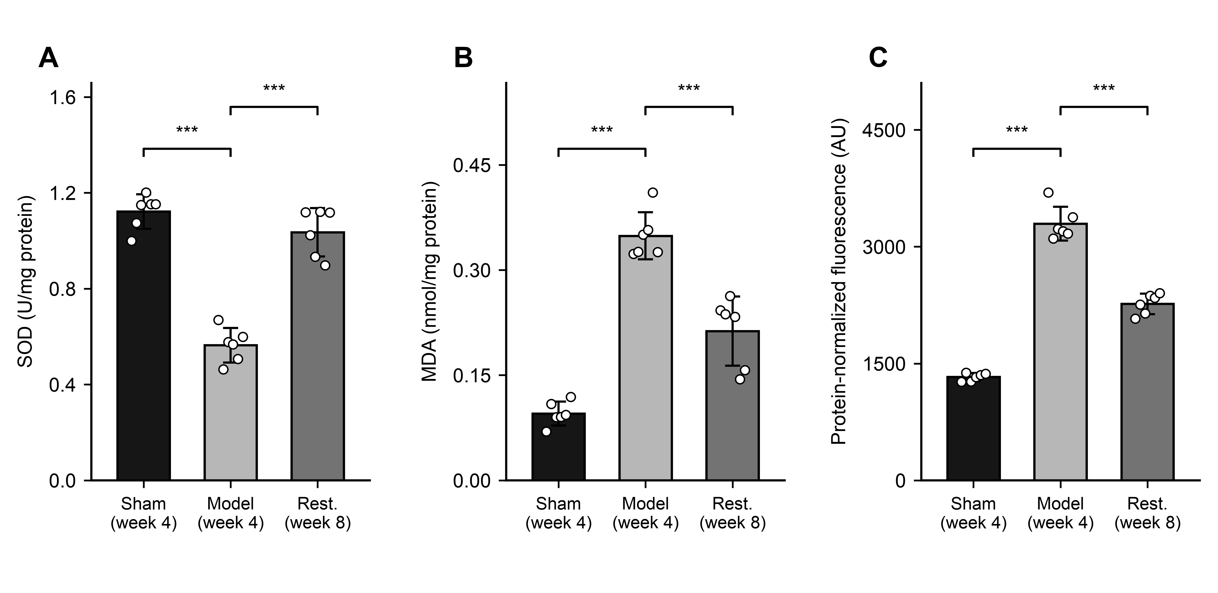
Fig. 1. Regional medullary SOD activity (A), MDA (B) and probe-associated fluorescence (C); mean ± sample SD, six records/group, reported to represent different rats. Identity-linked records were unavailable. Brackets compare model with sham or restoration; ***P < 0.001 (Games–Howell after Welch ANOVA; three comparisons/endpoint). Panel C is a protein-concentration-normalized, unvalidated auxiliary index (AU), not ROS concentration. Sham/model: week 4; restoration: week 8. Sham, sham-operated; Rest., restoration. Full outputs: Supplementary File 3.

Figure 2
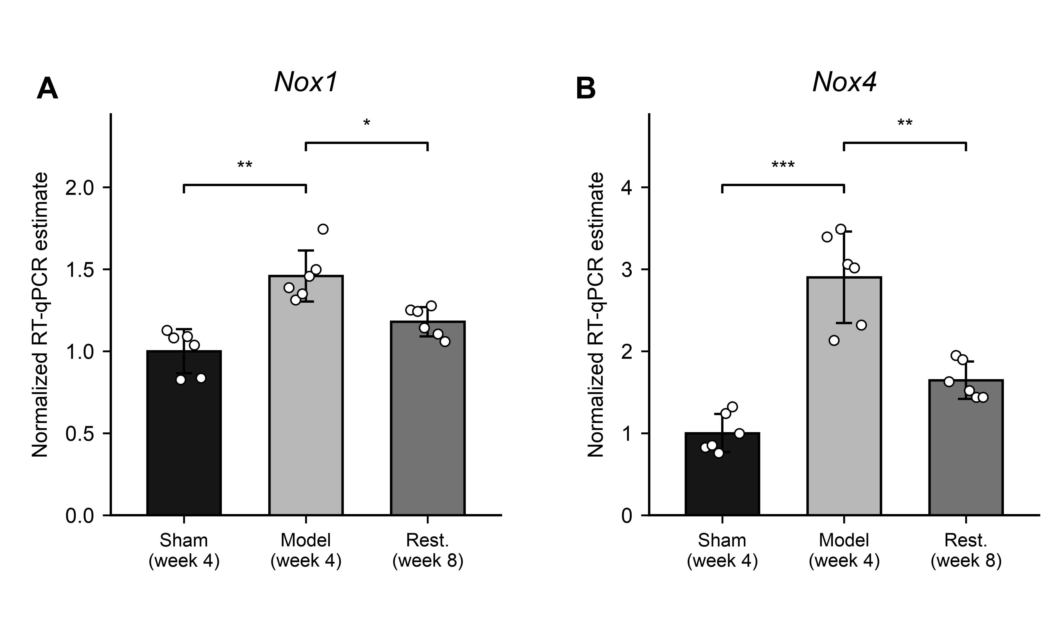
Fig. 2. Exploratory Nox1-targeted (A)/Nox4-targeted (B) normalized RT-qPCR estimates; mean ± sample SD, six records/group, reported to represent different rats. Pairing with β-actin follows investigator confirmation; quantities were divided by the sham arithmetic mean. Specificity was not established, so these are not validated transcript abundances. Brackets compare model with sham or restoration. *P < 0.05, **P < 0.01, ***P < 0.001: Welch tests on ΔCq, Holm-adjusted across all 18 original-panel comparisons. Sham/model: week 4; restoration: week 8. Sham, sham-operated; Rest., restoration. Full outputs: Supplementary File 4; annotation corrections: Table S2.

