Regional redox indices and Nox1 and Nox4 mRNA expression in rats with atlantoaxial joint disorder
Xiangying Yuan¹, Bin Yang², Zongbao He¹, Youkui Lv², Zijian Wu¹
1 School of Acupuncture and Tuina, Anhui University of Chinese Medicine, Hefei, Anhui 230012, China
2 Department of Rehabilitation and Physiotherapy, Anhui Provincial Corps Hospital, Hefei, Anhui 230041, China
Corresponding authors
Zijian Wu, School of Acupuncture and Tuina, Anhui University of Chinese Medicine, Hefei, Anhui 230012, China; email: wuzijian@ahtcm.edu.cn
Youkui Lv, Department of Rehabilitation and Physiotherapy, Anhui Provincial Corps Hospital, Hefei, Anhui 230041, China; email: lvyk126@126.com
Article type: Original Article
Short title: Medullary redox changes in atlantoaxial joint disorder

Summary
We examined regional redox indices and Nox1/Nox4 mRNA in male Wistar rats with atlantoaxial joint disorder. The parent experiment began with 60 rats; this report concerns sham-operated, model and restoration cohorts initially containing 10 rats each. Sham and model rats were sampled on day 28, whereas restoration rats underwent implant removal on day 28 and were sampled on day 56. Biochemical assays and RT-qPCR each included six independent rats per group. Compared with sham rats, model rats had lower superoxide dismutase activity and higher malondialdehyde, probe-associated fluorescence and estimated Nox1/Nox4 transcripts in medullary blocks containing the rostral ventrolateral medulla and adjacent tissue. Restoration-group measurements were generally closer to sham values at the later endpoint. These observations are consistent with regional redox imbalance in the model. Different sampling times, absence of a second-surgery sham control, unvalidated fluorescence-assay applicability to tissue, incomplete qPCR quality-control records and omission of postoperative analgesia limit interpretation. The findings do not establish a NOX-dependent sympathetic mechanism or a causal benefit of implant removal.
Key words: Atlantoaxial joint disorder; Ventrolateral medulla; Oxidative stress; NADPH oxidase; RT-qPCR

Introduction
Hypertension involves vascular, renal and neural mechanisms. Clinical studies have described associations between cervical spondylosis and hypertension [1], and small trials have examined blood pressure after spinal or upper-cervical interventions [2,3]. These observations motivate experimental investigation but do not establish that cervical joint abnormalities cause hypertension in patients or that spinal interventions provide an effective antihypertensive treatment.
Our previous work established a rat model in which a metallic implant placed in the left atlantoaxial joint produced joint misalignment and blood pressure elevation [4]. This model permits investigation of biological changes accompanying a sustained cervical perturbation. The implant also introduces local tissue injury and postoperative stress, however, so identifying a central mechanism requires controls that distinguish mechanical, inflammatory and nonspecific surgical effects.
Oxidative stress contributes to vascular dysfunction and altered autonomic regulation in hypertension [5,6,7]. The rostral ventrolateral medulla (RVLM) helps maintain sympathetic vasomotor tone [8]. Experimental studies in other hypertension models have implicated RVLM redox disturbances and NADPH oxidase (NOX) signaling in cardiovascular regulation [9,10,11,12]. Superoxide dismutase (SOD), malondialdehyde (MDA) and probe-associated fluorescence assess different aspects of redox status, whereas Nox1 and Nox4 transcripts provide information about gene expression. Their joint assessment can characterize a regional phenotype without demonstrating NOX enzyme activity or sympathetic activation.
We therefore examined these biochemical indices and Nox1/Nox4 mRNA in medullary blocks containing the RVLM and adjacent tissue. Sham and model rats were studied at the same endpoint, with a restoration group examined later after implant removal. A related report described Ang II/AT1-R signals in this model [13]. Blood-pressure observations were shared with that report; the biochemical and transcript analyses presented here were not reported there. Available blood-pressure archives and H&E images are provided descriptively as supplementary material. The present study tests regional group differences and explores a possible redox association rather than establishing a causal pathway.

Methods

Animals and ethics
Healthy clean-grade male Wistar rats, approximately 12 weeks old and weighing approximately 250 g, were supplied by the Laboratory Animal Center of Anhui Medical University (license no. SCXK [Wan] 2017-001). Rats were housed individually in the animal laboratory of the Institute of Acupuncture and Meridian Research, Anhui University of Chinese Medicine, at 22 ± 1°C and 60% relative humidity under an artificial 12 h light/12 h dark cycle, with food and water available ad libitum. Rats acclimatized for 1 week before allocation and surgery. Male rats were selected for consistency with the previous model study [4]. Applicability to female rats was not evaluated.
All animal procedures were approved by the Animal Ethics Committee of Anhui University of Chinese Medicine (approval no. AHUCM-rats-2022032). The approval covered the 60-rat parent experiment, model induction, foreign-body removal, and terminal sampling. Animal handling followed the Chinese Guidelines on the Humane Treatment of Laboratory Animals.

Study design and sampling
The parent experiment numbered 60 rats and allocated them by random numbers to sham operation (10) or model induction (50). All sham rats survived. During model induction, 6 rats died during surgery and 3 afterward; 41 survived, including 7 with implant loss and 34 with retained implants. After imaging and blood-pressure screening on day 28, successfully modeled rats were assigned by random numbers to model, restoration, and superior cervical ganglion resection groups of 10. The disposition of the remaining 4 rats with retained implants was undocumented. This report includes only sham, model, and restoration rats, initially 10 per group; ganglion-resection and electrophysiological results are not presented.
The implant was removed from restoration rats on day 28. Terminal sampling was on day 28 for sham and model rats and day 56 for restoration rats, without a time-matched second-surgery sham group. Each biochemical endpoint and RT-qPCR included 6 randomly selected independent rats per group, processed separately without cross-animal pooling. Target and reference Cq values were paired within each rat and measured once each. Original animal identifiers could not be matched to assay samples; numerical record order cannot establish pairing across assays or fully reconstruct premeasurement exclusions. The parent design allowed for preliminary estimates of 18% mortality and 17% implant loss to obtain at least 30 modeled rats. No single primary endpoint or formal outcome-based a priori sample-size calculation was specified.

Model induction and implant removal
The model was induced using the previously described procedure [4]. Rats were anesthetized with 2% inhaled isoflurane at a gas flow of 1 l/min. Anesthetic depth was monitored using respiratory rate and rhythm, the righting reflex, and the response to a noxious stimulus. After shaving and povidone-iodine disinfection, an anterior cervical incision was made, subcutaneous tissue and muscle were separated, and the trachea was displaced to the right to expose the left atlantoaxial joint. With the head rotated to the right, a disinfected S-shaped aluminum implant was inserted into the joint space, secured, and the incision closed. Penicillin sodium was administered intramuscularly at 400,000–800,000 units/kg once daily for 3 days. No postoperative analgesics were administered. Available records did not retain a written rationale or a specific ethics-committee opinion concerning the omission of postoperative analgesia. Food intake, activity, and the wound were checked at least daily for the first 3 postoperative days and 2–3 times per week thereafter. Nine rats died during or after model induction. Reported possible contributing factors were anesthetic overdose, cervical surgical injury, and postoperative infection; individual cause-of-death adjudication records were not retained.
Sham-operated rats underwent the same anterior cervical exposure without implantation. On day 28, implant position and joint morphology were assessed using a Definium-6000 digital X-ray system (GE). Distances between the odontoid process and the left and right lateral masses were measured on images magnified twofold. Model success required a retained implant, asymmetric joint morphology, a left–right distance difference >0.05 mm, and a systolic blood pressure increase of at least 20% relative to baseline with a plateau by week 4.
Restoration rats underwent implant removal on day 28 under the same isoflurane anesthesia. The joint was re-exposed through the original anterior approach, the head rotated rightward, and the implant removed with a needle holder before closure. Postoperative penicillin treatment was unchanged, and no postoperative analgesics were given. Systolic pressure for model screening was measured by tail cuff (IITC Life Science) at baseline and on days 7, 14, 21, and 28. The chamber was prewarmed for 10 min at 30°C; rats rested in a restrainer for 15 min. BPmon Win monitor 1.35 recorded pressure at the onset of the spindle-shaped waveform, and three readings were averaged per rat. These shared source observations [13] were not reanalyzed as a terminal three-group treatment comparison.

Terminal collection and histology
Terminal samples were collected on day 28 in sham and model rats and day 56 in restoration rats. Rats were anesthetized with 2% inhaled isoflurane at 1 l/min for abdominal aortic blood collection, followed by euthanasia with an overdose of inhaled isoflurane. Death was confirmed by the absence of spontaneous breathing, palpable cardiac activity, and withdrawal to a noxious stimulus before brainstem removal. The Paxinos and Watson rat brain atlas and a stereotaxic apparatus guided bilateral tissue collection from the RVLM region, using reference positions 12.12–12.48 mm posterior to bregma, 2.1–2.6 mm lateral, and 10.0–10.4 mm deep. The tissue blocks contained the RVLM and a small amount of adjacent medullary tissue and had a measured mass of approximately 100 mg per rat. They were regional blocks rather than precisely isolated RVLM nuclei, and samples were not pooled across animals.
Histological material from the parent experiment was prepared by perfusion with 4% paraformaldehyde in 0.1 mol/l PBS (pH 7.4), postfixation at 4°C for 24–48 h, paraffin embedding, and 4 μm sections, followed by standard hematoxylin–eosin staining. The supplied composite retains tissue and original scale-bar pixels. Specimen counts, image-to-animal correspondence, and field-selection records could not be confirmed; no quantitative histological analysis was performed.

Biochemical assays
Each medullary biochemical assay included 6 independent rats per group. Tissue was minced, ground in liquid nitrogen, lysed on ice in RIPA buffer containing 1 mmol/l PMSF, and centrifuged to collect the supernatant. Total protein concentration was measured using a BCA kit (Beyotime; cat. no. P0010). SOD activity was measured using a WST-1 assay (Nanjing Jiancheng Bioengineering Institute; cat. no. A001-3), with absorbance read at 450 nm. MDA was measured using a thiobarbituric acid (TBA) colorimetric assay (Nanjing Jiancheng Bioengineering Institute; cat. no. A003-1). The retained assay records specified absorbance measurement at 530 nm, whereas the kit manual recommended 532 nm. Both absorbance measurements used an RT-6000 microplate reader (Rayto).
ROS-associated fluorescence was measured using the proprietary green BBoxiProbe® O12 supplied with the BestBio BB-475015 kit, at excitation and emission wavelengths of 488 and 530 nm, respectively. The kit manual specifies fresh serum as the intended sample matrix; the kit was applied to medullary lysates in this study. Records validating its use in the tissue matrix or compatibility with the lysis buffer were unavailable. The fluorescence-reader model was not retained. This measurement was reported as a probe-associated fluorescence index, without assignment to a specific ROS species or absolute ROS concentration.
SOD activity was calculated by dividing the blank-corrected inhibition fraction by 0.5, multiplying by the reaction-to-sample volume ratio (0.24/0.02), and dividing by sample protein concentration (mg/ml); results were expressed as U/mg protein. MDA content was calculated from the blank-corrected sample-to-standard absorbance ratio, multiplied by a standard concentration of 10 nmol/ml, and divided by sample protein concentration; results were expressed as nmol/mg protein. Probe-associated fluorescence was divided by sample protein concentration and reported in protein-normalized arbitrary units (AU). This fluorescence index was not interpreted as an absolute quantity per unit protein mass.

Reverse transcription quantitative PCR
Reverse transcription quantitative PCR (RT-qPCR) analyses included 6 independent rats per group (n = 6). Each target and reference quantification cycle (Cq) was measured once per rat. Target and reference Cq values in the same worksheet column corresponded to the same animal and were paired within that animal. Samples were not pooled. Total RNA was extracted from medullary tissue blocks containing the RVLM using TRIzol reagent (Life Technologies; Thermo Fisher Scientific, Inc.; cat. no. 15596018). Genomic DNA was removed from 1 µg of RNA in a 10 µl reaction at 42°C for 2 min, followed by 1 min on ice. Reverse transcription was performed using PrimeScript RT reagent Kit with gDNA Eraser (Takara Bio, Inc.; cat. no. RR047A) in a 20 µl reaction at 37°C for 15 min followed by 85°C for 5 s. RT-qPCR used NovoStart SYBR qPCR SuperMix Plus (Novoprotein; cat. no. E096-01B) and a PikoReal 96 real-time PCR system (Thermo Fisher Scientific, Inc.). Each 10 µl reaction contained 5 µl of 2× SYBR mix, 1 µl each of forward and reverse primers (10 µmol/l), 1 µl of cDNA, and 2 µl of RNase-free water. Primer sequences were as follows: Nox1 forward, 5'-GCTCCAGACCTCCATTTG-3'; Nox1 reverse, 5'-CAGCCCCAACCAAGAAAC-3'; Nox4 forward, 5'-GGGTTAAACACCTCTGTC-3'; Nox4 reverse, 5'-GTAGTATTCTGGCCCTTG-3'; β-actin forward, 5'-CCCATCTATGAGGGTTACGC-3'; and β-actin reverse, 5'-TTTAATGTCACGCACGATTTC-3'. Expected amplicon lengths for Nox1, Nox4, and β-actin were 84, 95, and 150 bp, respectively. Cycling conditions were 95°C for 1 min followed by 40 cycles of 95°C for 20 s and 60°C for 1 min. Conversion to relative quantities assumed equal amplification efficiencies of approximately 100% for each target and β-actin [14]. Within-animal ΔCq was defined as target Cq minus the paired β-actin Cq. Relative quantity was calculated as $Q = 2^{−ΔCq}$. For each gene, this quantity was divided by the arithmetic mean of the relative quantities from the 6 sham-operated rats, giving the sham-operated group an arithmetic mean of 1. Amplification efficiencies and reference-gene stability were not validated. The assay reports mentioned amplification and melting-curve results, but the original curves were unavailable for inspection. Records of no-template controls (NTC) and no-reverse-transcription controls (no-RT) were also unavailable.

Statistical analysis
Statistical analyses used individual rats as experimental units and report mean ± sample SD. All six supplied values per group were included; no outliers were removed or missing values imputed. Repeated measurements did not increase biological n. Biochemical endpoints were compared using Welch’s one-way ANOVA and Games–Howell comparisons, with 95% confidence intervals. Shapiro–Wilk tests were diagnostic, with limited sensitivity at n = 6. Adjustment covered the three comparisons within each endpoint, not across the three biochemical endpoints. Tests were two-sided, with α = 0.05. Processed inputs, full outputs and software versions, and reproduction code are provided in Supplementary Data 1, File 3, and Appendix 1.
RT-qPCR inference used within-animal ΔCq values and independent-group Welch t tests. All 18 comparisons across the original six-target panel (AT1-R, Nox1, Nox4, RhoA, ROCK1, and ROCK2) formed one Holm correction family; correction was not restricted to the displayed genes. Supplementary Data 2, File 4, and Appendix 2 provide paired inputs, complete t statistics, degrees of freedom and exact P values, and reproducible code. Animal overlap across assays was not recoverable, so no cross-assay correlations were tested. Archived blood-pressure and H&E materials were displayed without new inferential tests. Model–sham comparisons use day-28 samples; comparisons involving restoration use day-56 samples.

Results

Archived blood pressure and histology
The blood-pressure workbook contained 24 model-labelled, 14 control-labelled, and 10 sham-labelled source rows. The 10 complete sham rows matched the thesis sham summaries, but missing values and repeated identifiers prevented unique reconstruction of the current model cohort. Only four entered restoration summaries remained for weeks 5–8, without animal-level dispersion. These records cannot independently validate the terminal cohorts (Supplementary Fig. S2; Data 3 and 4; File 5). H&E fields show nuclear staining and varied cellular profiles, but uncertain specimen counts and correspondence preclude conclusions about between-group injury or recovery (Fig. 1).

Regional biochemical indices
Each medullary biochemical endpoint was analyzed in 6 rats per group. SOD activities in the sham, model, and restoration groups were 1.122 ± 0.072, 0.564 ± 0.072, and 1.035 ± 0.101 U/mg protein, respectively. Corresponding MDA contents were 0.095 ± 0.017, 0.349 ± 0.034, and 0.213 ± 0.049 nmol/mg protein, and ROS-associated fluorescence values were 1326.9 ± 50.6, 3295.6 ± 216.3, and 2265.6 ± 131.6 AU (Fig. 2). Welch's ANOVA indicated differences among groups: SOD, F(2, 9.816) = 91.626; MDA, F(2, 8.500) = 130.738; and ROS-associated fluorescence, F(2, 7.804) = 314.907 (all P < 0.001). Model–sham mean differences and 95% confidence intervals are presented in Table 1. Compared with model rats sampled on day 28, restoration rats sampled on day 56 had higher SOD activity and lower MDA content and ROS-associated fluorescence (all Games–Howell-adjusted P < 0.001). Compared with sham rats, restoration rats had higher MDA content (adjusted P = 0.0033) and ROS-associated fluorescence (adjusted P < 0.001), whereas the difference in SOD activity was not statistically significant (adjusted P = 0.2534). The absence of a significant SOD difference does not establish equivalence. These restoration-group comparisons describe differences between groups sampled after different durations. Full numerical results are provided in Supplementary File 3.

Nox1 and Nox4 transcripts
Using paired target and reference measurements within each animal, relative Nox1 expression in the sham, model, and restoration groups was 1.000 ± 0.134, 1.459 ± 0.156, and 1.180 ± 0.090, respectively. Corresponding Nox4 expression was 1.000 ± 0.233, 2.902 ± 0.558, and 1.645 ± 0.227 (Fig. 3A and B; n = 6 per group). Both transcripts were higher in model rats than in sham rats (Holm-adjusted P = 0.0037 for Nox1 and P = 0.0001 for Nox4) and lower in restoration rats than in model rats (P = 0.0139 and 0.0037, respectively). Estimated Nox4 expression was higher in restoration rats than in sham rats (P = 0.0099). The Nox1 difference between restoration and sham rats did not meet the adjusted significance threshold (P = 0.0618); this does not establish equivalence or restoration of normal expression. Comparisons involving restoration rats span different terminal sampling times. Full results for the family of 18 adjusted tests are provided in Supplementary File 4.

Discussion
The day-28 model–sham comparison identified lower SOD activity together with higher MDA, probe-associated fluorescence and estimated Nox1/Nox4 transcripts in regional medullary tissue. These findings extend the original model characterization [4] by describing a biochemical and transcript phenotype. They do not independently reproduce the shared blood-pressure observations or establish an animal-level relationship between blood pressure and molecular endpoints, because cross-assay animal correspondence could not be recovered.
SOD contributes to antioxidant defense, whereas MDA is a lipid-peroxidation marker [15,16]. Their opposite directions are consistent with a regional redox disturbance. The fluorescence result requires greater caution: the O12 kit was designated for serum but was applied to RIPA tissue lysates without available validation of matrix or buffer compatibility. Its signal cannot identify a specific ROS species or an absolute concentration. Protein-concentration normalization does not correct tissue-composition differences or demonstrate assay validity, and common processing cannot exclude differential matrix effects between groups.
RVLM oxidative stress has been implicated in cardiovascular regulation in other experimental models [9,10,12,17]. The present anatomical resolution is more limited. The approximately 100 mg samples contained adjacent medullary tissue, so their measurements cannot be assigned specifically to RVLM neurons or a particular cell population. Higher Nox1/Nox4 mRNA does not establish higher NOX protein abundance, oxidase activity or the cellular source of the fluorescence signal. Protein-level confirmation, validated regional redox assays and NOX-targeted interventions would be needed to test those relationships.
Ang II/AT1-R signaling offers a plausible context for the observations. Earlier work links this signaling system to RVLM cardiovascular regulation and NOX-related sympathoexcitation [13,18,19]. Ang II and its receptors were not measured in the present analyses, and sympathetic discharge was not recorded for this report. The proposed sequence from altered cervical input through Ang II/AT1-R and NOX to sympathetic activation therefore remains a hypothesis. The available data cannot establish pathway order or mediation. The proposed relationships are illustrated in Fig. 4.
Restoration-group values generally lay closer to sham values, but restoration rats were sampled four weeks later than the other groups. Age, time, postoperative recovery, repeat anesthesia and a second operation are confounded with implant removal. Without time-matched and second-surgery sham controls, these comparisons cannot identify an independent implant-removal effect or establish reversal. Surgical implant removal also differs from clinical manual treatment, so these observations do not establish a clinical treatment rationale.
The archived H&E fields provide morphological context only. Unconfirmed specimen counts and image-to-animal correspondence preclude group-level conclusions about tissue damage or recovery. H&E staining alone cannot identify activated microglia, astrocytes or infiltrating immune cells. These images do not establish increased cellular density or inflammatory-cell identity; cell-specific markers and systematic sampling would be required.
Animal care also affects interpretation. No postoperative analgesics were administered, and a written rationale or a specific ethics opinion addressing that omission was unavailable. Pain and surgical stress could influence redox and transcriptional responses; their magnitude or persistence at terminal sampling is unknown. Ethics approval does not remove this methodological concern. Future experiments should incorporate an approved analgesic plan, documented welfare monitoring and controls appropriate to the intervention.
Additional limitations concern assay quality and sampling. Each qPCR target and reference was measured once per animal, preventing estimation of technical repeatability. Amplification efficiency and β-actin stability were unvalidated, and original amplification/melting curves and NTC/no-RT records were unavailable. Relative expression depends on an unverified equal-efficiency assumption. Processed values and paired Cq inputs permit computational reanalysis but cannot replace instrument outputs or animal-to-sample records. No single primary endpoint or formal a priori power calculation was specified. Only male rats were studied, and applicability to females is unknown.
The study provides exploratory evidence of regional redox and transcript differences in male rats with atlantoaxial joint disorder. The same-time model–sham comparison is the clearest biological contrast. Establishing anatomical specificity, a NOX-dependent sympathetic mechanism or a benefit of implant removal will require validated assays, recoverable sample identities and appropriately matched intervention controls.

Conflict of Interest
The authors declare that they have no known competing financial interests or personal relationships that could have appeared to influence the work reported in this paper.

Acknowledgments
This research was supported by the Provincial Natural Science Foundation of Anhui, China (grant no. 1608085MH185). The funder had no role in study design, data collection and analysis, manuscript preparation, or the decision to submit the article for publication.

Author contributions
Xiangying Yuan: Conceptualization, Investigation, Formal analysis, Writing – original draft. Bin Yang: Methodology, Investigation. Zongbao He: Investigation, Resources. Youkui Lv: Conceptualization, Supervision, Funding acquisition, Writing – review & editing. Zijian Wu: Conceptualization, Supervision, Project administration, Funding acquisition, Writing – review & editing.

Data availability
Processed medullary biochemical values, paired RT-qPCR Cq measurements, statistical outputs, and reproducible analysis and plotting scripts are provided in the supplementary material. Archived blood-pressure entries, entered summaries, the unmodified source workbook, and the supplied H&E composite are also provided. Blood-pressure source rows cannot be uniquely mapped to the current terminal cohorts, and H&E specimen counts and image-to-animal correspondence could not be recovered; these materials are presented descriptively. Original instrument outputs, complete assay quality-control records, and original animal-to-sample identifiers were unavailable for independent verification.

DECLARATION on the Use of AI
Codex (OpenAI; accessed October 2026; exact model identifier not archived) assisted with language editing, manuscript organization, methodological review, worksheet checking, statistical reanalysis, and development of conventional analysis and plotting code. Numerical inputs and reproducible scripts are supplied. Experimental data and experimental images were not generated; the H&E tissue and original scale-bar pixels were preserved. The authors reviewed the outputs, figures and conclusions and take responsibility for the work.

Supplementary material
Supplementary datasets, full statistical outputs, reproduction code, the archived blood-pressure workbook and H&E materials accompany this article. Item descriptions and Supplementary Figs. S1 and S2 are compiled in Yuan_supplementary_information.docx; individual numerical and source files are supplied separately in Supporting_Information.

References
1. Kalb S, Zaidi HA, Ribas-Nijkerk JC, Sindhwani MK, Clark JC, Martirosyan NL, Theodore N. Persistent outpatient hypertension is independently associated with spinal cord dysfunction and imaging characteristics of spinal cord damage among patients with cervical spondylosis. World Neurosurg. 2015;84:351–357.
2. Plaugher G, Long CR, Alcantara J, Silveus AD, Wood H, Lotun K, Menke JM, et al. Practice-based randomized controlled-comparison clinical trial of chiropractic adjustments and brief massage treatment at sites of subluxation in subjects with essential hypertension: pilot study. J Manipulative Physiol Ther. 2002;25:221–239.
3. Bakris G, Dickholtz M Sr, Meyer PM, Kravitz G, Avery E, Miller M, Brown J, et al. Atlas vertebra realignment and achievement of arterial pressure goal in hypertensive patients: a pilot study. J Hum Hypertens. 2007;21:347–352.
4. He ZB, Lv YK, Li H, Yao Q, Wang KM, Song XG, Wu ZJ, et al. Atlantoaxial misalignment causes high blood pressure in rats: a novel hypertension model. Biomed Res Int. 2017;2017:5986957.
5. Franco C, Sciatti E, Favero G, Bonomini F, Vizzardi E, Rezzani R. Essential hypertension and oxidative stress: novel future perspectives. Int J Mol Sci. 2022;23:14489.
6. Guzik TJ, Touyz RM. Oxidative stress, inflammation, and vascular aging in hypertension. Hypertension. 2017;70:660–667.
7. Incalza MA, D'Oria R, Natalicchio A, Perrini S, Laviola L, Giorgino F. Oxidative stress and reactive oxygen species in endothelial dysfunction associated with cardiovascular and metabolic diseases. Vascul Pharmacol. 2018;100:1–19.
8. Wenker IC, Abe C, Viar KE, Stornetta DS, Stornetta RL, Guyenet PG. Blood pressure regulation by the rostral ventrolateral medulla in conscious rats: effects of hypoxia, hypercapnia, baroreceptor denervation, and anesthesia. J Neurosci. 2017;37:4565–4583.
9. Chan SHH, Wu KLH, Chang AYW, Tai MH, Chan JYH. Oxidative impairment of mitochondrial electron transport chain complexes in rostral ventrolateral medulla contributes to neurogenic hypertension. Hypertension. 2009;53:217–227.
10. Huang YP, Jin HY, Yu HP. Inhibitory effects of alpha-lipoic acid on oxidative stress in the rostral ventrolateral medulla in rats with salt-induced hypertension. Int J Mol Med. 2017;39:430–436.
11. Kalsoom UE, Jin J, Meng W, Su Y, Wu C, Wu Q. The role of NADPH oxidases in central nervous system regulation of hypertension: mechanisms and therapeutic insights. Biomed Pharmacother. 2026;196:119096.
12. Yan JQ, Huang F, Hao F, Su XL, Meng Q, Xu MJ. Oxidative stress in the rostral ventrolateral medulla contributes to cardiovascular regulation in preeclampsia. Front Physiol. 2017;8:772.
13. Lv YK, Wu ZJ, Yang B, Gao DP, He ZB. Expression of angiotensin II and angiotensin II type 1 receptor in rostral ventrolateral medulla in a rat model of atlantoaxial joint disorder-induced hypertension. Biull Eksp Biol Med. 2026;181(5):546–550.
14. Livak KJ, Schmittgen TD. Analysis of relative gene expression data using real-time quantitative PCR and the 2(-Delta Delta C(T)) method. Methods. 2001;25:402–408.
15. Marrocco I, Altieri F, Peluso I. Measurement and clinical significance of biomarkers of oxidative stress in humans. Oxid Med Cell Longev. 2017;2017:6501046.
16. Cordiano R, Di Gioacchino M, Mangifesta R, Panzera C, Gangemi S, Minciullo PL. Malondialdehyde as a potential oxidative stress marker for allergy-oriented diseases: an update. Molecules. 2023;28:5979.
17. Chao YM, Rauchová H, Chan JYH. Disparate roles of oxidative stress in rostral ventrolateral medulla in age-dependent susceptibility to hypertension induced by systemic l-NAME treatment in rats. Biomedicines. 2022;10:2232.
18. Dampney RAL, Tan PSP, Sheriff MJ, Fontes MAP, Horiuchi J. Cardiovascular effects of angiotensin II in the rostral ventrolateral medulla: the push-pull hypothesis. Curr Hypertens Rep. 2007;9:222–227.
19. Gao L, Wang W, Li YL, Schultz HD, Liu D, Cornish KG, Zucker IH. Superoxide mediates sympathoexcitation in heart failure: roles of angiotensin II and NAD(P)H oxidase. Circ Res. 2004;95:937–944.

Tables
Table 1. Differences in ventrolateral medullary oxidative stress markers between model and sham rats sampled at the same time.
Outcome | Model minus sham | 95% confidence interval | Adjusted P value
SOD (U/mg protein) | −0.558 | −0.672 to −0.443 | <0.001
MDA (nmol/mg protein) | 0.253 | 0.209 to 0.298 | <0.001
ROS-associated fluorescence (AU) | 1968.8 | 1683.7 to 2253.8 | <0.001
Both groups were sampled on day 28, with 6 independent rats per group for each endpoint. Differences retain the original measurement units. Confidence intervals and P values were obtained from the three-group Games–Howell comparisons within each endpoint, without correction across endpoints. Fluorescence is reported in protein-normalized arbitrary units. These results describe group differences in regional tissue blocks and do not establish that NOX expression mediates blood pressure changes.

Figure 1
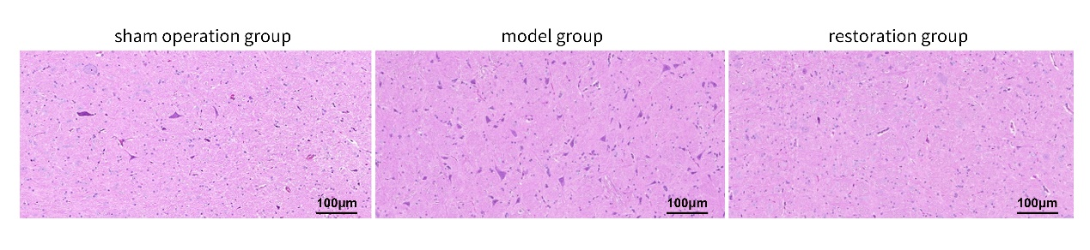
Fig. 1. Archived H&E fields labelled sham, model and restoration. Source tissue pixels and source-labelled 100 µm scale bars are retained. Animal counts, image-to-animal correspondence and sampling records were unavailable. These fields are illustrative and do not establish group-level histological differences.

Figure 2
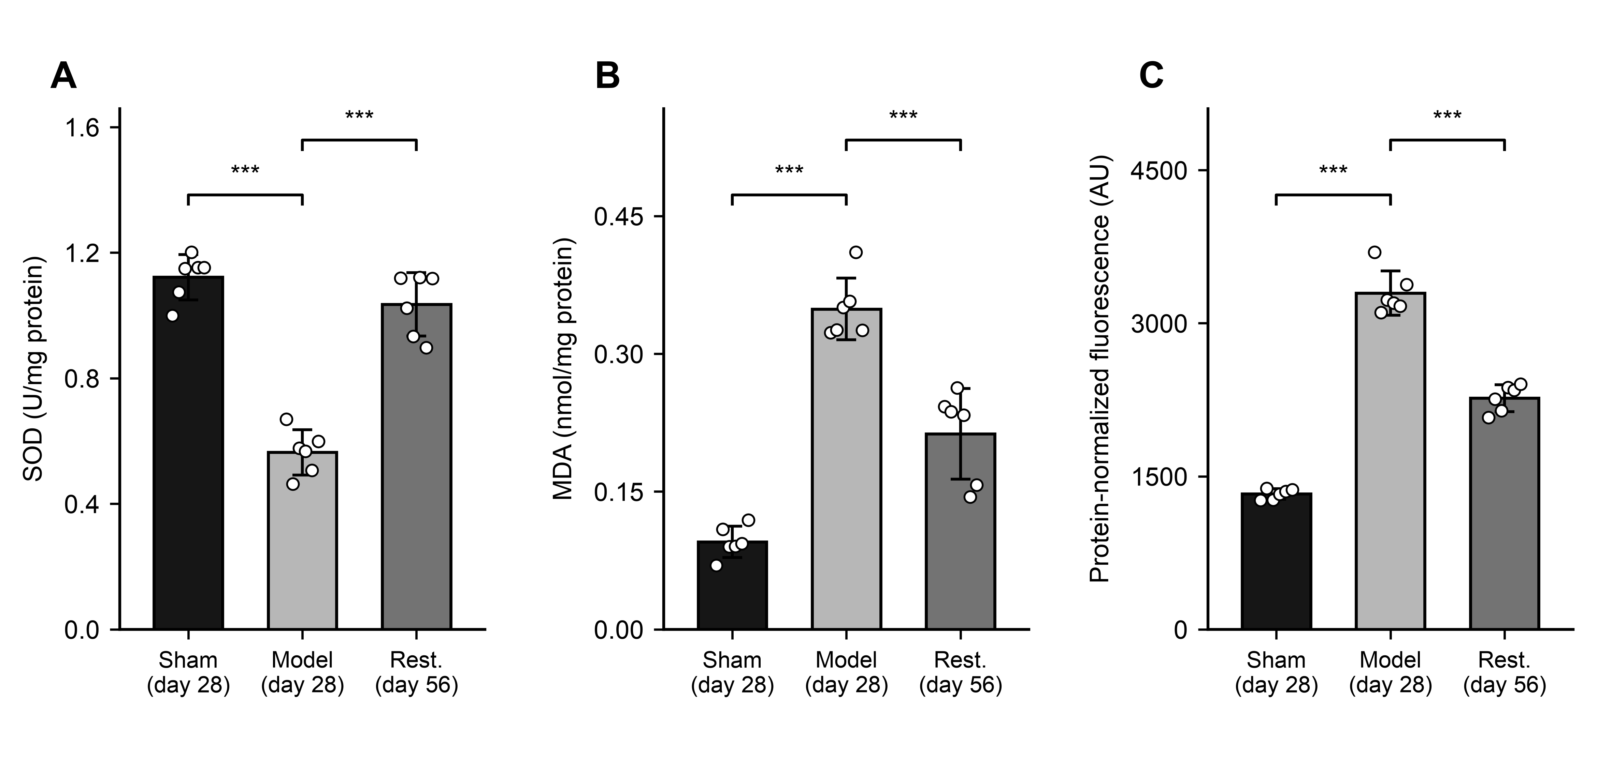
Fig. 2. Regional medullary biochemical indices: (A) SOD activity, (B) MDA content and (C) probe-associated fluorescence. Each group included six independent rats. Bars show arithmetic means, error bars sample SDs and points individual rats. Brackets compare model with sham or restoration; ***P < 0.001, from Games–Howell comparisons following Welch ANOVA. Adjustment covered three comparisons within each endpoint, without correction across endpoints. Fluorescence is a protein-concentration-normalized index in arbitrary units (AU). Sham and model rats were sampled on day 28 and restoration rats on day 56. Complete results are in Supplementary File 3. Sham, sham-operated; Rest., restoration. Codex assisted with conventional plotting code.

Figure 3
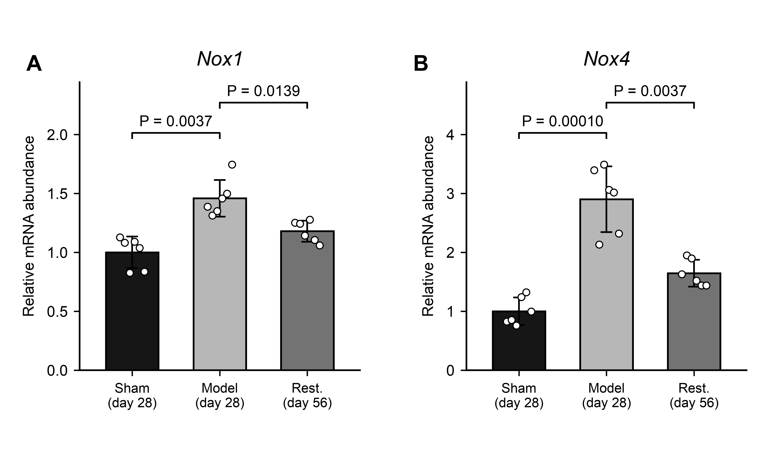
Fig. 3. Relative Nox1 (A) and Nox4 (B) mRNA in regional medullary tissue. Six independent rats were included per group. Bars indicate arithmetic means, error bars sample SDs and points individual rats. Expression was normalized within each rat to β-actin and calibrated to the sham arithmetic mean. Brackets compare model with sham or restoration. Tests used ΔCq with one Holm adjustment across all 18 original-panel comparisons. Displayed P values are Holm-adjusted across these 18 comparisons. Sham and model rats were sampled on day 28 and restoration rats on day 56. Full results are in Supplementary File 4. Sham, sham-operated; Rest., restoration. Codex assisted with conventional plotting code.

Figure 4
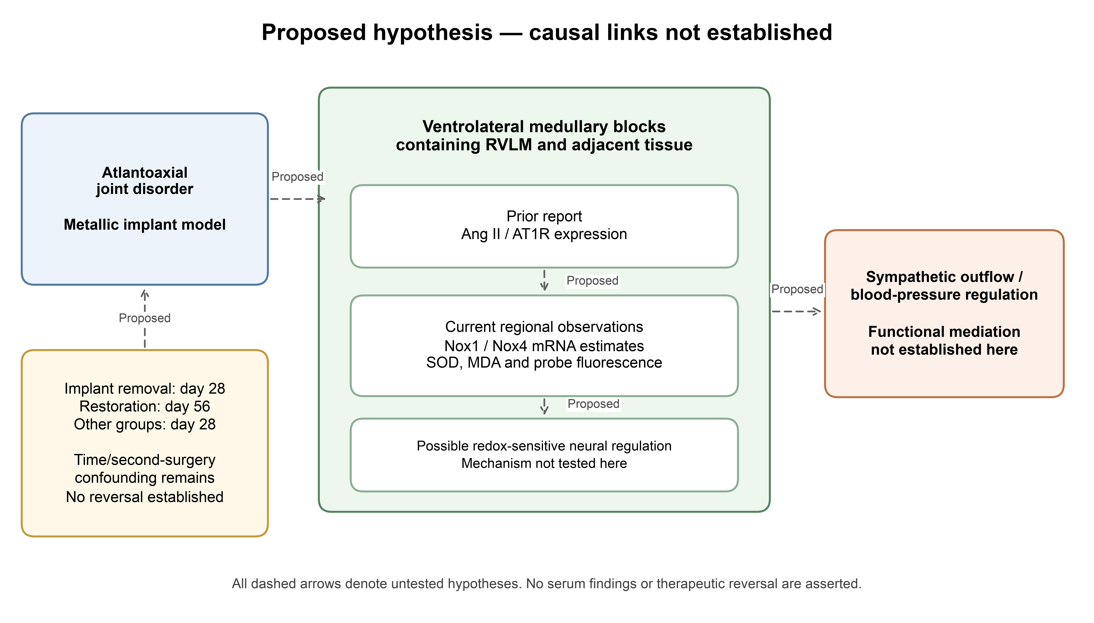
Fig. 4. Proposed relationships linking cervical perturbation, Ang II/AT1-R signaling, NOX-related redox changes and sympathetic blood-pressure regulation. Dashed arrows indicate relationships requiring testing. This study measured regional biochemical indices and Nox1/Nox4 transcripts, without pathway intervention or sympathetic recordings. Restoration samples were collected on day 56 versus day 28 for sham and model groups; time and repeat surgery confound implant-removal comparisons. Codex assisted with conventional diagram code.

