Regional medullary redox indices and Nox1/Nox4 mRNA expression in rats with atlantoaxial joint disorder
Xiangying Yuan¹, Bin Yang², Zongbao He¹, Youkui Lv², Zijian Wu¹
1 School of Acupuncture and Tuina, Anhui University of Chinese Medicine, Hefei, Anhui 230012, China
2 Department of Rehabilitation and Physiotherapy, Anhui Provincial Corps Hospital, Hefei, Anhui 230041, China
Corresponding authors
Zijian Wu, School of Acupuncture and Tuina, Anhui University of Chinese Medicine, Hefei, Anhui 230012, China; email: wuzijian@ahtcm.edu.cn
Youkui Lv, Department of Rehabilitation and Physiotherapy, Anhui Provincial Corps Hospital, Hefei, Anhui 230041, China; email: lvyk126@126.com
Article type: Short Communication
Short title: Medullary redox changes in atlantoaxial joint disorder

Summary
We examined regional medullary redox indices and Nox1/Nox4 transcripts in male Wistar rats with atlantoaxial joint disorder. Sham-operated and model rats were sampled on day 28; restoration rats underwent implant removal on day 28 and sampling on day 56. Each endpoint included six independent rats per group. In tissue containing the rostral ventrolateral medulla (RVLM) and adjacent medulla, day-28 model rats had lower SOD activity, higher MDA and probe-associated fluorescence, and estimated Nox1/Nox4 expression of 1.46/2.90-fold relative to sham rats. Restoration values were generally closer to sham values at the later endpoint. Unmatched sampling times, absent second-surgery controls, unvalidated tissue fluorescence-assay applicability, incomplete qPCR quality-control records and omission of postoperative analgesia limit interpretation. These exploratory observations do not establish RVLM-specific changes, NOX-dependent sympathetic mediation or an implant-removal effect.
Key words: Atlantoaxial joint disorder; Ventrolateral medulla; Oxidative stress; NADPH oxidase; RT-qPCR

A metallic implant in the rat atlantoaxial joint produces misalignment and blood-pressure elevation [1]. Oxidative stress is implicated in hypertension [2]; the rostral ventrolateral medulla (RVLM) regulates blood pressure [3], and experimental studies link regional redox disturbances to cardiovascular regulation [4,5]. We examined medullary biochemical indices and Nox1/Nox4 transcripts in this model. Blood-pressure observations were shared with a related Ang II/AT1-R report [6], whereas the present biochemical and transcript analyses were not reported there.
The Animal Ethics Committee of Anhui University of Chinese Medicine approved the 60-rat parent experiment, model induction, implant removal and terminal sampling (AHUCM-rats-2022032). Clean-grade male Wistar rats (approximately 12 weeks, 250 g; Anhui Medical University, license SCXK [Wan] 2017-001) were individually housed at 22 ± 1°C and 60% humidity under 12 h light/dark cycles, with free food/water and 1-week acclimatization. Animals were randomized to sham operation (10) or model induction (50). Six rats died intraoperatively and three afterward; seven survivors lost implants, leaving 34 with retained implants. Successfully modeled rats were randomized to model, restoration or superior cervical ganglion resection groups (10 each); four remained in reserve. This report includes sham, model and restoration cohorts only, initially 10 per group; each biochemical endpoint and RT-qPCR used six randomly selected independent rats per group without pooling. No single primary endpoint or formal a priori power calculation was specified. Animal-to-sample identifiers and cross-assay overlap could not be recovered.
Surgery used 2% inhaled isoflurane at 1 l/min, with respiratory, righting-reflex and noxious-withdrawal monitoring. An S-shaped aluminum implant was placed in the left atlantoaxial joint through an anterior cervical approach [1]; sham rats underwent exposure without implantation. Day-28 screening required retained implantation, joint asymmetry with a left–right odontoid–lateral-mass distance difference >0.05 mm, and systolic pressure ≥20% above baseline with a week-4 plateau. Restoration rats underwent implant removal on day 28. Penicillin sodium was given intramuscularly at 400,000–800,000 units/kg daily for 3 days. Possible contributors to the nine deaths were anesthetic overdose, cervical injury and infection; individual cause-of-death adjudication records were unavailable. No postoperative analgesics were administered; no written rationale or specific ethics-committee opinion about this omission was retained. Food intake, activity and wounds were checked daily for 3 days and 2–3 times weekly thereafter.
Sham/model rats were sampled on day 28 and restoration rats on day 56, without a time-matched second-surgery sham control. Abdominal aortic sampling under isoflurane was followed by inhaled-isoflurane overdose; death was confirmed when spontaneous breathing, palpable cardiac activity and withdrawal to a noxious stimulus were all absent, before brainstem removal. Atlas-guided bilateral tissue blocks (approximately 100 mg/rat) contained RVLM and adjacent medulla. For biochemical assays, tissue was lysed in RIPA/PMSF and protein measured by BCA. SOD (A001-3, WST-1) and MDA (A003-1, thiobarbituric acid; Nanjing Jiancheng) used RT-6000 absorbance readings at 450 and 530 nm, respectively; the MDA manual specified 532 nm. The fluorescence-reader model was not retained. BestBio BB-475015 O12 fluorescence was measured at excitation/emission 488/530 nm and divided by protein concentration, yielding an arbitrary-unit (AU) index. This serum-designated assay lacked tissue-matrix and buffer-compatibility validation; fluorescence is not an absolute ROS concentration or species-specific measure.
RNA extraction used TRIzol; reverse transcription used PrimeScript RR047A, followed by SYBR RT-qPCR on PikoReal 96. Each target and paired β-actin reference was measured once per rat, without technical replication. Within-rat ΔCq was target minus reference Cq. Relative quantity was calculated as $Q = 2^{−ΔCq}$ and divided by the arithmetic mean quantity of the six sham rats [7]. This assumes equal, approximately 100% amplification efficiencies. Efficiencies and β-actin stability were not validated; original amplification/melting curves and no-template/no-reverse-transcription control records were unavailable. Reagent details, primers, protocols and source-flow information are retained in Supplementary Methods.
Individual rats were experimental units; results are mean ± sample SD. All six supplied values per group were included, without outlier removal or imputation. Biochemical comparisons used Welch ANOVA and Games–Howell tests, adjusting three comparisons within each endpoint, without adjustment across endpoints. RT-qPCR inference used Welch t tests on ΔCq, with Holm correction across all 18 comparisons in the original six-target panel, not only the displayed genes. Tests were two-sided (α = 0.05). Inputs, complete outputs, confidence intervals and code accompany the manuscript; cross-assay correlations were not tested.
Across the terminal cohorts, Welch ANOVA gave F(2, 9.816) = 91.626 for SOD, F(2, 8.500) = 130.738 for MDA and F(2, 7.804) = 314.907 for fluorescence (all P < 0.001). In day-28 model versus sham rats, SOD was 0.564 ± 0.072 versus 1.122 ± 0.072 U/mg protein, MDA 0.349 ± 0.034 versus 0.095 ± 0.017 nmol/mg protein, and fluorescence 3295.6 ± 216.3 versus 1326.9 ± 50.6 AU (Fig. 1; all Games–Howell-adjusted P < 0.001; Supplementary Table S1). Estimated Nox1 expression was 1.459 ± 0.156 versus 1.000 ± 0.134, and Nox4 2.902 ± 0.558 versus 1.000 ± 0.233 (Fig. 2; Holm-adjusted P = 0.0037 and 0.0001).
At the later restoration endpoint, SOD was 1.035 ± 0.101, MDA 0.213 ± 0.049 and fluorescence 2265.6 ± 131.6 in the same respective units; all differed from model values (adjusted P < 0.001). Relative to sham, MDA and fluorescence remained higher (P = 0.0033 and <0.001), whereas the SOD difference was nonsignificant (P = 0.2534). Restoration Nox1/Nox4 estimates were 1.180 ± 0.090/1.645 ± 0.227, lower than model values (adjusted P = 0.0139/0.0037). Compared with sham, Nox4 remained higher (P = 0.0099); Nox1 was nonsignificant (P = 0.0618). Nonsignificance does not establish equivalence or normalization. Full three-cohort statistics are supplied.
Lower SOD activity and higher MDA provide complementary regional antioxidant and lipid-peroxidation observations [8]. Together with estimated Nox1/Nox4 elevations, these findings extend the model's characterization [1] and are consistent with redox disturbances in other hypertension models [4,5]. Transcript abundance does not establish increased NOX protein, oxidase activity or sympathetic output. Unvalidated O12 fluorescence is auxiliary; common processing cannot exclude differential matrix effects. Archived H&E fields and blood-pressure records are descriptive only (Supplementary Figs. S1/S2), with unconfirmed histological animal counts and unreconstructed terminal blood-pressure cohorts.
Interpretation remains constrained by regional rather than RVLM-specific sampling, incomplete qPCR quality control and untraceable cross-assay identities. Later restoration observations confound implant removal with age, elapsed time, recovery and repeat anesthesia/surgery. Omission of postoperative analgesia raises animal-welfare concerns and possible pain/stress confounding. Small exploratory samples and male-only inclusion limit precision and generalizability. The same-day model–sham comparison supports a regional phenotype; validated assays, anatomical localization and time-matched controls are required to investigate NOX-dependent sympathetic mediation or an implant-removal effect.

Acknowledgments
This research was supported by the Provincial Natural Science Foundation of Anhui, China (grant no. 1608085MH185). The funder had no role in study design, data collection and analysis, manuscript preparation, or the decision to submit the article for publication.

Conflict of Interest
The authors declare no competing interests.

Author contributions
Xiangying Yuan: Conceptualization, Investigation, Formal analysis, Writing – original draft. Bin Yang: Methodology, Investigation. Zongbao He: Investigation, Resources. Youkui Lv: Conceptualization, Supervision, Funding acquisition, Writing – review & editing. Zijian Wu: Conceptualization, Supervision, Project administration, Funding acquisition, Writing – review & editing.

Data availability
Inputs, complete statistical outputs/code, detailed methods, Table S1 and descriptive archived H&E/blood-pressure records accompany the manuscript. Original instrument outputs, complete quality-control records and animal-to-sample identifiers were unavailable for independent verification.

DECLARATION on the Use of AI
Codex (OpenAI; final-revision CLI 0.162.0-alpha.17.2, ChatGPT desktop 26.1007.30912; October 2026; underlying model identifier unarchived) assisted with editing, organization, methodological review, worksheet checking, statistical reanalysis and conventional analysis/plotting code. Authors verified the outputs and take responsibility. No experimental data or images were generated.

References
1. He ZB, Lv YK, Li H, Yao Q, Wang KM, Song XG, Wu ZJ, et al. Atlantoaxial misalignment causes high blood pressure in rats: a novel hypertension model. Biomed Res Int. 2017;2017:5986957.
2. Franco C, Sciatti E, Favero G, Bonomini F, Vizzardi E, Rezzani R. Essential hypertension and oxidative stress: novel future perspectives. Int J Mol Sci. 2022;23:14489.
3. Wenker IC, Abe C, Viar KE, Stornetta DS, Stornetta RL, Guyenet PG. Blood pressure regulation by the rostral ventrolateral medulla in conscious rats: effects of hypoxia, hypercapnia, baroreceptor denervation, and anesthesia. J Neurosci. 2017;37:4565–4583.
4. Chan SHH, Wu KLH, Chang AYW, Tai MH, Chan JYH. Oxidative impairment of mitochondrial electron transport chain complexes in rostral ventrolateral medulla contributes to neurogenic hypertension. Hypertension. 2009;53:217–227.
5. Yan JQ, Huang F, Hao F, Su XL, Meng Q, Xu MJ. Oxidative stress in the rostral ventrolateral medulla contributes to cardiovascular regulation in preeclampsia. Front Physiol. 2017;8:772.
6. Lv YK, Wu ZJ, Yang B, Gao DP, He ZB. Expression of angiotensin II and angiotensin II type 1 receptor in rostral ventrolateral medulla in a rat model of atlantoaxial joint disorder-induced hypertension. Biull Eksp Biol Med. 2026;181(5):546–550.
7. Livak KJ, Schmittgen TD. Analysis of relative gene expression data using real-time quantitative PCR and the 2(-Delta Delta C(T)) method. Methods. 2001;25:402–408.
8. Marrocco I, Altieri F, Peluso I. Measurement and clinical significance of biomarkers of oxidative stress in humans. Oxid Med Cell Longev. 2017;2017:6501046.

Figure 1
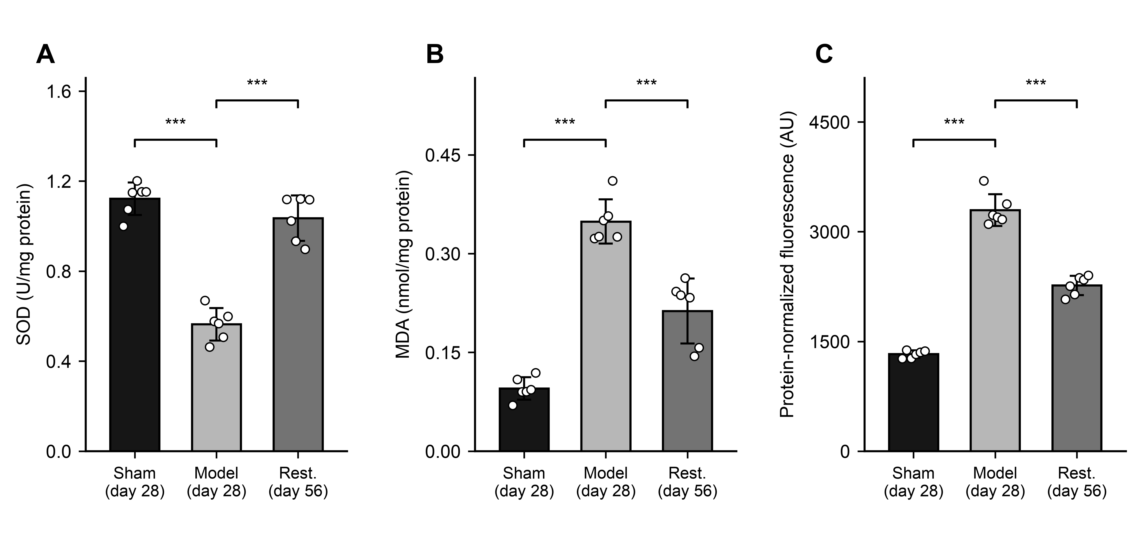
Fig. 1. Regional medullary SOD activity (A), MDA (B) and probe-associated fluorescence (C). Bars show mean ± sample SD; points indicate six independent rats/group. Brackets compare model with sham or restoration; ***P < 0.001 (Games–Howell after Welch ANOVA; three comparisons/endpoint). Fluorescence is protein-concentration-normalized AU. Sham/model: day 28; restoration: day 56. Sham, sham-operated; Rest., restoration. Full outputs: Supplementary File 3.

Figure 2
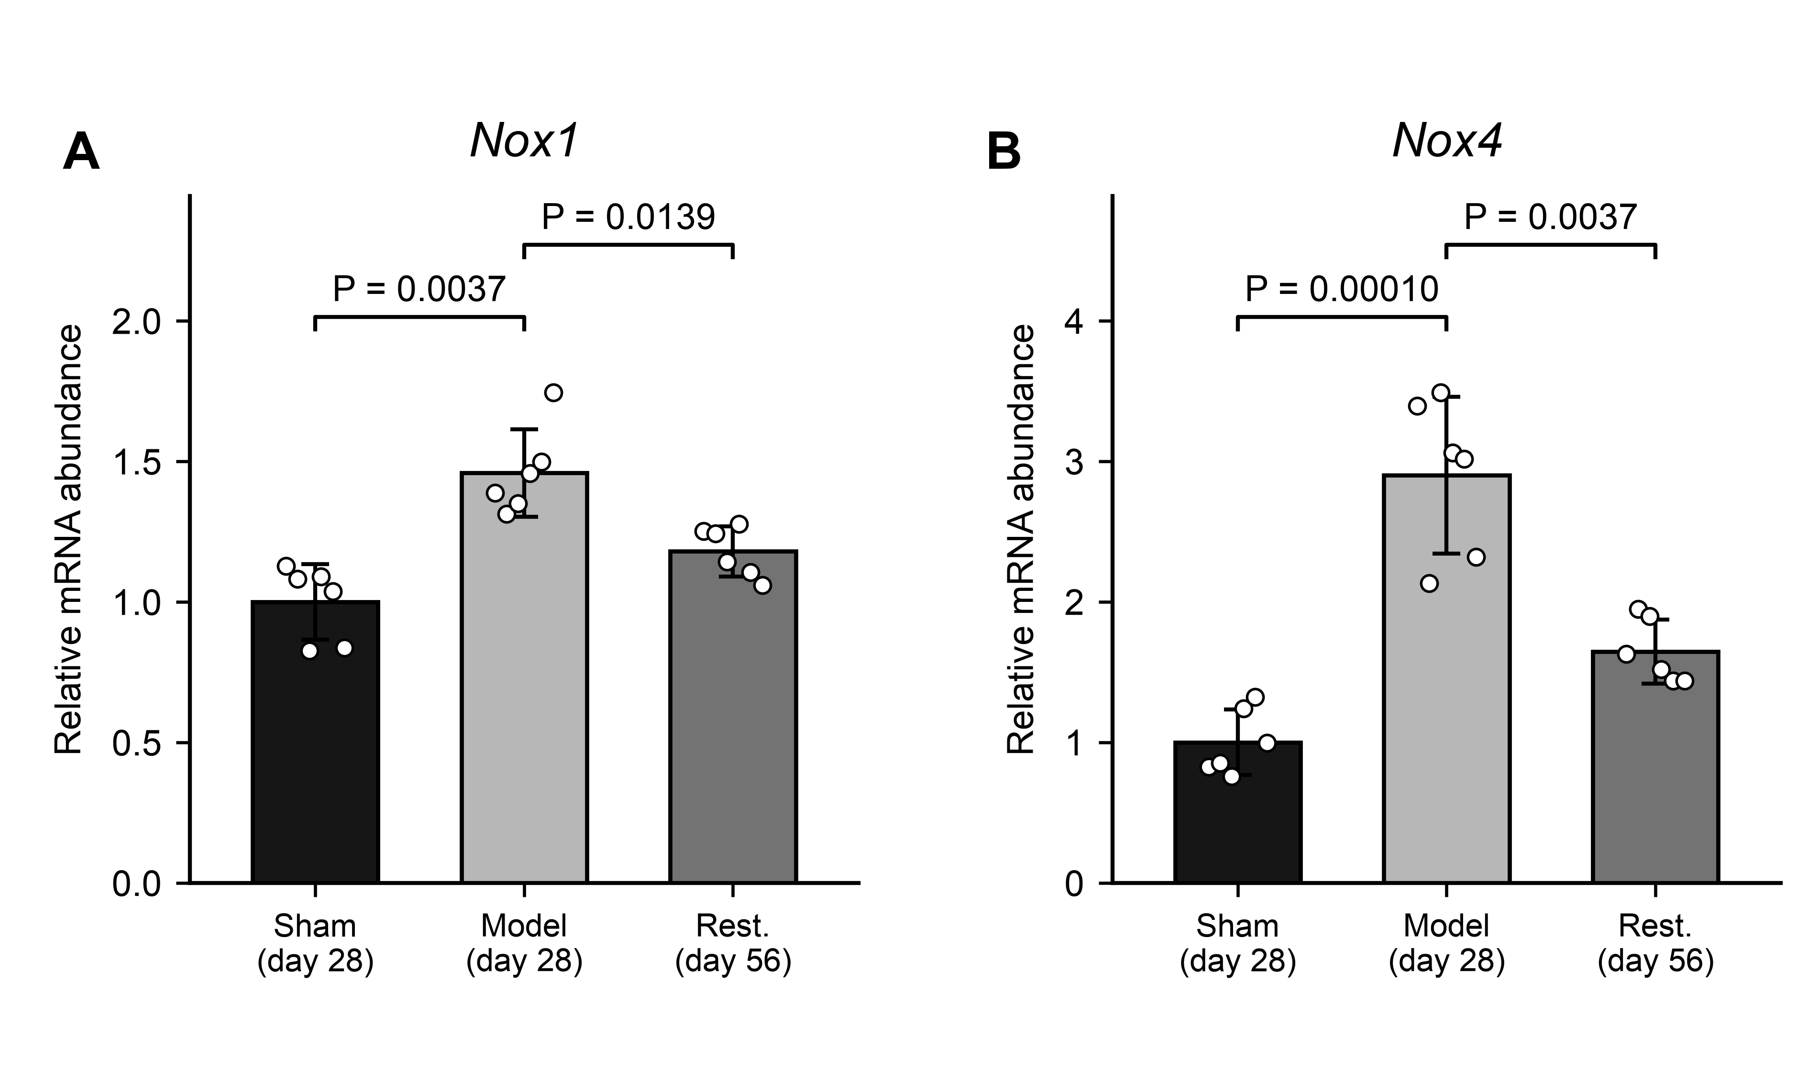
Fig. 2. Relative Nox1 (A)/Nox4 (B) transcripts; mean ± sample SD and six independent rats/group. Each rat's quantity was normalized to β-actin and the sham arithmetic mean. Brackets compare model with sham or restoration. P values: Welch tests on ΔCq, Holm-adjusted across all 18 original-panel comparisons. Sham/model: day 28; restoration: day 56. Sham, sham-operated; Rest., restoration. Full outputs: Supplementary File 4.

