Supplementary information
Regional medullary redox indices and Nox1/Nox4 mRNA expression in rats with atlantoaxial joint disorder
Xiangying Yuan, Bin Yang, Zongbao He, Youkui Lv and Zijian Wu

Data and analysis files
Supplementary Data 1. Processed values for oxidative stress measurements in medullary tissue blocks containing the RVLM and adjacent tissue shown in Fig. 1. Record order does not represent animal identifiers or establish pairing across endpoints.
Supplementary Data 2. Animal-paired RT-qPCR Cq measurements and normalized relative expression values used in Fig. 2, including Nox1, Nox4, reference Cq values, ΔCq, source worksheet column labels, and relative expression normalized to the sham group. Column labels identify source records and are not original animal identifiers.
Supplementary File 3. Medullary biochemical statistical summaries and comparisons, including Welch ANOVA statistics and degrees of freedom, Games–Howell mean differences and confidence intervals, and distribution diagnostics for the three groups.
Supplementary Appendix 1. Script reproducing medullary biochemical statistical calculations from Supplementary Data 1. Requires Python, NumPy, and SciPy.
Supplementary File 4. Complete RT-qPCR input for six targets and statistical output for all 18 comparisons in a single Holm correction family. The manuscript reports Nox1 and Nox4; the complete correction family is provided for reproducibility.
Supplementary Appendix 2. Script reproducing animal-paired RT-qPCR normalization and statistical comparisons from Supplementary File 4 and checking the 36 records in Supplementary Data 2. Requires Python, NumPy, and SciPy.
Supplementary Data 3. All 240 value positions in the three archived blood-pressure record blocks, including missing cells, original headers and identifiers, source rows and columns, and keys locating source rows. Record keys do not replace animal identities or establish terminal-group assignment or pairing across assays.
Supplementary Data 4. Original entered summaries under the model, sham-operation, and restoration labels in the archived workbook, including missing positions. Source labels are retained without treating them as verified allocations; the original sham-labelled summaries correspond numerically to the separately labelled control block. Animal counts and dispersion estimates were not imputed.
Supplementary File 5. Unmodified original blood-pressure workbook, retaining source records, labels, and embedded charts. Supplementary Fig. S2 displays the source records without adopting the inconsistent group attribution in the original embedded charts.
Supplementary File 6. Supplied H&E composite with the original Chinese group labels and scale bars. This assembled material is not an individual-animal microscope export or a complete image archive.
Supplementary Appendix 3. Conventional plotting script reproducing Supplementary Fig. S2 from Supplementary Data 3 and 4 with Arial lettering. It displays source records without animal-identity reconstruction, outlier exclusion, or inferential statistics.
Supplementary Appendix 4. Earlier individual-point plots from Supplementary Data 1 and 2, retaining the unchanged values, means and sample SDs. Supplementary Appendix 5 reproduces the current source-style bar plots (Figs. 1 and 2); requires Python, NumPy, Pandas and Matplotlib. It performs no new statistical tests.

Supplementary Figure S1
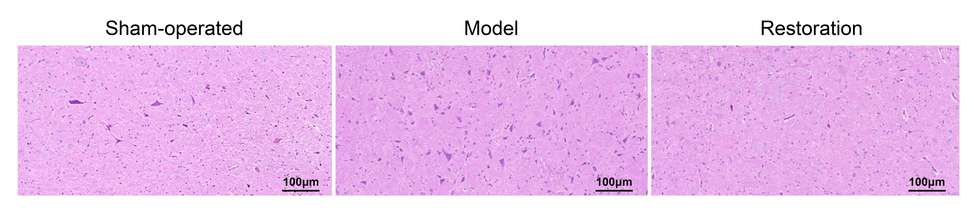
Supplementary Fig. S1. H&E images labelled sham-operated, model, and restoration in the supplied material. The three fields retain the source order and tissue pixels; the scale bars are labelled 100 μm in the source image, and calibration records were unavailable for independent inspection. These images illustrate only the appearance of the displayed fields. The number of rats contributing specimens per group, image-to-animal correspondence, and field-selection records could not be confirmed. No quantitative or between-group statistical analysis was performed. The fields do not establish within-group consistency, changes in neuronal number, or histological recovery after implant removal. Group labels outside the images are in English; the supplied composite is retained in Supplementary File 6.

Supplementary Figure S2
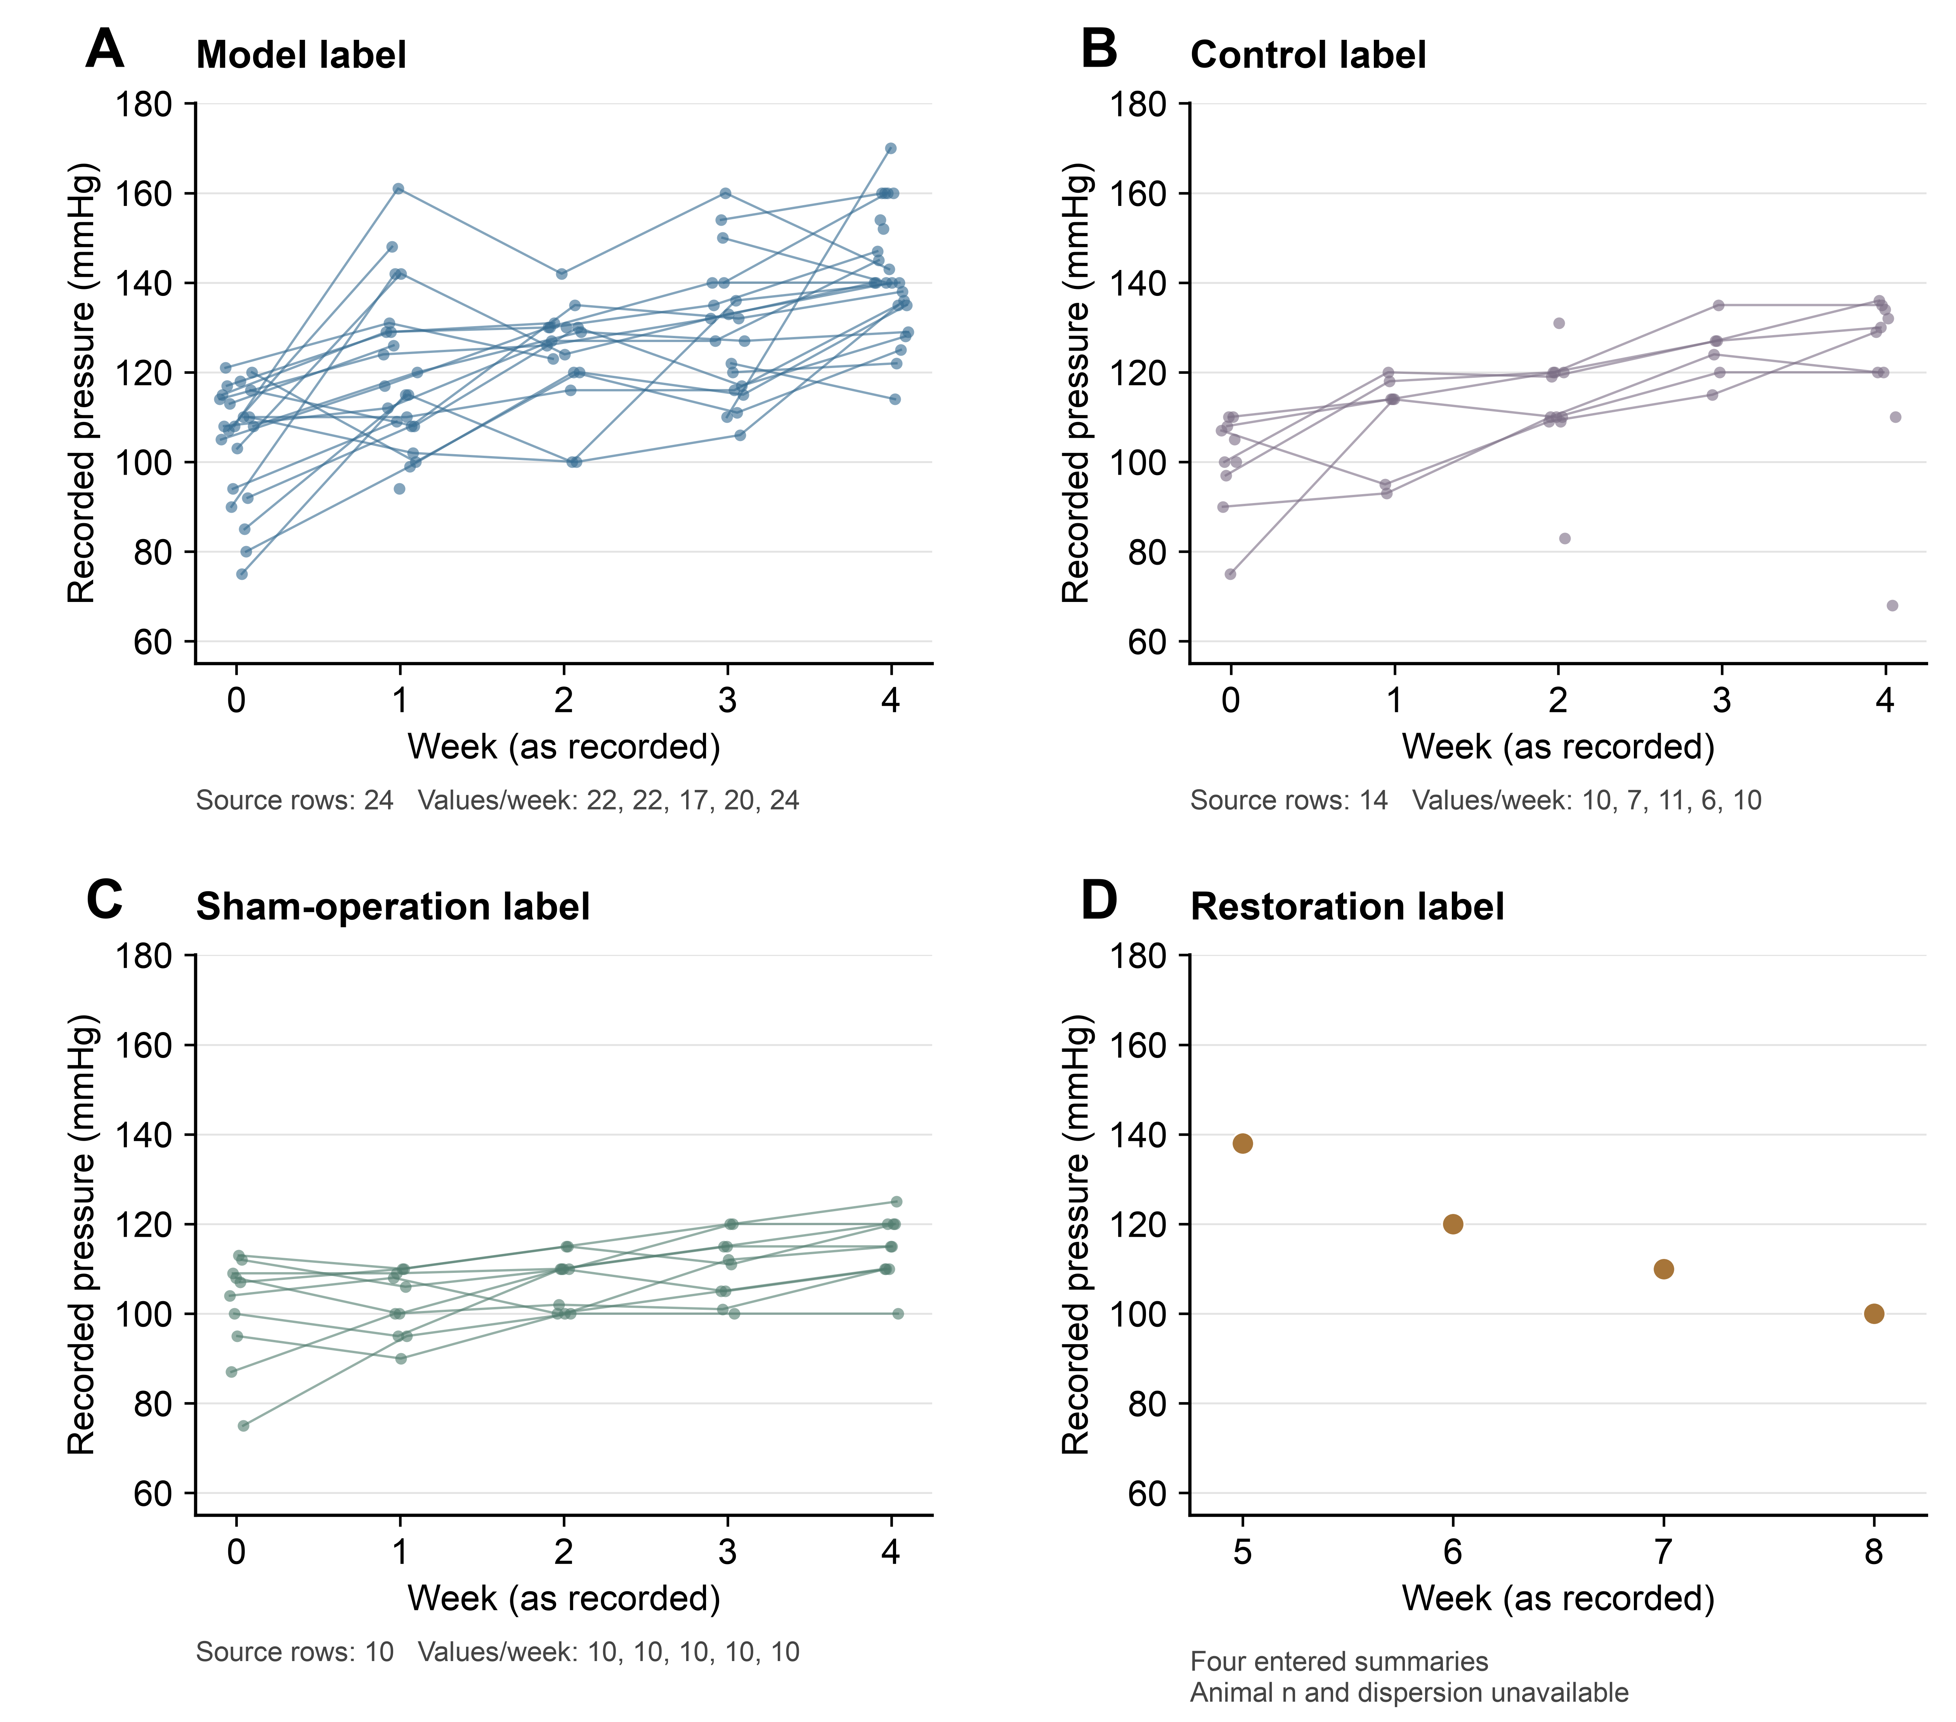
Supplementary Fig. S2. Descriptive display of blood-pressure records in the source workbook. Panels A–C show the preoperative-to-week-4 blocks originally labelled model, control, and sham operation, retaining 24, 14, and 10 source rows, respectively. These row counts are not verified independent animal sample sizes. Each point represents a stored numeric cell; lines connect only consecutive non-missing time points within the same source row. Small horizontal offsets separate overlapping records and do not denote differences in measurement time. Repeated labels are not merged, and missing observations interrupt lines. Panel D shows four entered restoration summaries at weeks 5–8; corresponding effective animal counts and dispersion estimates were unavailable. The original control label was retained without reassignment to sham or restoration. No error bars, P values, confidence intervals, or inferential statistics are shown, and the records do not establish a terminal three-group blood-pressure treatment comparison. Cell-level inputs, entered summaries, and the complete workbook are provided in Supplementary Data 3, Supplementary Data 4, and Supplementary File 5, respectively.

Supplementary Table S1
Differences in ventrolateral medullary oxidative stress markers between model and sham rats sampled at the same time.
Outcome | Model minus sham | 95% confidence interval | Adjusted P value
SOD (U/mg protein) | −0.558 | −0.672 to −0.443 | <0.001
MDA (nmol/mg protein) | 0.253 | 0.209 to 0.298 | <0.001
ROS-associated fluorescence (AU) | 1968.8 | 1683.7 to 2253.8 | <0.001
Both groups were sampled on day 28, with 6 independent rats per group for each endpoint. Differences retain the original measurement units. Confidence intervals and P values were obtained from the three-group Games–Howell comparisons within each endpoint, without correction across endpoints. Fluorescence is reported in protein-normalized arbitrary units. These results describe group differences in regional tissue blocks and do not establish that NOX expression mediates blood pressure changes. Fluorescence is not an absolute ROS concentration. Full comparisons are provided in Supplementary File 3.

Supplementary Methods and extended results
Detailed experimental procedures, source-flow information and complete numerical results are provided below. Reference numbers refer to the accompanying Short Communication.

Animals and ethics
Healthy clean-grade male Wistar rats, approximately 12 weeks old and weighing approximately 250 g, were supplied by the Laboratory Animal Center of Anhui Medical University (license no. SCXK [Wan] 2017-001). Rats were housed individually in the animal laboratory of the Institute of Acupuncture and Meridian Research, Anhui University of Chinese Medicine, at 22 ± 1°C and 60% relative humidity under an artificial 12 h light/12 h dark cycle, with food and water available ad libitum. Rats acclimatized for 1 week before allocation and surgery. Male rats were selected for consistency with the previous model study [1]. Applicability to female rats was not evaluated.
All animal procedures were approved by the Animal Ethics Committee of Anhui University of Chinese Medicine (approval no. AHUCM-rats-2022032). The approval covered the 60-rat parent experiment, model induction, foreign-body removal, and terminal sampling. Animal handling followed the Chinese Guidelines on the Humane Treatment of Laboratory Animals.

Study design and sampling
The parent experiment numbered 60 rats and allocated them by random numbers to sham operation (10) or model induction (50). All sham rats survived. During model induction, 6 rats died during surgery and 3 afterward; 41 survived, including 7 with implant loss and 34 with retained implants. After imaging and blood-pressure screening on day 28, successfully modeled rats were assigned by random numbers to model, restoration, and superior cervical ganglion resection groups of 10. The remaining 4 rats with retained implants were kept in reserve and were not allocated to the three subsequent 10-rat groups. This report includes only sham, model, and restoration rats, initially 10 per group; ganglion-resection and electrophysiological results are not presented.
The implant was removed from restoration rats on day 28. Terminal sampling was on day 28 for sham and model rats and day 56 for restoration rats, without a time-matched second-surgery sham group. Each biochemical endpoint and RT-qPCR included 6 randomly selected independent rats per group, processed separately without cross-animal pooling. Target and reference Cq values were paired within each rat and measured once each. Original animal identifiers could not be matched to assay samples; numerical record order cannot establish pairing across assays or fully reconstruct premeasurement exclusions. The parent design allowed for preliminary estimates of 18% mortality and 17% implant loss to obtain at least 30 modeled rats. No single primary endpoint or formal outcome-based a priori sample-size calculation was specified.

Model induction and implant removal
The model was induced using the previously described procedure [1]. Rats were anesthetized with 2% inhaled isoflurane at a gas flow of 1 l/min. Anesthetic depth was monitored using respiratory rate and rhythm, the righting reflex, and the response to a noxious stimulus. After shaving and povidone-iodine disinfection, an anterior cervical incision was made, subcutaneous tissue and muscle were separated, and the trachea was displaced to the right to expose the left atlantoaxial joint. With the head rotated to the right, a disinfected S-shaped aluminum implant was inserted into the joint space, secured, and the incision closed. Penicillin sodium was administered intramuscularly at 400,000–800,000 units/kg once daily for 3 days. No postoperative analgesics were administered. Available records did not retain a written rationale or a specific ethics-committee opinion concerning the omission of postoperative analgesia. Food intake, activity, and the wound were checked at least daily for the first 3 postoperative days and 2–3 times per week thereafter. Nine rats died during or after model induction. Reported possible contributing factors were anesthetic overdose, cervical surgical injury, and postoperative infection; individual cause-of-death adjudication records were not retained.
Sham-operated rats underwent the same anterior cervical exposure without implantation. On day 28, implant position and joint morphology were assessed using a Definium-6000 digital X-ray system (GE). Distances between the odontoid process and the left and right lateral masses were measured on images magnified twofold. Model success required a retained implant, asymmetric joint morphology, a left–right distance difference >0.05 mm, and a systolic blood pressure increase of at least 20% relative to baseline with a plateau by week 4.
Restoration rats underwent implant removal on day 28 under the same isoflurane anesthesia. The joint was re-exposed through the original anterior approach, the head rotated rightward, and the implant removed with a needle holder before closure. Postoperative penicillin treatment was unchanged, and no postoperative analgesics were given. Systolic pressure for model screening was measured by tail cuff (IITC Life Science) at baseline and on days 7, 14, 21, and 28. The chamber was prewarmed for 10 min at 30°C; rats rested in a restrainer for 15 min. BPmon Win monitor 1.35 recorded pressure at the onset of the spindle-shaped waveform, and three readings were averaged per rat. These shared source observations [6] were not reanalyzed as a terminal three-group treatment comparison.

Terminal collection and histology
Terminal samples were collected on day 28 in sham and model rats and day 56 in restoration rats. Rats were anesthetized with 2% inhaled isoflurane at 1 l/min for abdominal aortic blood collection, followed by euthanasia with an overdose of inhaled isoflurane. Death was confirmed by the absence of spontaneous breathing, palpable cardiac activity, and withdrawal to a noxious stimulus before brainstem removal. The Paxinos and Watson rat brain atlas and a stereotaxic apparatus guided bilateral tissue collection from the RVLM region, using reference positions 12.12–12.48 mm posterior to bregma, 2.1–2.6 mm lateral, and 10.0–10.4 mm deep. The tissue blocks contained the RVLM and a small amount of adjacent medullary tissue and had a measured mass of approximately 100 mg per rat. They were regional blocks rather than precisely isolated RVLM nuclei, and samples were not pooled across animals.
Histological material from the parent experiment was prepared by perfusion with 4% paraformaldehyde in 0.1 mol/l PBS (pH 7.4), postfixation at 4°C for 24–48 h, paraffin embedding, and 4 μm sections, followed by standard hematoxylin–eosin staining. The supplied composite retains tissue and original scale-bar pixels. Specimen counts, image-to-animal correspondence, and field-selection records could not be confirmed; no quantitative histological analysis was performed.

Biochemical assays
Each medullary biochemical assay included 6 independent rats per group. Tissue was minced, ground in liquid nitrogen, lysed on ice in RIPA buffer containing 1 mmol/l PMSF, and centrifuged to collect the supernatant. Total protein concentration was measured using a BCA kit (Beyotime; cat. no. P0010). SOD activity was measured using a WST-1 assay (Nanjing Jiancheng Bioengineering Institute; cat. no. A001-3), with absorbance read at 450 nm. MDA was measured using a thiobarbituric acid (TBA) colorimetric assay (Nanjing Jiancheng Bioengineering Institute; cat. no. A003-1). The retained assay records specified absorbance measurement at 530 nm, whereas the kit manual recommended 532 nm. Both absorbance measurements used an RT-6000 microplate reader (Rayto).
ROS-associated fluorescence was measured using the proprietary green BBoxiProbe® O12 supplied with the BestBio BB-475015 kit, at excitation and emission wavelengths of 488 and 530 nm, respectively. The kit manual specifies fresh serum as the intended sample matrix; the kit was applied to medullary lysates in this study. Records validating its use in the tissue matrix or compatibility with the lysis buffer were unavailable. The fluorescence-reader model was not retained. This measurement was reported as a probe-associated fluorescence index, without assignment to a specific ROS species or absolute ROS concentration.
SOD activity was calculated by dividing the blank-corrected inhibition fraction by 0.5, multiplying by the reaction-to-sample volume ratio (0.24/0.02), and dividing by sample protein concentration (mg/ml); results were expressed as U/mg protein. MDA content was calculated from the blank-corrected sample-to-standard absorbance ratio, multiplied by a standard concentration of 10 nmol/ml, and divided by sample protein concentration; results were expressed as nmol/mg protein. Probe-associated fluorescence was divided by sample protein concentration and reported in protein-normalized arbitrary units (AU). This fluorescence index was not interpreted as an absolute quantity per unit protein mass.

Reverse transcription quantitative PCR
Reverse transcription quantitative PCR (RT-qPCR) analyses included 6 independent rats per group (n = 6). Each target and reference quantification cycle (Cq) was measured once per rat. Target and reference Cq values in the same worksheet column corresponded to the same animal and were paired within that animal. Samples were not pooled. Total RNA was extracted from medullary tissue blocks containing the RVLM using TRIzol reagent (Life Technologies; Thermo Fisher Scientific, Inc.; cat. no. 15596018). Genomic DNA was removed from 1 µg of RNA in a 10 µl reaction at 42°C for 2 min, followed by 1 min on ice. Reverse transcription was performed using PrimeScript RT reagent Kit with gDNA Eraser (Takara Bio, Inc.; cat. no. RR047A) in a 20 µl reaction at 37°C for 15 min followed by 85°C for 5 s. RT-qPCR used NovoStart SYBR qPCR SuperMix Plus (Novoprotein; cat. no. E096-01B) and a PikoReal 96 real-time PCR system (Thermo Fisher Scientific, Inc.). Each 10 µl reaction contained 5 µl of 2× SYBR mix, 1 µl each of forward and reverse primers (10 µmol/l), 1 µl of cDNA, and 2 µl of RNase-free water. Primer sequences were as follows: Nox1 forward, 5'-GCTCCAGACCTCCATTTG-3'; Nox1 reverse, 5'-CAGCCCCAACCAAGAAAC-3'; Nox4 forward, 5'-GGGTTAAACACCTCTGTC-3'; Nox4 reverse, 5'-GTAGTATTCTGGCCCTTG-3'; β-actin forward, 5'-CCCATCTATGAGGGTTACGC-3'; and β-actin reverse, 5'-TTTAATGTCACGCACGATTTC-3'. Expected amplicon lengths for Nox1, Nox4, and β-actin were 84, 95, and 150 bp, respectively. Cycling conditions were 95°C for 1 min followed by 40 cycles of 95°C for 20 s and 60°C for 1 min. Conversion to relative quantities assumed equal amplification efficiencies of approximately 100% for each target and β-actin [7]. Within-animal ΔCq was defined as target Cq minus the paired β-actin Cq. Relative quantity was calculated as $Q = 2^{−ΔCq}$. For each gene, this quantity was divided by the arithmetic mean of the relative quantities from the 6 sham-operated rats, giving the sham-operated group an arithmetic mean of 1. Amplification efficiencies and reference-gene stability were not validated. The assay reports mentioned amplification and melting-curve results, but the original curves were unavailable for inspection. Records of no-template controls (NTC) and no-reverse-transcription controls (no-RT) were also unavailable.

Statistical analysis
Statistical analyses used individual rats as experimental units and report mean ± sample SD. All six supplied values per group were included; no outliers were removed or missing values imputed. Repeated measurements did not increase biological n. Biochemical endpoints were compared using Welch’s one-way ANOVA and Games–Howell comparisons, with 95% confidence intervals. Shapiro–Wilk tests were diagnostic, with limited sensitivity at n = 6. Adjustment covered the three comparisons within each endpoint, not across the three biochemical endpoints. Tests were two-sided, with α = 0.05. Processed inputs, full outputs and software versions, and reproduction code are provided in Supplementary Data 1, File 3, and Appendix 1.
RT-qPCR inference used within-animal ΔCq values and independent-group Welch t tests. All 18 comparisons across the original six-target panel (AT1-R, Nox1, Nox4, RhoA, ROCK1, and ROCK2) formed one Holm correction family; correction was not restricted to the displayed genes. Supplementary Data 2, File 4, and Appendix 2 provide paired inputs, complete t statistics, degrees of freedom and exact P values, and reproducible code. Animal overlap across assays was not recoverable, so no cross-assay correlations were tested. Archived blood-pressure and H&E materials were displayed without new inferential tests. Model–sham comparisons use day-28 samples; comparisons involving restoration use day-56 samples.

Extended results

Regional medullary biochemical indices
Each biochemical endpoint included 6 independent rats per group. Across the three terminal cohorts, Welch's ANOVA identified differences in SOD activity, F(2, 9.816) = 91.626; MDA, F(2, 8.500) = 130.738; and probe-associated fluorescence, F(2, 7.804) = 314.907 (all P < 0.001). In the same-time day-28 comparison, model rats had lower SOD activity than sham rats (0.564 ± 0.072 versus 1.122 ± 0.072 U/mg protein), higher MDA (0.349 ± 0.034 versus 0.095 ± 0.017 nmol/mg protein), and higher probe-associated fluorescence (3295.6 ± 216.3 versus 1326.9 ± 50.6 AU; Fig. 1). All three model–sham Games–Howell-adjusted P values were <0.001. Model–sham mean differences and 95% confidence intervals are provided in Supplementary Table S1; complete three-group outputs are in Supplementary File 3.

Nox1 and Nox4 transcripts in the day-28 comparison
Animal-paired target and reference Cq measurements were available for 6 rats per group. Estimated Nox1 expression was higher in model rats than in sham rats (1.459 ± 0.156 versus 1.000 ± 0.134), as was Nox4 expression (2.902 ± 0.558 versus 1.000 ± 0.233; Fig. 2A and B). The corresponding Holm-adjusted P values were 0.0037 and 0.0001. These P values use one correction family comprising all 18 comparisons in the original six-target panel. Complete results are provided in Supplementary File 4.

Observations at the later restoration endpoint
Restoration rats were sampled on day 56, four weeks after implant removal. SOD activity was 1.035 ± 0.101 U/mg protein, MDA was 0.213 ± 0.049 nmol/mg protein, and probe-associated fluorescence was 2265.6 ± 131.6 AU (Fig. 1). Compared with model rats sampled on day 28, restoration rats had higher SOD activity and lower MDA and fluorescence (all Games–Howell-adjusted P < 0.001). Relative to sham rats, restoration rats had higher MDA (adjusted P = 0.0033) and fluorescence (adjusted P < 0.001); the SOD difference was not statistically significant (adjusted P = 0.2534).
Estimated Nox1 and Nox4 expression in restoration rats was 1.180 ± 0.090 and 1.645 ± 0.227, respectively (Fig. 2; n = 6). Both were lower than in model rats, with Holm-adjusted P values of 0.0139 and 0.0037. Compared with sham rats, estimated Nox4 expression was higher (P = 0.0099), whereas the Nox1 difference did not meet the adjusted significance threshold (P = 0.0618). Nonsignificant SOD and Nox1 differences do not establish equivalence or normalization. Comparisons involving restoration rats span different terminal sampling times and cannot isolate an implant-removal effect.

Archived histology and blood-pressure records
The archived H&E fields show nuclear staining and varied cellular profiles (Supplementary Fig. S1). Unconfirmed specimen counts and image-to-animal correspondence limit their use to illustration; no group-level histological inference was made.
The archived blood-pressure workbook contained 24 model-labelled, 14 control-labelled and 10 sham-labelled source rows. The 10 complete sham rows matched the thesis sham summaries, but missing values and repeated identifiers prevented unique reconstruction of the present model cohort. Four entered restoration summaries remained for weeks 5–8, without animal-level dispersion. These records are displayed descriptively in Supplementary Fig. S2 and cannot independently validate the terminal cohorts (Supplementary Data 3 and 4; File 5).

