Supplementary information
Regional medullary redox profiles in rats with atlantoaxial joint disorder
Xiangying Yuan, Bin Yang, Zongbao He, Youkui Lv and Zijian Wu

Experimental methods and data interpretation
This supplement provides procedural details, numerical comparisons, qPCR annotation explanations and auxiliary observations. The manuscript and underlying thesis concern the same experiment; corresponding procedures were shared except for the anesthetic. This report uses the actual isoflurane regimen.

Tissue sampling and biochemical calculations
Bilateral atlas-guided blocks contained the RVLM and adjacent medulla. Reference coordinates were 12.12–12.48 mm posterior to bregma, 2.1–2.6 mm lateral and 10.0–10.4 mm deep. The approximately 100 mg mass referred to the regional block from one rat, not to a precisely isolated nucleus or pooled animals. Tissue was ground in liquid nitrogen, lysed on ice in RIPA with 1 mmol/l PMSF and centrifuged for supernatant collection. BCA protein concentration was used for biochemical normalization.
For SOD, the retained calculation was: inhibition fraction = 1 − (sample absorbance − sample blank)/(control absorbance − control blank). Activity = inhibition fraction/0.5 × (0.24/0.02)/protein concentration in mg/ml. The ratio 0.24/0.02 is the reaction-to-sample volume ratio, not evidence of an additional predilution. The source protocol used 20 μl sample, 20 μl enzyme solution and 200 μl substrate, with incubation at 37°C for 20 min and readout at 450 nm. Fourteen of the 18 inhibition values were outside the manufacturer-suggested 40–60% pilot optimization interval. A corresponding dilution-validation series was not retained. This recommendation was not treated as a proven hard validity boundary, and no observations were removed to force agreement with the interval.
For MDA, the retained calculation was: (sample absorbance − common blank)/(standard absorbance − common blank) × 10 nmol/ml divided by sample protein concentration in mg/ml. The result was expressed in nmol/mg protein. The experimental method specified 95°C for 40 min, cooling, centrifugation at 3500–4000 rpm for 10 min and absorbance at 530 nm. The manufacturer recommendation was 532 nm; it did not replace the recorded 530 nm. Equivalence of the two wavelengths was not independently established. The TBA chemistry was not treated as chemically specific proof of lipid peroxidation.

Table S1 Group estimates
Endpoint | Group | Week | n | Mean | SD
SOD | Sham-operated | 4 | 6 | 1.1218 | 0.0722
SOD | Model | 4 | 6 | 0.5640 | 0.0724
SOD | Restoration | 8 | 6 | 1.0352 | 0.1009
MDA-related TBA | Sham-operated | 4 | 6 | 0.0953 | 0.0171
MDA-related TBA | Model | 4 | 6 | 0.3488 | 0.0335
MDA-related TBA | Restoration | 8 | 6 | 0.2128 | 0.0494
Auxiliary O12 | Sham-operated | 4 | 6 | 1326.8795 | 50.6351
Auxiliary O12 | Model | 4 | 6 | 3295.6354 | 216.3438
Auxiliary O12 | Restoration | 8 | 6 | 2265.5740 | 131.6049

SOD: U/mg protein; MDA-related TBA: nmol/mg protein; auxiliary O12: protein-normalized arbitrary fluorescence units. Each endpoint includes six different rats per group, as confirmed by the investigators. Observation indices indicate source positions. Historical animal-to-sample and cross-assay linkage records were unavailable. SD denotes sample SD.

Table S2 Biochemical comparisons
Endpoint | Contrast | Difference | 95% GH interval | Adjusted P
SOD | Model − Sham | -0.5578 | -0.6722 to -0.4433 | 2.89e-07
SOD | Rest. − Sham | -0.0866 | -0.2278 to 0.0546 | 0.2534
SOD | Rest. − Model | 0.4712 | 0.3298 to 0.6125 | 1.66e-05
MDA | Model − Sham | 0.2535 | 0.2089 to 0.2981 | 1.04e-06
MDA | Rest. − Sham | 0.1175 | 0.0527 to 0.1824 | 0.0033
MDA | Rest. − Model | -0.1359 | -0.2042 to -0.0676 | 0.000964
O12 | Model − Sham | 1968.7559 | 1683.7202 to 2253.7917 | 3.43e-06
O12 | Rest. − Sham | 938.6945 | 765.5711 to 1111.8178 | 4.41e-06
O12 | Rest. − Model | -1030.0615 | -1323.5608 to -736.5622 | 1.83e-05

GH, Games–Howell. Adjustment and intervals cover the three pairwise contrasts within each endpoint, without cross-endpoint adjustment. Units match Table S1. Sham/model samples were collected at week 4 and restoration samples at week 8. Differences involving restoration are not paired treatment changes. Exact omnibus statistics and all comparison outputs are in Supplementary_Statistical_Results.json.

Targeted RT qPCR procedures and qualifications
Total RNA extraction used TRIzol (15596026). Genomic DNA removal used 1 μg RNA in a 10 μl reaction at 42°C for 2 min, followed by 1 min on ice. PrimeScript RR047A reverse transcription used a 20 μl reaction at 37°C for 15 min and 85°C for 5 s. PikoReal 96 reactions used NovoStart SYBR qPCR SuperMix Plus (E096-01B). Each 10 μl reaction contained 5 μl 2× SYBR mix, 1 μl of each 10 μmol/l primer, 1 μl cDNA and 2 μl RNase-free water. Cycling and melting conditions are reported in the main Methods.

Table S3 Primer sequences
Target | Forward primer 5′ to 3′ | Reverse primer 5′ to 3′ | Expected bp
Nox1 | GCTCCAGACCTCCATTTG | CAGCCCCAACCAAGAAAC | 84
Nox4 | GGGTTAAACACCTCTGTC | GTAGTATTCTGGCCCTTG | 95
Actb | CCCATCTATGAGGGTTACGC | TTTAATGTCACGCACGATTTC | 150

Primer-product lengths are expected design values. Supplementary File 1 contains amplification and melting exports, including broad, shouldered or additional melting features; the one-peak reporting limit does not verify a single product. Product identity, amplification efficiencies and β-actin stability were not validated. NTC/no-RT records were unavailable, and one measurement per assay/sample precluded assessment of technical-repeat precision. All original values were included without exclusions based on melt profiles.
For each assay, ΔCq = target Cq − paired Actb Cq; Q = 2 raised to −ΔCq. Normalized assay quantity = Q divided by the arithmetic mean Q of the six sham samples. This gives an arithmetic sham mean of 1, without setting each sham sample to 1. It is not identical to calibration by mean sham ΔCq. The estimates depend on the unverified equal-efficiency assumption. Statistical tests were performed on ΔCq, not on plotted fold values.

Table S4 Recorded Cq values and plate annotation corrections
Well | Recorded Cq result | Reference pairing | Annotation correction
B10-Ch5 | Nox1; Model; Cq 29.82 | Actb B07-Ch5: 16.22; ΔCq 13.60; summary D8/D3 | Empty/[none] → Unknown/SYBR; Nox1 and Model unchanged
D12-Ch5 | Nox4; Sham-operated; Cq 34.69 | Actb D06-Ch5: 16.37; ΔCq 18.32; summary F12/F2 | Empty/[none]/blank target → Unknown/SYBR/Nox4; Sham unchanged

Both wells have numerical Cq values in the original Cq Results worksheet and the summary workbook. Unknown is the software sample-type label for a test sample. The non-numeric Quantity entries are separate from the numerical Cq entries. The investigators confirmed the Plate annotations as errors after checking loading or laboratory records; those supporting records are not in the available archive. Both measurements were retained, with Cq values, sample assignments, reference pairings, normalization and statistical results unchanged. Original exports were preserved. Summary cell references refer to Sheet1 of 结果分析.xls.

Table S5 Full original qPCR comparison family
Recorded target | Comparison | ΔCq difference | Raw P | Holm P
AT1-R | Model vs Sham | -1.627 | 0.000189 | 0.0025
AT1-R | Rest. vs Sham | -0.850 | 0.0082 | 0.0247
AT1-R | Rest. vs Model | 0.777 | 0.000583 | 0.0047
Nox1 | Model vs Sham | -0.550 | 0.000407 | 0.0037
Nox1 | Rest. vs Sham | -0.247 | 0.0309 | 0.0618
Nox1 | Rest. vs Model | 0.303 | 0.0028 | 0.0139
Nox4 | Model vs Sham | -1.545 | 6.81e-06 | 0.000102
Nox4 | Rest. vs Sham | -0.738 | 0.0014 | 0.0099
Nox4 | Rest. vs Model | 0.807 | 0.000371 | 0.0037
RhoA | Model vs Sham | -0.567 | 2.68e-05 | 0.000376
RhoA | Rest. vs Sham | -0.312 | 0.0022 | 0.0129
RhoA | Rest. vs Model | 0.255 | 0.0029 | 0.0139
ROCK1 | Model vs Sham | -1.885 | 4.44e-06 | 7.1e-05
ROCK1 | Rest. vs Sham | -0.912 | 6.45e-09 | 1.16e-07
ROCK1 | Rest. vs Model | 0.973 | 0.000239 | 0.0029
ROCK2 | Model vs Sham | -1.518 | 1.02e-06 | 1.73e-05
ROCK2 | Rest. vs Sham | -1.093 | 0.000259 | 0.0029
ROCK2 | Rest. vs Model | 0.425 | 0.0395 | 0.0618

Holm correction covers 18 comparisons across AT1-R, Nox1, Nox4, RhoA, ROCK1 and ROCK2. The other target rows preserve the calculation family and are not additional interpreted findings or validated assay identities. ΔCq differences are numerator minus denominator; negative differences correspond to larger calculated quantities. Main-figure Nox1/Nox4 means and SDs describe arithmetic normalized quantities. Full inputs and test outputs are supplied separately.

Western blot source materials
Supplementary File 2 contains the supplied Western blot laboratory report, source Word document and original composite figure, preserved without alteration. Main Figure 3 retains the original β-actin, NOX1 and NOX4 strip images (A) and the original NOX4 (B) and NOX1 (C) summary graphs. The source document reports ImageJ analysis; β-actin is shown as a loading reference. Three rats per group were used, with summaries reported as mean ± SD, as confirmed by the investigators. The source panel displays one representative lane per group. The investigators confirmed that the source densitometry data are retained. The summary graphs reproduce the original analysis and were not independently recalculated or reanalyzed with the methods used for the present SOD, MDA or RT-qPCR results. The archived manuscript description reported one-way ANOVA and post hoc comparisons but did not name the specific post hoc test. Original significance annotations were preserved: model versus sham, P < 0.001 for both NOX4 and NOX1; restoration versus model, P < 0.01 for NOX4 and P < 0.05 for NOX1. The complete original composite was retained without changing its image content, brightness, contrast, graph values, error bars or significance annotations.

Animal welfare and source documentation
Approval AHUCM-rats-2022032, unavailable original ethics documents and the absence of postoperative analgesia are reported in the main Methods. The nine deaths comprised six intraoperative and three postoperative events. Individual cause adjudications and time-linked intervention records were not recoverable.

Supplementary Figure S1 Auxiliary fluorescence observation
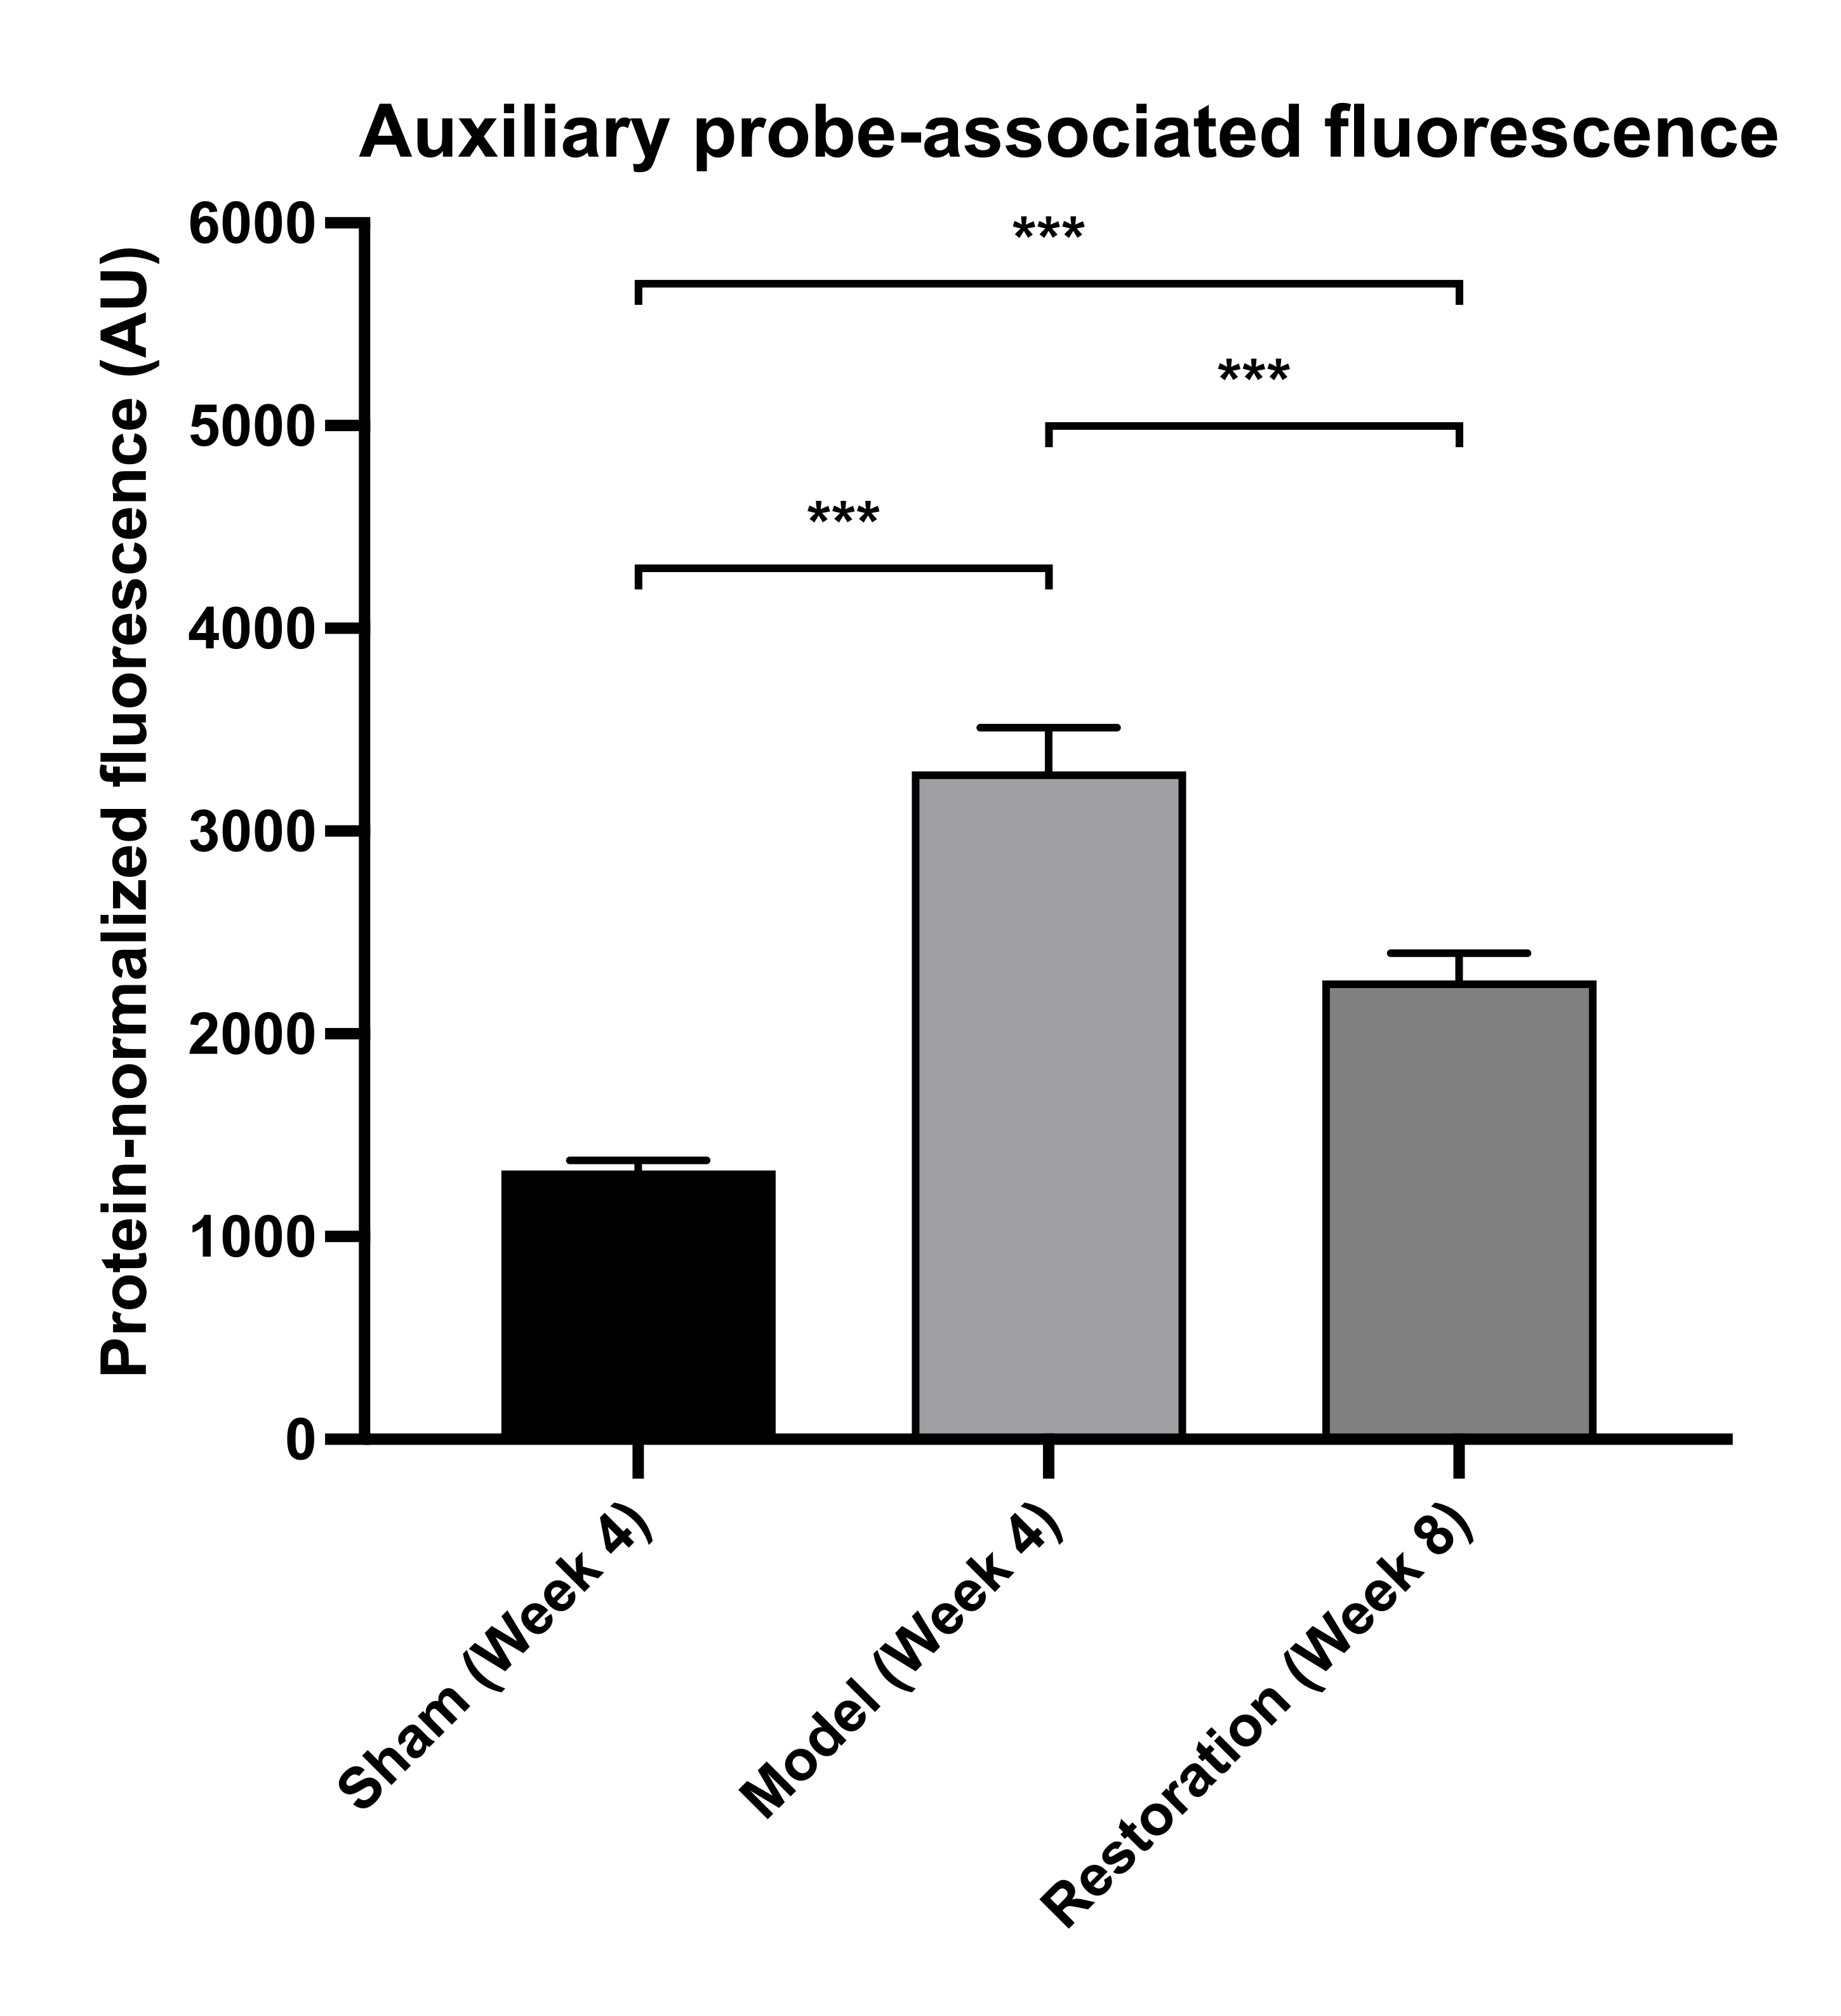
Fig. S1. Protein-normalized O12 probe-associated fluorescence in regional medullary lysates (n = 6/group). Bars show means and error bars indicate sample SD; brackets indicate Games–Howell-adjusted ***P < 0.001. AU, arbitrary units. The serum-designated BestBio BB-475015 probe was read at excitation/emission 488/530 nm; the reader model was not retained. Tissue/RIPA compatibility, spike recovery and dilutional behavior were not validated. Values are an auxiliary fluorescence index in arbitrary units and do not establish ROS concentration or source. Terminal sampling was at weeks 4, 4 and 8, as labeled; these comparisons do not isolate an implant-removal effect.

Supplementary Figure S2 Archived histological fields
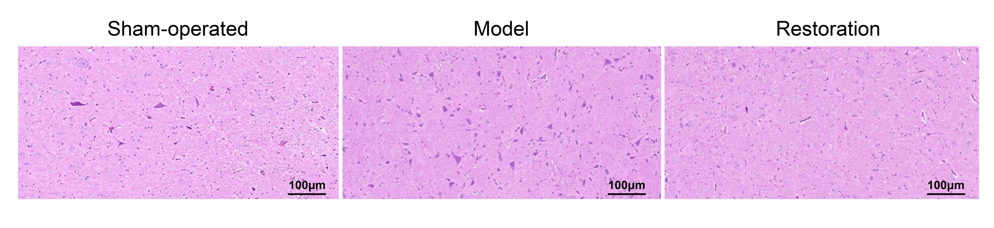
Fig. S2. Archived hematoxylin–eosin fields labeled sham-operated, model and restoration; original scale bars, 100 μm. Preparation used 4% paraformaldehyde perfusion, postfixation at 4°C for 24–48 h, paraffin embedding and 4 μm sections. Specimen counts, image-to-animal correspondence and field-selection records were unavailable. These illustrative panels do not establish group-level histological differences, neuronal injury or inflammatory-cell identity. The archived TIFF is also supplied.

