Supplementary information
Regional redox indices and Nox1 and Nox4 mRNA expression in rats with atlantoaxial joint disorder
Xiangying Yuan, Bin Yang, Zongbao He, Youkui Lv and Zijian Wu

Data and analysis files
Supplementary Data 1. Processed values for oxidative stress measurements in medullary tissue blocks containing the RVLM and adjacent tissue shown in Fig. 1. Record order does not represent animal identifiers or establish pairing across endpoints.
Supplementary Data 2. Animal-paired RT-qPCR Cq measurements and normalized relative expression values used in Fig. 2, including Nox1, Nox4, reference Cq values, ΔCq, source worksheet column labels, and relative expression normalized to the sham group. Column labels identify source records and are not original animal identifiers.
Supplementary File 3. Medullary biochemical statistical summaries and comparisons, including Welch ANOVA statistics and degrees of freedom, Games–Howell mean differences and confidence intervals, and distribution diagnostics for the three groups.
Supplementary Appendix 1. Script reproducing medullary biochemical statistical calculations from Supplementary Data 1. Requires Python, NumPy, and SciPy.
Supplementary File 4. Complete RT-qPCR input for six targets and statistical output for all 18 comparisons in a single Holm correction family. The manuscript reports Nox1 and Nox4; the complete correction family is provided for reproducibility.
Supplementary Appendix 2. Script reproducing animal-paired RT-qPCR normalization and statistical comparisons from Supplementary File 4 and checking the 36 records in Supplementary Data 2. Requires Python, NumPy, and SciPy.
Supplementary Data 3. All 240 value positions in the three archived blood-pressure record blocks, including missing cells, original headers and identifiers, source rows and columns, and keys locating source rows. Record keys do not replace animal identities or establish terminal-group assignment or pairing across assays.
Supplementary Data 4. Original entered summaries under the model, sham-operation, and restoration labels in the archived workbook, including missing positions. Source labels are retained without treating them as verified allocations; the original sham-labelled summaries correspond numerically to the separately labelled control block. Animal counts and dispersion estimates were not imputed.
Supplementary File 5. Unmodified original blood-pressure workbook, retaining source records, labels, and embedded charts. Supplementary Fig. S2 displays the source records without adopting the inconsistent group attribution in the original embedded charts.
Supplementary File 6. Supplied H&E composite with the original Chinese group labels and scale bars. This assembled material is not an individual-animal microscope export or a complete image archive.
Supplementary Appendix 3. Conventional plotting script reproducing Supplementary Fig. S2 from Supplementary Data 3 and 4 with Arial lettering. It displays source records without animal-identity reconstruction, outlier exclusion, or inferential statistics.
Supplementary Appendix 4. Script reproducing the main figures from Supplementary Data 1 and 2 with Arial lettering as 600 dpi TIFF and vector PDF. Individual values, means, sample SDs, and inferential results are unchanged.

Supplementary Figure S1
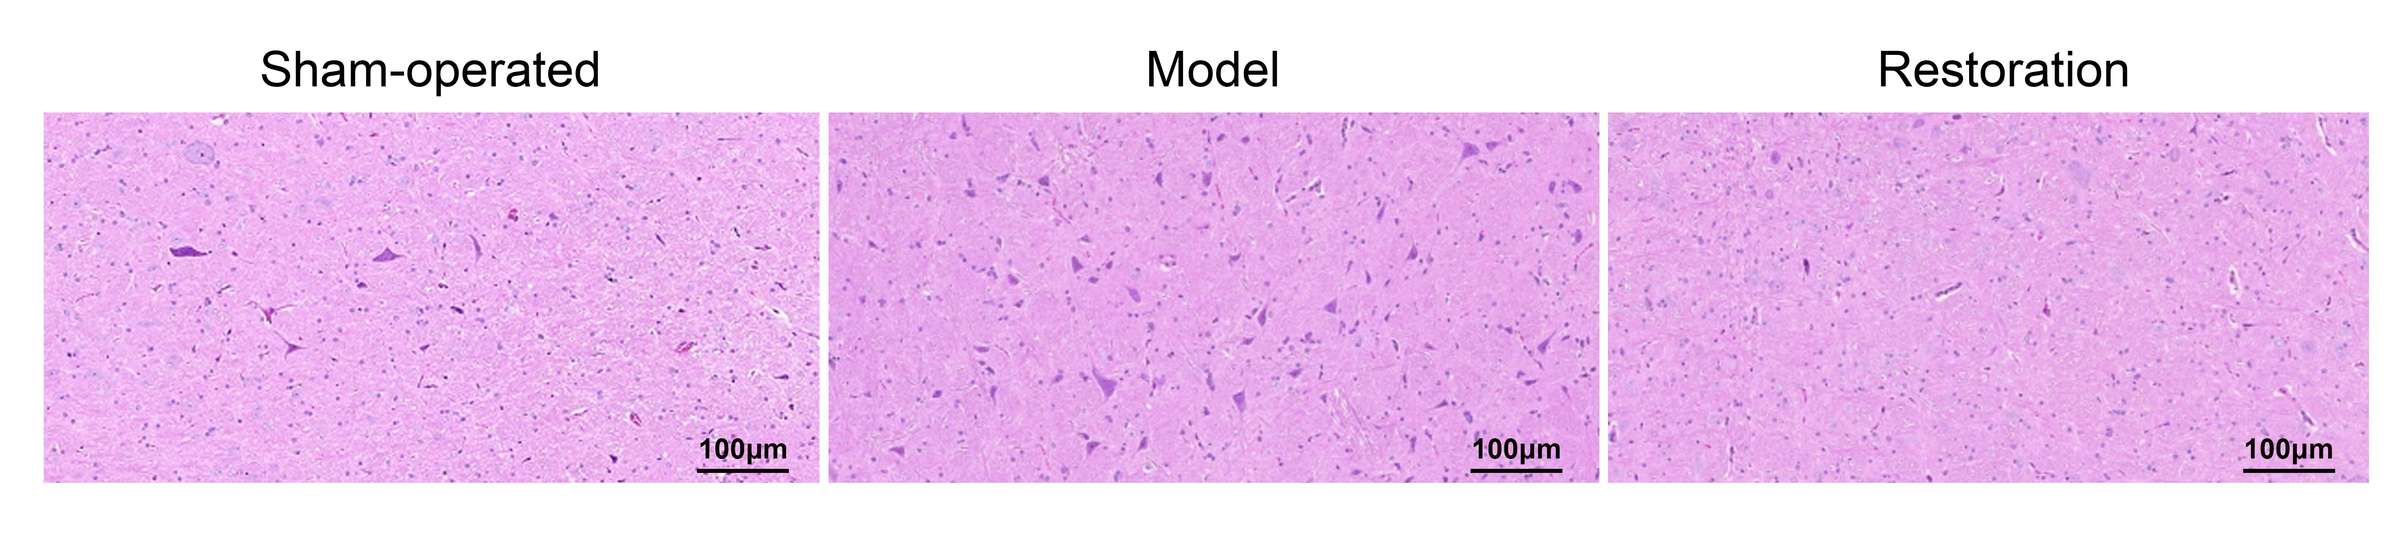
Supplementary Fig. S1. H&E images labelled sham-operated, model, and restoration in the supplied material. The three fields retain the source order and tissue pixels; the scale bars are labelled 100 μm in the source image, and calibration records were unavailable for independent inspection. These images illustrate only the appearance of the displayed fields. The number of rats contributing specimens per group, image-to-animal correspondence, and field-selection records could not be confirmed. No quantitative or between-group statistical analysis was performed. The fields do not establish within-group consistency, changes in neuronal number, or histological recovery after implant removal. Group labels outside the images are in English; the supplied composite is retained in Supplementary File 6.

Supplementary Figure S2
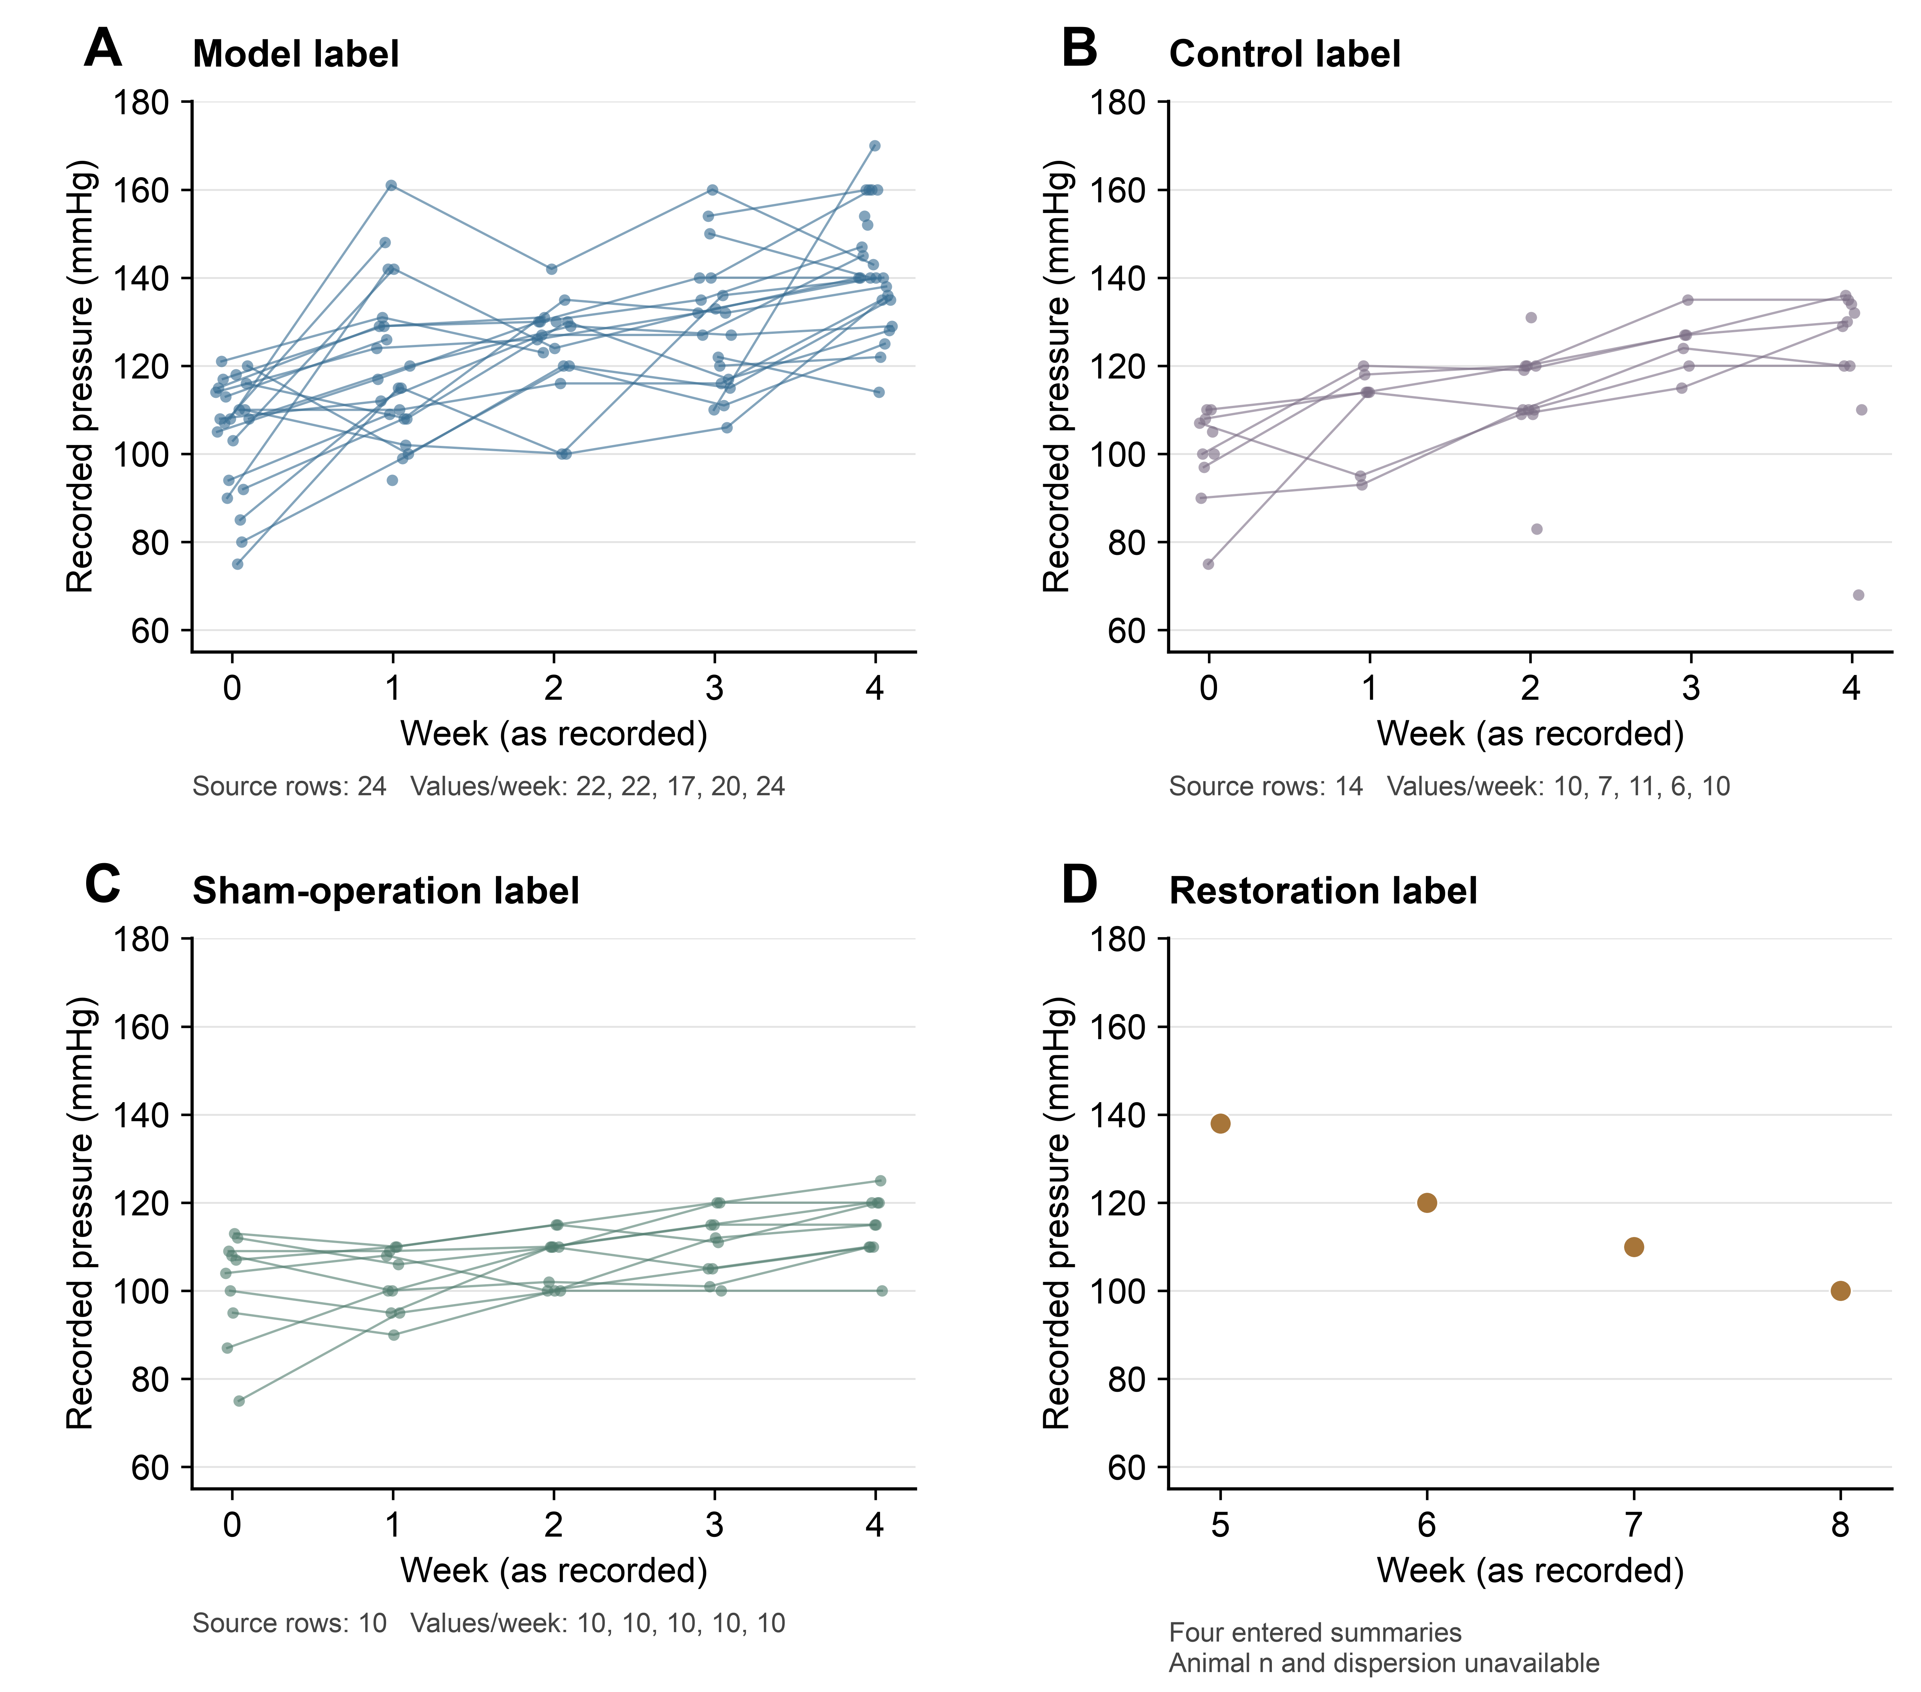
Supplementary Fig. S2. Descriptive display of blood-pressure records in the source workbook. Panels A–C show the preoperative-to-week-4 blocks originally labelled model, control, and sham operation, retaining 24, 14, and 10 source rows, respectively. These row counts are not verified independent animal sample sizes. Each point represents a stored numeric cell; lines connect only consecutive non-missing time points within the same source row. Small horizontal offsets separate overlapping records and do not denote differences in measurement time. Repeated labels are not merged, and missing observations interrupt lines. Panel D shows four entered restoration summaries at weeks 5–8; corresponding effective animal counts and dispersion estimates were unavailable. The original control label was retained without reassignment to sham or restoration. No error bars, P values, confidence intervals, or inferential statistics are shown, and the records do not establish a terminal three-group blood-pressure treatment comparison. Cell-level inputs, entered summaries, and the complete workbook are provided in Supplementary Data 3, Supplementary Data 4, and Supplementary File 5, respectively. Codex (OpenAI) assisted in developing the plotting code.

