Supplementary information
Regional medullary redox profiles in rats with atlantoaxial joint disorder
Xiangying Yuan, Bin Yang, Zongbao He, Youkui Lv and Zijian Wu

Experimental methods and data interpretation
This supplement describes assay procedures, calculations and supplementary observations.

Tissue sampling and biochemical calculations
Bilateral tissue blocks were dissected with reference to a rat brain atlas and included the RVLM and adjacent medulla. Reference coordinates were 12.12–12.48 mm posterior to bregma, 2.1–2.6 mm lateral and 10.0–10.4 mm deep. The bilateral sample weighed approximately 100 mg per rat in total; tissue was neither restricted to the RVLM nor pooled across animals. Tissue was ground in liquid nitrogen, lysed on ice in RIPA buffer containing 1 mmol/l PMSF and centrifuged. Supernatant protein concentration was measured by BCA assay and used for biochemical normalization.
SOD activity was calculated as follows: inhibition fraction = 1 − (sample absorbance − sample blank)/(control absorbance − control blank); activity = inhibition fraction/0.5 × (0.24/0.02)/protein concentration in mg/ml. The ratio 0.24/0.02 represents the reaction-to-sample volume ratio, not an additional predilution. Reactions contained 20 μl sample, 20 μl enzyme solution and 200 μl substrate, were incubated at 37°C for 20 min and were read at 450 nm. Fourteen of the 18 inhibition values were outside the manufacturer's suggested 40–60% interval for pilot optimization. This interval was not treated as a proven validity threshold, and no observations were excluded on this basis.
The MDA-related signal was calculated as (sample absorbance − common blank)/(standard absorbance − common blank) × 10 nmol/ml, divided by sample protein concentration in mg/ml. Results were expressed as nmol/mg protein. Reaction mixtures were heated at 95°C for 40 min, cooled and centrifuged at 3500–4000 rpm for 10 min before absorbance was measured at 530 nm. The manufacturer's recommended wavelength was 532 nm; the experiment used 530 nm, and equivalence between the two settings was not independently established. TBA reactivity was not interpreted as chemically specific evidence of lipid peroxidation.

Table S1 Group estimates
Endpoint | Group | Week | n | Mean | SD
SOD | Sham-operated | 4 | 6 | 1.1218 | 0.0722
SOD | Model | 4 | 6 | 0.5640 | 0.0724
SOD | Restoration | 8 | 6 | 1.0352 | 0.1009
MDA-related TBA | Sham-operated | 4 | 6 | 0.0953 | 0.0171
MDA-related TBA | Model | 4 | 6 | 0.3488 | 0.0335
MDA-related TBA | Restoration | 8 | 6 | 0.2128 | 0.0494
Auxiliary O12 | Sham-operated | 4 | 6 | 1326.8795 | 50.6351
Auxiliary O12 | Model | 4 | 6 | 3295.6354 | 216.3438
Auxiliary O12 | Restoration | 8 | 6 | 2265.5740 | 131.6049

SOD, U/mg protein; MDA-related TBA signal, nmol/mg protein; O12 fluorescence, protein-normalized arbitrary units. Each assay included six different rats per group, as confirmed by the investigators. Observation indices identify positions in the source files. Animal–sample and cross-assay linkage records were unavailable. SD, sample standard deviation.

Table S2 Biochemical comparisons
Endpoint | Contrast | Difference | 95% GH interval | Adjusted P
SOD | Model − Sham | -0.5578 | -0.6722 to -0.4433 | 2.89e-07
SOD | Rest. − Sham | -0.0866 | -0.2278 to 0.0546 | 0.2534
SOD | Rest. − Model | 0.4712 | 0.3298 to 0.6125 | 1.66e-05
MDA | Model − Sham | 0.2535 | 0.2089 to 0.2981 | 1.04e-06
MDA | Rest. − Sham | 0.1175 | 0.0527 to 0.1824 | 0.0033
MDA | Rest. − Model | -0.1359 | -0.2042 to -0.0676 | 0.000964
O12 | Model − Sham | 1968.7559 | 1683.7202 to 2253.7917 | 3.43e-06
O12 | Rest. − Sham | 938.6945 | 765.5711 to 1111.8178 | 4.41e-06
O12 | Rest. − Model | -1030.0615 | -1323.5608 to -736.5622 | 1.83e-05

GH, Games–Howell. Adjusted comparisons and confidence intervals cover the three pairwise contrasts within each endpoint, without adjustment across endpoints. Units are given in Table S1. Sham and model rats were sampled at week 4, and restoration rats at week 8. Comparisons involving restoration rats are between independent groups, not paired treatment changes. Omnibus statistics and all comparison outputs are provided in Supplementary_Statistical_Results.json.

Targeted RT-qPCR methods and limitations
Total RNA was extracted with TRIzol (15596026). Genomic DNA was removed from 1 μg RNA in a 10 μl reaction at 42°C for 2 min, followed by 1 min on ice. Reverse transcription was performed with PrimeScript RR047A in a 20 μl reaction at 37°C for 15 min and 85°C for 5 s. Reactions on the PikoReal 96 used NovoStart SYBR qPCR SuperMix Plus (E096-01B). Each 10 μl reaction contained 5 μl 2× SYBR mix, 1 μl of each 10 μmol/l primer, 1 μl cDNA and 2 μl RNase-free water. Cycling and melting conditions are given in the main Methods.

Table S3 Primer sequences
Target | Forward primer 5′ to 3′ | Reverse primer 5′ to 3′ | Expected bp
Nox1 | GCTCCAGACCTCCATTTG | CAGCCCCAACCAAGAAAC | 84
Nox4 | GGGTTAAACACCTCTGTC | GTAGTATTCTGGCCCTTG | 95
Actb | CCCATCTATGAGGGTTACGC | TTTAATGTCACGCACGATTTC | 150

Product lengths are the expected values from primer design. The amplification and melting exports in Supplementary File 1 include broad peaks, shoulders and additional melting features. The software's single-peak reporting limit does not confirm a single product. Product identity, amplification efficiency and β-actin stability were not validated. NTC/no-RT records were unavailable. Each assay was measured once per sample, so technical-repeat precision could not be assessed. All original values were retained; no samples were excluded on the basis of their melt profiles.
For each assay, ΔCq = target Cq − paired Actb Cq and Q = 2 raised to −ΔCq. Q was divided by the arithmetic mean Q of the six sham samples to obtain the normalized assay quantity. The sham-group arithmetic mean is therefore 1, but individual sham values are not set to 1. This calculation differs from calibration using mean sham ΔCq and depends on the unverified assumption of equal amplification efficiencies. Statistical comparisons used ΔCq rather than the plotted relative quantities.

Table S4 Full original qPCR comparison family
Recorded target | Comparison | ΔCq difference | Raw P | Holm P
AT1-R | Model vs Sham | -1.627 | 0.000189 | 0.0025
AT1-R | Rest. vs Sham | -0.850 | 0.0082 | 0.0247
AT1-R | Rest. vs Model | 0.777 | 0.000583 | 0.0047
Nox1 | Model vs Sham | -0.550 | 0.000407 | 0.0037
Nox1 | Rest. vs Sham | -0.247 | 0.0309 | 0.0618
Nox1 | Rest. vs Model | 0.303 | 0.0028 | 0.0139
Nox4 | Model vs Sham | -1.545 | 6.81e-06 | 0.000102
Nox4 | Rest. vs Sham | -0.738 | 0.0014 | 0.0099
Nox4 | Rest. vs Model | 0.807 | 0.000371 | 0.0037
RhoA | Model vs Sham | -0.567 | 2.68e-05 | 0.000376
RhoA | Rest. vs Sham | -0.312 | 0.0022 | 0.0129
RhoA | Rest. vs Model | 0.255 | 0.0029 | 0.0139
ROCK1 | Model vs Sham | -1.885 | 4.44e-06 | 7.1e-05
ROCK1 | Rest. vs Sham | -0.912 | 6.45e-09 | 1.16e-07
ROCK1 | Rest. vs Model | 0.973 | 0.000239 | 0.0029
ROCK2 | Model vs Sham | -1.518 | 1.02e-06 | 1.73e-05
ROCK2 | Rest. vs Sham | -1.093 | 0.000259 | 0.0029
ROCK2 | Rest. vs Model | 0.425 | 0.0395 | 0.0618

Holm correction covers 18 comparisons across AT1-R, Nox1, Nox4, RhoA, ROCK1 and ROCK2. The other targets are included to preserve the original calculation family; they are not interpreted as additional findings or confirmed assay identities. ΔCq differences are numerator minus denominator, with negative differences corresponding to larger calculated quantities. Means and SDs for Nox1/Nox4 in the main figure describe arithmetic normalized quantities. Full inputs and test outputs are provided separately.

Western blot source materials
Supplementary File 2 contains the Western blot laboratory report, source Word document, original composite figure and separately supplied chart TIFFs. These source files are provided without alteration. Main Figure 3 combines the original β-actin, NOX1 and NOX4 strip images (A) with the NOX4 (B) and NOX1 (C) summary graphs. Layout, labels and annotation line styles were reformatted; blot content, bar heights, displayed error ranges and star counts were retained. The source report describes ImageJ analysis, with β-actin shown as a loading reference. Three rats per group were used, and results were reported as mean ± SD, as confirmed by the investigators. One representative lane is shown per group. The investigators confirmed that the original densitometry data are retained. The summary analysis was not independently recalculated for this report. The archived methods describe one-way ANOVA and post hoc comparisons. The original pairwise results were retained: model versus sham, P < 0.001 for both proteins; restoration versus model, P < 0.01 for NOX4 and P < 0.05 for NOX1.

Animal welfare and source documentation
Ethical approval (AHUCM-rats-2022032) and the omission of postoperative analgesia are reported in the main Methods. Six deaths occurred intraoperatively and three postoperatively, for a total of nine.

Supplementary Figure S1 Auxiliary fluorescence observation
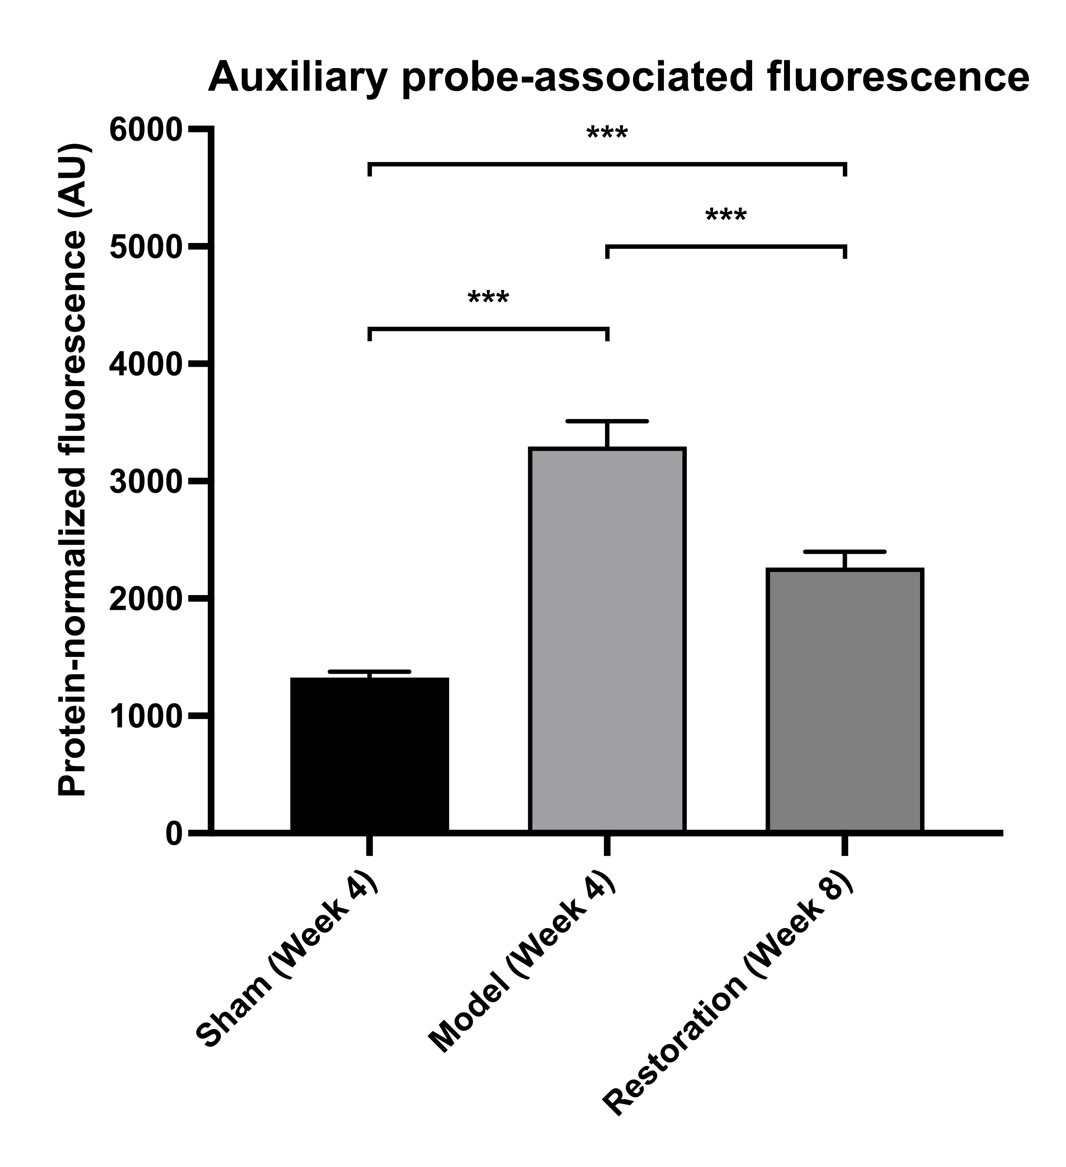
Fig. S1. Protein-normalized O12 probe-associated fluorescence in regional medullary lysates (n = 6/group). Bars show mean ± sample SD. Brackets indicate Games–Howell comparisons (***P < 0.001 for all comparisons). AU, arbitrary units. The serum-designated BestBio BB-475015 probe was read at excitation/emission wavelengths of 488/530 nm; the reader model could not be retrieved. Tissue/RIPA compatibility, spike recovery and dilutional behavior were not validated. These values are an auxiliary fluorescence index and do not establish ROS concentration or source. Terminal sampling was at weeks 4, 4 and 8, as labeled; the comparisons do not isolate an effect of implant removal.

Supplementary Figure S2 Archived histological fields
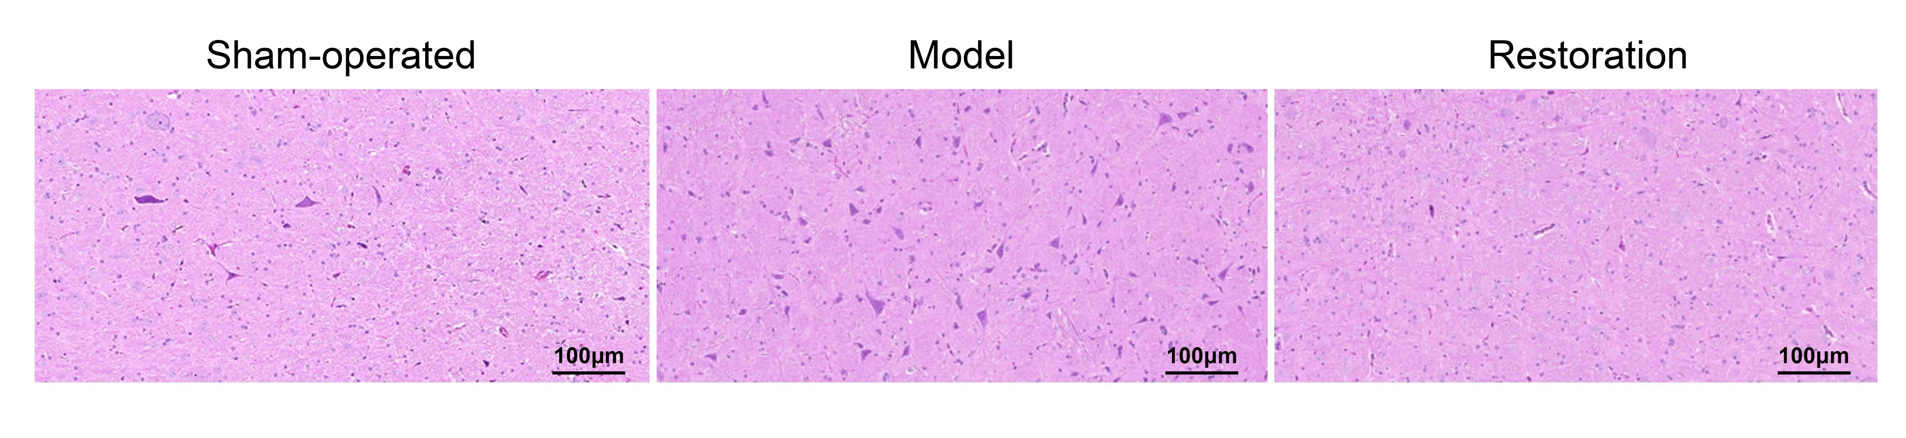
Fig. S2. Archived hematoxylin–eosin images labeled sham-operated, model and restoration. Original scale bars, 100 μm. Tissue preparation comprised perfusion with 4% paraformaldehyde, postfixation at 4°C for 24–48 h, paraffin embedding and sectioning at 4 μm. Specimen counts, image-to-animal correspondence and field-selection records were unavailable. The images are illustrative and do not establish group-level histological differences, neuronal injury or inflammatory-cell identity. The archived TIFF is also provided.

