Regional medullary redox profiles in rats with atlantoaxial joint disorder
Xiangying Yuan¹, Bin Yang², Zongbao He¹, Youkui Lv², Zijian Wu¹
¹ School of Acupuncture and Tuina, Anhui University of Chinese Medicine, Hefei, Anhui 230012, China
² Department of Rehabilitation and Physiotherapy, Anhui Provincial Corps Hospital, Hefei, Anhui 230041, China

Corresponding authors
Zijian Wu, School of Acupuncture and Tuina, Anhui University of Chinese Medicine, Hefei, Anhui 230012, China. Email: wuzijian@ahtcm.edu.cn
Youkui Lv, Department of Rehabilitation and Physiotherapy, Anhui Provincial Corps Hospital, Hefei, Anhui 230041, China. Email: lvyk126@126.com
Article type: Original Article
Running title: Medullary redox profiles in atlantoaxial disorder

Summary
Atlantoaxial joint disorder has been associated with elevated blood pressure in rats, but accompanying changes in medullary redox biochemistry are poorly characterized. We measured superoxide dismutase (SOD) activity, thiobarbituric acid (TBA)-derived malondialdehyde (MDA)-related signals and Nox1/Nox4-targeted RT-qPCR quantities. Male Wistar rats underwent sham exposure or atlantoaxial implantation. Sham and model groups were sampled at week 4. A separate restoration group underwent implant removal at week 4 and sampling at week 8. Tissue blocks contained the rostral ventrolateral medulla and adjacent medulla. Each biochemical and RT-qPCR assay used six independently processed rats per group; Western blotting used three. At week 4, SOD activity was lower in model than sham rats (0.564 ± 0.072 versus 1.122 ± 0.072 U/mg protein), whereas the MDA-related signal was higher (0.349 ± 0.034 versus 0.095 ± 0.017 nmol/mg protein; both adjusted P < 0.001). Nox1/Nox4-targeted quantities were also higher, but unconfirmed product specificity prevented their interpretation as transcript abundance. NOX1/NOX4 protein signals were higher in model than sham rats. At week 8, SOD activity in restoration rats was 1.035 ± 0.101 U/mg protein and the MDA-related signal was 0.213 ± 0.049 nmol/mg protein. These findings indicate altered regional medullary biochemistry in the model. Differences in sampling time prevent attribution of the later findings to implant removal, and the results do not establish a NOX-mediated mechanism.
Key words: Atlantoaxial joint; Medulla oblongata; Superoxide dismutase; Malondialdehyde; Oxidative stress

Introduction
Atlantoaxial joint misalignment has been associated with increased arterial pressure in rats [1]. This model allows the physiological consequences of an upper cervical joint disturbance to be studied under controlled conditions. A related study examined angiotensin II (Ang II) and its type 1 receptor (AT1-R) in the rostral ventrolateral medulla (RVLM) [2]. Whether this model is accompanied by changes in regional medullary redox biochemistry remains unclear.
The RVLM contains bulbospinal neurons that regulate sympathetic vasomotor activity [3]. Its contribution to blood-pressure control depends on physiological conditions, including oxygen availability, baroreceptor input and anesthesia [4]. Local redox regulation may influence this function. In spontaneously hypertensive rats, reduced RVLM antioxidant-enzyme activity has been associated with hypertension, and local antioxidant-enzyme gene transfer lowered arterial pressure [5]. Ang II-induced pressor responses have been linked to NADPH oxidase-dependent signaling in the RVLM [6]. Mitochondrial processes can also contribute to redox disturbances in this region [7].
NOX1 and NOX4 are potential contributors to regional redox regulation, with distinct regulatory properties and subcellular localization [8]. SOD activity and TBA-derived MDA-related signals provide complementary measures of antioxidant activity and oxidation-related biochemistry, although their interpretation depends on assay specificity [9]. These measurements may help characterize the medullary changes accompanying atlantoaxial joint disorder.
We therefore measured SOD activity and MDA-related signals in medullary tissue containing the RVLM, assessed NOX1 and NOX4 by Western blotting, and performed RT-qPCR targeting Nox1 and Nox4. We compared model and sham rats sampled at week 4 and separately examined a restoration group sampled at week 8, four weeks after implant removal.

Methods

Animals and experimental design
Animal care and experimental procedures followed the institutional guidelines of Anhui University of Chinese Medicine. The animal experiment was approved by the Animal Ethics Committee of Anhui University of Chinese Medicine (AHUCM-rats-2022032). Male Wistar rats, approximately 12 weeks old and weighing approximately 250 g, were obtained from the Laboratory Animal Center of Anhui Medical University. They were housed individually at 22 ± 1°C and 60% relative humidity under a 12 h light/12 h dark cycle, with free access to food and water. Rats were acclimatized for 1 week before the experiment. Environmental enrichment was not documented. Male rats were used to maintain consistency with the earlier model study.
Sixty rats were assigned by random numbers to sham operation (n = 10) or model induction (n = 50). Six rats died during model induction and three died postoperatively. Of the 41 survivors, seven lost their implants and 34 retained them. After screening, 30 successfully modeled rats were randomly allocated to the model, restoration or superior cervical ganglion resection groups (10 per group); four rats were kept in reserve. The present report includes the sham, model and restoration groups. SOD, MDA, auxiliary fluorescence and RT-qPCR measurements each used six independently processed rats per group, without pooling between animals. Western blotting used three rats per group. The available evidence for sample independence and linkage is described under Data availability.
No outcome-based a priori sample-size calculation was performed, and no single primary endpoint was prespecified. Blinding was not documented. Sham and model rats underwent terminal sampling at week 4. Restoration rats were allocated separately from the successfully modeled animals, underwent implant removal at week 4 and were sampled at week 8. There was no time-matched model group or second-surgery sham group at week 8.

Model induction and perioperative care
An S-shaped aluminum implant was placed in the left atlantoaxial joint through an anterior cervical approach, as described previously [1]. Sham rats underwent joint exposure without implantation. Successful modeling required a retained implant, asymmetric joint morphology with a left–right difference in the odontoid–lateral-mass distance >0.05 mm, and systolic pressure at least 20% above baseline that had reached a plateau by week 4. Implant position and joint morphology were assessed by digital radiography, and systolic pressure was measured by tail cuff. In the restoration group, the joint was re-exposed and the implant removed at week 4.
Model induction, implant removal and terminal sampling were performed under 2% inhaled isoflurane at a gas flow of 1 l/min. Anesthetic depth was monitored by respiration and reflex responses. Penicillin sodium was given intramuscularly at 400,000–800,000 units/kg once daily for 3 days after surgery. No postoperative analgesics were administered, and a specific written rationale or authorization for their omission was not retained. Food intake, activity and wounds were checked daily for the first 3 postoperative days and 2–3 times weekly thereafter. Anesthesia-related complications, surgical injury and infection were reported as possible causes of death.

Tissue collection and biochemical measurements
After abdominal aortic sampling under isoflurane anesthesia, rats received an overdose of inhaled isoflurane. The absence of spontaneous breathing, palpable cardiac activity and withdrawal to a noxious stimulus was confirmed before the brainstem was removed. Bilateral tissue samples, approximately 100 mg per rat in total, were dissected with reference to a rat brain atlas and contained the RVLM and adjacent medulla. Tissue was ground in liquid nitrogen and lysed on ice in RIPA buffer containing 1 mmol/l PMSF. After centrifugation, the supernatant was collected and its protein concentration measured by BCA assay (Beyotime, P0010).
Total SOD activity was measured by a WST-1 assay (Nanjing Jiancheng, A001-3). Reactions were incubated at 37°C for 20 min, and absorbance was measured at 450 nm with an RT-6000 reader. Activity was calculated from blank-corrected inhibition, the reaction-to-sample volume ratio and protein concentration, and expressed as U/mg protein. MDA-related signals were measured by the TBA assay (Nanjing Jiancheng, A003-1). Reaction mixtures were heated at 95°C for 40 min, cooled and centrifuged at 3500–4000 rpm for 10 min. Absorbance at 530 nm was converted using a 10 nmol/ml standard and normalized to protein concentration. Results are expressed as nmol/mg protein. Calculations and assay limitations are detailed in the Supplementary Information.
O12 probe-associated fluorescence and archived hematoxylin–eosin images are included as supplementary observations. The serum-designated fluorescence assay was not validated for tissue lysates or RIPA buffer. Histological specimen counts and the correspondence between images and individual animals could not be confirmed.

RT-qPCR
RNA was extracted with TRIzol and reverse-transcribed using the PrimeScript RT reagent Kit with gDNA Eraser (RR047A). SYBR reactions were run on a PikoReal 96 system at 95°C for 1 min, followed by 40 cycles of 95°C for 20 s and 60°C for 1 min. Melting analysis was then performed from 60°C to 95°C in 0.2°C increments. Primer sequences, expected product lengths and reaction composition are provided in the Supplementary Information. Each target and the β-actin reference were measured once per sample, without technical replicates.
For each sample, ΔCq was calculated as target Cq minus the paired β-actin Cq. Relative quantity was calculated as 2 raised to −ΔCq and divided by the arithmetic mean quantity of the six sham samples for that assay. The calculation assumed equal amplification efficiencies of approximately 100%. Amplification efficiency and reference-gene stability were not validated, and NTC/no-RT records were unavailable. Melt profiles were heterogeneous and product identity was not verified, leaving target specificity unconfirmed [10]. The normalized quantities are therefore reported as assay results rather than verified measures of target transcript abundance.

Western blotting and densitometric analysis
Tissue lysates from three rats per group were analyzed by Western blotting. Proteins were separated by 10% SDS–PAGE and transferred to PVDF membranes. Membranes were blocked with 5% non-fat milk for 2 h at room temperature, then incubated overnight at 4°C with antibodies against NOX1 (Bioss, bs-3682R; 1:1000), NOX4 (Bioss, bs-1091R; 1:1000) or β-actin (Zsbio, TA-09), followed by HRP-conjugated secondary antibodies (1:20,000). Chemiluminescent signals were recorded with a JS-1070P imaging system. Band intensities were measured in ImageJ, with β-actin as the loading reference. Figure 3 shows one representative lane per group and the original NOX4 and NOX1 summary data.

Statistical analysis
The rat was the experimental unit. SOD, MDA, fluorescence and RT-qPCR data are presented as mean ± sample SD, with six samples per group for each assay. All values in the supplied biochemical and RT-qPCR datasets were analyzed, without outlier removal or imputation. Biochemical data were compared by Welch one-way ANOVA followed by Games–Howell tests, with 95% confidence intervals. The three pairwise comparisons within each endpoint were adjusted; no adjustment was made across endpoints. RT-qPCR comparisons used two-sided Welch t tests on ΔCq, with Holm correction across the 18 comparisons in the original six-target, three-contrast family. Only Nox1 and Nox4 are presented here. The original Western blot analysis reported mean ± SD (n = 3 rats/group), one-way ANOVA and post hoc comparisons. The original summary data and significance annotations are reproduced without independent reanalysis. P < 0.05 was considered statistically significant. Comparisons involving restoration rats were between independent terminal groups. Cross-assay correlations were not calculated because overlap between the assay samples could not be reconstructed.

Results

Medullary SOD activity and MDA-related signals at week 4
At week 4, SOD activity was lower in model rats than in sham rats (0.564 ± 0.072 versus 1.122 ± 0.072 U/mg protein; Fig. 1A), a reduction of approximately 49.7%. The model-minus-sham difference was −0.558 U/mg protein (95% Games–Howell confidence interval, −0.672 to −0.443; adjusted P < 0.001).
The MDA-related TBA signal was higher in model rats (0.349 ± 0.034 versus 0.095 ± 0.017 nmol/mg protein; Fig. 1B). The model-minus-sham difference was 0.253 nmol/mg protein (95% confidence interval, 0.209 to 0.298; adjusted P < 0.001). Across all three terminal groups, Welch ANOVA gave F(2, 9.816) = 91.626 for SOD and F(2, 8.500) = 130.738 for the MDA-related signal (both P < 0.001). Group estimates and pairwise comparisons are listed in Supplementary Tables S1 and S2.

Nox1- and Nox4-targeted RT-qPCR
Normalized Nox1-targeted quantities were higher in model than sham samples (1.459 ± 0.156 versus 1.000 ± 0.134; Holm-adjusted P = 0.0037; Fig. 2A). Nox4-targeted quantities were also higher (2.902 ± 0.558 versus 1.000 ± 0.233; adjusted P = 0.0001; Fig. 2B).

Measurements in restoration rats at week 8
At week 8, four weeks after implant removal, SOD activity in restoration rats was 1.035 ± 0.101 U/mg protein and the MDA-related signal was 0.213 ± 0.049 nmol/mg protein. SOD activity was higher and the MDA-related signal lower than in model rats sampled at week 4 (both adjusted P < 0.001). Compared with week-4 sham rats, the MDA-related signal remained higher (adjusted P = 0.0033), whereas the difference in SOD activity was not significant (adjusted P = 0.2534).
Nox1- and Nox4-targeted quantities in restoration rats were 1.180 ± 0.090 and 1.645 ± 0.227, respectively. Both were lower than the model values (adjusted P = 0.0139 and 0.0037). The Nox4-targeted quantity remained higher than in sham rats (adjusted P = 0.0099), but the Nox1-targeted difference was not significant (adjusted P = 0.0618). All comparisons were between independent groups sampled at different terminal times.

NOX1 and NOX4 protein signals
Representative β-actin, NOX1 and NOX4 bands are shown in Fig. 3A. In the original densitometric analysis, NOX4 and NOX1 protein signals were higher in model than sham rats (both P < 0.001; Fig. 3B,C). Signals in restoration rats were lower than the model values (NOX4, P < 0.01; NOX1, P < 0.05). The analysis used n = 3 rats/group. Sham and model rats were sampled at week 4, and restoration rats at week 8.

Discussion
Rats with atlantoaxial joint disorder had lower medullary SOD activity and a higher MDA-related TBA signal than sham rats at week 4. Because the tissue blocks included the RVLM and adjacent medulla, these findings cannot be assigned to the RVLM alone or to a particular neuronal population.
The lower SOD activity is consistent with earlier work linking RVLM antioxidant defenses to blood-pressure regulation. In spontaneously hypertensive rats, local antioxidant-enzyme gene transfer lowered arterial pressure [5]. Our total-activity assay did not distinguish SOD isoforms or determine whether lower activity reflected altered enzyme abundance or another process. Ang II-dependent NADPH oxidase signaling [6] and mitochondrial processes [7] may contribute to medullary redox changes, but evidence for these mechanisms comes from other experimental settings. The related Ang II/AT1-R findings [2] provide context for the present observations without demonstrating their cause.
Several assay limitations affect the biochemical interpretation. Fourteen of the 18 SOD inhibition values were outside the manufacturer's suggested 40–60% interval for pilot optimization. This interval is not an absolute validity threshold, but the SOD estimates should be interpreted cautiously. TBA-derived chromogens are not specific to MDA [9]; the higher signal therefore cannot, by itself, establish lipid injury. The supplementary O12 fluorescence assay was not validated for the tissue matrix or RIPA buffer. Protein normalization and identical processing across groups do not exclude these sources of measurement bias.
The NOX findings also require a distinction between the measured signals and enzyme function. The original Western blot analysis showed higher NOX1 and NOX4 protein signals in model rats (Fig. 3), but protein abundance does not establish enzyme activity. NOX1 and NOX4 differ in activation requirements and localization [8], and NOX4 has shown protective effects in a vascular model [11]. The RT-qPCR quantities were also higher in model rats. However, unconfirmed product specificity, assumed amplification efficiencies, an unvalidated single reference gene, lack of technical replication and unavailable NTC/no-RT records prevent their interpretation as confirmed differences in Nox1/Nox4 transcript abundance. No NOX activity assay or isoform-specific intervention was performed to link these findings to the biochemical differences. The results do not identify the source of reactive oxygen species or establish a NOX–sympathetic–blood-pressure pathway.
SOD activity in restoration rats was closer to the sham value, whereas the MDA-related signal remained higher. These rats were sampled at week 8 and the other groups at week 4. The observed differences therefore cannot distinguish implant removal from elapsed time, aging, spontaneous changes in the model or repeat anesthesia and surgery. A model group retaining its implant until week 8 and a time-matched second-surgery sham group would be needed to separate these effects. The nonsignificant SOD comparison with sham rats does not demonstrate equivalence or normalization. Small samples, the use of males only, undocumented blinding and unavailable animal–sample linkage records also limit precision, generalizability and assessment of bias.
Postoperative analgesics were not given, and a specific rationale or authorization for their omission was not retained. This limits both the assessment of animal welfare and interpretation of the biochemical findings, which may have been influenced by pain or stress. Routine observation and antibiotic treatment do not demonstrate adequate pain relief. Future experiments should use an institutionally reviewed analgesia plan with predefined monitoring and intervention criteria.
In conclusion, atlantoaxial joint disorder was associated with lower regional medullary SOD activity and higher MDA-related TBA signals at week 4. The later restoration measurements cannot establish an effect of implant removal, and the molecular findings do not demonstrate a NOX-mediated mechanism.

Acknowledgments
This work was supported by the Provincial Natural Science Foundation of Anhui, China (grant no. 1608085MH185). The funder had no role in study design, data collection or analysis, manuscript preparation, or the decision to submit the manuscript.

Conflict of Interest
The authors declare no competing interests.

Author contributions
Xiangying Yuan: Conceptualization, Investigation, Formal analysis, Writing – original draft. Bin Yang: Methodology, Investigation. Zongbao He: Investigation, Resources. Youkui Lv: Conceptualization, Supervision, Funding acquisition, Writing – review and editing. Zijian Wu: Conceptualization, Supervision, Project administration, Funding acquisition, Writing – review and editing.

Data availability
Processed biochemical values, paired target/reference Cq values, statistical outputs and available original qPCR exports are provided with the article. Assay procedures and limitations are described in the Supplementary Information. The animal–sample ledger and records linking samples across assays could not be recovered. Biological replication and within-animal target/reference pairing were confirmed by the investigators; observation indices identify positions in the source files, not individual animals. Western blot source images and the laboratory report are provided in Supplementary File 2. The investigators confirmed that the original densitometry data are retained. Figure 3B,C present the original summary analysis, which was not independently recalculated for this report. Blood-pressure observations from the same experimental series were used in the related Ang II/AT1-R report [2] and are not presented here as new results.

DECLARATION on the Use of AI
Codex (OpenAI; CLI 0.162.0-alpha.17.2) assisted with manuscript polishing, editing and data checking. The authors reviewed and verified the outputs for factual accuracy and take full responsibility for the final manuscript.

References
1. He ZB, Lv YK, Li H, Yao Q, Wang KM, Song XG, Wu ZJ, et al. Atlantoaxial misalignment causes high blood pressure in rats: a novel hypertension model. Biomed Res Int 2017;2017:5986957.
2. Lv YK, Wu ZJ, Yang B, Gao DP, He ZB. Expression of angiotensin II and angiotensin II type 1 receptor in rostral ventrolateral medulla in a rat model of atlantoaxial joint disorder-induced hypertension. Bull Exp Biol Med 2026;181:546-550.
3. Morrison SF, Milner TA, Reis DJ. Reticulospinal vasomotor neurons of the rat rostral ventrolateral medulla: relationship to sympathetic nerve activity and the C1 adrenergic cell group. J Neurosci 1988;8:1286-1301.
4. Wenker IC, Abe C, Viar KE, Stornetta DS, Stornetta RL, Guyenet PG. Blood pressure regulation by the rostral ventrolateral medulla in conscious rats: effects of hypoxia, hypercapnia, baroreceptor denervation, and anesthesia. J Neurosci 2017;37:4565-4583.
5. Chan SHH, Tai MH, Li CY, Chan JYH. Reduction in molecular synthesis or enzyme activity of superoxide dismutases and catalase contributes to oxidative stress and neurogenic hypertension in spontaneously hypertensive rats. Free Radic Biol Med 2006;40:2028-2039.
6. Chan SHH, Hsu KS, Huang CC, Wang LL, Ou CC, Chan JYH. NADPH oxidase-derived superoxide anion mediates angiotensin II-induced pressor effect via activation of p38 mitogen-activated protein kinase in the rostral ventrolateral medulla. Circ Res 2005;97:772-780.
7. Chan SHH, Wu KLH, Chang AYW, Tai MH, Chan JYH. Oxidative impairment of mitochondrial electron transport chain complexes in rostral ventrolateral medulla contributes to neurogenic hypertension. Hypertension 2009;53:217-227.
8. Helmcke I, Heumüller S, Tikkanen R, Schröder K, Brandes RP. Identification of structural elements in Nox1 and Nox4 controlling localization and activity. Antioxid Redox Signal 2009;11:1279-1287.
9. Murphy MP, Bayir H, Belousov V, Chang CJ, Davies KJA, Davies MJ, Dick TP, et al. Guidelines for measuring reactive oxygen species and oxidative damage in cells and in vivo. Nat Metab 2022;4:651-662.
10. Bustin SA, Ruijter JM, van den Hoff MJB, Kubista M, Pfaffl MW, Shipley GL, Tran N, et al. MIQE 2.0: revision of the Minimum Information for Publication of Quantitative Real-Time PCR Experiments guidelines. Clin Chem 2025;71:634-651.
11. Schröder K, Zhang M, Benkhoff S, Mieth A, Pliquett R, Kosowski J, Kruse C, et al. Nox4 is a protective reactive oxygen species generating vascular NADPH oxidase. Circ Res 2012;110:1217-1225.

Figure 1
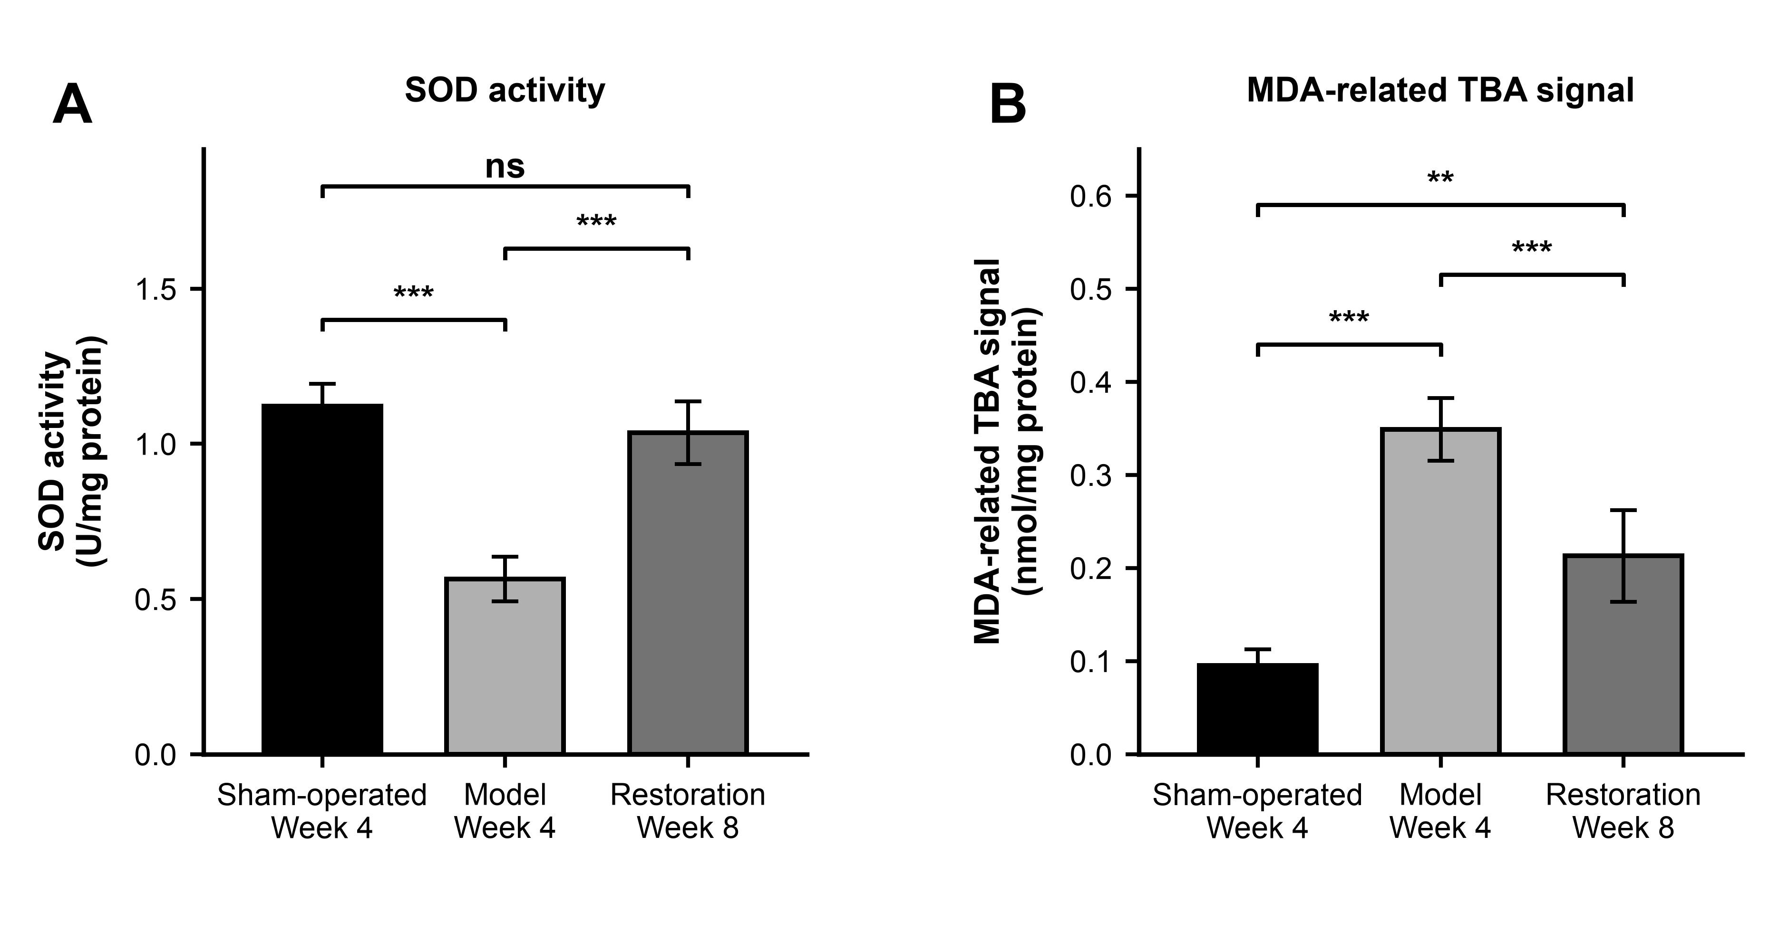
Fig. 1. SOD activity (A) and TBA-derived MDA-related signal (B) in regional medullary tissue. Bars show mean ± sample SD for six independently processed rats per group. Sham and model rats were sampled at week 4; restoration rats were sampled at week 8 after implant removal at week 4. Brackets indicate Games–Howell comparisons following Welch ANOVA, adjusted across the three comparisons within each endpoint: **P < 0.01, ***P < 0.001; ns, P ≥ 0.05. Comparisons involving restoration rats do not isolate an effect of implant removal. Tissue blocks included the RVLM and adjacent medulla.

Figure 2
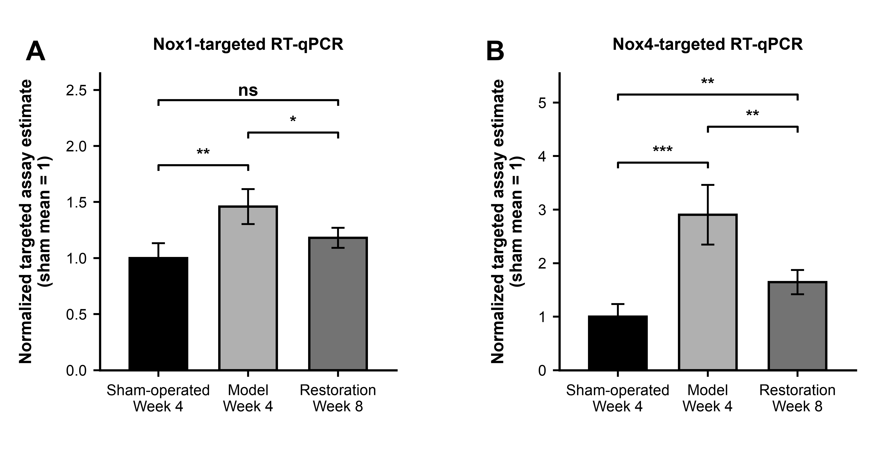
Fig. 2. Normalized Nox1-targeted (A) and Nox4-targeted (B) RT-qPCR quantities. Bars show mean ± sample SD (n = 6/group). Quantities were normalized to the arithmetic mean quantity of the sham samples; individual sham values were not set to 1. Comparisons used two-sided Welch t tests on ΔCq, with Holm correction across the original family of 18 comparisons: *P < 0.05, **P < 0.01, ***P < 0.001; ns, P ≥ 0.05. Target specificity and amplification efficiency were not established. Sham and model rats were sampled at week 4, and restoration rats at week 8.

Figure 3
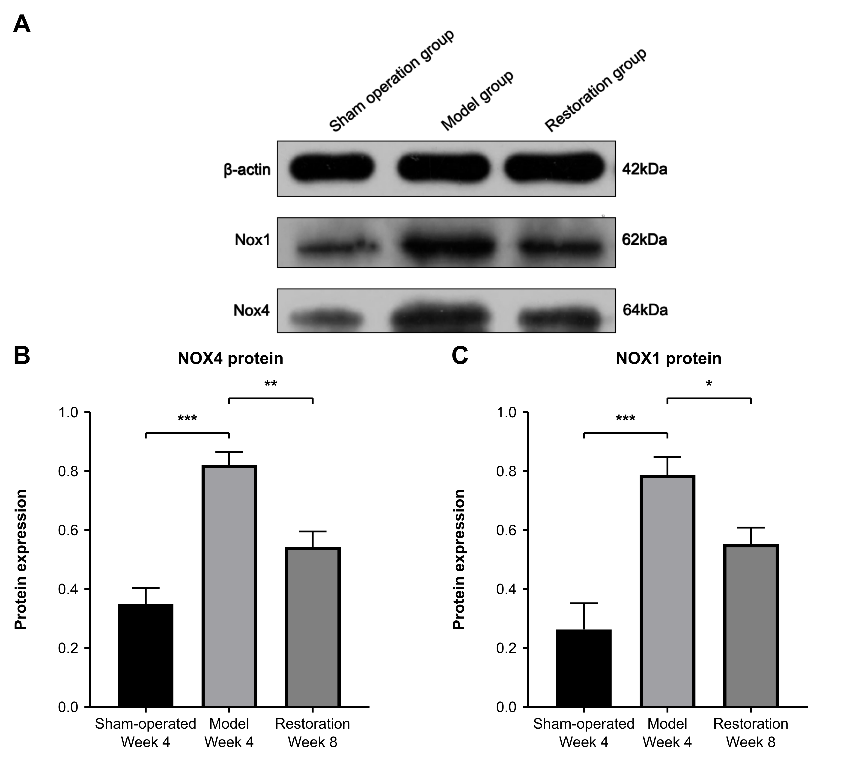
Fig. 3. Western blot analysis of regional medullary NOX1 and NOX4. (A) Representative β-actin, NOX1 and NOX4 blots, with one lane per group. Lanes from left to right represent sham, model and restoration rats. β-actin is shown as the loading reference. Molecular-mass labels follow the source figure: β-actin, 42 kDa; NOX1, 62 kDa; NOX4, 64 kDa. (B) NOX4 and (C) NOX1 summary data from the original analysis. Bars show mean ± SD (n = 3 rats/group). Brackets indicate the original pairwise comparisons: ***P < 0.001 for model versus sham rats for both proteins; **P < 0.01 for restoration versus model rats for NOX4; *P < 0.05 for restoration versus model rats for NOX1. Sham and model rats were sampled at week 4, and restoration rats at week 8. These comparisons do not isolate an effect of implant removal.

