Regional medullary redox indices and Nox1/Nox4 mRNA expression in rats with atlantoaxial joint disorder
Xiangying Yuan¹, Bin Yang², Zongbao He¹, Youkui Lv², Zijian Wu¹
1 School of Acupuncture and Tuina, Anhui University of Chinese Medicine, Hefei, Anhui 230012, China
2 Department of Rehabilitation and Physiotherapy, Anhui Provincial Corps Hospital, Hefei, Anhui 230041, China
Corresponding authors
Zijian Wu, School of Acupuncture and Tuina, Anhui University of Chinese Medicine, Hefei, Anhui 230012, China; email: wuzijian@ahtcm.edu.cn
Youkui Lv, Department of Rehabilitation and Physiotherapy, Anhui Provincial Corps Hospital, Hefei, Anhui 230041, China; email: lvyk126@126.com
Article type: Original Article
Short title: Medullary redox changes in atlantoaxial joint disorder

Summary
We examined whether atlantoaxial joint disorder is accompanied by regional medullary redox and transcript changes in male Wistar rats. Sham-operated and model rats were sampled on day 28; restoration rats underwent implant removal on day 28 and were sampled on day 56. Each biochemical endpoint and RT-qPCR included six independent rats per group. Tissue blocks contained the rostral ventrolateral medulla (RVLM) and adjacent medullary tissue. In the day-28 model–sham comparison, SOD activity was 0.564 versus 1.122 U/mg protein and MDA was 0.349 versus 0.095 nmol/mg protein. Probe-associated fluorescence was higher in model rats, and estimated Nox1/Nox4 expression was 1.46- and 2.90-fold relative to sham rats. Restoration-group measurements were generally closer to sham values at the later endpoint; SOD and Nox1 differences from sham were not statistically significant. The findings describe a regional redox and transcript phenotype accompanying the model. Interpretation is limited by unmatched terminal times, absence of a second-surgery sham control, unvalidated tissue fluorescence-assay applicability, incomplete qPCR quality-control records and omission of postoperative analgesia. The observations do not establish NOX-dependent sympathetic mediation or a causal effect of implant removal.
Key words: Atlantoaxial joint disorder; Ventrolateral medulla; Oxidative stress; NADPH oxidase; RT-qPCR

Introduction
Hypertension involves vascular, renal and neural regulation. Associations between cervical spondylosis and hypertension [1], together with small trials examining blood pressure after spinal or upper-cervical interventions [2,3], have prompted interest in the cardiovascular consequences of cervical disorders. Experimental models can help characterize the accompanying biological changes, while the clinical causal relationship and treatment implications remain unresolved.
Our previous study established a rat model in which a metallic implant in the left atlantoaxial joint produced joint misalignment and blood pressure elevation [4]. The model provides an experimental setting for studying sustained cervical perturbation. A remaining question is whether this condition is accompanied by regional changes in medullary tissue involved in autonomic regulation. Identifying such a phenotype would provide measurable endpoints for subsequent investigations of the model's central physiological effects.
Oxidative stress has been implicated in vascular dysfunction and altered autonomic regulation in hypertension [5,6,7]. The rostral ventrolateral medulla (RVLM) contributes to sympathetic vasomotor tone [8], and experimental studies in other hypertension models have linked RVLM redox disturbances and NADPH oxidase (NOX) signaling to cardiovascular regulation [9,10,11,12]. Superoxide dismutase (SOD) activity, malondialdehyde (MDA) and probe-associated fluorescence provide different readouts of regional redox status. Assessment of Nox1 and Nox4 transcripts alongside these biochemical indices can identify expression changes for future functional testing.
We therefore examined biochemical redox indices and Nox1/Nox4 mRNA in medullary blocks containing the RVLM and adjacent tissue. The comparison between model and sham rats used the same day-28 endpoint; a restoration cohort was examined at a later endpoint after implant removal. A related report described Ang II/AT1-R expression in this model [13]. Blood-pressure observations were shared with that report, whereas the biochemical and transcript analyses presented here were not reported there. Archived blood-pressure records are provided in the supplement. Illustrative H&E fields are included among the main figures, with source material retained in the supplement. The present study characterizes regional group differences and examines their relevance to a possible redox phenotype.

Methods

Animals and ethics
Healthy clean-grade male Wistar rats, approximately 12 weeks old and weighing approximately 250 g, were supplied by the Laboratory Animal Center of Anhui Medical University (license no. SCXK [Wan] 2017-001). Rats were housed individually in the animal laboratory of the Institute of Acupuncture and Meridian Research, Anhui University of Chinese Medicine, at 22 ± 1°C and 60% relative humidity under an artificial 12 h light/12 h dark cycle, with food and water available ad libitum. Rats acclimatized for 1 week before allocation and surgery. Male rats were selected for consistency with the previous model study [4]. Applicability to female rats was not evaluated.
All animal procedures were approved by the Animal Ethics Committee of Anhui University of Chinese Medicine (approval no. AHUCM-rats-2022032). The approval covered the 60-rat parent experiment, model induction, foreign-body removal, and terminal sampling. Animal handling followed the Chinese Guidelines on the Humane Treatment of Laboratory Animals.

Study design and sampling
The parent experiment numbered 60 rats and allocated them by random numbers to sham operation (10) or model induction (50). All sham rats survived. During model induction, 6 rats died during surgery and 3 afterward; 41 survived, including 7 with implant loss and 34 with retained implants. After imaging and blood-pressure screening on day 28, successfully modeled rats were assigned by random numbers to model, restoration, and superior cervical ganglion resection groups of 10. The disposition of the remaining 4 rats with retained implants was undocumented. This report includes only sham, model, and restoration rats, initially 10 per group; ganglion-resection and electrophysiological results are not presented.
The implant was removed from restoration rats on day 28. Terminal sampling was on day 28 for sham and model rats and day 56 for restoration rats, without a time-matched second-surgery sham group. Each biochemical endpoint and RT-qPCR included 6 randomly selected independent rats per group, processed separately without cross-animal pooling. Target and reference Cq values were paired within each rat and measured once each. Original animal identifiers could not be matched to assay samples; numerical record order cannot establish pairing across assays or fully reconstruct premeasurement exclusions. The parent design allowed for preliminary estimates of 18% mortality and 17% implant loss to obtain at least 30 modeled rats. No single primary endpoint or formal outcome-based a priori sample-size calculation was specified.

Model induction and implant removal
The model was induced using the previously described procedure [4]. Rats were anesthetized with 2% inhaled isoflurane at a gas flow of 1 l/min. Anesthetic depth was monitored using respiratory rate and rhythm, the righting reflex, and the response to a noxious stimulus. After shaving and povidone-iodine disinfection, an anterior cervical incision was made, subcutaneous tissue and muscle were separated, and the trachea was displaced to the right to expose the left atlantoaxial joint. With the head rotated to the right, a disinfected S-shaped aluminum implant was inserted into the joint space, secured, and the incision closed. Penicillin sodium was administered intramuscularly at 400,000–800,000 units/kg once daily for 3 days. No postoperative analgesics were administered. Available records did not retain a written rationale or a specific ethics-committee opinion concerning the omission of postoperative analgesia. Food intake, activity, and the wound were checked at least daily for the first 3 postoperative days and 2–3 times per week thereafter. Nine rats died during or after model induction. Reported possible contributing factors were anesthetic overdose, cervical surgical injury, and postoperative infection; individual cause-of-death adjudication records were not retained.
Sham-operated rats underwent the same anterior cervical exposure without implantation. On day 28, implant position and joint morphology were assessed using a Definium-6000 digital X-ray system (GE). Distances between the odontoid process and the left and right lateral masses were measured on images magnified twofold. Model success required a retained implant, asymmetric joint morphology, a left–right distance difference >0.05 mm, and a systolic blood pressure increase of at least 20% relative to baseline with a plateau by week 4.
Restoration rats underwent implant removal on day 28 under the same isoflurane anesthesia. The joint was re-exposed through the original anterior approach, the head rotated rightward, and the implant removed with a needle holder before closure. Postoperative penicillin treatment was unchanged, and no postoperative analgesics were given. Systolic pressure for model screening was measured by tail cuff (IITC Life Science) at baseline and on days 7, 14, 21, and 28. The chamber was prewarmed for 10 min at 30°C; rats rested in a restrainer for 15 min. BPmon Win monitor 1.35 recorded pressure at the onset of the spindle-shaped waveform, and three readings were averaged per rat. These shared source observations [13] were not reanalyzed as a terminal three-group treatment comparison.

Terminal collection and histology
Terminal samples were collected on day 28 in sham and model rats and day 56 in restoration rats. Rats were anesthetized with 2% inhaled isoflurane at 1 l/min for abdominal aortic blood collection, followed by euthanasia with an overdose of inhaled isoflurane. Death was confirmed by the absence of spontaneous breathing, palpable cardiac activity, and withdrawal to a noxious stimulus before brainstem removal. The Paxinos and Watson rat brain atlas and a stereotaxic apparatus guided bilateral tissue collection from the RVLM region, using reference positions 12.12–12.48 mm posterior to bregma, 2.1–2.6 mm lateral, and 10.0–10.4 mm deep. The tissue blocks contained the RVLM and a small amount of adjacent medullary tissue and had a measured mass of approximately 100 mg per rat. They were regional blocks rather than precisely isolated RVLM nuclei, and samples were not pooled across animals.
Histological material from the parent experiment was prepared by perfusion with 4% paraformaldehyde in 0.1 mol/l PBS (pH 7.4), postfixation at 4°C for 24–48 h, paraffin embedding, and 4 μm sections, followed by standard hematoxylin–eosin staining. The supplied composite retains tissue and original scale-bar pixels. Specimen counts, image-to-animal correspondence, and field-selection records could not be confirmed; no quantitative histological analysis was performed.

Biochemical assays
Each medullary biochemical assay included 6 independent rats per group. Tissue was minced, ground in liquid nitrogen, lysed on ice in RIPA buffer containing 1 mmol/l PMSF, and centrifuged to collect the supernatant. Total protein concentration was measured using a BCA kit (Beyotime; cat. no. P0010). SOD activity was measured using a WST-1 assay (Nanjing Jiancheng Bioengineering Institute; cat. no. A001-3), with absorbance read at 450 nm. MDA was measured using a thiobarbituric acid (TBA) colorimetric assay (Nanjing Jiancheng Bioengineering Institute; cat. no. A003-1). The retained assay records specified absorbance measurement at 530 nm, whereas the kit manual recommended 532 nm. Both absorbance measurements used an RT-6000 microplate reader (Rayto).
ROS-associated fluorescence was measured using the proprietary green BBoxiProbe® O12 supplied with the BestBio BB-475015 kit, at excitation and emission wavelengths of 488 and 530 nm, respectively. The kit manual specifies fresh serum as the intended sample matrix; the kit was applied to medullary lysates in this study. Records validating its use in the tissue matrix or compatibility with the lysis buffer were unavailable. The fluorescence-reader model was not retained. This measurement was reported as a probe-associated fluorescence index, without assignment to a specific ROS species or absolute ROS concentration.
SOD activity was calculated by dividing the blank-corrected inhibition fraction by 0.5, multiplying by the reaction-to-sample volume ratio (0.24/0.02), and dividing by sample protein concentration (mg/ml); results were expressed as U/mg protein. MDA content was calculated from the blank-corrected sample-to-standard absorbance ratio, multiplied by a standard concentration of 10 nmol/ml, and divided by sample protein concentration; results were expressed as nmol/mg protein. Probe-associated fluorescence was divided by sample protein concentration and reported in protein-normalized arbitrary units (AU). This fluorescence index was not interpreted as an absolute quantity per unit protein mass.

Reverse transcription quantitative PCR
Reverse transcription quantitative PCR (RT-qPCR) analyses included 6 independent rats per group (n = 6). Each target and reference quantification cycle (Cq) was measured once per rat. Target and reference Cq values in the same worksheet column corresponded to the same animal and were paired within that animal. Samples were not pooled. Total RNA was extracted from medullary tissue blocks containing the RVLM using TRIzol reagent (Life Technologies; Thermo Fisher Scientific, Inc.; cat. no. 15596018). Genomic DNA was removed from 1 µg of RNA in a 10 µl reaction at 42°C for 2 min, followed by 1 min on ice. Reverse transcription was performed using PrimeScript RT reagent Kit with gDNA Eraser (Takara Bio, Inc.; cat. no. RR047A) in a 20 µl reaction at 37°C for 15 min followed by 85°C for 5 s. RT-qPCR used NovoStart SYBR qPCR SuperMix Plus (Novoprotein; cat. no. E096-01B) and a PikoReal 96 real-time PCR system (Thermo Fisher Scientific, Inc.). Each 10 µl reaction contained 5 µl of 2× SYBR mix, 1 µl each of forward and reverse primers (10 µmol/l), 1 µl of cDNA, and 2 µl of RNase-free water. Primer sequences were as follows: Nox1 forward, 5'-GCTCCAGACCTCCATTTG-3'; Nox1 reverse, 5'-CAGCCCCAACCAAGAAAC-3'; Nox4 forward, 5'-GGGTTAAACACCTCTGTC-3'; Nox4 reverse, 5'-GTAGTATTCTGGCCCTTG-3'; β-actin forward, 5'-CCCATCTATGAGGGTTACGC-3'; and β-actin reverse, 5'-TTTAATGTCACGCACGATTTC-3'. Expected amplicon lengths for Nox1, Nox4, and β-actin were 84, 95, and 150 bp, respectively. Cycling conditions were 95°C for 1 min followed by 40 cycles of 95°C for 20 s and 60°C for 1 min. Conversion to relative quantities assumed equal amplification efficiencies of approximately 100% for each target and β-actin [14]. Within-animal ΔCq was defined as target Cq minus the paired β-actin Cq. Relative quantity was calculated as $Q = 2^{−ΔCq}$. For each gene, this quantity was divided by the arithmetic mean of the relative quantities from the 6 sham-operated rats, giving the sham-operated group an arithmetic mean of 1. Amplification efficiencies and reference-gene stability were not validated. The assay reports mentioned amplification and melting-curve results, but the original curves were unavailable for inspection. Records of no-template controls (NTC) and no-reverse-transcription controls (no-RT) were also unavailable.

Statistical analysis
Statistical analyses used individual rats as experimental units and report mean ± sample SD. All six supplied values per group were included; no outliers were removed or missing values imputed. Repeated measurements did not increase biological n. Biochemical endpoints were compared using Welch’s one-way ANOVA and Games–Howell comparisons, with 95% confidence intervals. Shapiro–Wilk tests were diagnostic, with limited sensitivity at n = 6. Adjustment covered the three comparisons within each endpoint, not across the three biochemical endpoints. Tests were two-sided, with α = 0.05. Processed inputs, full outputs and software versions, and reproduction code are provided in Supplementary Data 1, File 3, and Appendix 1.
RT-qPCR inference used within-animal ΔCq values and independent-group Welch t tests. All 18 comparisons across the original six-target panel (AT1-R, Nox1, Nox4, RhoA, ROCK1, and ROCK2) formed one Holm correction family; correction was not restricted to the displayed genes. Supplementary Data 2, File 4, and Appendix 2 provide paired inputs, complete t statistics, degrees of freedom and exact P values, and reproducible code. Animal overlap across assays was not recoverable, so no cross-assay correlations were tested. Archived blood-pressure and H&E materials were displayed without new inferential tests. Model–sham comparisons use day-28 samples; comparisons involving restoration use day-56 samples.

Results

Regional medullary biochemical indices
Each biochemical endpoint included 6 independent rats per group. Across the three terminal cohorts, Welch's ANOVA identified differences in SOD activity, F(2, 9.816) = 91.626; MDA, F(2, 8.500) = 130.738; and probe-associated fluorescence, F(2, 7.804) = 314.907 (all P < 0.001). In the same-time day-28 comparison, model rats had lower SOD activity than sham rats (0.564 ± 0.072 versus 1.122 ± 0.072 U/mg protein), higher MDA (0.349 ± 0.034 versus 0.095 ± 0.017 nmol/mg protein), and higher probe-associated fluorescence (3295.6 ± 216.3 versus 1326.9 ± 50.6 AU; Fig. 1). All three model–sham Games–Howell-adjusted P values were <0.001. Model–sham mean differences and 95% confidence intervals are provided in Supplementary Table S1; complete three-group outputs are in Supplementary File 3.

Nox1 and Nox4 transcripts in the day-28 comparison
Animal-paired target and reference Cq measurements were available for 6 rats per group. Estimated Nox1 expression was higher in model rats than in sham rats (1.459 ± 0.156 versus 1.000 ± 0.134), as was Nox4 expression (2.902 ± 0.558 versus 1.000 ± 0.233; Fig. 2A and B). The corresponding Holm-adjusted P values were 0.0037 and 0.0001. These P values use one correction family comprising all 18 comparisons in the original six-target panel. Complete results are provided in Supplementary File 4.

Observations at the later restoration endpoint
Restoration rats were sampled on day 56, four weeks after implant removal. SOD activity was 1.035 ± 0.101 U/mg protein, MDA was 0.213 ± 0.049 nmol/mg protein, and probe-associated fluorescence was 2265.6 ± 131.6 AU (Fig. 1). Compared with model rats sampled on day 28, restoration rats had higher SOD activity and lower MDA and fluorescence (all Games–Howell-adjusted P < 0.001). Relative to sham rats, restoration rats had higher MDA (adjusted P = 0.0033) and fluorescence (adjusted P < 0.001); the SOD difference was not statistically significant (adjusted P = 0.2534).
Estimated Nox1 and Nox4 expression in restoration rats was 1.180 ± 0.090 and 1.645 ± 0.227, respectively (Fig. 2; n = 6). Both were lower than in model rats, with Holm-adjusted P values of 0.0139 and 0.0037. Compared with sham rats, estimated Nox4 expression was higher (P = 0.0099), whereas the Nox1 difference did not meet the adjusted significance threshold (P = 0.0618). Nonsignificant SOD and Nox1 differences do not establish equivalence or normalization. Comparisons involving restoration rats span different terminal sampling times and cannot isolate an implant-removal effect.

Archived histology and blood-pressure records
The archived H&E fields show nuclear staining and varied cellular profiles (Fig. 3). Unconfirmed specimen counts and image-to-animal correspondence limit their use to illustration; no group-level histological inference was made.
The archived blood-pressure workbook contained 24 model-labelled, 14 control-labelled and 10 sham-labelled source rows. The 10 complete sham rows matched the thesis sham summaries, but missing values and repeated identifiers prevented unique reconstruction of the present model cohort. Four entered restoration summaries remained for weeks 5–8, without animal-level dispersion. These records are displayed descriptively in Supplementary Fig. S2 and cannot independently validate the terminal cohorts (Supplementary Data 3 and 4; File 5).

Discussion
The same-day comparison of model and sham rats on day 28 identified lower SOD activity and higher MDA, probe-associated fluorescence and estimated Nox1/Nox4 expression in medullary tissue containing the RVLM. This regional biochemical and transcript phenotype extends the earlier characterization of atlantoaxial misalignment and blood-pressure elevation [4]. Its contribution is to identify redox-related changes accompanying the model, providing specific measurements for subsequent studies of its central physiological consequences.
SOD contributes to antioxidant defense, whereas MDA is commonly used as an index of lipid peroxidation [15,16]. The lower SOD activity and higher MDA in model rats therefore provide complementary observations of altered regional redox status. Higher probe-associated fluorescence followed the same group pattern, but is best regarded as an auxiliary assay signal. The three measurements assess different processes and should not be combined into an estimate of absolute ROS production.
Previous experimental studies have linked oxidative disturbances in the RVLM to cardiovascular regulation in several hypertension models [9,10,12,17]. The present observations place the cervical-joint model within this broader physiological context. Increased Nox1 and Nox4 transcripts identify gene-expression changes that merit further investigation, but transcript abundance alone does not demonstrate increased NOX protein, oxidase activity or the source of an oxidant signal. Anatomically resolved measurements and NOX-directed interventions would help determine whether these expression changes have functional relevance.
The previously reported Ang II/AT1-R expression changes in this model provide another point of connection [13]. Experimental work on RVLM angiotensin signaling and angiotensin-associated NOX pathways offers a possible framework for interpreting the regional findings [18,19]. Angiotensin signaling and sympathetic discharge were not measured in the present analyses. Accordingly, the relationships illustrated in Fig. 4 are proposed links for testing, rather than an established sequence connecting cervical perturbation, NOX activity and blood-pressure regulation.
Restoration-group measurements were generally closer to sham values than those of model rats. However, MDA, probe-associated fluorescence and estimated Nox4 expression remained higher than sham values, and nonsignificant differences in SOD and Nox1 do not establish normalization. These later observations describe a distinct sampling condition after implant removal. They motivate a controlled follow-up of the time course rather than demonstrating reversal of the model phenotype or supporting extrapolation to clinical manual treatment.

Limitations
The principal design limitation is that sham and model rats were sampled on day 28, whereas restoration rats were sampled on day 56, without a time-matched second-surgery sham control. Implant removal is therefore confounded with age, elapsed time, recovery, repeat anesthesia and surgery. The approximately 100 mg tissue blocks included the RVLM and adjacent medullary tissue; results cannot be assigned specifically to RVLM neurons or another cell population. Archived H&E fields are illustrative only: animal counts and sampling correspondence were unknown, and neither group-level injury nor inflammatory-cell identity can be inferred.
Assay validity also limits interpretation. The serum-designated O12 kit was used in RIPA tissue lysates without validation of tissue-matrix or buffer compatibility; common processing and protein normalization do not establish validity or exclude differential matrix effects. Each qPCR target and reference was measured once per animal, without technical replication. Amplification efficiencies and stability of the single reference gene, β-actin, were not validated, while original amplification/melting curves and NTC/no-RT records were unavailable. Relative transcript estimates depend on the unverified efficiency assumption. Reanalysis of retained inputs cannot replace these laboratory quality-control records.
Animal-to-sample identifiers and overlap across assays could not be recovered, preventing full reconstruction of sample flow or valid cross-assay correlations. No postoperative analgesics were administered, and no written rationale or specific ethics-committee opinion about this omission was retained. Pain and surgical stress may have affected the measured outcomes; their contribution cannot be determined from these data. The small assay samples, absence of a prespecified single primary endpoint and formal a priori power calculation, and restriction to male rats further limit precision and generalizability. Future work requires traceable sampling, validated assays, appropriate controls and documented analgesic care.

Conclusions
Male rats with atlantoaxial joint disorder showed altered redox indices and estimated Nox1/Nox4 expression in medullary tissue containing the RVLM. The same-day model–sham contrast supports a regional exploratory phenotype. These observations do not establish RVLM-specific changes, a NOX-dependent sympathetic mechanism or an independent benefit of implant removal.

Conflict of Interest
The authors declare that they have no known competing financial interests or personal relationships that could have appeared to influence the work reported in this paper.

Acknowledgments
This research was supported by the Provincial Natural Science Foundation of Anhui, China (grant no. 1608085MH185). The funder had no role in study design, data collection and analysis, manuscript preparation, or the decision to submit the article for publication.

Author contributions
Xiangying Yuan: Conceptualization, Investigation, Formal analysis, Writing – original draft. Bin Yang: Methodology, Investigation. Zongbao He: Investigation, Resources. Youkui Lv: Conceptualization, Supervision, Funding acquisition, Writing – review & editing. Zijian Wu: Conceptualization, Supervision, Project administration, Funding acquisition, Writing – review & editing.

Data availability
Processed medullary biochemical values, paired RT-qPCR Cq measurements, statistical outputs, and reproducible analysis and plotting scripts are provided in the supplementary material. Archived blood-pressure entries, entered summaries, the unmodified source workbook, and the supplied H&E composite are also provided. Blood-pressure source rows cannot be uniquely mapped to the current terminal cohorts, and H&E specimen counts and image-to-animal correspondence could not be recovered; these materials are presented descriptively. Original instrument outputs, complete assay quality-control records, and original animal-to-sample identifiers were unavailable for independent verification.

DECLARATION on the Use of AI
Codex (OpenAI; accessed October 2026; exact model identifier not archived) assisted with language editing, manuscript organization, methodological review, worksheet checking, statistical reanalysis, and development of conventional analysis and plotting code. Numerical inputs and reproducible scripts are supplied. Experimental data and experimental images were not generated; the H&E tissue and original scale-bar pixels were preserved. The authors reviewed the outputs, figures and conclusions and take responsibility for the work.

Supplementary material
Supplementary datasets, full statistical outputs, reproduction code, the archived blood-pressure workbook and H&E materials accompany this article. Item descriptions, Supplementary Table S1 and Supplementary Figs. S1 and S2 are compiled in Yuan_supplementary_information.docx; individual numerical and source files are supplied separately in Supporting_Information.

References
1. Kalb S, Zaidi HA, Ribas-Nijkerk JC, Sindhwani MK, Clark JC, Martirosyan NL, Theodore N. Persistent outpatient hypertension is independently associated with spinal cord dysfunction and imaging characteristics of spinal cord damage among patients with cervical spondylosis. World Neurosurg. 2015;84:351–357.
2. Plaugher G, Long CR, Alcantara J, Silveus AD, Wood H, Lotun K, Menke JM, et al. Practice-based randomized controlled-comparison clinical trial of chiropractic adjustments and brief massage treatment at sites of subluxation in subjects with essential hypertension: pilot study. J Manipulative Physiol Ther. 2002;25:221–239.
3. Bakris G, Dickholtz M Sr, Meyer PM, Kravitz G, Avery E, Miller M, Brown J, et al. Atlas vertebra realignment and achievement of arterial pressure goal in hypertensive patients: a pilot study. J Hum Hypertens. 2007;21:347–352.
4. He ZB, Lv YK, Li H, Yao Q, Wang KM, Song XG, Wu ZJ, et al. Atlantoaxial misalignment causes high blood pressure in rats: a novel hypertension model. Biomed Res Int. 2017;2017:5986957.
5. Franco C, Sciatti E, Favero G, Bonomini F, Vizzardi E, Rezzani R. Essential hypertension and oxidative stress: novel future perspectives. Int J Mol Sci. 2022;23:14489.
6. Guzik TJ, Touyz RM. Oxidative stress, inflammation, and vascular aging in hypertension. Hypertension. 2017;70:660–667.
7. Incalza MA, D'Oria R, Natalicchio A, Perrini S, Laviola L, Giorgino F. Oxidative stress and reactive oxygen species in endothelial dysfunction associated with cardiovascular and metabolic diseases. Vascul Pharmacol. 2018;100:1–19.
8. Wenker IC, Abe C, Viar KE, Stornetta DS, Stornetta RL, Guyenet PG. Blood pressure regulation by the rostral ventrolateral medulla in conscious rats: effects of hypoxia, hypercapnia, baroreceptor denervation, and anesthesia. J Neurosci. 2017;37:4565–4583.
9. Chan SHH, Wu KLH, Chang AYW, Tai MH, Chan JYH. Oxidative impairment of mitochondrial electron transport chain complexes in rostral ventrolateral medulla contributes to neurogenic hypertension. Hypertension. 2009;53:217–227.
10. Huang YP, Jin HY, Yu HP. Inhibitory effects of alpha-lipoic acid on oxidative stress in the rostral ventrolateral medulla in rats with salt-induced hypertension. Int J Mol Med. 2017;39:430–436.
11. Kalsoom UE, Jin J, Meng W, Su Y, Wu C, Wu Q. The role of NADPH oxidases in central nervous system regulation of hypertension: mechanisms and therapeutic insights. Biomed Pharmacother. 2026;196:119096.
12. Yan JQ, Huang F, Hao F, Su XL, Meng Q, Xu MJ. Oxidative stress in the rostral ventrolateral medulla contributes to cardiovascular regulation in preeclampsia. Front Physiol. 2017;8:772.
13. Lv YK, Wu ZJ, Yang B, Gao DP, He ZB. Expression of angiotensin II and angiotensin II type 1 receptor in rostral ventrolateral medulla in a rat model of atlantoaxial joint disorder-induced hypertension. Biull Eksp Biol Med. 2026;181(5):546–550.
14. Livak KJ, Schmittgen TD. Analysis of relative gene expression data using real-time quantitative PCR and the 2(-Delta Delta C(T)) method. Methods. 2001;25:402–408.
15. Marrocco I, Altieri F, Peluso I. Measurement and clinical significance of biomarkers of oxidative stress in humans. Oxid Med Cell Longev. 2017;2017:6501046.
16. Cordiano R, Di Gioacchino M, Mangifesta R, Panzera C, Gangemi S, Minciullo PL. Malondialdehyde as a potential oxidative stress marker for allergy-oriented diseases: an update. Molecules. 2023;28:5979.
17. Chao YM, Rauchová H, Chan JYH. Disparate roles of oxidative stress in rostral ventrolateral medulla in age-dependent susceptibility to hypertension induced by systemic l-NAME treatment in rats. Biomedicines. 2022;10:2232.
18. Dampney RAL, Tan PSP, Sheriff MJ, Fontes MAP, Horiuchi J. Cardiovascular effects of angiotensin II in the rostral ventrolateral medulla: the push-pull hypothesis. Curr Hypertens Rep. 2007;9:222–227.
19. Gao L, Wang W, Li YL, Schultz HD, Liu D, Cornish KG, Zucker IH. Superoxide mediates sympathoexcitation in heart failure: roles of angiotensin II and NAD(P)H oxidase. Circ Res. 2004;95:937–944.

Figure 1
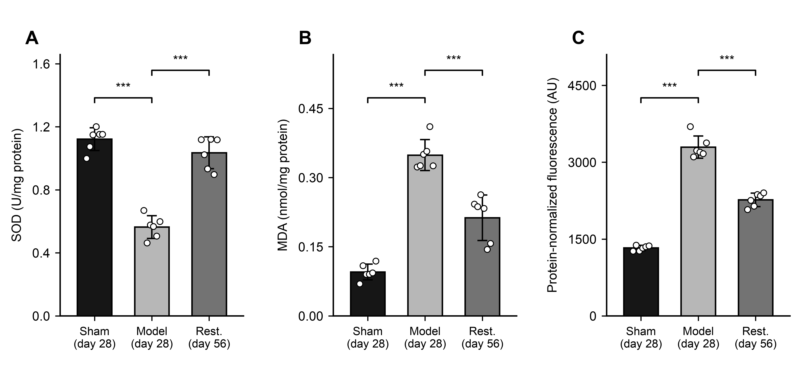
Fig. 1. Regional medullary biochemical indices: (A) SOD activity, (B) MDA content and (C) probe-associated fluorescence. Each group included six independent rats. Bars show arithmetic means, error bars sample SDs and points individual rats. Brackets compare model with sham or restoration; ***P < 0.001, from Games–Howell comparisons following Welch ANOVA. Adjustment covered three comparisons within each endpoint, without correction across endpoints. Fluorescence is a protein-concentration-normalized index in arbitrary units (AU). Sham and model rats were sampled on day 28 and restoration rats on day 56. Complete results are in Supplementary File 3. Sham, sham-operated; Rest., restoration.

Figure 2
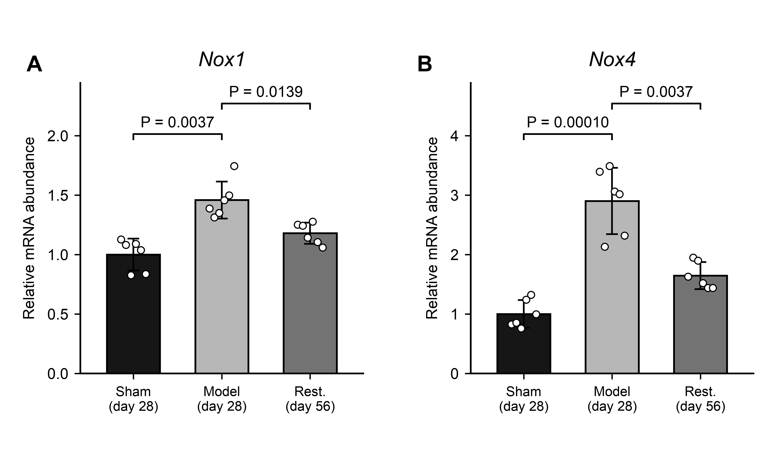
Fig. 2. Relative Nox1 (A) and Nox4 (B) mRNA in regional medullary tissue. Six independent rats were included per group. Bars indicate arithmetic means, error bars sample SDs and points individual rats. Expression was normalized within each rat to β-actin and calibrated to the sham arithmetic mean. Brackets compare model with sham or restoration. Tests used ΔCq with one Holm adjustment across all 18 original-panel comparisons. Displayed P values are Holm-adjusted across these 18 comparisons. Sham and model rats were sampled on day 28 and restoration rats on day 56. Full results are in Supplementary File 4. Sham, sham-operated; Rest., restoration.

Figure 3
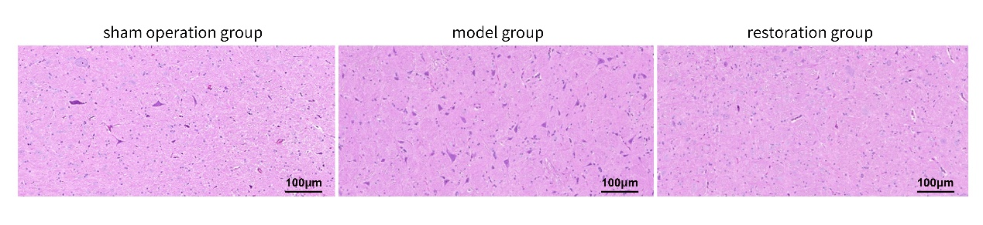
Fig. 3. Archived H&E fields labelled sham, model and restoration. Source tissue pixels and source-labelled 100 µm scale bars are retained. Animal counts, image-to-animal correspondence and sampling records were unavailable. These fields are illustrative and do not establish group-level histological differences.

Figure 4
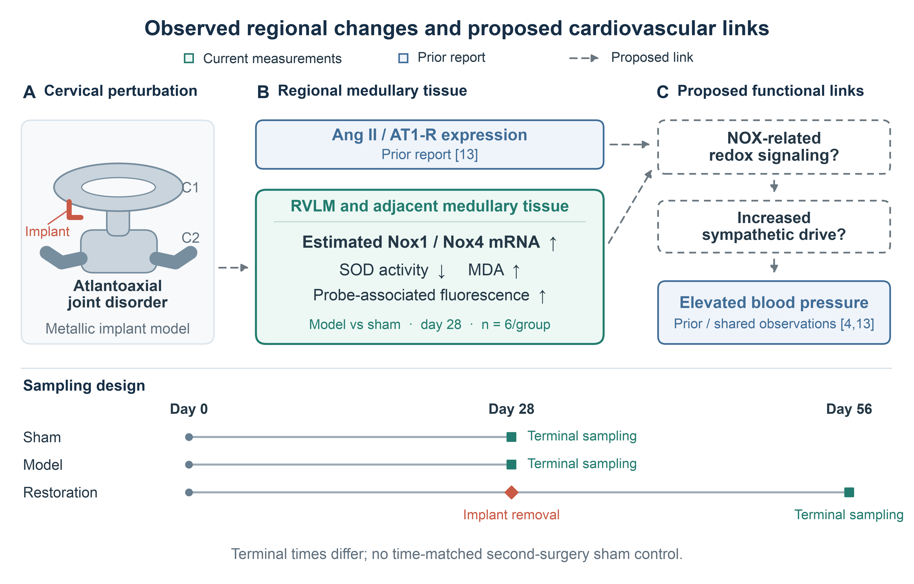
Fig. 4. Regional observations and proposed cardiovascular links. Green denotes current regional measurements; blue denotes prior reports [4,13]. Upward and downward symbols indicate day-28 model–sham differences. Dashed arrows and outlines denote untested functional relationships. Nox1/Nox4 mRNA does not establish NOX activity or sympathetic mediation. The cervical symbol is schematic. Separate timelines show day-28 terminal sampling in sham/model rats and day-56 sampling after day-28 implant removal in restoration rats. Time and repeat surgery confound implant-removal comparisons.

