Regional medullary redox profiles in rats with atlantoaxial joint disorder
Xiangying Yuan¹, Bin Yang², Zongbao He¹, Youkui Lv², Zijian Wu¹
¹ School of Acupuncture and Tuina, Anhui University of Chinese Medicine, Hefei, Anhui 230012, China
² Department of Rehabilitation and Physiotherapy, Anhui Provincial Corps Hospital, Hefei, Anhui 230041, China

Corresponding authors
Zijian Wu, School of Acupuncture and Tuina, Anhui University of Chinese Medicine, Hefei, Anhui 230012, China. Email: wuzijian@ahtcm.edu.cn
Youkui Lv, Department of Rehabilitation and Physiotherapy, Anhui Provincial Corps Hospital, Hefei, Anhui 230041, China. Email: lvyk126@126.com
Article type: Original Article
Running title: Medullary redox profiles in atlantoaxial disorder

Summary
Atlantoaxial joint disorder has been associated with elevated blood pressure in a rat model, but its regional medullary biochemical phenotype remains incompletely characterized. We examined superoxide dismutase (SOD) activity and thiobarbituric acid (TBA)-derived malondialdehyde (MDA)-related signals, with Nox1/Nox4-targeted RT-qPCR as an exploratory measurement. Male Wistar rats underwent sham exposure or atlantoaxial implantation. Sham and model cohorts were sampled at week 4; an independent restoration cohort underwent implant removal at week 4 and sampling at week 8. Each endpoint included six independently processed rat samples per group. Tissue blocks contained the rostral ventrolateral medulla and adjacent medulla. At week 4, model rats had lower SOD activity than sham rats (0.564 ± 0.072 versus 1.122 ± 0.072 U/mg protein) and higher MDA-related signals (0.349 ± 0.034 versus 0.095 ± 0.017 nmol/mg protein; both adjusted P < 0.001). Normalized Nox1/Nox4-targeted estimates were also higher, although unconfirmed product specificity precluded conclusions about transcript abundance. At week 8, restoration-cohort SOD and MDA-related values were 1.035 ± 0.101 and 0.213 ± 0.049, respectively. The concurrent comparison supports a descriptive regional biochemical difference. The unmatched later cohort and exploratory qPCR results do not establish an implant-removal effect or a NOX-mediated mechanism.
Key words: Atlantoaxial joint; Medulla oblongata; Superoxide dismutase; Malondialdehyde; Oxidative stress

Introduction
An experimental model of atlantoaxial joint misalignment has been associated with increased arterial pressure in rats [1]. It provides a means of examining physiological changes accompanying an upper cervical joint disturbance. A related study examined angiotensin II (Ang II) and its type 1 receptor (AT1-R) in the rostral ventrolateral medulla (RVLM) of rats with this disorder [2]. Blood-pressure observations from the underlying experimental program were also used in that report. The present study focuses on regional biochemical and Nox1/Nox4-targeted assay observations.
The RVLM contains bulbospinal neurons involved in sympathetic vasomotor regulation [3]. Its contribution to blood-pressure control varies with physiological state, including oxygen availability, baroreceptor input and anesthesia [4]. Regional redox regulation is relevant to this function. In spontaneously hypertensive rats, reduced RVLM antioxidant-enzyme activity has been linked to hypertension, and local antioxidant-enzyme gene transfer lowered arterial pressure [5]. Ang II-induced pressor responses have also been linked to NADPH oxidase-dependent RVLM signaling [6], while mitochondrial processes provide another route to regional redox disturbance [7].
These findings provide a rationale for examining regional redox biochemistry in the atlantoaxial model. NOX1 and NOX4 are candidate redox-related enzymes with distinct regulatory and subcellular properties [8]. SOD activity and TBA-derived MDA-related signals offer complementary biochemical observations, interpreted according to their detection chemistry [9].
We examined SOD activity and MDA-related signals in tissue containing the RVLM and adjacent medulla, with Nox1/Nox4-targeted RT-qPCR as an exploratory molecular measurement. The report emphasizes the concurrent week-4 model–sham comparison and separately describes an independent cohort sampled at week 8 after implant removal. This design characterizes the regional phenotype and provides observations for subsequent mechanistic studies.

Methods

Animals and experimental design
The parent experiment was approved by the Animal Ethics Committee of Anhui University of Chinese Medicine (AHUCM-rats-2022032); the original approval letter and approved protocol were no longer available. Male Wistar rats, approximately 12 weeks old and weighing approximately 250 g, were obtained from the Laboratory Animal Center of Anhui Medical University. Rats were housed individually at 22 ± 1°C and 60% relative humidity under a 12 h light/12 h dark cycle, with unrestricted food and water. Acclimatization lasted 1 week. Environmental enrichment was not documented. Male rats were used for consistency with the earlier model study.
Sixty rats were initially allocated by random numbers to sham operation (n = 10) or model induction (n = 50). Six modeled rats died intraoperatively and three postoperatively. Of 41 survivors, seven lost their implants and 34 retained them. After screening, 30 successfully modeled rats were allocated by random numbers to model, restoration or superior cervical ganglion resection cohorts (10 each); four were retained in reserve. Only sham, model and restoration cohorts are reported here. Each biochemical and RT-qPCR endpoint used six separately processed rat samples per group, without cross-animal pooling. The basis for biological replication and sample linkage is given in Data availability.
The design was exploratory, without an outcome-based a priori sample-size calculation or a prespecified single primary endpoint. Blinding was not documented. Sham and model rats underwent terminal sampling at week 4. Restoration rats were independently allocated from the successfully modeled population, underwent implant removal at week 4 and were sampled at week 8. No week-8 time-matched model or second-surgery sham cohort was available.

Model induction and perioperative care
An S-shaped aluminum implant was inserted into the left atlantoaxial joint through an anterior cervical approach, following the previously described model [1]. Sham rats underwent exposure without implantation. Model success required a retained implant, asymmetric joint morphology with a left–right odontoid–lateral-mass distance difference >0.05 mm, and systolic pressure at least 20% above baseline with a plateau by week 4. Screening used digital radiography and tail-cuff pressure measurements. Restoration rats underwent re-exposure and implant removal at week 4.
Model induction, implant removal and terminal sampling used 2% inhaled isoflurane at a gas flow of 1 l/min. Anesthetic depth was monitored through respiration and reflex responses. Penicillin sodium was administered intramuscularly at 400,000–800,000 units/kg once daily for 3 days after surgery. No postoperative analgesics were administered; a specific written rationale or authorization for their omission was not retained. Food intake, activity and wounds were checked daily for the first 3 postoperative days and 2–3 times weekly thereafter. Anesthesia-related complications, surgical injury and infection were reported as possible contributors to the deaths, without individual adjudication records.

Tissue collection and biochemical measurements
After abdominal aortic sampling under isoflurane, rats received an overdose of inhaled isoflurane. Death was confirmed by the absence of spontaneous breathing, palpable cardiac activity and withdrawal to a noxious stimulus before brainstem removal. Atlas-guided bilateral regional blocks, approximately 100 mg per rat, contained the RVLM and adjacent medullary tissue. Tissue was ground in liquid nitrogen and lysed on ice in RIPA buffer containing 1 mmol/l PMSF. Supernatants were collected after centrifugation, and protein concentration was measured by BCA assay (Beyotime, P0010).
Total SOD activity was measured by a WST-1 assay (Nanjing Jiancheng, A001-3). The reaction was incubated at 37°C for 20 min, and absorbance was read at 450 nm using an RT-6000 reader. Blank-corrected inhibition was converted using the reaction-to-sample volume ratio and the corresponding protein concentration, yielding U/mg protein. MDA-related signals were measured by the TBA assay (Nanjing Jiancheng, A003-1). Reaction mixtures were heated at 95°C for 40 min, cooled and centrifuged at 3500–4000 rpm for 10 min. Absorbance at 530 nm was converted using a 10 nmol/ml standard and normalized to protein concentration, yielding nmol/mg protein. Detailed calculations and assay qualifications are provided in the Supplementary Information.
Auxiliary O12 probe-associated fluorescence and archived hematoxylin–eosin fields are presented only in the Supplementary Information. Tissue/RIPA compatibility of the serum-designated fluorescence assay was not validated, and histological specimen counts and image-to-animal correspondence could not be confirmed.

Exploratory targeted RT qPCR
RNA was extracted using TRIzol, and reverse transcription used PrimeScript RT reagent Kit with gDNA Eraser (RR047A). SYBR reactions were run on a PikoReal 96 system. The program comprised 95°C for 1 min and 40 cycles of 95°C for 20 s and 60°C for 1 min, followed by melting analysis from 60°C to 95°C in 0.2°C increments. Primer sequences, expected product lengths and reaction composition are given in the Supplementary Information. Each target and β-actin reference was measured once per sample, without technical replication.
Within-sample ΔCq was target Cq minus paired β-actin Cq. Relative quantity was calculated as 2 raised to −ΔCq and divided by the arithmetic mean quantity of the six sham samples for that assay. Equal, approximately 100% amplification efficiencies were assumed; efficiencies and reference-gene stability were not validated, and NTC/no-RT records were unavailable. Heterogeneous melt profiles and absent product-identity evidence left specificity unconfirmed [10]; results were retained as exploratory normalized assay estimates. Both B10-Ch5 (Nox1, model; Cq 29.82) and D12-Ch5 (Nox4, sham-operated; Cq 34.69) had numerical Cq values in the original Cq Results exports and were included in the analysis. Author-confirmed plate annotation corrections are documented in Supplementary Table S4. Cq values, sample assignments, reference pairings and statistical results were unchanged; original exports were preserved.

Statistical analysis
The rat was the experimental unit. Results are mean ± sample SD, with six samples per group per endpoint. All supplied observations were included without outlier removal or imputation. Biochemical comparisons used Welch one-way ANOVA and Games–Howell tests with 95% confidence intervals, adjusting three comparisons within each endpoint without cross-endpoint adjustment. RT-qPCR inference used two-sided Welch t tests on ΔCq, with Holm correction across all 18 comparisons in the original six-target, three-contrast family; only Nox1 and Nox4 are displayed. P < 0.05 was the significance threshold. Restoration comparisons were between independent terminal cohorts. Cross-assay correlations were not calculated because sample overlap was not recoverable.

Results

Regional biochemical differences at week 4
Model rats had lower regional SOD activity than concurrent sham rats: 0.564 ± 0.072 versus 1.122 ± 0.072 U/mg protein (Fig. 1A). The model-minus-sham difference was −0.558 U/mg protein, with a 95% Games–Howell confidence interval of −0.672 to −0.443 and adjusted P < 0.001. The model mean was approximately 49.7% lower than the sham mean.
The MDA-related TBA signal was higher in model than sham rats: 0.349 ± 0.034 versus 0.095 ± 0.017 nmol/mg protein (Fig. 1B). The model-minus-sham difference was 0.253 nmol/mg protein, with a 95% confidence interval of 0.209 to 0.298 and adjusted P < 0.001. Across the three terminal cohorts, Welch ANOVA yielded F(2, 9.816) = 91.626 for SOD and F(2, 8.500) = 130.738 for the MDA-related signal (both P < 0.001). Complete estimates and pairwise results are given in Supplementary Tables S1 and S2.

Exploratory molecular assay observations
Normalized Nox1-targeted assay estimates were 1.459 ± 0.156 in model samples and 1.000 ± 0.134 in sham samples, with Holm-adjusted P = 0.0037 (Fig. 2A). Corresponding Nox4-targeted estimates were 2.902 ± 0.558 and 1.000 ± 0.233, with adjusted P = 0.0001 (Fig. 2B).

Observations in the later restoration cohort
At week 8, four weeks after implant removal, restoration-cohort SOD activity was 1.035 ± 0.101 U/mg protein and the MDA-related signal was 0.213 ± 0.049 nmol/mg protein. Relative to week-4 model values, SOD was higher and the MDA-related signal lower (both adjusted P < 0.001). The MDA-related signal remained higher than the week-4 sham value (adjusted P = 0.0033); the SOD comparison with sham was nonsignificant (adjusted P = 0.2534).
Restoration-cohort Nox1/Nox4-targeted estimates were 1.180 ± 0.090 and 1.645 ± 0.227, respectively. Both were lower than model estimates (adjusted P = 0.0139 and 0.0037). Compared with sham, the Nox4-targeted estimate remained higher (adjusted P = 0.0099), whereas the Nox1-targeted difference was nonsignificant (adjusted P = 0.0618). These comparisons involve independent cohorts sampled at different terminal times.

Discussion
At week 4, model rats had lower regional medullary SOD activity and a higher MDA-related TBA signal than concurrent sham rats. These observations add a regional biochemical dimension to the established cervical model. SOD activity and the TBA-derived signal address antioxidant activity and an oxidation-related readout, respectively. Because the blocks contained the RVLM and adjacent medulla, the findings concern a regional tissue phenotype rather than a defined nucleus or neuronal population.
The SOD finding is biologically relevant to earlier intervention work in spontaneously hypertensive rats, in which local restoration of RVLM antioxidant enzymes lowered arterial pressure [5]. The present total-activity assay does not distinguish SOD isoforms, enzyme abundance or the reason for reduced activity. Together with the higher MDA-related signal, it motivates closer examination of regional redox regulation in this model. Ang II-dependent NADPH oxidase signaling [6] and mitochondrial processes [7] are plausible candidates for such work, supported by studies in other experimental settings. The related Ang II/AT1-R observations [2] supply further context without establishing that either process mediates the present differences.
Measurement characteristics limit the biochemical interpretation. Fourteen of the 18 SOD inhibition values fell outside the manufacturer-suggested 40–60% pilot optimization interval, and corresponding dilution-validation records were unavailable. This recommendation is not a demonstrated hard validity boundary, but quantitative interpretation requires caution. TBA-derived chromogens are not chemically specific to MDA [9], so the signal cannot independently establish lipid injury. The supplementary O12 index also lacks tissue-matrix and buffer-compatibility validation. Protein normalization and common processing do not resolve these assay-specific uncertainties.
The targeted qPCR differences remain exploratory. NOX1 and NOX4 have distinct activation requirements and localization [8], and NOX4 has shown protective effects in a vascular experimental setting [11]. Functional interpretation is therefore context dependent. The unconfirmed product specificity, assumed efficiencies, unvalidated single reference gene and absence of technical replication and retained NTC/no-RT records prevent a conclusion of established Nox1/Nox4 upregulation. No NOX enzyme-activity measurement or isoform-specific perturbation linked these assays to the regional biochemical phenotype. The data support further investigation of these candidates, without identifying a ROS source or a NOX–sympathetic–blood-pressure pathway.
The restoration cohort describes a later phenotype: its mean SOD activity was closer to the sham value, while the MDA-related signal remained higher. Implant removal cannot be isolated from elapsed time, age, spontaneous model evolution or repeat anesthesia and surgery because restoration animals were sampled at week 8 and the other cohorts at week 4. A continued-implant week-8 cohort and a time-matched second-surgery sham cohort would distinguish these possibilities. The nonsignificant SOD comparison does not establish equivalence or normalization. Small, male-only samples, undocumented blinding and unavailable historical sample-linkage records further limit precision, generalizability and assessment of bias.
The omission of postoperative analgesia also limits interpretation of the regional endpoints and evaluation of animal welfare. The retained records did not provide a specific rationale or authorization for its omission. Routine observations and antibiotic treatment do not establish adequate pain relief, and pain- or stress-related influences cannot be excluded. Prospective work should incorporate an institutionally reviewed analgesia plan with predefined monitoring and intervention criteria.
In conclusion, rats with atlantoaxial joint disorder showed lower regional medullary SOD activity and higher MDA-related TBA signals than concurrent sham rats at week 4. The findings characterize an exploratory regional biochemical phenotype. The later restoration observations and targeted qPCR estimates do not establish an implant-removal effect or a NOX-mediated mechanism.

Acknowledgments
This research was supported by the Provincial Natural Science Foundation of Anhui, China (grant no. 1608085MH185). The funder had no role in study design, data collection and analysis, manuscript preparation, or the decision to submit the article for publication.

Conflict of Interest
The authors declare no competing interests.

Author contributions
Xiangying Yuan: Conceptualization, Investigation, Formal analysis, Writing – original draft. Bin Yang: Methodology, Investigation. Zongbao He: Investigation, Resources. Youkui Lv: Conceptualization, Supervision, Funding acquisition, Writing – review and editing. Zijian Wu: Conceptualization, Supervision, Project administration, Funding acquisition, Writing – review and editing.

Data availability
Processed biochemical values, paired target/reference Cq values, statistical results and available original qPCR exports accompany this article. Detailed assay qualifications and documentation of the plate annotation corrections are in the Supplementary Information. The historical animal–sample ledger and cross-assay linkage were not recoverable; biological replication and same-animal target/reference pairing were confirmed by the investigators. Observation indices are source positions, not animal identifiers.

DECLARATION on the Use of AI
Codex (OpenAI; CLI 0.162.0-alpha.17.2) assisted with manuscript polishing, editing and data checking. The authors are responsible for reviewing and verifying the outputs and take full responsibility for the final manuscript.

References
1. He ZB, Lv YK, Li H, Yao Q, Wang KM, Song XG, Wu ZJ, Qin X. Atlantoaxial misalignment causes high blood pressure in rats: a novel hypertension model. Biomed Res Int 2017;2017:5986957.
2. Lv YK, Wu ZJ, Yang B, Gao DP, He ZB. Expression of angiotensin II and angiotensin II type 1 receptor in rostral ventrolateral medulla in a rat model of atlantoaxial joint disorder-induced hypertension. Bull Exp Biol Med 2026;181:546-550.
3. Morrison SF, Milner TA, Reis DJ. Reticulospinal vasomotor neurons of the rat rostral ventrolateral medulla: relationship to sympathetic nerve activity and the C1 adrenergic cell group. J Neurosci 1988;8:1286-1301.
4. Wenker IC, Abe C, Viar KE, Stornetta DS, Stornetta RL, Guyenet PG. Blood pressure regulation by the rostral ventrolateral medulla in conscious rats: effects of hypoxia, hypercapnia, baroreceptor denervation, and anesthesia. J Neurosci 2017;37:4565-4583.
5. Chan SHH, Tai MH, Li CY, Chan JYH. Reduction in molecular synthesis or enzyme activity of superoxide dismutases and catalase contributes to oxidative stress and neurogenic hypertension in spontaneously hypertensive rats. Free Radic Biol Med 2006;40:2028-2039.
6. Chan SHH, Hsu KS, Huang CC, Wang LL, Ou CC, Chan JYH. NADPH oxidase-derived superoxide anion mediates angiotensin II-induced pressor effect via activation of p38 mitogen-activated protein kinase in the rostral ventrolateral medulla. Circ Res 2005;97:772-780.
7. Chan SHH, Wu KLH, Chang AYW, Tai MH, Chan JYH. Oxidative impairment of mitochondrial electron transport chain complexes in rostral ventrolateral medulla contributes to neurogenic hypertension. Hypertension 2009;53:217-227.
8. Helmcke I, Heumüller S, Tikkanen R, Schröder K, Brandes RP. Identification of structural elements in Nox1 and Nox4 controlling localization and activity. Antioxid Redox Signal 2009;11:1279-1287.
9. Murphy MP, Bayir H, Belousov V, Chang CJ, Davies KJA, Davies MJ, Dick TP, Finkel T, Forman HJ, Janssen-Heininger Y, Gems D, Kagan VE, Kalyanaraman B, Larsson NG, Milne GL, Nyström T, Poulsen HE, Radi R, Van Remmen H, Schumacker PT, Thornalley PJ, Toyokuni S, Winterbourn CC, Yin H, Halliwell B. Guidelines for measuring reactive oxygen species and oxidative damage in cells and in vivo. Nat Metab 2022;4:651-662.
10. Bustin SA, Ruijter JM, van den Hoff MJB, Kubista M, Pfaffl MW, Shipley GL, Tran N, Rödiger S, Untergasser A, Mueller R, Nolan T, Milavec M, Burns MJ, Huggett JF, Vandesompele J, Wittwer CT. MIQE 2.0: revision of the Minimum Information for Publication of Quantitative Real-Time PCR Experiments guidelines. Clin Chem 2025;71:634-651.
11. Schröder K, Zhang M, Benkhoff S, Mieth A, Pliquett R, Kosowski J, Kruse C, Luedike P, Michaelis UR, Weissmann N, Dimmeler S, Shah AM, Brandes RP. Nox4 is a protective reactive oxygen species generating vascular NADPH oxidase. Circ Res 2012;110:1217-1225.

Figure 1
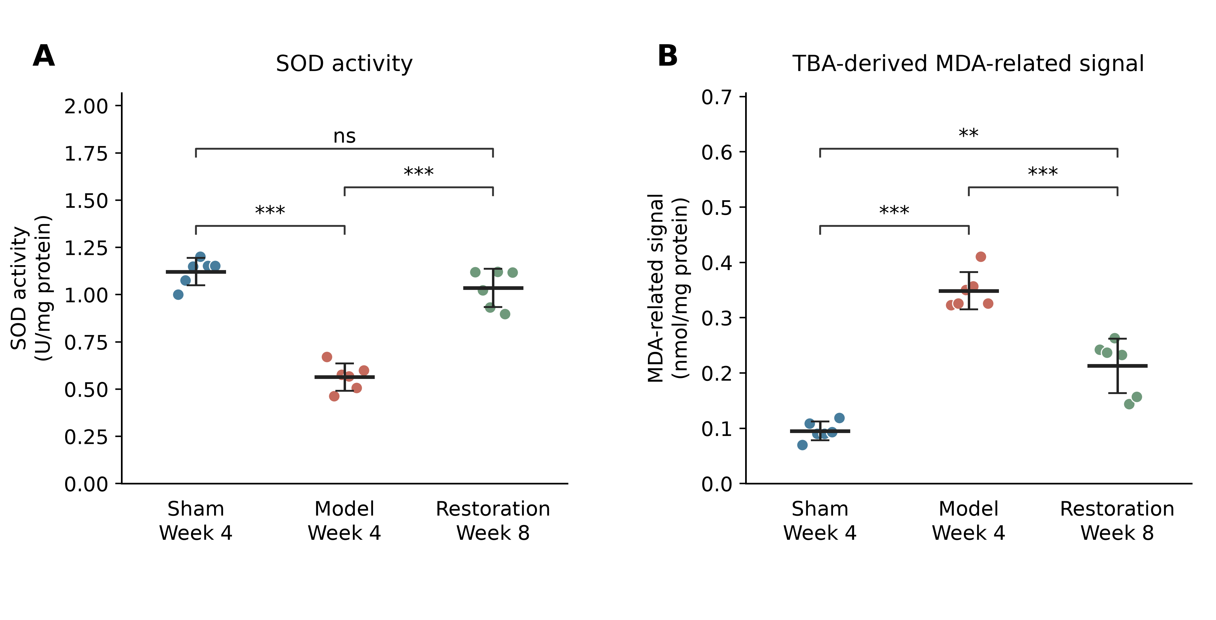
Fig. 1. Regional medullary SOD activity (A) and TBA-derived MDA-related signal (B). Points show the six independently processed samples per group; horizontal lines and error bars indicate mean ± sample SD. Sham and model cohorts were sampled at week 4; the independent restoration cohort was sampled at week 8 after implant removal at week 4. Brackets show Games–Howell comparisons following Welch ANOVA, with adjustment across the three comparisons within each endpoint: **P < 0.01, ***P < 0.001; ns, P ≥ 0.05. Comparisons involving restoration do not isolate an implant-removal effect. Tissue contained the RVLM and adjacent medulla.

Figure 2
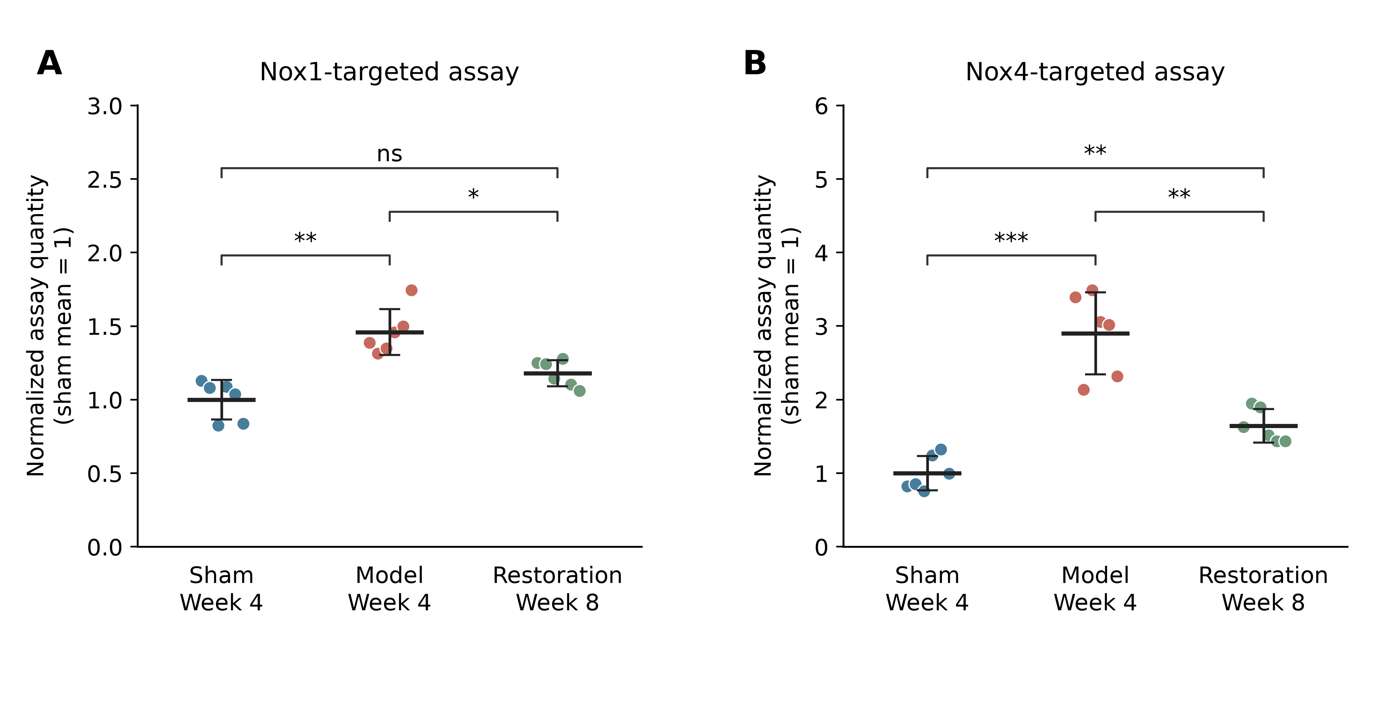
Fig. 2. Exploratory normalized Nox1-targeted (A) and Nox4-targeted (B) RT-qPCR assay estimates. Points show samples; horizontal lines and error bars indicate mean ± sample SD (n = 6/group). Quantities were normalized to the arithmetic mean quantity in sham samples; individual sham values were not set to 1. Statistics used ΔCq and two-sided Welch t tests, with Holm correction across the original 18-comparison family: *P < 0.05, **P < 0.01, ***P < 0.001; ns, P ≥ 0.05. Target specificity and amplification efficiency were not established. Sham/model sampling was at week 4 and restoration sampling at week 8.

