ECEN 468/719 Advanced Logic Design

Department of Electrical and Computer Engineering

Texas A&M University

Lab 11: Combining Canny Edge Detector with System Bus, Memory and UART

Objectives
In this lab, we will combine Canny Edge Detector, SRAM, and UART through the System bus.
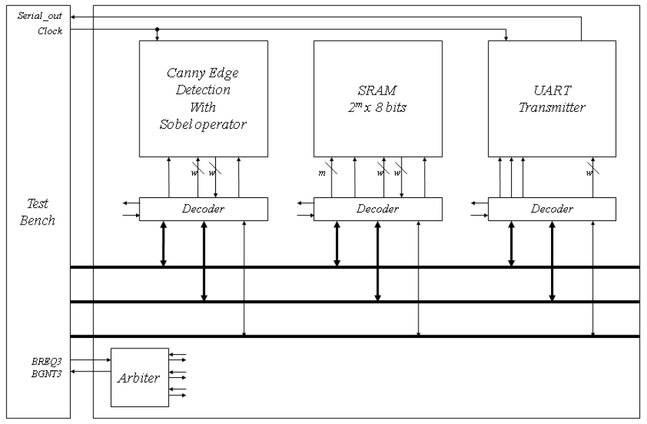
Figure 1. Block diagram of the system

Combining the edge detector with the system bus
In lab 10, the image data moves between the test bench and the modules. The large internal memory required by the image was declared in the test bench. In this lab, we will use the SRAM to store the image. Figure 1 shows the entire system for this lab. The test bench is related only to BMP images in/out and controls logic. It still has internal memory to read and write BMP files.

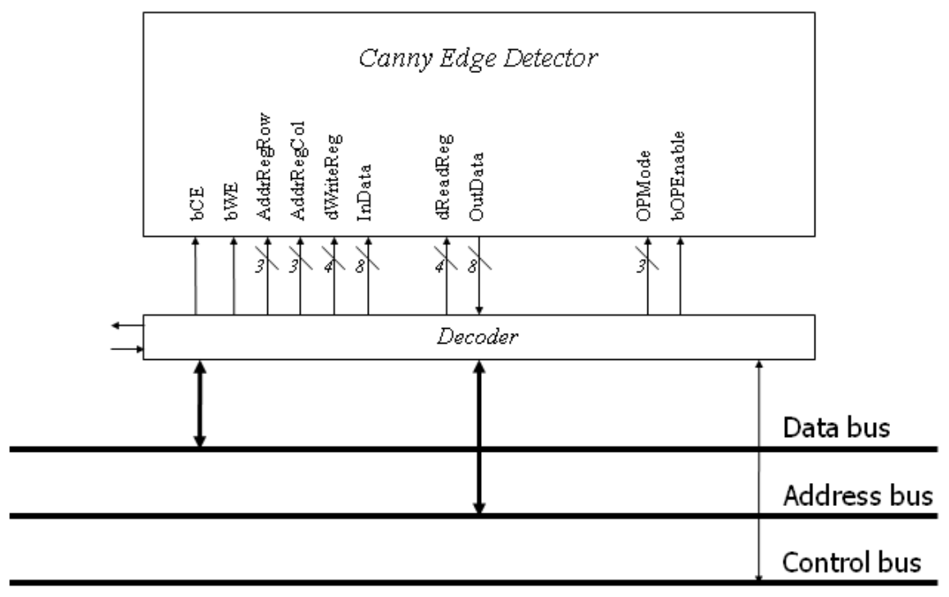
Figure 2. Connection of the Canny Edge Detector and its decoder

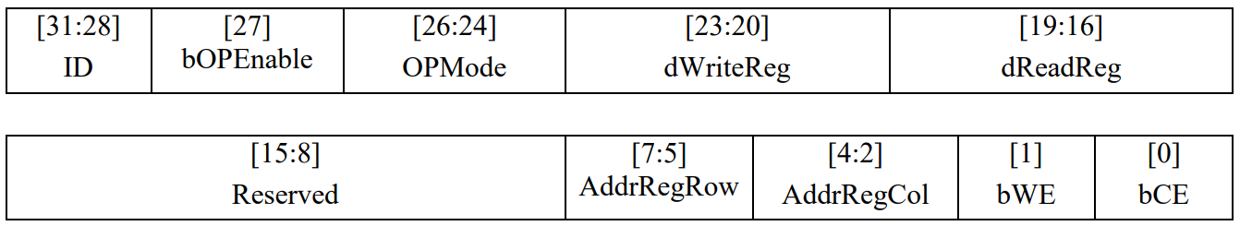
Figure 3. Address map of the Canny Edge Detector

Figure 2 shows signals interconnected between the Canny Edge Detector module and its decoder. To attach the module to the system bus, an address decoder (wrapper) is required to decode the control signals. Figure 3 shows the address map. The 4 most significant bits are used for the identification number of devices. We assume that the ID of the Canny Edge Detector is 0100. The remaining is used for control signals and address signals for control.

Figure 4 shows an example of the noise reduction process. In the first step, the test bench sends all the data to memory. And then, only data which are needed to be fetched is transmitted from the memory to the test bench and into the canny edge detector module finally. After completion of the block processing in the detector module, the data will be read by test-bench, and it will be sent to the proper memory back.

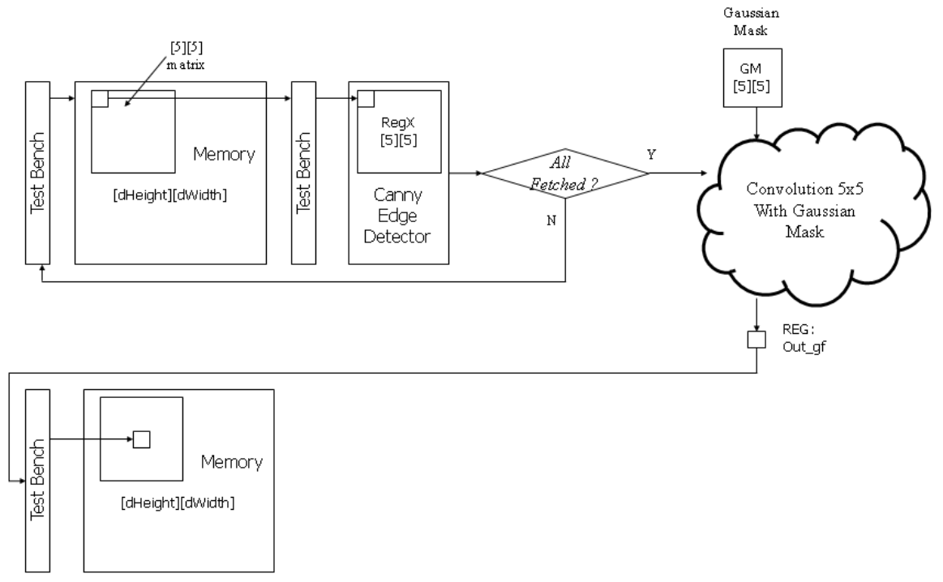
Figure 4. Data flow of Noise Reduction

For debugging, the system needs to send several messages through UART. In this lab, the messages should be sent to indicate the completion of each stage (i.e., noise reduction, gradient extraction, non-maximum suppression, and hysteresis thresholding).

The messages below should be sent through UART.
Noise reduction: ‘N’ = 0x4E
Gradient extraction: ‘G’ = 0x47
Non-maximum suppression: ‘S’ = 0x53
Hysteresis thresholding: ‘H’ = 0x48

Reconfiguration of SRAM
We will expand the size of memory elements to support Canny Edge Detector. Figure 5 shows the memory maps to support it. While it operates with the Canny edge detector, it needs some space to store intermediate images such as an image whose noise is reduced, the gradient information, direction information, an image after the NMS process, the original image, and the final image after hysteresis thresholding. Thus, you will assign memory addresses for each memory block. Figure 5 is an example of memory allocation.

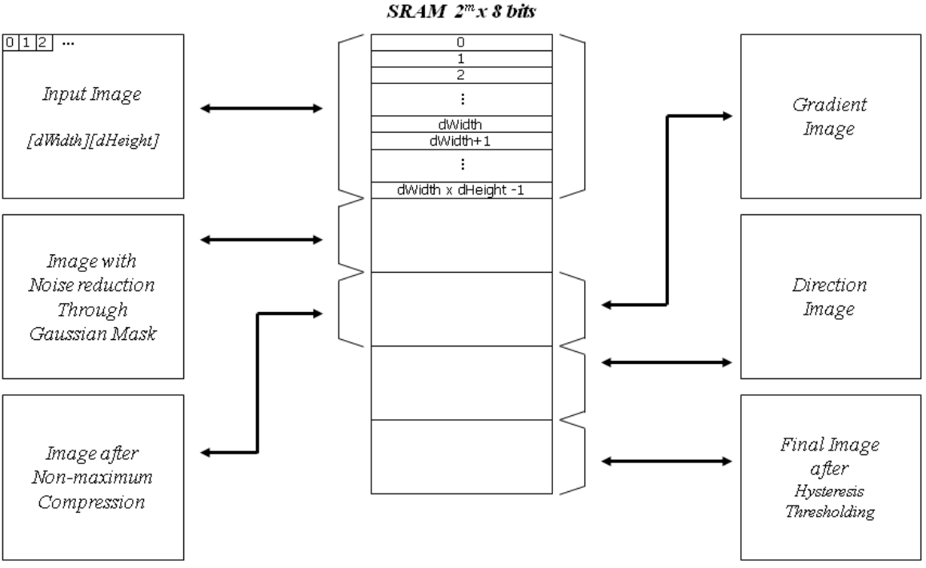
Figure 5. SRAM memory allocation

The memory size depends on the size of the images to be processed. You need to estimate the image size. For example, if the largest image you want to simulate is 200x200 pixels, then we need a memory larger than 200 x 200 x 5 x 8 bits. In this case, the address port of the SRAM should be at least 18 (2¹⁷ < 200 x 200 x 5 < 2¹⁸).

Implementation & Simulation
You will need to implement the wrapper for the canny edge detector for this lab.
Please login to the Olympus server and create a working directory for this lab using the following commands.
## Create and navigate to the working directory.
mkdir -p $HOME/ECEN468/Lab11/src
cd $HOME/ECEN468/Lab11/src
Download the zip file (lab11_code.zip) from Piazza and extract it. In the extracted folders, you will find five files named WRAP_CANNY.v, Arbiter.v, systemtop.v, tb.v, generic.sdb, osu018_stdcells.v, and osu018_stdcells.db. Copy them to the working directory.
Please copy WRAP_SRAM.v, SRAM.v, virtSRAM.v, WRAP_UART.v, UART_XMTR.v, Control_Unit.v, Datapath_Unit.v, Canny_Edge.v from previous labs into the working directory. For the Canny Edge design, please change the high threshold to 10 and the low threshold to 3.
You will need to insert code in the test-bench (tb.v). Please refer to the code in the Gaussian smoothing process, then complete the test bench for the memory operations, UART transmitter, gradient magnitude and direction, non-maximum suppression, and hysteresis thresholding process.

Commands for reference:
load-ecen-468
source /opt/coe/synopsys/vcs-mx/L-2016.06-SP2-4/setup.vcs-mx.sh
vcs -full64 tb.v (vcs -full64 tb.v is you use two-dimensional array)
./simv
vcs -full64 tb_comp.v
./simv

Synthesis
The 256K SRAM is too large to synthesize. We will replace the SRAM.v with virtSRAM.v. The module should have precisely the same in/out ports as your SRAM module.

Please open systemtop.v, modify `include “SRAM.v” to `include “virtSRAM.v”.

Run the command below to invoke the design analyzer.

## Create and navigate to a separate working directory.
mkdir $HOME/ECEN468/Lab11/src/dv_Work
cd $HOME/ECEN468/Lab11/src/dv_Work
## Launch Design Vision
source /opt/coe/synopsys/syn/O-2018.06-SP3/setup.syn.sh
design_vision &

In Design Vision, please do the same steps as in the previous labs:
- Link the libraries
- Analyze
- Elaborate
- Compile
- File -> Save as -> CannyEdge_gate.v
- write_sdf CannyEdge.sdf
- Copy systemtop.sdf and systemtop_gate.v to the parent directory

Gate Simulation
For gate simulation, we need systemtop_gate.v, systemtop.sdf, and osu018_stdcells.v, and test bench.

Open systemtop_gate.v, you will find the SRAM module synthesized with “virtSRAM.v”. Please comment out the SRAM module in systemtop_gate.v. We will use the original SRAM module from SRAM.v for the gate simulation.

We will use the previous testbench as a template to create a testbench for the gate simulation.
$ cp tb.v gate_tb.v

Please open the new testbench “gate_tb.v” and do the following modifications:
- Make sure the following three lines are on the top of the file.
`timescale 1ns/10ps
`include “systemtop_gate.v”
`include “osu018_stdcells.v”
`include “SRAM.v”
- Remove the following line if it exists.
`include “systemtop.v”
- Make sure the following two lines are at the bottom of the file. (within the module entity)
initial
$sdf_annotate(“systemtop.sdf”, systemtop_01);
- If you want to generate the waveform file, change the name of the dump file to “wave_gate.dump” in your testbench. Please note that the file size will be huge, and be careful when you use the generation. You may delete the file after completing this lab for your Linux server capacity allowed. $dumpfile (“wave_gate.dump”);

Run the following command to start the simulation.
source /opt/coe/synopsys/vcs-mx/L-2016.06-SP2-4/setup.vcs-mx.sh
vcs -full64 gate_tb.v
./simv
vcs -full64 tb_comp.v
./simv
If you see the error below, please make changes to modules WRAP_SRAM and WRAP_UART, and WRAP_CANNY in systemtop_gate.v file.
Err : The 32-bit expression “Addressbus” is connected to 20-bit port “AddressBus”. - change “tri [19:0] AddressBus” to “tri [31:0] AddressBus”;
Err : The 32-bit expression “Addressbus” is connected to 4-bit port “AddressBus”. - change “tri [31:28] AddressBus” to “tri [31:0] AddressBus”;
Err : The 32-bit expression “Addressbus” is connected to 16-bit port “AddressBus”. - change “tri [31:16] AddressBus” to “tri [31:0] AddressBus”;

Submission
Please only submit one PDF file containing the following items:
systemtop:
- Screenshots of the terminal output after running ./simv.
- Images generated by the simulation.
- Justification of the correctness of the results.
- Screenshots of the code you implemented.
systemtop Gate:
- Screenshots of the simulation output after running ./simv.

