ECEN 468 Advanced Logic Design
Department of Electrical and Computer Engineering
Texas A&M University
Lab 12
Introduction to Verilog AMS and Simulator
Purpose:
Verilog-AMS HDL is a standard modeling language for analog circuits, and Virtuoso is a simulator for Verilog AMS. We will design a simple application: Phase Locked Loop with Verilog AMS and use Virtuoso for simulation.
Preparation:
1. Brief introduction to PLL(Phase Locked Loop).
We will simulate the functionality of PLL. A phase-locked loop or phase lock loop (PLL) is a control system that generates an output signal whose phase is related to the phase of an input “reference” signal. It is an electronic circuit with a variable frequency oscillator and a phase detector. This circuit compares the phase of the input signal with the phase of the signal derived from its output oscillator and adjusts the frequency of its oscillator to keep the phases matched. The signal from the phase detector is used to control the oscillator in a feedback loop.
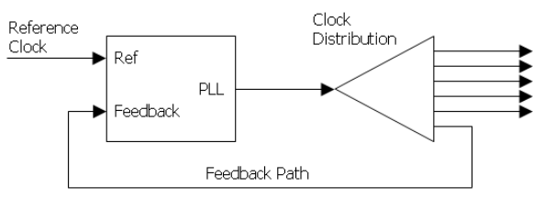
Figure 1 Clock Distribution
Frequency is the derivative of phase. Keeping the input and output phase in the lock step implies keeping the input and output frequencies in the lock step. Consequently, a phase-locked loop can track an input frequency, or it can generate a frequency that is a multiple of the input frequency. We will simulate properties that are used for indirect frequency synthesis or demodulation.
Figure 1 shows the clock distribution of the PLL block. Typically, the reference clock enters the chip and drives a phase-locked loop (PLL), which drives the system’s clock distribution. The clock distribution is usually balanced so that the clock arrives at every endpoint simultaneously. One of those endpoints is the PLL’s feedback input. The function of the PLL is to compare the distributed clock to the incoming reference clock and vary the phase and frequency of its output until the reference and feedback clocks are phase and frequency matched.
A PLL includes a Phase detector, Low-pass filter, Variable-frequency oscillator, and feedback path(which may include a frequency divider), as shown in Figure 2.
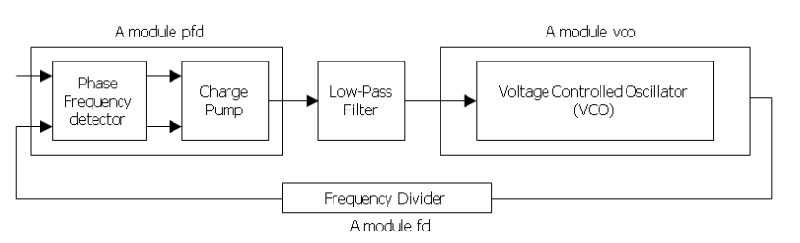Figure 2 Phase Locked Loop block diagram
A phase detector compares two input signals and produces an error signal which is proportional to their phase difference. The error signal is then low-pass filtered and used to drive a VCO, which creates an output phase. The output is fed through an optional divider back to the input of the system, producing a negative feedback loop. If the output phase drifts, the error signal will increase, driving the VCO phase in the opposite direction to reduce the error. Thus the output phase is locked to the phase at the other input. This input is called the reference.
2. Description of Verilog AMS
Verilog-AMS Hardware Description Language(HDL) is derived from the IEEE 1364 Verilog HDL specification. The intent of Verilog-AMS HDL is to let designers create and use modules that encapsulate high-level behavioral descriptions as well as structural descriptions of systems and components. The behavior of each module can be described mathematically in terms of its terminals and external parameters applied to the modules. The structure of each component can be described in terms of interconnected sub-components. These descriptions can be used in many disciplines, such as electrical, mechanical, fluid dynamics, and thermodynamics.
A system is considered to be a collection of interconnected components that are acted upon by a stimulus and produce a response. The components themselves might also be systems. If a component does not have any sub-components, then it is considered a primitive component. Each primitive component connects to one or more nodes. The behavior of each component is defined in terms of signal values at each node. The components connect to nodes through ports to build a hierarchy as shown in Figure 3.
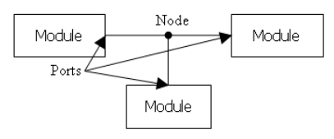
Figure 3 Components connect to nodes through ports
To simulate systems, it is necessary to have a complete description of the system and all of its components. Descriptions of systems are given structurally. That is, the description of a system contains instances of components and how they are interconnected. Descriptions of primitive components are given behaviorally. That is, a mathematical description is given that relates the signals at the ports of the component.
3. Functional Simulation
Make a working folder for this lab.
HOME]$ mkdir ECEN468/Lab12/SRC (make work folder)
HOME]$ cd ECEN468/Lab12/SRC (move to work folder) ECEN468/Lab12/SRC]$ /opt/coe/ncsu/ncsu-cdk-1.6.0.beta/ncsu.sh
(Start Virtuoso)
Then, this will load Virtuoso, and you will see Command Interpreter Window (CIW) as shown in Figure 4.

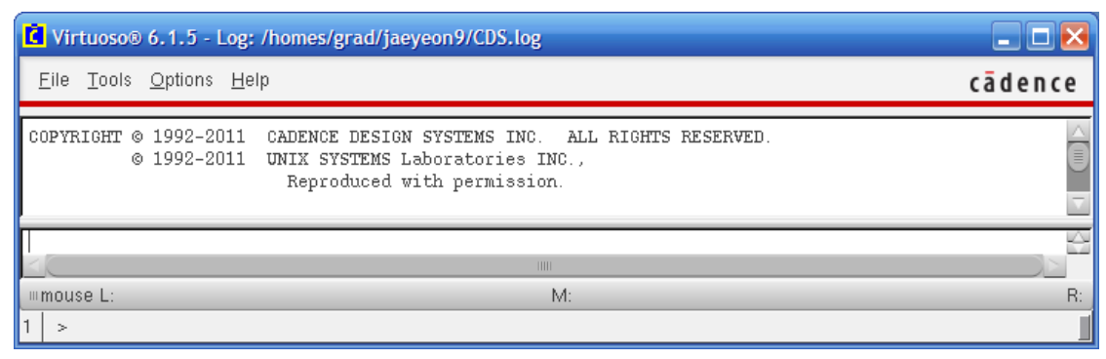
Figure 4 Command Interpreter Window (CIW)
Select Tools – Library Manager to open Library Manager (Figure 5). In Library Manager, there are three main sections which are Library, Cell and View. Library section lists all libraries which contain their all cells such as vexp, vnpn, vpnp, vpulse, and so on. Each cell can be viewed different views such as symbols, schematics, and so on as shown in View section.
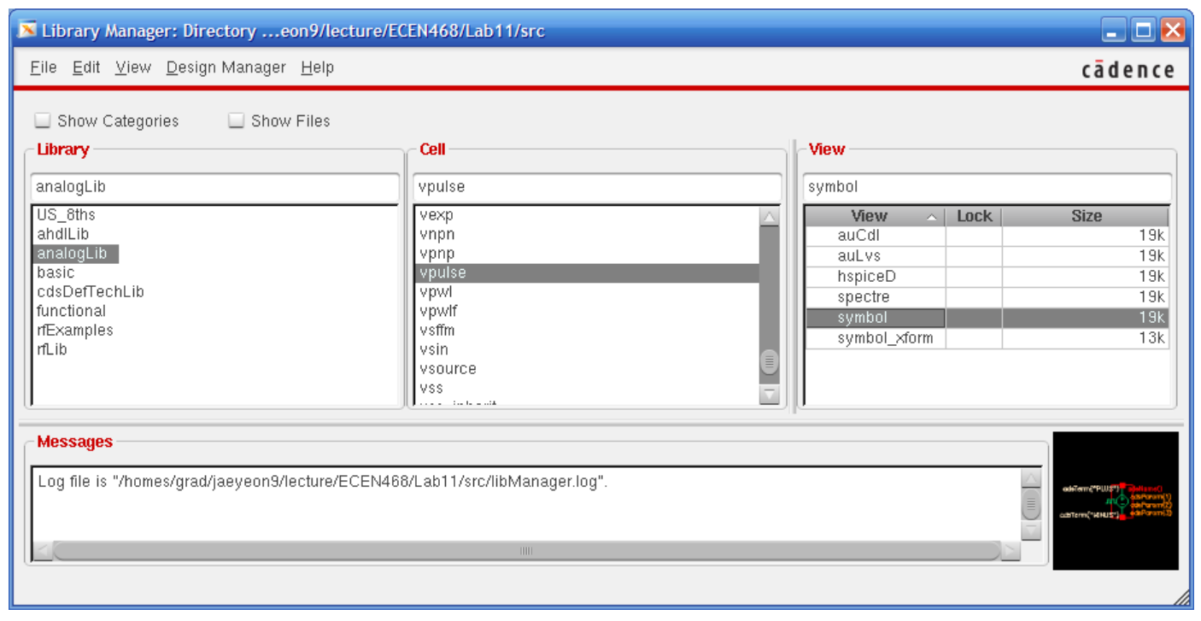Figure 5 Library Manager
You will follow these steps to design and simulate PLL in this lab.
4.1. Creating Library
4.2. Creating Cells
4.3. Connect Cells and Make PLL
4.4. Connect input pulse to PLL
4.5. Simulation
3.1. Creating Library
You will create a library which will contains cells such as Phase Frequency Detector(PFD), Voltage Controlled Oscillator(VCO), Frequency Divider(FD) and top module. From the Library Manager, select File – New – Library. In the New Library window (Figure 6(a)), write PLL as a name of the library and click OK. And, you will use reference existing technology libraries as a technology file as shown in Figure 6(b). In the reference existing technology libraries window, move all technology libraries in left box to right box (Figure 6(c)). Then, you will see PLL library in the Library section in Library Manager.

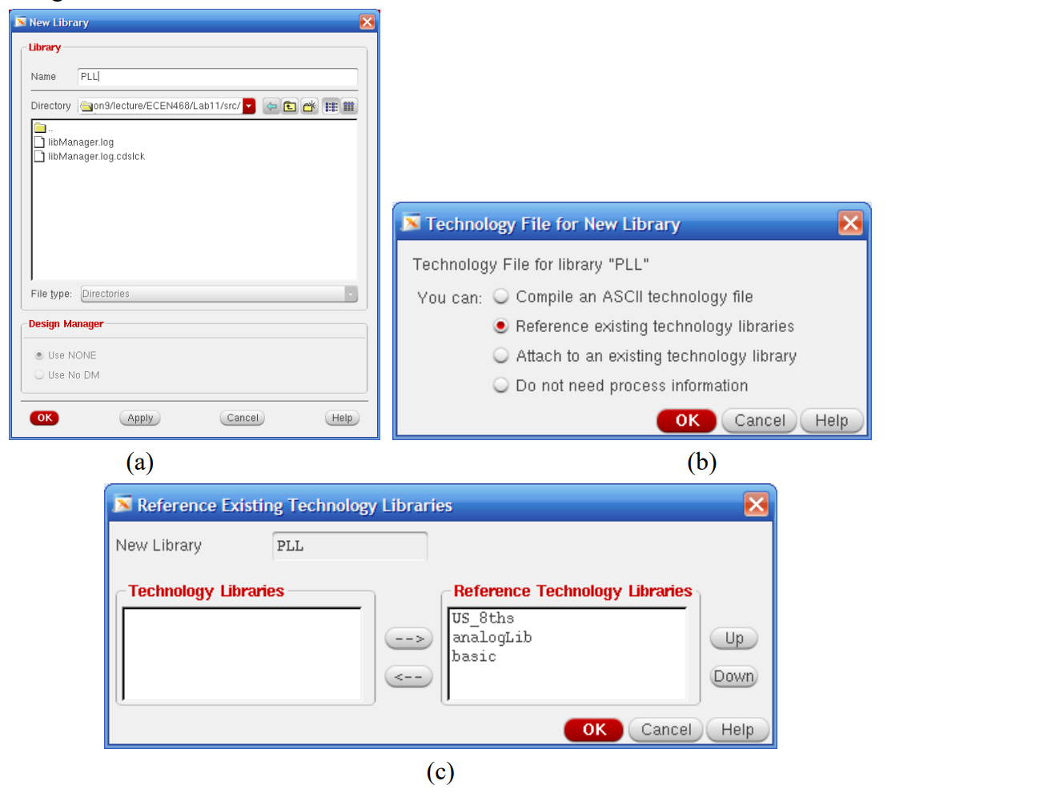
(c)
Figure 6 Creating a Library
(a)New Library window (b) Technology options (c) reference existing technology libraries window
3.2. Creating Cells
We will create cells in PLL and start to design with Phase Frequency Detector (PFD). Figure 7 shows entire schematic of input signal and PLL which will be implemented in this lab. To create a cell PFD, click PLL in the Library section, and select File – New – Cell View. And write pfd as a cell name and choose VerilogA as a type of the cell as shown in Figure 8(a). And click OK. If you see the question
about next license, click Always to keep this rule for the next license options (Figure 8(b)). 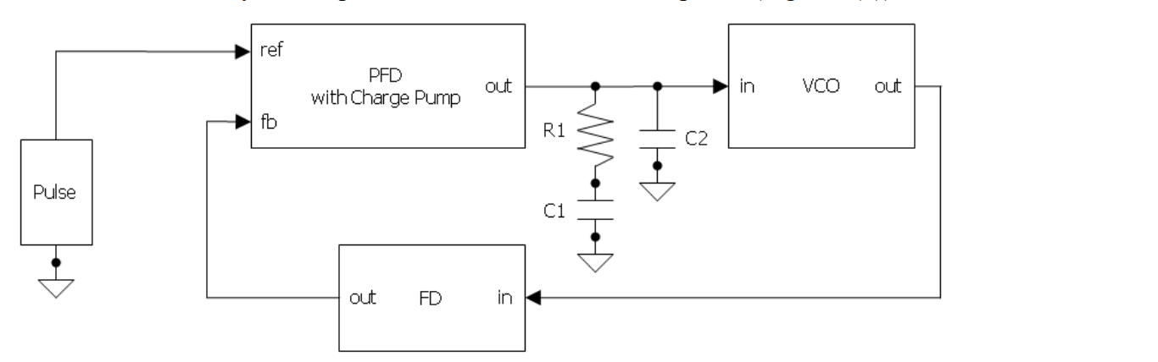Figure 7 Schematic of the input signal and PLL

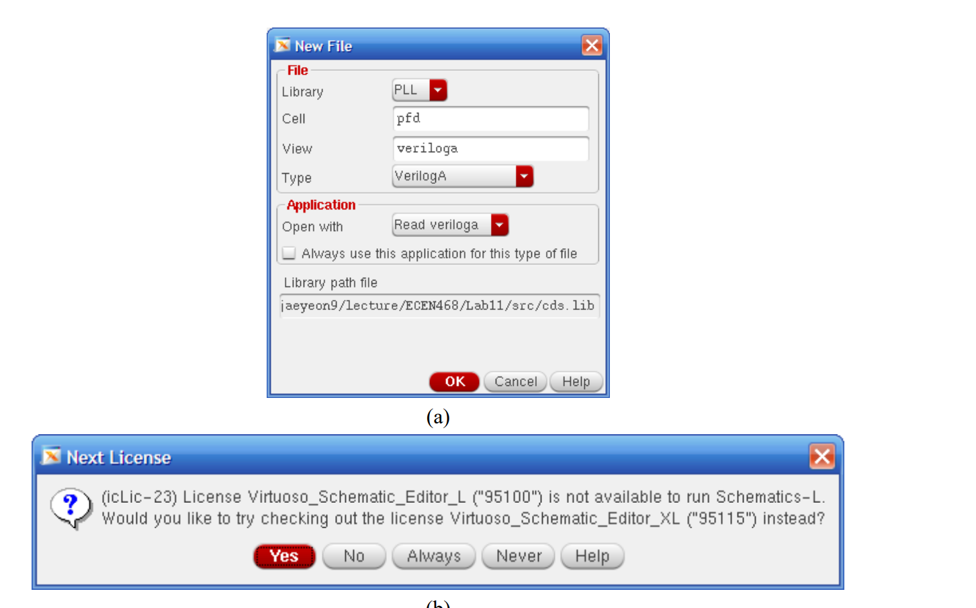(b)
Figure 8 Processes of creating a cell
Then, an editor will be opened, and it has the default contents of the cell pfd. Write only input and output signal names as shown in Figure 9. It will automatically generate the ports while we make a symbol of this cell.
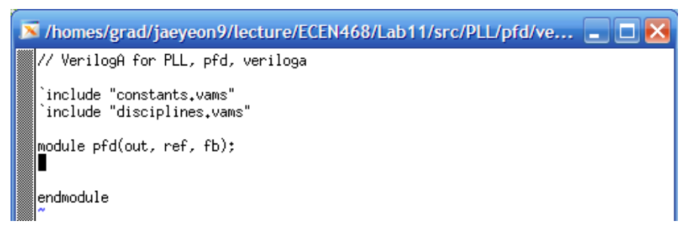
Figure 9 Verilog A file of the PFD cell
After closing the editor, a dialog about a symbol will be viewed because we do not have a symbol of PFD cell yet. Just click Yes to create it. The names of default signals will be shown in Symbol generation option dialog(Figure 10(a)) because we already defined the input and output signals with verilog A module. Change the pins to proper positions. For ref and fb(feedback), put them in Left pins editor and for out pin, put it in Right Pins. And click the List button to select the direction of the signals. Change the direction of ref and fb to an input, and for out, change to an output. 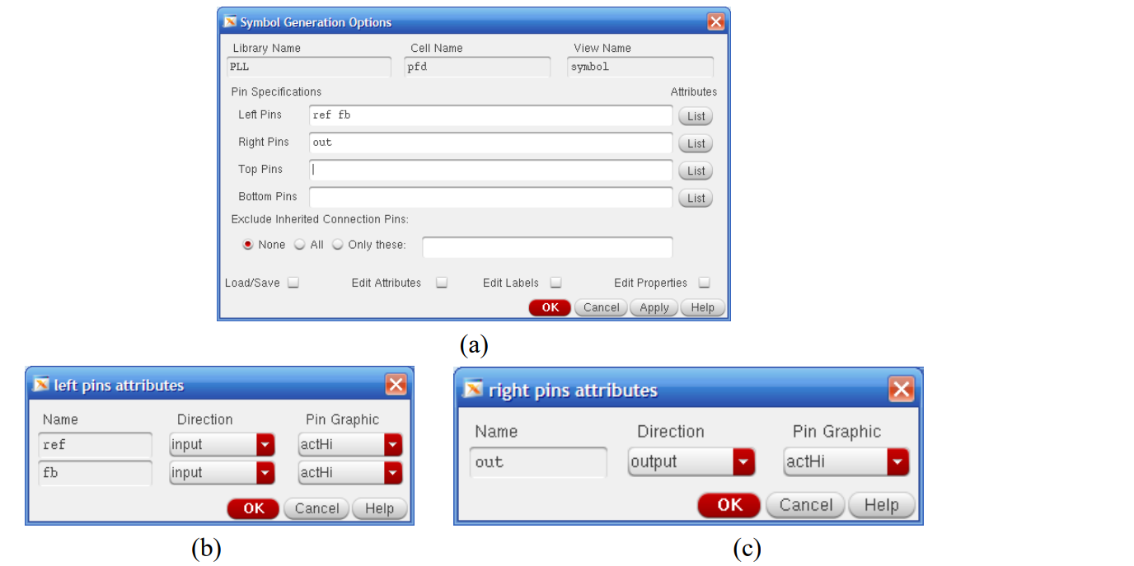

Figure 10 Verilog A file of the PFD cell
Then, you will see the pfd symbol as shown in Figure 11. It is a default symbol for pfd module. You can make it fancy or any shape you want. Then, just close the window.
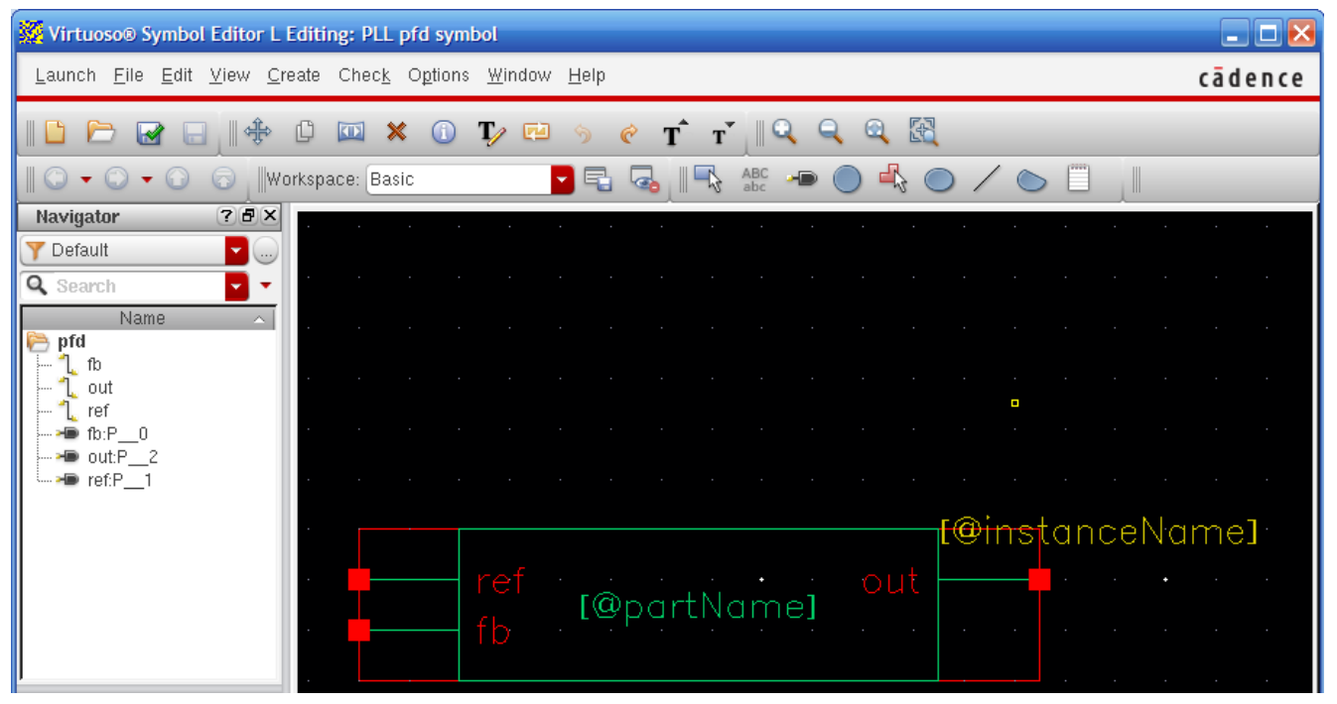Figure 11 Symbol view of pfd module
After closing the window, you will be back in Library Manager. Now it shows the pfd cell in PLL library list. (Figure 12)
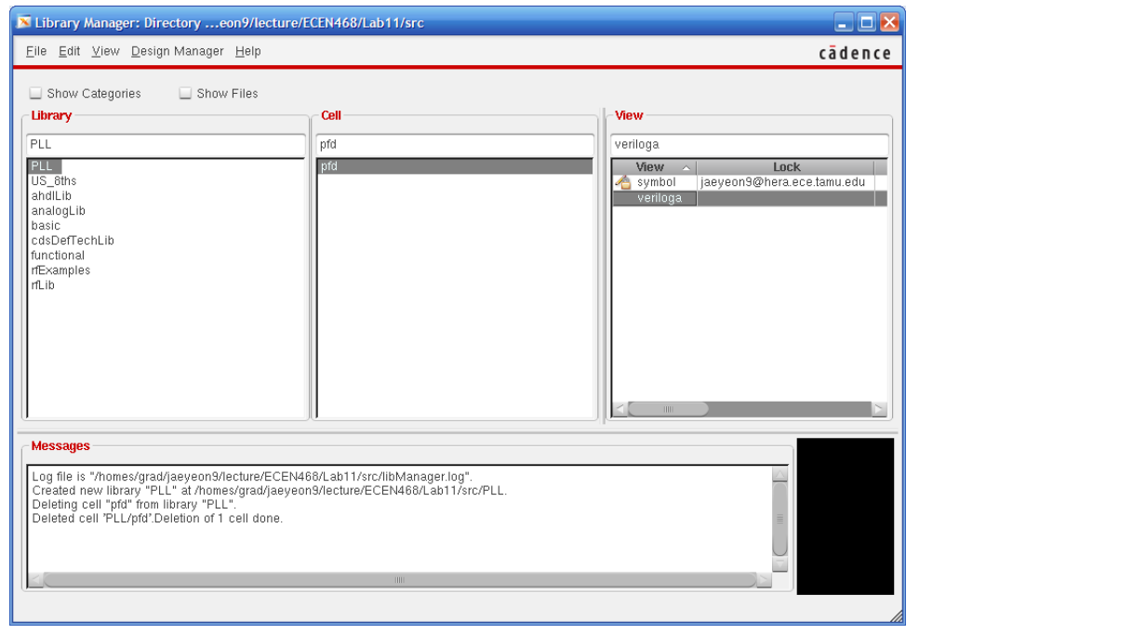
Figure 12 Library Manager, pfd cell generation
In the view section, Phase Frequency Detector Cell has symbol view and veriloga view. If you click symbol view in the view section, you will see its symbol view (Figure 11). If veriloga, it will open an editor for veriloga.
If you are familiar with the editor, you can just describe PFD module in the editor. Or, you can use any editor to modify a veriloga file. You will find the veriloga file(veriloga.va) the path below. You may refer to the codes at the end of the manual.
ECEN468/Lab12/SRC/PLL/PFD/veriloga
Create Frequency Divider and Voltage Controled Oscillator referring to the section 3.2.
● Frequency Divider
- name : fd
- input name : in (to Right Pins)
- output name : out (to Left Pins)
● Voltage Controlled Oscillator
- name : vco
- input name : in (to Left Pins)
- output name : out (to Right Pins)
And, describe their behavior into the veriloga files referring to the codes at the end of the manual. After making all cells of PLL, you will have three cells which are fd, pfd and vco cells as shown in Figure 13.
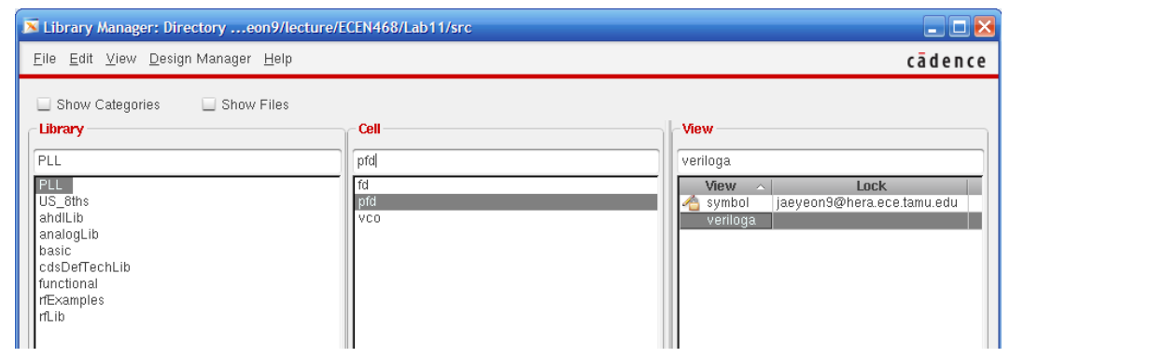Figure 13 Library Manager, pfd, fd and vco cells generation
3.3. Connect Cells and Make PLL
Now we have all cells to make PLL block. With the cells (pfd, fd, vco), we will connect them together and make PLL top module. It is also a cell. To create a cell PLL top, click PLL in the Library section, and select File – New – Cell View. And write plltop as a cell name and choose schmatic as a type of the cell as shown in Figure 14(a). And click OK. Then you will see blank virtuoso blank schematic editor.(Figure 14(b))
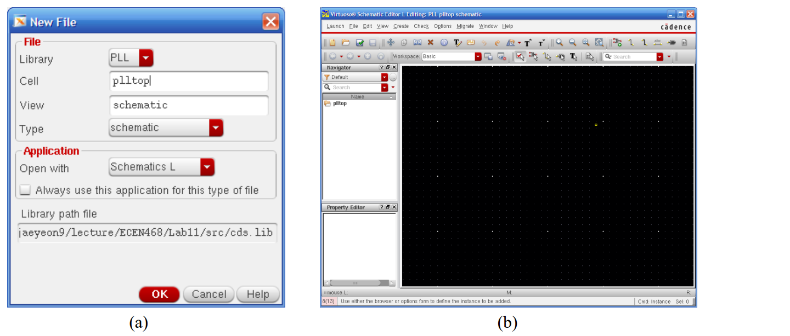
Figure 14 Creating a cell, plltop
In the schematic editor, you will load three sub-cells and connect them. Select Create-Instance and write PLL as a Library and pfd as a cell to place pfd cell into the schematic editor (Figure 15). Place fd and vco as well.
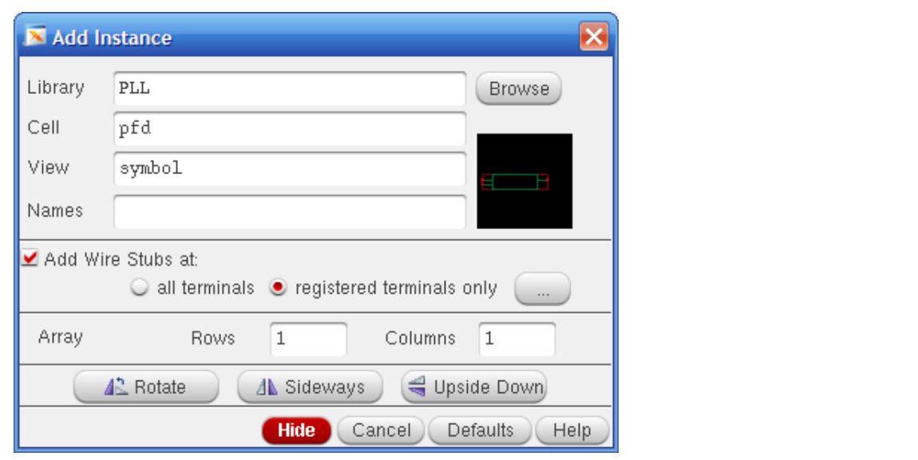
Figure 15 Creating a cell, plltop
Also, create a resister and two capacitor using Create-Instance. And, connect all cells referring to Figure 7 as shown Figure 16. For the names of library and cell and values, please refer to Table I. To connect the instances, please use wires using Create-Wire (narrow).
 | Library | Cell | Value
Resistor R1 | analogLib | res | 134.041K
Capacitor C1 | analogLib | cap | 475p
Capacitor C2 | analogLib | cap | 32p
Ground | analogLib | gnd | non

Table I. Resistor, Capacitor and Ground
Figure 16 is the final schematic of the plltop. And, save the file using File-Save. 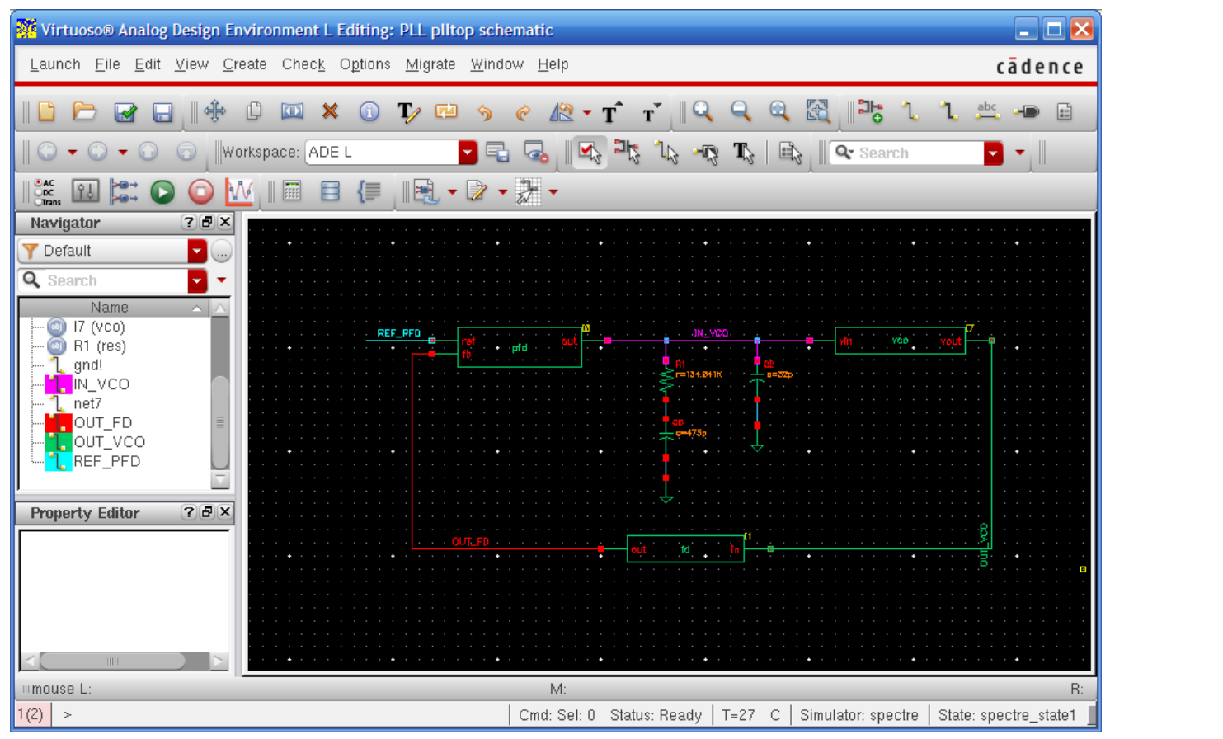Figure 16 The final schematic of plltop cell
3.4. Connect input pulse to PLL
An input pulse source will be used as the input of the plltop. And it will connect to ref port of the pfd cell. Select Create-Instance, and write analogLib as a Library name and vpulse as a Cell name. Put the specifications of the vpulse as +1V for Vmax(voltage1), -1V for Vmin(voltage2), 100ns for Period and 1ns for Rise time and Fall time. Now we made all circuits to simulate. And Click the nets and put each net name for all nets as shown in Figure 17. And then save it to keep the schematic. Once you modify anything in the schematic, you should click File - Check and Save.
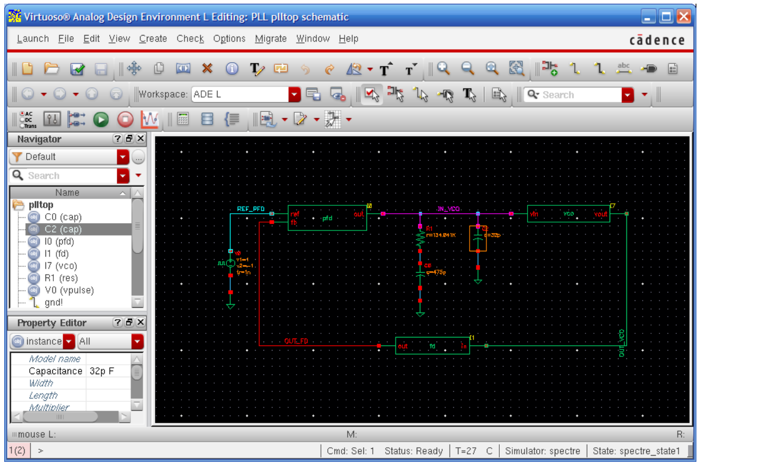Figure 17 The schematic of plltop and input pulse
We will create net names for wires. Please use the net names of TABLE II. Click Create-Wire Name and put the wire name and click Hide. And, click the wire that you want to put the name on.
Wires | Wire names
ref of pfd | REF_PFD
out of fd | OUT_FD
out of vco | OUT_VCO
in of vco | IN_VCO

Table II. Net names
3.5. Simulation
Now we will simulate plltop module which has been described as a Verilog A and schematic. In the virtuoso schematic editor, Select Launch – ADE(Analog Design Environment) L to invoke simulator. And select analysis type using Analyses-Choose (Figure 18). Select tran as a Analysis type and put proper simulation time as a Stop Time. We will simulate it for 50us in this lab, thus write 50u in the box. Then, check moderate as the Accuracy Defaults, and click OK.
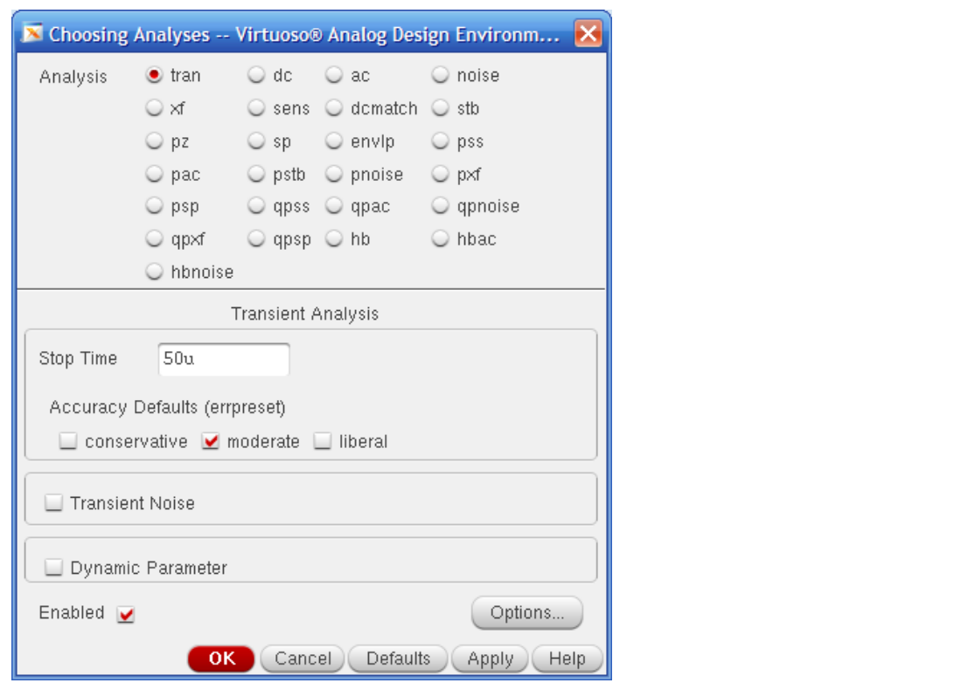
Figure 18 Analyses Dialog
In the Outputs section of the ADE window, click right button of the mouse. Then, click Edit to choose the wires that we want to plot. And, click From Schematic and click the wires we want to plot. Click the nets you want to check and click OK. Choose net REF_PFD, OUT_FD, OUT_VCO and IN_VCO. Then the waveform will be displayed as shown in Figure 21.
You may want to save the current settings for future simulation, and do not need to set the settings again later when you simulate. Save the current state selecting Sessions – Save state. Just check “CellView” and click OK as shown in Figure 19. When you want to load the current state saved, select Sessions – Load state and check “CellView”.
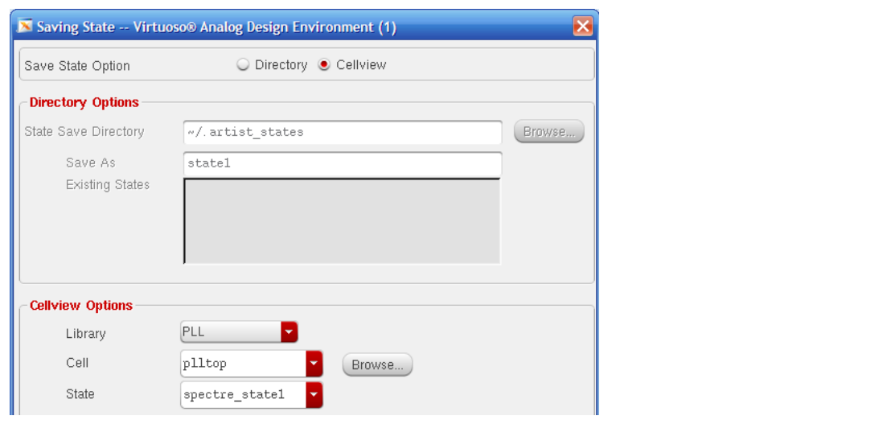
Figure 19 Saving state
Now we set all settings for simulation. Then, select Simulation – Netlist and run to simulate the plltop with the settings. Then, it will show simulation status as shown in Figure 20, and show the waveform will be displayed as shown in Figure 21.
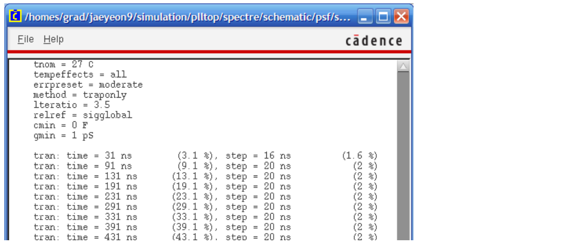
Figure 20 Simulation process
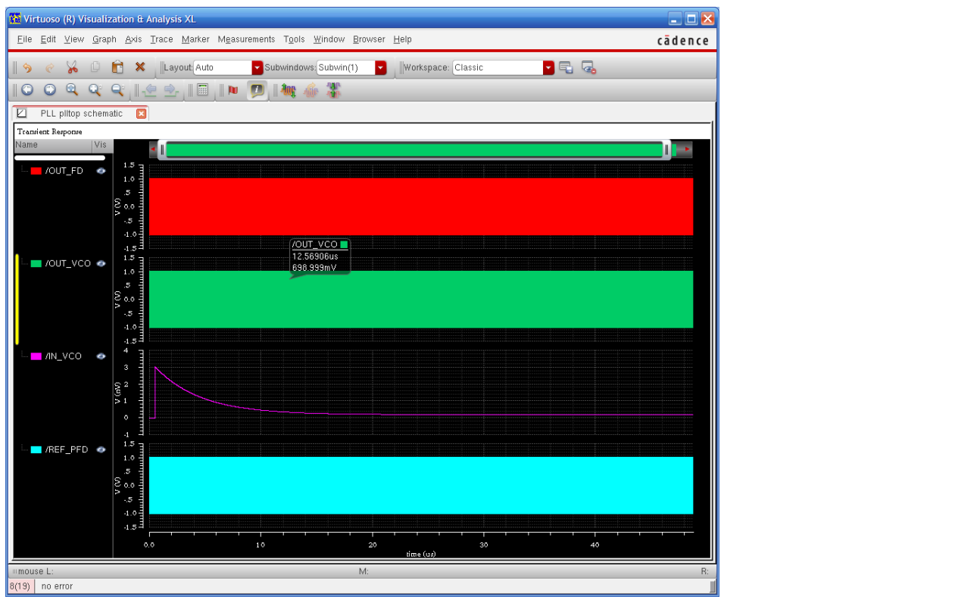(a)
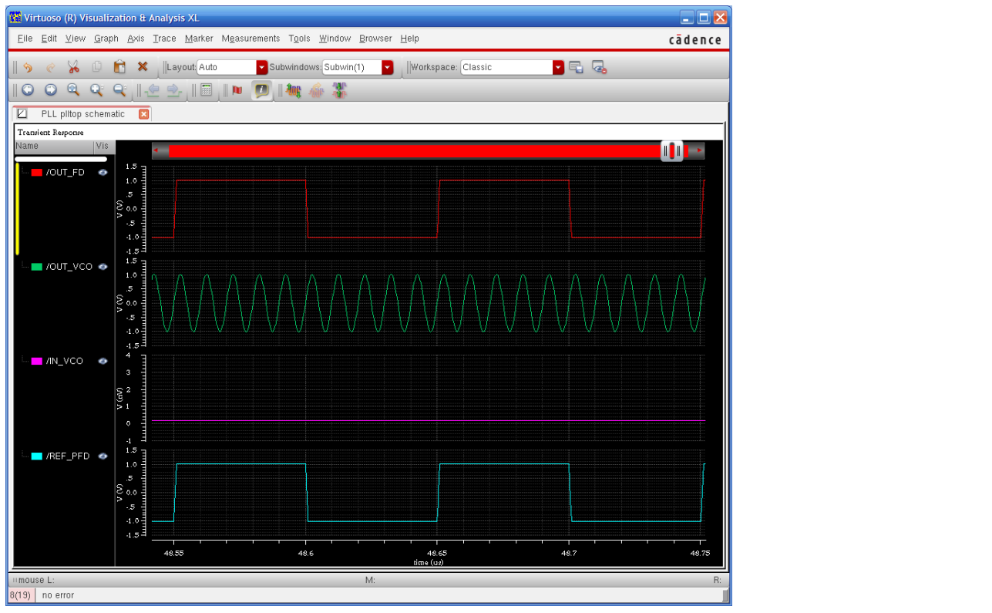(b)
Figure 21 Final simulation results
Requirements:
1. General requirements.
a. It should control PLL correctly.
b. Please make sure the same net names and cell names with being described in this manual.
c. Late penalty : 20% of total score will be deducted on each subsequent day after due date.
2. Please only submit one PDF file with the following items:
a. Simulation results including the four nets in table II (the one like Figure 21)
b. Let’s assume that you want to generate 1GHz output of the Voltage Controlled Oscillator with a 1MHz reference clock. Please mention what parts should be modified.

// ----------------------------------------------------
// Phase Frequency Detector
// ----------------------------------------------------
// VerilogA for PLL, pfd, veriloga
`include "constants.vams"
`include "disciplines.vams"
module pfd(out, ref, fb);
output out; electrical out; // current output
input ref; voltage ref; // positive input (edge triggered) input fb; voltage fb; // inverting input (edge triggered)
parameter real iout=100u;
parameter real vh=1;
parameter real vl=-1;
parameter real vth=(vh+vl)/2;
parameter integer dir=1 from [-1:1] exclude 0;
// dir=1 for positive edge trigger
// dir=-1 for negative edge trigger
parameter real tt=1n from (0:inf);
parameter real td=0 from [0:inf);
integer state;
analog begin
// Implement phase detector
@(cross(V(ref)-vth, dir))
if (state > -1) state = state - 1;
@(cross(V(fb)-vth, dir))
if (state < 1) state = state + 1;
// Implement charge pump
I(out) <+ transition(iout*state, td, tt);
end
endmodule

// ----------------------------------------------------
// Frequency Divider
// ----------------------------------------------------
// VerilogA for PLL, fd, veriloga
`include "constants.vams"
`include "disciplines.vams"
module fd(out, in);
output out; voltage out; // output
input in; voltage in; // input (edge triggered)
parameter real vh=+1;
parameter real vl=-1;
parameter real vth=(vh+vl)/2;
parameter integer ratio=10 from [2:inf);
parameter integer dir=1 from [-1:1] exclude 0;
// dir=1 for positive edge trigger
// dir=-1 for negative edge trigger
parameter real tt=1n from (0:inf);
parameter real td=0 from [0:inf);
integer count, n;
analog begin
@(cross(V(in) - vth, dir)) begin
count = count + 1;
if (count >= ratio)
count = 0;
n = (2*count >= ratio);
end
V(out) <+ transition(n ? vh : vl, td, tt);
end
endmodule
//
---------------------------------------------------- // Voltage Controlled Oscillator
// ---------------------------------------------------- `include "disciplines.vams"
`include "constants.vams"
`define PI 3.14159265358979323846264338327950288419716939937511
module vco(in, out);
input in;
output out;
voltage in, out;
parameter real amp = 1;
parameter real center_freq = 100M;
parameter real vco_gain = 50M;
parameter integer steps_per_period = 32;
real phase;
real inst_freq;
real real_vout;
analog begin
inst_freq = center_freq + vco_gain * V(in); $bound_step (1.0 / (steps_per_period*inst_freq));
phase = idtmod(inst_freq,0,1);
V(out) <+ amp * sin (2 * `PI * phase); end
endmodule

