Calibration Guide

Calibrating the length scale of the scanned bubble chamber pictures such that the pixel size corresponds to the real bubble chamber dimensions is an important analysis process. This calibration allows the program to convert the momentum measurements to electron volt units, which a student can use in further analysis.

The original bubble chamber analysis used fiducial markers to calibrate the length scale and correct any optical distortions that may have been introduced by the camera. Many papers, such as [1], mention the use of the fiducial markers and the relevant computer software that was employed for correction procedures. Originally, the design team wanted to use a similar calibration system, however, an extensive survey of the literature available online yielded no information for the numerical positions of the fiducial markers. Hence, this idea was not employed in the final product. It is currently believed by the design team and Prof. Bailey that information about these fiducial markers may be available in paper archives at either SLAC or LBN but, due to limited time, this option was not explored.

To calibrate the length scale for the traxis analysis framework, the design team used the printed output from the original analysis of the bubble chamber events. This information is contained within 2 binders that originally belonged to Prof. Luste and currently Prof. Bailey has access to them. The printed output contains the calibrated positions of the start and end points of tracks and locations of interaction vertices [See Appendix A]. For each calibrated measurement available in the output, the corresponding position in pixel coordinates was also measured. Locating the points on the picture required knowledge of the interaction and some guess work as only a condensed summary of the full information is available.

As the absolute location of points provides no information needed by the analysis, for calibration a multiplicative constant was derived to ensure that the distances between the points are consistent. More mathematically, if is the calibrated position of the point available in the print out of the original analysis and is the corresponding position in pixel coordinates, then the calibration factor is given by:
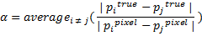
This calibration factor can then be applied to any measurement, such as radius and track length, to yield the results in calibrated units.

A limitation of this technique is that the calibrated positions were derived using a stereographic combination of three different views of the same event, while the film available for analysis contains only one such view. Hence, in certain cases, the calibrated position might not correspond to the pixel measurement. It is believed by the design team that these are due to optical distortions and in such cases these points were discarded when deriving the calibration constant.

The calibration constant needs to be re-derived every time the scanner or resolution of the images is changed. Its value can be updated in the file constants.py.

References
[1] M. Goddard, “Strange Particles produced by p Collisions at 10.3 GeV/c”, M.S. thesis, Department of Physics, University of Toronto, Toronto, ON, 1975.

Appendix A
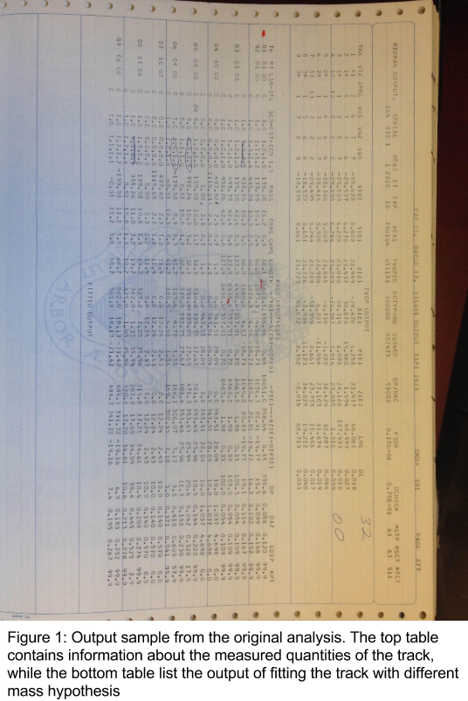
Figure 1 shows a sample output table from the original analysis of one of the bubble chamber events. On the very top row, the number under the heading “Serial” is the unique identifier for the bubble chamber event. This exact number appears on the corresponding film image as well. See the Lab handout for more information.

The first table, labelled “TVGP output”, contains the information about the tracks. Note that for a given event, only a select few tracks are measured and some guess work is required to find the corresponding track on the image. The column “TRK” is the unique numerical identifier for the track. The column “VTX” contains the vertex information for the track and it can come in 3 different formats:
*n (with n being an integer) means the track is terminated at vertex n
n* (with n being an integer) means the track starts at vertex n
nm (with n, m being integers) means the track starts at vertex n and is terminated at vertex m

The columns “X(B)”, “Y(B)”, “Z(B)” list the start positions of the tracks in cm and columns “X(E)”, “Y(E)”, “Z(E)” list the end positions of the tracks in cm. Column “LNG” and “DL” contain the lengths and thicknesses of the tracks in cm.

The second table, labelled “Mass Hypothesis”, contains information from fitting the track with certain mass hypotheses. Each track in “TVGP output” is fitted using a particle with known mass, as listed under the column “MASS”. Typically, the last mass fitted for the track is the best fit value. Based on discussions with Prof. Orr, it is believed that the track fitting takes into account energy loss using the Bethe-Bloch function. The column “LENGTH” lists the length of the track in cm, columns “P(B)” and “P(E)” list the start and end momenta of the track in MeV, “AZ(B)” and “AZ(E)” list the start and end azimuthal angles of the track and “DIP(B)” and “DIP(E)” list the dip angles at the start and end of the track respectively.

To get the pixel coordinates of a point on the image, one can use the traxis software to place a track marker at that point, save a session and inspect the JSON file for marker coordinates.
Reference line is not known exactly
The reference is believed to be the horizontal plane

