Method of Digitization
Initially an EPSON V300 scanner was used to digitize the film. However, the EPSON V700 scanner, available in the Digital Studio at Robarts Library can also be used. Obtaining access to the scanner is described in [1]. A film holder, which was used extensively in the digitization process, is available in the cabinet beside the scanner as shown in Figure 1.
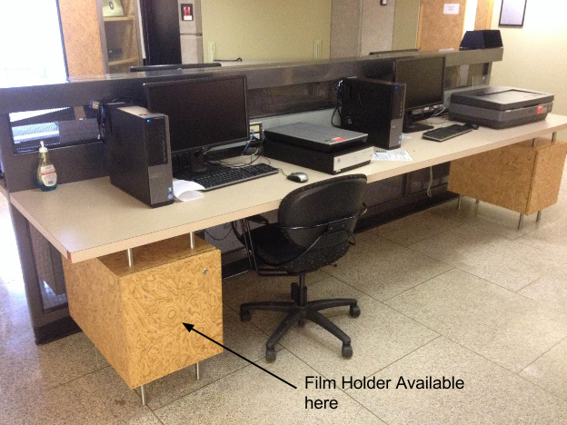
The method to load the image and instructions provided on using the EPSON scanning software are based on the V300 scanner but the instructions are applicable to V700 scanner without any modifications.

1 Loading the image
Before the scanning process is started, the film needs to be loaded into the film holder provided with the scanner. There are multiple holders available; it is recommended that the one applicable for 35mm film be used. The instructions on loading the film are below:
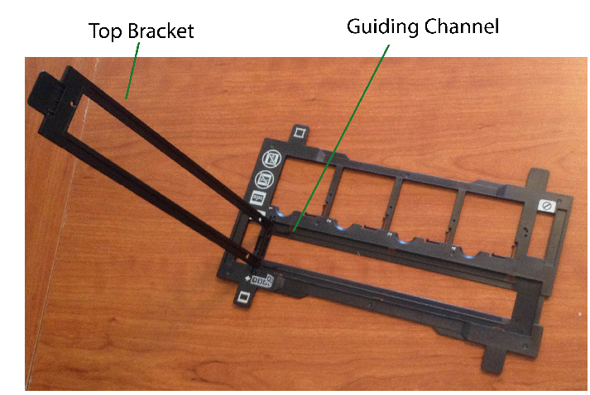
- Clean the film using a dry tissue. Visually inspect to ensure that no dust particles are on the surface.
- Open the top bracket as shown in Figure 2.
- Slide the film into the small guiding channels. Ensure that the film is straight and that the front side of the image is facing down. Otherwise, when the film is scanned, the orientation of the resulting picture will be flipped.
- Close the top bracket. Again, ensure that the film is placed between the guiding channels.
- Place the film holder on top of the scanning bed. There are side markers available to guide the position of the holder. An example is shown in Figure 3.
- Close the top lid of the scanner.

To ensure that the scanned image is not distorted, when the film is secured on the film holder, it is to be as flat as possible. It is recommended that prior to starting the scan process, the film be stretched out straight and rolled up in the opposite orientation to correct for the tendency of the film to curl up. It is recommended that the film be stretched out/rolled up in the opposite orientation for a few days.

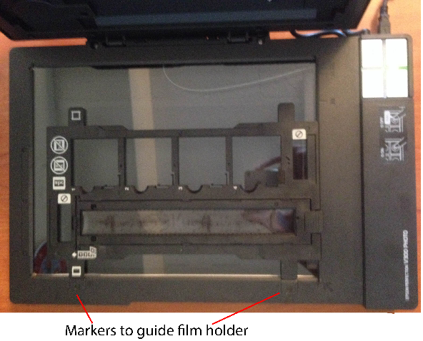
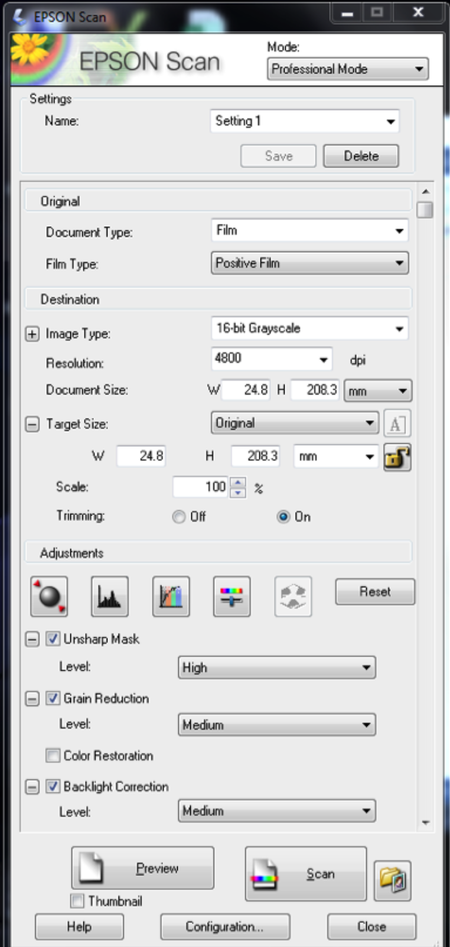
Figure 3: Film holder on the scanning bed. The holder will slide into the markers on the side.

2 Scanning the film
Once the film has been loaded, the instructions provided below can be used to digitize the image.
- Open the “EPSON Scan” Software on the computer connected to the scanner
- Select “Professional Mode” for scanning. It will open a window as shown in Figure 4.
- Input the settings listed in Table 1.
- Use the preview button to create a temporary low-resolution scan. Using the “Marquee Tool”, select a region around the film. This region will be scanned at the full resolution
- Press “Scan” to start the scanning process
- Other film can be scanned by loading a new piece in the holder following the instructions in Section 1 and simply repeating step 5 in Section 2.
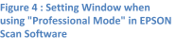

Table 1: Settings recommended for scanning
Scanning option | Setting
Document Type | Film
Film Type | Positive Film
Image Type | 16-bit grayscale
Unsharp Mask | High
Grain reduction | Medium
Backlight correction | Medium
Level Correction | Shadow at 72, midtones at 1.20, highlights at 212 and output at 18 and 246.

Tips for scanning
It is recommended that 2 bubble chamber events be scanned at the same time; this will cut down the time needed for scanning.
In post processing, using image software such as Photoshop or imagemagick, the scanned image can be split in half and low resolution images can be created for user browsing.

References
- “Digital Studio” [Online]. http://www.utoronto.ca/ic/digitalstudio/index.html

