groupby문제.pdf
SQL> select to_char(hire_date,'MM') 월, count(employee_id) 입사자수
2 from employees
3 group by to_char(hire_date,'MM')
4 order by 월;

월 입사자수
---- ----------
01 14
02 13
03 17
04 7
05 6
06 11
07 7
08 9
09 5
10 6
11 5

월 입사자수
---- ----------
12 7

groupby_01.pdf
0.
SQL> select ename, mgr, nvl2(mgr,'담당','상위자') 관리자
2 from emp;

ENAME MGR 관리자
-------------------- ---------- ------------------
SMITH 7902 담당
ALLEN 7698 담당
WARD 7698 담당
JONES 7839 담당
MARTIN 7698 담당
BLAKE 7839 담당
CLARK 7839 담당
SCOTT 7566 담당
KING 상위자
TURNER 7698 담당
ADAMS 7788 담당
JAMES 7698 담당
FORD 7566 담당
MILLER 7782 담당
1.
SQL> select nvl(to_char(department_id),'No Department') 부서번호, round(avg(salary)) 평균급여
2 from employees
3 group by department_id
4 having avg(salary) > 6000;

부서번호 평균급여
-------------------------------------------------------------------------------- ----------
100 8601
No Department 7000
90 19333
20 9500
70 10000
110 10154
80 8956
40 6500
2.
SQL> select DEPARTMENT_ID, AVG(SALARY)
2 from employees
3 group by department_id
4 having avg(salary)>=10000;

DEPARTMENT_ID AVG(SALARY)
------------- -----------
90 19333.3333
70 10000
110 10154
3.
SQL> select DEPARTMENT_ID, AVG(SALARY)
2 from employees
3 where department_id not in (50,40)
4 group by department_id
5 order by AVG(SALARY) desc;

DEPARTMENT_ID AVG(SALARY)
------------- -----------
90 19333.3333
110 10154
70 10000
20 9500
80 8955.88235
100 8601.33333
60 5760
10 4400
30 4150

9 rows selected.
4.
SQL> select FIRST_NAME, LAST_NAME, SALARY, COMMISSION_PCT, (salary+commission_pct) TOTAL
2 from employees
3 where commission_pct is not null
4 order by TOTAL desc;
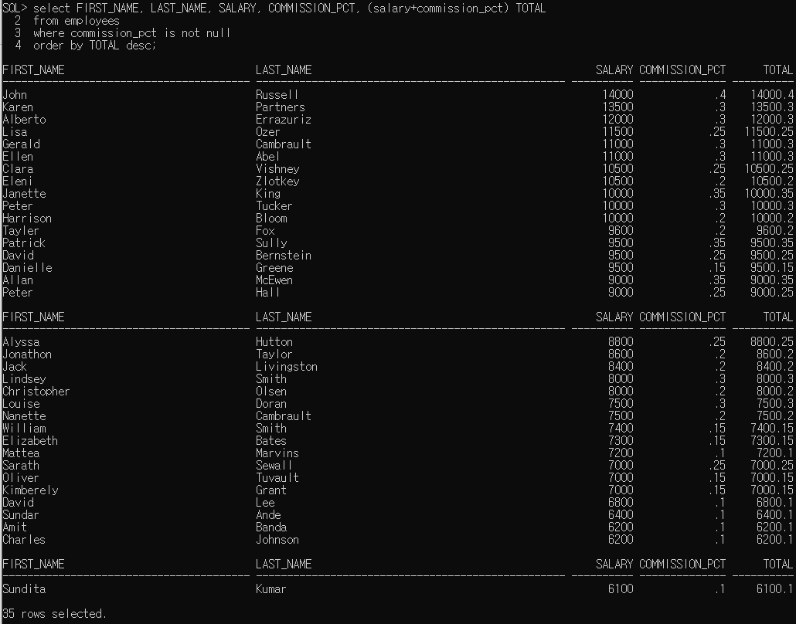
FIRST_NAME LAST_NAME SALARY COMMISSION_PCT TOTAL
---------------------------------------- -------------------------------------------------- ---------- -------------- ----------
John Russell 14000 .4 14000.4
Karen Partners 13500 .3 13500.3
Alberto Errazuriz 12000 .3 12000.3
Lisa Ozer 11500 .25 11500.25
Gerald Cambrault 11000 .3 11000.3
Ellen Abel 11000 .3 11000.3
Clara Vishney 10500 .25 10500.25
Eleni Zlotkey 10500 .2 10500.2
Janette King 10000 .35 10000.35
Peter Tucker 10000 .3 10000.3
Harrison Bloom 10000 .2 10000.2
Tayler Fox 9600 .2 9600.2
Patrick Sully 9500 .35 9500.35
David Bernstein 9500 .25 9500.25
Danielle Greene 9500 .15 9500.15
Allan McEwen 9000 .35 9000.35
Peter Hall 9000 .25 9000.25

FIRST_NAME LAST_NAME SALARY COMMISSION_PCT TOTAL
---------------------------------------- -------------------------------------------------- ---------- -------------- ----------
Alyssa Hutton 8800 .25 8800.25
Jonathon Taylor 8600 .2 8600.2
Jack Livingston 8400 .2 8400.2
Lindsey Smith 8000 .3 8000.3
Christopher Olsen 8000 .2 8000.2
Louise Doran 7500 .3 7500.3
Nanette Cambrault 7500 .2 7500.2
William Smith 7400 .15 7400.15
Elizabeth Bates 7300 .15 7300.15
Mattea Marvins 7200 .1 7200.1
Sarath Sewall 7000 .25 7000.25
Oliver Tuvault 7000 .15 7000.15
Kimberely Grant 7000 .15 7000.15
David Lee 6800 .1 6800.1
Sundar Ande 6400 .1 6400.1
Amit Banda 6200 .1 6200.1
Charles Johnson 6200 .1 6200.1

FIRST_NAME LAST_NAME SALARY COMMISSION_PCT TOTAL
---------------------------------------- -------------------------------------------------- ---------- -------------- ----------
Sundita Kumar 6100 .1 6100.1

