Graduation Project Progress Report 1

Title | OMRiDA: Omni Mathematical expression Recognition  via Domain Adaptation
Summary  (in 150 words) | We selected baseline models and constructed datasets. We reproduced the baseline models on HME datasets. PosFormer was evaluated on CROHME and MNE, while TAMER was implemented on CROHME and HME100K. To validate our approach, we tested these models on PME data but faced a vocabulary mismatch problem. Since using both PME and HME data was central to our project, we built a dataset that aligned both domains under a shared vocabulary. This dataset includes HME-PME pairs, where each PME sample was generated based on its HME counterpart. To use this paired dataset for cross-domain learning, we proposed three domain adaptation directions: (1) 1-stage DA (Explicit, Adversarial, Contrastive), (2) 2-stage DA (SFDA), and (3) DG. We implemented the DLA model from scratch as a baseline for domain adaptation. Though current performance is limited, it builds a foundation for future experiments, which will apply and evaluate these approaches step by step.
Advisor | Prof. Dongjin Kim
Period | 2025. 03. 01 ~ 2025. 12. 20

Name | Department | Student ID | Hanyang email | Phone
Sungmin Yang | Dept. of Data Science | 2020005723 | yangsp704@hanyang.ac.kr | 010-8791-3607
Soyeon Kim | Dept. of Data Science | 2021096417 | ssoglet@hanyang.ac.kr | 010-3873-5707

College of Data Science
Hanyang University
1. Progress to Date

1.1. Selection of Baseline Models

In this project, we aim to bridge domains of Handwritten Mathematical Expression Recognition (HMER) and Printed Mathematical Expression Recognition (PMER). To compare the performance of our own model with State-Of-The-Art (SOTA) results, we need both HMER and PMER baseline models. Additionally, we need Mathematical Expression Recognition (MER) models which can handle both handwritten and printed Mathematical Expressions (MEs) for domain adaptation. We selected two models for HMER and domain adaptation, and one for PMER.

HMER models can be classified into five categories based on their main architecture: CNN-RNN decoder based, tree decoder based, transformer based, graph based, and cross-attention/custom approaches. Among these, we chose tree decoder based and transformer-based models, as many recent studies have adopted these methods and showed SOTA performance. We used PosFormer[1] and TAMER[2] for HMER, which are transformer-based and tree-aware transformer-based, respectively. Since most recent HMER models are open-sourced, we were able to select the ones best suited to our needs. We chose PosFormer because it improves performance by using a positional-aware architecture and achieves SOTA results on CROHME 2016, 2019 and HME100K. TAMER combines a tree-aware structure with the advantages of transformers, showing SOTA performance on CROHME 2014. These models use different dataset loading methods, helping us understand both approaches - image-based and pickle-based data loading.

We selected IM2TEX[3] for PMER, and DLA[4] and PAL[5] for domain adaptation between the two domains. PMER has relatively fewer studies compared to HMER, and most of their codes aren’t publicly available, which led us to choose models with released implementations. There are also only a few MER studies which apply domain adaptation to both PMER and HMER, and their codes are likewise unavailable. Since domain adaptation strategies vary, we decided to use DLA and PAL, which use explicit alignment and adversarial alignment, respectively. Although our implementation may not perfectly replicate the original models, we attempted to build them by ourselves to better understand and compare the key strategies they employ.

1.2. HMER Model Baseline Implementation

First, we implemented PosFormer, led by Sungmin, and TAMER, led by Soyeon. PosFormer is a transformer-based model and imports a dataset as image files. TAMER is a tree-based model and imports a dataset as a pickle file. Both models were trained on CROHME and HME100K dataset, with PosFormer additionally trained on MNE dataset. We initially planned to evaluate the performance of both models on all datasets provided in the studies. However, the released checkpoint for PosFormer is only available for CROHME, so we evaluated its performance on CROHME only, except HME100K. TAMER provides checkpoints for both CROHME and HME100K, allowing us to test it on both datasets. Following the original studies, we used Expression Recognition Rate (Exprate), 1-error rate, and 2-error rate as evaluation metrics to assess the model performance from the provided checkpoints. The test results were consistent with those reported in the original paper, for all datasets and metrics. Figure 1 and Figure 2 show test results of PosFormer, while Figure 3 and Figure 4 show test results of TAMER.

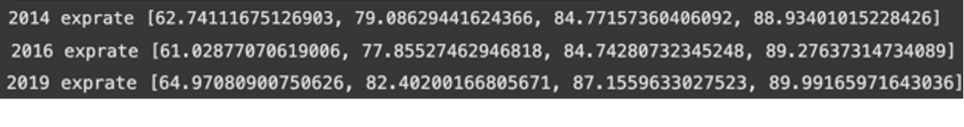
Figure 1: Results of PosFormer on CROHME 2014, 2016, 2019

Figure 2: Results of PosFormer on MNE N1, N2, N3

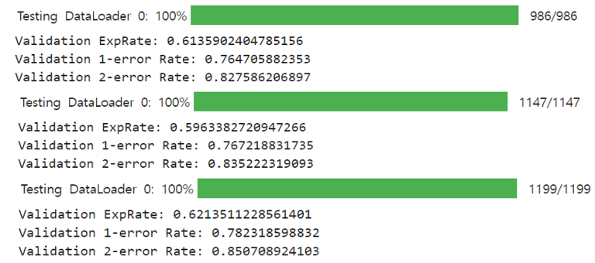
Figure 3: Results of TAMER on CROHME 2014, 2016, 2019

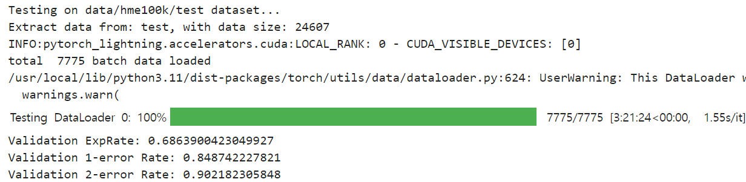
Figure 4: Results of TAMER on HME100K

Second, to evaluate the performance of HMER models on the PME dataset, we used im2latex as a test dataset. For TAMER, we converted im2latex images into pickle files, which is the required format for the model pipeline. However, a mismatch in vocabulary size between the datasets caused compatibility issues. To handle this challenge, we considered two solutions: (1) training the model on im2latex dataset, or (2) modifying im2latex dataset to fit the vocabulary of CROHME. We chose the latter approach and resolved the issue by subsampling im2latex data to align with the CROHME dictionary. The detailed process and result are described in the dataset section.

1.3. PMER Model Baseline Implementation

We chose IM2TEX as our baseline model since its codes are publicly available. Also, it’s a representative model in the PMER domain, marking the beginning of active research in this area. At the time IM2TEX was developed, there was no suitable large-scale dataset for PMER. To overcome this problem, the researchers of IM2TEX constructed a large dataset composed of real-world MEs written in LaTeX format - known as im2latex-100k. This dataset became a standard benchmark in the PMER domain. We use im2latex-100k and a handwritten version of it, and will compare the result from the IM2TEX model on them.

1.4. Domain Adaptation Model Baseline Implementation

Lastly, we planned to use DLA and PAL as baseline models for both HMER and PMER. However, since their codes aren’t publicly available, we decided to implement them from scratch. Given the scarcity of domain adaptation models for HMER and PMER, and the fact that these models represent key approaches, we chose to reproduce them as closely as possible. These reproduced versions will be used as pseudo-baseline models, as they’re not official. For DLA implementation, the code is nearly complete and currently in the training step. Even though we couldn’t replicate the model exactly as described in the paper, we’ll reuse and build upon this code for our own models. Through the process of analyzing the model architecture and dataset, we generated a new dataset structure for our future research and identified some notable characteristics of the dataset. These are detailed in the next section. Our DLA implementation code is available on GitHub. https://github.com/yyysssmmm/OMRiDA.git

1.5. Build Dataset

In the process of implementing baseline models and DLA, we identified several notable features of the datasets. In Particular, the DLA study used the original CROHME and its printed versions as paired data to train the model. They generated printed MEs by rendering LaTex captions. Since this printed version of the CROHME dataset wasn’t released and having both handwritten and printed versions of the same dataset is crucial for comparing the performance on each domain, we rendered the CROHME dataset into printed MEs ourselves, following the same approach. We refer to this newly created dataset as Competition on Recognition of Online Printed Mathematical Expressions (CROPME). The CROPME dataset consists of train dataset and test datasets named 2014, 2016, and 2019. We rendered all of these into printed versions and will use them as train and test datasets accordingly.

Regarding im2latex, there’re several versions of the dataset and we’ve found a handwritten version of im2latex, which we can pair with the original im2latex. To avoid the dictionary mismatch problems encountered when testing im2latex on TAMER, we aligned the im2latex vocabulary with that of CROHME. Matching was performed by leveraging the fact that nearly all CROHME vocabulary tokens are included in the im2latex vocabulary, allowing us to extract a meaningful intersection. The difference mainly came from the presence of decorative labels such as \bf (bold) and \it (italic), text-only labels, and a larger variety of symbolic characters in im2latex. Ultimately, 113 CROHME vocabulary items and 576 im2latex items made an overlap of 112 tokens. The one additional CROHME token, \over (a deprecated fraction expression), was excluded to ensure compatibility. We finalized a unified vocabulary of 113 symbols to support consistent prediction across both domains.

After filtering im2latex images using this shared vocabulary, around 3,000 out of 10,000 images remained. Most of the these filtered im2latex images have paired handwritten images, resulting in 3,153 paired samples. The remaining unpaired im2latex dataset contains only 40 images. We’ll further evaluate whether this small dataset is useful. The total number of each dataset is summarized in the tables below.

train
paired CROHME |  | paired im2latex
PME | HME | PME | HME
8834 | 8834 | 3153 | 3153
Table 1: Total number of train dataset

test
PME |  |  |  | HME
CROPME 2014 | CROPME 2016 | CROPME 2019 | unpaired im2latex | CROHME 2014 | CROHME 2016 | CROHME 2019
986 | 1147 | 1199 | 40 | 989 | 1147 | 1199
Table 2: Total number of test dataset

1.6. Approaches for General MER

After the construction of the dataset which consists of unified vocabulary words and contains PME-HME pairs, the detailed methodologies for domain adaptation were discussed.

The simple idea for bridging the gap between two different domains is to align the features; thus several feature alignment methods were devised as one direction of approach. We categorized this as the Domain Adaptation (DA) method which uses both domains during the alignment and adaptation process. For the feature alignment approach that aligns feature differences during training, explicit matching, adversarial matching, and contrastive matching approaches were devised as distinct options. Similarly, Source Free Domain Adaptation (SFDA) was devised as a type of DA that does not align features during training, but instead goes through an adaptation stage on the target domain after training on a source domain. In another perspective, rather than involving both domains in the training and alignment stage, we also considered the possibility of relying on a single domain to generate the general MER model, by applying Domain Generation (DG) approaches. We will focus on experimenting several different approaches based on these two major methodology component frameworks - DA and DG - more precisely 3 component frameworks:

- 1-stage DA - training and alignment done at the same time (DA-explicit, DA-adversarial, DA-contrastive)
- Explicit Matching: directly aligns PME and HME features (e.g. , MSE or KLD loss on context vectors)
- Adversarial Matching: uses a domain discriminator to encourage domain-invariant representations
- Contrastive Matching: brings representations of paired PME-HME samples closer while pushing apart unrelated ones

These methods assume paired or co-available domains during training and aim to learn a shared latent space across both modalities

- 2-stage DA - training and adaptation are performed in separate stages
- SFDA-type approaches:
  - The model is trained only on the source domain (e.g., PME), then adapted to the target domain (e.g., HME) using unlabeled target data
- Style Transfer approaches:
  - These methods transform source-domain images (e.g, PME) into target-domain style (e.g., HME) using image-to-image translation models such as CycleGAN [6]
  - The converted images are then used to train or fine-tune the model on synthetic target-style data, effectively bridging the visual domain gap before recognition

- DG - training only done on source domains, without accessing the target domain
The objective is to learn domain-invariant features that generalize well to unseen domains.

- Test-Time Generalization (TTG):
on models trained with source-only data, there are several test-time generalization techniques such as:
- Test-Time Augmentation (TTAug): applying multiple augmented versions of the same input
- Test-Time Ensemble (TTE): aggregating predictions from different model views
- Test-Time Adaptation (TTA): updating model statistics or classifier during real time inference.

- Source-side Generalization:
Unlike test-time generalization which adapts the model at inference by leveraging only the observed test input, source-side generalization focuses on learning domain-invariant representations during training, without any access to target domain at any stage. In this approach, the main objective is to build robustness purely through source-domain diversity and architectural or algorithmic constraints.

Considering the constraints of our project, which demand lightweight models and interpretable inference processes, we carefully reviewed both source-side and test-time generalization techniques, and decided to adopt TTA as our primary DG approach among the various methods listed above.

All three approaches will be tested under a consistent experimental setup. Once the best-performing strategy is identified, we will proceed with ablation studies to further optimize model performance. Supplementary ideas for ablation studies include:

- Adding a tree-based submodule, which is often used in current SOTA HMER models
- Changing encoder & decoder backbone architectures
- Preparing a pretrained embedding model for LaTeX representations, such as MathBERT
- Applying domain unlearning techniques to selectively remove source-domain-specific features and examine their effect on generalization across domains
2. Preliminary Results

To summarize the constructed dataset described on section 1.5, we have one pair from CROHME and one pair from im2latex for the training data. We considered six different input combinations for feature alignment in the training step:

- unpaired CROHME HME (baseline SOTA)
- CROHME pair + unpaired im2latex PME
- CROHME pair + unpaired im2latex HME
- im2latex pair + unpaired CROHME PME
- im2latex pair + unpaired CROHME HME
- CROHME pair + im2latex pair

Accordingly, for each input combination, we focus on comparing model performances on 3 different test cases:

- CROHME 2014, 2016, 2019
- CROPME 2014, 2016, 2019
- sampled im2latex PME

2.1 Understanding Domain Gap

When reproducing the performance of SOTA HMER models, we were able to closely match the reported results using the official GitHub implementations. We confirmed that baseline models achieved decent performance not only on a single HME dataset but also across at least two different HME sources. For example, the PosFormer model showed reliable results on both CROHME and MNE, while TAMER also performed well on CROHME and the HME100K dataset. However, as shown in Figure 5 and Figure 6, both models which are trained solely on HME data completely failed to recognize the corresponding PME images, despite the fact that the paired HME and PME inputs represent exactly the same MEs. The output accuracy on PME inputs was not just lower - it dropped to nearly zero, even though PME images are generally visually simpler and structurally clearer than handwritten ones. This result strongly suggests that HMER models are over-specialized for handwritten data and fail to generalize to other modalities, even when those modalities represent the same content more cleanly.

This highlights a significant lack of generalization in current HMER architectures when it comes to handling cross-domain MEs. One example of paired mathematical expression and the model’s predictions are shown in Figure 7.

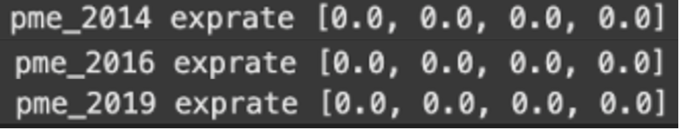
Figure 5: Results of PosFormer on CROPME 2014, 2016, 2019

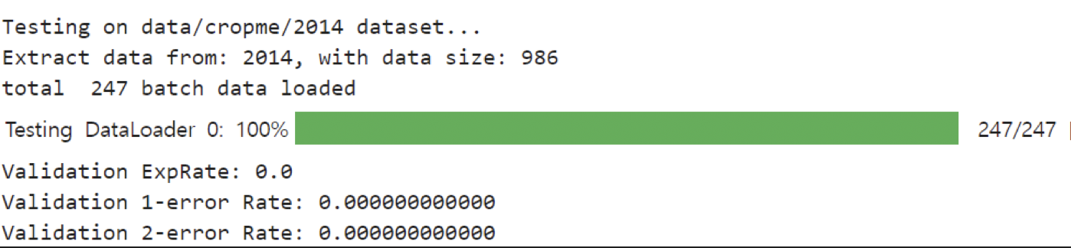
Figure 6: Results of TAMER on CROPME 2014

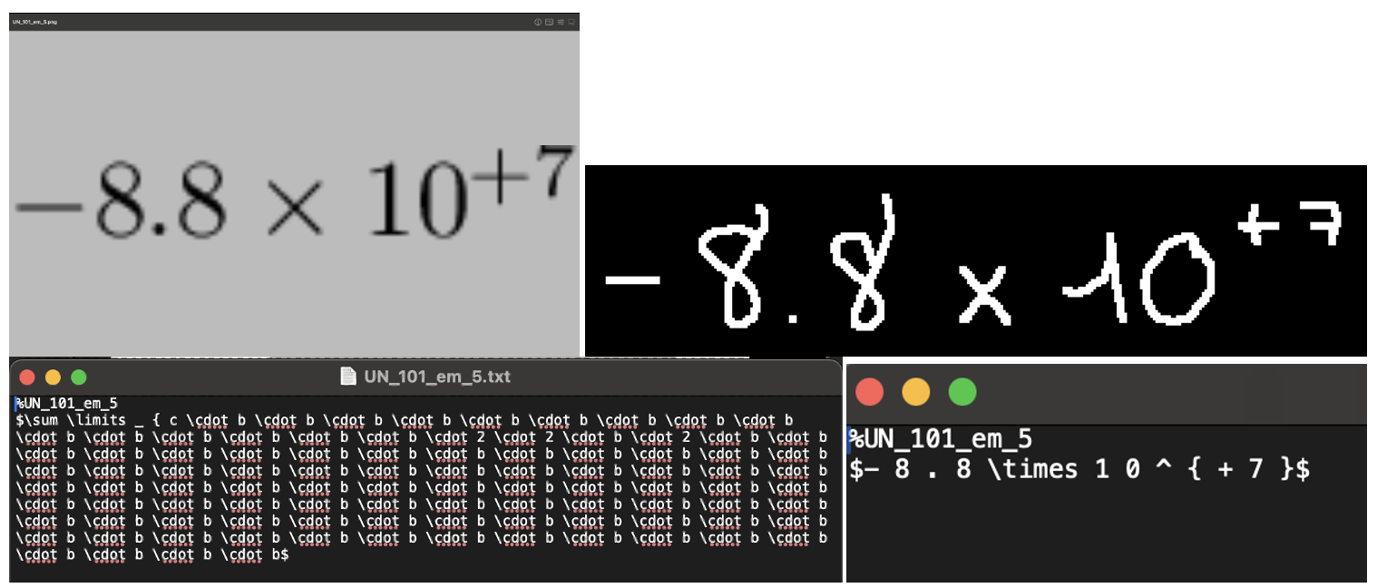
Figure 7: Example of paired CROHME images (upper left: PME, upper right: HME) and the model’s predicted label for each image (lower left: generated Latex on PME, lower right: generated Latex on HME). It is conspicuous that the model didn’t even produce a result similar to the ground truth label on the PME image and completely failed to predict the correct answer.

2.2 Implementing DLA Model

Considering the generality failure described in section 2.1, it is necessary to come up with an idea for building a general MER model that can learn representative features from both PME and HME domains.

DLA is a model described in the paper [4], which uses explicit matching techniques to align features from the two domain datasets. Unfortunately, the code was not publicly released, so we built a pseudo DLA model from scratch, aiming to implement every detail as closely as possible to the original paper. The training process requires sufficient time, since the model includes a large number of parameters due to its complex structure, including cross-attention for feature alignment. We evaluated the model at a middle-point checkpoint, but it still generated irrelevant, meaningless outputs, with 0 exact matches in both cases (CROHME pair + unpaired im2latex PME) and (CROHME pair + unpaired im2latex HME), due to the model being undertrained.

We expect that once fully trained on the paired dataset, the model will perform much better on both domains, as human reasoning does. However, its final performance may not be directly comparable to the original paper, since we re-implemented the model ourselves and some details may differ.

3. Plan for Final Submission
Briefly summarizing, the project contents completed during the 1st semester are as follows:

- Build a unified dataset for PME and HME domains that share the same tokens (vocabulary words), by sampling from the original CROHME and im2latex datasets.
- Implement DLA model from scratch (since the code was not released), and evaluate its performance on the sampled test dataset for both PME and HME domain.
- Propose several domain adaptation ideas to be tested in the project.

The remaining tasks are to build models for the proposed idea, and compare the performance by aggregating the results on sampled PME and HME dataset. We plan to find some approaches to our project that exceed the performance of the current SOTA model, and examine why that approach is better than the current model and other proposed domain adaptation methods. The specific plans for the remaining tasks in timeline are written down as below:

- July - Experiment set up & Explicit Alignment
- Evaluate the performance of baseline models (PosFormer, TAMER, IM2TEX) on our sampled datasets, and compare with the DLA baseline.
- Fix unified hyperparameters using wandb and prepare the setup for our explicit alignment-based experiments (we’ve already built the DLA model by ourselves, which can be categorized as using explicit alignment domain adaptation approach).
- Experiment with improved explicit alignment methods over DLA, such as applying KLD loss instead of MSE for context matching, or using multi-head attention.

- August - Adversarial Alignment
- Implement PAL and PAL v2 from scratch as baseline adversarial alignment models
- Extend the idea of PAL by applying our adversarial alignment methods to improve performance

- September - Contrastive Alignment
- Apply contrastive learning techniques (e.g., InfoNCE loss) to our model
- Leverage the paired HME-PME dataset to define positive pairs (matched expressions across domains) and negative pairs (unmatched expressions), allowing the model to align semantically similar features while separating domain-specific noise.

- October - 2-stage DA (SFDA) & Domain Generalization
- Explore 2-stage DA methods such as SFDA and CycleGAN
- Apply TTA (Test-Time Adaptation) approach for the Domain Generalization methodology.

- November - Performance Review & Ablation Study
- Aggregate results across all methods and compare with SOTA
- Analyze which ideas contributed most to performance gain or failure
- Conduct ablation studies to refine key components and improve robustness

- December - Final Presentation Preparation
- Prepare final presentation materials such as PPT, poster, demo video, presentation, script, etc.
- Organize and upload all materials to GitHub for reproducibility and documentation.

4. References

[1] Guan, T., Lin, C., Shen, W., & Yang, X. (2024, September). PosFormer: recognizing complex handwritten mathematical expression with position forest transformer. In European Conference on Computer Vision (pp. 130-147). Cham: Springer Nature Switzerland.

[2] Zhu, J., Zhao, W., Li, Y., Hu, X., & Gao, L. (2025, April). Tamer: Tree-aware transformer for handwritten mathematical expression recognition. In Proceedings of the AAAI Conference on Artificial Intelligence (Vol. 39, No. 10, pp. 10950-10958).

[3] Deng, Y., Kanervisto, A., Ling, J., & Rush, A. M. (2017, July). Image-to-markup generation with coarse-to-fine attention. In International Conference on Machine Learning (pp. 980-989). PMLR.

[4] Le, A. D. (2020). Recognizing handwritten mathematical expressions via paired dual loss attention network and printed mathematical expressions. In Proceedings of the IEEE/CVF Conference on Computer Vision and Pattern Recognition Workshops (pp. 566-567).

[5] Wu, J. W., Yin, F., Zhang, Y. M., Zhang, X. Y., & Liu, C. L. (2019). Image-to-markup generation via paired adversarial learning. In Machine learning and knowledge discovery in databases: European conference, ECML PKDD 2018, Dublin, Ireland, September 10–14, 2018, Proceedings, Part I 18 (pp. 18-34). Springer International Publishing.

[6] Jun-Yan Zhu, Taesung Park, Phillip Isola, and Alexei A Efros. Unpaired image-to-image translation using cycleconsistent adversarial networks. In ICCV, 2017.

