SDEV 4 Assignment
Value: 26%
Hand Out Date: Monday 7th March 2016
Due Date: Wednesday 23rd March 2016
Specification
You will work as part of a team of two to build a small CRUD Java application with a console-based user interface that serves as a front-end to a relational database.
The database should consist of 3-4 tables with one to many and many to many relationships
The model of the system should have 3-4 Java classes which should be annotated to form entities using the JPA specification including:
- Use of the Java Persistence API to develop and run JPA entities
- Use of Java Persistence Query Language (JPQL)
- Perform object-to-relational mappings (ORM) for persistent data
- Implement persistent entities (managmentfactory)

The model should also incorporate the use of suitable types of collections for manipulation and retrieval of data i.e. Set, Map, List etc

The user of the system should be able to do the following:
- Add an entity to the database
- Update an entity in the database
- Delete an entity in the database
- Query an entity in the database
- Manipulate collections(press option 4)

Marks will be awarded for:
- Good program design
- Fully working CRUD application
- Validation of data entry
- Use of JPA annotations not covered in class(treemap)
- Use of aspects of the Collections API not covered in class

Smart things
Test only manue
-validation(exeption hanling)

Completed assignments in a zip file should be uploaded to Moodle by 10pm on Wednesday 23rd March 2016 - one upload per group please
Students will be required to demo their working program during the lab in week 9
Every student must be present to demonstrate their working system, otherwise a zero mark is awarded

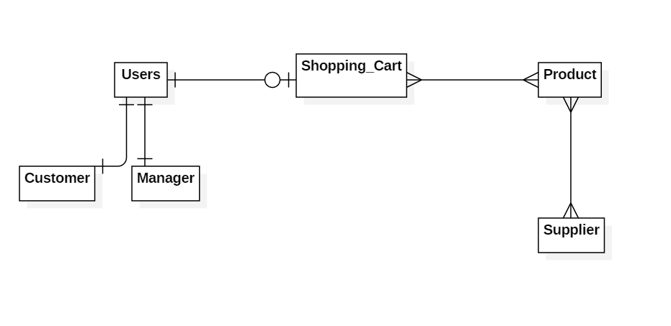
@Entity
@Table(name = "STAFF")
public class Staff implements Serializable {
@Id
private int id;
@Column(name = "SNAME")
private String name;

@ManyToMany (cascade = CascadeType.ALL)
@JoinTable(name="CONTACT_STAFF",
joinColumns = @JoinColumn(name="SID"),
inverseJoinColumns=@JoinColumn(name="CID"))
private List<Contact> clist = new ArrayList<>();

@Entity
@Table(name = "CONTACT")
public class Contact implements Serializable {
@Id
@Column(name = "CID")
private int id;
@Column(name = "CNAME")
private String name;

private String address;

@Column(name = "PHONE")
private String phoneNumber;

private String email;

@ManyToMany(mappedBy = "clist")
private List<Staff> slist = new ArrayList<>();

