C++ Programming Assignment 7

# Question 1:

In this question, you are asked to correct the given code, ensuring that it functions properly. After making the necessary corrections, please share the updated code along with screenshots of the correct output.  
  
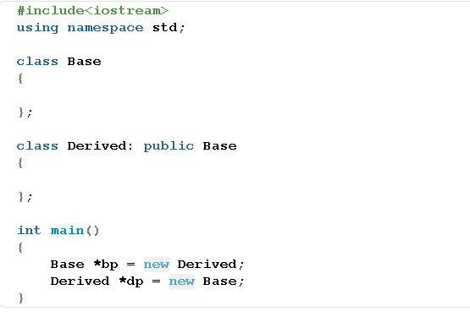

# Question 2:

Similarly, for Question 2, make the required corrections to the provided code. Once the code is working as expected, please share the corrected code along with screenshots showing the output.  
  
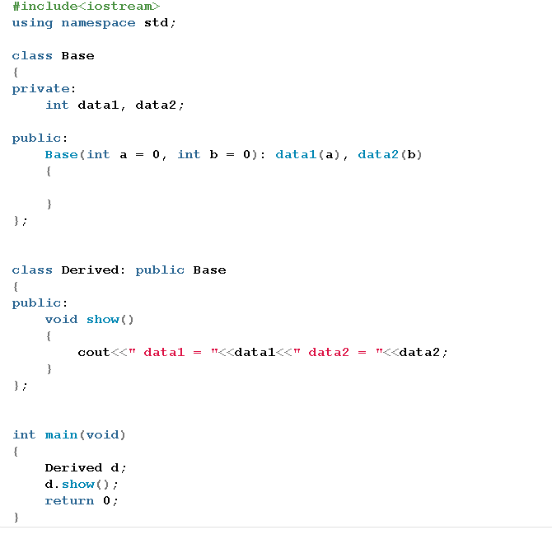

**Submission Guidelines:**

1. Create a folder on your Google Drive for the assignment.
2. Take full-screen screenshots of each task/program completed on your system’s IDE (online compiler screenshots are not valid).
3. Do not crop or edit the screenshots in any way to maintain clarity.
4. Upload the full-screen screenshots into the folder.
5. After uploading the screenshots, get the [shareable link](https://youtu.be/BbLmHRqHCAw) to the folder.
6. Submit the link to the assignment section.