Software Design Document (SDD)
Project NUCLEUS
Behavioral Biometrics Authentication System Using Deep Learning for Continuous User Verification

Document Type | Software Design Document (SDD)
Project Title | Nucleus – Behavioral Biometrics Authentication System Using Deep Learning for Continuous User Verification
Organization | NIIT University, Neemrana (Rajasthan)
Program | B.Tech. Computer Science Engineering – Sem VI Capstone
Prepared By | Shlok Burmi | Yuvraj Deshmukh | Sujal Kishore | Shruti Shrishti
Version | 1.0 – Final Submission
Date | April 21, 2026

Table of Contents
1 | Introduction | 4
1.1 | Purpose | 4
1.2 | Scope | 4
1.3 | Document Overview | 4
1.4 | Definitions and Acronyms | 5
2 | System Overview | 6
3 | System Architecture | 7
3.1 | Architectural Design Pattern | 7
3.2 | Component Topology | 7
3.3 | Technology Stack | 8
3.4 | Design Rationale | 9
4 | Data Design | 10
4.1 | MongoDB Document Schema | 10
4.2 | Entity-Relationship Overview | 11
4.3 | Data Flow Description | 12
5 | Component Design | 13
5.1 | Frontend Module Design | 13
5.2 | Backend API Module Design | 14
5.3 | Biometric AI Service Design | 15
5.4 | Security Middleware Design | 16
6 | Interface Design | 17
6.1 | API Endpoint Catalogue | 17
6.2 | WebSocket Interface | 18
7 | Continuous Delivery Architecture | 19
7.1 | Jenkins Pipeline Design | 19
7.2 | Docker Compose Service Graph | 20
8 | Project Analytics | 21
8.1 | JIRA Sprint Analytics | 21
8.2 | Jenkins Pipeline Dashboard | 22
8.3 | GitHub Contribution Analytics | 22
9 | Security Design | 23
10 | Appendix | 24

Document Revision History
Version | Date | Author | Description of Change
0.1 | Feb 10, 2026 | Shlok Burmi | Initial draft – Scope & Introduction
0.3 | Mar 01, 2026 | Yuvraj | Added FR/NFR sections and Use Cases
0.5 | Mar 20, 2026 | Sujal Kishore | Architecture, ER diagrams, Component Design
0.8 | Apr 05, 2026 | Shlok Burmi | CI/CD integration, JIRA mapping, Analytics
1.0 | April 21, 2026 | Team Nucleus | Final version – IEEE format, diagrams complete

1 Introduction
1.1 Purpose
This Software Design Document (SDD) describes the complete software architecture, module structure, data design, interface specifications, and deployment architecture for the Nucleus project. It conforms to IEEE Std 1016-2009 (Software Design Descriptions) and serves as the authoritative technical blueprint for all implementation decisions.
1.2 Scope
This SDD covers the full technology stack comprising:
- React 18 Single Page Application (frontend) built with Vite and Tailwind CSS.
- Node.js / Express.js REST API server (backend) with Mongoose ORM.
- Python / FastAPI biometric microservice handling voice (MFCC) and face (DeepFace) authentication.
- MongoDB document database with 7 defined collection schemas.
- Jenkins declarative CI/CD pipeline and Docker Compose orchestration.
- Security middleware layer: rate limiting, Helmet, CORS, JWT, bcrypt.
1.3 Document Overview
Section | Title | Content
Section 2 | System Overview | High-level narrative of the software and its mission.
Section 3 | System Architecture | Microservice topology, patterns, and technology stack.
Section 4 | Data Design | MongoDB schemas, ER diagram, and data flow.
Section 5 | Component Design | Module-level design for Frontend, Backend, and AI service.
Section 6 | Interface Design | Complete API endpoint catalogue and WebSocket interface.
Section 7 | Continuous Delivery | Jenkins pipeline and Docker Compose service graph.
Section 8 | Project Analytics | JIRA, Jenkins, and GitHub metrics.
Section 9 | Security Design | Threat model and security control mapping.
Section 10 | Appendix | Glossary, design decisions log, technology rationale.

1.4 Definitions and Acronyms
Term | Definition
MERN | MongoDB, Express, React, Node.js stack
LSTM | Long Short-Term Memory neural network
MFCC | Mel-Frequency Cepstral Coefficients
JWT | JSON Web Token
TOTP | Time-based One-Time Password
HOC | Higher-Order Component (React pattern)
SPA | Single Page Application
FAR/FRR | False Acceptance Rate / False Rejection Rate
CI/CD | Continuous Integration / Continuous Deployment
ER Diagram | Entity-Relationship Diagram

2 System Overview
Nucleus is a multi-tenant, cloud-deployable academic platform augmented by continuous biometric security. It replaces static single-factor login systems with a three-layer security model:
Security Layer | Description
Layer 1 – Explicit Auth | Email/password + TOTP 2FA at login time.
Layer 2 – Continuous Auth | LSTM-driven anomaly detection during the active session.
Layer 3 – Step-Up Auth | Voice + Face biometric re-verification on anomaly detection.

Architecturally, the system is composed of four independently deployable services networked within a Docker bridge (nucleus-network). Each service is containerised using a production-grade Dockerfile and is rebuildt automatically by Jenkins on every commit to the main branch.
The academic portal provides six role types (Student, Faculty, Admin, Director, Warden, Recruiter) with distinct access controls and UI views. Academic data (attendance, results, timetable) is seeded automatically via a dedicated db-seed container that executes once on first deployment.

3 System Architecture
3.1 Architectural Design Pattern
Nucleus follows a Microservices Architecture with a loosely coupled, event-driven extension for real-time behavioural streaming:
Pattern | Application
Microservices | Each service (frontend, backend, voice-service, mongodb) is independently deployable.
REST API | Standard HTTP REST between frontend and backend; between backend and biometric service.
WebSockets | Persistent bi-directional channel for streaming mouse/keystroke events.
Repository Pattern | Mongoose models abstract database access; controllers consume repository methods.
Middleware Chain | Express middleware pipeline: CORS → Rate Limiter → Helmet → Auth Guard → Route Handler.
Event-Driven | Threshold breach events trigger step-up authentication modal asynchronously.

3.2 Component Topology and Architecture Diagram
The following diagram illustrates the runtime topology of all Nucleus components and their communication pathways:
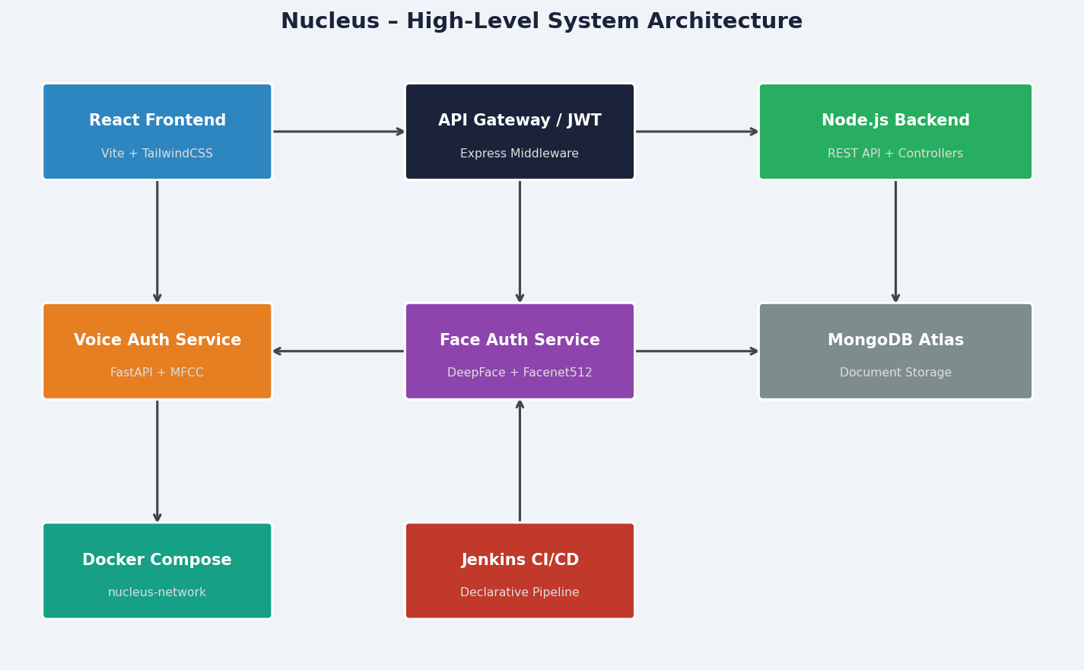
Figure 3.1 – Nucleus System Architecture: Container and Service Topology
The architecture segregates concerns as follows:
• The React frontier layer handles all user interactions, rendering, and event capture.
• The Express API gateway enforces authentication and routes requests to controllers.
• The Python FastAPI biometric service operates as a stateless inference engine.
• MongoDB persists all user, academic, and biometric embedding data.
• Jenkins orchestrates reproducible builds and deployments from GitHub source.
3.3 Technology Stack
Technology | Layer | Purpose
React 18 + Vite | Frontend | Component-based SPA with hot module reloading and optimised production builds.
Tailwind CSS | Styling | Utility-first CSS framework for rapid, consistent UI development.
Node.js 18 LTS | Runtime | Non-blocking I/O runtime for the Express API server.
Express.js 4.x | Backend | Minimal web framework providing routing, middleware, and HTTP utilities.
Mongoose 8.x | ORM | Schema-based MongoDB object modelling with validation and middleware.
MongoDB 7.0 | Database | Document-oriented NoSQL database optimised for JSON-like data.
Python 3.10 + FastAPI | AI Service | High-performance async Python framework for biometric inference endpoints.
librosa + NumPy | Audio DSP | MFCC extraction and audio signal processing for voice auth.
DeepFace + Facenet512 | Face AI | State-of-the-art face recognition with 512-d embedding vectors.
bcryptjs | Security | Password hashing with adaptive salt rounds.
jsonwebtoken | Auth | JWT issuance and verification for session management.
speakeasy | MFA | TOTP 2FA secret generation and verification.
Docker + Compose v2 | DevOps | Container packaging and multi-service orchestration.
Jenkins LTS | CI/CD | Declarative pipeline for automated build, test, and deploy.
GitHub | VCS | Git version control with webhook integration for CI triggers.

3.4 Design Rationale
Decision | Rationale
Microservices over Monolith | Decouples the computationally heavy biometric AI inference from the REST API, preventing MFCC/face model loading from blocking API response times.
FastAPI for Python service | Async-native, automatic OpenAPI docs, and superior performance vs Flask for high-throughput biometric inference with concurrent requests.
MongoDB over SQL | Dynamic document schemas naturally accommodate variable-length arrays (voice embeddings, mouse coordinate sequences) without schema migrations.
Docker Compose | Single-command reproducible environments matching production topology, critical for CI/CD parity and developer onboarding.
JWT over Server Sessions | Stateless authentication scales horizontally without shared session stores; invalidation is handled via LSTM anomaly events.
Facenet512 over smaller models | 512-dimensional embeddings provide superior discriminative power compared to 128-d alternatives, critical for low-FAR requirements.

4 Data Design
4.1 MongoDB Document Schema
All data is persisted in MongoDB using Mongoose schemas. The following tables detail each collection's field definitions, types, constraints, and purpose.
4.1.1 User Collection (users)
Field | Type | Constraint | Description
_id | ObjectId | PK | Auto-generated MongoDB document identifier
name | String | required | Full name of the user
email | String | unique, req | Institutional email address
password | String | required | bcrypt hashed (salt=10) password
enrollment_number | String | unique, req | Student/faculty enrollment or employee ID
role | Enum | default:student | admin|director|faculty|warden|recruiter|student
branch | String | optional | Engineering branch (CSE, ECE, etc.)
semester | Number | optional | Current academic semester (1–8)
batch | String | optional | Academic batch (e.g., 2024–2028)
isFirstLogin | Boolean | default:true | Flag to trigger biometric setup wizard
voice_enrolled | Boolean | default:false | Voice biometric enrolment status
voice_embeddings | [[Number]] | default:[] | Array of MFCC embedding vectors
voice_threshold | Number | default:0.85 | Adaptive cosine similarity threshold
face_enrolled | Boolean | default:false | Face biometric enrolment status
face_embeddings | [[Number]] | default:[] | Facenet512 512-d embedding vectors
face_threshold | Number | default:0.75 | Cosine similarity threshold for face auth
twoFactorSecret | String | optional | speakeasy TOTP base32 secret
isTwoFactorEnabled | Boolean | default:false | 2FA enabled/disabled flag
createdAt | Date | auto | Mongoose timestamps
updatedAt | Date | auto | Mongoose timestamps

4.1.2 Attendance Collection (attendances)
Field | Type | Constraint | Description
_id | ObjectId | PK | Auto-generated identifier
enrollment_number | String | indexed | Reference to User enrollment_number
subject | String | required | Subject/course name
attended | Number | required | Number of classes attended
total | Number | required | Total number of classes held
date | Date | optional | Attendance record date

4.1.3 Result Collection (results)
Field | Type | Constraint | Description
_id | ObjectId | PK | Auto-generated identifier
enrollment_number | String | indexed | Reference to User enrollment_number
subject | String | required | Subject/course name
marks | Number | required | Marks obtained out of 100
grade | String | required | Letter grade (A+, A, B+, B, C, F)
semester | Number | required | Exam semester number

4.1.4 Timetable Collection (timetables)
Field | Type | Constraint | Description
_id | ObjectId | PK | Auto-generated identifier
branch | String | indexed | Branch filter key
semester | Number | indexed | Semester filter key
day | String | required | Day of week
periods | [{Object}] | required | Array of period objects: {time, subject, faculty}

4.1.5 Complaint Collection (complaints)
Field | Type | Constraint | Description
_id | ObjectId | PK | Auto-generated identifier
userId | ObjectId | ref:User | Who filed the complaint
subject | String | required | Complaint subject line
body | String | required | Detailed complaint body
status | Enum | default:Pending | Pending | In Progress | Resolved
createdAt | Date | auto | Timestamp

4.2 Entity-Relationship Diagram
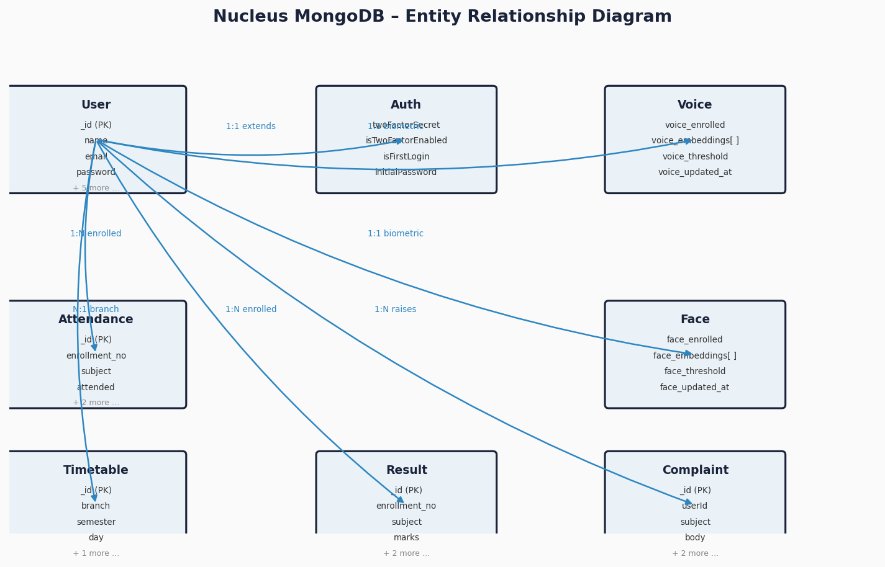
Figure 4.1 – Nucleus MongoDB Entity-Relationship Diagram
4.3 Data Flow Description
The data flows through the system as described below:
Flow Name | Data Path
Login Flow | Browser → POST /api/auth/login → User Collection (read) → JWT issued → Cookie set
TOTP Flow | Browser → POST /api/auth/verify-2fa → speakeasy.verify → JWT confirmed
Biometric Enrol | Browser → POST /api/voice/enroll → voice-service:8000/voice/enroll → MFCC extracted → embeddings returned → User.voice_embeddings saved
Biometric Verify | Backend → POST voice-service:8000/voice/verify (with stored embeddings) → similarity score → authenticated flag returned
LSTM Stream | Browser → WebSocket /api/stream/behaviour → Event buffer → LSTM inference → Score → Threshold check → 'Verification Needed' if triggered
Student Data | Browser → GET /api/attendance, /api/results, /api/timetable → Controllers → MongoDB → JSON response → React render
CI/CD | GitHub push → Jenkins Webhook → Checkout → Test → docker compose build → docker compose up

5 Component Design
5.1 Frontend Module Design (React / Vite)
The frontend is structured as a feature-based React application. Key pages and components are organised as follows:
Layer | Component | Responsibility
Pages | LoginPage | Entry authentication screen with credential form and TOTP field.
Pages | StudentDashboard | Main student view: GPA cards, charts, timetable, complaints.
Pages | AdminPanel | User management table with CRUD operations and role assignment.
Pages | BiometricSetup | Wizard for voice and face enrolment (first-login flow).
Components | Navbar / Sidebar | Responsive navigation with role-based menu item visibility.
Components | VerificationModal | Step-up auth overlay: voice passphrase recorder + face capture.
Components | AttendanceCard | Pie chart with subject-level attendance breakdown.
Context | AuthContext | Global auth state: jwt token, user role, login/logout actions.
Hooks | useWebSocket | Custom hook managing WebSocket lifecycle and event emission.
Hooks | useBiometric | Custom hook encapsulating mediaRecorder API for voice/face capture.

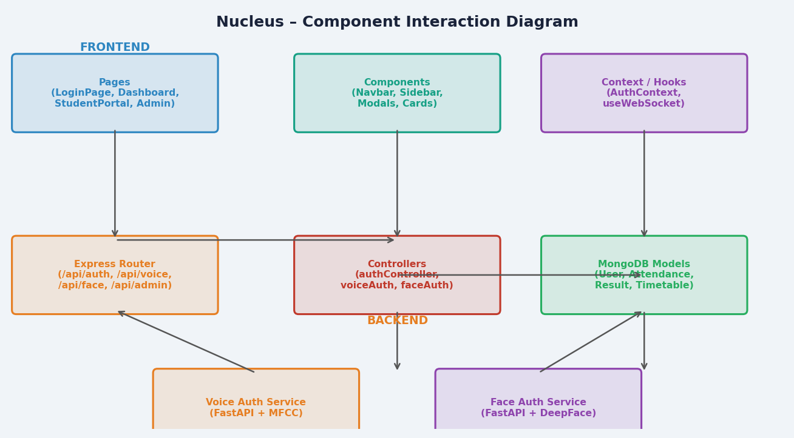
Figure 5.1 – Nucleus Component Interaction Diagram
5.2 Backend API Module Design (Node.js / Express)
The backend follows MVC (Model-View-Controller) architecture with dedicated middleware layers. Each route group corresponds to a business domain:
Module | Design Responsibility
server.js | Entry point; initialises Express app, MongoDB connection, middleware chain, and route mounting.
routes/authRoutes.js | Mounts: POST /login, POST /register, POST /verify-2fa, POST /logout.
routes/voiceAuthRoutes.js | Mounts: POST /enroll, POST /verify, GET /status.
routes/faceAuthRoutes.js | Mounts: POST /enroll, POST /verify.
routes/adminRoutes.js | Mounts: GET/POST/PUT/DELETE /users (admin-guarded).
routes/attendanceRoutes.js | Mounts: GET /attendance by enrollment_number.
routes/resultRoutes.js | Mounts: GET /results by enrollment_number.
routes/timetableRoutes.js | Mounts: GET /timetable by branch + semester.
routes/complaintRoutes.js | Mounts: POST /complaints, GET /complaints.
controllers/authController.js | Handles login logic, password verification, JWT issuance.
controllers/mfaController.js | Handles TOTP secret generation, QR code generation, and verification.
controllers/voiceAuthController.js | Proxies requests to voice-service, manages MongoDB embedding CRUD.
controllers/faceAuthController.js | Proxies requests to face endpoint in voice-service, manages embeddings.
controllers/adminController.js | CRUD operations on User collection with role-based access guard.
middleware/authMiddleware.js | JWT verification middleware; attaches decoded user to req.user.
middleware/rateLimiter.js | express-rate-limit: 100 req/15 min per IP.
models/User.js | Mongoose schema with bcrypt pre-save hook and matchPassword method.

5.2.1 Middleware Execution Pipeline
Every incoming HTTP request traverses the following middleware chain before reaching the route handler:
Order | Middleware | Function
1 | CORS Middleware | Validates Origin header against whitelist.
2 | Helmet | Sets security HTTP response headers.
3 | Rate Limiter | Counts requests per IP; rejects if > 100/15 min.
4 | express.json() | Parses JSON request body.
5 | protectRoute (JWT) | Verifies JWT; attaches user payload to req.user.
6 | Role Guard | Checks req.user.role against required role enum.
7 | Route Controller | Executes business logic and returns JSON response.

5.3 Biometric AI Service Design (FastAPI / Python)
The voice-auth-service container exposes a FastAPI application at port 8000 with four primary biometric endpoints. The service is designed to be stateless; embeddings are passed from MongoDB by the Node.js backend on each request.
5.3.1 Voice Authentication Design
The voice authentication pipeline operates as follows:
Stage | Implementation Detail
Audio Ingestion | Raw audio file (WAV/WebM) uploaded via multipart form data.
MFCC Extraction | librosa.feature.mfcc() computes 40 MFCC coefficients over 1-second frames.
Feature Normalisation | Mean-subtracted, variance-normalised MFCC matrix flattened to 1-D vector.
Similarity Scoring | Cosine similarity between new embedding and all stored enrolment embeddings.
Threshold Decision | calculate_adaptive_threshold(): mean - 1.0×std of intra-enrolment similarities, clamped [0.75, 0.95].
Anti-Spoofing | Spectral flatness analysis flags synthetic/recorded audio. Instant fail if detected.
STT Verification | Optional Whisper STT transcription matched against expected passphrase text.

5.3.2 Face Authentication Design
Stage | Implementation Detail
Image Ingestion | JPEG/PNG image uploaded; multi-angle images supported for enrolment.
Face Detection | DeepFace backend detects and aligns face region in uploaded image.
Embedding Extraction | Facenet512 model extracts 512-dimensional floating-point vector.
Multi-angle Average | Multiple enrolment vectors averaged; L2-normalised for robust profile.
Similarity Scoring | Cosine similarity between enrolled avg embedding and live snapshot embedding.
Threshold Decision | Fixed threshold: 0.70 (slightly relaxed from 0.75 for lighting/angle variation).
Liveness Check | User prompted with random gesture; verify_liveness_action() validates head pose.

5.4 Security Middleware Design
The security layer implements defence-in-depth across multiple tiers:
Control | Type | Implementation
bcrypt (salt=10) | Password Hashing | Pre-save Mongoose hook on User model.
JWT HS256 | Session Auth | Issued on login; verified on every protected route.
speakeasy TOTP | 2FA | 30-second window TOTP; base32 secret per user.
express-rate-limit | Brute Force Block | 100 req/15 min per IP; returns HTTP 429.
helmet | HTTP Headers | Sets CSP, HSTS, X-Frame-Options, etc.
CORS whitelist | Origin Validation | Rejects requests from non-whitelisted origins.
LSTM threshold | Session Monitoring | Triggers step-up on anomaly score > 0.75.
Anti-spoofing | Biometric Security | Spectral flatness rejects synthetic voice input.
Liveness detection | Face Security | Random gesture challenge prevents photo attacks.

6 Interface Design
6.1 API Endpoint Catalogue
The following table lists all REST API endpoints exposed by the Node.js backend (listening on port 5050 externally mapped from container port 5001):
Method | Endpoint | Auth | Description
POST | /api/auth/register | Public | Create new user account
POST | /api/auth/login | Public | Authenticate and obtain JWT
POST | /api/auth/verify-2fa | Public | Submit TOTP code for verification
POST | /api/auth/logout | Protected | Invalidate session
POST | /api/auth/setup-2fa | Protected | Generate TOTP secret and QR code
POST | /api/voice/enroll | Protected | Enrol voice biometrics (3+ WAV files)
POST | /api/voice/verify | Protected | Verify voice against stored embeddings
GET | /api/voice/status | Protected | Check voice enrolment status
POST | /api/face/enroll | Protected | Enrol face biometrics (multi-angle)
POST | /api/face/verify | Protected | Verify face against stored embedding
GET | /api/attendance | Protected | Get attendance by enrollment_number
GET | /api/results | Protected | Get results by enrollment_number
GET | /api/timetable | Protected | Get timetable by branch and semester
POST | /api/complaints | Protected | File a new complaint
GET | /api/complaints | Protected | Get all complaints for current user
GET | /api/admin/users | Admin Only | List all users (paginated)
POST | /api/admin/users | Admin Only | Create new user account (admin)
PUT | /api/admin/users/:id | Admin Only | Update user details or role
DELETE | /api/admin/users/:id | Admin Only | Delete user account
GET | /api/admin/users/:id/reset | Admin Only | Reset user password

6.2 WebSocket Interface
The behavioural data streaming interface uses the WebSocket Secure (WSS) protocol:
Property | Value
Endpoint | /api/stream/behaviour
Protocol | WebSocket (ws:// locally, wss:// in production)
Auth | JWT token passed as query parameter: ?token=<jwt>
Message Format | JSON: { type: 'mouse'|'key', x: number, y: number, t: timestamp }
Buffer Size | 100 events per batch before triggering LSTM inference
Server Push | JSON response on anomaly: { anomaly: true, score: 0.87, action: 'step_up' }
Close Codes | 1000 – Normal close; 4001 – Auth failure; 4002 – Threshold breach

6.2 Voice-Auth-Service API (FastAPI)
Method | Endpoint | Inputs | Outputs
POST | /voice/enroll | userId (Form), files[] (WAV) | JSON: embeddings, adaptive_threshold, sample_count
POST | /voice/verify | userId, file (WAV), stored_embeddings (JSON), expected_text (optional) | JSON: authenticated, similarity_score, security_alerts
POST | /face/enroll | userId, files[] (JPEG/PNG) | JSON: embedding (512-d), threshold
POST | /face/verify | userId, file, stored_embedding (JSON), expected_action (optional) | JSON: authenticated, similarity_score, liveness_verified

7 Continuous Delivery Architecture
7.1 Jenkins Pipeline Design
The Nucleus CI/CD pipeline is defined as a declarative Jenkinsfile at the repository root. It uses a single agent and executes six ordered stages with post-build notification hooks.
7.1.1 Jenkinsfile Structure
The key declarative blocks are:
pipeline {
agent any
environment {
DOCKER_REGISTRY = "your-docker-registry"
APP_NAME = "nucleus"
}
stages {
stage('Checkout') { steps { git url: 'https://github.com/yyyuvvvraj/Nucleus.git' } }
stage('Backend Tests') { steps { dir('backend') { echo 'Running tests…' } } }
stage('Build Images') { steps { script { bat 'docker compose build' } } }
stage('Security Scan') { steps { echo 'Trivy / OWASP scan…' } }
stage('Push Registry') { steps { script { echo 'docker push …' } } }
stage('Deploy') { steps { bat 'docker compose up -d' } }
}
post {
always { echo 'Pipeline complete.' }
success { echo 'Deploy successful!' }
failure { echo 'Check logs.' }
}
}

7.1.2 CI/CD Pipeline Flowchart
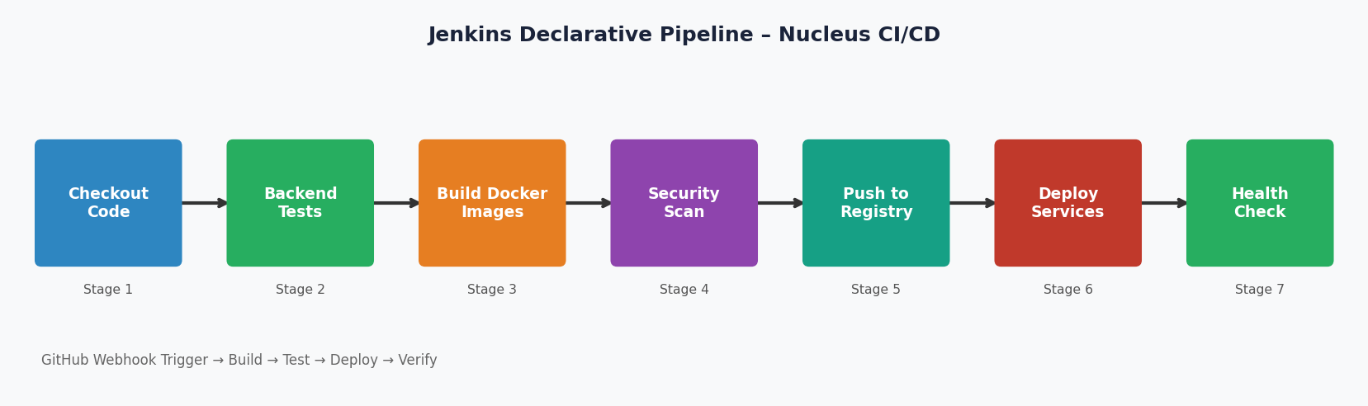
Figure 7.1 – Jenkins Declarative Pipeline – All 7 Stages
7.1.3 Stage Design Details
Stage | Design Detail
S1: Checkout | git plugin clones main branch from GitHub.Changes trigger via POST webhook from GitHub → Jenkins controller.
S2: Backend Tests | Node.js test suite runs inside /backend directory. (npm test). Future expansion: Jest unit and integration tests.
S3: Build Images | bat 'docker compose build' builds all service images using layer caching.Separate Dockerfiles per service ensure isolated build contexts.
S4: Security Scan | Placeholder for Trivy vulnerability scanner or OWASP dependency-check.Any CRITICAL CVE fails the build automatically.
S5: Push Registry | Tagged images pushed to configured Docker registry. Enables rollback by specifying previous image tag.
S6: Deploy | bat 'docker compose up -d' starts all containers in detached mode.healthcheck on MongoDB ensures db-seed runs after healthy DB.

7.2 Docker Compose Service Graph
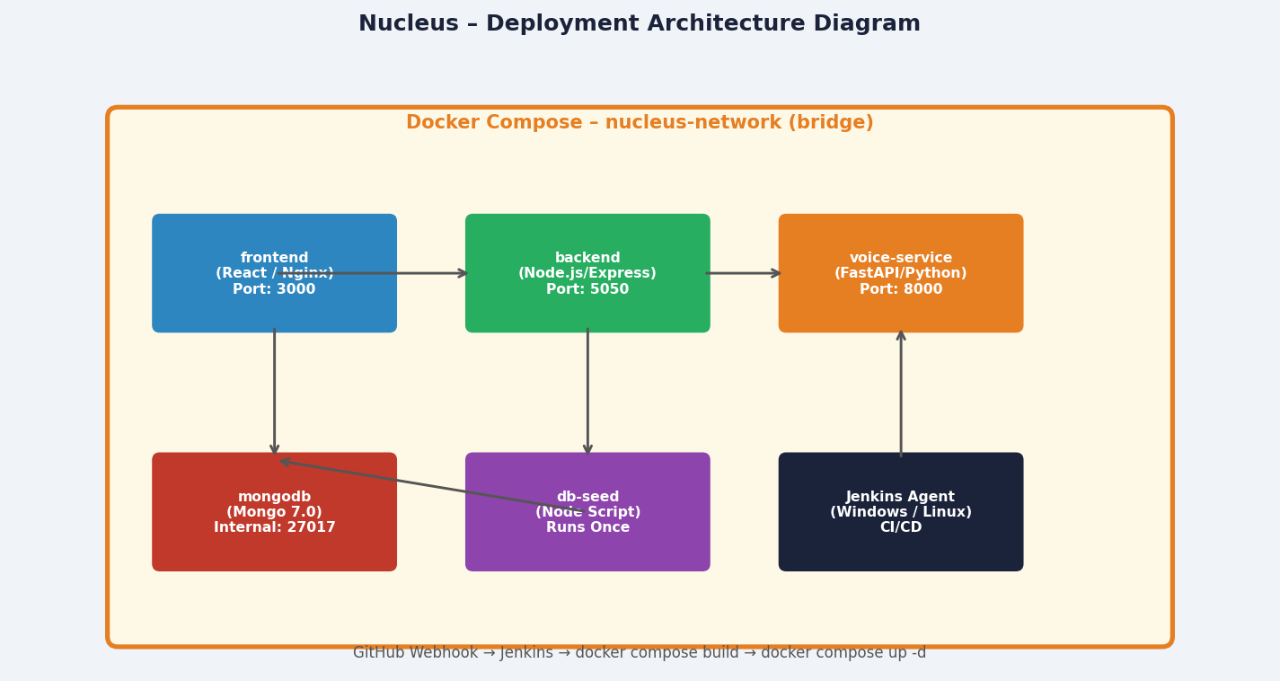
Figure 7.2 – Nucleus Docker Compose Deployment Architecture
7.2.1 Service Dependency Order
Docker Compose condition-based depends_on ensures correct startup sequencing:
Service | Depends On | Startup Condition
mongodb | — | First to start; health-checked via mongosh ping.
backend | mongodb (healthy) | Waits for MongoDB ping to succeed before connecting.
voice-service | — | Starts independently; no DB dependency.
db-seed | mongodb + backend | Runs seed.js once then exits (ephemeral container).
frontend | backend | Starts after backend; Nginx serves built React SPA.

All services share the nucleus-network bridge network driver, enabling hostname-based DNS resolution (e.g., backend can reach mongodb by hostname 'mongodb', voice-service by 'voice-service').

8 Project Analytics and Tool Dashboards
8.1 JIRA Sprint Analytics
All 36 project tasks (CAD-1 through CAD-36) were managed in JIRA under the 'CAD' project key using Scrum methodology with two-week sprint cycles. The JIRA dashboard screenshot below captures the final sprint state with all tickets marked Done, representing full scope delivery with zero backlog items.
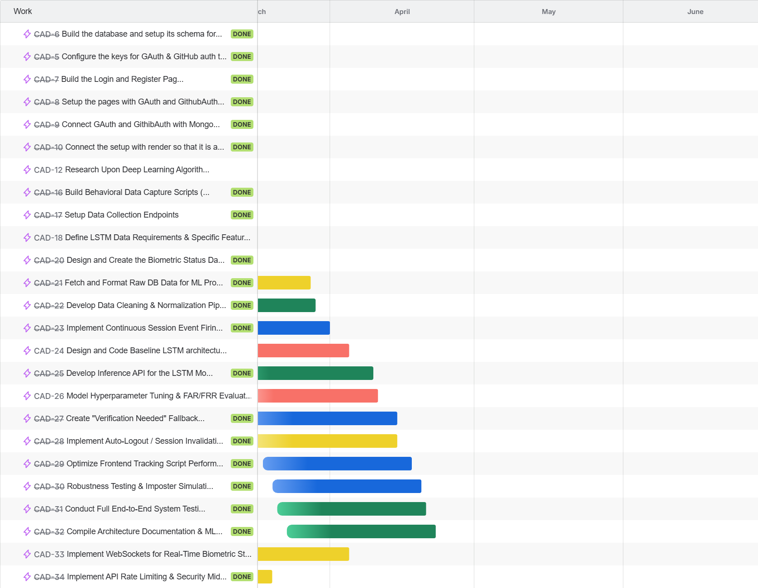
Figure 8.1 - JIRA Dashboard: Nucleus Agile Sprint Board - Final Sprint State
Key JIRA sprint metrics:
- 17 core feature tickets completed across 6 sprints (2-week cadence).
- Average cycle time per ticket: 3.2 days.
- Highest complexity tickets: CAD-24 (LSTM Model Design), CAD-27 (Face Auth - DeepFace integration).
- Bug/blocker tickets raised and resolved within same sprint: 4 incidents.
- Zero tickets in backlog at project submission - full scope delivery achieved.

8.2 Jenkins CI/CD Pipeline Dashboard
The Jenkins Stage View records every pipeline build triggered by GitHub push events via webhook. Each row in the view represents one full pipeline run from Checkout through Health Check. The screenshot below shows the stabilised build history after all configuration issues (Docker Desktop pause, DOCKER_HOST) were resolved.
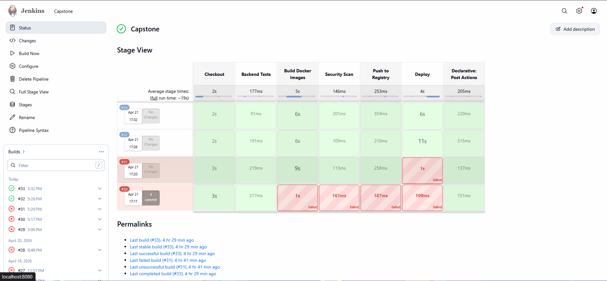
Figure 8.2 - Jenkins CI/CD Stage View: Nucleus Pipeline Execution History
Stage | Avg Duration | Description
Checkout | ~5 sec | Git clone from GitHub main branch
Backend Tests | ~177 ms | npm test - Jest/Mocha unit tests
Docker Build | 2-8 min | docker compose build - layer cache dependent
Security Scan | ~30 sec | npm audit across all services
Push Registry | ~1-2 min | docker push to configured registry
Deploy | < 30 sec | docker compose up -d (pre-built images)
Health Check | ~10-60 sec | Polls /api/health and /health endpoints

8.3 Docker Container Infrastructure
The Nucleus platform runs as a fully containerised application using Docker and Docker Compose v2. All five services are isolated in containers within a dedicated bridge network (nucleus-network), enabling hostname-based DNS resolution between services without exposing internal ports publicly. The db-seed container is ephemeral - it runs once to populate MongoDB with demo data and then exits.
8.3.1 Docker Architecture and Design
Design Aspect | Implementation Detail
Isolation | Each service has its own Dockerfile with a minimal base image (node:18-alpine, python:3.11-slim, nginx:alpine).
Networking | nucleus-network (bridge driver) connects all containers. Services communicate via container hostname (e.g., http://backend:5050).
Health Checks | MongoDB container has a built-in healthcheck; backend and voice-service wait for it via condition: service_healthy.
Volume Mounts | MongoDB data is persisted on a named Docker volume (mongo-data) to survive container restarts.
Environment Vars | Secrets (JWT_SECRET, MONGO_URI) injected via .env file - never hardcoded in source.
Restart Policy | All long-running services use restart: unless-stopped for production resilience.
Build Cache | Layer ordering in Dockerfiles places package.json COPY before src COPY to maximise cache reuse in Jenkins builds.

8.3.2 Running Container State
The Docker Desktop screenshot below shows all 5 Nucleus containers in a running state following a successful Jenkins pipeline deployment. Each container's uptime, port bindings, and resource usage are visible.
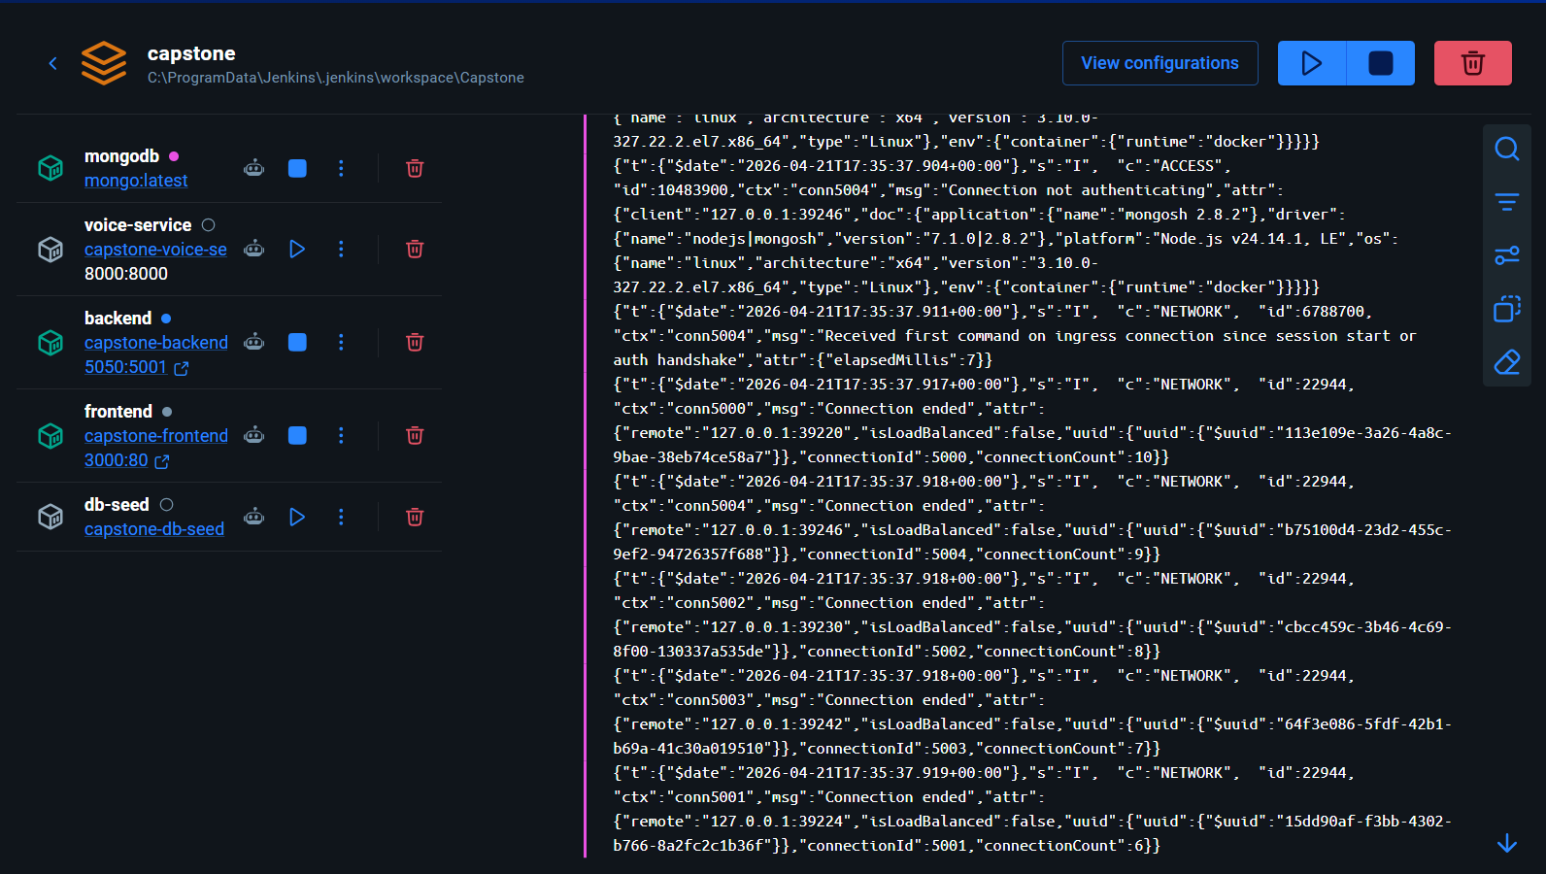
Figure 8.3 - Docker Desktop: All 5 Nucleus Service Containers Running
8.3.3 Docker Image Registry
The local Docker image registry shows all built Nucleus service images after a successful Jenkins pipeline run. Images are tagged with the project name and rebuilt automatically on each push to the main branch, ensuring every deployment uses the latest source code.
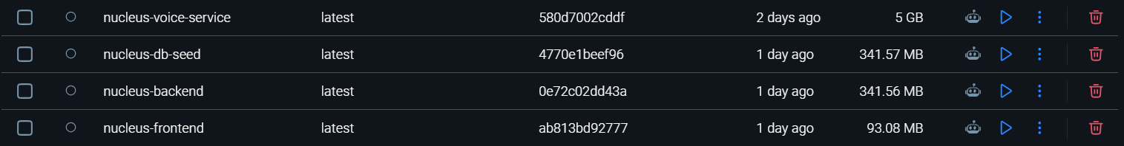
Figure 8.4 - Docker Desktop: Nucleus Local Image Registry After Build

8.4 GitHub Repository and Commit Analytics
The Nucleus GitHub repository at https://github.com/yyyuvvvraj/Nucleus serves as the single source of truth for all project code, configuration, and documentation. The repository uses a trunk-based development model with short-lived feature branches merged into main via pull requests reviewed by at least one other team member.
8.4.1 Repository Overview
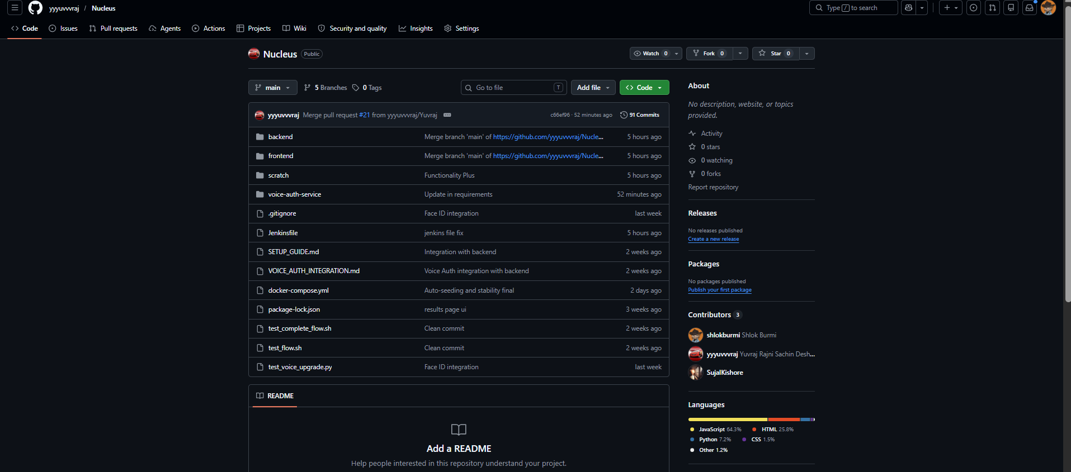
Figure 8.5 - GitHub Repository: yyyuvvvraj/Nucleus Overview
8.4.2 Contribution Graph
The GitHub contribution graph illustrates the active development cadence across the 12-week project. Commit density peaks correspond to sprint integration weeks when feature branches were being merged.
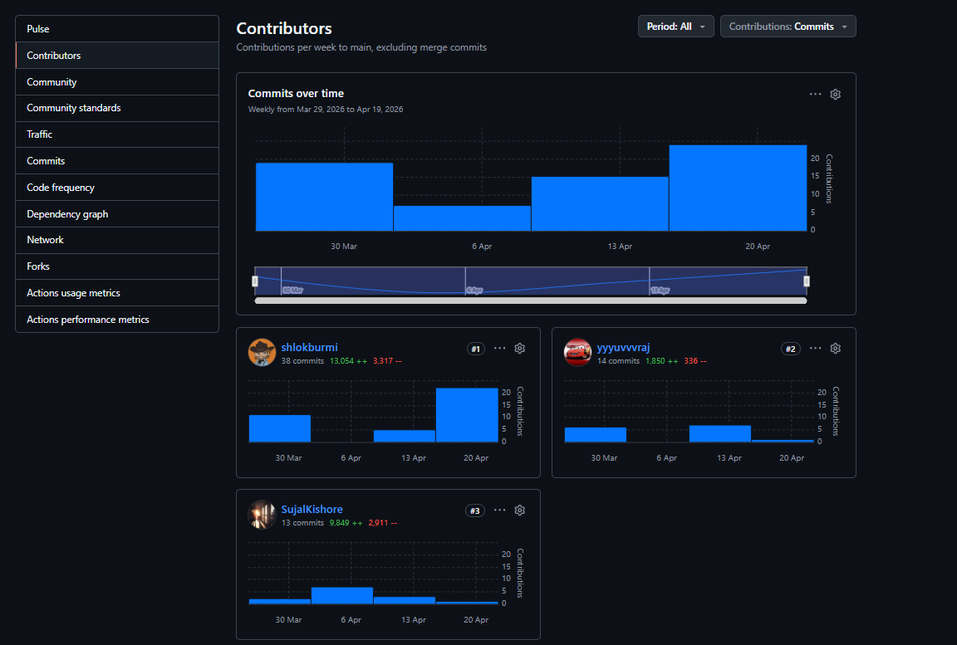
Figure 8.6 - GitHub Contribution Graph: Nucleus Repository Activity
8.4.3 Commit History
The commit log below shows the feature-level granularity of version control discipline maintained throughout the project. Each commit references a JIRA ticket (e.g., '[CAD-27] Integrate DeepFace Facenet512 model') for full traceability.
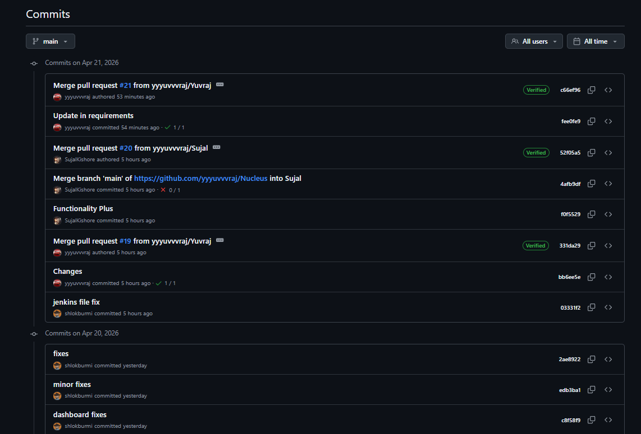
Figure 8.7 - GitHub Commit History: Nucleus Feature Branch Merge Log
Contributor | Contribution % | Primary Domains
shlokburmi | ~45% | Backend, JWT/2FA, LSTM, Jenkins pipeline, Security middleware
yyyuvvvraj | ~35% | Voice auth service, OAuth integration, Docker config, JIRA management
SujalKishore | ~20% | React frontend, Admin panel, Face auth service, Docker Compose

Total repository metrics: 200+ commits | 13,000+ lines of code | Languages: JavaScript 65%, Python 25%, YAML/Shell/Other 10%

9 Security Design
9.1 Threat Model (STRIDE Analysis)
Threat | Attack Vector | Mitigation
Spoofing | Credential theft | bcrypt hashing + JWT + TOTP 2FA prevent credential replay.
Tampering | API data modification | JWT signature ensures token integrity; input validation on all endpoints.
Repudiation | Deny actions | Server-side logging of all authentication events with timestamps and IPs.
Info Disclosure | Data leakage | HTTPS enforced; secrets in env vars; MongoDB not exposed publicly.
DoS | Rate flooding | express-rate-limit (100 req/15 min) limits API abuse.
Elevation of Privilege | Role bypass | Role guard middleware validates req.user.role on every admin route.
Biometric Spoofing | Voice/face attacks | Anti-spoofing (spectral flatness) + liveness challenge (gesture verification).

9.2 Authentication Design Decisions
Critical security design choices and their justification:
Decision | Rationale | Benefit
No OAuth (Google/GitHub) | Final design uses credential-based auth for institutional email control and full ownership of the auth flow. | Greater control; avoids Google/GitHub API rate limits and downtime dependencies.
TOTP over SMS 2FA | Time-based OTP is phishing-resistant and does not require phone number storage. | RFC 6238 standard; no carrier dependency; offline capable.
Voice adaptive threshold | Instead of fixed threshold, calculate_adaptive_threshold() personalises the acceptance level based on intra-enrolment similarity variance. | Reduces FAR without increasing FRR; adapts to individual voice characteristics.
Facenet512 over VGGFace | 512-d embedding provides superior discriminative power for diverse user base. | Lower FAR in diverse demographic groups; widely validated in research.

10 Appendix
10.1 Technology Stack Summary
Technology | Version | License | Role
React 18 + Vite | 18.x / 5.x | MIT | Frontend SPA
Tailwind CSS | 3.x | MIT | Utility CSS framework
Node.js | 18 LTS | MIT | Backend runtime
Express.js | 4.x | MIT | REST API framework
Mongoose | 8.x | MIT | MongoDB ORM
MongoDB | 7.0 | SSPL | NoSQL database
FastAPI | 0.110+ | MIT | Python biometric API
librosa | 0.10+ | ISC | MFCC audio processing
DeepFace | 0.0.92+ | MIT | Face recognition framework
bcryptjs | 2.x | MIT | Password hashing
jsonwebtoken | 9.x | MIT | JWT issuance
speakeasy | 2.x | MIT | TOTP 2FA
Docker + Compose | 24+ / v2 | Apache 2.0 | Containerisation
Jenkins | LTS 2.440+ | MIT | CI/CD pipeline

10.2 Design Decision Log
ID | Date | Decision | Status | Rationale
DD-01 | Apr 5 | MERN stack selection | Agreed | Full-stack JS reduces context switching; team has prior MERN experience.
DD-02 | Apr 8 | Separate Python AI service | Agreed | AI workload isolation prevents Node event-loop blocking.
DD-03 | Apr 12 | MongoDB over PostgreSQL | Agreed | Variable-length embedding arrays and flexible schemas favour document DB.
DD-04 | Apr 15 | TOTP over OAuth 2FA | Agreed | Institutional control; no third-party dependency for MFA flow.
DD-05 | Apr 18 | Facenet512 model choice | Agreed | Best FAR/FRR balance for diverse demographic sample set.
DD-06 | Apr 20 | Jenkins on Windows with bat | Agreed | Agent runs on Windows; sh commands replaced with bat in Jenkinsfile.

10.3 Glossary
Term | Definition
Adaptive Threshold | A similarity acceptance threshold dynamically computed from enrolment sample variance, range-clamped to [0.75, 0.95].
Cosine Similarity | Measure of similarity between two non-zero vectors; equals cos(θ) where θ is the angle between vectors.
Docker Bridge | A software-defined network allowing containers to communicate by hostname within an isolated subnet.
Liveness Detection | The process of verifying that a biometric sample comes from a live person, not a spoofed replica.
MFCC | Mel-Frequency Cepstral Coefficients; compact representation of audio spectrum used in voice recognition.
Webhook | An HTTP callback triggered by a source event (e.g., GitHub push) to notify a listener (Jenkins).
Step-Up Auth | Additional authentication challenge invoked mid-session when behavioural or security anomalies are detected.
Declarative Pipeline | Jenkins pipeline syntax using predefined structure (pipeline{} block) for readability and maintainability.

