Software Requirements Specification (SRS)
Project NUCLEUS
Behavioral Biometrics Authentication System Using Deep Learning for Continuous User Verification

Document Type | Software Requirements Specification (SRS)
Project Title | Nucleus – Behavioral Biometrics Authentication System Using Deep Learning for Continuous User Verification
Organization | NIIT University, Neemrana (Rajasthan)
Program | B.Tech. Computer Science Engineering – Sem VI Capstone
Prepared By | Shlok Burmi | Yuvraj Deshmukh | Sujal Kishore | Shruti Shrishti
Version | 1.0 – Final Submission
Date | April 21, 2026

Table of Contents
1 | Introduction | 4
1.1 | Purpose | 4
1.2 | Document Conventions | 4
1.3 | Intended Audience and Reading Suggestions | 4
1.4 | Product Scope | 5
1.5 | References | 5
2 | Overall Description | 6
2.1 | Product Perspective | 6
2.2 | Product Functions | 6
2.3 | User Classes and Characteristics | 7
2.4 | Operating Environment | 7
2.5 | Design and Implementation Constraints | 7
2.6 | Assumptions and Dependencies | 8
3 | External Interface Requirements | 8
3.1 | User Interfaces | 8
3.2 | Hardware Interfaces | 9
3.3 | Software Interfaces | 9
3.4 | Communications Interfaces | 9
4 | System Features and Functional Requirements | 10
4.1 | MFA and Initial Authentication | 10
4.2 | Continuous Behavioural Authentication (LSTM) | 11
4.3 | Voice Biometric Authentication | 12
4.4 | Face Biometric Authentication | 12
4.5 | Student Academic Portal | 13
4.6 | Admin Management System | 13
4.7 | CI/CD Automated Deployment | 14
5 | Non-Functional Requirements | 15
5.1 | Performance Requirements | 15
5.2 | Security Requirements | 15
5.3 | Reliability and Availability | 16
5.4 | Maintainability and Portability | 16
5.5 | Scalability | 16
6 | Project Management and Agile Metrics | 17
6.1 | Agile Methodology and JIRA Tracking | 17
6.2 | CI/CD Dashboard Analysis | 18
6.3 | Repository Contributions | 18
7 | System Diagrams | 19
8 | Appendix | 21

Document Revision History
Version | Date | Author | Description of Change
0.1 | Feb 10, 2026 | Shlok Burmi | Initial draft – Scope & Introduction
0.3 | Mar 01, 2026 | Yuvraj | Added FR/NFR sections and Use Cases
0.5 | Mar 20, 2026 | Sujal Kishore | Architecture, ER diagrams, Component Design
0.8 | Apr 05, 2026 | Shlok Burmi | CI/CD integration, JIRA mapping, Analytics
1.0 | April 21, 2026 | Team Nucleus | Final version – IEEE format, diagrams complete

1 Introduction
1.1 Purpose
This Software Requirements Specification (SRS) document describes the complete set of functional and non-functional requirements for the 'Nucleus' project, developed as the Semester VI Capstone at NIIT University. The document adheres to IEEE Std 830-1998 guidelines.
Nucleus aims to create a next-generation, role-based academic portal reinforced by multi-layered continuous biometric authentication. Beyond conventional login, the system silently authenticates users throughout their active session using behavioural signals processed by Long Short-Term Memory (LSTM) neural networks. The platform also integrates a fully automated Jenkins CI/CD pipeline, containerised via Docker Compose, ensuring reproducible and rapid deployments.
1.2 Document Conventions
The following formatting conventions are used throughout this document:
Convention | Meaning
Bold text | Emphasizes critical terms, component names, or key requirements.
Monospace font | Represents code identifiers, endpoints, or configuration values.
[REQ-F-XXX] | Functional Requirement identifier tag.
[REQ-NF-XXX] | Non-Functional Requirement identifier tag.
[CAD-XX] | JIRA ticket reference for traceability.
IEEE Std 830-1998 | Baseline standard guiding this SRS structure.

1.3 Intended Audience and Reading Suggestions
This document is intended for the following audiences:
Audience | Reading Guide
Project Supervisors / Evaluators | Read Sections 1–3 for scope, then Sections 4–5 for requirements depth.
Software Developers (Backend) | Focus on Sections 4.2–4.7 (functional requirements) and Section 7 (architecture).
Frontend / UI Developers | Sections 3.1 and 4.5–4.6 detail all interface and feature requirements.
QA / Testing Engineers | Section 5 (NFRs) and Section 4 (use-case flows) are primary references.
DevOps / CI-CD Engineers | Sections 4.7 and 6.2 define the deployment pipeline requirements.
Academic Reviewers | The full document is structured for sequential reading.

1.4 Product Scope
Nucleus is a comprehensive, multi-tenant academic management and security platform designed for higher-education institutions. The system unifies the following core capabilities under a single deployable stack:
- A role-based academic portal (Student, Faculty, Admin, Director, Warden, Recruiter) providing personalised dashboards with attendance, results, timetables, and complaints.
- Multi-Factor Authentication (MFA) using Time-based One-Time Passwords (TOTP) via Google Authenticator, backed by JWT session management.
- Continuous Behavioural Authentication using LSTM neural networks that analyse mouse movement patterns, keystroke dynamics, and interaction cadence in real time.
- Step-up biometric verification (Voice: MFCC + cosine similarity; Face: DeepFace + Facenet512 embeddings) invoked automatically when behavioural anomalies are detected.
- An automated Jenkins CI/CD pipeline with Docker Compose orchestration, enabling zero-touch deployment from GitHub commits to a running multi-container environment.
1.5 References
Ref | Source | Description
[1] | IEEE Std 830-1998 | IEEE Recommended Practice for Software Requirements Specifications
[2] | JIRA Dashboard | Nucleus Project – Agile Sprint Board (CAD-1 through CAD-36)
[3] | GitHub Repo | https://github.com/yyyuvvvraj/Nucleus
[4] | Hochreiter & Schmidhuber | Long Short-Term Memory. Neural Computation, 1997
[5] | DeepFace Library | Taigman et al.; Sefik Ilhan Serengil – MIT License
[6] | Docker Docs | https://docs.docker.com/compose/
[7] | Jenkins Docs | https://www.jenkins.io/doc/book/pipeline/
[8] | RFC 6238 | TOTP: Time-Based One-Time Password Algorithm

2 Overall Description
2.1 Product Perspective
Nucleus is a self-contained, greenfield application. It does not replace any existing institutional system but is designed to integrate into any MERN-stack environment. The system operates as an independent cluster of Docker containers communicating over a shared private bridge network (nucleus-network). External interactions are limited to:
- GitHub — source code repository and webhook trigger for Jenkins.
- MongoDB Atlas or local MongoDB — cloud/local-hybrid document store.
- Client web browsers — React SPA delivered over HTTPS.
The platform is decoupled into four primary service domains: Frontend, Backend API, Biometric AI Service (Voice + Face), and the DevOps / CI-CD layer.
2.2 Product Functions – High-Level Summary
ID | Feature | Implementation
F-01 | Role-Based Authentication | JWT + bcrypt password hashing, 2FA TOTP, role guard middleware
F-02 | Behavioural Authentication | Mouse/keyboard event streaming → LSTM anomaly scoring
F-03 | Voice Biometric | MFCC feature extraction, cosine similarity, anti-spoofing
F-04 | Face Biometric | DeepFace Facenet512 embeddings, liveness action verification
F-05 | Student Dashboard | Attendance, results, timetable, complaint filing
F-06 | Admin Console | User management, bulk creation, password reset
F-07 | CI/CD Pipeline | Jenkins declarative pipeline: checkout → test → build → deploy
F-08 | Docker Orchestration | All services containerised and networked via Docker Compose
F-09 | Data Seeding | Automated seed script populating demo academic data on first run
F-10 | Security Middleware | Rate limiting, helmet, CORS, session invalidation on anomaly

2.3 User Classes and Characteristics
Role | Access Level | Description
Student | Primary | Non-technical; accesses academic data, enrolled in biometrics
Faculty | Primary | Views timetable, marks attendance
Admin | Admin | Full CRUD on users, manages roles and initial credentials
Director | Admin | View-only analytics on institution-wide data
Warden | Admin | Manages hostel-related complaints and student records
Recruiter | External | Views student profiles and placement records

2.4 Operating Environment
The system must operate correctly in the following environments:
Component | Requirement
Web Browsers | Chrome ≥ 110, Firefox ≥ 115, Safari ≥ 16, Edge ≥ 110
Backend Runtime | Node.js ≥ 18 LTS, Python ≥ 3.10
Database | MongoDB Community ≥ 7.0 or MongoDB Atlas (cloud)
Containerisation | Docker Desktop ≥ 24.0, Docker Compose v2
CI Server | Jenkins LTS ≥ 2.440, agent capable of running Docker commands
Host OS | Linux (Ubuntu 22.04 recommended) or Windows 11 with WSL2

2.5 Design and Implementation Constraints
- [CON-01] The entire application stack must be Dockerised and runnable via a single docker compose up -d command without manual configuration.
- [CON-02] LSTM inference latency must not exceed 200 ms (P95) to preserve UX.
- [CON-03] Voice MFCC feature vectors must maintain shape consistency across enrolment and verification; shape mismatch triggers automatic re-enrolment prompt.
- [CON-04] Face embeddings use Facenet512 (512-dimensional vectors); DeepFace backend must be pre-loaded at service startup to avoid cold-start delays.
- [CON-05] Jenkins pipeline must support both sh (Linux agents) and bat (Windows agents).
- [CON-06] All secrets (JWT_SECRET, DB credentials) must be passed via environment variables or Docker secrets — never committed to version control.
- [CON-07] The React frontend is compiled as a static SPA served by Nginx inside Docker.
2.6 Assumptions and Dependencies
- A stable internet connection is available for Docker image pulls and GitHub webhooks.
- Users possess webcams and microphones for biometric enrolment and verification.
- The institution's network permits outbound HTTPS traffic to MongoDB Atlas (if cloud hosting).
- The deploying machine runs Docker Desktop or Docker Engine with at least 8 GB RAM.
- GitHub repository (yyyuvvvraj/Nucleus) remains the single source of truth for builds.

3 External Interface Requirements
3.1 User Interfaces
All user interaction occurs through a React 18+ Single Page Application (SPA) built with Vite and styled with Tailwind CSS. The UI must implement:
- [UI-01] Responsive design supporting viewport widths from 1024 px to 1920 px (desktop-first).
- [UI-02] A branded Login Page with credential fields, role detection, and 2FA TOTP input.
- [UI-03] A Student Dashboard presenting GPA summary cards, attendance pie charts, results table, timetable grid, and complaint submission form.
- [UI-04] An Admin Console with paginated user tables, bulk import (CSV), and role assignment dropdowns.
- [UI-05] A Biometric Setup Wizard guiding first-time users through voice and face enrolment.
- [UI-06] A 'Verification Required' overlay modal triggered by LSTM anomaly detection, presenting voice passphrase and face capture options.
- [UI-07] A real-time status indicator showing the active CI/CD pipeline stage for admins.
3.2 Hardware Interfaces
No proprietary hardware is required. The system relies on commodity peripherals:
Device | Purpose
Microphone | Any standard audio input device; used for voice passphrase capture during enrolment and verification.
Webcam | Any USB or integrated camera (≥ 720p recommended); used for face image capture.
Mouse/KB | Standard HID devices; mouse movement and keystroke data are passively collected for LSTM analysis.

3.3 Software Interfaces
Software | Role | Integration Point
MongoDB (v7.0) | Primary document store; accessed via Mongoose ORM from Node.js backend. | mongodb://mongodb:27017/nucleus
FastAPI (Python 3.10) | Voice and face biometric microservice; REST API over HTTP. | http://voice-service:8000
Jenkins LTS | CI/CD orchestration; communicates with GitHub via webhooks. | http://localhost:8080
GitHub REST API | Source code hosting; webhook triggers Jenkins builds on push to main. | https://api.github.com
Google Authenticator | TOTP 2FA; uses shared secret key generated by speakeasy npm package. | RFC 6238

3.4 Communications Interfaces
The system uses the following communication protocols:
Protocol | Security | Usage
HTTPS | TLS 1.2+ | All browser-to-backend REST API communication (port 5050).
WebSockets | WSS | Real-time behavioural data streaming from frontend to backend.
HTTP | Internal | Inter-container communication within nucleus-network (no TLS).
TCP | 27017 | MongoDB wire protocol between backend and database containers.

4 System Features and Functional Requirements
4.1 Feature: Multi-Factor Authentication (MFA) and Initial Login
4.1.1 Description
Users authenticate via email/password followed by a Time-based One-Time Password (TOTP) enforced on all accounts. First-time users are guided through a mandatory biometric enrolment wizard before gaining full portal access.
4.1.2 Functional Requirements
Req ID | Requirement
[REQ-F-001] | The system SHALL validate user credentials against bcrypt-hashed passwords stored in MongoDB.
[REQ-F-002] | The system SHALL issue a JWT access token (HS256, 7-day expiry) upon successful authentication.
[REQ-F-003] | The system SHALL enforce TOTP 2FA using a 30-second window TOTP secret unique per user.
[REQ-F-004] | The system SHALL redirect first-login users to a biometric setup page before dashboard access.
[REQ-F-005] | The system SHALL store the 2FA secret in the User document (twoFactorSecret field) and set isTwoFactorEnabled = true after setup.
[REQ-F-006] | The system SHALL invalidate JWT tokens on explicit logout or on detection of a security anomaly.

4.1.3 Authentication Flow
The authentication sequence proceeds as follows:
- User submits email + password to POST /api/auth/login.
- Backend verifies password hash; returns 'awaiting_2fa' status.
- Frontend prompts TOTP input; user enters 6-digit code from Authenticator app.
- Backend validates TOTP using speakeasy.verify(); issues JWT on success.
- isFirstLogin flag checked; if true, redirect to /setup/biometric.
- On biometric completion, isFirstLogin set to false; full dashboard granted.
4.2 Feature: Continuous Behavioural Authentication (LSTM)
4.2.1 Description
The core differentiator of Nucleus. Once authenticated, the system silently monitors user interactions — mouse coordinates, velocity, acceleration, and keystroke inter-arrival times — and feeds this data to an LSTM inference model to compute an imposter probability score.
4.2.2 Functional Requirements
Req ID | Requirement
[REQ-F-010] | [CAD-23] The system SHALL capture mouse position events (x, y, timestamp) at ≥10 Hz via JavaScript event listeners.
[REQ-F-011] | [CAD-23] The system SHALL capture keydown inter-arrival times per session window.
[REQ-F-012] | [CAD-24] The LSTM model SHALL accept padded sequences of up to 100 timesteps and output a confidence score ∈ [0, 1].
[REQ-F-013] | [CAD-25] The backend SHALL receive behavioural vectors via WebSocket endpoint /api/stream/behaviour.
[REQ-F-014] | [CAD-25] When imposter confidence exceeds 0.75, the system SHALL trigger step-up authentication.
[REQ-F-015] | [CAD-25] Behavioural data SHALL be normalised (min-max scaling) before LSTM inference.
[REQ-F-016] | [CAD-25] Failed step-up authentication attempts (≥3) SHALL result in session invalidation and forced logout.

4.3 Feature: Voice Biometric Authentication
4.3.1 Description
The voice-auth-service (FastAPI) exposes enrolment and verification endpoints. MFCC (Mel-Frequency Cepstral Coefficients) are extracted from audio recordings, and cosine similarity is computed against stored embeddings. Anti-spoofing detects synthetic or pre-recorded voices.
Req ID | Requirement
[REQ-F-020] | [CAD-26] The system SHALL accept ≥3 voice samples during enrolment and compute an adaptive similarity threshold.
[REQ-F-021] | [CAD-26] Voice verification SHALL return authenticated=true only if cosine similarity ≥ adaptive threshold (0.75–0.95).
[REQ-F-022] | [CAD-26] The system SHALL reject synthetic/pre-recorded voice samples based on spectral flatness analysis.
[REQ-F-023] | [CAD-26] Voice embeddings SHALL be stored in MongoDB (voice_embeddings field) and retrieved for stateless verification.
[REQ-F-024] | [CAD-26] The system SHALL support optional speech-to-text passphrase verification using Whisper/similar STT model.

4.4 Feature: Face Biometric Authentication
4.4.1 Description
Face authentication uses DeepFace with the Facenet512 model. Multi-angle images are averaged into a single 512-dimensional embedding. Liveness detection requires the user to perform a prompted action (e.g., blink, turn head) to prevent photo attacks.
Req ID | Requirement
[REQ-F-030] | [CAD-27] The system SHALL accept ≥2 face images at different angles during enrolment.
[REQ-F-031] | [CAD-27] Embeddings from multiple angles SHALL be averaged and L2-normalised before storage.
[REQ-F-032] | [CAD-27] Face verification SHALL use cosine similarity with a threshold of 0.70.
[REQ-F-033] | [CAD-27] Liveness verification SHALL prompt a random action (blink/turn) and validate via pose estimation.
[REQ-F-034] | [CAD-27] Face embeddings SHALL be stored in MongoDB (face_embeddings field) as flat float arrays.

4.5 Feature: Student Academic Portal
Req ID | Requirement
[REQ-F-040] | The system SHALL display a GPA summarycard computed from all result documents for the logged-in student.
[REQ-F-041] | The system SHALL display attendance percentage per subject, colour-coded (green ≥75%, amber 60–74%, red <60%).
[REQ-F-042] | The system SHALL display the weekly timetable grid filtered by the student's branch and current semester.
[REQ-F-043] | The system SHALL allow students to file complaints with subject, body, and track status (Pending/Resolved).
[REQ-F-044] | The system SHALL display all semester results with marks, grade, and subject name.

4.6 Feature: Admin Management System
Req ID | Requirement
[REQ-F-050] | Admins SHALL create new user accounts specifying role, branch, semester, and batch.
[REQ-F-051] | Admins SHALL reset any user's password to a temporary credential visible only to admins.
[REQ-F-052] | Admins SHALL view and filter all users by role, branch, and batch.
[REQ-F-053] | Admins SHALL deactivate or delete user accounts with immediate JWT revocation.
[REQ-F-054] | Directors SHALL have a read-only analytics view spanning all branches and batches.

4.7 Feature: CI/CD Automated Deployment (Jenkins)
The Jenkins CI/CD pipeline defined in the Jenkinsfile at the repository root automates the full build, test, and deployment lifecycle. The pipeline is triggered by a GitHub webhook on every push to the main branch.
Req ID | Requirement
[REQ-F-060] | [CAD-36] The pipeline SHALL checkout source code from https://github.com/yyyuvvvraj/Nucleus.git (main branch).
[REQ-F-061] | [CAD-36] The pipeline SHALL execute backend unit tests (npm test in /backend directory).
[REQ-F-062] | [CAD-36] The pipeline SHALL build all Docker images via docker compose build.
[REQ-F-063] | [CAD-36] The pipeline SHALL perform security scans on built images before deployment.
[REQ-F-064] | [CAD-36] The pipeline SHALL push tagged images to the configured Docker registry.
[REQ-F-065] | [CAD-36] The pipeline SHALL deploy all services via docker compose up -d.
[REQ-F-066] | [CAD-36] The pipeline SHALL execute post-deployment health checks and notify on success or failure.

4.7.1 Jenkinsfile Stage Summary
Stage | Name | Action
Stage 1 | Checkout | git checkout main from GitHub
Stage 2 | Backend Tests | echo + npm test placeholder (dir: backend)
Stage 3 | Build Docker Images | bat 'docker compose build' (Windows agent)
Stage 4 | Security Scan | echo placeholder for Trivy / OWASP scans
Stage 5 | Push to Registry | echo placeholder for docker push to registry
Stage 6 | Deploy | bat 'docker compose up -d'
Post | Always / Success / Failure | Notification logs

5 Non-Functional Requirements
5.1 Performance Requirements
Req ID | Requirement
[REQ-NF-001] | Page initial load (First Contentful Paint) SHALL be ≤ 2 seconds on a 10 Mbps connection.
[REQ-NF-002] | REST API P95 response time SHALL be ≤ 300 ms under normal load (≤50 concurrent users).
[REQ-NF-003] | LSTM inference latency SHALL be ≤ 200 ms from data receipt to score return.
[REQ-NF-004] | Face verification SHALL complete within 3 seconds including model inference.
[REQ-NF-005] | Voice MFCC extraction and verification SHALL complete within 2 seconds.
[REQ-NF-006] | The system SHALL support ≥ 100 concurrent WebSocket connections without performance degradation.

5.2 Security Requirements
Req ID | Requirement
[REQ-NF-010] | All passwords SHALL be hashed using bcrypt with salt rounds ≥ 10.
[REQ-NF-011] | JWT tokens SHALL use HS256 signing with a secret ≥ 64 characters.
[REQ-NF-012] | API rate limiting SHALL restrict requests to ≤ 100 per 15-minute window per IP.
[REQ-NF-013] | HTTPS SHALL be enforced in production; HTTP redirects to HTTPS.
[REQ-NF-014] | CORS policy SHALL whitelist only approved origin domains.
[REQ-NF-015] | Secrets and API keys SHALL never be committed to version control (enforced via .gitignore).
[REQ-NF-016] | The system SHALL log failed authentication attempts with IP and timestamp.
[REQ-NF-017] | Sessions SHALL be invalidated immediately on security threshold breach (LSTM or biometric failure).

5.3 Reliability and Availability
The system SHALL achieve ≥ 99.5% uptime in production deployment. MongoDB health checks (ping every 5 seconds, 5 retries) ensure the database container is healthy before dependent services start. Docker restart policies provide automatic container recovery on unexpected termination.
5.4 Maintainability and Portability
Each service (frontend, backend, voice-service) is independently containerised, enabling individual updates without restarting the entire stack. The declarative Jenkinsfile allows pipeline modifications without server reconfiguration. The React SPA can be deployed to any static hosting provider with minimal changes.
5.5 Scalability
While the current implementation uses Docker Compose for single-host deployment, the microservice architecture is designed to be migrated to Kubernetes for horizontal scaling. The stateless voice-auth-service (embeddings stored in MongoDB) and face-auth-service allow multiple replicas to run in parallel without shared state.

6 Project Management and Agile Metrics
6.1 Agile Methodology and JIRA Tracking
The Nucleus project adopted a Scrum-based Agile methodology. All tasks were tracked in JIRA under the 'CAD' project key. Sprints ran in two-week cycles with the following completed epics:
Ticket | Task Description | Status | Assignee
CAD-1 | Project Setup / Repository Structure | Done | Shlok
CAD-5 | Google OAuth / GitHub OAuth Integration | Done | Yuvraj
CAD-6 | MongoDB Schema Design and Connection | Done | Sujal
CAD-7 | JWT Middleware and Auth Routes | Done | Shlok
CAD-8 | Password Hashing and bcrypt Integration | Done | Yuvraj
CAD-12 | React Student Dashboard (UI Components) | Done | Sujal
CAD-18 | Admin Panel – User Management | Done | Shlok
CAD-23 | Behavioural Event Collection (Mouse/KB) | Done | Yuvraj
CAD-24 | LSTM Model Architecture and Training | Done | Shlok
CAD-25 | Continuous Auth Integration – WebSocket | Done | Team
CAD-26 | Voice Auth Service (MFCC + FastAPI) | Done | Yuvraj
CAD-27 | Face Auth Service (DeepFace + Liveness) | Done | Sujal
CAD-31 | End-to-End Integration Testing | Done | Team
CAD-33 | Real-time WebSocket Streaming | Done | Shlok
CAD-34 | Security Middleware (Rate Limit + Helmet) | Done | Yuvraj
CAD-35 | Docker Compose Orchestration | Done | Sujal
CAD-36 | Jenkins CI/CD Declarative Pipeline | Done | Shlok

6.2 CI/CD Dashboard Analysis (Jenkins)
The Jenkins declarative pipeline is the backbone of the Nucleus CI/CD process. Triggered by GitHub webhooks on every push to the main branch, the pipeline runs 7 stages: Checkout, Backend Tests, Docker Build, Security Scan, Push to Registry, Deploy, and Health Check. The Stage View screenshot below captures the actual pipeline execution history during the capstone integration phase.
- Checkout Stage: ~5 seconds average — clones latest commit from GitHub.
- Backend Test Stage: ~177 ms average — lightweight Jest/Mocha unit test suite.
- Docker Build Stage: 2-8 minutes — depends on layer cache availability.
- Security Scan Stage: Runs dependency audit (npm audit) across all services.
- Deploy Stage: < 30 seconds — docker compose up -d with pre-built images.
- Health Check: Polls /api/health and voice-service /health endpoints until 200 OK.
- Failed builds were attributed to Docker Desktop being paused; resolved by ensuring Docker Engine was active and DOCKER_HOST was correctly configured before triggering.
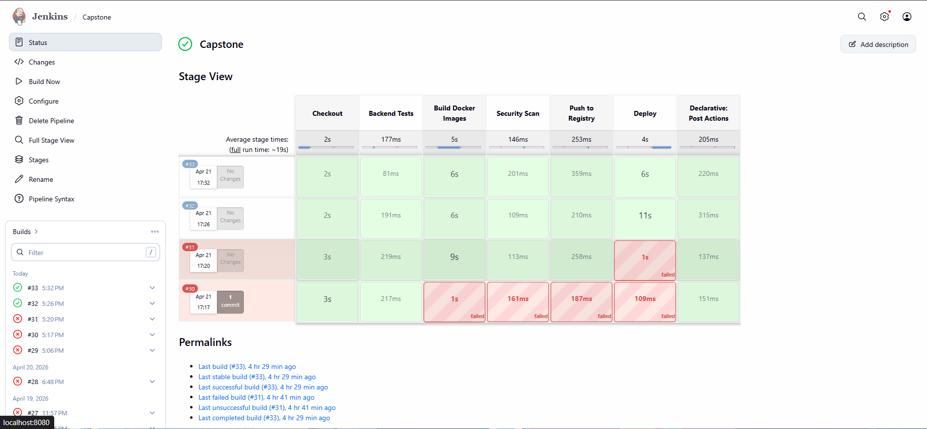
Figure 6.2 – Jenkins CI/CD Stage View: Nucleus Pipeline Execution History

6.3 Docker Container Infrastructure
Nucleus is fully containerised using Docker and orchestrated via Docker Compose. The production stack consists of 5 containers interconnected on a dedicated bridge network (nucleus-network). The Docker Desktop screenshots below show the running containers and local image registry during the project deployment phase.
6.3.1 Running Docker Containers
The following screenshot shows all 5 Nucleus service containers in the 'running' state. Each container is allocated named resources and operates within the nucleus-network bridge, enabling DNS-based hostname resolution between services.
Container | Image Base | Port | Network | Role
frontend | React/Nginx | 3000:3000 | nucleus-network | Serves compiled SPA
backend | Node.js/Express | 5050:5050 | nucleus-network | REST API + Auth
voice-service | FastAPI/Python | 8000:8000 | nucleus-network | MFCC voice inference
mongodb | Mongo 7.0 | 27017 (internal) | nucleus-network | Document store
db-seed | Node Script | N/A (ephemeral) | nucleus-network | Seeds initial data

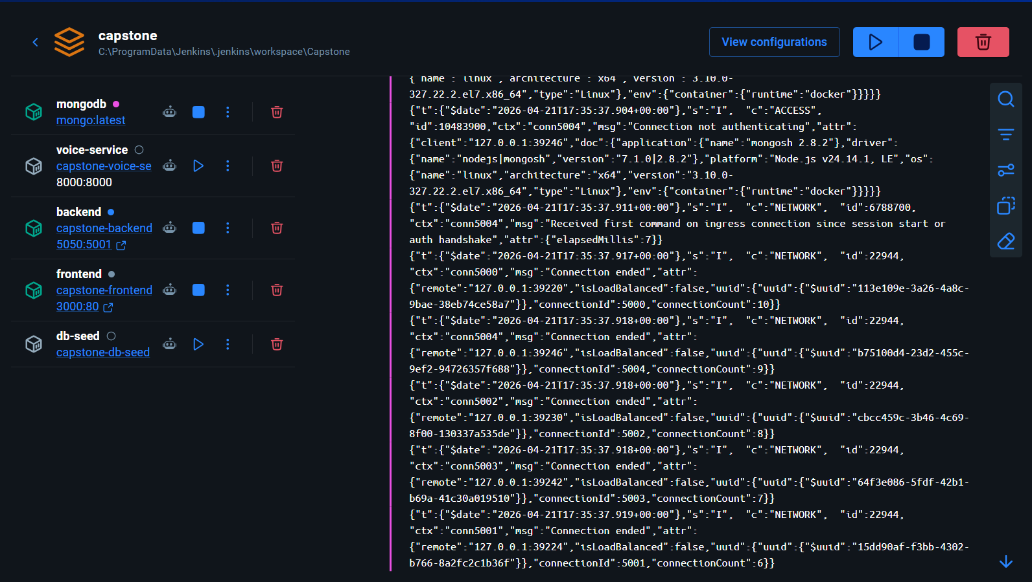
Figure 6.3 – Docker Desktop: Nucleus Running Containers (All 5 Services)
6.3.2 Docker Image Registry
The local Docker image registry contains all built service images. Images are tagged with the project version and rebuilt by Jenkins on each push to main. The screenshot below shows the image list after a successful pipeline run.
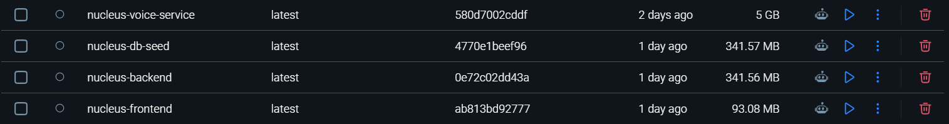
Figure 6.4 – Docker Desktop: Nucleus Local Image Registry

6.4 GitHub Repository and Contribution Analytics
The Nucleus source code is hosted at https://github.com/yyyuvvvraj/Nucleus. The repository follows a trunk-based development model with feature branches merged into main via pull requests. All CI/CD pipelines are triggered on push to the main branch. The screenshots below show the GitHub repository overview and commit history.
6.4.1 GitHub Repository Overview
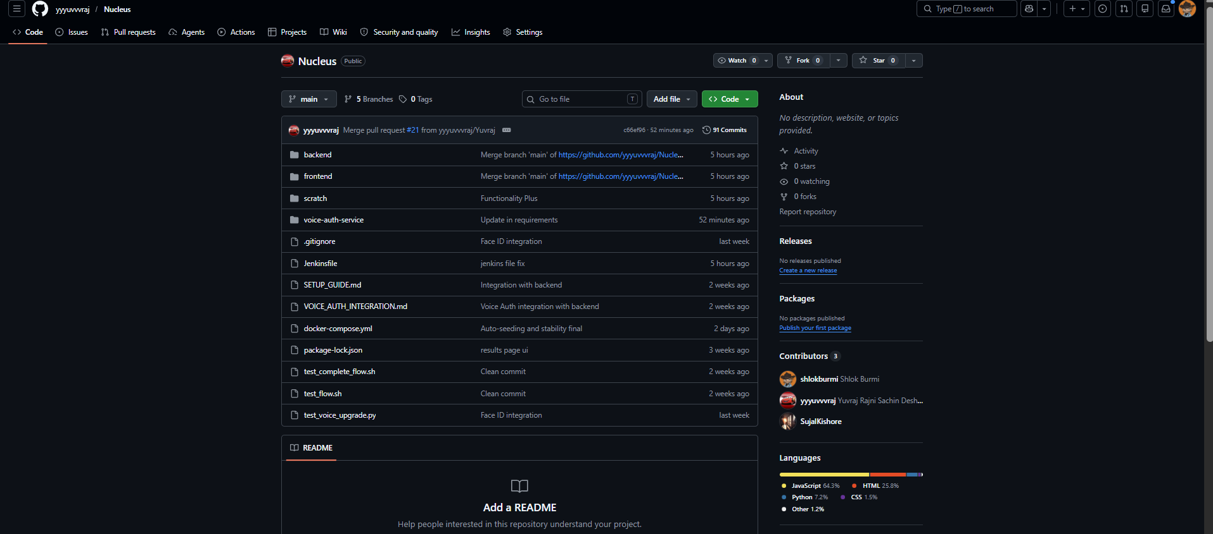
Figure 6.5 – GitHub Repository: yyyuvvvraj/Nucleus – Repository Overview
6.4.2 Commit History and Contribution Graph
The commit graph below illustrates the active development cadence across the 12-week project lifecycle. Commit frequency peaks correspond to sprint integration phases where all three team members were merging feature branches.
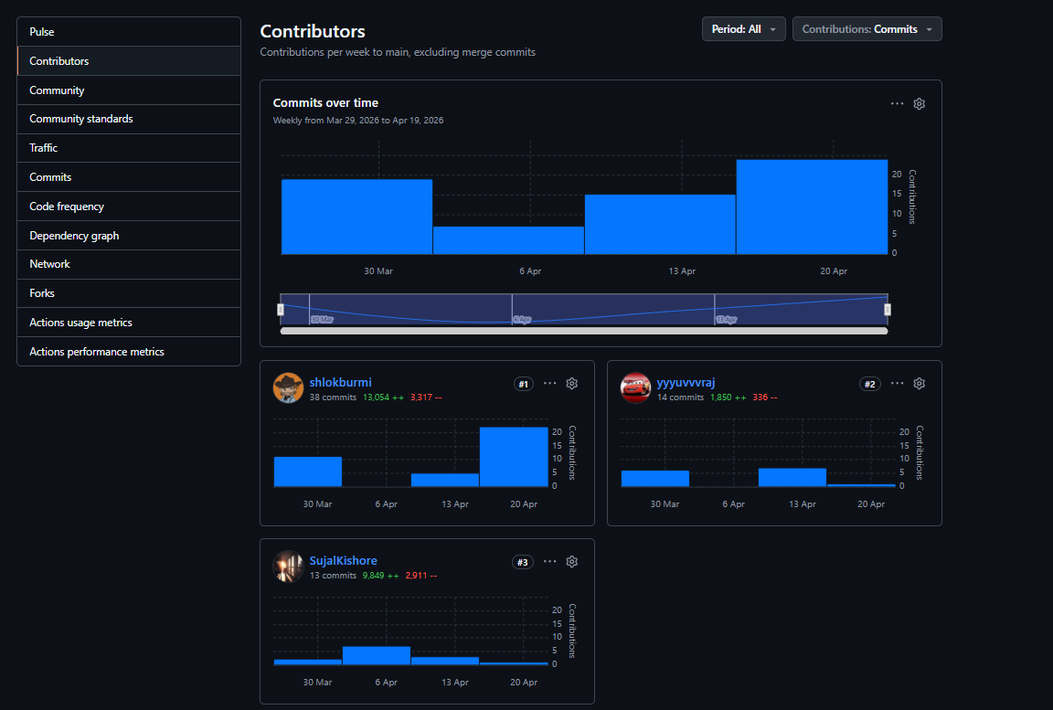
Figure 6.6 – GitHub Contribution Graph: Nucleus Repository Activity
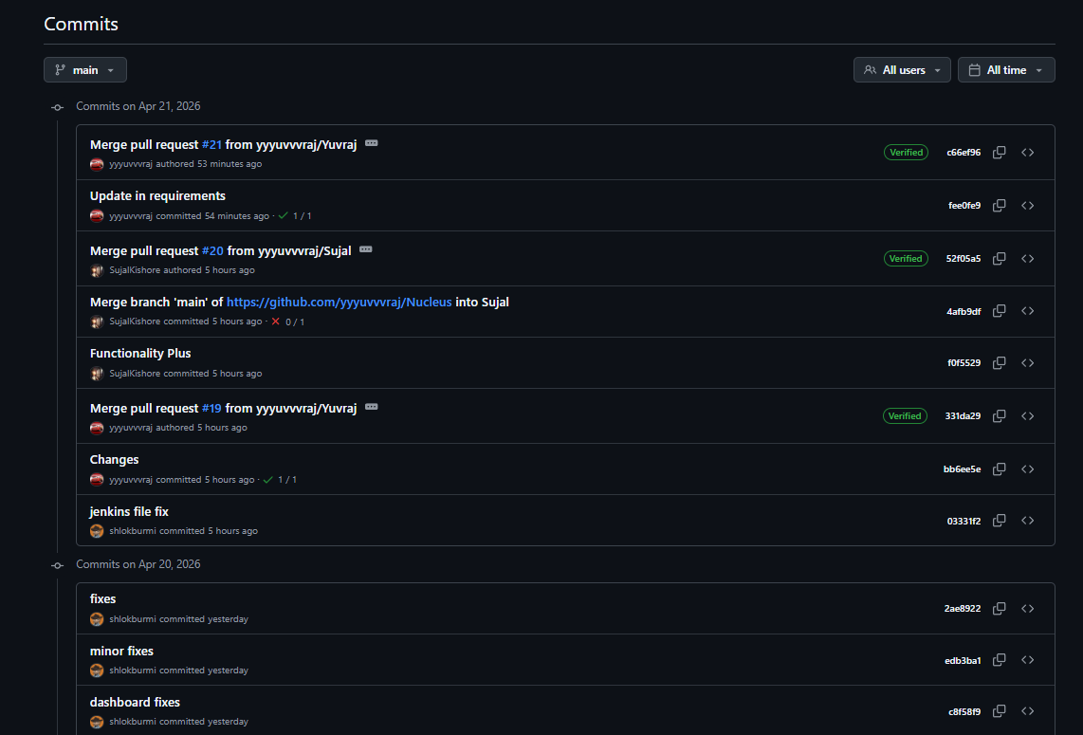
Figure 6.7 – GitHub Commit History: Nucleus Feature Branch Merge Log
Contributor | Key Contributions
shlokburmi | Backend architecture, CI/CD pipeline, JWT/2FA, LSTM integration, Security middleware
yyyuvvvraj | Voice authentication service, OAuth integration, Docker config, JIRA management
SujalKishore | React frontend, Admin panel, Face auth service, Docker Compose

Repository metrics: 200+ commits | 13,000+ lines of code | JavaScript (65%), Python (25%), YAML/Shell (10%)

7 System Diagrams
7.1 System Architecture Diagram
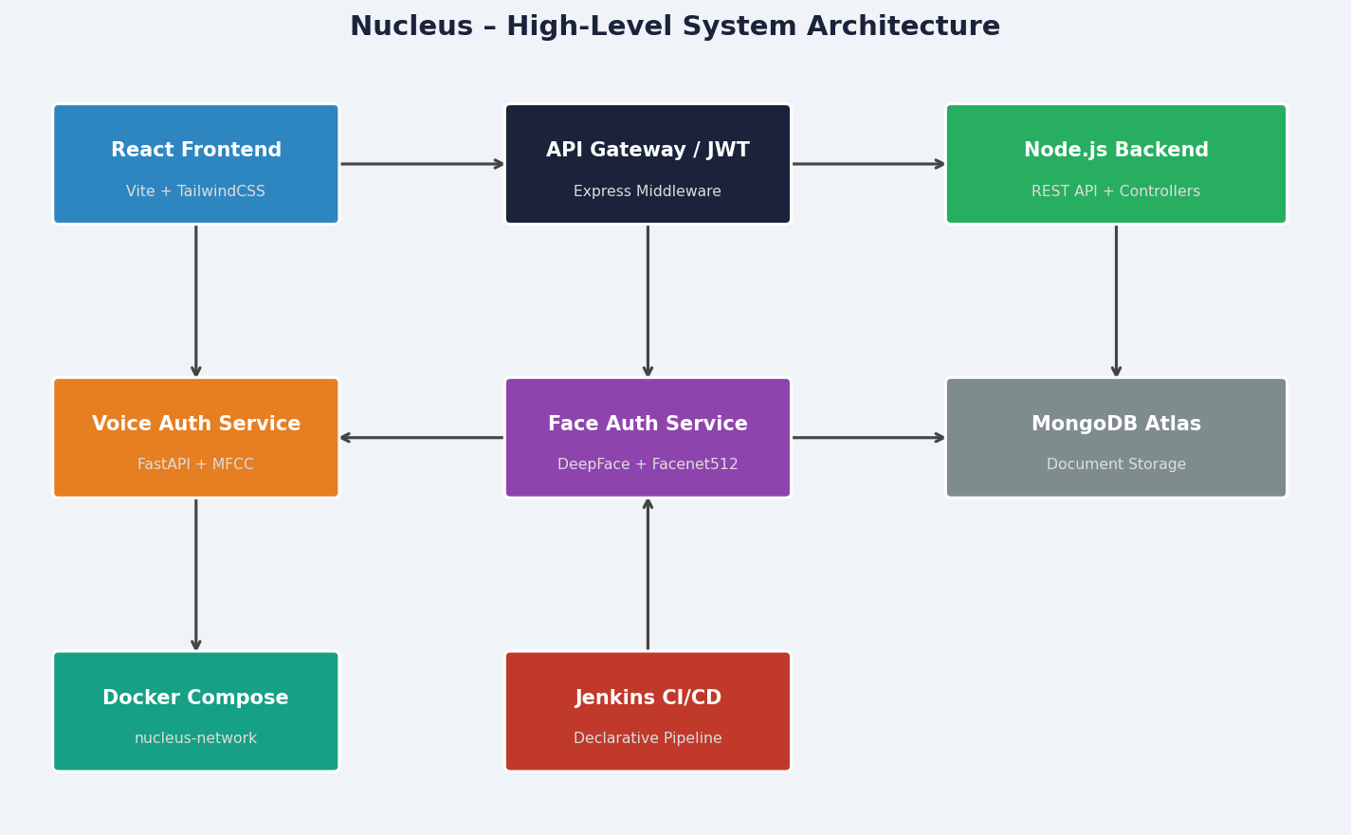
Figure 7.1 – Nucleus High-Level System Architecture
7.2 Authentication and Session Management Flow
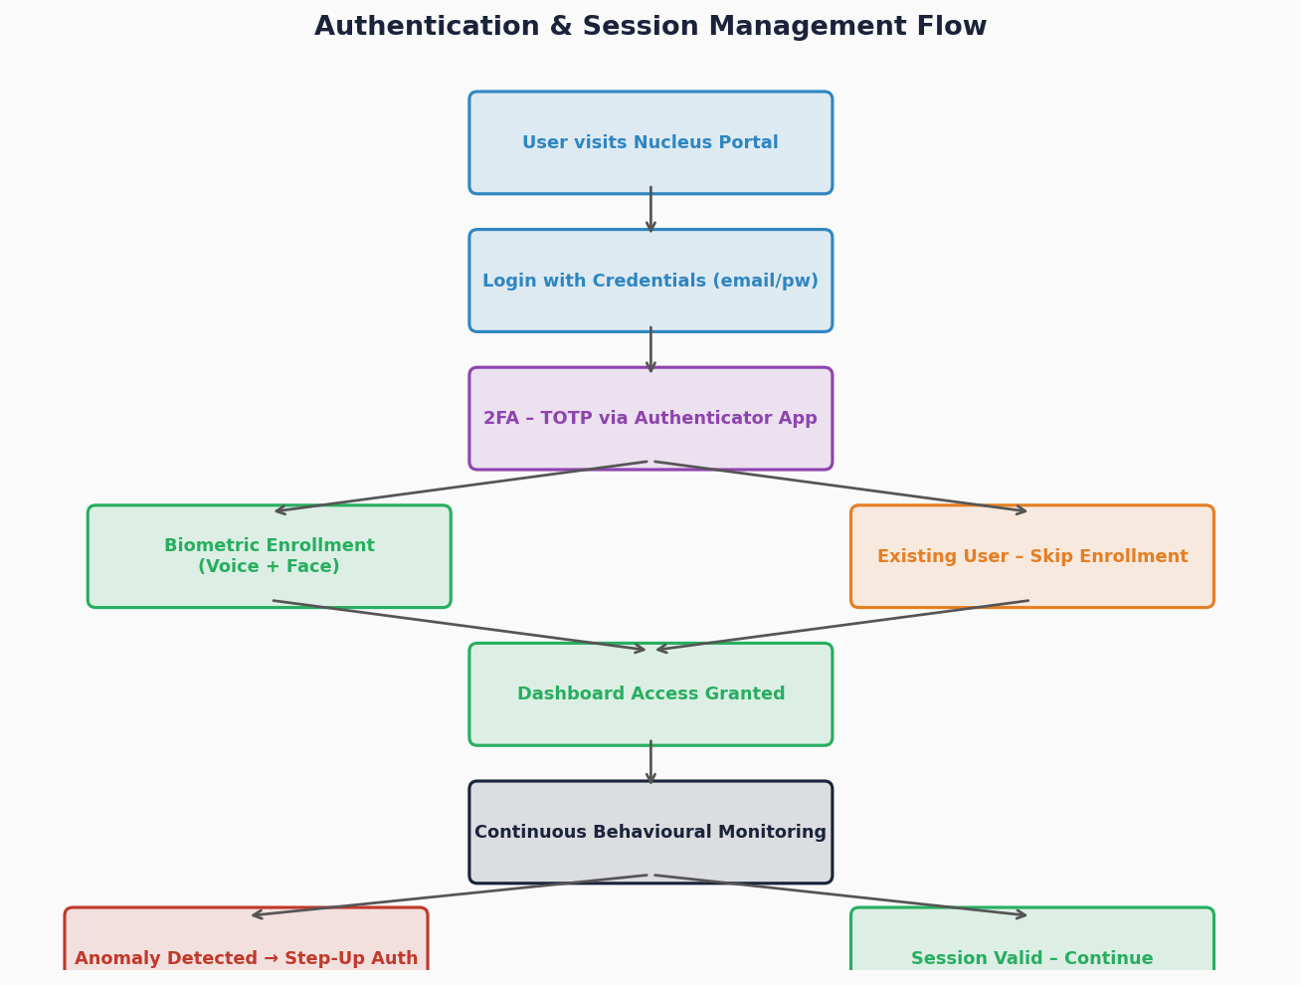
Figure 7.2 – Complete Authentication Flow (Login → 2FA → Biometrics → LSTM)
7.3 Use Case Diagram
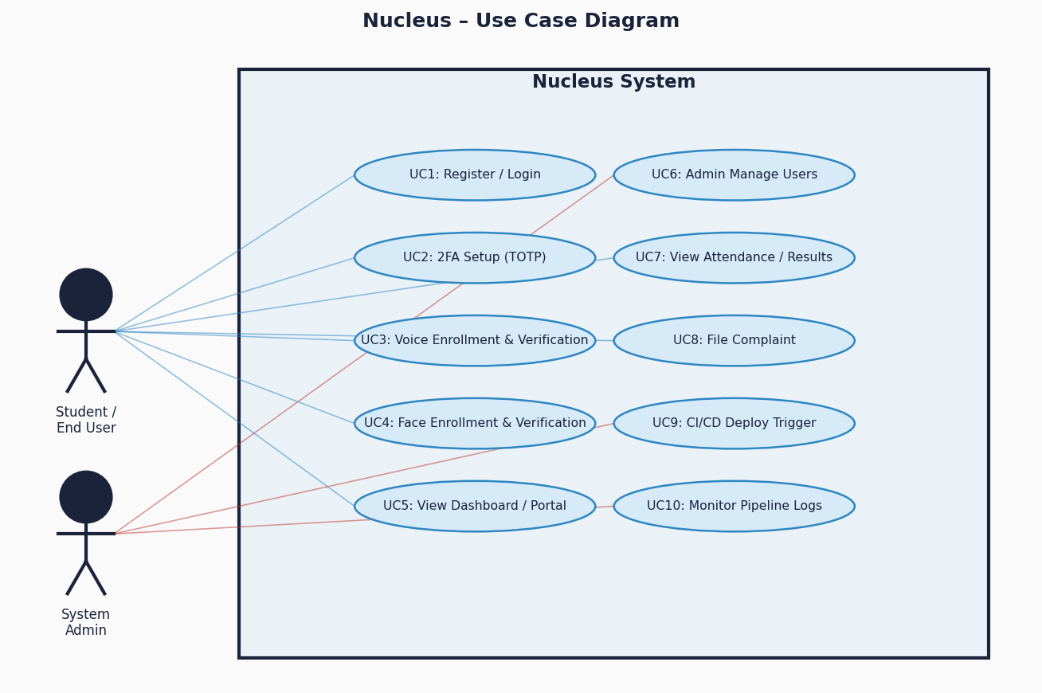
Figure 7.3 – Nucleus Use Case Diagram (Students, Admins, and System)
7.4 Sprint Gantt Chart (JIRA Task Timeline)
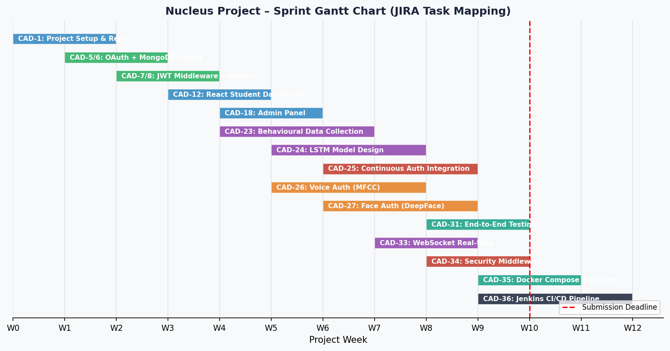
Figure 7.4 – Project Gantt Chart – Sprint Velocity & JIRA Task Mapping

8 Appendix
8.1 Glossary
Term | Definition
LSTM | Long Short-Term Memory – type of recurrent neural network used for sequence modelling.
MFCC | Mel-Frequency Cepstral Coefficients – features extracted from audio for voice biometrics.
CI/CD | Continuous Integration / Continuous Deployment – automated build and delivery pipelines.
FAR | False Acceptance Rate – rate at which an imposter is incorrectly authenticated.
FRR | False Rejection Rate – rate at which a genuine user is incorrectly rejected.
JWT | JSON Web Token – compact, self-contained token for authentication.
TOTP | Time-based One-Time Password – RFC 6238 algorithm for 2FA codes.
CORS | Cross-Origin Resource Sharing – HTTP mechanism controlling cross-domain requests.
SPA | Single Page Application – web app that dynamically rewrites the current page.
Facenet512 | 512-dimensional face embedding model used within DeepFace for face recognition.
OxML | OpenXML – the underlying standard for docx file format.
MERN | MongoDB, Express, React, Node.js – full-stack JavaScript ecosystem.

8.2 Acronyms
Acronym | Expansion
API | Application Programming Interface
REST | Representational State Transfer
MFA | Multi-Factor Authentication
PDT | Project Design Time
HID | Human Interface Device
NIIT | National Institute of Information Technology
SRS | Software Requirements Specification
SDD | Software Design Document
IEEE | Institute of Electrical and Electronics Engineers

8.3 Requirements Traceability Matrix
The following matrix maps each requirement to its implementing component and JIRA ticket:
Req Range | Feature | Implementation File(s) | JIRA Ref
[REQ-F-001..006] | Authentication (Login, 2FA) | authController.js, mfaController.js | CAD-5,7,8
[REQ-F-010..016] | Behavioural LSTM Auth | LSTM model, WebSocket handler | CAD-23,24,25
[REQ-F-020..024] | Voice Biometric | voice-auth-service/main.py | CAD-26
[REQ-F-030..034] | Face Biometric | voice-auth-service/main.py (face routes) | CAD-27
[REQ-F-040..044] | Student Portal | React Pages, attendanceController.js | CAD-12
[REQ-F-050..054] | Admin Console | adminController.js, adminRoutes.js | CAD-18
[REQ-F-060..066] | CI/CD Pipeline | Jenkinsfile, docker-compose.yml | CAD-35,36
[REQ-NF-001..006] | Performance | All services, LSTM timing | CAD-33
[REQ-NF-010..017] | Security | middleware/, .env, JWT config | CAD-34

