Cloudra: Geometric Reasoning and Scientific Evidence in Autonomous Mechanism Exploration
Working Draft — 29 October 2026

1. Introduction

1.1 The Physical Foundations and Challenges of Autonomous Reaction Mechanism Research
Determining the mechanism of an organic reaction is an important component of research in organic synthetic methodology. The validity of a mechanistic claim depends on internal consistency among three-dimensional molecular geometries, pathways on the reaction potential energy surface, and rigorous quantum-chemical evidence. In multistep reactions and complex stereoselective competition, this process is highly sensitive to the underlying physics: normal termination of a single geometry optimization (exit 0) does not mean that a stable reaction intermediate has been located; the presence of a single imaginary frequency alone cannot establish that a structure is the first-order saddle point for the target elementary reaction; and once an intrinsic reaction coordinate (IRC) trajectory veers toward dissociation or configurational inversion, all preceding energy calculations lose their physical basis for mechanistic interpretation.
Recent agent systems for computational chemistry have made remarkable progress. El Agente Q ¹, Aitomia ², and Gráfico ⁶ have successfully automated the orchestration of complex quantum-chemical calculations and the execution of typed workflows; Estructural ⁴ and ARCHE ⁵ have demonstrated the feasibility of using specialized tools for molecular fragment editing, atom mapping, and transition-state geometry preparation; and Quntur ³ has further explored reaction kinetics and transition-state research. However, two major bottlenecks remain as these systems move toward fully autonomous exploration of organic reaction mechanisms.
Large language models have inherent limitations in three-dimensional geometric reasoning. In complex organic reactions, aligning stereochemical orientations, assembling reaction fragments, and preparing pathway endpoints impose demanding geometric requirements. As explicitly noted by frontier studies such as Quntur ³, the preparation of complex reaction pathways and transition states often requires human experts to assist with endpoint alignment. Requiring large language models to directly infer or manipulate the underlying three-dimensional Cartesian coordinates can readily lead to erroneous computational results through hallucinations in spatial perception.
Normal termination of a calculation does not establish the scientific validity and completeness of its products. Existing agent systems can successfully invoke quantum-chemical software and obtain computational results, but their final deliverables generally rely on the generative model's subjective summaries and assertions about its own results in conversation. Consequently, a model may declare an exploration complete without ensuring that the delivered mechanism is physically rigorous and traceable: confirmation of zero imaginary frequencies for intermediates is lacking, and connectivity between first-order saddle points and bidirectional IRC paths cannot be established. Enabling chemists' research intentions to guide three-dimensional geometric exploration while anchoring every step of reasoning in immutable physicochemical evidence remains a challenge for truly autonomous mechanistic research.

1.2 Cloudra: A Physical Contract–Driven System for Autonomous Mechanism Exploration
To address these bottlenecks, we introduce Cloudra, a multi-agent system for the autonomous exploration of reaction mechanisms involving small organic molecules. Cloudra's central design philosophy is the complete separation of scientific responsibilities: large language models propose mechanistic hypotheses, plan exploration pathways, and diagnose computational setbacks scientifically; the underlying deterministic software maintains rigorous atom-topology correspondences and performs local spatial operations; and an independent system of physical validation gates oversees all computational products, determining whether mechanistic claims are accepted according to deterministic physicochemical rules.
Figure 1 summarizes a structured literature sample of 85 chemical AI agent systems: 39 concern materials or surfaces, 23 concern finite molecules or complexes, 12 concern soft matter or biomolecules, and a further 11 demonstrate multiple categories of objects. Figures 2 and 3 show documented tasks in the finite-molecule/complex category and benchmark Cloudra's capabilities alongside existing systems; the complete matrix and sources for each entry are provided in the accompanying literature materials.
For geometric reasoning, Cloudra adopts a paradigm of “intelligent restraint,” removing three-dimensional spatial operations from the large language model's cognitive workload. The system connects cheminformatics-based structural perception with local geometric operators. A maximum common-subgraph (MCS) algorithm retrieves molecular fragments, while atom mapping and reaction-center identification tightly link molecular topology to spatial coordinates; measurement operators provide bond lengths, bond angles, dihedral angles, and stereochemical features, while local manipulation operators perform fragment rotation, translation, and transition-state assembly. Large language models need not guess the underlying Cartesian coordinates. Instead, they issue structural transformation instructions expressing clear chemical intentions, allowing hypotheses to evolve through observable geometric changes and reducing the need for manual endpoint alignment.
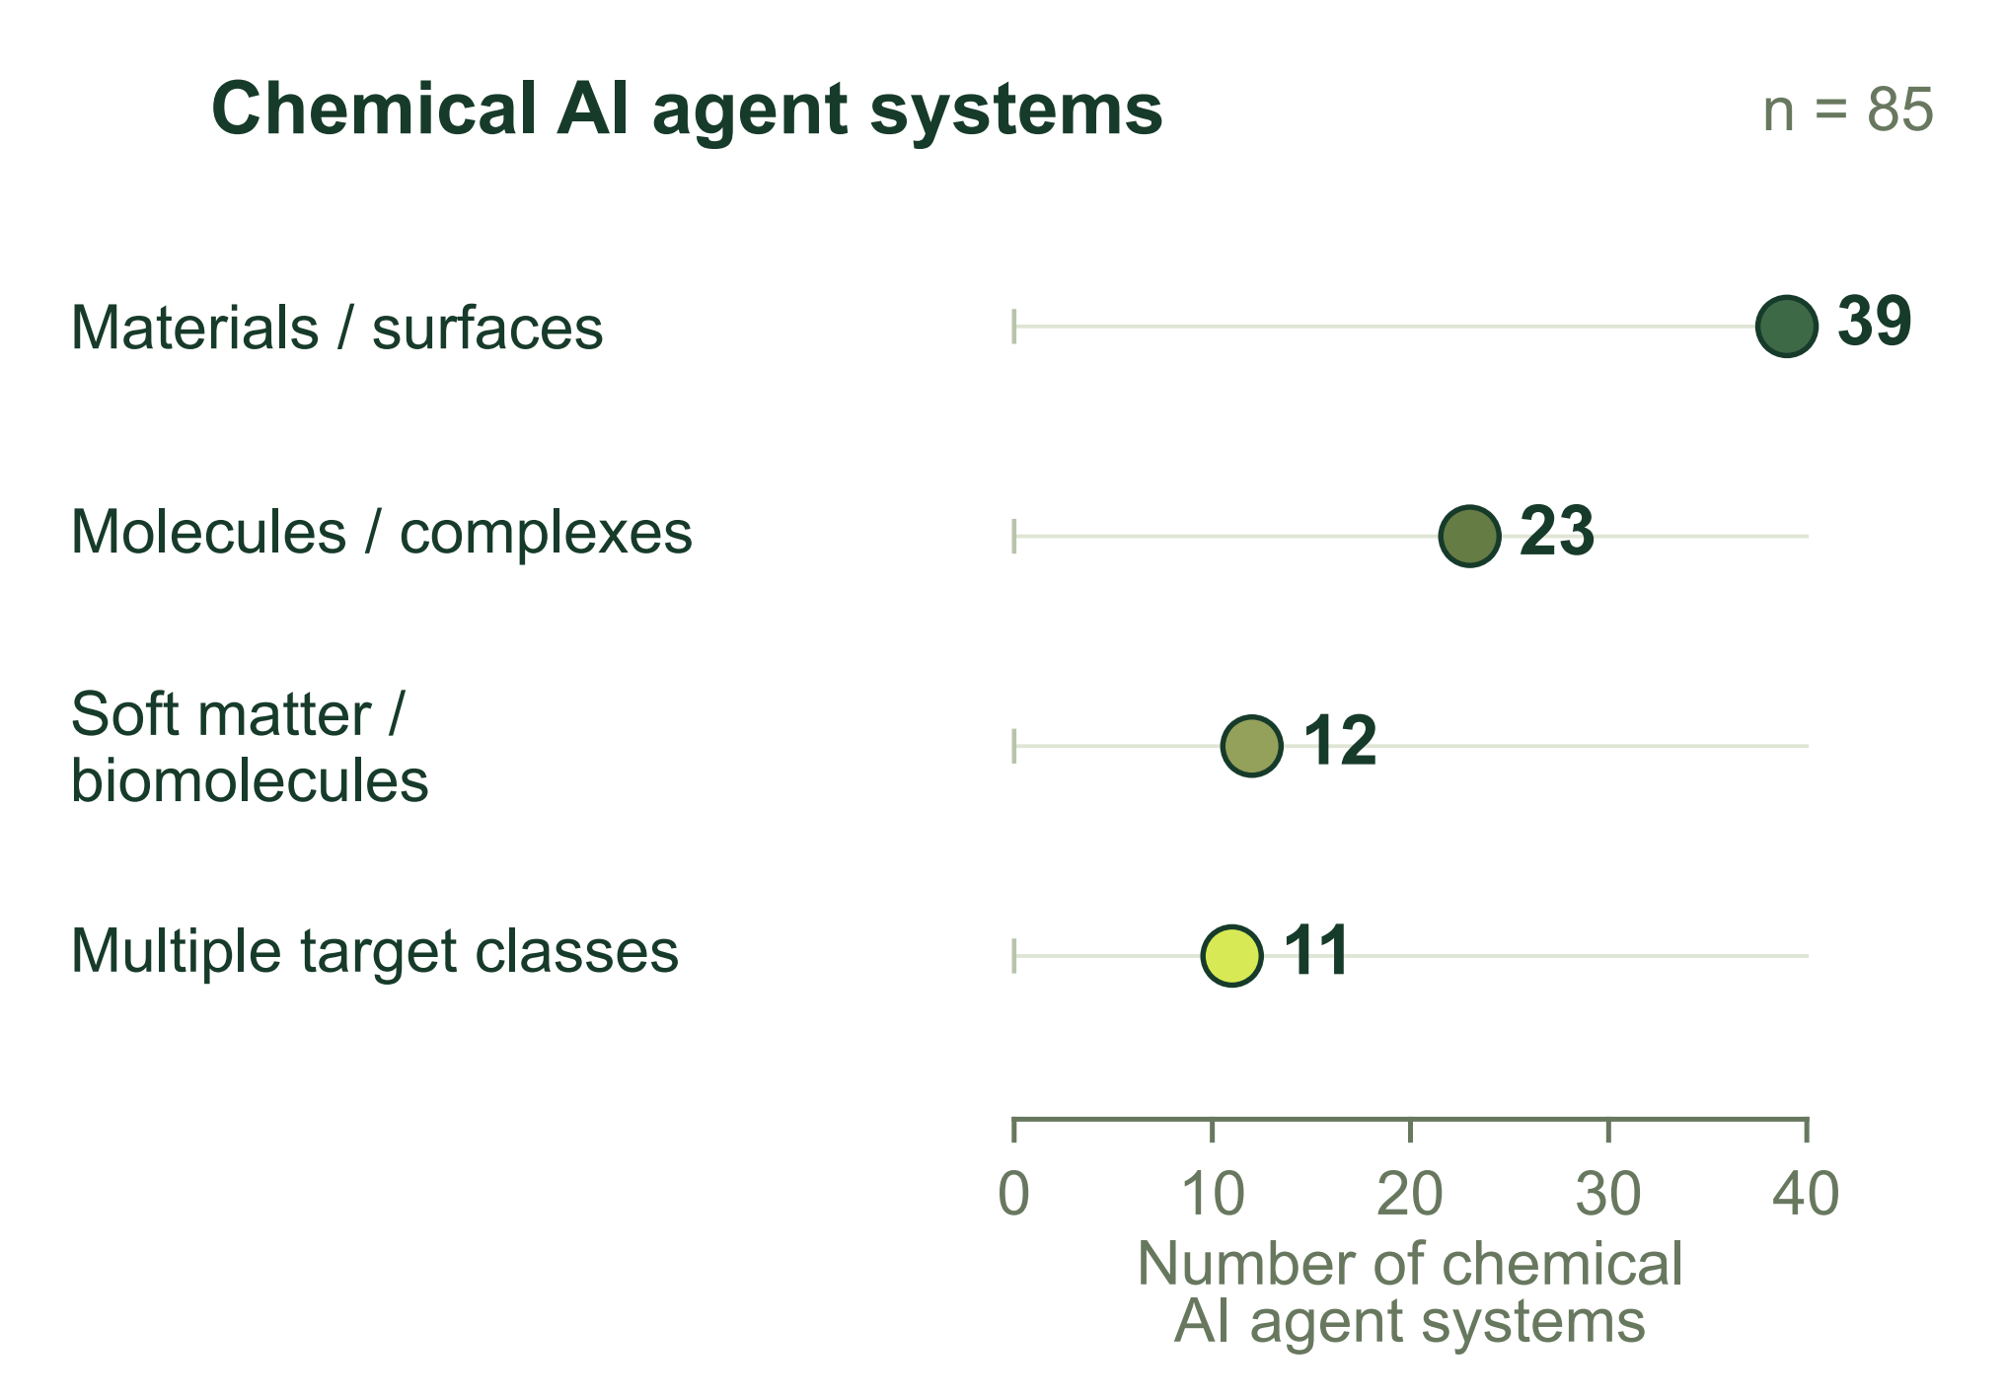
Figure 1. Physical targets in a structured literature sample of 85 chemical AI agent systems: 39 materials/surface, 23 finite-molecule/complex, 12 soft-matter/biomolecular, and 11 cross-class systems.
For scientific delivery, Cloudra establishes a directed acyclic graph of mechanistic evidence centered on chemical entities (the Delivery DAG). This differs fundamentally from conventional pipelines of task calls: nodes in Cloudra's delivery graph represent ground-state chemical species in the reaction mechanism, while edges represent elementary reaction steps for which verification of a first-order saddle point (with exactly one valid imaginary frequency) and bidirectional IRC paths has been completed. Every advance in a scientific claim must be directly bound to genuine underlying quantum-chemical calculation logs, while the Supervisor gate reviews the state of the delivery graph against scientific contracts to ensure that errors in programmatic judgments are not overlooked. Even if the large language model declares the exploration complete during interaction, a step lacking complete frequency or pathway support remains unconfirmed, suppressing false mechanistic deliverables.
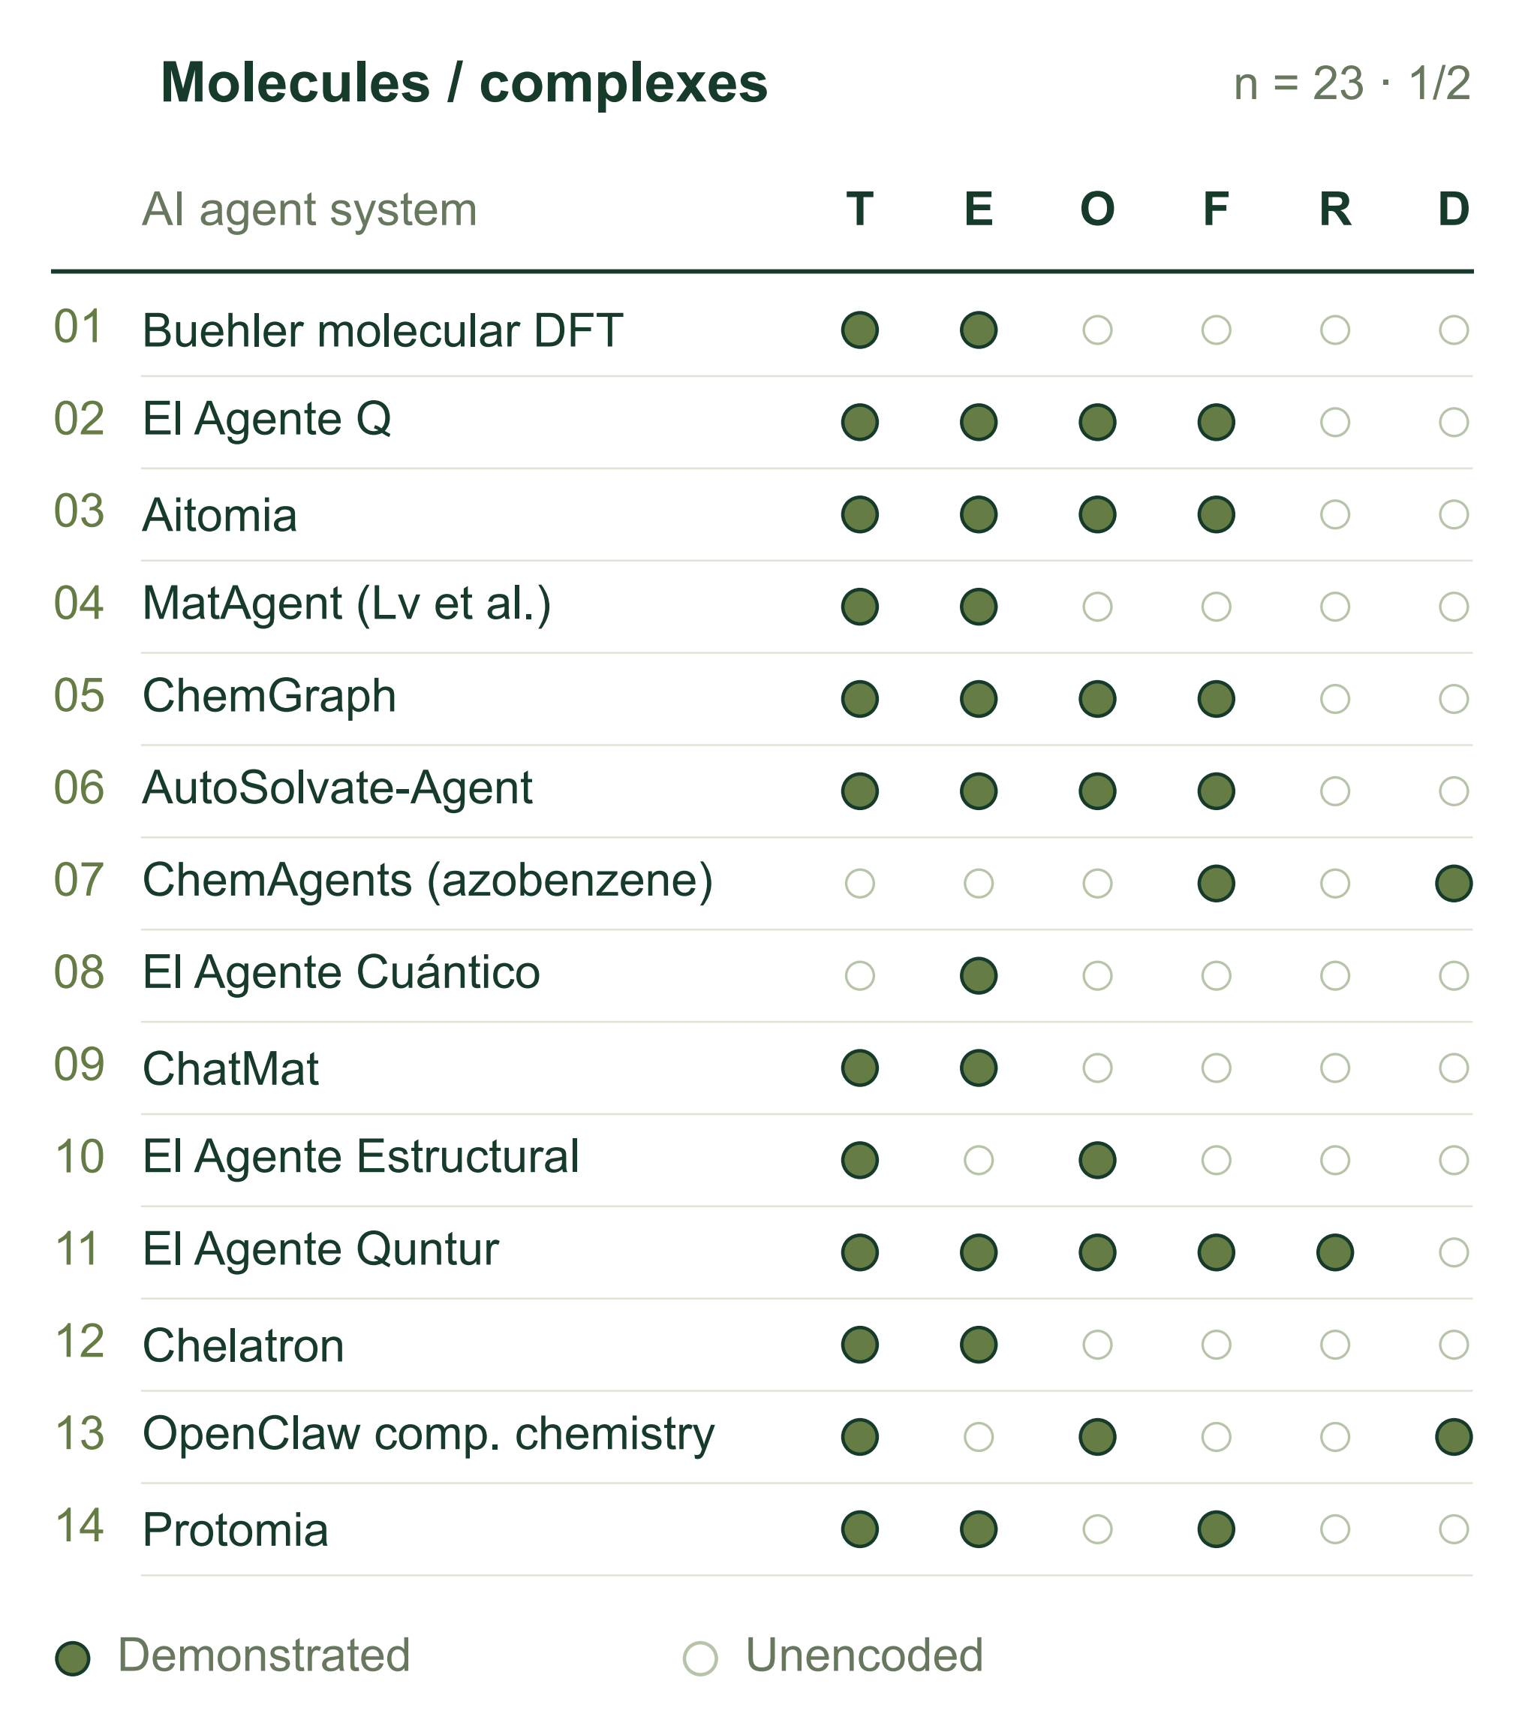
Figure 2. Documented tasks in the finite-molecule/complex class (panel 1 of 2; 23 chemical AI agent systems in total). T: structure construction/editing; E: static energy/properties; O: geometry optimization; F: vibrations/thermochemistry; R: explicit pathways/TS; D: molecular/quantum dynamics. Filled cells denote positive evidence; blanks are unencoded, not absent capabilities.
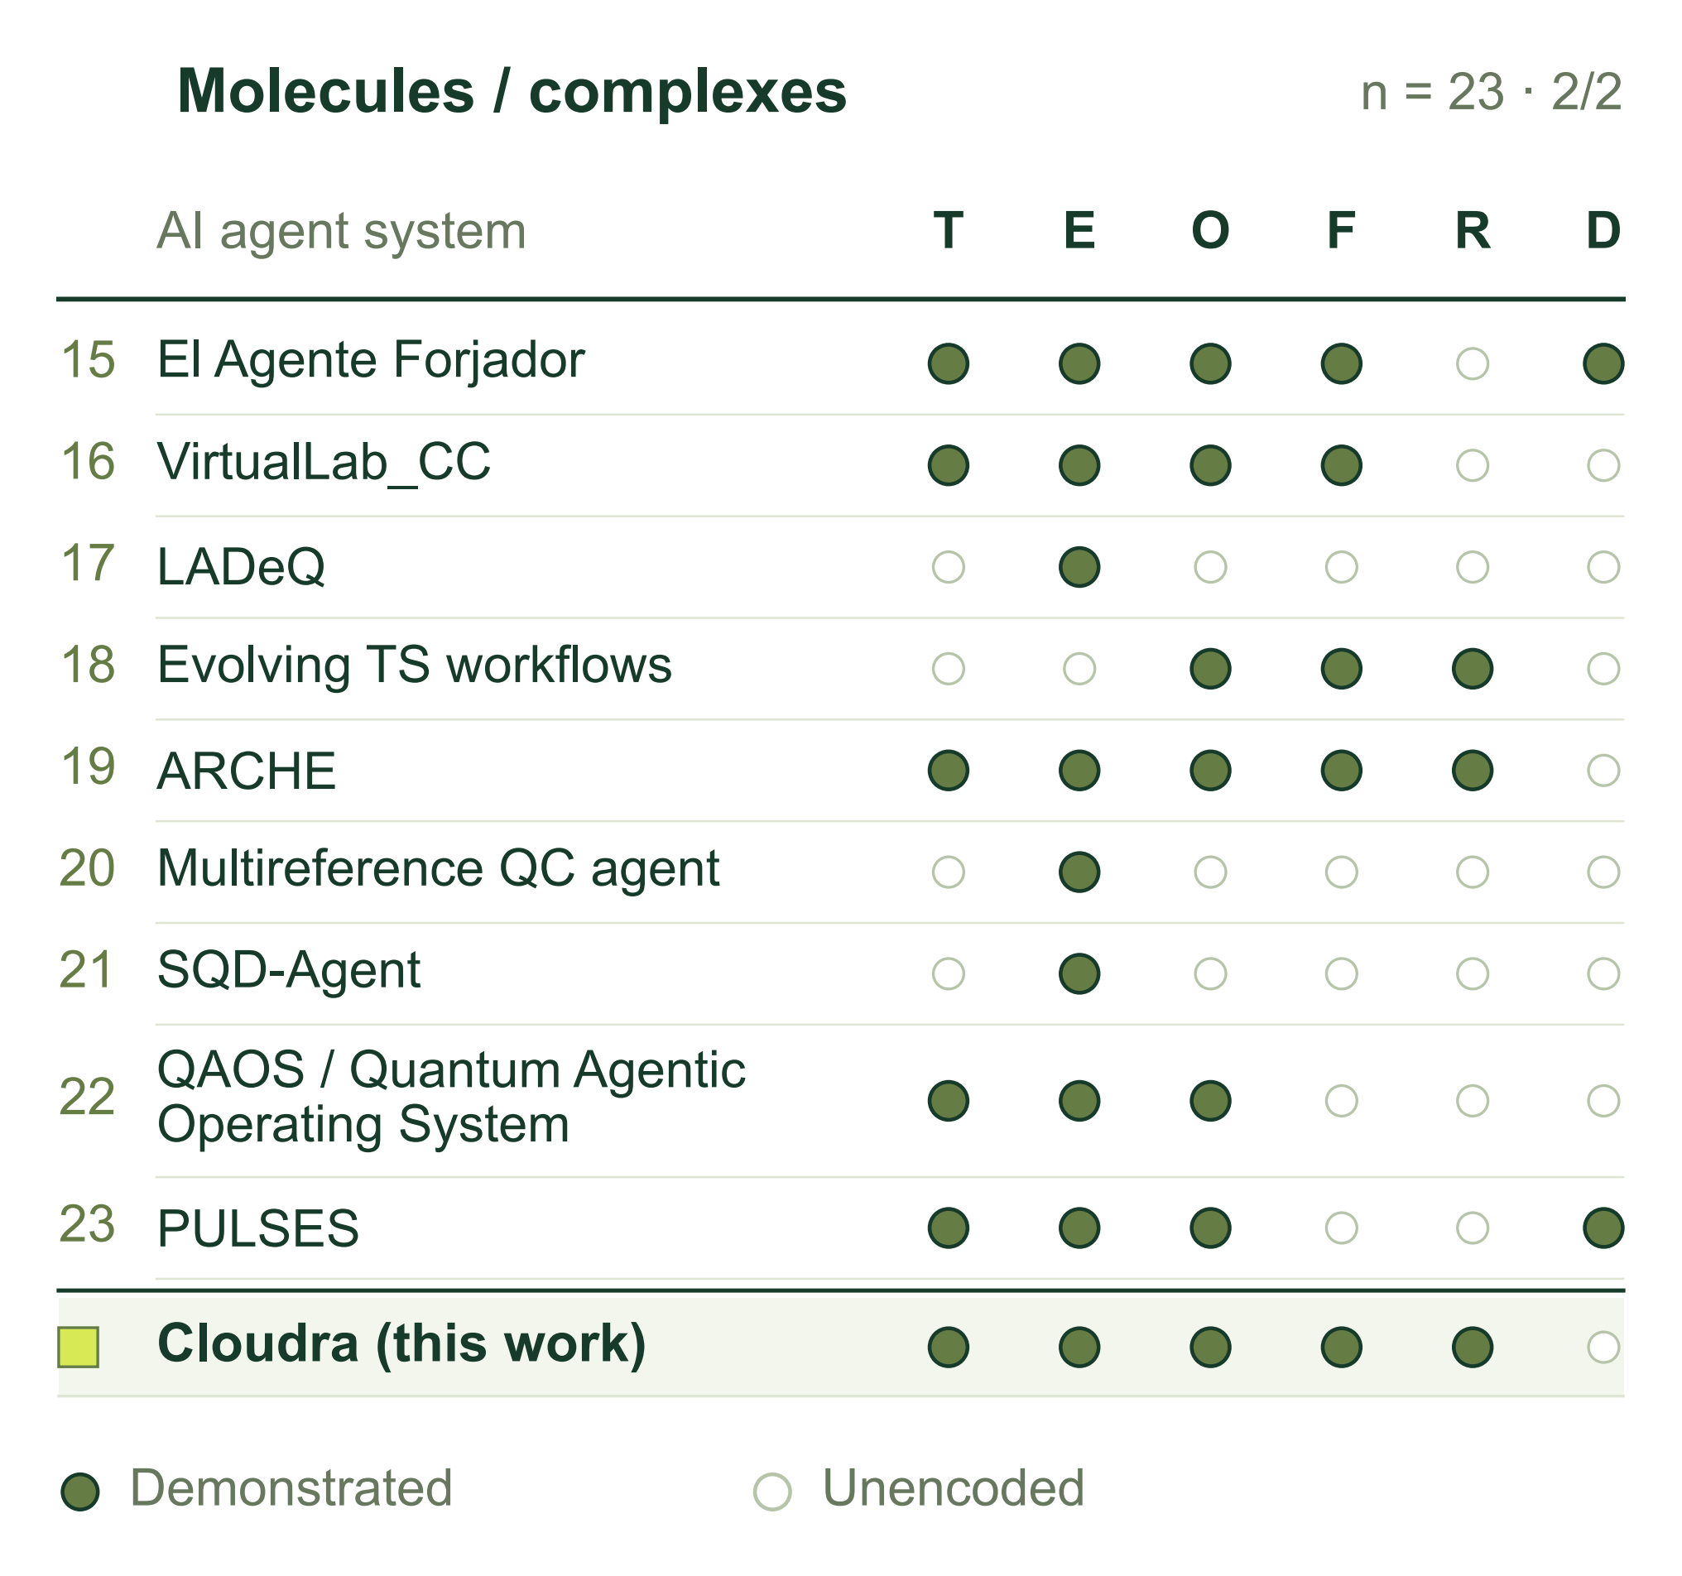
Figure 3. Chemical AI agent systems in the finite-molecule/complex class, continued (panel 2 of 2), using the codes in Figure 2. Cloudra (this work) is benchmarked at the bottom. Complete matrices for all 85 chemical AI agent systems and source-level qualifications accompany the draft.

1.3 Core Contributions
Cloudra introduces a mechanism delivery graph (Delivery DAG) in which chemical species and elementary reactions are the entities and physicochemical laws serve as validation gates. By assigning authority over evidence to the underlying quantum-chemical products rather than the large language model's natural-language descriptions, the system constrains model behavior to suppress false completion and scientific hallucinations during long-range scientific reasoning.
To address the widespread bottlenecks of human intervention and spatial hallucinations in molecular geometric reasoning, this work establishes the methodological paradigm of “intelligent restraint.” Geometric operations, including maximum common-subgraph topological mapping, steric graph traversal, and transition-state fragment assembly, are implemented as underlying deterministic operators. This allows large language models to focus on formulating higher-level chemical hypotheses, selecting among competing pathways, and identifying the causes of failure, achieving end-to-end autonomous localization of transition states for complex organic reactions.
This work develops CloudraBench to evaluate graph coverage, physical self-consistency, and quantitative barrier accuracy from native computational outputs. Its 50 chemical tasks cover elementary and multistep processes, stereochemistry, and the applicability limits of the allowed methods. Evaluation combines 48 independent runs with three repeats on four tasks and a full-benchmark, four-configuration experiment comprising 200 independent ablation sandboxes, examining repeatability and coverage across tasks, respectively.

2 System Design and Methods

2.1 System Overview and Division of Responsibilities
Cloudra takes reactant identities, reaction conditions, target species or mechanistic questions, and computational requirements as inputs. It represents candidate elementary steps in a delivery evidence graph, generates molecular configurations, submits quantum chemical calculations, and associates returned structures, energies, frequencies, and paths with the corresponding species or steps. The graph stores proposed and verified chemical objects together with unresolved calculation requirements.


Figure 4. Cloudra multi-agent system architecture: coupling mechanistic hypothesis generation (Coordinator), deterministic geometric manipulation (Operators), asynchronous computational execution (ComputeDB), and physical evidence validation gates.

The multi-agent system divides responsibilities by functional role. The Coordinator formulates mechanistic hypotheses, proposes candidate elementary reaction steps, and maintains exploration branches. Computational agents execute assigned reaction steps, invoking geometric operators to assemble three-dimensional coordinates and scheduling quantum chemical calculations. When an assigned step encounters geometric divergence, saddle-point nonconvergence, or pathway bifurcation, the computational agent assesses whether the step remains viable; if the current step appears obstructed, it feeds diagnostic information back to the Coordinator to adjust the hypothesis or switch branches. The Supervisor independently audits the delivery graph against task specifications, maintaining review notes separately from parsed computational facts.

2.1.1 Asynchronous Computation Scheduling and Resource Management
The computational execution harness is governed by a central calculation ledger (ComputeDB), which enforces state management across the lifecycle of each job. Dedicated capacity pools partition execution across local execution threads, remote SSH clusters, and Slurm supercomputing queues, enforcing hardware concurrency quotas to prevent queue overflow. Prior to dispatch, the scheduler computes an immutable SHA-256 content digest from Cartesian coordinates, electronic spin and charge, and level of theory; identical active or cached jobs are reused to achieve deduplication. Process liveness and execution concurrency are tracked via operating-system file exclusive locks (flock), avoiding termination of background quantum-chemistry jobs holding active locks during monitor exceptions. Computational agents interact with the scheduler via event-driven notifications: upon calculation termination, the harness dispatches completion events, allowing agents to read artifacts asynchronously without polling loops.

2.2 Molecular Representations and Geometric Operators
A molecular input consists of an attributed graph $H=(A,B)$ and Cartesian coordinates $X∈ℝ^{n×3}$. Here $A$ is the atom set, $B$ is the bond set, and each row of $X$ gives one atom position. Atom and bond attributes encode chemical identity; coordinate operators update $X$ and return measured changes. Operators that replace atoms or functional groups also update $H$.

2.2.1 Atom Correspondence and Reaction Centers
Atom attributes retain element, isotope, formal charge, hydrogen count, radical-electron count, and declared stereochemistry; bond attributes retain order and stereochemical labels. Components lacking three-dimensional coordinates are embedded using ETKDGv3 [12,13], then assembled if necessary. Existing coordinates are retained. Complete, unique atom-map labels on both endpoints define the correspondence directly and must agree in element and isotope. Otherwise, let $A_{P}$ and $A_{R}$ be the product and reactant heavy-atom sets. Candidate bijections $π:A_{P}→A_{R}$ satisfy $z_{i}^{P}=z_{π(i)}^{R}$ and $ι_{i}^{P}=ι_{π(i)}^{R}$, where $z$ is atomic number and $ι$ is isotope label. Each candidate is scored by
$\begin{aligned}J(π)=2(N_{f}+N_{b})+N_{o} \\ +4Δ_{H}+8Δ_{q}+8Δ_{r}+2N_{s}.\end{aligned}$ (2.1)
Let $B_{P}^{π}$ denote product bonds expressed in reactant atom indices. Bond formation and cleavage are the set differences $B_{P}^{π}⧵B_{R}$ and $B_{R}⧵B_{P}^{π}$, with cardinalities $N_{f}$ and $N_{b}$. The count $N_{o}$ includes pairs in $B_{P}^{π}∩B_{R}$ whose bond orders differ. For $a∈\{H,q,r\}$, the mismatch is $Δ_{a}=\sum_{i∈A_{P}}{|}a_{i}^{P}−a_{π(i)}^{R}|$, where $H$, $q$, and $r$ are the atom hydrogen count, formal charge, and radical-electron count. $N_{s}$ counts stereochemical mismatches. Exactly one declared tetrahedral label contributes one mismatch, increasing $J$ by 2. When both corresponding atoms carry tetrahedral labels, the comparison requires four corresponding neighbors, including a single hydrogen where applicable; it corrects for neighbor-order parity before comparing the labels. Noncomparable two-sided tetrahedral environments contribute no mismatch.
For element–isotope classes of sizes $n_{g}$, the search space contains $N_{Π}=\prod_{g}{n_{g}}!$ bijections. All are enumerated when $N_{Π}≤{10}^{5}$. Above this limit, MCS seeds use element matching, unrestricted bond-order matching, ring-to-ring matching, and complete rings [13]. The MCS timeout is 10 s, and each endpoint contributes at most 64 substructure matches. Unmatched atoms are paired within element–isotope classes after sorting by hydrogen count, degree, and input index. The search then merges candidates having identical bond-edit facts and score, keeping the lexicographically smallest mapping for each group. Representatives are sorted by score and then atom-map sequence; the first 16 form the heavy-atom candidate set $C$. For nonempty $C$, define optimal score $J_{\text{min}}={\text{min}}_{π∈C}J(π)$ and tolerance set $𝒩=\{π∈C:J(π)≤J_{\text{min}}+2\}$. An unlabeled mapping is reported as unique when $|𝒩|=1$, ambiguous when $|𝒩|>1$, and inconclusive when $C=∅$.
The retained heavy-atom candidates are combined with compatible bindings to both concrete endpoint graphs and expanded to all-atom correspondences. Compatible explicit hydrogen labels are preserved first; remaining local hydrogens are paired by isotope on corresponding heavy atoms. For unmatched isotope groups of sizes $h_{g}$, the remaining $N_{H}=\prod_{g}{h_{g}}!$ permutations are enumerated when $N_{H}<257$. An expansion with $N_{H}≥257$ yields an inconclusive result unless compatible explicit hydrogen labels resolve the permutation space. Complete maps are deduplicated, ranked by score and atom-map sequence, and evaluated with the same +2 ambiguity criterion. The selected all-atom bijection reorders the product into reactant atom order. Formed and broken bonds define the reaction-center coordinate pairs used to monitor subsequent path interpolation, while bond-order modifications are recorded alongside the transformed graph.

2.2.2 Structural Measurements and Rigid Body Operations
Structural perception converts coordinates into bond lengths, bond angles, dihedral angles, ring conformations, and close contacts. For coordinates $x_{i}$, the interatomic distance is $d_{ij}=‖x_{j}−x_{i}‖$; the bond angle at vertex $j$ is obtained from the normalized dot product of the two bond vectors. Comparisons of distances with reference bond lengths and van der Waals contact scales provide geometric diagnostics, while the molecular graph retains the established identity. Connectivity is perceived at entry for coordinate-only inputs; subsequent local coordinate transformations retain this graph and remeasure anomalies before and after transformation.
Default fragment selection on either side of an acyclic bond uses graph connectivity: the specified bond $a−b$ is temporarily removed, and the connected component containing $b$, denoted $ℱ_{b}$, is selected. If the endpoints remain connected after bond removal, movement within a ring framework requires an explicit atom group. Let $ℱ$ denote the explicitly specified moving atom group or the component $ℱ_{b}$ obtained by bond removal. To rotate the selected fragment about an axis, Rodrigues' formula is applied to every $i∈ℱ$:
$\begin{aligned}x_{i}^{′}=a+R(\hat{u},θ)(x_{i}−a), \\ R=\text{cos}θI+(1−\text{cos}θ)\hat{u}{\hat{u}}^{T} \\ +\text{sin}θ[\hat{u}]_{×}.\end{aligned}$ (2.2)
Here, $a$ is a point on the axis, $\hat{u}$ its unit direction, $θ$ the rotation angle, $I$ the identity matrix, and $\left[\hat{u}]_{×}v=\hat{u}×v\right.$. Coordinates outside the selected set are unchanged. Stretching bond $a−b$ translates $ℱ_{b}$ as a whole:
$\begin{aligned}x_{i}^{′}=x_{i}+(L−d_{ab})\frac{x_{b}−x_{a}}{d_{ab}}, \\ i∈ℱ_{b}.\end{aligned}$ (2.3)
Here $L$ is the target bond length; coordinates outside $ℱ_{b}$ remain fixed. Chirality inversion rotates two separable branches around their center to exchange branch directions. Group substitution removes the specified-side fragment, docks the new group along the original attachment-bond direction, and updates the graph. To compare structures before and after optimization, the system differences distance-perceived connectivity sets under the same element sequence and classifies gained or lost contacts as intra- or interfragment changes.

2.2.3 Branch Crowding and Reactant Preorganization
For candidate axes that pass checks of hybridization, ring structure, and substituent graph inequivalence, the system uses a decaying branch descriptor to provide local steric crowding information:
$\begin{aligned}B_{s}=\sum_{k∈T_{s}}{c_{k}}r_{k}ρ^{ℓ_{k}}, \\ ρ=0.5,0≤ℓ_{k}≤5.\end{aligned}$ (2.4)
Here $r_{k}$ represents the van der Waals radius of atom $k$. $T_{s}$ is generated by a last-in-first-out depth-first traversal starting from the substituent root at depth zero, with the adjacent axis-end atom marked visited. On popping an unvisited atom, the algorithm records its traversal depth $ℓ_{k}$ and pushes its unvisited neighbors if $ℓ_{k}<5$. The weighting coefficient is $c_{k}=1.5$ for a root of graph degree at least 3, and $c_{k}=1$ otherwise.
The descriptor uses standard van der Waals radii in Å: H 1.20, B 1.92, C 1.70, N 1.55, O 1.52, F 1.47, P 1.80, S 1.80, Cl 1.75, Br 1.85, and I 1.98 (1.70 fallback for unlisted elements). The rounded branch values are summed across all four substituents on the axis; a cumulative score $B_{s}≥9.0$ flags the axis as congested for subsequent conformational inspection.
During multicomponent preorganization, the primary fragment is fixed at the origin. Remaining fragments undergo orientation sampling on the unit sphere. With $K$ samples, direction $s$ is
$\begin{aligned}{\hat{u}}_{s}=(a_{s}\text{cos}sγ,y_{s},a_{s}\text{sin}sγ), \\ a_{s}=\sqrt{1−y_{s}^{2}},y_{s}=1−\frac{2s}{K−1}, \\ γ=π(3−\sqrt{5}).\end{aligned}$ (2.5)
Here $γ=π(3−\sqrt{5})≈2.3999\text{ rad}$ (${137.5}^{∘}$) represents the Golden Angle, generating a Fibonacci spherical spiral grid for uniform distribution of directions. The axial twist about ${\hat{u}}_{s}$ is $2πs/K$ (default $K=32$). Translation along the interfragment vector resolves steric overlap. For a set $W$ of guided atom pairs with target distance windows $\left[l_{ij} , u_{ij}\right]$, placement $X$ is scored by
$\begin{aligned}S(X)={\text{max}}_{(i,j)∈W} \\ \{0,l_{ij}−d_{ij}(X),d_{ij}(X)−u_{ij}\}.\end{aligned}$ (2.6)
Candidate configurations with low $S(X)$ are deployed as seeds for distance-restrained MMFF94 force-field optimization, guiding fragments toward target interaction intervals while relaxing nonbonded contacts. Qualified candidates must simultaneously satisfy force-field convergence, distance compliance, stereochemical retention, and fragment contact connectivity $d_{i^{*}j^{*}}≤1.7(r_{i^{*}}+r_{j^{*}})$. Qualified candidates are ranked by unconstrained single-point energy and clustered with a heavy-atom Kabsch RMSD threshold of 0.5 Å to yield preorganization seeds.

2.2.4 Endpoint Alignment and IDPP Interpolation
After all-atom correspondence is established, each endpoint is centered. Let $P$ and $R$ be the centered product and reactant coordinate matrices. Kabsch alignment solves
$\begin{aligned}{\text{min}}_{Q^{T}Q=I,\text{det}Q=1}‖PQ−R‖_{F}^{2}, \\ P^{T}R=UΣV^{T}, \\ Q=U\text{diag}[1,1,\text{det}(UV^{T})]V^{T}.\end{aligned}$ (2.7)
The resulting matrix $Q$ is the proper rigid-body rotation matrix. The determinant correction factor $\text{det}(UV^{T})$ enforces $\text{det}Q=+1$, ruling out improper reflections and preserving chiral configuration.
For $M$ images including endpoints, define $λ_{k}=k/(M−1)$ and initialize $X_{k}=(1−λ_{k})R+λ_{k}PQ$. The image-dependent pair potential (IDPP) method [8] interpolates in internal pair-distance space ($d_{ij,k}^{*}=(1−λ_{k})d_{ij}^{R}+λ_{k}d_{ij}^{P}$), defining its potential objective as
$\begin{aligned}d_{ij,k}^{*}=(1−λ_{k})d_{ij}^{R}+λ_{k}d_{ij}^{P}, \\ V_{k}=\sum_{i<j}{\frac{{\left(d_{ij,k}−d_{ij,k}^{*}\right)}^{2}}{d_{ij,k}^{4}}}.\end{aligned}$ (2.8)
The inverse-fourth-power weighting $d_{ij,k}^{−4}$ imparts stiffness to short covalent bonds, prioritizing the preservation of basic covalent distances while allowing long-range nonbonded contacts to relax. Standard mode couples intermediate images with improved-tangent nudged elastic band (NEB) springs and optimizes with MDMin, evaluating convergence by the maximum force residual across movable atoms. Lightweight mode evaluates target distances with an objective denominator $\text{max}(d_{ij,k}^{*},0.1\text{Å})^{4}$ and relaxes intermediate images independently using Adam optimization.
Active monitoring pairs $W$ incorporate bond-state changes, pairs bonded at both endpoints with $|Δd|≥0.15$ Å, and the five atom pairs exhibiting the largest endpoint distance variations. Within the monitoring set $W$, the primary reaction coordinate is selected by $p^{*}∈{\text{argmax}}_{p∈W}|d_{p}^{P}−d_{p}^{R}|$, setting $m=(d_{p^{*}}^{R}+d_{p^{*}}^{P})/2$. The initial transition-state guess is extracted from the first image $k$ satisfying $(d_{p^{*},k}−m)(d_{p^{*}}^{R}−m)≤0$, or the image minimizing $\left|d_{p^{*},k} − m\right|$. The selected configuration serves as the initial seed for saddle-point optimization.

2.3 Evidence Graph and Scientific Validation

2.3.1 Species Occurrences and Evidence Requirements
The delivery evidence graph is $G=(V,E)$, where vertices $v∈V$ represent chemical species occurrences and directed edges $e=(v_{i},v_{j})∈E$ represent elementary reaction steps. A mapping $κ:V→𝒮$ maps each occurrence to its canonical chemical identity, allowing cyclical pathways to represent regenerated catalyst occurrences as distinct topological nodes sharing the same chemical identity. Stationary-point geometries, frequencies, and absolute energies attach to species nodes; transition-state geometries, imaginary vibration vectors, and reaction paths attach to elementary-step edges.
Each graph element carries a declarative stage requirement set $K$. Standard elementary steps require the sequence $K=\{\text{ts_opt},\text{frequency},\text{short_irc}\}$, supplemented by thermochemical corrections when mandated by the task rubric. Calculation outputs are archived as content-digested immutable records. Parsed facts take the form $f=(c,o,r,d)$, where $c$ is the check item, $o∈\{+,−,?\}$ denotes support, contradiction, or uncertainty, $r$ is the artifact provenance reference, and $d$ encapsulates quantitative metrics.
For tasks declaring explicit property checks $R$ and optional checks $O$, the scientific evidence acceptance criterion over target-associated facts $F_{t}$ evaluates as
$\begin{aligned}S_{t}=1[R≠∅] \\ ∧⋀_{c∈R}1[∃f∈F_{t}:f.c=c,f.o=+] \\ ∧1[∄f∈F_{t}:f.c∈R∪O,f.o=−].\end{aligned}$ (2.9)
When $R≠∅$, any missing required fact or active contradiction in $R∪O$ invalidates $S_{t}$. When $R=∅$, fact-level evaluation is omitted, delegating verification to the stage-chain requirements.

2.3.2 Curvature and Reaction Mode Diagnostics
Stationary-point curvature is evaluated from the mass-weighted Hessian:
$\begin{aligned}H_{mw}=M^{−1/2}∇_{x}^{2}UM^{−1/2}, \\ H_{mw}v_{k}=λ_{k}v_{k}.\end{aligned}$ (2.10)
In the vibrational subspace orthogonal to translational and rotational degrees of freedom, negative eigenvalues $λ_{k}<0$ correspond to imaginary harmonic frequencies $ν_{k}<0$. The number of imaginary frequencies is $n_{imag}=\sum_{k}{1}[ν_{k}<0]$. Ground-state reaction intermediates require $n_{imag}=0$, whereas transition states require strictly $n_{imag}=1$.
Provenance verification confirms that the geometry evaluated by vibrational frequency analysis matches the optimized stationary point. For coordinate matrices $X$ and $Y$ centered at the origin, the geometry match requires
$δ_{π}(X,Y)={\text{max}}_{i}‖Y_{π(i)}Q_{π}−X_{i}‖≤3×{10}^{−6}\text{ Å},$
evaluated across element-conserving permutation mappings $π$ and optimal Kabsch rotations $Q_{π}$.
For a first-order saddle point with imaginary normal-mode displacement vector $u$, the mode-alignment diagnostic measures projected motion along the monitored reaction-center pairs $W$:
$η=\frac{{\text{max}}_{(i,j)∈W}‖u_{i}−u_{j}‖}{{\text{max}}_{i<j}‖u_{i}−u_{j}‖}.$ (2.11)
The diagnostic $η∈[0,1]$ evaluates whether the imaginary normal mode aligns primarily with the monitored reaction coordinates, identifying spectator motions such as methyl wagging or solvent libration prior to path integration.

2.3.3 IRC Direction and Endpoint Consistency
Intrinsic reaction coordinate (IRC) trajectories evolve from the saddle point along the steepest-descent path in mass-weighted coordinates $q=M^{1/2}x$ [9,10]:
$\begin{aligned}\frac{dq_{±}}{ds}=−\frac{∇_{q}U}{\left\|∇_{q}U\right\|}, \\ q_{init,±}≈q_{TS}±ϵv_{−}.\end{aligned}$ (2.12)
Cloudra validates that the IRC path originates at the verified saddle point and extracts the terminal frame in each integration direction. For complete-minimum pathways, dual-direction continuity is established by taking each terminal IRC frame, performing unconstrained geometry optimization, and verifying that the resulting stationary point has zero imaginary frequencies ($n_{imag}=0$) and matches the declared chemical identity of the corresponding endpoint species in molecular topology and stereochemistry (enforced via canonical isomeric SMILES equality).
For elementary steps yielding dissociated molecular components, each dissociated product must independently converge to a verified minimum. Directional alignment is validated through the reactant-side distance interval predicate. Over the monitored pair set $W$, let $q_{TS}$, $q_{E}$, and $q_{R}$ denote distance vectors at the transition state, terminal IRC frame, and reactant reference. With covalent cutoffs $c_{ij}=1.25(r_{i}+r_{j})$ and tolerance $τ=0.10$ Å, define $W_{c}=\{(i,j)∈W:d_{ij}^{R}≤c_{ij}\}$ and interval
$\left[a_{p},b_{p}]=[\text{min}(d_{p}^{TS},d_{p}^{R})−τ,\text{max}(d_{p}^{TS},d_{p}^{R})+τ\right].$
The Boolean predicate $is_between$ is satisfied when ${\left\|q_{E}−q_{R}‖_{2}<‖q_{TS}−q_{R}\right\|}_{2}$ and $a_{p}≤d_{p}^{E}≤b_{p}$ for all $p∈W_{c}$. Dissociated product pathways require satisfaction of $is_between$ alongside verified component minima to certify reaction continuity.

2.3.4 Evidence Aggregation and Energies
For elementary step $e$, let $K_{e}$ denote the set of mandatory scientific stages. The stage verification predicate $P_{e,k}=1$ indicates that stage $k$ possesses bound computational evidence satisfying its physical acceptance criteria ($P_{e,k}=0$ otherwise). Stage-chain completion is defined by
$A_{e}=⋀_{k∈K_{e}}P_{e,k}.$ (2.13)
When explicit property checks $R$ are declared, full step qualification requires the conjunction $A_{e}∧S_{e}$. Stage states are tracked through explicit dispositions (supported, pending, skipped, or rejected), distinguishing documented exemptions or limitations from completed calculation artifacts.
The electronic activation barrier is computed directly from verified stationary-point energies:
$ΔE_{e}^{‡}=E_{TS,e}−E_{ref,e}.$ (2.14)
Energies share a consistent quantum chemical level of theory. For thermochemical profiles, zero-point energy, enthalpy, and Gibbs free-energy corrections are evaluated from harmonic partition functions under declared temperature and pressure specifications.

2.4 Diagnostics and Recovery
The harness categorizes computational setbacks into execution errors, numerical nonconvergence, and physical evidence defects. Execution errors encompass input syntax, environmental faults, or parsing anomalies. Numerical status tracks self-consistent field (SCF) and geometry optimization convergence. Physical evidence defects identify curvature violations ($n_{imag}≠1$), imaginary-mode misalignment ($η<η_{thresh}$), unverified IRC endpoints, or chemical graph discrepancies.
Let $T$ denote the set of declared target species and elementary steps. Extending $P_{e,k}$ across all targets $t∈T$, the outstanding scientific evidence requirements form the unsatisfied contract set:
$U=\{(t,k):t∈T,k∈K_{t},P_{t,k}=0\}.$ (2.15)
The set $U$ records the agent's outstanding targets. Structured diagnostic feedback maps non-zero entries in $U$ to underlying SCF nonconvergence, normal-mode misalignment, broken IRC lineages, or chemical graph discrepancies. When a calculation fails, the harness preserves historical artifacts and updates $U$, providing the agent with geometric and calculation status details for adjustment.
Recovery preserves historical attempts and raw calculation outputs while rescheduling dependent stages. Atom index reordering, evidence binding, and graph status updates are handled by the harness, allowing the model to focus on modifying chemical constraints, adjusting dihedral angles, or selecting alternative electronic-structure approximations.

2.5 Implementation Defaults
The implementation described here corresponds to Cloudra revision 70daa5a. Preorganization uses 32 rigid orientations, up to 8 guided placements, minimum interfragment separation 1.0 Å, fragment-contact multiplier 1.7, and heavy-atom RMSD clustering threshold 0.5 Å. MMFF94 relaxation uses up to 2000 iterations per phase with a distance restraint force constant of 100.0. Standard IDPP employs 10 images optimized via MDMin (100 steps, force tolerance $f_{\text{max}}=0.1$, NEB spring constant $k=0.1$); lightweight IDPP uses Adam optimization (4000 steps, step size 0.02, gradient tolerance ${10}^{−7}$). Path convergence criteria evaluate the maximum force residual on intermediate path images.

2.6 CloudraBench construction and experimental design

2.6.1 Task coverage and tier rationale

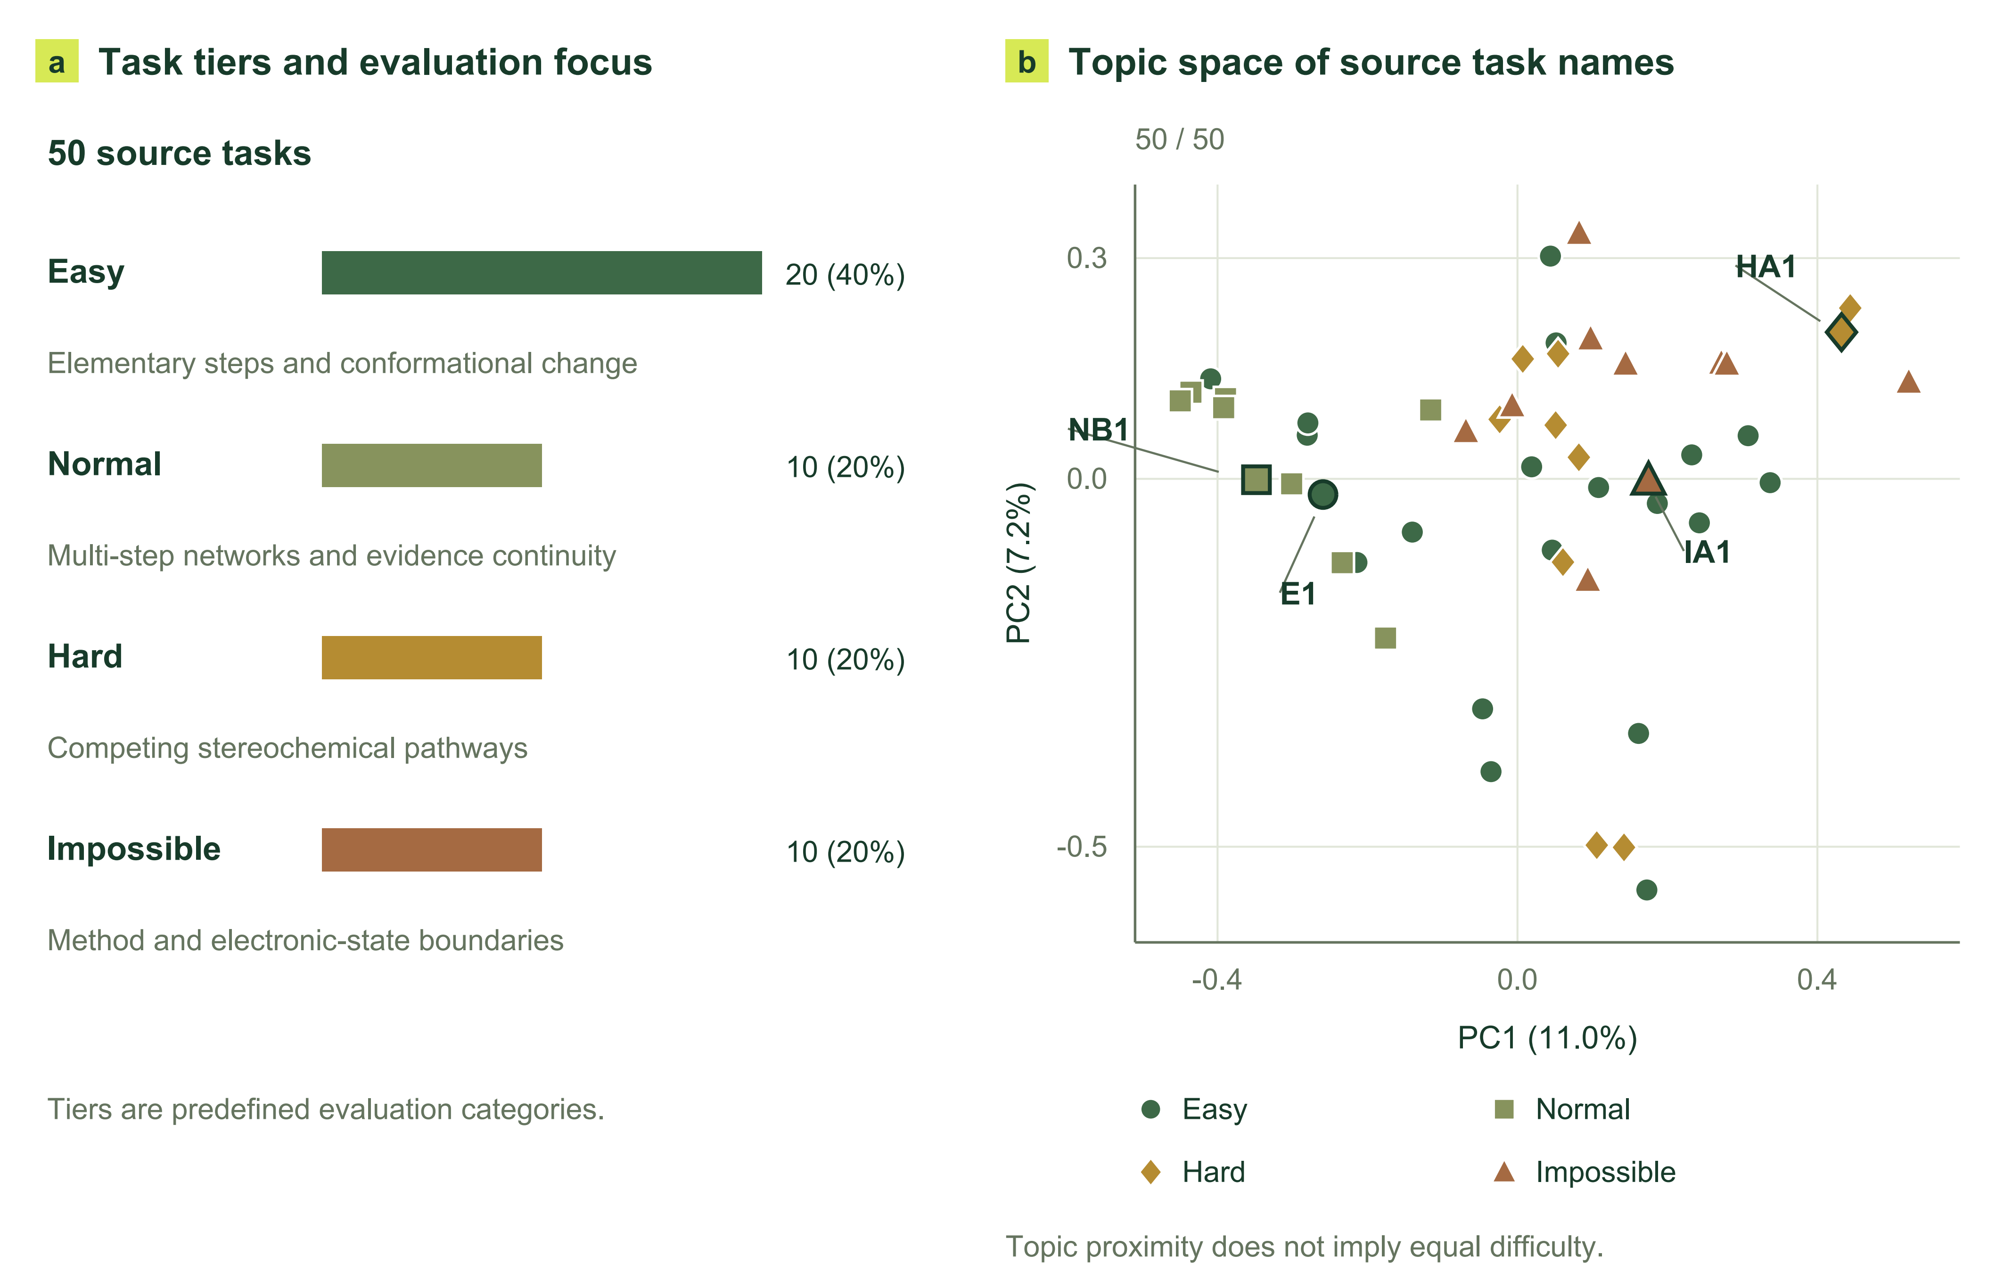
Figure 5. CloudraBench task composition and research themes. (a) Counts and evaluation focus of the four task tiers. (b) Two-dimensional PCA of BAAI/bge-m3 embeddings of all 50 original task names. E1, NB1, HA1, and IA1 are the four tasks used in the repeated-run experiment. Colors and marker shapes encode the predefined task tiers. The projection illustrates thematic relationships within the task bank; tiers are defined by research requirements, and semantic distance does not establish computational difficulty.

CloudraBench contains 50 tasks: 20 Easy tasks examine elementary transformations, conformational changes, and basic execution reliability; 10 Normal tasks examine intermediate identification and multistep continuity; 10 Hard tasks examine competing pathways and stereochemical identity; and 10 Impossible tasks examine the limits of the allowed methods and justified negative conclusions (Figure 5). The larger Easy set broadens basic chemical coverage, while each of the other categories retains a distinct test. Chemical families and research requirements intersect, so related reactions can span tiers through different pathway, configuration, or electronic-state requirements. Selection considers both discriminative value and computational tractability, using literature support and reference calculations rather than assigning difficulty from reaction names alone. An accompanying task catalogue records the name, input conditions, and allowed methods for every task.

2.6.2 Reference answers and evaluation protocol
Each task fixes the chemical conditions, charge, spin, deliverables, and allowed methods. Easy, Normal, and Hard tasks permit xTB, PM7, and B3LYP-D3(BJ)/def2-SVP; Impossible tasks are restricted to xTB and PM7. Computational evidence is read from native ORCA or Gaussian logs. Reference answers specify species, elementary steps, stereochemical identities, and applicable numerical or negative targets. Numerical barriers are electronic energy differences at a consistent level of theory; stable-minimum references and actual IRC connectivity are verified separately. For accessible reaction steps requiring verification, TS frequencies, bidirectional IRCs, outer-frame provenance, and endpoint optimization/frequency calculations form the evidence chain. Species-property and electronic-state questions are checked against their specified targets.
Graph structure, self-consistency, and accuracy are evaluated separately and combined with weights of 0.1, 0.3, and 0.6. Scientific acceptance and delivery completeness are reported separately. Offline organization recovers information already present in a run, recording human intervention and field provenance without adding research conclusions from Gold. Correct recognition of a method limitation does not require an invented barrier. Reference-evidence completeness, special treatment, and unresolved qualifications are documented per task; the presence of a reference graph and complete scientific acceptance are assessed separately.

2.6.3 Repeated-task experiment and full-benchmark ablation
The two experiments compare four experimental branches: Guided, Record, Standard, and Brief-errors. In these experimental settings, Guided retains explicit evidence organization, scientific checks, and detailed diagnostics; Record removes mandatory acceptance; Standard additionally removes explicit DAG tools and neutralizes scientific feedback; and Brief-errors compresses diagnostic information. The repeated-task experiment uses E1, NB1, HA1, and IA1 with three independent runs per task and configuration, yielding 48 runs to examine repeatability and research trajectories. The full-benchmark experiment uses one independent sandbox per task and configuration across all 50 tasks, yielding 200 sandboxes to examine coverage across tasks. Comparisons use common task statements, method restrictions, and offline organization rules; run versions, budgets, and stopping reasons are archived with the data.

3 Results and Discussion
This chapter first presents the overall outcomes of 48 independent repeated runs and 200 full-benchmark ablation sandboxes. It then draws questions from research trajectories and uses paired local comparisons and internal-state interventions to examine the origins of performance differences.

3.1 End-to-end benchmark evaluation
End-to-end evaluation combines a repeated four-task study with a full-task four-configuration experiment, examining repeatability and coverage across tasks, respectively. We present these evaluations first and then use specific research trajectories to examine the origins of configuration differences.

3.1.1 The 48-run experiment with three repeats on four tasks
The repeated-task study compares four configurations on E1, NB1, HA1, and IA1 with three independent runs per combination, yielding 48 runs. The tasks concern elimination-reaction preorganization, multistep decarboxylation, stereochemical ring opening, and electronic-structure method limits. Runs used DeepSeek-v4-flash, with conversations, tool calls, calculation ledgers, and native quantum-chemical outputs archived. Repeats test whether a configuration difference depends on a single exploration trajectory, while retaining the sequence from the initial hypothesis to final delivery.

3.1.2 The 200-sandbox four-configuration ablation across all 50 tasks
The full-benchmark experiment places each of the 50 tasks in all four configurations, with one independent sandbox per task–configuration combination, yielding 200 sandboxes. It examines whether configuration differences extend across chemical families and research requirements, complementing the stability information from the repeated-task experiment.

3.1.3 Overall patterns and mechanistic analysis
The overall results show differences among the configurations. Guided achieves the strongest overall performance, whereas Standard is weaker particularly on Impossible and other tasks. On Easy tasks, the other configurations perform similarly. We next use research trajectories to examine how these differences relate to geometry operations, evidence organization, and decisions to end a study.

The following analysis draws specific problems from archived research trajectories and uses Qwen3.8:27b for local paired diagnostics that vary molecular representation, option order, geometric information, evidence references, or reasoning mode. Original trajectories locate how problems arose; paired inputs test which information affects judgments; internal-state interventions trace the contribution of measured facts to selection. These analyses connect chemical intent to geometric operations and local calculations to scientific evidence.

3.2 From chemical intent to reliable geometric operations

3.2.1 Molecular identity provides a persistent reference for operations


Figure 6. Molecular-identity judgments under changes in molecular representation and option order. Each of the 16 molecular pairs has four input conditions. Circles and diamonds indicate correct and incorrect judgments, respectively; the letters retain the model's actual answers. Shaded regions denote identical-string conditions. The right panel shows the two C₅H₈ connectivities in pair 14 and the meanings of the answer options.

A geometric modification first requires identifying the molecule, atoms, and reaction center to which it applies. A molecule can be represented by different SMILES traversals, while a molecular formula can describe different connectivities. To examine how the model handles these distinctions, we constructed 16 molecular-identity pairs covering identical identities, connectivity changes within the same molecular formula, changes in connectivity and charge location, double-bond stereochemistry, and protonation changes. Each pair was presented using the original strings or equivalent rewritings and with two answer orders, yielding 64 judgments.
The model answered 58 correctly. Equivalent rewriting changed the semantic judgment in 4 of 32 matched representation comparisons; reversing answer order changed the judgment in 6 of 32 matched option-order comparisons. All six of the latter cases involved repeated selection of the letter A. One C₅H₈ pair in Figure 6 illustrates this behavior directly: an endocyclic and an exocyclic double bond define different connectivities, yet the model answered A under all four conditions, although A meant “same” in one order and “different” in the other. This result locates representation sensitivity in judgments about the chemical objects themselves and indicates the need for stable identity references throughout a research process.
Cloudra assigns this role to molecular topology, atom mapping, and reaction centers. These references allow subsequent measurements, fragment movements, and endpoint comparisons to remain attached to the originally specified objects as the model moves between descriptions and configurations. Atom correspondence also connects product-endpoint alignment, path interpolation, and reaction-center monitoring, allowing local geometric operations to proceed with a consistent set of chemical identities.

3.2.2 Geometric measurements reduce repeated numerical reasoning
After identifying the research objects, the model must extract spatial relationships relevant to an operation from their coordinates. We selected four actual structures from the NB1 trajectories and asked the model to compare two specified interatomic distances. Each structure was presented with both answer orders and with either a complete XYZ geometry or program-measured distances. These two information conditions were further crossed with direct-answer and thinking modes, producing 32 native chat calls (Figure 7).
In direct-answer mode, all eight responses to XYZ inputs selected A, with four correct answers. Providing measured distances produced eight correct answers and preserved the semantic answer when option order was reversed. With thinking enabled, the XYZ condition produced seven correct answers; the remaining response reached the output limit of 1,024 generated tokens. Increasing the budget for that input alone yielded a correct answer within 1,353 generated tokens. All eight answers in the measured-distance condition were correct. Across the eight paired comparisons with thinking enabled, the median generated token counts were 807.5 for XYZ inputs and 86 for measured distances.

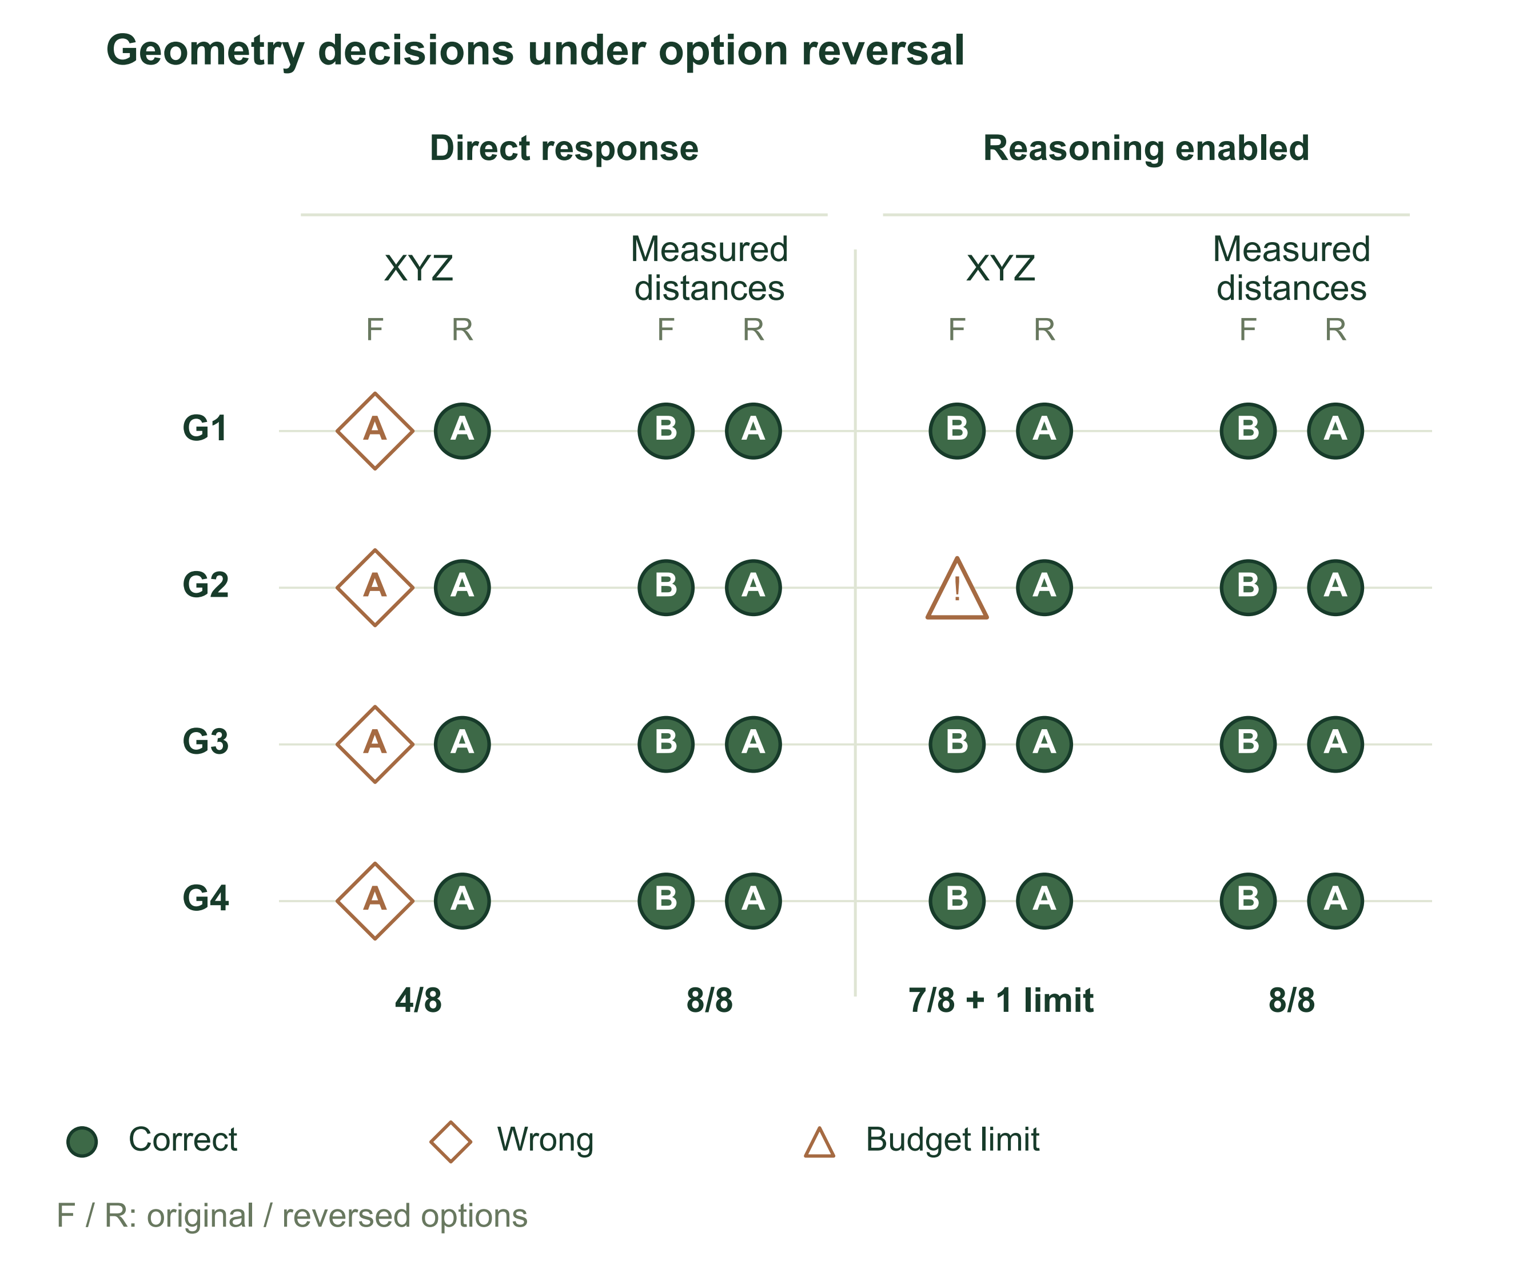  Figure 7. Geometry judgments under coordinate inputs and measured-distance inputs. Four source structures are compared under direct response and reasoning-enabled conditions, each with original (F) and reversed (R) option order. Circles indicate correct judgments, diamonds incorrect judgments, and the triangle a response that reached the output budget. Letters retain the actual answers. |  | 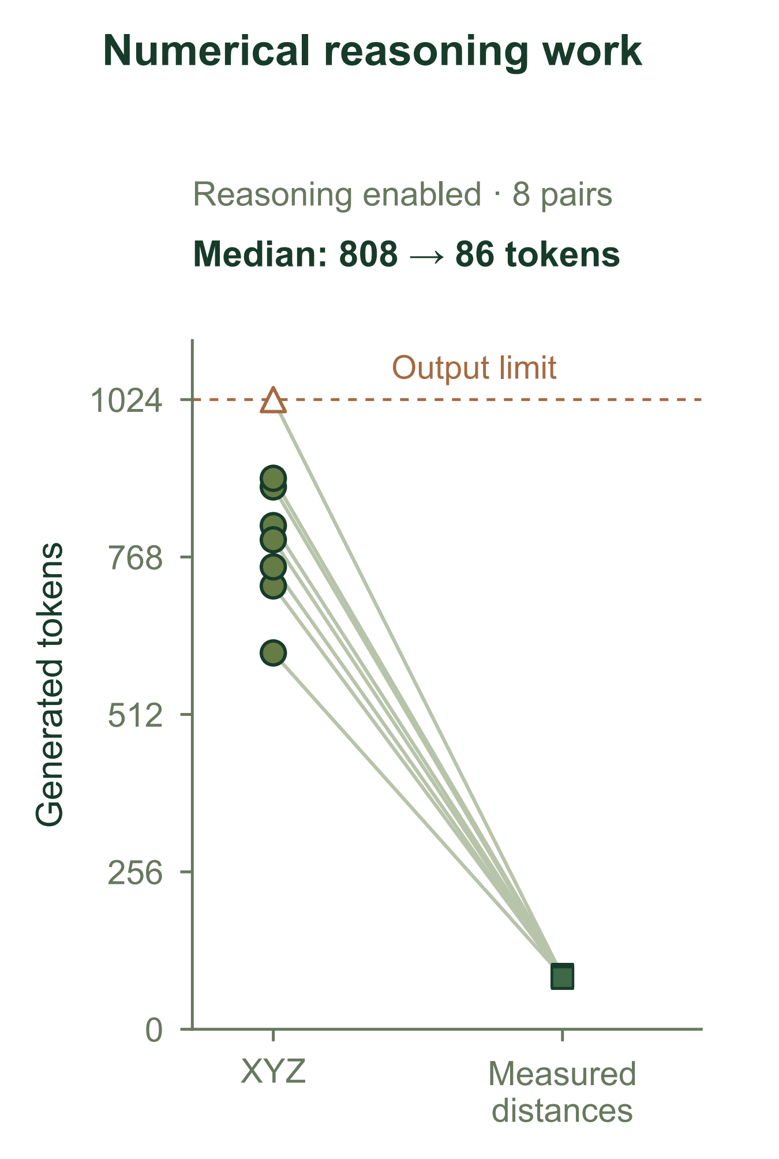  Figure 8. Generated-token counts with reasoning enabled. Each line connects Cartesian-coordinate input and measured-distance input for the same source structure and option order; eight paired comparisons are shown. The dashed line marks the output limit.

These results suggest that geometric judgment combines atom identification, numerical calculation, and relational comparison. Additional reasoning can perform these local calculations, while program measurements directly supply the relational quantities needed for the subsequent decision. Cloudra therefore allows the model to express objectives through bond lengths, bond angles, dihedral angles, and fragment relationships, and uses deterministic operators to change the coordinates. This division of work assigns repeated numerical operations to the program and makes the resulting changes directly inspectable, consistent with the allocation of responsibilities in program-aided language models.[15] Descriptions of steric crowding, reactant preorganization, and local fragment rotation build on this foundation to use spatial relationships in selecting and constructing candidate configurations.

3.2.3 Feedback must match the specified atoms and geometric objective
Deterministic execution must remain aligned with chemical intent. An actual E1 trajectory provides a complete example. The model sought to bring the dihedral angle defined by the transferring hydrogen H7, C2, C3, and leaving atom Cl4 close to 180°. It rotated the fragment on the C3 side about the C2–C3 axis by +120° and −120°, producing candidates A and B, and set the C3–Cl4 distance to 2.35 Å. The representative dihedral in the default structure report involved H5, whereas the current objective involved H7. The model then explicitly measured H7–C2–C3–Cl4 in both candidates, obtaining approximately 59.4° and 179.4°, and used candidate B in its next actual submission.
Figures 9 and 10 show Newman projections along C2→C3 drawn directly from the saved candidate coordinates. Candidate B places the H7 target angle within 0.6° of 180°, compared with a residual of 120.6° for A. The corresponding residuals for the H5 comparison were 124.2° and 115.8° in A and B, respectively. These measurements reveal the object dependence of feedback: a reading acquires its chemical meaning through its correspondence to the currently specified atoms and operational objective.

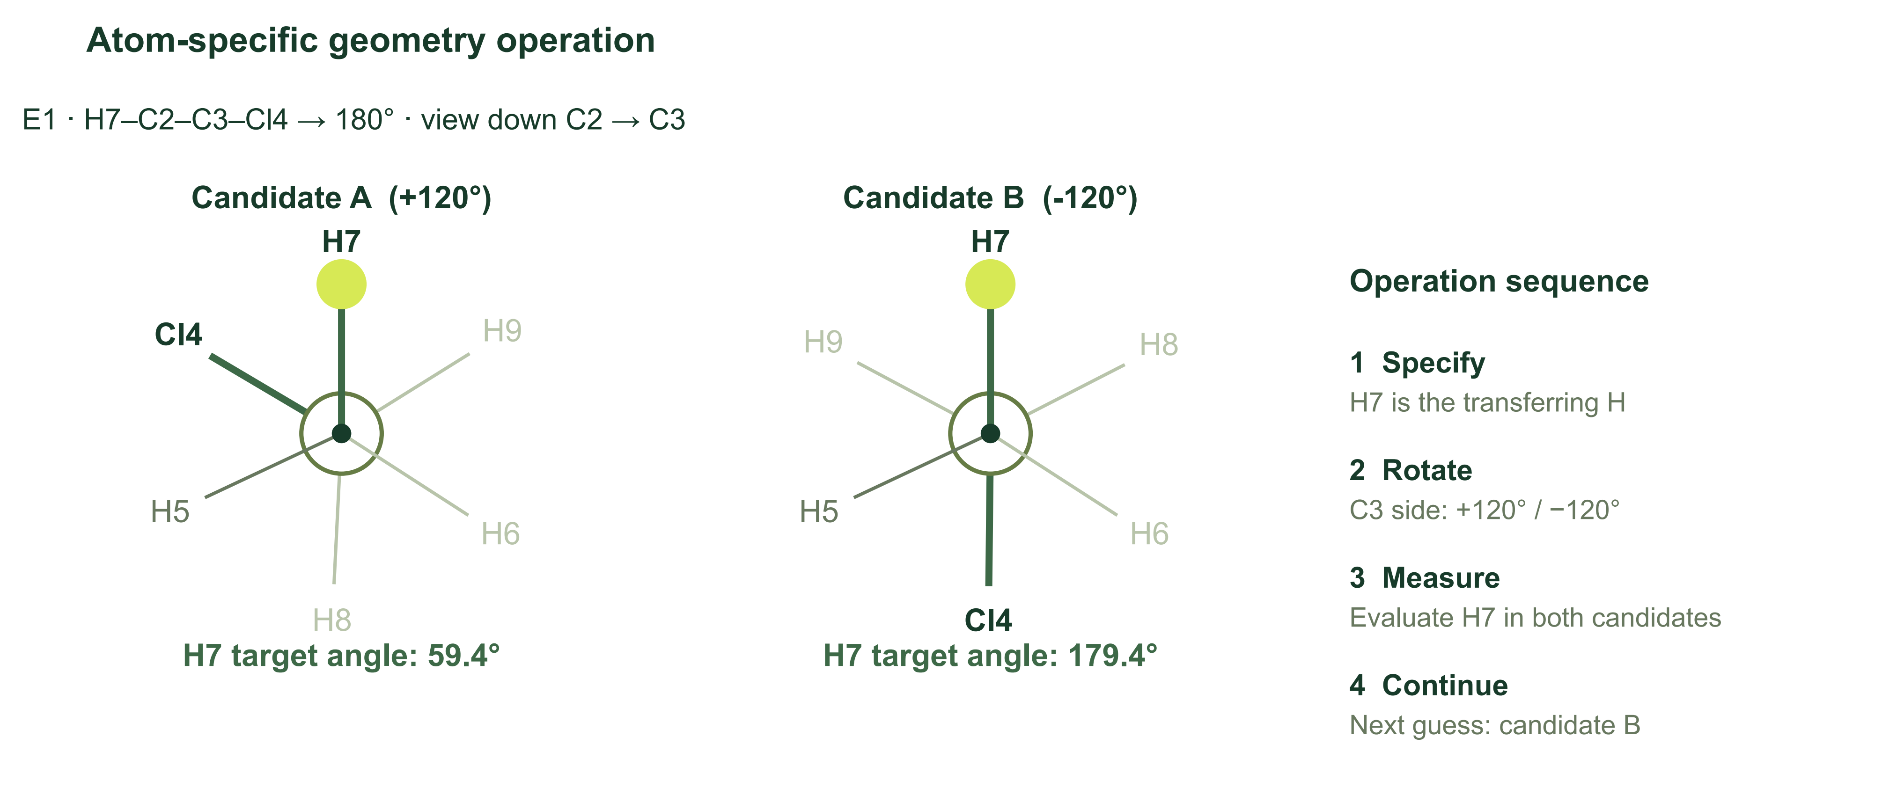
Figure 9. Target-specific geometry operations in E1. Newman projections retain the directions of the original candidate coordinates viewed down C2→C3. H7 is the specified transferring atom. Candidate A and candidate B give target angles of 59.4° and 179.4°, respectively. The operation sequence is shown alongside the projections.
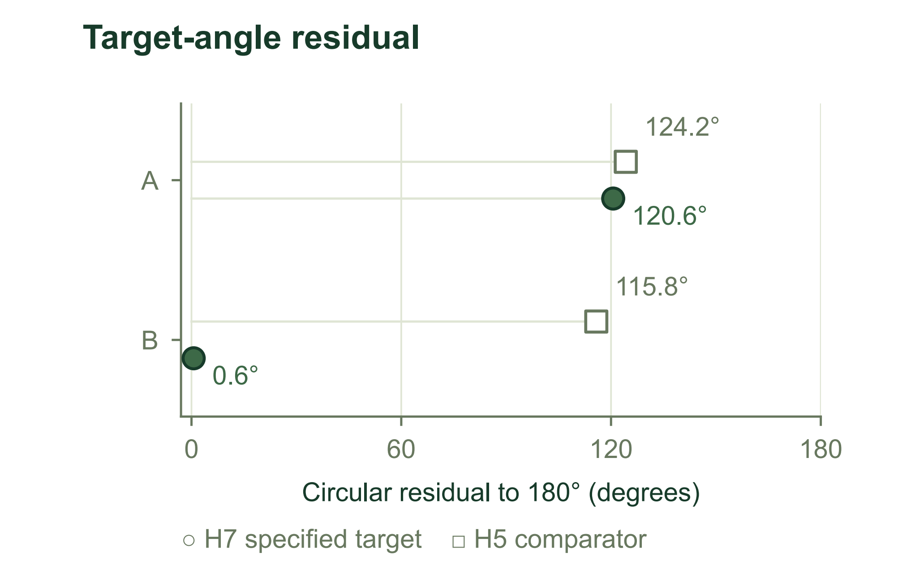  Figure 10. Circular angular residuals from the specified 180° target for candidates A and B. H7 is the specified target atom; H5 is the comparator. |  | 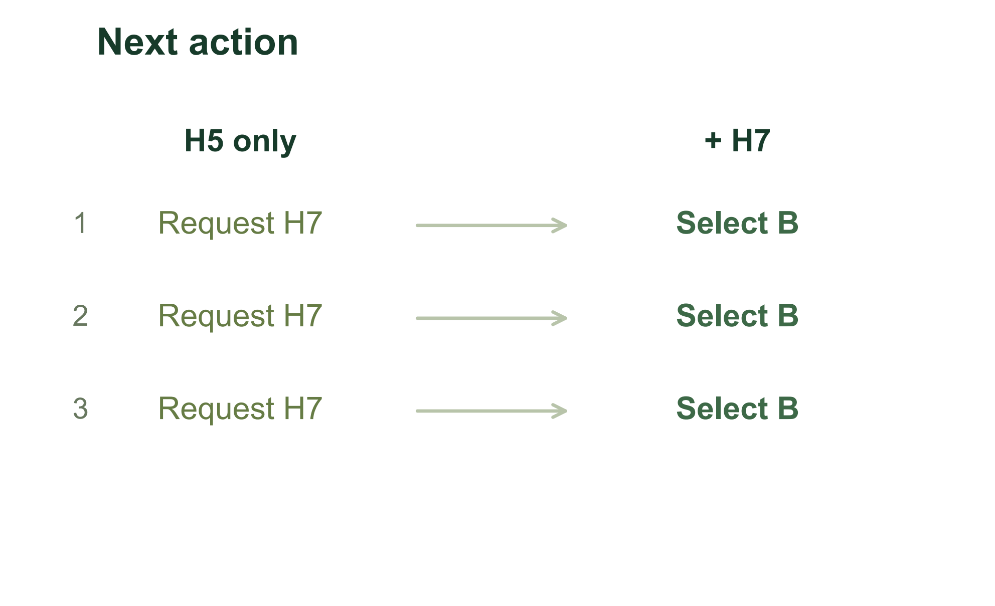  Figure 11. Next-action choices under three local option permutations. When only H5 measurements are supplied, the model requests H7 measurements; with H7 supplied, it selects candidate B.

Local comparisons using the same measurements further connect information to action. When only H5 measurements were provided, the model requested an additional H7 measurement under all three cyclic option permutations. Adding H7 measurements led it to select B under all three permutations. Two further paired tests of information sufficiency also shifted from requesting additional measurements to judging the information sufficient when the target quantity was added. Atom mapping, internal coordinates, fragment operations, and feedback can therefore be understood as one sequence of research actions: identify the target object, make the geometric change, measure the target quantity, and select the next candidate. Preorganization, rigid-body alignment, and path preparation use the same correspondence to carry reaction intent into subsequent exploration of the potential energy surface.

3.2.4 Internal transfer of measured facts affects selection
To examine how the model uses supplied measurements, we performed activation replacement at a single token position in the same local quantized model.[16] One distance in the input was changed from 2.029 Å to 1.029 Å, while the other remained at 1.248 Å, reversing the correct comparison answer. We then transferred the residual-stream state at the numeric token position from the original input into the modified input at layers 7, 15, 31, and 47, and read the full-vocabulary probability assigned to the answer supported by the original fact.

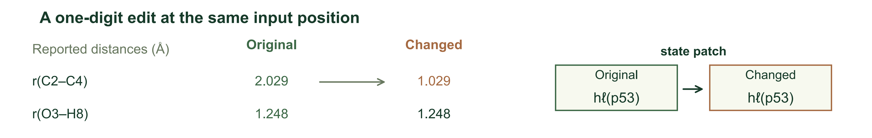
Figure 12. Intervention on a single reported distance. A one-digit edit changes the C2–C4 distance from 2.029 to 1.029 Å while O3–H8 remains 1.248 Å. The original-input residual state at token position 53 is inserted into the changed-input run at a specified layer. Token positions are zero-based.
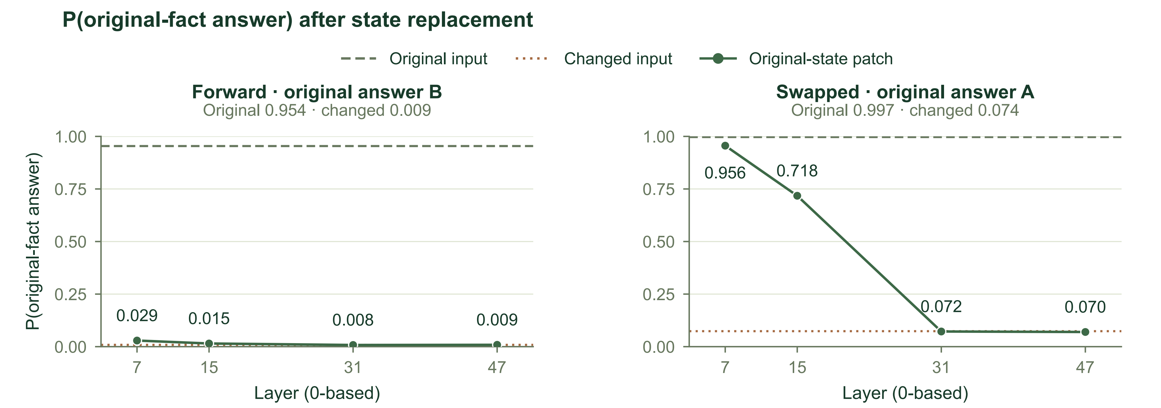
Figure 13. Original-fact answer probability after state replacement. Curves show full-vocabulary probability mass for the original-fact answer under forward (B) and swapped (A) option order, including bare and leading-space token spellings. Horizontal lines show original-input and changed-input baselines. Layer indices are zero-based.

Figure 14. Control substitutions for the state-intervention experiment. Same-state self replacement at p53 and replacement of the unchanged prefix at p0 preserve all vocabulary logits in both option orders. The table reports the maximum absolute logit difference. Token positions are zero-based.

The effect varied with layer and option order (Figure 13). With reversed options, the probability of A, the original-fact answer, increased from 0.074 for the modified input to 0.956 and 0.718 after replacement at layers 7 and 15, respectively. Replacements at layers 31 and 47 yielded 0.072 and 0.070. With the original option order, the probability of answer B changed from 0.009 to 0.029 and 0.015 after replacement at the first two tested layers, while the last two remained close to the modified-input baseline. Self-replacement controls and control replacements at an unchanged prefix position produced zero logit differences across the full vocabulary.
This internal intervention extends the analysis from supplying measurements to examining the causal mechanisms governing how measurement information shapes decisions: under reversed options, intermediate-layer state replacements dramatically flipped model predictions, demonstrating that localized numerical representations directly participate in downstream choices. Under the original option order, however, the patch produced only a minor shift, aligning closely with the behavioral positional bias identified in Section 3.2.1—when the target answer occupies the non-preferred option B, deep attention is readily captured by the shallow positional prior. This asymmetry establishes at the representation level that injecting ungrounded numerical facts into free-form text prompts is highly vulnerable to attentional attenuation and prior biases; only by coupling deterministic structural operators that explicitly bind geometric measurements, chemical entities, and operational semantics can a stable scientific decision loop be established. Cloudra's structured measurements thus serve not only as the outputs of geometric calculation, but as indispensable physical anchors for subsequent mechanistic reasoning.

3.3 From local computational results to evidence-supported scientific delivery

3.3.1 The DAG preserves scientific support relationships among results
Once geometric objects enter computation, optimized structures, energies, frequencies, and paths must be assembled into support for the same reaction step. The local validity and attribution of each result jointly determine this support chain: frequencies must correspond to the declared saddle point, the IRC must start from that saddle point, and optimizations and frequencies for the final frames on both sides must correspond to the respective endpoints. The DAG records these relationships on species and elementary steps, providing a persistent research index as results accumulate. Execution state, numerical convergence, and scientific support are recorded separately, allowing subsequent work to wait for a calculation, revise and rerun it, or continue assembling evidence.
We extracted four source evidence chains from the archive and constructed versions that preserved the links or changed a single reference. Crossing these with flat and linked representations and two answer orders yielded 32 inputs. The altered references concerned the frequency geometry, IRC starting geometry, endpoint-optimization input, or target species; local termination, convergence, energy, and frequency values were held constant. Figure 15 illustrates the E1 case: changing the frequency geometry reference from the saddle point to an existing endpoint changes how that frequency result supports the current step.
All 16 judgments with linked representations were correct, compared with 14 of 16 with flat representations. Both errors occurred when a reference had been changed and the options reversed, in E1 and the second NB1 step. In subsequent native follow-up calls on two selected source chains, enabling thinking yielded correct judgments for all 16 judgments of the evidence relationships, including the two previously incorrect cases. This result suggests that explicit links reduce the model's work in locating and assembling computational relationships, consistent with observations that graph encoding affects relational reasoning in language models.[17] In Cloudra, this representation is further bound to actual computational artifacts, allowing scientific facts to accumulate continuously for the same species, step, and attempt.

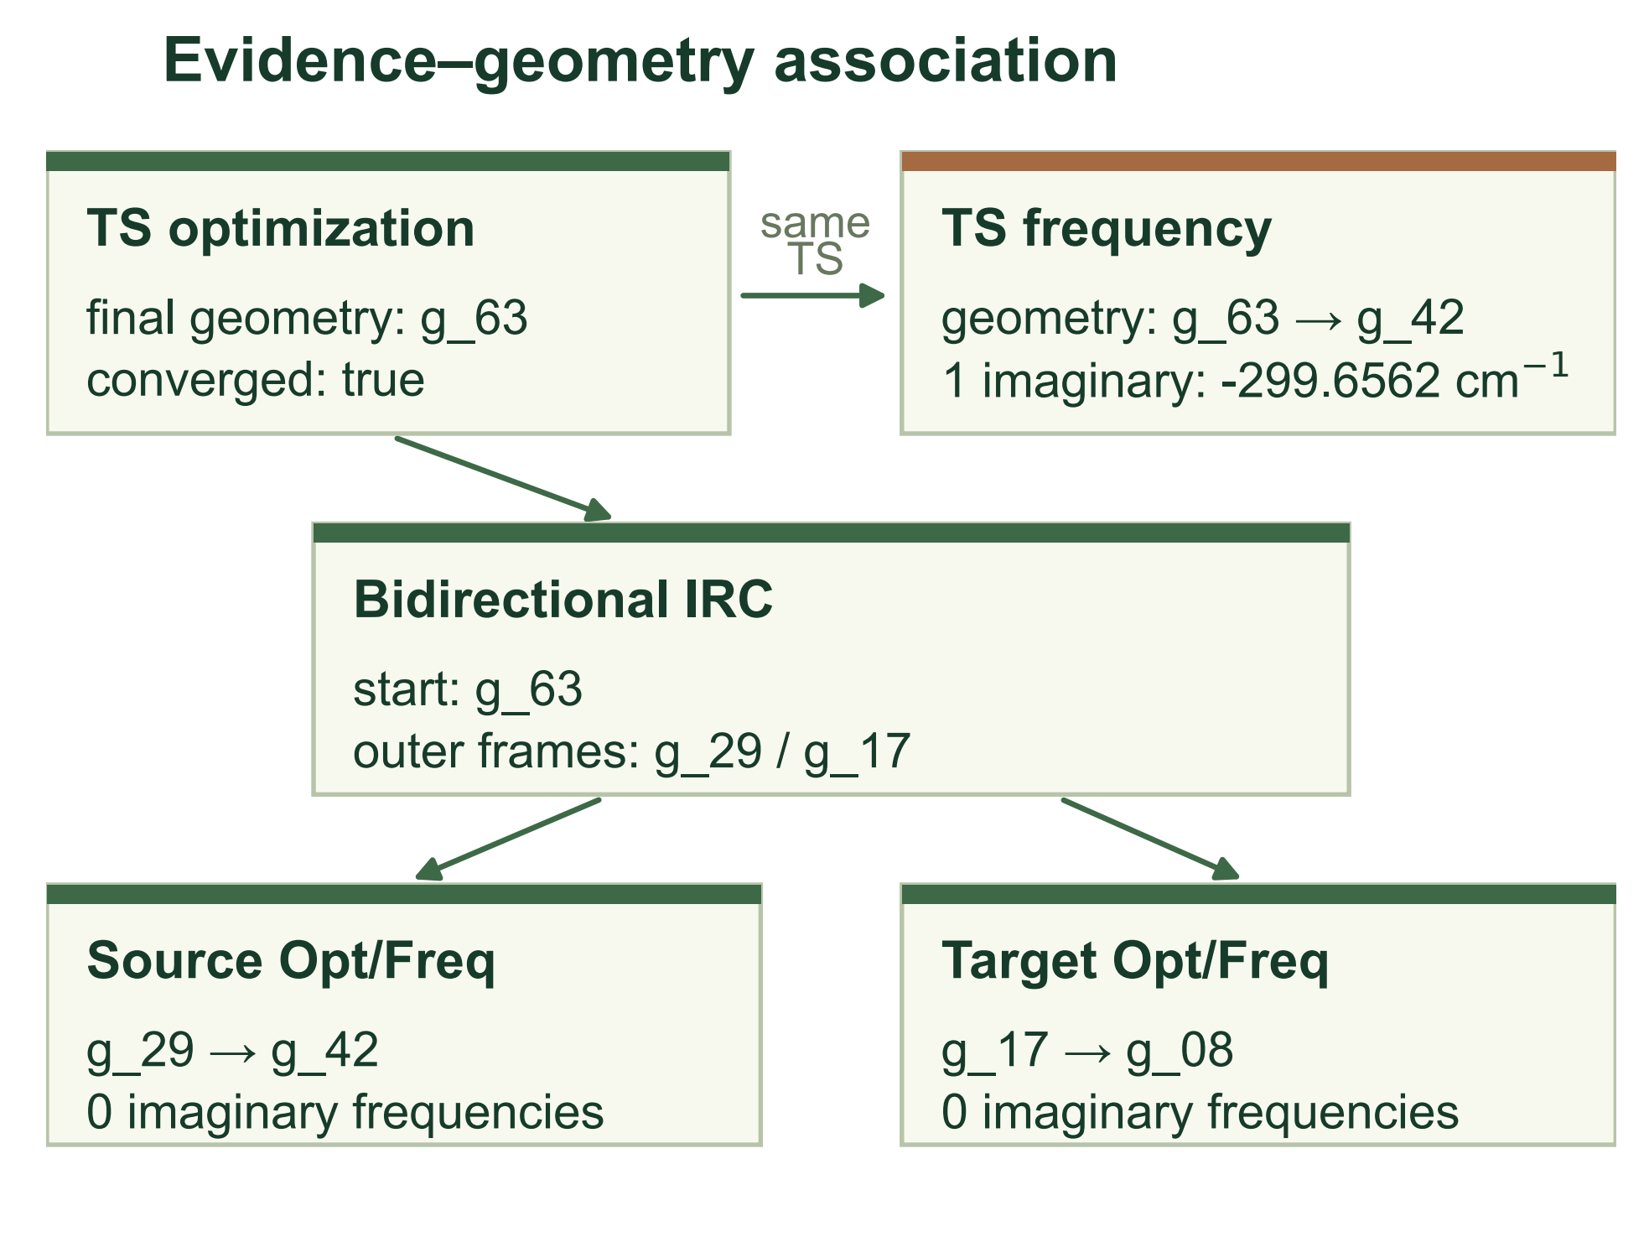  Figure 15. Evidence–geometry association in the E1 source chain. The controlled input changes the frequency geometry reference from g_63 to g_42 while retaining local termination, convergence, energy, and frequency values. The diagram preserves the links from TS optimization through bidirectional IRC to endpoint optimization and frequency calculations. |  | 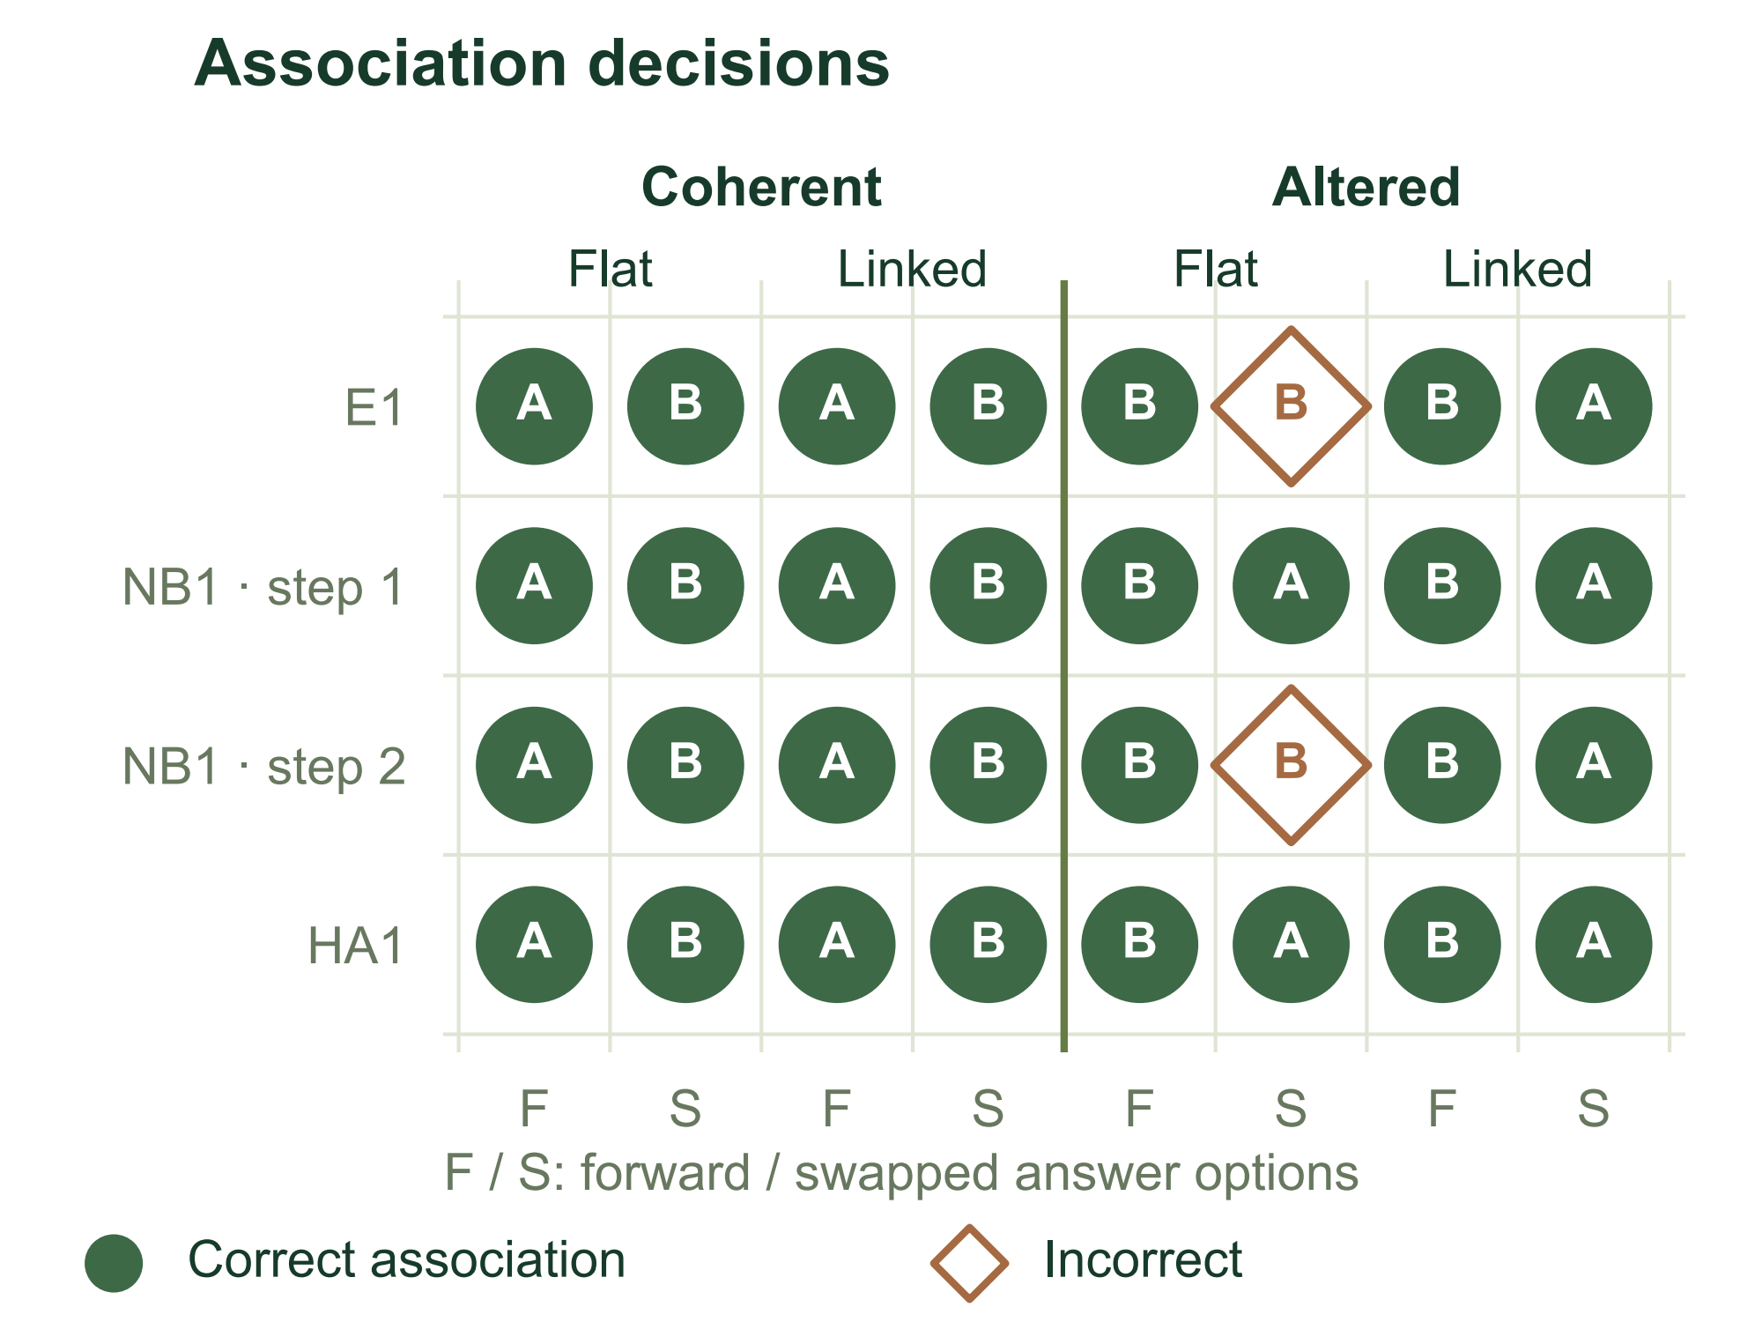  Figure 16. Association judgments for 32 inputs across four source chains, crossed by coherent or altered association, flat or linked presentation, and forward (F) or swapped (S) answer order. Letters retain the saved A/B responses; circles indicate correct associations and diamonds incorrect associations.

3.3.2 Diagnostics turn evidence gaps into concrete research actions
Broken evidence chains must be translated into targeted, physically grounded feedback to effectively drive autonomous corrective actions. When confronted with voluminous unstructured text outputs from quantum-chemical calculations, large language models readily overlook critical geometric and physical anomalies within their attention context. In contrast, structured diagnostic operators eliminate textual redundancy by isolating specific failure modes (e.g., steric clash atom pairs, imaginary-mode misalignments, or trajectory endpoint dislocations), providing concrete targets for subsequent local iterations.
Autonomous exploration trajectories highlight the decisive impact of diagnostic granularity on recovery. In a Brief-errors HA1 trial, where specific diagnostic feedback on IRC-endpoint linkage was ablated in favor of compact error codes, the Computational Agent succumbed to blind retries—mechanically substituting source-minimum references while leaving the underlying geometric disconnection unresolved. Conversely, in a Guided NB1 trial, the underlying verification detected zero imaginary frequencies and categorized the failure as a normal-mode error; the Coordinator immediately formulated a targeted retry plan, directing the Computational Agent to revise transition-state guess parameters and optimization constraints, which were faithfully incorporated into the rescheduled calculation. This ablation demonstrates that recovery in long-horizon mechanism elucidation depends not merely on detecting setbacks, but on bridging evidence defects directly to the specific chemical entities and computational parameters requiring revision.[18]
This mechanism substantiates the empirical efficacy of Cloudra's multi-agent division of responsibilities: Computational Agents iteratively refine specific geometries and paths using localized feedback, the Coordinator oversees branching hypotheses and route selection across the reaction network, and the Supervisor audits cumulative support against immutable task rubrics. Supported by central asynchronous execution and durable ledgers, each role maintains continuous context around shared chemical entities, preventing communicative drift across extended exploration horizons.

3.3.3 Outstanding requirements must remain part of completion decisions
The final stage of scientific delivery requires a global determination: whether the accumulated computational artifacts genuinely satisfy rigorous physicochemical acceptance contracts. An autonomous IA1 trajectory reveals an inherent vulnerability of large language models during scientific research: premature completion hallucination. In this case, the reaction step lacked mandatory bidirectional short_irc verification, with an empty waiver list; however, because the Supervisor had previously offered affirmative comments on intermediate optimization convergence, the model suffered cognitive drift and attempted to declare the exploration complete. In an unconstrained or purely conversational architecture, such unsupported mechanistic claims would escape scrutiny and produce false deliverables.
Here, the delivery graph's deterministic physical gate intervened decisively. The harness rejected the premature completion request and injected the unresolved short_irc requirement as a hard constraint back into the context. Confronted with this unyielding physical reality, the model immediately rectified its claim in the subsequent submission, correctly downgrading its status to partial completion (Figure 17).

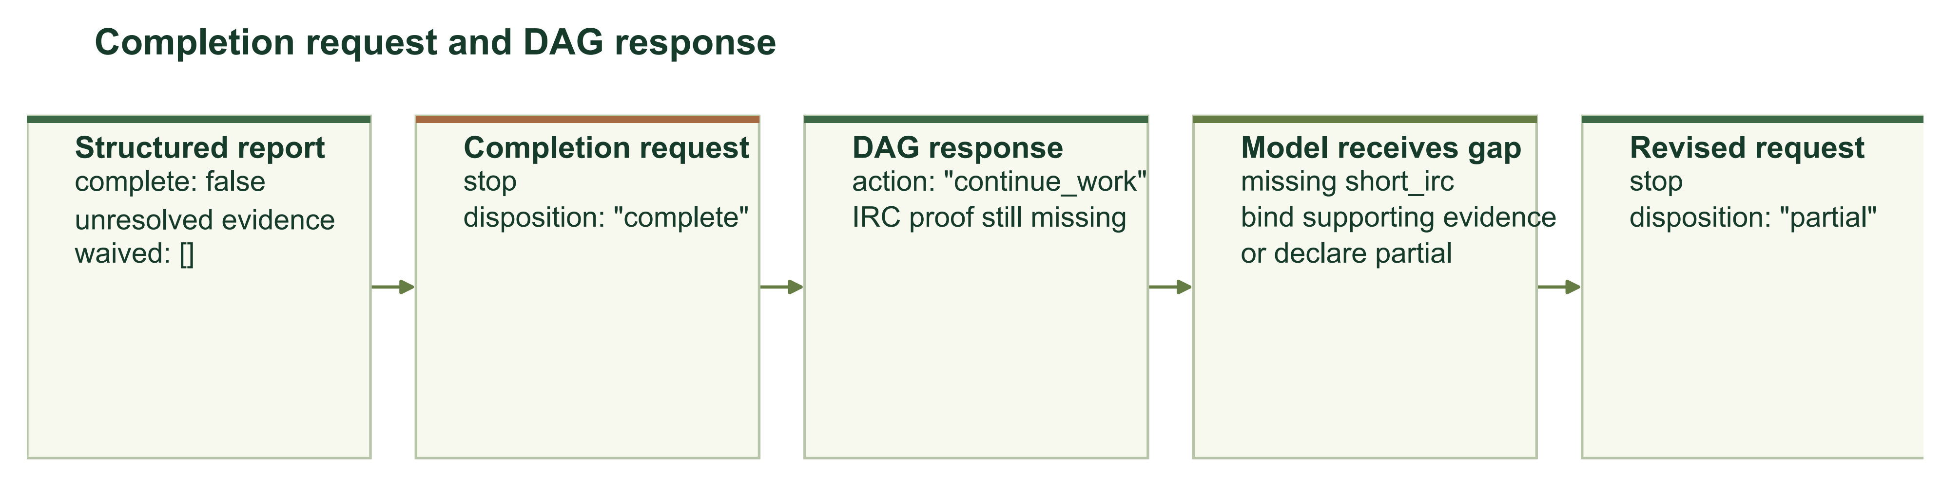
Figure 17. Completion requests and DAG feedback in the original IA1 trajectory. A report with unresolved evidence is followed by a completion request, a response identifying missing short_irc proof, feedback to the model, and a revised partial-completion request.

When physical state is explicitly recorded in an immutable ledger, the model reliably anchors its reasoning to this authoritative source. Across 12 paired trials evaluating IA1 under both minimal summary and extended 12-message history contexts, the model achieved 100% accuracy in identifying unsatisfied scientific requirements across all state queries and reversed option orders. The delivery DAG thus provides an immutable coordinate system for subsequent reasoning: demarcating verified entities, pinpointing existing deficits, and determining whether to pursue additional calculations or submit partial deliverables reflecting physical reality.
The two design themes converge here. On the geometric reasoning side, the architecture binds chemical intent to explicit atom indices, local topologies, and three-dimensional operators, freeing the language model from prone numerical arithmetic to focus on hypothesis evolution. On the scientific evidence side, the delivery DAG and physical validation gates retain strict authority over claim acceptance, anchoring every conclusion to genuine quantum-chemical artifacts. Cloudra's empirical findings demonstrate that only by providing deterministic operational handles for intent and enforcing immutable physical contracts for delivery can the generative capabilities of large language models be transformed into rigorous, reproducible, and autonomous scientific discovery.

References
[1] Zou, Y., et al. El Agente: An autonomous agent for quantum chemistry. Matter 2025, 8, 102263. https://doi.org/10.1016/j.matt.2025.102263
[2] Hu, J., et al. Aitomia: An Agentic Framework for AI-Driven Atomistic and Quantum Chemical Simulations. Journal of Chemical Theory and Computation 2026, 22, 6557–6571. https://doi.org/10.1021/acs.jctc.6c00591
[3] Pérez-Sánchez, J. B., et al. El Agente Quntur: A research collaborator agent for quantum chemistry. Chem 2026, 103259. https://doi.org/10.1016/j.chempr.2026.103259
[4] Choi, C., et al. El Agente Estructural: An Artificially Intelligent Molecular Editor. 2026. https://arxiv.org/abs/2602.04849
[5] Li, D., et al. Autonomous Chemical Mechanistic Discovery through Agentic Reasoning and Validation. 2026. https://arxiv.org/abs/2609.11147
[6] Bai, J., et al. El Agente Gráfico: A Semantic Execution Runtime for Scientific Agents. arXiv:2602.17902v2, 2026. https://arxiv.org/abs/2602.17902v2
[7] Kabsch, W. A discussion of the solution for the best rotation to relate two sets of vectors. Acta Crystallographica Section A 1978, 34, 827–828. https://doi.org/10.1107/S0567739478001680
[8] Smidstrup, S.; Pedersen, A.; Stokbro, K.; Jónsson, H. Improved initial guess for minimum energy path calculations. The Journal of Chemical Physics 2014, 140, 214106. https://doi.org/10.1063/1.4878664
[9] Fukui, K. Formulation of the reaction coordinate. The Journal of Physical Chemistry 1970, 74, 4161–4163. https://doi.org/10.1021/j100717a029
[10] Maeda, S.; Harabuchi, Y.; Ono, Y.; Taketsugu, T.; Morokuma, K. Intrinsic reaction coordinate: Calculation, bifurcation, and automated search. International Journal of Quantum Chemistry 2015, 115, 258–269. https://doi.org/10.1002/qua.24757
[11] FACCTs. ORCA 6.1 Manual: Vibrational frequencies and Intrinsic reaction coordinate. https://www.faccts.de/docs/orca/6.1/manual/contents/structurereactivity/frequencies.html
[12] Riniker, S.; Landrum, G. A. Better Informed Distance Geometry: Using What We Know To Improve Conformation Generation. Journal of Chemical Information and Modeling 2015, 55, 2562–2574. https://doi.org/10.1021/acs.jcim.5b00654
[13] RDKit. Getting Started in Python: Conformer Generation and Maximum Common Substructure. https://www.rdkit.org/docs/GettingStartedInPython.html
[14] Cloudra source code. Revision 70daa5a. https://github.com/yyywaa/Cloudra-mechanism-agent/tree/70daa5a
[15] Gao, L.; Madaan, A.; Zhou, S.; et al. PAL: Program-aided Language Models. Proceedings of the 40th International Conference on Machine Learning 2023, 202, 10764–10799. https://proceedings.mlr.press/v202/gao23f.html
[16] Zhang, F.; Nanda, N. Towards Best Practices of Activation Patching in Language Models: Metrics and Methods. International Conference on Learning Representations 2024. https://proceedings.iclr.cc/paper_files/paper/2024/hash/06a52a54c8ee03cd86771136bc91eb1f-Abstract-Conference.html
[17] Fatemi, B.; Perozzi, B.; Halcrow, J. Talk like a Graph: Encoding Graphs for Large Language Models. International Conference on Learning Representations 2024. https://research.google/pubs/talk-like-a-graph-encoding-graphs-for-large-language-models/
[18] Gou, Z.; Shao, Z.; Gong, Y.; et al. CRITIC: Large Language Models Can Self-Correct with Tool-Interactive Critiquing. International Conference on Learning Representations 2024. https://arxiv.org/abs/2305.11738

