Cloudra: Geometric Reasoning and Scientific Evidence in Autonomous Mechanism Exploration
Working Draft (Introduction & Methods) — 28 October 2026

1. Introduction

1.1 The Physical Foundations and Challenges of Autonomous Reaction Mechanism Research
Determining the mechanism of an organic reaction is an important component of research in organic synthetic methodology. The validity of a mechanistic claim depends on internal consistency among three-dimensional molecular geometries, pathways on the reaction potential energy surface, and rigorous quantum-chemical evidence. In multistep reactions and complex stereoselective competition, this process is highly sensitive to the underlying physics: normal termination of a single geometry optimization (exit 0) does not mean that a stable reaction intermediate has been located; the presence of a single imaginary frequency alone cannot establish that a structure is the first-order saddle point for the target elementary reaction; and once an intrinsic reaction coordinate (IRC) trajectory veers toward dissociation or configurational inversion, all preceding energy calculations lose their physical basis for mechanistic interpretation.
Recent agent systems for computational chemistry have made remarkable progress. El Agente Q ¹, Aitomia ², and Gráfico ⁶ have successfully automated the orchestration of complex quantum-chemical calculations and the execution of typed workflows; Estructural ⁴ and ARCHE ⁵ have demonstrated the feasibility of using specialized tools for molecular fragment editing, atom mapping, and transition-state geometry preparation; and Quntur ³ has further explored reaction kinetics and transition-state research. However, two major bottlenecks remain as these systems move toward fully autonomous exploration of organic reaction mechanisms.
Large language models have inherent limitations in three-dimensional geometric reasoning. In complex organic reactions, aligning stereochemical orientations, assembling reaction fragments, and preparing pathway endpoints impose demanding geometric requirements. As explicitly noted by frontier studies such as Quntur ³, the preparation of complex reaction pathways and transition states often requires human experts to assist with endpoint alignment. Requiring large language models to directly infer or manipulate the underlying three-dimensional Cartesian coordinates can readily lead to erroneous computational results through hallucinations in spatial perception.
Normal termination of a calculation does not establish the scientific validity and completeness of its products. Existing agent systems can successfully invoke quantum-chemical software and obtain computational results, but their final deliverables generally rely on the generative model's subjective summaries and assertions about its own results in conversation. Consequently, a model may declare an exploration complete without ensuring that the delivered mechanism is physically rigorous and traceable: confirmation of zero imaginary frequencies for intermediates is lacking, and connectivity between first-order saddle points and bidirectional IRC paths cannot be established. Enabling chemists' research intentions to guide three-dimensional geometric exploration while anchoring every step of reasoning in immutable physicochemical evidence remains a challenge for truly autonomous mechanistic research.

1.2 Cloudra: A Physical Contract–Driven System for Autonomous Mechanism Exploration
To address these bottlenecks, we introduce Cloudra, a multi-agent system for the autonomous exploration of reaction mechanisms involving small organic molecules. Cloudra's central design philosophy is the complete separation of scientific responsibilities: large language models propose mechanistic hypotheses, plan exploration pathways, and diagnose computational setbacks scientifically; the underlying deterministic software maintains rigorous atom-topology correspondences and performs local spatial operations; and an independent system of physical validation gates oversees all computational products, determining whether mechanistic claims are accepted according to deterministic physicochemical rules.
Figure 1 places Cloudra within a structured literature sample of 85 chemical AI agent systems: 39 concern materials or surfaces, 23 concern finite molecules or complexes, 12 concern soft matter or biomolecules, and a further 11 demonstrate multiple categories of objects. Figures 2 and 3 show the documented tasks in the finite-molecule/complex category; the complete matrix and sources for each entry are provided in the accompanying literature materials.
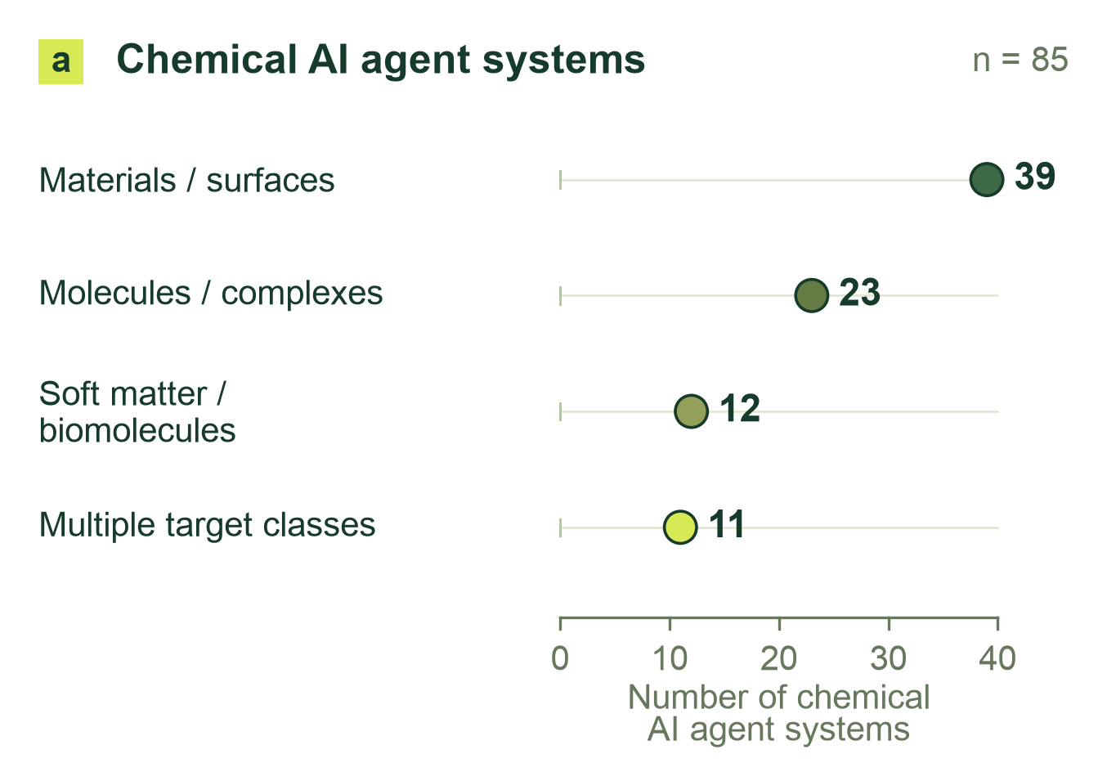
Figure 1: Physical targets in a structured literature sample of 85 chemical AI agent systems: 39 materials/surface, 23 finite-molecule/complex, 12 soft-matter/biomolecular, and 11 cross-class systems.
For geometric reasoning, Cloudra adopts a paradigm of “intelligent restraint,” removing three-dimensional spatial operations from the large language model's cognitive workload. The system connects cheminformatics-based structural perception with local geometric operators. A maximum common-subgraph (MCS) algorithm retrieves molecular fragments, while atom mapping and reaction-center identification tightly link molecular topology to spatial coordinates; measurement operators provide bond lengths, bond angles, dihedral angles, and stereochemical features, while local manipulation operators perform fragment rotation, translation, and transition-state assembly. Large language models need not guess the underlying Cartesian coordinates. Instead, they issue structural transformation instructions expressing clear chemical intentions, allowing hypotheses to evolve through observable geometric changes and reducing the need for manual endpoint alignment.
For scientific delivery, Cloudra establishes a directed acyclic graph of mechanistic evidence centered on chemical entities (the Delivery DAG). This differs fundamentally from conventional pipelines of task calls: nodes in Cloudra's delivery graph represent ground-state chemical species in the reaction mechanism, while edges represent elementary reaction steps for which verification of a first-order saddle point (with exactly one valid imaginary frequency) and bidirectional IRC paths has been completed. Every advance in a scientific claim must be directly bound to genuine underlying quantum-chemical calculation logs, while the Supervisor gate reviews the state of the delivery graph against scientific contracts to ensure that errors in programmatic judgments are not overlooked. Even if the large language model declares the exploration complete during interaction, a step lacking complete frequency or pathway support remains unconfirmed, suppressing false mechanistic deliverables.
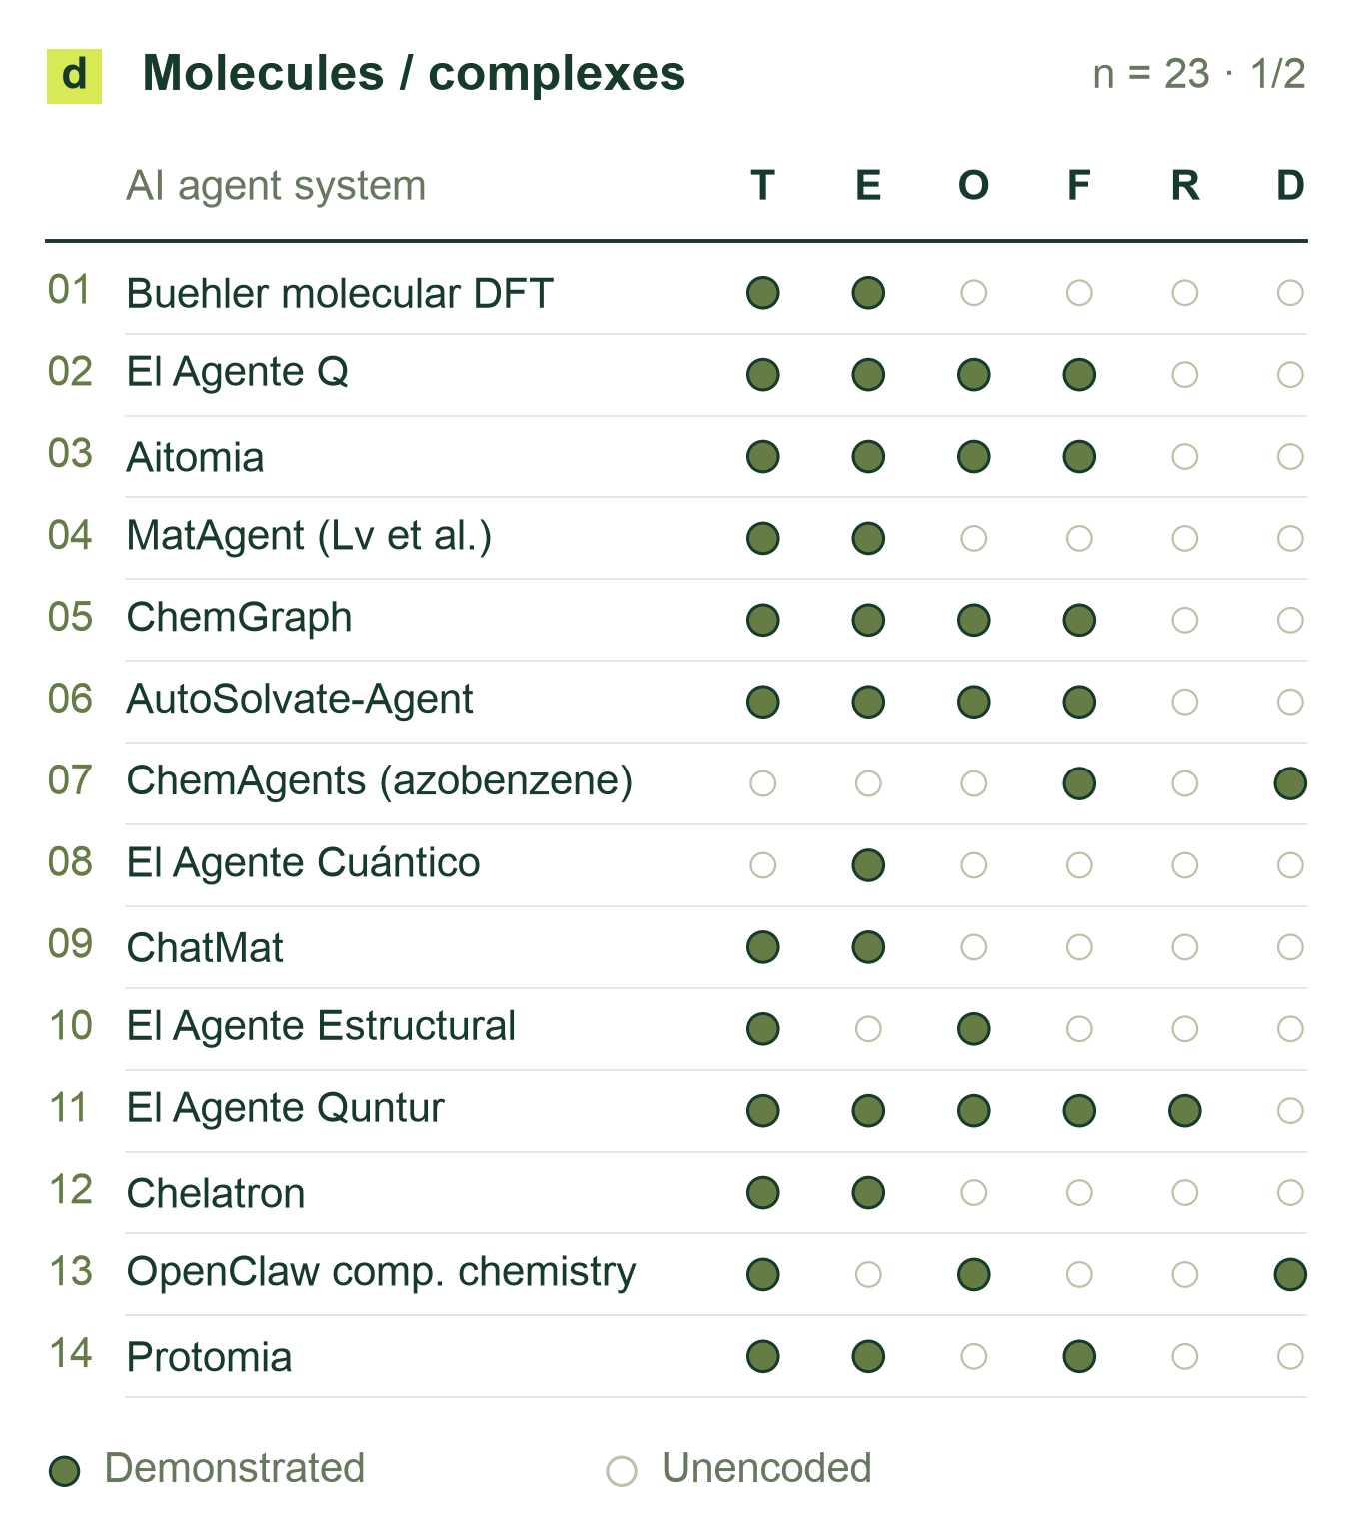
Figure 2: Documented tasks in the finite-molecule/complex class (panel 1 of 2; 23 chemical AI agent systems in total). T: structure construction/editing; E: static energy/properties; O: geometry optimization; F: vibrations/thermochemistry; R: explicit pathways/TS; D: molecular/quantum dynamics. Filled cells denote positive evidence; blanks are unencoded, not absent capabilities.
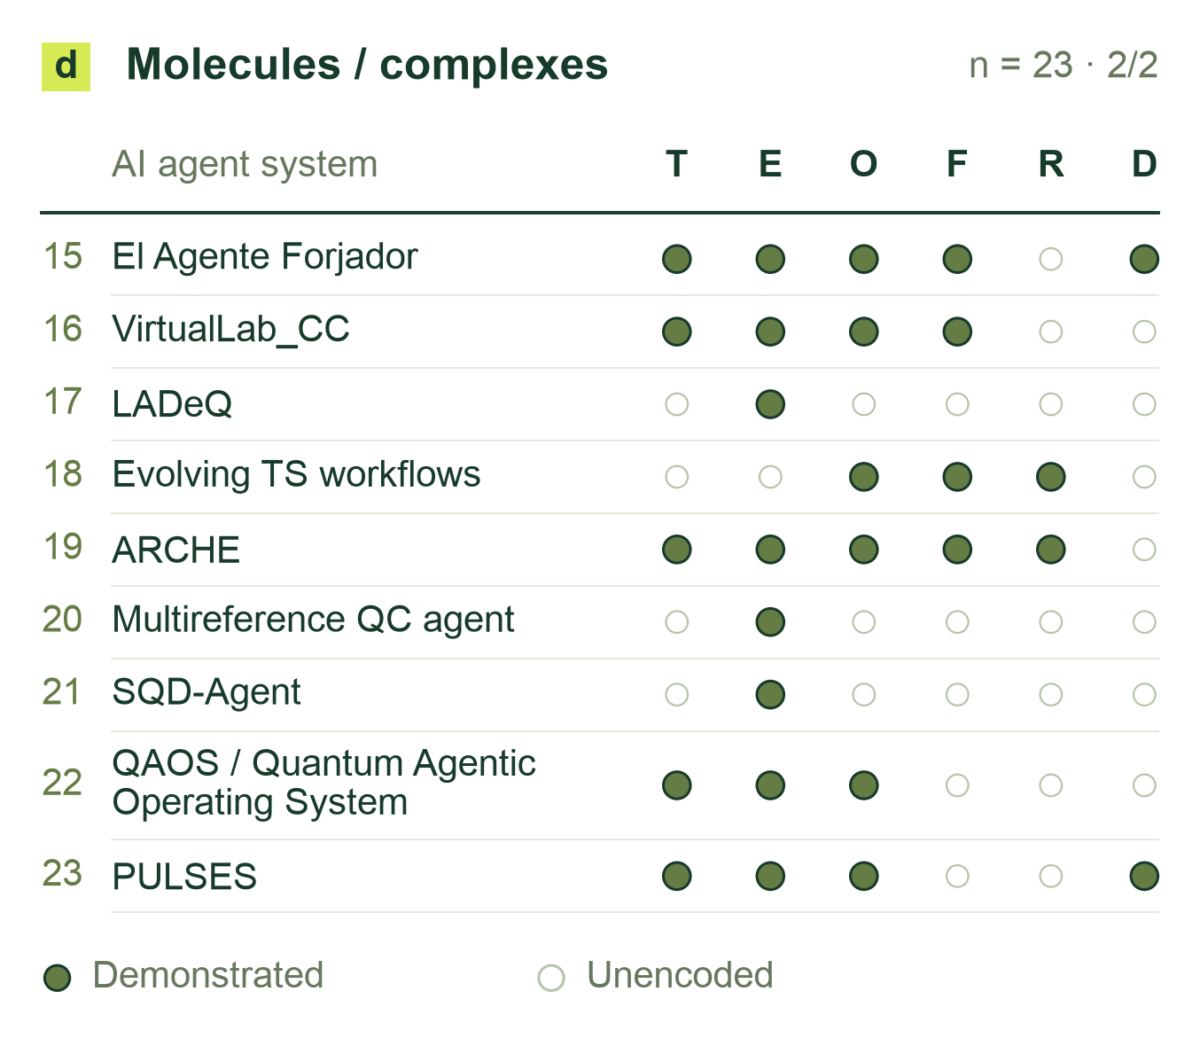
Figure 3: Chemical AI agent systems in the finite-molecule/complex class, continued (panel 2 of 2), using the codes in Figure 2. Complete matrices for all 85 chemical AI agent systems and source-level qualifications accompany the draft.

1.3 Core Contributions
Cloudra introduces a mechanism delivery graph (Delivery DAG) in which chemical species and elementary reactions are the entities and physicochemical laws serve as validation gates. By assigning authority over evidence to the underlying quantum-chemical products rather than the large language model's natural-language descriptions, the system constrains model behavior to suppress false completion and scientific hallucinations during long-range scientific reasoning.
To address the widespread bottlenecks of human intervention and spatial hallucinations in molecular geometric reasoning, this work establishes the methodological paradigm of “intelligent restraint.” Geometric operations, including maximum common-subgraph topological mapping, steric graph traversal, and transition-state fragment assembly, are implemented as underlying deterministic operators. This allows large language models to focus on formulating higher-level chemical hypotheses, selecting among competing pathways, and identifying the causes of failure, achieving end-to-end autonomous localization of transition states for complex organic reactions.
To meet the need for rigorous evaluation of mechanism exploration, this work develops CloudraBench, a reaction mechanism evaluation framework grounded in native computational products and independent of subjective scoring. The benchmark comprises 50 representative organic chemistry tasks spanning Easy and Normal reactions, Hard stereoselective competition, and Impossible physically inaccessible reactions. Through a four-arm ablation study across 200 independent sandboxes, the evaluation extracts evidence directly from native calculation logs, and the scoring program verifies graph-structure coverage, physical self-consistency, and quantitative barrier accuracy, establishing a reproducible empirical baseline for the field.

2 System Design and Methods

2.1 System Overview and Division of Responsibilities
Cloudra takes reactant identities, reaction conditions, target species or mechanistic questions, and computational requirements as inputs. It represents candidate elementary steps in a delivery evidence graph, generates molecular configurations, submits quantum chemical calculations, and associates returned structures, energies, frequencies, and paths with the corresponding species or steps. The graph stores proposed and verified chemical objects together with unresolved calculation requirements.

Figure 4: Cloudra multi-agent system architecture: coupling mechanistic hypothesis generation (Coordinator), deterministic geometric manipulation (Operators), asynchronous computational execution (ComputeDB), and physical evidence validation gates.
The multi-agent system divides responsibilities by functional role. The Coordinator formulates mechanistic hypotheses, proposes candidate elementary reaction steps, and maintains exploration branches. Computational agents execute assigned reaction steps, invoking geometric operators to assemble three-dimensional coordinates and scheduling quantum chemical calculations. When an assigned step encounters geometric divergence, saddle-point nonconvergence, or pathway bifurcation, the computational agent assesses whether the step remains viable; if the current step appears obstructed, it feeds diagnostic information back to the Coordinator to adjust the hypothesis or switch branches. The Supervisor independently audits the delivery graph against task specifications, maintaining review notes separately from parsed computational facts.

2.1.1 Asynchronous Computation Scheduling and Resource Management
The computational execution harness is governed by a central calculation ledger (`ComputeDB`), which enforces state management across the lifecycle of each job. Dedicated capacity pools partition execution across local execution threads, remote SSH clusters, and Slurm supercomputing queues, enforcing hardware concurrency quotas to prevent queue overflow. Prior to dispatch, the scheduler computes an immutable SHA-256 content digest from Cartesian coordinates, electronic spin and charge, and level of theory; identical active or cached jobs are reused to achieve deduplication. Process liveness and execution concurrency are tracked via operating-system file exclusive locks (`flock`), avoiding termination of background quantum-chemistry jobs holding active locks during monitor exceptions. Computational agents interact with the scheduler via event-driven notifications: upon calculation termination, the harness dispatches completion events, allowing agents to read artifacts asynchronously without polling loops.

2.2 Molecular Representations and Geometric Operators
A molecular input consists of an attributed graph $H=(A,B)$ and Cartesian coordinates $X∈ℝ^{n×3}$. Here $A$ is the atom set, $B$ is the bond set, and each row of $X$ gives one atom position. Atom and bond attributes encode chemical identity; coordinate operators update $X$ and return measured changes. Operators that replace atoms or functional groups also update $H$.

2.2.1 Atom Correspondence and Reaction Centers
Atom attributes retain element, isotope, formal charge, hydrogen count, radical-electron count, and declared stereochemistry; bond attributes retain order and stereochemical labels. Components lacking three-dimensional coordinates are embedded using ETKDGv3 [6,7], then assembled if necessary. Existing coordinates are retained. Complete, unique atom-map labels on both endpoints define the correspondence directly and must agree in element and isotope. Otherwise, let $A_{P}$ and $A_{R}$ be the product and reactant heavy-atom sets. Candidate bijections $π:A_{P}→A_{R}$ satisfy $z_{i}^{P}=z_{π(i)}^{R}$ and $ι_{i}^{P}=ι_{π(i)}^{R}$, where $z$ is atomic number and $ι$ is isotope label. Each candidate is scored by
$J(π)=2(N_{f}+N_{b})+N_{o}+4Δ_{H}+8Δ_{q}+8Δ_{r}+2N_{s}.$ (2.1)
Let $B_{P}^{π}$ denote product bonds expressed in reactant atom indices. Bond formation and cleavage are the set differences $B_{P}^{π}⧵B_{R}$ and $B_{R}⧵B_{P}^{π}$, with cardinalities $N_{f}$ and $N_{b}$. The count $N_{o}$ includes pairs in $B_{P}^{π}∩B_{R}$ whose bond orders differ. For $a∈\{H,q,r\}$, the mismatch is $Δ_{a}=\sum_{i∈A_{P}}{|}a_{i}^{P}−a_{π(i)}^{R}|$, where $H$, $q$, and $r$ are the atom hydrogen count, formal charge, and radical-electron count. $N_{s}$ counts stereochemical mismatches. Exactly one declared tetrahedral label contributes one mismatch, increasing $J$ by 2. When both corresponding atoms carry tetrahedral labels, the comparison requires four corresponding neighbors, including a single hydrogen where applicable; it corrects for neighbor-order parity before comparing the labels. Noncomparable two-sided tetrahedral environments contribute no mismatch.
For element–isotope classes of sizes $n_{g}$, the search space contains $N_{Π}=\prod_{g}{n_{g}}!$ bijections. All are enumerated when $N_{Π}≤{10}^{5}$. Above this limit, MCS seeds use element matching, unrestricted bond-order matching, ring-to-ring matching, and complete rings [7]. The MCS timeout is 10 s, and each endpoint contributes at most 64 substructure matches. Unmatched atoms are paired within element–isotope classes after sorting by hydrogen count, degree, and input index. The search then merges candidates having identical bond-edit facts and score, keeping the lexicographically smallest mapping for each group. Representatives are sorted by score and then atom-map sequence; the first 16 form the heavy-atom candidate set $C$. For nonempty $C$, define optimal score $J_{min}=\min_{π∈C}J(π)$ and tolerance set $𝒩=\{π∈C:J(π)≤J_{min}+2\}$. An unlabeled mapping is reported as unique when $|𝒩|=1$, ambiguous when $|𝒩|>1$, and inconclusive when $C=∅$.
The retained heavy-atom candidates are combined with compatible bindings to both concrete endpoint graphs and expanded to all-atom correspondences. Compatible explicit hydrogen labels are preserved first; remaining local hydrogens are paired by isotope on corresponding heavy atoms. For unmatched isotope groups of sizes $h_{g}$, the remaining $N_{H}=\prod_{g}{h_{g}}!$ permutations are enumerated when $N_{H}<257$. An expansion with $N_{H}≥257$ yields an inconclusive result unless compatible explicit hydrogen labels resolve the permutation space. Complete maps are deduplicated, ranked by score and atom-map sequence, and evaluated with the same +2 ambiguity criterion. The selected all-atom bijection reorders the product into reactant atom order. Formed and broken bonds define the reaction-center coordinate pairs used to monitor subsequent path interpolation, while bond-order modifications are recorded alongside the transformed graph.

2.2.2 Structural Measurements and Rigid Body Operations
Structural perception converts coordinates into bond lengths, bond angles, dihedral angles, ring conformations, and close contacts. For coordinates $x_{i}$, the interatomic distance is $d_{ij}=‖x_{j}−x_{i}‖$; the bond angle at vertex $j$ is obtained from the normalized dot product of the two bond vectors. Comparisons of distances with reference bond lengths and van der Waals contact scales provide geometric diagnostics, while the molecular graph retains the established identity. Connectivity is perceived at entry for coordinate-only inputs; subsequent local coordinate transformations retain this graph and remeasure anomalies before and after transformation.
Default fragment selection on either side of an acyclic bond uses graph connectivity: the specified bond $a−b$ is temporarily removed, and the connected component containing $b$, denoted $ℱ_{b}$, is selected. If the endpoints remain connected after bond removal, movement within a ring framework requires an explicit atom group. Let $ℱ$ denote the explicitly specified moving atom group or the component $ℱ_{b}$ obtained by bond removal. To rotate the selected fragment about an axis, Rodrigues' formula is applied to every $i∈ℱ$:
$\begin{aligned}x_{i}^{′}=a+R(\hat{u},θ)(x_{i}−a),R=cosθI+(1−cosθ)\hat{u}{\hat{u}}^{T} \\ +sinθ[\hat{u}]_{×}.\end{aligned}$ (2.2)
Here, $a$ is a point on the axis, $\hat{u}$ its unit direction, $θ$ the rotation angle, $I$ the identity matrix, and $\left[\hat{u}]_{×}v=\hat{u}×v\right.$. Coordinates outside the selected set are unchanged. Stretching bond $a−b$ translates $ℱ_{b}$ as a whole:
$\begin{aligned}x_{i}^{′}=x_{i}+(L−d_{ab})\frac{x_{b}−x_{a}}{d_{ab}}, \\ i∈ℱ_{b}.\end{aligned}$ (2.3)
Here $L$ is the target bond length; coordinates outside $ℱ_{b}$ remain fixed. Chirality inversion rotates two separable branches around their center to exchange branch directions. Group substitution removes the specified-side fragment, docks the new group along the original attachment-bond direction, and updates the graph. To compare structures before and after optimization, the system differences distance-perceived connectivity sets under the same element sequence and classifies gained or lost contacts as intra- or interfragment changes.

2.2.3 Branch Crowding and Reactant Preorganization
For candidate axes that pass checks of hybridization, ring structure, and substituent graph inequivalence, the system uses a decaying branch descriptor to provide local steric crowding information:
$\begin{aligned}B_{s}=\sum_{k∈T_{s}}{c_{k}}r_{k}ρ^{ℓ_{k}}, \\ ρ=0.5,0≤ℓ_{k}≤5.\end{aligned}$ (2.4)
Here $r_{k}$ represents the van der Waals radius of atom $k$. $T_{s}$ is generated by a last-in-first-out depth-first traversal starting from the substituent root at depth zero, with the adjacent axis-end atom marked visited. On popping an unvisited atom, the algorithm records its traversal depth $ℓ_{k}$ and pushes its unvisited neighbors if $ℓ_{k}<5$. The weighting coefficient is $c_{k}=1.5$ for a root of graph degree at least 3, and $c_{k}=1$ otherwise.
The descriptor uses standard van der Waals radii in Å: H 1.20, B 1.92, C 1.70, N 1.55, O 1.52, F 1.47, P 1.80, S 1.80, Cl 1.75, Br 1.85, and I 1.98 (1.70 fallback for unlisted elements). The rounded branch values are summed across all four substituents on the axis; a cumulative score $B_{s}≥9.0$ flags the axis as congested for subsequent conformational inspection.
During multicomponent preorganization, the primary fragment is fixed at the origin. Remaining fragments undergo orientation sampling on the unit sphere. With $K$ samples, direction $s$ is
${\hat{u}}_{s}=(a_{s}cossγ,y_{s},a_{s}sinsγ),a_{s}=\sqrt{1−y_{s}^{2}},y_{s}=1−\frac{2s}{K−1},γ=π(3−\sqrt{5}).$ (2.5)
Here $γ=π(3−\sqrt{5})≈2.3999\text{ rad}$ (${137.5}^{∘}$) represents the Golden Angle, generating a Fibonacci spherical spiral grid for uniform distribution of directions. The axial twist about ${\hat{u}}_{s}$ is $2πs/K$ (default $K=32$). Translation along the interfragment vector resolves steric overlap. For a set $W$ of guided atom pairs with target distance windows $\left[l_{ij} , u_{ij}\right]$, placement $X$ is scored by
$\begin{aligned}S(X)=\max_{(i,j)∈W} \\ \{0,l_{ij}−d_{ij}(X),d_{ij}(X)−u_{ij}\}.\end{aligned}$ (2.6)
Candidate configurations with low $S(X)$ are deployed as seeds for distance-restrained MMFF94 force-field optimization, guiding fragments toward target interaction intervals while relaxing nonbonded contacts. Qualified candidates must simultaneously satisfy force-field convergence, distance compliance, stereochemical retention, and fragment contact connectivity $d_{i^{*}j^{*}}≤1.7(r_{i^{*}}+r_{j^{*}})$. Qualified candidates are ranked by unconstrained single-point energy and clustered with a heavy-atom Kabsch RMSD threshold of 0.5 Å to yield preorganization seeds.

2.2.4 Endpoint Alignment and IDPP Interpolation
After all-atom correspondence is established, each endpoint is centered. Let $P$ and $R$ be the centered product and reactant coordinate matrices. Kabsch alignment solves
$\min_{Q^{T}Q=I,detQ=1}‖PQ−R‖_{F}^{2},P^{T}R=UΣV^{T},Q=Udiag[1,1,det(UV^{T})]V^{T}.$ (2.7)
The resulting matrix $Q$ is the proper rigid-body rotation matrix. The determinant correction factor $det(UV^{T})$ enforces $detQ=+1$, ruling out improper reflections and preserving chiral configuration.
For $M$ images including endpoints, define $λ_{k}=k/(M−1)$ and initialize $X_{k}=(1−λ_{k})R+λ_{k}PQ$. The image-dependent pair potential (IDPP) method [2] interpolates in internal pair-distance space ($d_{ij,k}^{*}=(1−λ_{k})d_{ij}^{R}+λ_{k}d_{ij}^{P}$), defining its potential objective as
$d_{ij,k}^{*}=(1−λ_{k})d_{ij}^{R}+λ_{k}d_{ij}^{P},V_{k}=\sum_{i<j}{\frac{{\left(d_{ij,k}−d_{ij,k}^{*}\right)}^{2}}{d_{ij,k}^{4}}}.$ (2.8)
The inverse-fourth-power weighting $d_{ij,k}^{−4}$ imparts stiffness to short covalent bonds, prioritizing the preservation of basic covalent distances while allowing long-range nonbonded contacts to relax. Standard mode couples intermediate images with improved-tangent nudged elastic band (NEB) springs and optimizes with MDMin, evaluating convergence by the maximum force residual across movable atoms. Lightweight mode evaluates target distances with an objective denominator $max(d_{ij,k}^{*},0.1\text{Å})^{4}$ and relaxes intermediate images independently using Adam optimization.
Active monitoring pairs $W$ incorporate bond-state changes, pairs bonded at both endpoints with $|Δd|≥0.15$ Å, and the five atom pairs exhibiting the largest endpoint distance variations. Within the monitoring set $W$, the primary reaction coordinate is selected by $p^{*}∈{argmax}_{p∈W}|d_{p}^{P}−d_{p}^{R}|$, setting $m=(d_{p^{*}}^{R}+d_{p^{*}}^{P})/2$. The initial transition-state guess is extracted from the first image $k$ satisfying $(d_{p^{*},k}−m)(d_{p^{*}}^{R}−m)≤0$, or the image minimizing $\left|d_{p^{*},k} − m\right|$. The selected configuration serves as the initial seed for saddle-point optimization.

2.3 Evidence Graph and Scientific Validation

2.3.1 Species Occurrences and Evidence Requirements
The delivery evidence graph is $G=(V,E)$, where vertices $v∈V$ represent chemical species occurrences and directed edges $e=(v_{i},v_{j})∈E$ represent elementary reaction steps. A mapping $κ:V→𝒮$ maps each occurrence to its canonical chemical identity, allowing cyclical pathways to represent regenerated catalyst occurrences as distinct topological nodes sharing the same chemical identity. Stationary-point geometries, frequencies, and absolute energies attach to species nodes; transition-state geometries, imaginary vibration vectors, and reaction paths attach to elementary-step edges.
Each graph element carries a declarative stage requirement set $K$. Standard elementary steps require the sequence $K=\{\text{ts\backslash _opt},\text{frequency},\text{short\backslash _irc}\}$, supplemented by thermochemical corrections when mandated by the task rubric. Calculation outputs are archived as content-digested immutable records. Parsed facts take the form $f=(c,o,r,d)$, where $c$ is the check item, $o∈\{+,−,?\}$ denotes support, contradiction, or uncertainty, $r$ is the artifact provenance reference, and $d$ encapsulates quantitative metrics.
For tasks declaring explicit property checks $R$ and optional checks $O$, the scientific evidence acceptance criterion over target-associated facts $F_{t}$ evaluates as
$S_{t}=1[R≠∅]∧⋀_{c∈R}1[∃f∈F_{t}:f.c=c,f.o=+]∧1[∄f∈F_{t}:f.c∈R∪O,f.o=−].$ (2.9)
When $R≠∅$, any missing required fact or active contradiction in $R∪O$ invalidates $S_{t}$. When $R=∅$, fact-level evaluation is omitted, delegating verification to the stage-chain requirements.

2.3.2 Curvature and Reaction Mode Diagnostics
Stationary-point curvature is evaluated from the mass-weighted Hessian:
$H_{mw}=M^{−1/2}∇_{x}^{2}UM^{−1/2},H_{mw}v_{k}=λ_{k}v_{k}.$ (2.10)
In the vibrational subspace orthogonal to translational and rotational degrees of freedom, negative eigenvalues $λ_{k}<0$ correspond to imaginary harmonic frequencies $ν_{k}<0$. The number of imaginary frequencies is $n_{imag}=\sum_{k}{1}[ν_{k}<0]$. Ground-state reaction intermediates require $n_{imag}=0$, whereas transition states require strictly $n_{imag}=1$.
Provenance verification confirms that the geometry evaluated by vibrational frequency analysis matches the optimized stationary point. For coordinate matrices $X$ and $Y$ centered at the origin, the geometry match requires $δ_{π}(X,Y)=\max_{i}‖Y_{π(i)}Q_{π}−X_{i}‖≤3×{10}^{−6}\text{ Å}$, evaluated across element-conserving permutation mappings $π$ and optimal Kabsch rotations $Q_{π}$.
For a first-order saddle point with imaginary normal-mode displacement vector $u$, the mode-alignment diagnostic measures projected motion along the monitored reaction-center pairs $W$:
$η=\frac{\max_{(i,j)∈W}‖u_{i}−u_{j}‖}{\max_{i<j}‖u_{i}−u_{j}‖}.$ (2.11)
The diagnostic $η∈[0,1]$ evaluates whether the imaginary normal mode aligns primarily with the monitored reaction coordinates, identifying spectator motions such as methyl wagging or solvent libration prior to path integration.

2.3.3 IRC Direction and Endpoint Consistency
Intrinsic reaction coordinate (IRC) trajectories evolve from the saddle point along the steepest-descent path in mass-weighted coordinates $q=M^{1/2}x$ [3,4]:
$\frac{dq_{±}}{ds}=−\frac{∇_{q}U}{\left\|∇_{q}U\right\|},q_{init,±}≈q_{TS}±ϵv_{−}.$ (2.12)
Cloudra validates that the IRC path originates at the verified saddle point and extracts the terminal frame in each integration direction. For complete-minimum pathways, dual-direction continuity is established by taking each terminal IRC frame, performing unconstrained geometry optimization, and verifying that the resulting stationary point has zero imaginary frequencies ($n_{imag}=0$) and matches the declared chemical identity of the corresponding endpoint species in molecular topology and stereochemistry (enforced via canonical isomeric SMILES equality).
For elementary steps yielding dissociated molecular components, each dissociated product must independently converge to a verified minimum. Directional alignment is validated through the reactant-side distance interval predicate. Over the monitored pair set $W$, let $q_{TS}$, $q_{E}$, and $q_{R}$ denote distance vectors at the transition state, terminal IRC frame, and reactant reference. With covalent cutoffs $c_{ij}=1.25(r_{i}+r_{j})$ and tolerance $τ=0.10$ Å, define $W_{c}=\{(i,j)∈W:d_{ij}^{R}≤c_{ij}\}$ and interval $\left[a_{p},b_{p}]=[min(d_{p}^{TS},d_{p}^{R})−τ,max(d_{p}^{TS},d_{p}^{R})+τ\right]$. The Boolean predicate $is_between$ is satisfied when ${\left\|q_{E}−q_{R}‖_{2}<‖q_{TS}−q_{R}\right\|}_{2}$ and $a_{p}≤d_{p}^{E}≤b_{p}$ for all $p∈W_{c}$. Dissociated product pathways require satisfaction of $is_between$ alongside verified component minima to certify reaction continuity.

2.3.4 Evidence Aggregation and Energies
For elementary step $e$, let $K_{e}$ denote the set of mandatory scientific stages. The stage verification predicate $P_{e,k}=1$ indicates that stage $k$ possesses bound computational evidence satisfying its physical acceptance criteria ($P_{e,k}=0$ otherwise). Stage-chain completion is defined by
$A_{e}=⋀_{k∈K_{e}}P_{e,k}.$ (2.13)
When explicit property checks $R$ are declared, full step qualification requires the conjunction $A_{e}∧S_{e}$. Stage states are tracked through explicit dispositions (supported, pending, skipped, or rejected), distinguishing documented exemptions or limitations from completed calculation artifacts.
The electronic activation barrier is computed directly from verified stationary-point energies:
$ΔE_{e}^{‡}=E_{TS,e}−E_{ref,e}.$ (2.14)
Energies share a consistent quantum chemical level of theory. For thermochemical profiles, zero-point energy, enthalpy, and Gibbs free-energy corrections are evaluated from harmonic partition functions under declared temperature and pressure specifications.

2.4 Diagnostics and Recovery
The harness categorizes computational setbacks into execution errors, numerical nonconvergence, and physical evidence defects. Execution errors encompass input syntax, environmental faults, or parsing anomalies. Numerical status tracks self-consistent field (SCF) and geometry optimization convergence. Physical evidence defects identify curvature violations ($n_{imag}≠1$), imaginary-mode misalignment ($η<η_{thresh}$), unverified IRC endpoints, or chemical graph discrepancies.
Let $T$ denote the set of declared target species and elementary steps. Extending $P_{e,k}$ across all targets $t∈T$, the outstanding scientific evidence requirements form the unsatisfied contract set:
$U=\{(t,k):t∈T,k∈K_{t},P_{t,k}=0\}.$ (2.15)
The set $U$ records the agent's outstanding targets. Structured diagnostic feedback maps non-zero entries in $U$ to underlying SCF nonconvergence, normal-mode misalignment, broken IRC lineages, or chemical graph discrepancies. When a calculation fails, the harness preserves historical artifacts and updates $U$, providing the agent with geometric and calculation status details for adjustment.
Recovery preserves historical attempts and raw calculation outputs while rescheduling dependent stages. Atom index reordering, evidence binding, and graph status updates are handled by the harness, allowing the model to focus on modifying chemical constraints, adjusting dihedral angles, or selecting alternative electronic-structure approximations.

2.5 Implementation Defaults
The implementation described here corresponds to Cloudra revision 70daa5a. Preorganization uses 32 rigid orientations, up to 8 guided placements, minimum interfragment separation 1.0 Å, fragment-contact multiplier 1.7, and heavy-atom RMSD clustering threshold 0.5 Å. MMFF94 relaxation uses up to 2000 iterations per phase with a distance restraint force constant of 100.0. Standard IDPP employs 10 images optimized via MDMin (100 steps, force tolerance $f_{max}=0.1$, NEB spring constant $k=0.1$); lightweight IDPP uses Adam optimization (4000 steps, step size 0.02, gradient tolerance ${10}^{−7}$). Path convergence criteria evaluate the maximum force residual on intermediate path images.
[1] Kabsch, W. A discussion of the solution for the best rotation to relate two sets of vectors. Acta Crystallographica Section A 1978, 34, 827–828. https://doi.org/10.1107/S0567739478001680 [2] Smidstrup, S.; Pedersen, A.; Stokbro, K.; Jónsson, H. Improved initial guess for minimum energy path calculations. The Journal of Chemical Physics 2014, 140, 214106. https://doi.org/10.1063/1.4878664 [3] Fukui, K. Formulation of the reaction coordinate. The Journal of Physical Chemistry 1970, 74, 4161–4163. https://doi.org/10.1021/j100717a029 [4] Maeda, S.; Harabuchi, Y.; Ono, Y.; Taketsugu, T.; Morokuma, K. Intrinsic reaction coordinate: Calculation, bifurcation, and automated search. International Journal of Quantum Chemistry 2015, 115, 258–269. https://doi.org/10.1002/qua.24757 [5] FACCTs. ORCA 6.1 Manual: Vibrational frequencies and Intrinsic reaction coordinate. https://www.faccts.de/docs/orca/6.1/manual/contents/structurereactivity/frequencies.html ; https://www.faccts.de/docs/orca/6.1/manual/contents/structurereactivity/irc.html [6] Riniker, S.; Landrum, G. A. Better Informed Distance Geometry: Using What We Know To Improve Conformation Generation. Journal of Chemical Information and Modeling 2015, 55, 2562–2574. https://doi.org/10.1021/acs.jcim.5b00654 [7] RDKit. Getting Started in Python: Conformer Generation and Maximum Common Substructure. https://www.rdkit.org/docs/GettingStartedInPython.html

References
[1] Zou, Y., et al. El Agente: An autonomous agent for quantum chemistry. Matter 2025, 8, 102263. https://doi.org/10.1016/j.matt.2025.102263
[2] Hu, J., et al. Aitomia: An Agentic Framework for AI-Driven Atomistic and Quantum Chemical Simulations. Journal of Chemical Theory and Computation 2026, 22, 6557–6571. https://doi.org/10.1021/acs.jctc.6c00591
[3] Pérez-Sánchez, J. B., et al. El Agente Quntur: A research collaborator agent for quantum chemistry. Chem 2026, 103259. https://doi.org/10.1016/j.chempr.2026.103259
[4] Choi, C., et al. El Agente Estructural: An Artificially Intelligent Molecular Editor. 2026. https://arxiv.org/abs/2602.04849
[5] Li, D., et al. Autonomous Chemical Mechanistic Discovery through Agentic Reasoning and Validation. 2026. https://arxiv.org/abs/2609.11147
[6] Bai, J., et al. El Agente Gráfico: A Semantic Execution Runtime for Scientific Agents. arXiv:2602.17902v2, 2026. https://arxiv.org/abs/2602.17902v2
[7] Kabsch, W. A discussion of the solution for the best rotation to relate two sets of vectors. Acta Crystallographica Section A 1978, 34, 827–828. https://doi.org/10.1107/S0567739478001680
[8] Smidstrup, S.; Pedersen, A.; Stokbro, K.; Jónsson, H. Improved initial guess for minimum energy path calculations. The Journal of Chemical Physics 2014, 140, 214106. https://doi.org/10.1063/1.4878664
[9] Fukui, K. Formulation of the reaction coordinate. The Journal of Physical Chemistry 1970, 74, 4161–4163. https://doi.org/10.1021/j100717a029
[10] Maeda, S.; Harabuchi, Y.; Ono, Y.; Taketsugu, T.; Morokuma, K. Intrinsic reaction coordinate: Calculation, bifurcation, and automated search. International Journal of Quantum Chemistry 2015, 115, 258–269. https://doi.org/10.1002/qua.24757
[11] FACCTs. ORCA 6.1 Manual: Vibrational frequencies and Intrinsic reaction coordinate. https://www.faccts.de/docs/orca/6.1/manual/contents/structurereactivity/frequencies.html
[12] Riniker, S.; Landrum, G. A. Better Informed Distance Geometry: Using What We Know To Improve Conformation Generation. Journal of Chemical Information and Modeling 2015, 55, 2562–2574. https://doi.org/10.1021/acs.jcim.5b00654
[13] RDKit. Getting Started in Python: Conformer Generation and Maximum Common Substructure. https://www.rdkit.org/docs/GettingStartedInPython.html
[14] Cloudra source code. Revision 70daa5a. https://github.com/yyywaa/Cloudra-mechanism-agent/tree/70daa5a

