Cloudra: Geometric Reasoning and Scientific Evidence in Autonomous Mechanism Exploration
Working Draft — 29 October 2026

1. Introduction

1.1 The Physical Foundations and Challenges of Autonomous Reaction Mechanism Research
Determining the mechanism of an organic reaction is an important component of research in organic synthetic methodology. The validity of a mechanistic claim depends on internal consistency among three-dimensional molecular geometries, pathways on the reaction potential energy surface, and rigorous quantum-chemical evidence. In multistep reactions and complex stereoselective competition, this process is highly sensitive to the underlying physics: normal termination of a single geometry optimization (exit 0) does not mean that a stable reaction intermediate has been located; the presence of a single imaginary frequency alone cannot establish that a structure is the first-order saddle point for the target elementary reaction; and once an intrinsic reaction coordinate (IRC) trajectory veers toward dissociation or configurational inversion, all preceding energy calculations lose their physical basis for mechanistic interpretation.
Recent agent systems for computational chemistry have made remarkable progress. El Agente Q ¹, Aitomia ², and Gráfico ⁶ have successfully automated the orchestration of complex quantum-chemical calculations and the execution of typed workflows; Estructural ⁴ and ARCHE ⁵ have demonstrated the feasibility of using specialized tools for molecular fragment editing, atom mapping, and transition-state geometry preparation; and Quntur ³ has further explored reaction kinetics and transition-state research. However, two major bottlenecks remain as these systems move toward fully autonomous exploration of organic reaction mechanisms.
Large language models have inherent limitations in three-dimensional geometric reasoning. In complex organic reactions, aligning stereochemical orientations, assembling reaction fragments, and preparing pathway endpoints impose demanding geometric requirements. As explicitly noted by frontier studies such as Quntur ³, the preparation of complex reaction pathways and transition states often requires human experts to assist with endpoint alignment. Requiring large language models to directly infer or manipulate the underlying three-dimensional Cartesian coordinates can readily lead to erroneous computational results through hallucinations in spatial perception.
Normal termination of a calculation does not establish the scientific validity and completeness of its products. Existing agent systems can successfully invoke quantum-chemical software and obtain computational results, but their final deliverables generally rely on the generative model's subjective summaries and assertions about its own results in conversation. Consequently, a model may declare an exploration complete without ensuring that the delivered mechanism is physically rigorous and traceable: confirmation of zero imaginary frequencies for intermediates is lacking, and connectivity between first-order saddle points and bidirectional IRC paths cannot be established. Enabling chemists' research intentions to guide three-dimensional geometric exploration while anchoring every step of reasoning in immutable physicochemical evidence remains a challenge for truly autonomous mechanistic research.

1.2 Cloudra: A Physical Contract–Driven System for Autonomous Mechanism Exploration
To address these bottlenecks, we introduce Cloudra, a multi-agent system for the autonomous exploration of reaction mechanisms involving small organic molecules. Cloudra's central design philosophy is the complete separation of scientific responsibilities: large language models propose mechanistic hypotheses, plan exploration pathways, and diagnose computational setbacks scientifically; the underlying deterministic software maintains rigorous atom-topology correspondences and performs local spatial operations; and an independent system of physical validation gates oversees all computational products, determining whether mechanistic claims are accepted according to deterministic physicochemical rules.
Figure 1 places Cloudra within a structured literature sample of 85 chemical AI agent systems: 39 concern materials or surfaces, 23 concern finite molecules or complexes, 12 concern soft matter or biomolecules, and a further 11 demonstrate multiple categories of objects. Figures 2 and 3 show the documented tasks in the finite-molecule/complex category; the complete matrix and sources for each entry are provided in the accompanying literature materials.
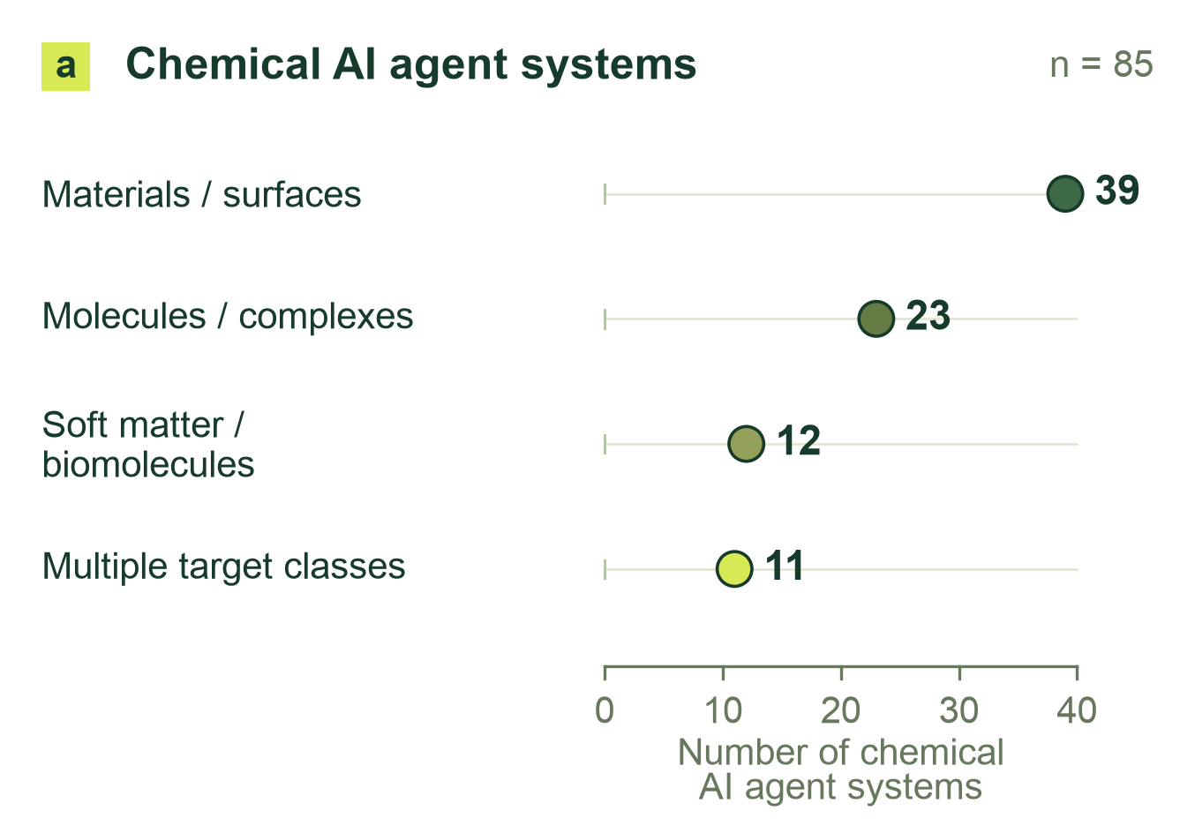
Figure 1: Physical targets in a structured literature sample of 85 chemical AI agent systems: 39 materials/surface, 23 finite-molecule/complex, 12 soft-matter/biomolecular, and 11 cross-class systems.
For geometric reasoning, Cloudra adopts a paradigm of “intelligent restraint,” removing three-dimensional spatial operations from the large language model's cognitive workload. The system connects cheminformatics-based structural perception with local geometric operators. A maximum common-subgraph (MCS) algorithm retrieves molecular fragments, while atom mapping and reaction-center identification tightly link molecular topology to spatial coordinates; measurement operators provide bond lengths, bond angles, dihedral angles, and stereochemical features, while local manipulation operators perform fragment rotation, translation, and transition-state assembly. Large language models need not guess the underlying Cartesian coordinates. Instead, they issue structural transformation instructions expressing clear chemical intentions, allowing hypotheses to evolve through observable geometric changes and reducing the need for manual endpoint alignment.
For scientific delivery, Cloudra establishes a directed acyclic graph of mechanistic evidence centered on chemical entities (the Delivery DAG). This differs fundamentally from conventional pipelines of task calls: nodes in Cloudra's delivery graph represent ground-state chemical species in the reaction mechanism, while edges represent elementary reaction steps for which verification of a first-order saddle point (with exactly one valid imaginary frequency) and bidirectional IRC paths has been completed. Every advance in a scientific claim must be directly bound to genuine underlying quantum-chemical calculation logs, while the Supervisor gate reviews the state of the delivery graph against scientific contracts to ensure that errors in programmatic judgments are not overlooked. Even if the large language model declares the exploration complete during interaction, a step lacking complete frequency or pathway support remains unconfirmed, suppressing false mechanistic deliverables.
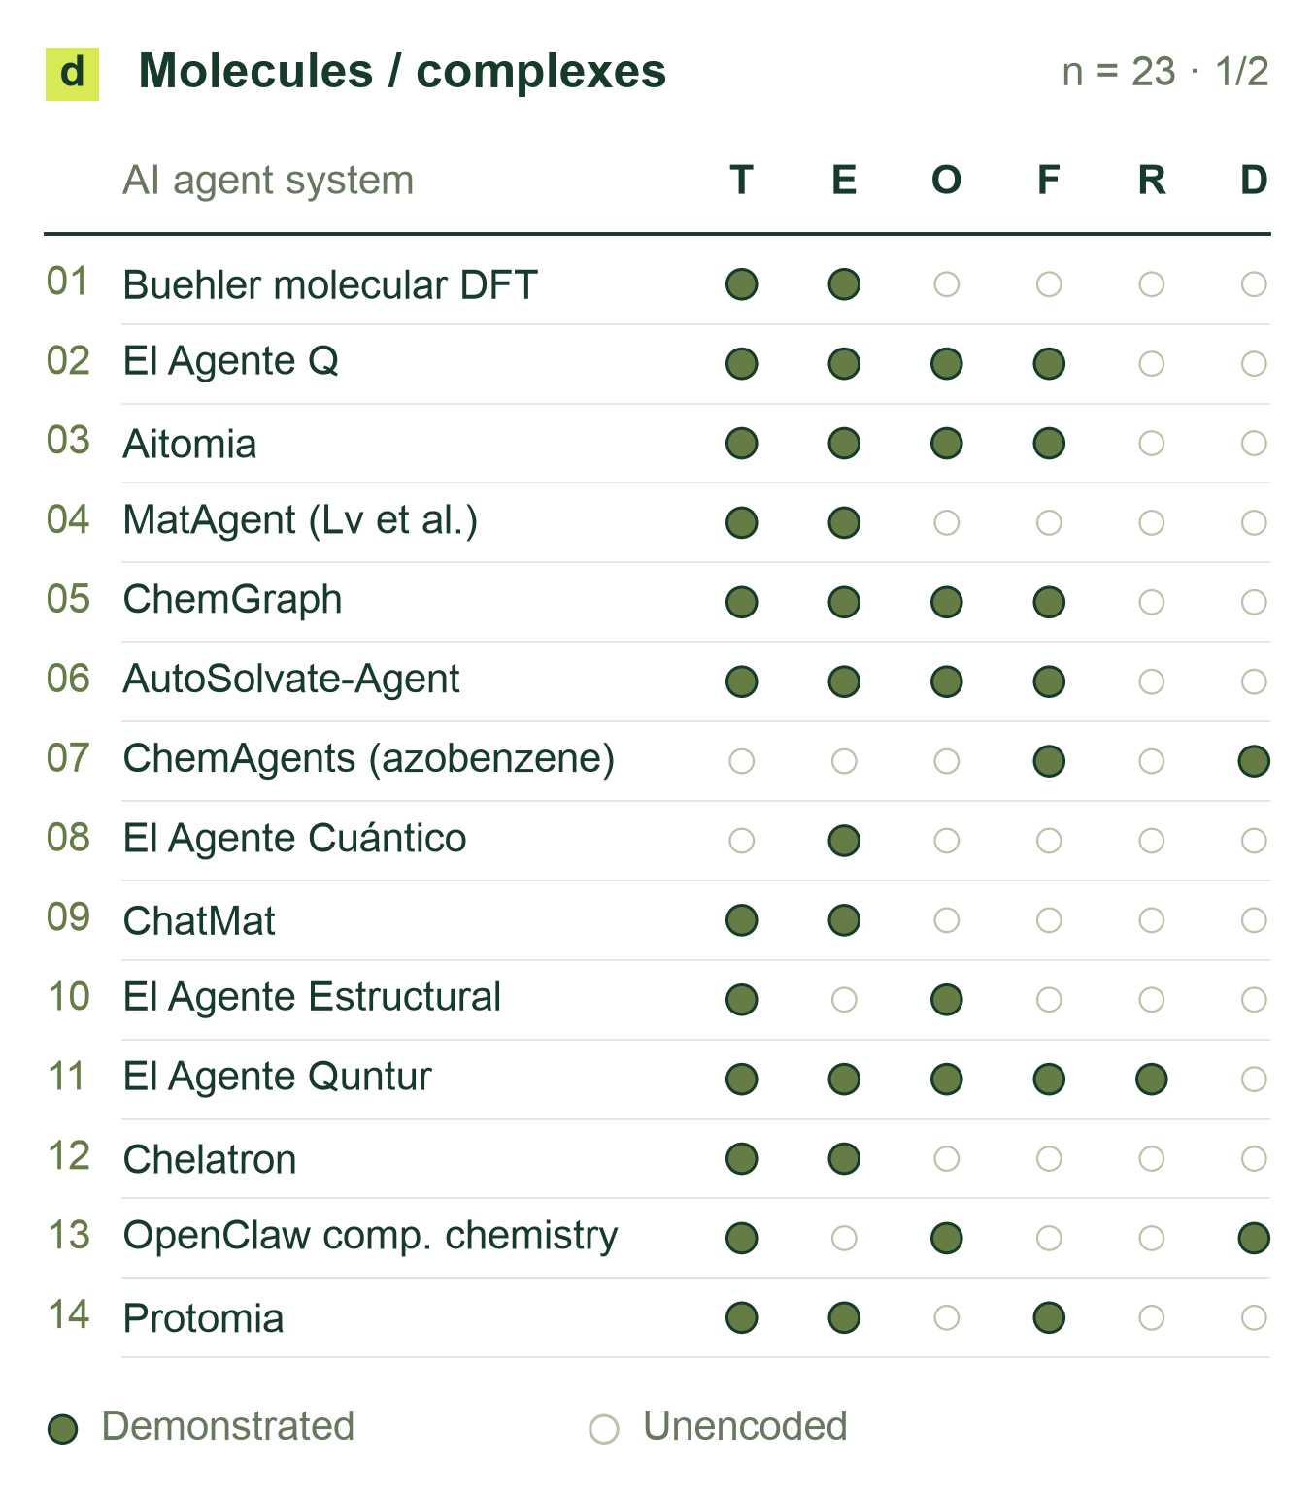
Figure 2: Documented tasks in the finite-molecule/complex class (panel 1 of 2; 23 chemical AI agent systems in total). T: structure construction/editing; E: static energy/properties; O: geometry optimization; F: vibrations/thermochemistry; R: explicit pathways/TS; D: molecular/quantum dynamics. Filled cells denote positive evidence; blanks are unencoded, not absent capabilities.
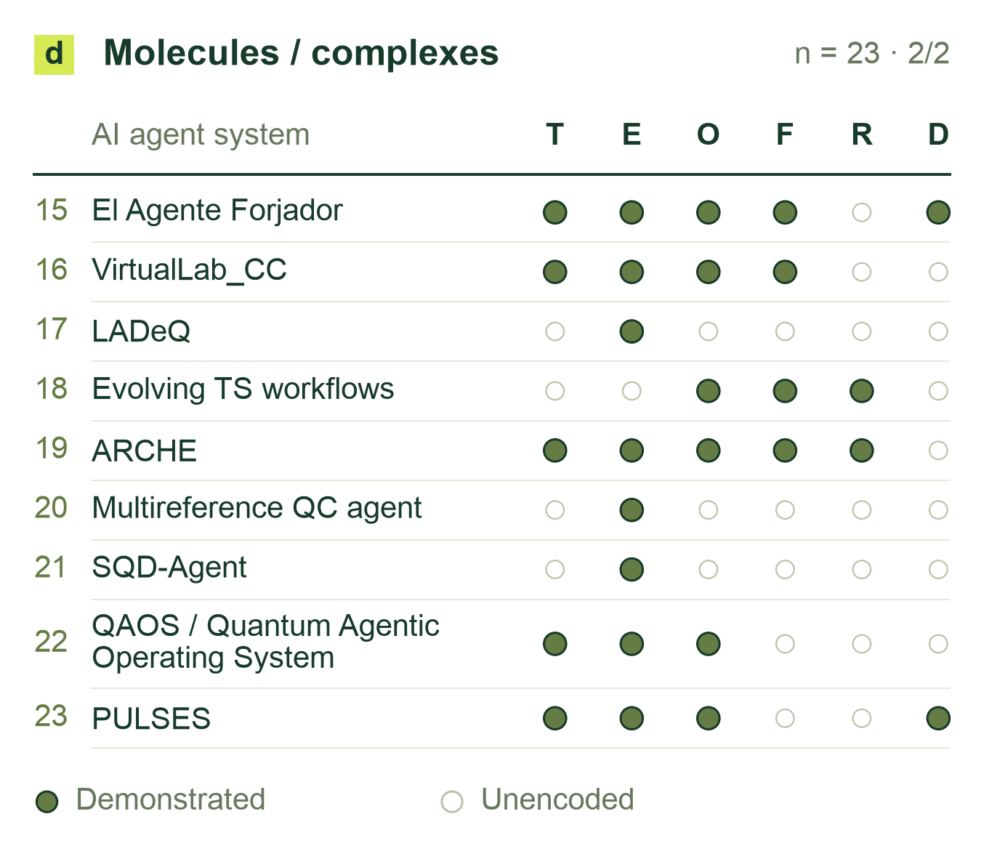
Figure 3: Chemical AI agent systems in the finite-molecule/complex class, continued (panel 2 of 2), using the codes in Figure 2. Complete matrices for all 85 chemical AI agent systems and source-level qualifications accompany the draft.

1.3 Core Contributions
Cloudra introduces a mechanism delivery graph (Delivery DAG) in which chemical species and elementary reactions are the entities and physicochemical laws serve as validation gates. By assigning authority over evidence to the underlying quantum-chemical products rather than the large language model's natural-language descriptions, the system constrains model behavior to suppress false completion and scientific hallucinations during long-range scientific reasoning.
To address the widespread bottlenecks of human intervention and spatial hallucinations in molecular geometric reasoning, this work establishes the methodological paradigm of “intelligent restraint.” Geometric operations, including maximum common-subgraph topological mapping, steric graph traversal, and transition-state fragment assembly, are implemented as underlying deterministic operators. This allows large language models to focus on formulating higher-level chemical hypotheses, selecting among competing pathways, and identifying the causes of failure, achieving end-to-end autonomous localization of transition states for complex organic reactions.
To meet the need for rigorous evaluation of mechanism exploration, this work develops CloudraBench, a reaction mechanism evaluation framework grounded in native computational products and independent of subjective scoring. The benchmark comprises 50 representative organic chemistry tasks spanning Easy and Normal reactions, Hard stereoselective competition, and Impossible physically inaccessible reactions. Through a four-arm ablation study across 200 independent sandboxes, the evaluation extracts evidence directly from native calculation logs, and the scoring program verifies graph-structure coverage, physical self-consistency, and quantitative barrier accuracy, establishing a reproducible empirical baseline for the field.

2 System Design and Methods

2.1 System Overview and Division of Responsibilities
Cloudra takes reactant identities, reaction conditions, target species or mechanistic questions, and computational requirements as inputs. It represents candidate elementary steps in a delivery evidence graph, generates molecular configurations, submits quantum chemical calculations, and associates returned structures, energies, frequencies, and paths with the corresponding species or steps. The graph stores proposed and verified chemical objects together with unresolved calculation requirements.


Figure 4: Cloudra multi-agent system architecture: coupling mechanistic hypothesis generation (Coordinator), deterministic geometric manipulation (Operators), asynchronous computational execution (ComputeDB), and physical evidence validation gates.

The multi-agent system divides responsibilities by functional role. The Coordinator formulates mechanistic hypotheses, proposes candidate elementary reaction steps, and maintains exploration branches. Computational agents execute assigned reaction steps, invoking geometric operators to assemble three-dimensional coordinates and scheduling quantum chemical calculations. When an assigned step encounters geometric divergence, saddle-point nonconvergence, or pathway bifurcation, the computational agent assesses whether the step remains viable; if the current step appears obstructed, it feeds diagnostic information back to the Coordinator to adjust the hypothesis or switch branches. The Supervisor independently audits the delivery graph against task specifications, maintaining review notes separately from parsed computational facts.

2.1.1 Asynchronous Computation Scheduling and Resource Management
The computational execution harness is governed by a central calculation ledger (`ComputeDB`), which enforces state management across the lifecycle of each job. Dedicated capacity pools partition execution across local execution threads, remote SSH clusters, and Slurm supercomputing queues, enforcing hardware concurrency quotas to prevent queue overflow. Prior to dispatch, the scheduler computes an immutable SHA-256 content digest from Cartesian coordinates, electronic spin and charge, and level of theory; identical active or cached jobs are reused to achieve deduplication. Process liveness and execution concurrency are tracked via operating-system file exclusive locks (`flock`), avoiding termination of background quantum-chemistry jobs holding active locks during monitor exceptions. Computational agents interact with the scheduler via event-driven notifications: upon calculation termination, the harness dispatches completion events, allowing agents to read artifacts asynchronously without polling loops.

2.2 Molecular Representations and Geometric Operators
A molecular input consists of an attributed graph $H=(A,B)$ and Cartesian coordinates $X∈ℝ^{n×3}$. Here $A$ is the atom set, $B$ is the bond set, and each row of $X$ gives one atom position. Atom and bond attributes encode chemical identity; coordinate operators update $X$ and return measured changes. Operators that replace atoms or functional groups also update $H$.

2.2.1 Atom Correspondence and Reaction Centers
Atom attributes retain element, isotope, formal charge, hydrogen count, radical-electron count, and declared stereochemistry; bond attributes retain order and stereochemical labels. Components lacking three-dimensional coordinates are embedded using ETKDGv3 [12,13], then assembled if necessary. Existing coordinates are retained. Complete, unique atom-map labels on both endpoints define the correspondence directly and must agree in element and isotope. Otherwise, let $A_{P}$ and $A_{R}$ be the product and reactant heavy-atom sets. Candidate bijections $π:A_{P}→A_{R}$ satisfy $z_{i}^{P}=z_{π(i)}^{R}$ and $ι_{i}^{P}=ι_{π(i)}^{R}$, where $z$ is atomic number and $ι$ is isotope label. Each candidate is scored by

$J(π)=2(N_{f}+N_{b})+N_{o}+4Δ_{H}+8Δ_{q}+8Δ_{r}+2N_{s}.$ (2.1)

Let $B_{P}^{π}$ denote product bonds expressed in reactant atom indices. Bond formation and cleavage are the set differences $B_{P}^{π}⧵B_{R}$ and $B_{R}⧵B_{P}^{π}$, with cardinalities $N_{f}$ and $N_{b}$. The count $N_{o}$ includes pairs in $B_{P}^{π}∩B_{R}$ whose bond orders differ. For $a∈\{H,q,r\}$, the mismatch is $Δ_{a}=\sum_{i∈A_{P}}{|}a_{i}^{P}−a_{π(i)}^{R}|$, where $H$, $q$, and $r$ are the atom hydrogen count, formal charge, and radical-electron count. $N_{s}$ counts stereochemical mismatches. Exactly one declared tetrahedral label contributes one mismatch, increasing $J$ by 2. When both corresponding atoms carry tetrahedral labels, the comparison requires four corresponding neighbors, including a single hydrogen where applicable; it corrects for neighbor-order parity before comparing the labels. Noncomparable two-sided tetrahedral environments contribute no mismatch.
For element–isotope classes of sizes $n_{g}$, the search space contains $N_{Π}=\prod_{g}{n_{g}}!$ bijections. All are enumerated when $N_{Π}≤{10}^{5}$. Above this limit, MCS seeds use element matching, unrestricted bond-order matching, ring-to-ring matching, and complete rings [13]. The MCS timeout is 10 s, and each endpoint contributes at most 64 substructure matches. Unmatched atoms are paired within element–isotope classes after sorting by hydrogen count, degree, and input index. The search then merges candidates having identical bond-edit facts and score, keeping the lexicographically smallest mapping for each group. Representatives are sorted by score and then atom-map sequence; the first 16 form the heavy-atom candidate set $C$. For nonempty $C$, define optimal score $J_{min}=\min_{π∈C}J(π)$ and tolerance set $𝒩=\{π∈C:J(π)≤J_{min}+2\}$. An unlabeled mapping is reported as unique when $|𝒩|=1$, ambiguous when $|𝒩|>1$, and inconclusive when $C=∅$.
The retained heavy-atom candidates are combined with compatible bindings to both concrete endpoint graphs and expanded to all-atom correspondences. Compatible explicit hydrogen labels are preserved first; remaining local hydrogens are paired by isotope on corresponding heavy atoms. For unmatched isotope groups of sizes $h_{g}$, the remaining $N_{H}=\prod_{g}{h_{g}}!$ permutations are enumerated when $N_{H}<257$. An expansion with $N_{H}≥257$ yields an inconclusive result unless compatible explicit hydrogen labels resolve the permutation space. Complete maps are deduplicated, ranked by score and atom-map sequence, and evaluated with the same +2 ambiguity criterion. The selected all-atom bijection reorders the product into reactant atom order. Formed and broken bonds define the reaction-center coordinate pairs used to monitor subsequent path interpolation, while bond-order modifications are recorded alongside the transformed graph.

2.2.2 Structural Measurements and Rigid Body Operations
Structural perception converts coordinates into bond lengths, bond angles, dihedral angles, ring conformations, and close contacts. For coordinates $x_{i}$, the interatomic distance is $d_{ij}=‖x_{j}−x_{i}‖$; the bond angle at vertex $j$ is obtained from the normalized dot product of the two bond vectors. Comparisons of distances with reference bond lengths and van der Waals contact scales provide geometric diagnostics, while the molecular graph retains the established identity. Connectivity is perceived at entry for coordinate-only inputs; subsequent local coordinate transformations retain this graph and remeasure anomalies before and after transformation.
Default fragment selection on either side of an acyclic bond uses graph connectivity: the specified bond $a−b$ is temporarily removed, and the connected component containing $b$, denoted $ℱ_{b}$, is selected. If the endpoints remain connected after bond removal, movement within a ring framework requires an explicit atom group. Let $ℱ$ denote the explicitly specified moving atom group or the component $ℱ_{b}$ obtained by bond removal. To rotate the selected fragment about an axis, Rodrigues' formula is applied to every $i∈ℱ$:

$\begin{aligned}x_{i}^{′}=a+R(\hat{u},θ)(x_{i}−a),R=cosθI+(1−cosθ)\hat{u}{\hat{u}}^{T} \\ +sinθ[\hat{u}]_{×}.\end{aligned}$ (2.2)

Here, $a$ is a point on the axis, $\hat{u}$ its unit direction, $θ$ the rotation angle, $I$ the identity matrix, and $\left[\hat{u}]_{×}v=\hat{u}×v\right.$. Coordinates outside the selected set are unchanged. Stretching bond $a−b$ translates $ℱ_{b}$ as a whole:
$\begin{aligned}x_{i}^{′}=x_{i}+(L−d_{ab})\frac{x_{b}−x_{a}}{d_{ab}}, \\ i∈ℱ_{b}.\end{aligned}$ (2.3)
Here $L$ is the target bond length; coordinates outside $ℱ_{b}$ remain fixed. Chirality inversion rotates two separable branches around their center to exchange branch directions. Group substitution removes the specified-side fragment, docks the new group along the original attachment-bond direction, and updates the graph. To compare structures before and after optimization, the system differences distance-perceived connectivity sets under the same element sequence and classifies gained or lost contacts as intra- or interfragment changes.

2.2.3 Branch Crowding and Reactant Preorganization
For candidate axes that pass checks of hybridization, ring structure, and substituent graph inequivalence, the system uses a decaying branch descriptor to provide local steric crowding information:
$\begin{aligned}B_{s}=\sum_{k∈T_{s}}{c_{k}}r_{k}ρ^{ℓ_{k}}, \\ ρ=0.5,0≤ℓ_{k}≤5.\end{aligned}$ (2.4)
Here $r_{k}$ represents the van der Waals radius of atom $k$. $T_{s}$ is generated by a last-in-first-out depth-first traversal starting from the substituent root at depth zero, with the adjacent axis-end atom marked visited. On popping an unvisited atom, the algorithm records its traversal depth $ℓ_{k}$ and pushes its unvisited neighbors if $ℓ_{k}<5$. The weighting coefficient is $c_{k}=1.5$ for a root of graph degree at least 3, and $c_{k}=1$ otherwise.
The descriptor uses standard van der Waals radii in Å: H 1.20, B 1.92, C 1.70, N 1.55, O 1.52, F 1.47, P 1.80, S 1.80, Cl 1.75, Br 1.85, and I 1.98 (1.70 fallback for unlisted elements). The rounded branch values are summed across all four substituents on the axis; a cumulative score $B_{s}≥9.0$ flags the axis as congested for subsequent conformational inspection.
During multicomponent preorganization, the primary fragment is fixed at the origin. Remaining fragments undergo orientation sampling on the unit sphere. With $K$ samples, direction $s$ is

${\hat{u}}_{s}=(a_{s}cossγ,y_{s},a_{s}sinsγ),a_{s}=\sqrt{1−y_{s}^{2}},y_{s}=1−\frac{2s}{K−1},γ=π(3−\sqrt{5}).$ (2.5)

Here $γ=π(3−\sqrt{5})≈2.3999\text{ rad}$ (${137.5}^{∘}$) represents the Golden Angle, generating a Fibonacci spherical spiral grid for uniform distribution of directions. The axial twist about ${\hat{u}}_{s}$ is $2πs/K$ (default $K=32$). Translation along the interfragment vector resolves steric overlap. For a set $W$ of guided atom pairs with target distance windows $\left[l_{ij} , u_{ij}\right]$, placement $X$ is scored by
$\begin{aligned}S(X)=\max_{(i,j)∈W} \\ \{0,l_{ij}−d_{ij}(X),d_{ij}(X)−u_{ij}\}.\end{aligned}$ (2.6)
Candidate configurations with low $S(X)$ are deployed as seeds for distance-restrained MMFF94 force-field optimization, guiding fragments toward target interaction intervals while relaxing nonbonded contacts. Qualified candidates must simultaneously satisfy force-field convergence, distance compliance, stereochemical retention, and fragment contact connectivity $d_{i^{*}j^{*}}≤1.7(r_{i^{*}}+r_{j^{*}})$. Qualified candidates are ranked by unconstrained single-point energy and clustered with a heavy-atom Kabsch RMSD threshold of 0.5 Å to yield preorganization seeds.

2.2.4 Endpoint Alignment and IDPP Interpolation
After all-atom correspondence is established, each endpoint is centered. Let $P$ and $R$ be the centered product and reactant coordinate matrices. Kabsch alignment solves

$\min_{Q^{T}Q=I,detQ=1}‖PQ−R‖_{F}^{2},P^{T}R=UΣV^{T},Q=Udiag[1,1,det(UV^{T})]V^{T}.$ (2.7)

The resulting matrix $Q$ is the proper rigid-body rotation matrix. The determinant correction factor $det(UV^{T})$ enforces $detQ=+1$, ruling out improper reflections and preserving chiral configuration.
For $M$ images including endpoints, define $λ_{k}=k/(M−1)$ and initialize $X_{k}=(1−λ_{k})R+λ_{k}PQ$. The image-dependent pair potential (IDPP) method [8] interpolates in internal pair-distance space ($d_{ij,k}^{*}=(1−λ_{k})d_{ij}^{R}+λ_{k}d_{ij}^{P}$), defining its potential objective as

$d_{ij,k}^{*}=(1−λ_{k})d_{ij}^{R}+λ_{k}d_{ij}^{P},V_{k}=\sum_{i<j}{\frac{{\left(d_{ij,k}−d_{ij,k}^{*}\right)}^{2}}{d_{ij,k}^{4}}}.$ (2.8)

The inverse-fourth-power weighting $d_{ij,k}^{−4}$ imparts stiffness to short covalent bonds, prioritizing the preservation of basic covalent distances while allowing long-range nonbonded contacts to relax. Standard mode couples intermediate images with improved-tangent nudged elastic band (NEB) springs and optimizes with MDMin, evaluating convergence by the maximum force residual across movable atoms. Lightweight mode evaluates target distances with an objective denominator $max(d_{ij,k}^{*},0.1\text{Å})^{4}$ and relaxes intermediate images independently using Adam optimization.
Active monitoring pairs $W$ incorporate bond-state changes, pairs bonded at both endpoints with $|Δd|≥0.15$ Å, and the five atom pairs exhibiting the largest endpoint distance variations. Within the monitoring set $W$, the primary reaction coordinate is selected by $p^{*}∈{argmax}_{p∈W}|d_{p}^{P}−d_{p}^{R}|$, setting $m=(d_{p^{*}}^{R}+d_{p^{*}}^{P})/2$. The initial transition-state guess is extracted from the first image $k$ satisfying $(d_{p^{*},k}−m)(d_{p^{*}}^{R}−m)≤0$, or the image minimizing $\left|d_{p^{*},k} − m\right|$. The selected configuration serves as the initial seed for saddle-point optimization.

2.3 Evidence Graph and Scientific Validation

2.3.1 Species Occurrences and Evidence Requirements
The delivery evidence graph is $G=(V,E)$, where vertices $v∈V$ represent chemical species occurrences and directed edges $e=(v_{i},v_{j})∈E$ represent elementary reaction steps. A mapping $κ:V→𝒮$ maps each occurrence to its canonical chemical identity, allowing cyclical pathways to represent regenerated catalyst occurrences as distinct topological nodes sharing the same chemical identity. Stationary-point geometries, frequencies, and absolute energies attach to species nodes; transition-state geometries, imaginary vibration vectors, and reaction paths attach to elementary-step edges.
Each graph element carries a declarative stage requirement set $K$. Standard elementary steps require the sequence $K=\{\text{ts\backslash _opt},\text{frequency},\text{short\backslash _irc}\}$, supplemented by thermochemical corrections when mandated by the task rubric. Calculation outputs are archived as content-digested immutable records. Parsed facts take the form $f=(c,o,r,d)$, where $c$ is the check item, $o∈\{+,−,?\}$ denotes support, contradiction, or uncertainty, $r$ is the artifact provenance reference, and $d$ encapsulates quantitative metrics.
For tasks declaring explicit property checks $R$ and optional checks $O$, the scientific evidence acceptance criterion over target-associated facts $F_{t}$ evaluates as

$S_{t}=1[R≠∅]∧⋀_{c∈R}1[∃f∈F_{t}:f.c=c,f.o=+]∧1[∄f∈F_{t}:f.c∈R∪O,f.o=−].$ (2.9)

When $R≠∅$, any missing required fact or active contradiction in $R∪O$ invalidates $S_{t}$. When $R=∅$, fact-level evaluation is omitted, delegating verification to the stage-chain requirements.

2.3.2 Curvature and Reaction Mode Diagnostics
Stationary-point curvature is evaluated from the mass-weighted Hessian:

$H_{mw}=M^{−1/2}∇_{x}^{2}UM^{−1/2},H_{mw}v_{k}=λ_{k}v_{k}.$ (2.10)

In the vibrational subspace orthogonal to translational and rotational degrees of freedom, negative eigenvalues $λ_{k}<0$ correspond to imaginary harmonic frequencies $ν_{k}<0$. The number of imaginary frequencies is $n_{imag}=\sum_{k}{1}[ν_{k}<0]$. Ground-state reaction intermediates require $n_{imag}=0$, whereas transition states require strictly $n_{imag}=1$.
Provenance verification confirms that the geometry evaluated by vibrational frequency analysis matches the optimized stationary point. For coordinate matrices $X$ and $Y$ centered at the origin, the geometry match requires $δ_{π}(X,Y)=\max_{i}‖Y_{π(i)}Q_{π}−X_{i}‖≤3×{10}^{−6}\text{ Å}$, evaluated across element-conserving permutation mappings $π$ and optimal Kabsch rotations $Q_{π}$.
For a first-order saddle point with imaginary normal-mode displacement vector $u$, the mode-alignment diagnostic measures projected motion along the monitored reaction-center pairs $W$:
$η=\frac{\max_{(i,j)∈W}‖u_{i}−u_{j}‖}{\max_{i<j}‖u_{i}−u_{j}‖}.$ (2.11)
The diagnostic $η∈[0,1]$ evaluates whether the imaginary normal mode aligns primarily with the monitored reaction coordinates, identifying spectator motions such as methyl wagging or solvent libration prior to path integration.

2.3.3 IRC Direction and Endpoint Consistency
Intrinsic reaction coordinate (IRC) trajectories evolve from the saddle point along the steepest-descent path in mass-weighted coordinates $q=M^{1/2}x$ [9,10]:
$\frac{dq_{±}}{ds}=−\frac{∇_{q}U}{\left\|∇_{q}U\right\|},q_{init,±}≈q_{TS}±ϵv_{−}.$ (2.12)
Cloudra validates that the IRC path originates at the verified saddle point and extracts the terminal frame in each integration direction. For complete-minimum pathways, dual-direction continuity is established by taking each terminal IRC frame, performing unconstrained geometry optimization, and verifying that the resulting stationary point has zero imaginary frequencies ($n_{imag}=0$) and matches the declared chemical identity of the corresponding endpoint species in molecular topology and stereochemistry (enforced via canonical isomeric SMILES equality).
For elementary steps yielding dissociated molecular components, each dissociated product must independently converge to a verified minimum. Directional alignment is validated through the reactant-side distance interval predicate. Over the monitored pair set $W$, let $q_{TS}$, $q_{E}$, and $q_{R}$ denote distance vectors at the transition state, terminal IRC frame, and reactant reference. With covalent cutoffs $c_{ij}=1.25(r_{i}+r_{j})$ and tolerance $τ=0.10$ Å, define $W_{c}=\{(i,j)∈W:d_{ij}^{R}≤c_{ij}\}$ and interval $\left[a_{p},b_{p}]=[min(d_{p}^{TS},d_{p}^{R})−τ,max(d_{p}^{TS},d_{p}^{R})+τ\right]$. The Boolean predicate $is_between$ is satisfied when ${\left\|q_{E}−q_{R}‖_{2}<‖q_{TS}−q_{R}\right\|}_{2}$ and $a_{p}≤d_{p}^{E}≤b_{p}$ for all $p∈W_{c}$. Dissociated product pathways require satisfaction of $is_between$ alongside verified component minima to certify reaction continuity.

2.3.4 Evidence Aggregation and Energies
For elementary step $e$, let $K_{e}$ denote the set of mandatory scientific stages. The stage verification predicate $P_{e,k}=1$ indicates that stage $k$ possesses bound computational evidence satisfying its physical acceptance criteria ($P_{e,k}=0$ otherwise). Stage-chain completion is defined by
$A_{e}=⋀_{k∈K_{e}}P_{e,k}.$ (2.13)
When explicit property checks $R$ are declared, full step qualification requires the conjunction $A_{e}∧S_{e}$. Stage states are tracked through explicit dispositions (supported, pending, skipped, or rejected), distinguishing documented exemptions or limitations from completed calculation artifacts.
The electronic activation barrier is computed directly from verified stationary-point energies:
$ΔE_{e}^{‡}=E_{TS,e}−E_{ref,e}.$ (2.14)
Energies share a consistent quantum chemical level of theory. For thermochemical profiles, zero-point energy, enthalpy, and Gibbs free-energy corrections are evaluated from harmonic partition functions under declared temperature and pressure specifications.

2.4 Diagnostics and Recovery
The harness categorizes computational setbacks into execution errors, numerical nonconvergence, and physical evidence defects. Execution errors encompass input syntax, environmental faults, or parsing anomalies. Numerical status tracks self-consistent field (SCF) and geometry optimization convergence. Physical evidence defects identify curvature violations ($n_{imag}≠1$), imaginary-mode misalignment ($η<η_{thresh}$), unverified IRC endpoints, or chemical graph discrepancies.
Let $T$ denote the set of declared target species and elementary steps. Extending $P_{e,k}$ across all targets $t∈T$, the outstanding scientific evidence requirements form the unsatisfied contract set:
$U=\{(t,k):t∈T,k∈K_{t},P_{t,k}=0\}.$ (2.15)
The set $U$ records the agent's outstanding targets. Structured diagnostic feedback maps non-zero entries in $U$ to underlying SCF nonconvergence, normal-mode misalignment, broken IRC lineages, or chemical graph discrepancies. When a calculation fails, the harness preserves historical artifacts and updates $U$, providing the agent with geometric and calculation status details for adjustment.
Recovery preserves historical attempts and raw calculation outputs while rescheduling dependent stages. Atom index reordering, evidence binding, and graph status updates are handled by the harness, allowing the model to focus on modifying chemical constraints, adjusting dihedral angles, or selecting alternative electronic-structure approximations.

2.5 Implementation Defaults
The implementation described here corresponds to Cloudra revision 70daa5a. Preorganization uses 32 rigid orientations, up to 8 guided placements, minimum interfragment separation 1.0 Å, fragment-contact multiplier 1.7, and heavy-atom RMSD clustering threshold 0.5 Å. MMFF94 relaxation uses up to 2000 iterations per phase with a distance restraint force constant of 100.0. Standard IDPP employs 10 images optimized via MDMin (100 steps, force tolerance $f_{max}=0.1$, NEB spring constant $k=0.1$); lightweight IDPP uses Adam optimization (4000 steps, step size 0.02, gradient tolerance ${10}^{−7}$). Path convergence criteria evaluate the maximum force residual on intermediate path images.

3 Results and Discussion
Cloudra is designed around two transitions in reaction-mechanism research: translating chemical intent into concrete geometric operations, and assembling local computational results into support for a scientific conclusion. Using autonomous research trajectories, paired local comparisons, and interventions on internal model states, this section examines how information contributes to these transitions and connects molecular representations, geometric operators, the evidence DAG, and diagnostic feedback.

3.1 Experimental systems and task coverage
The 50 chemical problems in CloudraBench cover elementary transformations, multistep processes, competing pathways, stereochemistry, and electronic-state-dependent judgments. They comprise 20 Easy, 10 Normal, 10 Hard, and 10 Impossible tasks. Each task combines a chemical category with a research requirement. For example, an electrocyclic reaction may require identifying a reaction pathway or comparing the stereochemical outcomes of different directions of rotation. The same representations of reactants and products may also describe rearrangements between different configurations or questions of accessibility on a specified electronic surface. In a semantic analysis of task names, Diels–Alder reactions and cyclobutene ring openings each formed neighborhoods spanning difficulty levels, reflecting the intersecting distributions of chemical topics and research requirements.
The process analysis uses 48 fully archived autonomous runs: four system configurations—Guided, Record, Standard, and Brief-errors—applied to four representative tasks, with three repeats per condition. The tasks were fluoride-mediated elimination of chloroethane (E1), thermal decarboxylation of malonic acid (NB1), a stereochemical problem involving 3-methylcyclobutene ring opening (HA1), and a cyclobutadiene self-rearrangement problem involving rectangular and square configurations (IA1). These tasks respectively require preorganization of a reaction center, continuity between successive steps, comparison of competing configurations, and assessment of a specified potential-energy-surface description. The formal runs proceeded without human intervention. Archived conversations, tool calls, visible outputs, and computational artifacts provide the sources for the analysis. A total of 6,087 relevant scientific tool-result records were extracted to trace relationships between research objectives, program responses, and subsequent actions.
The archived runs used DeepSeek-v4-flash. Local diagnostics used Qwen3.8:27b with paired inputs constructed around source structures or evidence chains. These diagnostics varied molecular representation, option order, geometric information, evidence references, or reasoning mode, and recorded actual choices and generated token counts. The original trajectories show how problems arose during research; paired inputs reveal how specific information contributed to judgments; and internal-state interventions further trace the influence of measured facts on selection. The following analysis develops the two design themes through these three levels of evidence.

3.2 From chemical intent to reliable geometric operations

3.2.1 Molecular identity provides a persistent reference for operations
A geometric modification first requires identifying the molecule, atoms, and reaction center to which it applies. A molecule can be represented by different SMILES traversals, while a molecular formula can describe different connectivities. To examine how the model handles these distinctions, we constructed 16 molecular-identity pairs covering identical identities, connectivity changes within the same molecular formula, changes in connectivity and charge location, double-bond stereochemistry, and protonation changes. Each pair was presented using the original strings or equivalent rewritings and with two answer orders, yielding 64 judgments.
The model answered 58 correctly. Equivalent rewriting changed the semantic judgment in 4 of 32 matched representation comparisons; reversing answer order changed the judgment in 6 of 32 matched option-order comparisons. All six of the latter cases involved repeated selection of the letter A. One C₅H₈ pair in Figure 5 illustrates this behavior directly: an endocyclic and an exocyclic double bond define different connectivities, yet the model answered A under all four conditions, although A meant “same” in one order and “different” in the other. This result locates representation sensitivity in judgments about the chemical objects themselves and indicates the need for stable identity references throughout a research process.
Cloudra assigns this role to molecular topology, atom mapping, and reaction centers. These references allow subsequent measurements, fragment movements, and endpoint comparisons to remain attached to the originally specified objects as the model moves between descriptions and configurations. Atom correspondence also connects product-endpoint alignment, path interpolation, and reaction-center monitoring, allowing local geometric operations to proceed with a consistent set of chemical identities.


Figure 5. Molecular-identity judgments under changes in molecular representation and option order. Each of the 16 molecular pairs has four input conditions. Circles and diamonds indicate correct and incorrect judgments, respectively; the letters retain the model's actual answers. Shaded regions denote identical-string conditions. The right panel shows the two C₅H₈ connectivities in pair 14 and the meanings of the answer options.

3.2.2 Geometric measurements reduce repeated numerical reasoning
After identifying the research objects, the model must extract spatial relationships relevant to an operation from their coordinates. We selected four actual structures from the NB1 trajectories and asked the model to compare two specified interatomic distances. Each structure was presented with both answer orders and with either a complete XYZ geometry or program-measured distances. These two information conditions were further crossed with direct-answer and thinking modes, producing 32 native chat calls (Figure 6).
In direct-answer mode, all eight responses to XYZ inputs selected A, with four correct answers. Providing measured distances produced eight correct answers and preserved the semantic answer when option order was reversed. With thinking enabled, the XYZ condition produced seven correct answers; the remaining response reached the output limit of 1,024 generated tokens. Increasing the budget for that input alone yielded a correct answer within 1,353 generated tokens. All eight answers in the measured-distance condition were correct. Across the eight paired comparisons with thinking enabled, the median generated token counts were 807.5 for XYZ inputs and 86 for measured distances.
These results suggest that geometric judgment combines atom identification, numerical calculation, and relational comparison. Additional reasoning can perform these local calculations, while program measurements directly supply the relational quantities needed for the subsequent decision. Cloudra therefore allows the model to express objectives through bond lengths, bond angles, dihedral angles, and fragment relationships, and uses deterministic operators to change the coordinates. This division of work assigns repeated numerical operations to the program and makes the resulting changes directly inspectable, consistent with the allocation of responsibilities in program-aided language models.[15] Descriptions of steric crowding, reactant preorganization, and local fragment rotation build on this foundation to use spatial relationships in selecting and constructing candidate configurations.


Figure 6. Paired comparisons of coordinate inputs, program measurements, and reasoning modes. The left panel shows responses for four source structures under four conditions and two option orders; triangles indicate responses that reached the output budget. Each line in the right panel connects the actual generated token counts for the two information conditions for the same structure and option order with thinking enabled.

3.2.3 Feedback must match the specified atoms and geometric objective
Deterministic execution must remain aligned with chemical intent. An actual E1 trajectory provides a complete example. The model sought to bring the dihedral angle defined by the transferring hydrogen H7, C2, C3, and leaving atom Cl4 close to 180°. It rotated the fragment on the C3 side about the C2–C3 axis by +120° and −120°, producing candidates A and B, and set the C3–Cl4 distance to 2.35 Å. The representative dihedral in the default structure report involved H5, whereas the current objective involved H7. The model then explicitly measured H7–C2–C3–Cl4 in both candidates, obtaining approximately 59.4° and 179.4°, and used candidate B in its next actual submission.
Figure 7 shows Newman projections along C2→C3 drawn directly from the saved candidate coordinates. Candidate B places the H7 target angle within 0.6° of 180°, compared with a residual of 120.6° for A. The corresponding residuals for the H5 comparison were 124.2° and 115.8° in A and B, respectively. These measurements reveal the object dependence of feedback: a reading acquires its chemical meaning through its correspondence to the currently specified atoms and operational objective.
Local comparisons using the same measurements further connect information to action. When only H5 measurements were provided, the model requested an additional H7 measurement under all three cyclic option permutations. Adding H7 measurements led it to select B under all three permutations. Two further paired tests of information sufficiency also shifted from requesting additional measurements to judging the information sufficient when the target quantity was added. Atom mapping, internal coordinates, fragment operations, and feedback can therefore be understood as one sequence of research actions: identify the target object, make the geometric change, measure the target quantity, and select the next candidate. Preorganization, rigid-body alignment, and path preparation use the same correspondence to carry reaction intent into subsequent exploration of the potential energy surface.


Figure 7. Alignment with the target and candidate selection in E1. Newman projections of candidates A and B are drawn using the projection direction of the original coordinates. H7 is the specified target atom. The lower panel compares the circular residuals of H7 and H5 relative to the target angle and shows the change from requesting a target measurement to selecting B across three local option permutations.

3.2.4 Internal transfer of measured facts affects selection
To examine how the model uses supplied measurements, we performed activation replacement at a single token position in the same local quantized model.[16] One distance in the input was changed from 2.029 Å to 1.029 Å, while the other remained at 1.248 Å, reversing the correct comparison answer. We then transferred the residual-stream state at the numeric token position from the original input into the modified input at layers 7, 15, 31, and 47, and read the full-vocabulary probability assigned to the answer supported by the original fact.
The effect varied with layer and option order (Figure 8). With reversed options, the probability of A, the original-fact answer, increased from 0.074 for the modified input to 0.956 and 0.718 after replacement at layers 7 and 15, respectively. Replacements at layers 31 and 47 yielded 0.072 and 0.070. With the original option order, the probability of answer B changed from 0.009 to 0.029 and 0.015 after replacement at the first two tested layers, while the last two remained close to the modified-input baseline. Self-replacement controls and control replacements at an unchanged prefix position produced zero logit differences across the full vocabulary.
This internal intervention extends the analysis from supplying measurements to examining how measurement information contributes to selection. States at a specified numeric position can change subsequent answer preferences, with the effect depending on both the transfer location and the organization of the answers. Together with the behavioral option-order comparisons, this finding suggests that tool outputs should maintain correspondence among facts, objects, and the decision being made. Cloudra's structured measurements thus serve as both the results of geometric calculations and inputs to the model's next research judgment.


Figure 8. Internal-state replacement for a single measured fact. The upper panel shows the changed distance value and residual-stream replacement. The middle panels plot the probability of the original-fact answer and the two input baselines under each option order. The lower panel shows self-replacement and prefix-replacement controls. Layer and token indices are zero-based.

3.3 From local computational results to evidence-supported scientific delivery

3.3.1 The DAG preserves scientific support relationships among results
Once geometric objects enter computation, optimized structures, energies, frequencies, and paths must be assembled into support for the same reaction step. The local validity and attribution of each result jointly determine this support chain: frequencies must correspond to the declared saddle point, the IRC must start from that saddle point, and optimizations and frequencies for the final frames on both sides must correspond to the respective endpoints. The DAG records these relationships on species and elementary steps, providing a persistent research index as results accumulate. Execution state, numerical convergence, and scientific support are recorded separately, allowing subsequent work to wait for a calculation, revise and rerun it, or continue assembling evidence.
We extracted four source evidence chains from the archive and constructed versions that preserved the links or changed a single reference. Crossing these with flat and linked representations and two answer orders yielded 32 inputs. The altered references concerned the frequency geometry, IRC starting geometry, endpoint-optimization input, or target species; local termination, convergence, energy, and frequency values were held constant. Figure 9a illustrates the E1 case: changing the frequency geometry reference from the saddle point to an existing endpoint changes how that frequency result supports the current step.
All 16 judgments with linked representations were correct, compared with 14 of 16 with flat representations. Both errors occurred when a reference had been changed and the options reversed, in E1 and the second NB1 step. In subsequent native follow-up calls on two selected source chains, enabling thinking yielded correct judgments for all 16 judgments of the evidence relationships, including the two previously incorrect cases. This result suggests that explicit links reduce the model's work in locating and assembling computational relationships, consistent with observations that graph encoding affects relational reasoning in language models.[17] In Cloudra, this representation is further bound to actual computational artifacts, allowing scientific facts to accumulate continuously for the same species, step, and attempt.

3.3.2 Diagnostics turn evidence gaps into concrete research actions
Linkage states must enter feedback accessible to the model to support correction. In one NB1 case, the complete response already contained the blocking atom pair, but the model initially printed only the first 2,500 characters of the full summary, leaving that object outside the visible output. A targeted read of the blocking field then exposed the relevant information. The model revised the reaction center within the same attempt, and a subsequent optimization job entered the queue. This trajectory shows that output selection and object localization lie between fact generation and the next action.
Two other trajectories illustrate the interaction between scientific guidance and operational interfaces. In a Brief-errors HA1 case, the experimental configuration removed the specific diagnosis of an IRC-endpoint linkage problem. The model then changed only the source-minimum reference, and resubmission retained the linkage gap. In a Guided NB1 case, the underlying check found zero imaginary frequencies, while the Computing Agent saw a mode-error category. The Coordinator then supplied a specific retry plan, which the Computing Agent used to prepare a new guess and revised saddle-point optimization settings, incorporating the changes into the computational definition actually executed. Together, these cases show that recovery requires connecting the problematic evidence to the object or calculation that needs revision. Research on model self-correction through external tool feedback likewise emphasizes this connection.[18]
This explains how Cloudra organizes scientific diagnostics and multi-agent collaboration. Computational agents revise specific attempts using structural and path feedback; coordinating agents use the results to continue a route or switch candidates; and supervising agents review the available support against task requirements. Asynchronous scheduling and persistent execution retain ongoing calculations, allowing each role to resume work on the same objects when results return. Shared objects and evidence connect the judgments of different roles, while subsequent calculations supply new facts for the next decision.

3.3.3 Outstanding requirements must remain part of completion decisions
Scientific delivery also requires a global judgment: whether the available results satisfy the research requirements. In an actual IA1 trajectory, the DAG report explicitly retained unmet evidence requirements and an empty waiver list, while a Supervisor had already endorsed part of the computational evidence. The model nevertheless attempted to end the research as complete. The program again returned a decision to continue and placed the missing short_irc requirement back into context; the model immediately changed its ending request to partial completion (Figure 9c). This behavior indicates that local results, review comments, and global research requirements may all contribute to the model's completion decision. Persistent scientific state provides a common reference for them.
The model can also use explicit state directly. In 12 comparisons of authoritative sources constructed around this case, every judgment followed the existing records of outstanding, unwaived requirements. When supplied either the latest report alone or a history window containing 12 original messages, all 12 responses across three state questions and two answer orders likewise retained the unmet requirements. The DAG can therefore provide an explicit starting point for the next round of reasoning: which objects the available support belongs to, what gaps remain, and whether to obtain further evidence or submit partial results that reflect the current state. Supervisor review helps interpret routes, methods, and the scope of exceptions.
The two design themes converge here. On the geometric side, Cloudra preserves correspondence between chemical intent and atoms, fragments, and target quantities. On the evidence side, it preserves correspondence between scientific claims and computational results, support relationships, and outstanding requirements. Internal coordinates allow the model to advance through executable geometric changes; the DAG allows the resulting calculations to contribute to a cumulative scientific judgment. These designs serve a common research process in which model-proposed objectives remain connected to objects that can be manipulated, changes that can be observed, and evidence that can support delivery.


Figure 9. Evidence links and completion decisions. a, A changed frequency-geometry reference in the E1 source chain. b, The 32 responses for four source chains under crossed conditions of linkage status, representation, and option order. c, The behavioral sequence in the original IA1 trajectory, from the report of outstanding requirements through a completion request and DAG feedback to a partial-completion request.

References
[1] Zou, Y., et al. El Agente: An autonomous agent for quantum chemistry. Matter 2025, 8, 102263. https://doi.org/10.1016/j.matt.2025.102263
[2] Hu, J., et al. Aitomia: An Agentic Framework for AI-Driven Atomistic and Quantum Chemical Simulations. Journal of Chemical Theory and Computation 2026, 22, 6557–6571. https://doi.org/10.1021/acs.jctc.6c00591
[3] Pérez-Sánchez, J. B., et al. El Agente Quntur: A research collaborator agent for quantum chemistry. Chem 2026, 103259. https://doi.org/10.1016/j.chempr.2026.103259
[4] Choi, C., et al. El Agente Estructural: An Artificially Intelligent Molecular Editor. 2026. https://arxiv.org/abs/2602.04849
[5] Li, D., et al. Autonomous Chemical Mechanistic Discovery through Agentic Reasoning and Validation. 2026. https://arxiv.org/abs/2609.11147
[6] Bai, J., et al. El Agente Gráfico: A Semantic Execution Runtime for Scientific Agents. arXiv:2602.17902v2, 2026. https://arxiv.org/abs/2602.17902v2
[7] Kabsch, W. A discussion of the solution for the best rotation to relate two sets of vectors. Acta Crystallographica Section A 1978, 34, 827–828. https://doi.org/10.1107/S0567739478001680
[8] Smidstrup, S.; Pedersen, A.; Stokbro, K.; Jónsson, H. Improved initial guess for minimum energy path calculations. The Journal of Chemical Physics 2014, 140, 214106. https://doi.org/10.1063/1.4878664
[9] Fukui, K. Formulation of the reaction coordinate. The Journal of Physical Chemistry 1970, 74, 4161–4163. https://doi.org/10.1021/j100717a029
[10] Maeda, S.; Harabuchi, Y.; Ono, Y.; Taketsugu, T.; Morokuma, K. Intrinsic reaction coordinate: Calculation, bifurcation, and automated search. International Journal of Quantum Chemistry 2015, 115, 258–269. https://doi.org/10.1002/qua.24757
[11] FACCTs. ORCA 6.1 Manual: Vibrational frequencies and Intrinsic reaction coordinate. https://www.faccts.de/docs/orca/6.1/manual/contents/structurereactivity/frequencies.html
[12] Riniker, S.; Landrum, G. A. Better Informed Distance Geometry: Using What We Know To Improve Conformation Generation. Journal of Chemical Information and Modeling 2015, 55, 2562–2574. https://doi.org/10.1021/acs.jcim.5b00654
[13] RDKit. Getting Started in Python: Conformer Generation and Maximum Common Substructure. https://www.rdkit.org/docs/GettingStartedInPython.html
[14] Cloudra source code. Revision 70daa5a. https://github.com/yyywaa/Cloudra-mechanism-agent/tree/70daa5a
[15] Gao, L.; Madaan, A.; Zhou, S.; et al. PAL: Program-aided Language Models. Proceedings of the 40th International Conference on Machine Learning 2023, 202, 10764–10799. https://proceedings.mlr.press/v202/gao23f.html
[16] Zhang, F.; Nanda, N. Towards Best Practices of Activation Patching in Language Models: Metrics and Methods. International Conference on Learning Representations 2024. https://proceedings.iclr.cc/paper_files/paper/2024/hash/06a52a54c8ee03cd86771136bc91eb1f-Abstract-Conference.html
[17] Fatemi, B.; Perozzi, B.; Halcrow, J. Talk like a Graph: Encoding Graphs for Large Language Models. International Conference on Learning Representations 2024. https://research.google/pubs/talk-like-a-graph-encoding-graphs-for-large-language-models/
[18] Gou, Z.; Shao, Z.; Gong, Y.; et al. CRITIC: Large Language Models Can Self-Correct with Tool-Interactive Critiquing. International Conference on Learning Representations 2024. https://arxiv.org/abs/2305.11738

