Final Project for the
Biomedical Information Retrieval Course

Deadline: the week of Jan 17, 2022 or before

Overview

Implement a COVID-19 vs Subject X search system for biomedical documents based on customized word embedding technology (or word2vector) representation. In specific, each group can choose any IR model from the textbook and then considers it as the retrieval kernel for smart full text search.

System Description

- This final project uses biomedical abstract data for representation purpose.
- Each group deals with the COVID-19[LitCovid: an open database of COVID-19 literature] and at least one specific subject as target search scope.
- Feel free to adopt any methods from the preprocessing stage of the IR system paper. The most important part is analysis.
- Display the “relations evidence” of the COVID-19 and corresponding specific subject, such as highlight the sentences with up and/or down relationships, query expansion, etc.

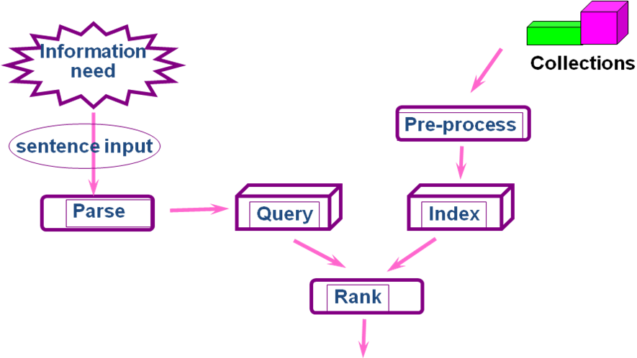
Results

