Original Article
Tri-Modal Fusion of Perfusion Neuroimaging, Radiomics, and Clinical Data for 90-Day Outcome Prediction in Acute Ischemic Stroke
Yingwei Guo, PhD¹, Saitao You, PhD¹, Lisha Zhang, PhD², Hongbo Bi, PhD¹, Cong Zhang, PhD¹, Zhichao Wang, PhD¹, Yingjian Yang, PhD³, Hongcai Wang, PhD⁴, Lingchuan Sun, PhD¹
¹ College of Electrical and Information Engineering, Northeast Petroleum University, Daqing 163318, China
² Department of Obstetrics and Gynecology, Daqing People's Hospital, Daqing 163318, China
³ Department of Radiological Research and Development, Shenzhen Lanmage Medical Technology Co., Ltd, Shenzhen 518000, China
⁴ University Hospital, Northeast Petroleum University, Daqing 163318, China
Corresponding Authors:
Lingchuan Sun, PhD, College of Electrical and Information Engineering, Northeast Petroleum University, Daqing 163318, China. Tel: 0459-6503272
Lisha Zhang, PhD, Department of Obstetrics and Gynecology, Daqing People's Hospital, Daqing 163318, China. Tel: 0459-6503272
Yingjian Yang, PhD, Department of Radiological Research and Development, Shenzhen Lanmage Medical Technology Co., Ltd, Shenzhen 518000, China. Tel: 0459-6503272
Emails: sunlingchuan@nepu.edu.cn; 714030471@qq.com; yingjian.yang@lanmage.com
Funding Information:
National Natural Science Foundation of China, Grant/Award Number: 82572349; Heilongjiang Province Natural Science Foundation Joint Guidance Project, Grant/Award Number: LH2024F044; Weifang Science and Technology Development Plan Project in Shandong Province, China, Grant/Award Number: 2025YX093; China Postdoctoral Science Foundation, Grant/Award Number: 2023M741054; General Program of China Postdoctoral Science Foundation, Grant/Award Number: 2024M750398

Abstract
Background and Purpose: Early prediction of 90-day outcome in acute ischemic stroke (AIS) may assist treatment stratification and post-acute planning. We developed Tri-CAF, a tri-modal cross-attention framework for prognosis prediction using perfusion imaging, dynamic radiomics, and clinical variables.
Methods: This retrospective multicenter study included an internal perfusion-weighted imaging cohort (77 AIS patients) and an external multicenter computed tomography perfusion cohort from ISLES 2024 (149 AIS patients), both evaluated with five-fold stratified cross-validation. Tri-CAF combines paired temporal maximum- and minimum-intensity projections of 4D perfusion data encoded by a hierarchically frozen Swin-UNETR, dual-domain radiomics across 40 perfusion frames encoded with a transformer, and structured clinical variables encoded with a grouped multilayer perceptron. The primary endpoint was 90-day modified Rankin Scale dichotomized as favorable (0–2) versus poor (3–6). Performance was assessed with AUC, accuracy, F1-score, precision, and recall, with 95% confidence intervals estimated by 1000 bootstrap resamples.
Results: Tri-CAF achieved AUCs of 0.813 (95% CI: 0.709–0.896) and 0.836 (95% CI: 0.764–0.897) with accuracies of 0.740 and 0.813 in the internal and external cohorts, respectively. Compared with late fusion, Tri-CAF increased AUC from 0.716 to 0.813 in the internal cohort and from 0.765 to 0.836 in the external cohort. Among ablation baselines, radiomics was the strongest unimodal model, and image-radiomics was the strongest bimodal model.
Conclusions: Tri-CAF provides a multimodal framework for AIS prognosis by combining perfusion compression, dynamic radiomics, and guided cross-modal fusion, with favorable discrimination in both cohorts.
Keywords: acute ischemic stroke, prognosis prediction, perfusion imaging, radiomics, cross-attention fusion, multimodal deep learning

Introduction
Acute ischemic stroke (AIS) remains a major cause of death and long-term disability worldwide. Despite improvements in reperfusion therapy, a substantial proportion of patients still experience poor 90-day functional outcomes after apparently successful recanalization (1,2). This mismatch between angiographic success and clinical recovery reflects marked inter-patient heterogeneity in collateral status, infarct evolution, and reperfusion injury. Accordingly, robust early prognosis models are clinically relevant for treatment selection, peri-procedural management, and rehabilitation planning (3,4). Recent systematic reviews have highlighted the growing potential of deep learning approaches for stroke outcome prediction (5,6), while machine learning models have shown promise in improving prognostic accuracy compared with conventional clinical scoring systems (7). A recent comprehensive review further emphasized that AI-assisted approaches can achieve clinically meaningful performance with area under the curve values above 0.80 when integrating multimodal data (8).
Reliable outcome prediction in AIS requires integration of complementary data sources. Clinical variables such as age, vascular risk factors, and baseline National Institutes of Health Stroke Scale (NIHSS) scores remain central to routine assessment (9,10), but clinical information alone does not directly quantify tissue viability or hemodynamic reserve. Imaging biomarkers therefore provide essential objective information for prognosis modeling.
Perfusion imaging is particularly attractive because it captures dynamic cerebral hemodynamics. Compared with static angiographic imaging, 4D perfusion imaging, including perfusion-weighted imaging (PWI) and CT perfusion (CTP), better characterizes collateral filling, infarct core, and potentially salvageable tissue (11,12,13). However, direct learning from full temporal perfusion sequences introduces substantial redundancy, increases computational burden, and may aggravate overfitting in limited medical datasets (14,15). These issues reduce the practical utility of raw 4D perfusion tensors for outcome prediction.
Radiomics provides additional quantitative descriptors by characterizing intensity and texture heterogeneity from medical images (16,17). Prior studies have shown that radiomics can improve prediction of stroke outcome and tissue evolution when combined with imaging or clinical baselines (18,19). Nevertheless, most existing radiomics pipelines focus on spatial-domain descriptors and pay limited attention to temporal-frequency patterns embedded in dynamic perfusion data. In parallel, multimodal studies often rely on direct concatenation or late fusion, which insufficiently model the semantic mismatch between high-dimensional imaging features and low-dimensional structured clinical variables (20,21,22). Recent advances in vision transformers have demonstrated superior capability in capturing long-range dependencies compared with conventional convolutional architectures (23,24). Cross-attention mechanisms, in particular, have emerged as an effective strategy for aligning heterogeneous data modalities by enabling dynamic information retrieval across feature spaces (25,26). Attention-based multimodal fusion approaches have shown promising results in various medical image analysis tasks (27). Fully automated multimodal MRI-based approaches have also been developed for recanalization prediction in ischemic stroke patients (28), demonstrating the clinical utility of integrating multiple imaging sequences. These developments provide new opportunities for designing more sophisticated multimodal fusion strategies in medical prognosis modeling.
In this study, we propose Tri-CAF, a tri-modal cross-attention framework that integrates spatiotemporal extreme-value projection, dual-domain radiomics encoding, and cascaded cross-attention fusion to predict 90-day functional outcome in AIS. The purpose of this study was to evaluate whether this framework can improve multimodal prognosis prediction under limited sample size and cross-cohort heterogeneity settings.

Materials and Methods

Compliance with ethical standards
This retrospective study was approved by the Institutional Review Board of the corresponding author's institution (approval no. NEPU-IRB-2024-018), and the requirement for informed consent was waived due to the retrospective nature of the study. The external cohort (ISLES 2024) is a publicly available dataset with open access; its use complied with the challenge's data use agreement. All patient data were anonymized before analysis.

Overall framework
We propose Tri-CAF, a tri-modal deep learning framework for 90-day outcome prediction in AIS (Fig. 1). The framework includes four components: (1) preprocessing for multimodal 4D perfusion imaging, dynamic radiomics sequences, and structured clinical data using spatiotemporal extreme-value projection; (2) modality-specific encoders, including Swin-UNETR for imaging, a dual-domain radiomics encoder, and a grouped clinical encoder; (3) cascaded cross-attention, in which imaging features sequentially query clinical and radiomics representations; and (4) an aggregation and classification head that outputs the probability of favorable or poor 90-day outcome.

Data input and preprocessing
To support the tri-modal architecture and reduce cross-domain heterogeneity, we used a standardized preprocessing pipeline including image cleaning, cross-modal normalization, dynamic radiomics extraction, and structured clinical transformation.

Physically informed dimensionality reduction and multi-window mapping
For raw 4D perfusion sequences, skull stripping was first performed using threshold segmentation and morphological operations, followed by affine registration to the dynamic perfusion space. Paired spatiotemporal extreme-value projection images were then generated by extracting the voxel-wise temporal maximum and minimum signals. To harmonize dynamic range across centers and modalities while improving perfusion conspicuity, a multi-channel windowing and clipping strategy was applied. After conversion to a standard neuroimaging orientation, three independent channels with predefined centers and widths were used to generate normalized stacked tensors for model input. The temporal maximum-intensity projection was defined as follows:
$$I_{tMIP}(x,y,z)=\max_{1≤t≤T}I(x,y,z,t),$$
where I(x,y,z,t) denotes the perfusion signal at voxel (x,y,z) and time point t. In the corresponding minimum-intensity form,
$$I_{tMinIP}(x,y,z)=\min_{1≤t≤T}I(x,y,z,t).$$
For multi-window mapping, three channel-specific window centers C_k and widths W_k were used: (C_1=40, W_1=80) for brain tissue visualization, (C_2=80, W_2=200) for subdural window, and (C_3=40, W_3=380) for extended soft tissue context. After clipping within each window, min-max normalization was applied and the three channels were stacked to form the final tensor X_(img).

Foreground cropping and spatial resampling
To reduce computational burden and remove irrelevant background, a dynamic-threshold-based foreground cropping operator was used to extract the minimum 3D bounding box enclosing the brain parenchyma. The cropped region of interest was then resampled to a standardized spatial resolution using trilinear interpolation without corner alignment to avoid spatial bias in downstream features.

Dynamic radiomics alignment and leakage-free normalization
Based on the registered brain-parenchymal foreground mask, high-throughput radiomics features were extracted frame by frame from 40 consecutive perfusion time points. B-spline interpolation and fixed gray-level discretization were applied. To address scale heterogeneity while avoiding data leakage, all continuous features were normalized using statistics estimated exclusively from the training set. Depending on cohort-specific distributions, either global tensor normalization across time or frame-wise normalization was applied, and the resulting transformation was fixed for validation and held-out test folds within each cohort.

Structured processing of clinical variables
Structured clinical variables, including demographic factors, neurological severity scores, and vascular risk histories, were transformed into machine-readable inputs. Time-related variables were converted to continuous values in minutes, and categorical features were binarized. Missing values were imputed with a constant baseline value and subsequently standardized using training-set statistics. This approach preserved matrix continuity while implicitly retaining potential information about missingness patterns.

Multidimensional data augmentation
To improve robustness under small-sample and multicenter settings, multidimensional online augmentation was applied during training. Geometric augmentation included random flipping, rotation, translation, and scaling. Intensity perturbation included random intensity shifting, Gaussian noise, gamma correction, and random masking. All augmentations were disabled during validation and testing.

Modality-specific feature encoding

Swin-UNETR imaging encoder with hierarchical freezing
For spatial anatomical feature extraction from 3D perfusion tensors, a Swin-UNETR backbone based on windowed self-attention was adopted (24). To accelerate convergence under limited sample sizes, pretrained weights from self-supervised pre-training on large-scale medical imaging datasets were used. Because the pretrained model was trained on single-channel input, an adaptive channel-expansion strategy was employed by replicating the patch-embedding weights across the three input channels and dividing by sqrt(3) to preserve activation variance. A hierarchical freezing strategy was implemented: the patch-embedding layer and the first two stages (layers1 and layers2) were frozen to preserve low-level visual features, whereas the last two stages (layers3 and layers4) along with the projection head were fine-tuned to adapt to perfusion-specific semantics. The resulting imaging feature map was projected to a 512-channel representation while preserving spatial topology.

Dual-domain radiomics encoder with temporal-frequency modeling
To overcome the limitation of static global radiomics encoding, we modeled the 40-frame dynamic radiomics sequence in both temporal and frequency domains. Let X_(rad)(R)^(B× T× F) denote the radiomics sequence, where B is the batch size, T is the number of temporal frames, and F is the feature dimension. Temporal features were projected into a hidden space,
$$H_{t}=X_{rad}W_{t}+b_{t},$$
and a real-valued FFT was applied along the temporal axis to obtain spectral magnitude features,
$$H_{f}=|RFFT(X_{rad},dim=1)|.$$
Zero-padding was used where necessary to align temporal and frequency sequence lengths to T. The two branches were concatenated and compressed through a fusion projection,
$$F_{rad}=Proj([H_{t};H_{f}]).$$
A transformer encoder with a prepended CLS token was then used to model global dependencies. Instead of retaining only the CLS token, the full normalized sequence was preserved for downstream cross-attention, providing a fine-grained radiomics memory bank.

Grouped clinical encoder
Rather than directly concatenating heterogeneous clinical variables, we constructed a grouped clinical encoder inspired by clinical reasoning. Using the external cohort as an example, variables were organized into semantically meaningful groups, including demographics, neurological baseline, vascular risk factors, treatment timing, and severity-scale information. Each group was processed by an independent two-layer multilayer perceptron and then stacked into a structured sequence representation, thereby reducing numerical conflict across heterogeneous variables and preserving clinically coherent grouping.

Cascaded cross-attention fusion
Conventional late fusion assumes independence across modalities and is therefore ill-suited to heterogeneous feature spaces. We designed a cascaded cross-attention module that mirrors the clinical reasoning process in which imaging findings guide the retrieval of relevant clinical and radiomic information.
Before interaction, all modality-specific features were projected into a common fusion dimension. The Swin-UNETR feature map was reduced through a 3D convolution and flattened into an imaging token sequence, while the grouped clinical sequence and radiomics sequence were linearly projected into the same latent space. The image sequence can be written as
$$F_{img}=LayerNorm(Flatten({Conv}_{1×1×1}(X_{img}))),$$
where the sequence length satisfies S=D× H× W after spatial flattening.
In the first stage, imaging tokens served as queries and clinical tokens served as keys and values. This allowed each spatial imaging location to dynamically attend to relevant clinical priors. The corresponding scaled dot-product attention was formulated as follows:
$$A_{cli}=Softmax(\frac{(F_{img}W_{Q})(F_{cli}W_{K})^{T}}{\sqrt{d}}),$$
$${F′}_{img}=F_{img}+A_{cli}(F_{cli}W_{V}),$$
where W_(Q), W_(K), and W_(V) are learnable projection matrices and d is the head dimension.
In the second stage, the clinically enhanced imaging representation was used as the query for a second cross-attention operation over the radiomics sequence, enabling dynamic perfusion texture information to be injected into the macro-anatomical representation:
$${F′′}_{img}={F′}_{img}+Softmax(\frac{({F′}_{img}{W′}_{Q})(F_{rad}{W′}_{K})^{T}}{\sqrt{d}})(F_{rad}{W′}_{V}).$$

Aggregation and classification
The deeply aligned multimodal feature sequence was further processed by a feed-forward network with GELU activation. Global average pooling was then applied over the spatial dimension to obtain a compact patient-level representation, which was finally passed to a multilayer perceptron classifier to predict 90-day functional outcome. The final prediction probability can be written as
$$ŷ=sigma(MLP(GAP(FFN({F′′}_{img})))),$$
where σ() denotes the sigmoid activation.

Experiments

Datasets
To evaluate robustness, small-sample adaptability, and cross-modal generalization, experiments were conducted in two independent AIS cohorts using a consistent architecture, preprocessing pipeline, and hyperparameter configuration.
The internal cohort comprised 77 patients with AIS from a private dataset and included PWI, diffusion-weighted imaging, and complete 90-day modified Rankin Scale (mRS) follow-up data. This cohort was mainly used to evaluate performance under a small-sample setting and to support ablation analysis. The external cohort was derived from the ISLES 2024 multicenter public challenge dataset and included 149 patients with CT-based baseline imaging and 4D perfusion sequences. This cohort was used to evaluate robustness to cohort, center, and modality shifts under the same evaluation protocol.
Baseline clinical characteristics and 90-day outcomes are summarized in Table 1. Differences in some baseline characteristics were observed between cohorts, whereas outcome distribution was broadly similar, reflecting the heterogeneity expected in real-world multicenter datasets.

Experimental design
The experimental design was intended to assess the effectiveness, generalizability, and contribution of each Tri-CAF component. Five-fold stratified cross-validation was adopted so that the outcome distribution in each fold matched that of the full dataset. Within each fold, an independent validation split was used for hyperparameter tuning and threshold selection, and sample uniqueness checks were applied to prevent leakage. The entire procedure was conducted independently in the internal MRI cohort and the external CT cohort, so the reported results reflect parallel evaluation under matched protocols rather than a single train-on-one/test-on-the-other hold-out experiment.
Ablation experiments were designed under strict variable control and included three levels: (1) unimodal baselines using only clinical, imaging, or radiomics features; (2) bimodal fusion baselines using image-clinical, image-radiomics, and clinical-radiomics combinations with concatenation-based fusion; and (3) multimodal fusion comparisons between conventional late fusion and the proposed cascaded cross-attention strategy.
Representative literature baselines were also included, namely deep affine transformation fusion (DAFT) as a strong linear-fusion method and direct spatiotemporal modeling of raw 4D perfusion data as a high-dimensional alternative (21,14).

Implementation details
The framework was implemented in PyTorch and trained on a high-performance GPU platform suitable for 3D networks. Gradient accumulation was set to 8, increasing the effective batch size from 4 to 32. The AdamW optimizer was used with an initial learning rate of 1×10^(-4) and weight decay of 0.05. A cosine annealing warm-restart schedule was applied, together with automatic mixed precision to improve efficiency. To handle class imbalance, focal loss was used (29). At inference, test-time augmentation with sagittal flipping was applied and predictions were averaged across the original and flipped images. The random seed was fixed to 42 for reproducibility.

Statistical analysis
A comprehensive set of metrics was used, including AUC, accuracy, macro F1-score, precision, and recall. Receiver operating characteristic curves, precision-recall curves, and confusion matrices were generated for visualization. For all major metrics, 95% confidence intervals were estimated using 1000 bootstrap resamples.

Results

Dual-domain radiomics representation
Before evaluating overall predictive performance, we visualized the extracted dynamic radiomics features to assess the dual-domain encoding strategy. Time-domain heatmaps showed normalized radiomics trajectories across 40 perfusion frames, whereas frequency-domain heatmaps obtained after FFT revealed concentrated frequency-specific patterns. Compared with the more dispersed temporal representation, the frequency-domain view more clearly highlighted compact dynamic texture patterns in the perfusion foreground. These observations suggest that frequency-domain features may complement temporal variation and provide stable inputs for multimodal fusion (Fig. 2).

Ablation analysis of multimodal complementarity
Comprehensive ablation studies were performed in both cohorts. Among unimodal models, radiomics achieved the highest AUC in both the internal PWI cohort (0.744) and the external CTP cohort (0.700), whereas clinical-only and imaging-only models were more limited. Among bimodal models, image-radiomics performed best in both cohorts, with AUCs of 0.785 internally and 0.833 externally; clinical-radiomics also yielded competitive external performance (AUC 0.776). These findings are consistent with complementarity between macroscopic imaging representations and compact perfusion texture descriptors.
At the multimodal level, conventional late fusion did not fully exploit this complementarity. In the internal cohort, late fusion reached an AUC of 0.716, and in the external cohort it reached 0.765. In contrast, Tri-CAF achieved an AUC of 0.813 (95% CI: 0.709–0.896) in the internal cohort and 0.836 (95% CI: 0.764–0.897) in the external cohort, suggesting that cross-attention-guided semantic alignment may better reconcile heterogeneous feature spaces and improve robustness (Fig. 3).

Comparison with representative fusion methods
To benchmark the proposed framework against representative fusion strategies, we further compared Tri-CAF with conventional late fusion, a direct spatiotemporal modeling approach, and DAFT-based multimodal fusion on the ISLES 2024 dataset. Tri-CAF ranked highest by AUC and showed the most balanced overall classification profile in this cohort (Table 4).

Overall discrimination and cross-modal stability
Receiver operating characteristic analysis showed that Tri-CAF maintained the highest AUC among the plotted models in both the internal PWI cohort and the external CTP cohort (Fig. 4). Five-fold metric distributions for Tri-CAF remained comparatively compact, particularly in the external multicenter cohort, where AUC, accuracy, and F1-score stayed within relatively narrow ranges across folds (Fig. 5). This pattern is consistent with a multimodal representation that was not obviously dominated by center-specific noise or modality-specific instability.

Prediction balance and potential clinical utility
Balanced identification of favorable and poor outcomes is essential for clinical deployment. In the internal cohort, Tri-CAF correctly identified poor and favorable outcomes at rates of 71.4% and 76.2%, respectively. In the external cohort, these rates increased to 80.0% and 81.8%, indicating a favorable sensitivity-specificity balance (Fig. 6). This pattern suggests potential utility as a decision-support tool for early risk stratification.

Discussion
This study presents a tri-modal deep learning framework for predicting 90-day functional outcome in AIS from perfusion imaging, radiomics, and structured clinical variables. Across two cohorts evaluated independently under matched five-fold protocols, including an internal PWI cohort and an external multicenter CTP cohort, Tri-CAF showed favorable discrimination and numerically outperformed conventional late fusion. These findings suggest that the proposed design may improve multimodal prognosis modeling in settings characterized by limited sample size and cross-cohort heterogeneity.
One strength of the framework is its physically informed dimensionality reduction for 4D perfusion imaging. Although direct learning from raw temporal sequences may preserve more complete hemodynamic information, it is computationally demanding and vulnerable to redundancy and acquisition variability. The paired tMIP/tMinIP strategy compresses temporal information into a more manageable representation while retaining salient perfusion extremes related to collateral patterns. This design is well suited to heterogeneous acquisition conditions.
Another strength is the dual-domain radiomics encoder. By jointly modeling temporal trajectories and FFT-derived frequency information, it captures dynamic perfusion texture variation beyond conventional static radiomics descriptors. The ablation results indicate that radiomics contributed strongly to standalone and fused performance, supporting the value of structured integration of handcrafted and learned perfusion descriptors.
The fusion strategy is also important. Conventional concatenation-based multimodal fusion often assumes straightforward compatibility across modalities, which is rarely true in stroke datasets combining dense imaging features with sparse structured variables. In Tri-CAF, imaging features guide retrieval from clinical and radiomics representations through cascaded cross-attention. This mechanism improved performance over late fusion in both cohorts, suggesting that guided inter-modal interaction may help reduce modality conflict and improve semantic consistency.

Limitations
Several limitations should be acknowledged. First, the internal cohort was relatively small and retrospectively collected, which may limit statistical precision despite the use of cross-validation and bootstrap confidence intervals. Second, the present study focused on binary prediction of 90-day modified Rankin Scale outcomes; ordinal regression approaches may provide a more clinically nuanced endpoint in future work. Third, although an external multicenter cohort was included, the study design reflects parallel cross-cohort evaluation rather than strict hold-out external validation, and the model was not compared against established clinical scoring systems such as the iScore (30). Fourth, interpretability remains limited at the voxel level despite the improved multimodal interaction provided by the fusion design. Future work should incorporate explainability analysis such as attention visualization or Grad-CAM, prospective hold-out external validation, and comparison with clinically established prognostic scores to strengthen translational value.

Conclusion
Tri-CAF integrates spatiotemporal extreme-value projection, dual-domain radiomics encoding, and cascaded cross-attention to predict 90-day functional outcome in acute ischemic stroke. Parallel evaluation in an internal PWI cohort and an external multicenter CTP cohort showed favorable discrimination and consistently better performance than conventional late fusion. These results support the potential of the proposed framework as a computer-aided solution for stroke prognosis based on multimodal perfusion imaging, radiomics, and structured clinical data.

Data Availability
The ISLES 2024 dataset used in this study is publicly available through the challenge organizers. The internal PWI cohort data are not publicly available due to privacy restrictions but may be available from the corresponding author upon reasonable request. The implementation code is available from the authors upon reasonable request and will be publicly released after completion of peer review.

Conflict of Interest
The authors declare that they have no known competing financial interests or personal relationships that could have appeared to influence the work reported in this study.

Acknowledgments
The authors thank the ISLES 2024 challenge organizers for providing the public dataset.

Author Contributions
Yingwei Guo:Conceptualization, Methodology, Software, Writing – original draft.Saitao You:Data curation, Investigation.Lisha Zhang:Data curation, Supervision, Writing – review and editing.Hongbo Bi:Supervision, Writing – review and editing.Cong Zhang:Validation, Visualization.Zhichao Wang:Validation, Visualization.Yingjian Yang:Resources, Supervision, Writing – review and editing.Hongcai Wang:Investigation, Writing – review and editing.Lingchuan Sun:Conceptualization, Supervision, Writing – review and editing.

References
1. Holliday, E., others. Developing a multivariable prediction model for functional outcome after reperfusion therapy for acute ischaemic stroke: study protocol for the Targeting Optimal Thrombolysis Outcomes (TOTO) multicentre cohort study. BMJ Open. 2020;10(4):7.
2. Herzog, L., others. Deep Learning Versus Neurologists: Functional Outcome Prediction in LVO Stroke Patients Undergoing Mechanical Thrombectomy. Stroke. 2023;54(7):1761–1769.
3. Tong, E., others. The role of imaging in acute ischemic stroke. Neurosurgical Focus. 2014;36(1):17.
4. Sillanp\"a\"a, N.. Role of perfusion imaging in acute stroke. Panminerva Medica. 2013;55(1):29–41.
5. Nielsen, Askjell Fuhrmann, Andersen, Mikkel, Hansen, Martin, others. Deep learning for outcome prediction in acute ischemic stroke: A systematic review. European Radiology. 2023;33:1234–1245.
6. Heo, Joonnyung, Yoon, Jin Gyu, Park, Hyungjong, Kim, Young Dae, Nam, Hyo Suk, Heo, Ji Hoe. Machine learning-based model for prediction of outcomes in acute stroke. Stroke. 2022;53(4):1125–1132.
7. Bacchi, Simone, Zerner, Jordan, Dong, Benjamin, Bradley, William G., Cheng, Sophia, Jannes, James, Kleinig, Timothy, Koblar, Simon A., Smith, Erin, Maller, Jerome J., others. Prediction of outcome in acute ischemic stroke using machine learning. Biomedical Signal Processing and Control. 2023;82:104567.
8. Ramesh, Subasini, Umapathy, Snekhalatha. Revolutionizing acute ischemic stroke care: a systematic review of machine learning and deep learning applications in diagnosis and outcome prediction. The Egyptian Journal of Neurology, Psychiatry and Neurosurgery. 2026;62(1). doi:10.1186/s41983-026-01091-7.
9. Gu, Y. M., others. Prediction of post stroke depression with machine learning: A national multicenter cohort study. Journal of Psychiatric Research. 2025;187:123–133.
10. Badr, M. Y., others. Assessment of incidence of cerebral vascular diseases and prediction of stroke risk in chronic obstructive pulmonary disease patients using multimodal biomarkers. Clinical Respiratory Journal. 2023;17(3):211–228.
11. McDonough, R., others. Computed tomography-based triage of extensive baseline infarction: ASPECTS and collaterals versus perfusion imaging for outcome prediction. Journal of Neurointerventional Surgery. 2021;13(10):869–874.
12. Broocks, G., others. Quantitative Lesion Water Uptake as Stroke Imaging Biomarker: A Tool for Treatment Selection in the Extended Time Window?. Stroke. 2022;53(1):201–209.
13. Welle, F., others. Tissue Outcome Prediction in Patients with Proximal Vessel Occlusion and Mechanical Thrombectomy Using Logistic Models. Translational Stroke Research. 2024;15(4):739–749.
14. Amador, K., others. Providing clinical context to the spatio-temporal analysis of 4D CT perfusion to predict acute ischemic stroke lesion outcomes. Journal of Biomedical Informatics. 2024;149:105777.
15. Pinto, A., others. Enhancing Clinical MRI Perfusion Maps with Data-Driven Maps of Complementary Nature for Lesion Outcome Prediction. Medical Image Computing and Computer Assisted Intervention (MICCAI). 2018.
16. Lambin, Philippe, Rios-Velazquez, Emmanuel, Leijenaar, Ralph, Carvalho, Sara, van Stiphout, Ruud G. P. M., Granton, Patrick, Zegers, Catharina M. L., Gillies, Robert, Boellard, Ronald, Dekker, Andre, Aerts, Hugo J. W. L.. Radiomics: extracting more information from medical images using advanced feature analysis. European Journal of Cancer. 2012;48(4):441–446.
17. Gillies, Robert J., Kinahan, Paul E., Hricak, Hedvig. Radiomics: images are more than pictures, they are data. Radiology. 2016;278(2):563–577.
18. Oliveira, G., others. Deep Learning-Based Extraction of Biomarkers for the Prediction of the Functional Outcome of Ischemic Stroke Patients. Diagnostics. 2023;13(24):24.
19. Ramos, L. A., others. Combination of Radiological and Clinical Baseline Data for Outcome Prediction of Patients With an Acute Ischemic Stroke. Frontiers in Neurology. 2022;13:884486.
20. Zihni, E., others. Multimodal Fusion Strategies for Outcome Prediction in Stroke. International Joint Conference on Biomedical Engineering Systems and Technologies. 2020.
21. Borsos, B., others. Predicting stroke outcome: A case for multimodal deep learning methods with tabular and CT Perfusion data. Artificial Intelligence in Medicine. 2024;147:102748.
22. Liu, Y. K., others. Functional Outcome Prediction in Acute Ischemic Stroke Using a Fused Imaging and Clinical Deep Learning Model. Stroke. 2023;54(9):2316–2327.
23. Liu, Ze, Lin, Yutong, Cao, Yue, Hu, Han, Wei, Yixuan, Zhang, Zheng, Lin, Stephen, Guo, Baining. Swin Transformer: Hierarchical Vision Transformer using Shifted Windows. ICCV. 2021.
24. Hatamizadeh, Ali, Tang, Yucheng, Nath, Vishwesh, Yang, Dong, Myronenko, Andriy, Landman, Bennett, Roth, Holger R., Xu, Daguang. SwinUNETR: Swin Transformers for Semantic Segmentation of Brain Tumors in MRI Images. arXiv preprint arXiv:2201.01266. 2022.
25. P\"olsterl, Sebastian, Nascimento, Jo ao, Wachinger, Christian. Combining 3D Image and Tabular Data via the Deep Affine Transformation. International Conference on Medical Imaging with Deep Learning (MIDL). 2021.
26. Zhou, Jun, Chen, Wei, Huang, Yufei, Li, Xiaoming. Attention-based multimodal fusion for medical image analysis. Biomedical Signal Processing and Control. 2023;80:104321.
27. Wang, Li, Zhang, Hao, Liu, Mingxia, Shen, Dinggang. Deep learning-based brain lesion segmentation and classification using multimodal MRI. Biomedical Signal Processing and Control. 2024;86:105234.
28. Ahsan, Rafia, Vargas-Ibarra, Sof\'ia, Vigneron, Vincent, Maaref, Hichem, Garcia-Salicetti, Sonia. Fully Automated Recanalization Prediction in Ischemic Stroke Patients Using Multimodal MRI. Proceedings of the 19th International Joint Conference on Biomedical Engineering Systems and Technologies. 2026:312–319. doi:10.5220/0014310400004070.
29. Lin, Tsung-Yi, Goyal, Priya, Girshick, Ross, He, Kaiming, Doll\'ar, Piotr. Focal Loss for Dense Object Detection. ICCV. 2017.
30. Saposnik, Gustavo, Kapral, Moira K., Liu, Yang, Hall, Robert, O'Donnell, Martin J., Raptis, Sophia, Tu, Jack V., Mamdani, Muhammad, Austin, Peter C.. iScore: a risk score to predict death early after hospitalization for an acute ischemic stroke. Circulation. 2011;123(7):739–749.

Table 1. Baseline characteristics and 90-day outcomes of the two independent cohorts. mRS: modified Rankin Scale; IQR: interquartile range; SD: standard deviation; NIHSS: National Institutes of Health Stroke Scale.
Variable | PWI (N=77) | CTP (N=149)
Age, years (mean ± SD) | 71.6 ± 10.5 | 71.3 ± 14.6
Male sex, n (%) | 59 (76.6) | 75 (50.7)
Hypertension, n (%) | 58 (75.3) | 85 (57.4)
Diabetes mellitus, n (%) | 25 (32.5) | 24 (16.3)
Atrial fibrillation, n (%) | 27 (35.1) | 40 (27.2)
Admission NIHSS, median (IQR) | 11 (4–15) | 10 (6–16)
90-day mRS, median (IQR) | 2 (0–5) | 1 (0–4)
Favorable (mRS 0–2), n (%) | 42 (54.5) | 99 (66.4)
Poor (mRS 3–6), n (%) | 35 (45.5) | 50 (33.6)

Table 2. Five-fold cross-validation ablation results in the internal MRI cohort (77 patients). All values are reported as mean (95% CI). cli: clinical; img: imaging; rad: radiomics.
Model | Accuracy | F1-score | Precision | Recall | AUC
cli_only | 0.639 (0.532–0.740) | 0.635 (0.526–0.739) | 0.639 (0.531–0.743) | 0.640 (0.531–0.742) | 0.686 (0.572–0.798)
img_only | 0.532 (0.429–0.636) | 0.522 (0.412–0.629) | 0.553 (0.441–0.663) | 0.548 (0.448–0.647) | 0.540 (0.415–0.659)
rad_only | 0.702 (0.597–0.805) | 0.699 (0.593–0.805) | 0.712 (0.609–0.809) | 0.710 (0.605–0.811) | 0.744 (0.623–0.847)
img_cli | 0.595 (0.481–0.701) | 0.592 (0.480–0.700) | 0.601 (0.491–0.707) | 0.601 (0.491–0.709) | 0.573 (0.443–0.713)
img_rad | 0.727 (0.623–0.819) | 0.723 (0.622–0.818) | 0.725 (0.625–0.821) | 0.727 (0.623–0.827) | 0.785 (0.677–0.885)
cli_rad | 0.623 (0.506–0.728) | 0.619 (0.506–0.727) | 0.632 (0.520–0.740) | 0.631 (0.521–0.741) | 0.679 (0.555–0.799)
late_fusion | 0.621 (0.506–0.740) | 0.616 (0.506–0.737) | 0.620 (0.511–0.739) | 0.621 (0.511–0.740) | 0.716 (0.589–0.832)
Tri-CAF | 0.740 (0.636–0.831) | 0.735 (0.633–0.827) | 0.737 (0.636–0.830) | 0.737 (0.636–0.829) | 0.813 (0.709–0.896)

Table 3. Five-fold cross-validation ablation results in the external CT cohort (149 patients). All values are reported as mean (95% CI). cli: clinical; img: imaging; rad: radiomics.
Model | Accuracy | F1-score | Precision | Recall | AUC
cli_only | 0.618 (0.537–0.698) | 0.553 (0.470–0.639) | 0.558 (0.470–0.643) | 0.554 (0.473–0.638) | 0.582 (0.482–0.687)
img_only | 0.564 (0.483–0.644) | 0.520 (0.442–0.600) | 0.522 (0.443–0.601) | 0.523 (0.443–0.606) | 0.531 (0.430–0.627)
rad_only | 0.652 (0.584–0.732) | 0.624 (0.549–0.704) | 0.624 (0.551–0.700) | 0.634 (0.555–0.714) | 0.700 (0.603–0.790)
img_cli | 0.584 (0.503–0.664) | 0.551 (0.471–0.636) | 0.553 (0.477–0.635) | 0.557 (0.474–0.642) | 0.544 (0.442–0.644)
img_rad | 0.758 (0.691–0.832) | 0.728 (0.650–0.805) | 0.729 (0.651–0.810) | 0.730 (0.651–0.810) | 0.833 (0.761–0.900)
cli_rad | 0.691 (0.624–0.759) | 0.640 (0.559–0.717) | 0.648 (0.565–0.729) | 0.638 (0.559–0.712) | 0.776 (0.695–0.851)
late_fusion | 0.691 (0.617–0.765) | 0.667 (0.588–0.745) | 0.666 (0.589–0.741) | 0.679 (0.596–0.759) | 0.765 (0.683–0.840)
Tri-CAF | 0.813 (0.745–0.872) | 0.796 (0.723–0.863) | 0.790 (0.717–0.859) | 0.809 (0.736–0.874) | 0.836 (0.764–0.897)

Table 4. Performance comparison between Tri-CAF and representative existing fusion strategies on the ISLES 2024 dataset.
Method | AUC | F1-score | Accuracy | Precision | Recall
Late Fusion | 0.765 | 0.667 | 0.691 | 0.666 | 0.679
Spatiotemporal modeling (14) | 0.501 | 0.730 | 0.682 | 0.712 | 0.745
DAFT fusion (21) | 0.798 | 0.733 | 0.764 | 0.745 | 0.747
Tri-CAF (ours) | 0.836 | 0.796 | 0.813 | 0.790 | 0.809

Figures
Figure 1. The overall architecture of the proposed tri-modal cross-attention fusion framework. The pipeline consists of four main modules: (1) Data inputs and pre-processing, utilizing 4D perfusion-derived tMIP images, radiomics sequences, and clinical metadata; (2) Modality-specific encoding, featuring a frozen and trainable Swin-UNETR image encoder, a radiomics dual-domain encoder equipped with Fast Fourier Transform (FFT), and a Clinical Group-Wise Encoder; (3) Cross-attention fusion, where image tokens sequentially query clinical and radiomics tokens to achieve deep semantic alignment; and (4) Aggregation and classification for the final 90-day functional outcome prediction. tMIP: temporal Maximum Intensity Projection; FFN: Feed-Forward Network.
Figure 2. Visualization of radiomics feature representations in the time and frequency domains. The heatmaps illustrate the normalized values (Z-scores) of the extracted radiomics features across the temporal domain (left) and the frequency domain after Fast Fourier Transform (right). The dual-domain representation highlights compact dynamic texture patterns in the perfusion foreground.
Figure 3. Ablation study on the performance of different modalities and fusion strategies. The bar chart compares the area under the receiver operating characteristic curve (AUC) between the two cohorts. Blue bars represent the internal MRI cohort, and orange bars represent the external CT cohort. Error bars indicate the 95% confidence intervals (CI).
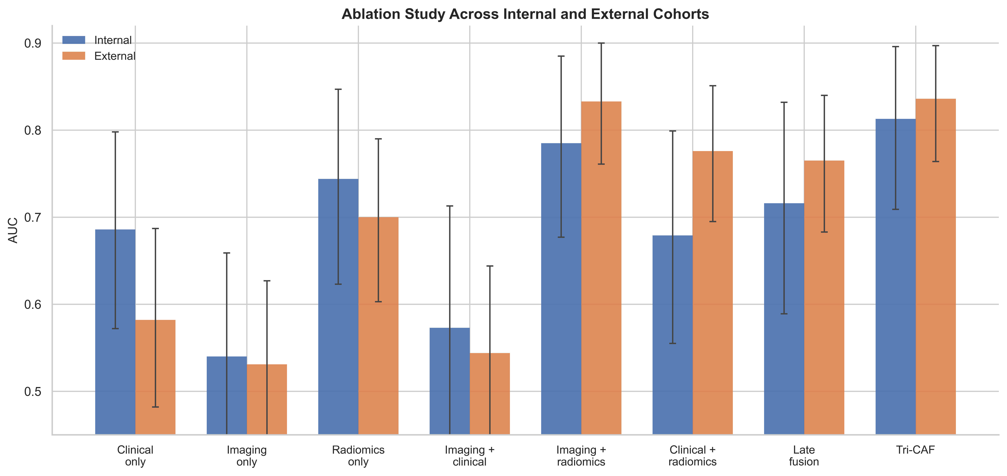
Figure 4. Receiver operating characteristic (ROC) curves for the two cohorts. Left: The internal PWI cohort. Right: The external CTP cohort.
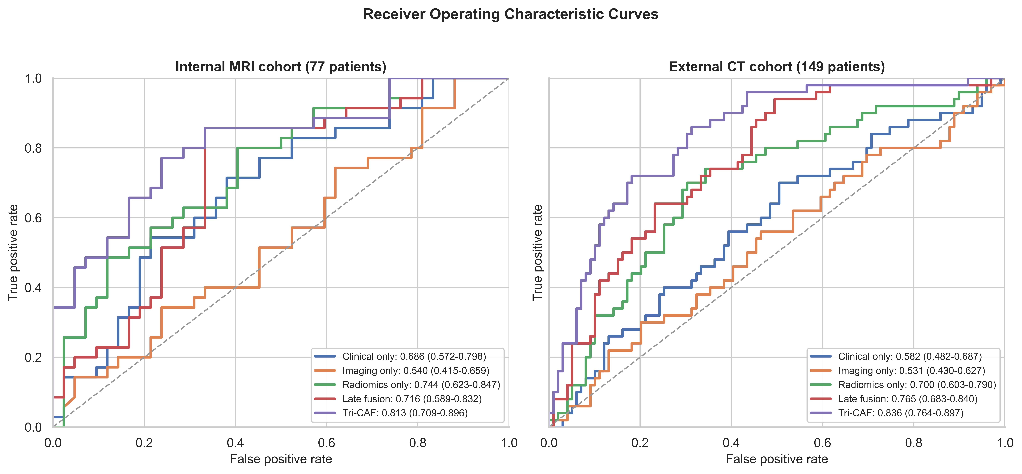
Figure 5. Five-fold performance distributions for Tri-CAF. Left: Internal MRI cohort. Right: External CT cohort. Boxplots summarize fold-wise AUC, accuracy, F1-score, precision, and recall.
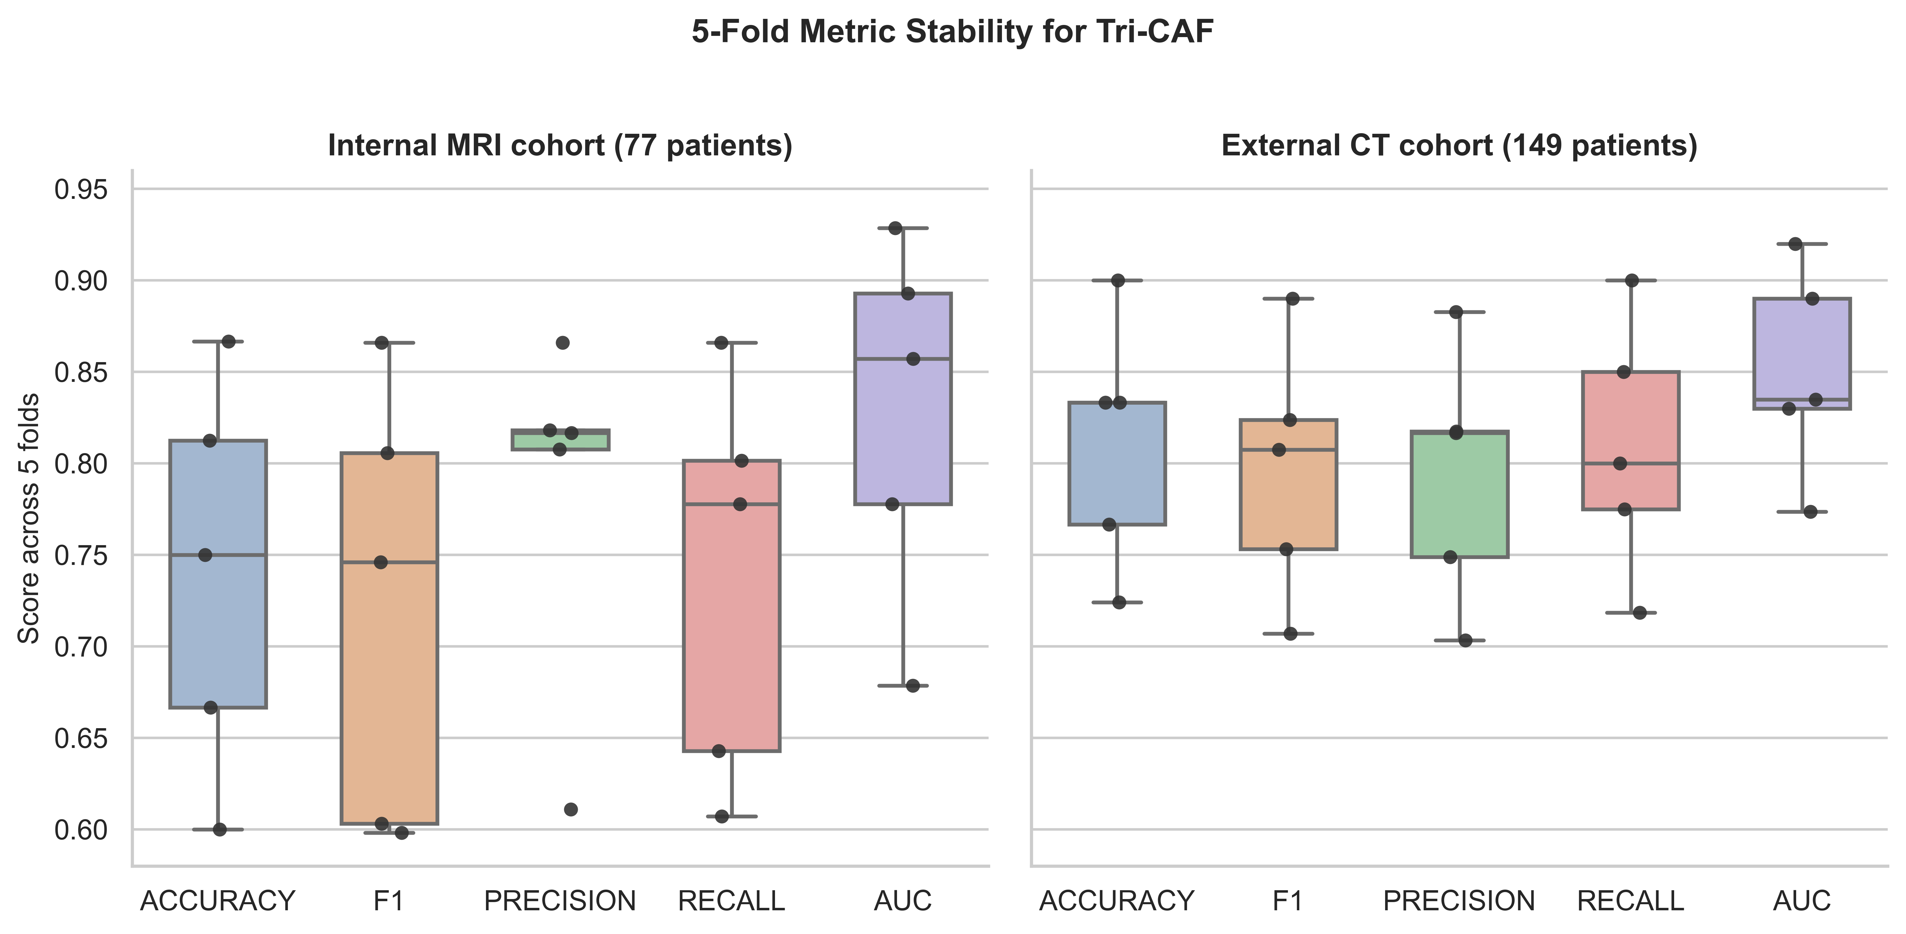
Figure 6. Out-of-fold confusion matrices for Tri-CAF predictions. Left: Internal PWI cohort. Right: External CTP cohort.
