Course5-minimum-snap by QP & close-form

QP-matlab

1.1 assignment
Homework 1.1: In matlab, use the ‘quadprog’ QP solver, write down a minimum snap trajectory generator

1.2 结果和分析
（1）图中，颜色曲线为计算的轨迹（xy座标），黑色为速度曲线(v-time座标)；
曲线共有8个节点，7segments;
（2）轨迹曲线光滑，速度曲线光滑，速度约束正确。对于图示轨迹，在1个节点附近有减速至0再回退的过程；

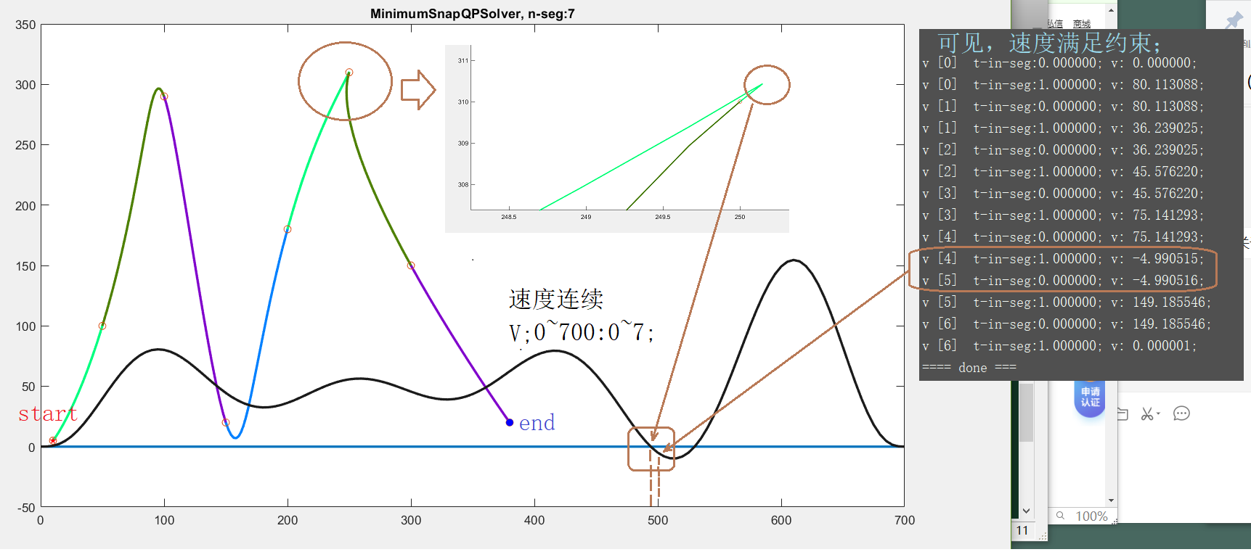

1.3主要code (matlab)

1.3.1计算A,q(边界条件和pvaj约束)
[Aeq beq]= getAbeq(n_seg, n_order, waypoints, ts, start_cond, end_cond)

%#####################################################
% p,v,a,j constraint in start,
Aeq_start = zeros(4, n_all_poly); %row-num,col-num; !! 4��Լ��;
beq_start = zeros(4, 1);
% STEP 2.1: write expression of Aeq_start and beq_start
% start_cond = [waypoints(1), 0, 0, 0]; NOTE��ʱ��0��4��Լ����
% end_cond = [waypoints(end), 0, 0, 0];
% p0~p7;
calc_pos=1;
Aeq_start(1,1)=1; %pose, t=0; p0;
Aeq_start(2,2)=1; %v,p1;
Aeq_start(3,3)=2; %acc,p2;
Aeq_start(4,4)=2*3; %jerk;p3;

beq_start=start_cond;
%#####################################################
% p,v,a constraint in end
Aeq_end = zeros(4, n_all_poly);
beq_end = zeros(4, 1);
% STEP 2.2: write expression of Aeq_end and beq_end
%p0~p7;
%calc_pos=n_all_poly-(n_order+1); %�ڽ�β�ļ���������p0~p7; old,err??
%calc_pos=1;
for k=0:size(end_cond,1)-1 %����:0,1,2,3��; k=k_No-1; %p34's k & (k); k�׵�����
%for i=calc_pos:n_all_poly
var_start=(n_seg-1)*(n_order+1)+1;
for i=0:n_order %n_all_poly-1
%p_No=i-calc_pos;
%for k=1:(n_order+1)
%if p_No>=(k-1)
if i>=k
%Aeq_end(k+1,i+1)=factorial(i)/factorial(i-k);
Aeq_end(k+1,i+var_start)=factorial(i)/factorial(i-k);
end
%end
end
end
beq_end=end_cond;

%#####################################################
% position constrain in all middle waypoints
Aeq_wp = zeros(n_seg-1, n_all_poly);
beq_wp = zeros(n_seg-1, 1);
% STEP 2.3: write expression of Aeq_wp and beq_wp
%
for j=0:(n_seg-1)-1
Aeq_wp(j+1, (j+1)*(n_order+1)+1 )=1;
beq_wp(j+1,:)=waypoints(j+1+1);
end
%##################################################### pos
% position continuity constrain between each 2 segments
Aeq_con_p = zeros(n_seg-1, n_all_poly);
beq_con_p = zeros(n_seg-1, 1);
% STEP 2.4: write expression of Aeq_con_p and beq_con_p
%
%k=0;
for j=0:(n_seg-1)-1
j_start=(j)*(n_order+1)+1;
for i=0:n_order
Aeq_con_p(j+1,j_start+i)=1;
end
j_1_start=(j+1)*(n_order+1)+1;
Aeq_con_p(j+1,j_1_start)=-1;
end

1.3.2计算Q（目标函数）
function Q = getQ(n_seg, n_order, ts)
Q = [];
for k = 1:n_seg
Q_k = [];
%#####################################################
% STEP 1.1: calculate Q_k of the k-th segment
% order: p0,p1,p7;
for i=5:(n_order+1)
for j=5:(n_order+1)
Q_k(i,j)=(i-1)*(i-2)*(i-3)*(i-4)*(j-1)*(j-2)*(j-3)*(j-4)/(i+j-1-1-7);
end
end

Q = blkdiag(Q, Q_k);
end

1.4 算法流程
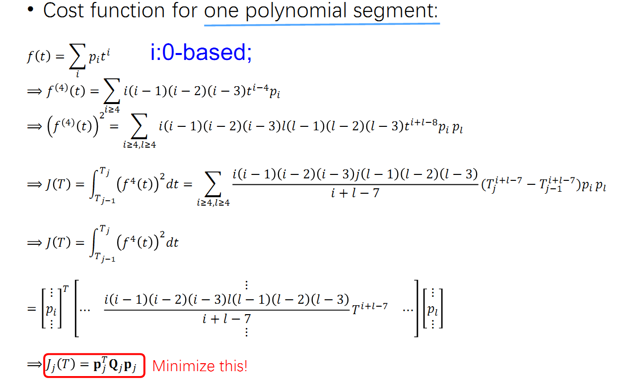
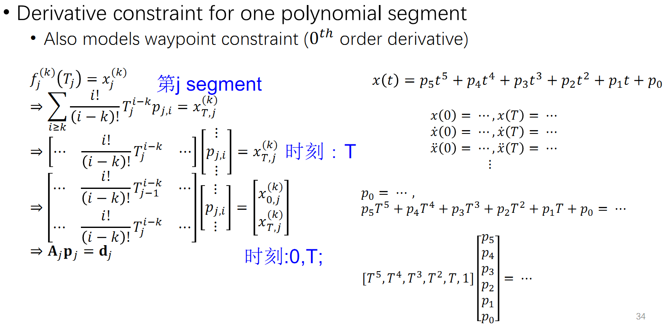
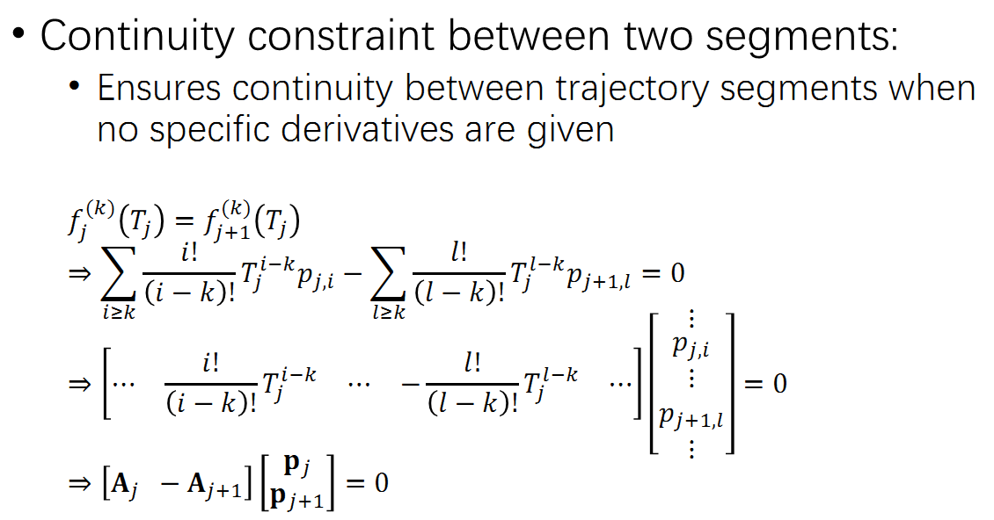

close-form-matlab

2.1assignment
Homework 1.2: In matlab, generate minimum snap trajectory based on the closed form solution

2.2Results & analyse

2.2.1轨迹
生成轨迹和QP方法相同；close-form的计算速度大大优于QP方法；
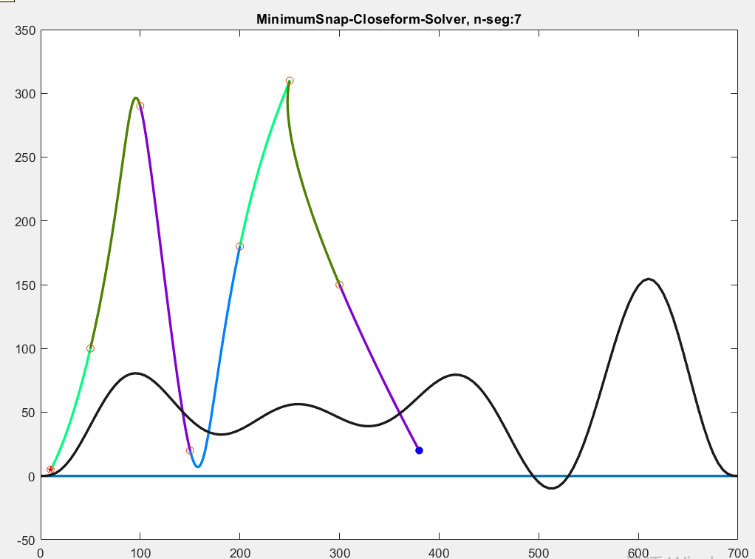

2.2.2和QP方法结果的对比(计算结果相同)
- QP方法得到的多项式参数和节点速度
=== QP solver ===

poly_coef_x =

10
0
0
0
216.47
-299.67
149.82
-26.619
50
80.113
-9.5823
-66.079
33.768
40.26
-36.511
8.0322
100
36.239
18.394
22.495
-31.472
-10.13
19.715
-5.241
150
45.576
-18.593
6.1651
30.162
-1.9039
-16.973
5.5662
200
75.141
24.136
-36.861
-39.128
13.151
21.991
-8.43
250
-4.9905
-36.867
82.911
61.445
-31.932
-37.019
16.453
300
149.19
51.449
-155.14
-77.632
91.475
78.155
-57.491

v [0] t-in-seg:0.000000; v: 0.000000;
v [0] t-in-seg:1.000000; v: 80.113088;
v [1] t-in-seg:0.000000; v: 80.113088;
v [1] t-in-seg:1.000000; v: 36.239025;
v [2] t-in-seg:0.000000; v: 36.239025;
v [2] t-in-seg:1.000000; v: 45.576220;
v [3] t-in-seg:0.000000; v: 45.576220;
v [3] t-in-seg:1.000000; v: 75.141293;
v [4] t-in-seg:0.000000; v: 75.141293;
v [4] t-in-seg:1.000000; v: -4.990515;
v [5] t-in-seg:0.000000; v: -4.990516;
v [5] t-in-seg:1.000000; v: 149.185546;
v [6] t-in-seg:0.000000; v: 149.185546;
v [6] t-in-seg:1.000000; v: 0.000001;
==== done ===
- Close-form方法得到的多项式参数和节点速度
~~~ close-form solver ~~~

poly_coef_x =

10
0
0
0
216.47
-299.67
149.82
-26.619
50
80.113
-9.5823
-66.079
33.768
40.26
-36.511
8.0322
100
36.239
18.394
22.495
-31.472
-10.13
19.715
-5.241
150
45.576
-18.593
6.1651
30.162
-1.9039
-16.973
5.5662
200
75.141
24.136
-36.861
-39.128
13.151
21.991
-8.43
250
-4.9905
-36.867
82.911
61.445
-31.932
-37.019
16.453
300
149.19
51.449
-155.14
-77.632
91.475
78.155
-57.491

v [0] t-in-seg:0.000000; v: 0.000000;
v [0] t-in-seg:1.000000; v: 80.113088;
v [1] t-in-seg:0.000000; v: 80.113088;
v [1] t-in-seg:1.000000; v: 36.239025;
v [2] t-in-seg:0.000000; v: 36.239025;
v [2] t-in-seg:1.000000; v: 45.576220;
v [3] t-in-seg:0.000000; v: 45.576220;
v [3] t-in-seg:1.000000; v: 75.141293;
v [4] t-in-seg:0.000000; v: 75.141293;
v [4] t-in-seg:1.000000; v: -4.990515;
v [5] t-in-seg:0.000000; v: -4.990515;
v [5] t-in-seg:1.000000; v: 149.185546;
v [6] t-in-seg:0.000000; v: 149.185546;
v [6] t-in-seg:1.000000; v: -0.000000;
==== done ===

2.3code

2.3.1 M（多项式系数和pvaj之间的对应矩阵）
function M = getM(n_seg, n_order, ts)
M = [];
for k = 1:n_seg
M_k = [];
%#####################################################
% STEP 1.1: calculate M_k of the k-th segment
% p0?p7; => pvaj (t=0) & pvaj (t=1);
% M p = d;
%M_row=zeros(1,(n_order+1));
M_k=zeros(8,n_order+1);
M_k(1, 1) = 1; %p(t=0);
M_k(2, 2) = 1; %v(t=0);
M_k(3, 3) = 2; %a(t=0);
M_k(4, 4) = 2*3; %j(t=0);

M_k(5, :) = [1,1,1,1, 1,1,1,1]; %p(t=1);
M_k(6, :) = [0,1,2,3, 4,5,6,7]; %v(t=1);
M_k(7, :) = [0,0,2,6, 12,20,30,42]; %a(t=1);
M_k(8, :) = [0,0,0,6, 24,60,120,210]; %j(t=1);

M = blkdiag(M, M_k);
end
end

2.3.2Ct（pvaj自由部分和固定部分与全部pvaj的对应矩阵,即选择矩阵）
function Ct = getCt(n_seg, n_order)
%#####################################################
% STEP 2.1: finish the expression of Ct
%[ dF
% dp ];
k=n_seg;

dF_dim=4+4+(n_seg-1);
dp_dim=4*k+4-(dF_dim);

Ct=zeros(8*k,4*k+4);
Ct(1,1)=1; %p0(t=0); %p00,v00,a00,j00;
Ct(2,2)=1;
Ct(3,3)=1;
Ct(4,4)=1; %j0(t=0);

for i=0:n_seg-1-1 % p01(p10); p11(p20); p21(p30);...
Ct(5+i*(n_order+1), 5+i) = 1; %p0(t=1); pj (t=1);
Ct(5+i*(n_order+1)+4, 5+i) = 1; %p1(t=0); pj+1(t=0);
end

Ct(8*k-4+1,4+(n_seg-1)+1 )=1; %pk(t=1)
Ct(8*k-4+2,4+(n_seg-1)+2 )=1; %vk(t=1)
Ct(8*k-4+3,4+(n_seg-1)+3 )=1; %ak(t=1)
Ct(8*k-4+4,4+(n_seg-1)+4 )=1; %jk(t=1)

for i=0:n_seg-1-1
start=i*(n_order+1);
start_dp=i*3;
Ct(start+6,dF_dim+start_dp+1)=1; %v0(t=1);
Ct(start+7,dF_dim+start_dp+2)=1; %a0(t=1);
Ct(start+8,dF_dim+start_dp+3)=1; %j0(t=1);

Ct(start+10,dF_dim+start_dp+1)=1; %v1(t=0);
Ct(start+11,dF_dim+start_dp+2)=1; %a1(t=0);
Ct(start+12,dF_dim+start_dp+3)=1; %j1(t=0);
end

2.4principles
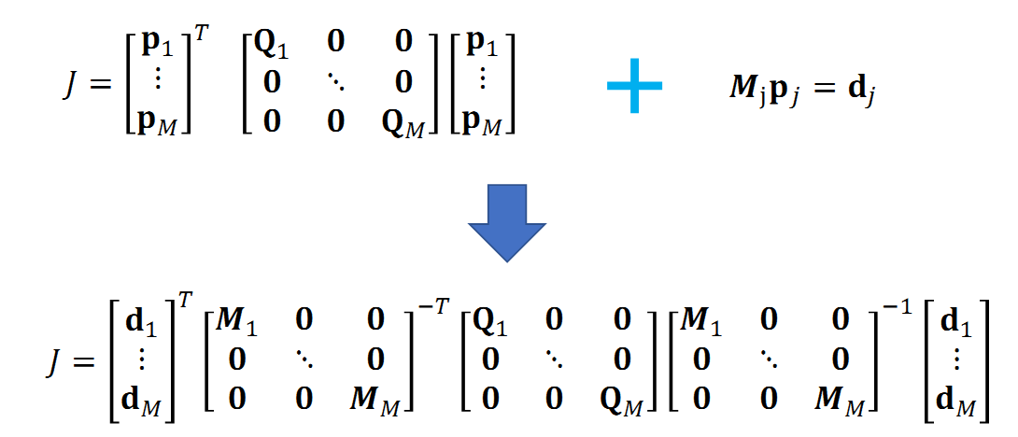
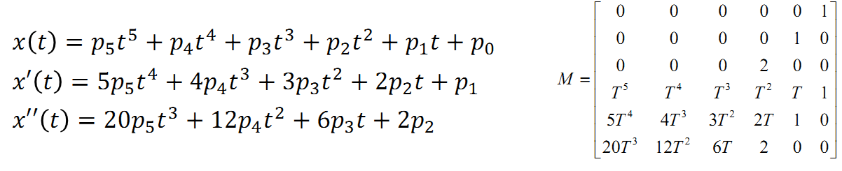
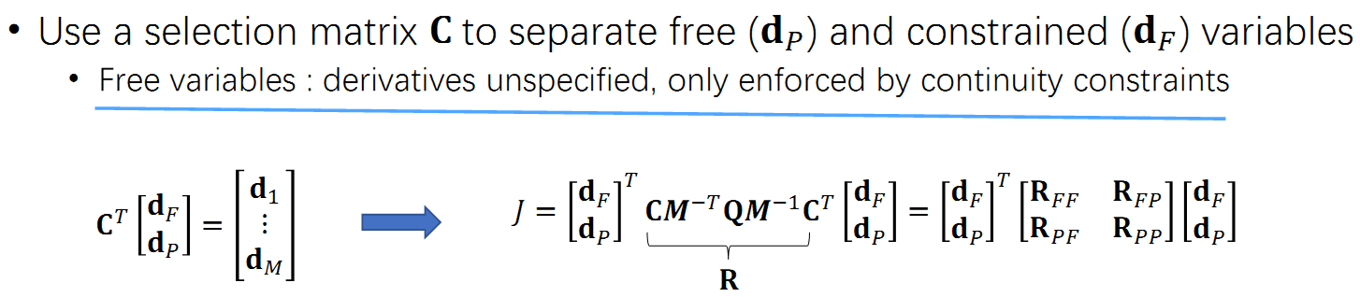


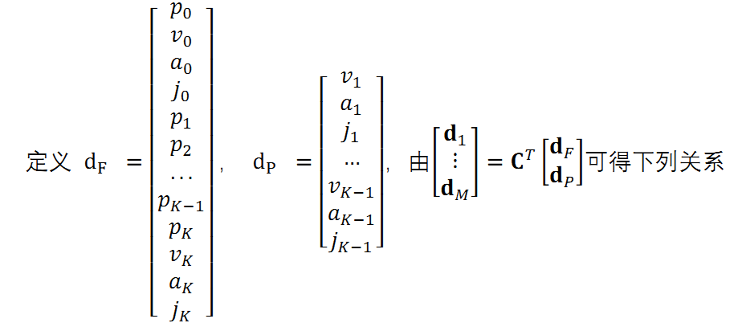
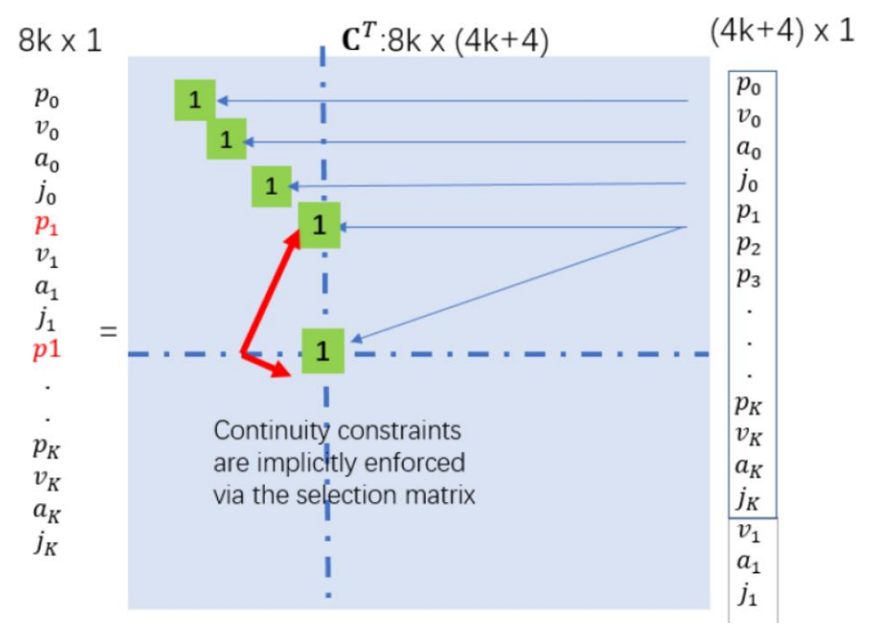

3.c++-OOQP
Homework 2.1: In C++/ROS, use the OOQP solver, write down a minimum snap trajectory generator

4.c++-close-form
Homework 2.2: In C++/ROS, use Eigen, generate minimum snap trajectory based on the closed form solution

