Course2-A*_Dijkstra_JPS

A* 和Dijkstra

1.1 assignment
• This project work will focus on path ﬁnding and obstacle avoidance in a 2D grid map.
• A 2D grid map is generated randomly every time the Project is run, which contains the
obstacles, start point and target point locations will be provided. You can also change
the probability of obstacles in the map in obstacle_map.m
• You need to implement a 2D A* path search method to plan an optimal path with safety
guarantee.

1.2 结果
（1）图中，绿色实心圆●为障碍物，黑色空心圆○为搜索过的区域，★为最优路径；
左下角为start,右上角为target/end;
- 可见,A*搜索范围小，速度快，但是结果不是最优；
Dijkstra搜索范围大，速度较慢，但是结果最优；
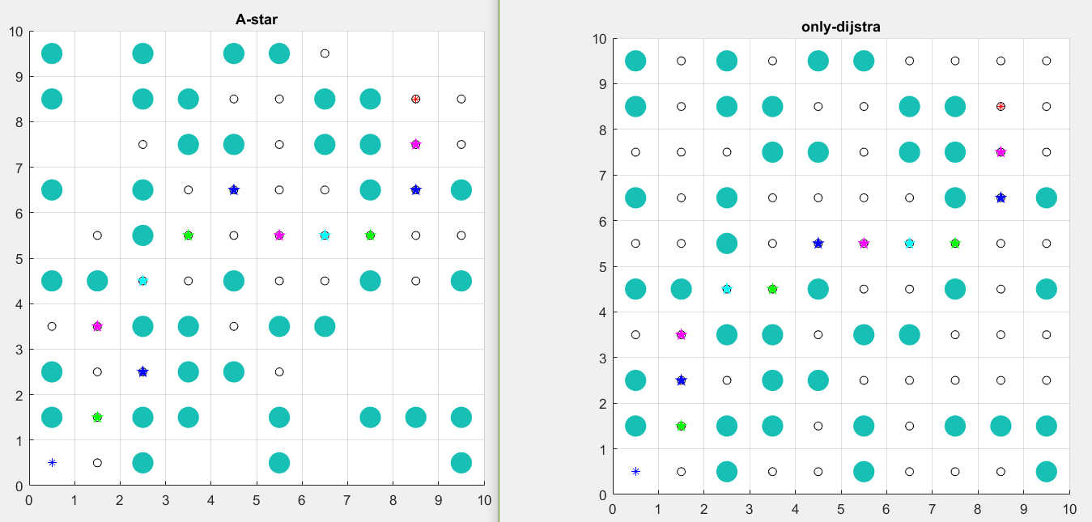

1.3主要code (matlab)
while(1)
exp_node_x=-1;exp_node_y=-1;
if is_1st_run
node_x=xNode; node_y=yNode;
exp_node_x=node_x;exp_node_y=node_y;
%ret: %|X val |Y val ||h(n) |g(n)|f(n)|;
exp_array=expand_array(node_x,node_y,gn,xTarget,yTarget,CLOSED,MAX_X,MAX_Y,only_dijstra);
a=0;
else
%�ҵ�unexpand��elem
unexpand_num=0;
for j=1:OPEN_COUNT
if (OPEN(j,1)==1) %==1:un-expanded;
unexpand_num=unexpand_num+1;
break;%only above 0; break for loop;
end
end
if unexpand_num==0 %if queue is empty,return FALSE(failed??),break;
break;
end
%open-list:%(1/0,xval,yval,parent_xval,parent_yval,hn,gn,fn)
i_min = min_fn(OPEN,OPEN_COUNT,xTarget,yTarget);
a=OPEN(i_min,:);
OPEN(i_min,1)=0;%expanded;
exp_node_x=OPEN(i_min,2); exp_node_y=OPEN(i_min,3);
tmp_gn=OPEN(i_min,7);
parentX=OPEN(i_min,4); parentY=OPEN(i_min,5);
CLOSED_COUNT=CLOSED_COUNT+1;
CLOSED(CLOSED_COUNT,1)=exp_node_x;
CLOSED(CLOSED_COUNT,2)=exp_node_y;

if OPEN(i_min,2)==xTarget && OPEN(i_min,3)==yTarget
NoPath=0; %this node is goal,return TRUE,break;
endOpenNo=i_min;
break;
end
%tmp_gn=distance(parentX,parentY, exp_node_x,exp_node_y);
%|X val |Y val ||h(n) |g(n)|f(n)|
exp_array=expand_array(exp_node_x,exp_node_y,tmp_gn,xTarget,yTarget,CLOSED,MAX_X,MAX_Y,only_dijstra);
end
%put expand into open-list??
%OPEN(OPEN_COUNT,1)=0;%expanded;
exp_array_num=size(exp_array,1);
for i=1:size(exp_array,1)
elem=exp_array(i,:);
OPEN_COUNT=OPEN_COUNT+1;
OPEN(OPEN_COUNT,:)=insert_open(elem(1),elem(2),exp_node_x,exp_node_y,elem(3),elem(4),elem(5));%(xNode,yNode,xNode,yNode,goal_distance,path_cost,goal_distance);
exp_rcd(size(exp_rcd,1)+1,:)=[elem(1),elem(2)];%!!!
end

is_1st_run=false;
%
%finish the while loop
%

a=0;
end %End of While Loop

1.4 算法流程
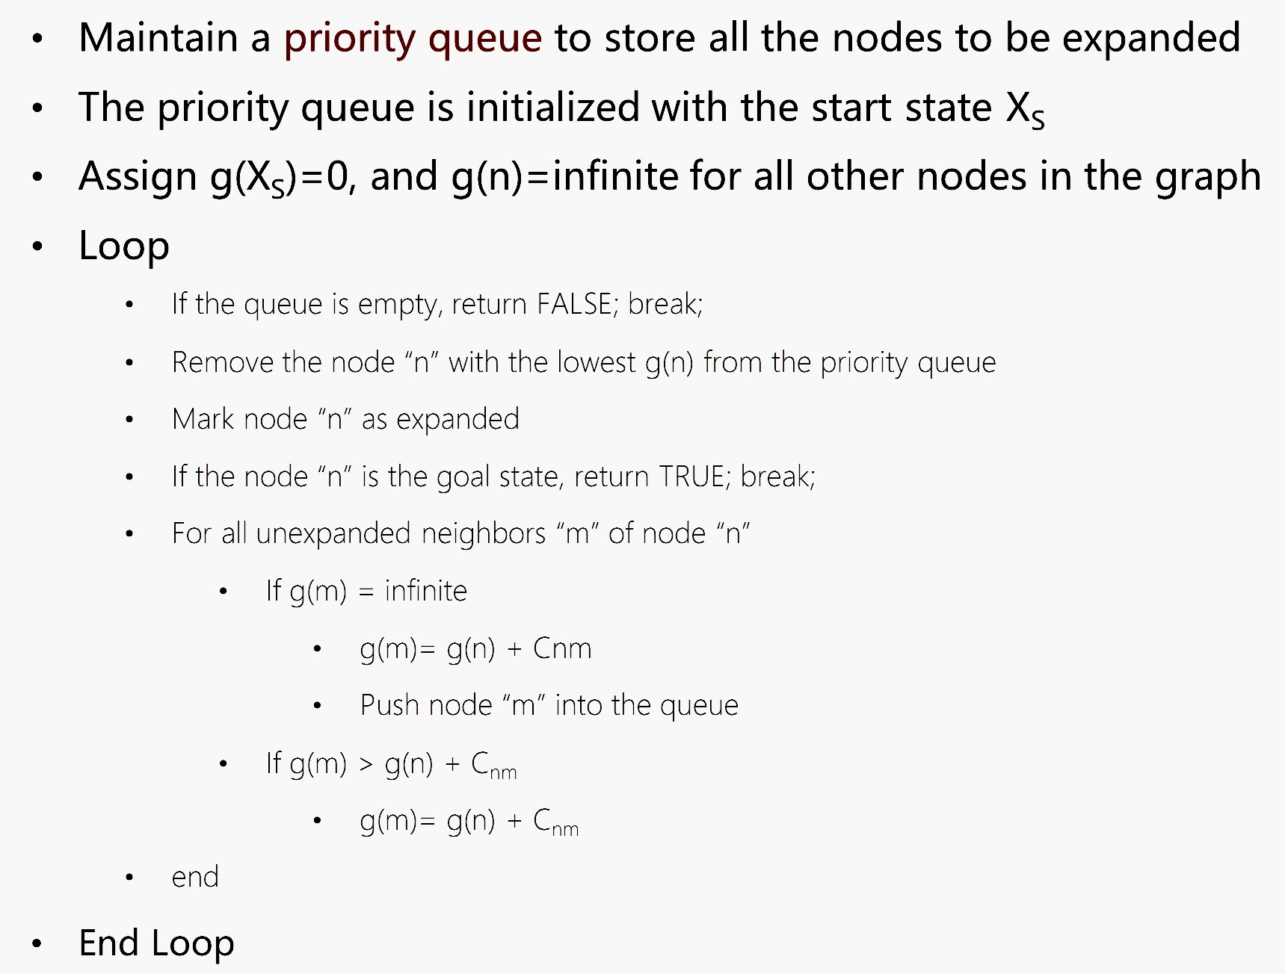

1.5 算法分析
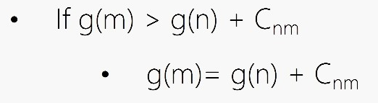的实现是通过while(1)的多次循环，即：上次循环修改了g(n)，下次循环时的expand_neighbor时重新计算了g(m);

