Back-end

summary

2.一、温故FeatureManager
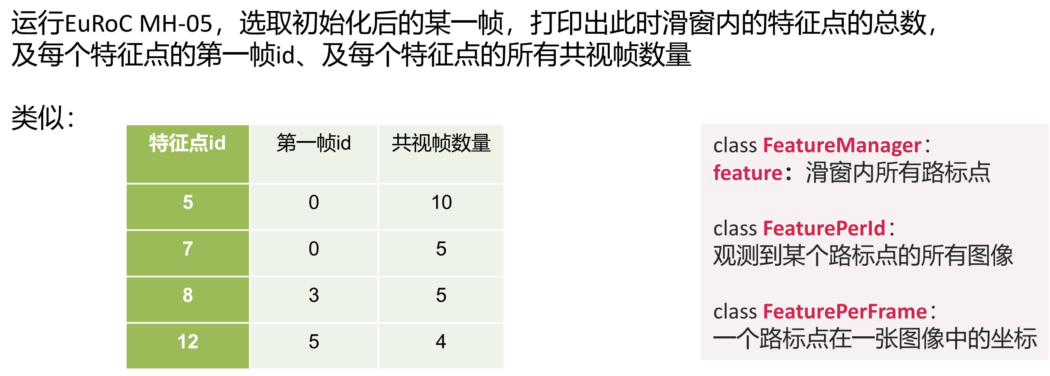

Code，加在此处
void Estimator::solveOdometry()
{
if (frame_count < WINDOW_SIZE)
return;
if (solver_flag == NON_LINEAR)
{
TicToc t_tri;
printf("----before triangle;\n");
f_manager.dbg_dsp_feat();

结果
feat-id {0}; viewed_frm-num: 4;
feat-id {1}; viewed_frm-num: 5;
feat-id {2}; viewed_frm-num: 5;
feat-id {3}; viewed_frm-num: 7;
feat-id {4}; viewed_frm-num: 6;
feat-id {5}; viewed_frm-num: 11;
feat-id {6}; viewed_frm-num: 11;
feat-id {7}; viewed_frm-num: 6;
feat-id {8}; viewed_frm-num: 6;
feat-id {9}; viewed_frm-num: 6;
feat-id {10}; viewed_frm-num: 6;
feat-id {11}; viewed_frm-num: 6;
。。。
feat-id {433}; viewed_frm-num: 1;
feat-id {434}; viewed_frm-num: 1;
feat-id {440}; viewed_frm-num: 1;
feat-id {445}; viewed_frm-num: 1;
feat-id {449}; viewed_frm-num: 1;
feat-id {450}; viewed_frm-num: 1;
feat-id {456}; viewed_frm-num: 1;
feat-id {459}; viewed_frm-num: 1;
feat-id {461}; viewed_frm-num: 1;
feat-id {462}; viewed_frm-num: 1;
feat-id {463}; viewed_frm-num: 1;

二、分析slideWindow()
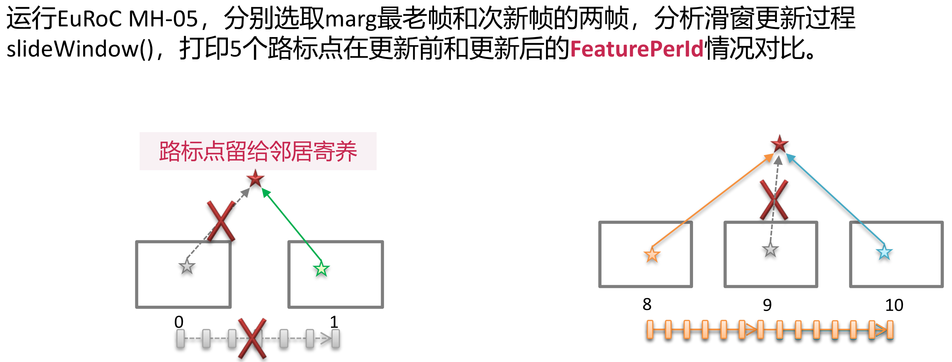

Code
1个feature-id对应1个landmark；
Code，位于：Estimator::processImage();
观察初始化之后的变化情况；
TicToc t_margin;
printf("--- before slideWindow()----\n");
f_manager.dbg_dsp_feat();
slideWindow();

printf("--- aft slideWindow()----\n");
f_manager.dbg_dsp_feat();
//printf("exit test;\n");exit(0);
f_manager.removeFailures();

结果
- start-frm为0
--- before slideWindow()----
feat-id {1301}; start-frm:0; viewed_frm-num: 6;
feat-id {1302}; start-frm:0; viewed_frm-num: 8;
feat-id {1303}; start-frm:0; viewed_frm-num: 1;
feat-id {1304}; start-frm:0; viewed_frm-num: 11;
feat-info {1304}0;11; uv_norm: 0.338350 0.073170 1.000000
feat-info {1304}0;11; uv_norm: 0.314769 0.050032 1.000000
feat-info {1304}0;11; uv_norm: 0.272545 0.032781 1.000000
feat-info {1304}0;11; uv_norm: 0.203884 0.023135 1.000000
feat-info {1304}0;11; uv_norm: 0.114341 0.034500 1.000000
feat-info {1304}0;11; uv_norm: 0.015689 0.065554 1.000000
feat-info {1304}0;11; uv_norm: -0.088429 0.101917 1.000000
feat-info {1304}0;11; uv_norm: -0.196745 0.135185 1.000000
feat-info {1304}0;11; uv_norm: -0.317864 0.165028 1.000000
feat-info {1304}0;11; uv_norm: -0.451976 0.183717 1.000000
feat-info {1304}0;11; uv_norm: -0.602698 0.186094 1.000000
feat-id {1305}; start-frm:0; viewed_frm-num: 6;
feat-id {1309}; start-frm:0; viewed_frm-num: 6;
feat-id {1310}; start-frm:0; viewed_frm-num: 8;
feat-id {1311}; start-frm:0; viewed_frm-num: 4;
feat-id {1312}; start-frm:0; viewed_frm-num: 6;
feat-id {1317}; start-frm:0; viewed_frm-num: 8;
feat-id {1322}; start-frm:0; viewed_frm-num: 8;
--- aft slideWindow()----
feat-id {1301}; start-frm:0; viewed_frm-num: 5;
feat-id {1302}; start-frm:0; viewed_frm-num: 7;
feat-id {1304}; start-frm:0; viewed_frm-num: 10;
feat-info {1304}0;10; uv_norm: 0.314769 0.050032 1.000000
feat-info {1304}0;10; uv_norm: 0.272545 0.032781 1.000000
feat-info {1304}0;10; uv_norm: 0.203884 0.023135 1.000000
feat-info {1304}0;10; uv_norm: 0.114341 0.034500 1.000000
feat-info {1304}0;10; uv_norm: 0.015689 0.065554 1.000000
feat-info {1304}0;10; uv_norm: -0.088429 0.101917 1.000000
feat-info {1304}0;10; uv_norm: -0.196745 0.135185 1.000000
feat-info {1304}0;10; uv_norm: -0.317864 0.165028 1.000000
feat-info {1304}0;10; uv_norm: -0.451976 0.183717 1.000000
feat-info {1304}0;10; uv_norm: -0.602698 0.186094 1.000000
feat-id {1305}; start-frm:0; viewed_frm-num: 5;
feat-id {1309}; start-frm:0; viewed_frm-num: 5;
feat-id {1310}; start-frm:0; viewed_frm-num: 7;
feat-id {1311}; start-frm:0; viewed_frm-num: 3;
feat-id {1312}; start-frm:0; viewed_frm-num: 5;
feat-id {1317}; start-frm:0; viewed_frm-num: 7;
feat-id {1322}; start-frm:0; viewed_frm-num: 7;
feat-id {1324}; start-frm:0; viewed_frm-num: 5;
1 BackEnd processImage dt: 269.100301 stamp: 1403638526.827830 p_wi: -0.031308 -0.432830 0.127119

- Start-frm>0
--- before slideWindow()----
feat-id {1301}; start-frm:3; viewed_frm-num: 6;
feat-id {1302}; start-frm:3; viewed_frm-num: 8;
feat-id {1303}; start-frm:3; viewed_frm-num: 1;
feat-id {1304}; start-frm:3; viewed_frm-num: 8;
feat-info {1304}3;8; uv_norm: 0.338350 0.073170 1.000000
feat-info {1304}3;8; uv_norm: 0.314769 0.050032 1.000000
feat-info {1304}3;8; uv_norm: 0.272545 0.032781 1.000000
feat-info {1304}3;8; uv_norm: 0.203884 0.023135 1.000000
feat-info {1304}3;8; uv_norm: 0.114341 0.034500 1.000000
feat-info {1304}3;8; uv_norm: 0.015689 0.065554 1.000000
feat-info {1304}3;8; uv_norm: -0.088429 0.101917 1.000000
feat-info {1304}3;8; uv_norm: -0.196745 0.135185 1.000000
feat-id {1305}; start-frm:3; viewed_frm-num: 6;
feat-id {1309}; start-frm:3; viewed_frm-num: 6;
feat-id {1310}; start-frm:3; viewed_frm-num: 8;
feat-id {1311}; start-frm:3; viewed_frm-num: 4;
feat-id {1312}; start-frm:3; viewed_frm-num: 6;
feat-id {1317}; start-frm:3; viewed_frm-num: 8;
feat-id {1322}; start-frm:3; viewed_frm-num: 8;
--- aft slideWindow()----
feat-id {1301}; start-frm:2; viewed_frm-num: 6;
feat-id {1302}; start-frm:2; viewed_frm-num: 8;
feat-id {1303}; start-frm:2; viewed_frm-num: 1;
feat-id {1304}; start-frm:2; viewed_frm-num: 8;
feat-info {1304}2;8; uv_norm: 0.338350 0.073170 1.000000
feat-info {1304}2;8; uv_norm: 0.314769 0.050032 1.000000
feat-info {1304}2;8; uv_norm: 0.272545 0.032781 1.000000
feat-info {1304}2;8; uv_norm: 0.203884 0.023135 1.000000
feat-info {1304}2;8; uv_norm: 0.114341 0.034500 1.000000
feat-info {1304}2;8; uv_norm: 0.015689 0.065554 1.000000
feat-info {1304}2;8; uv_norm: -0.088429 0.101917 1.000000
feat-info {1304}2;8; uv_norm: -0.196745 0.135185 1.000000
feat-id {1305}; start-frm:2; viewed_frm-num: 6;
feat-id {1309}; start-frm:2; viewed_frm-num: 6;
feat-id {1310}; start-frm:2; viewed_frm-num: 8;
feat-id {1311}; start-frm:2; viewed_frm-num: 4;
feat-id {1312}; start-frm:2; viewed_frm-num: 6;
feat-id {1317}; start-frm:2; viewed_frm-num: 8;
feat-id {1322}; start-frm:2; viewed_frm-num: 8;

分析
Start-frm表示从存储起始位置??，不是真实的视频帧的序号；
Frm_count表示slide-window种的帧数，不是已处理的帧的数目；

三、手画因子图
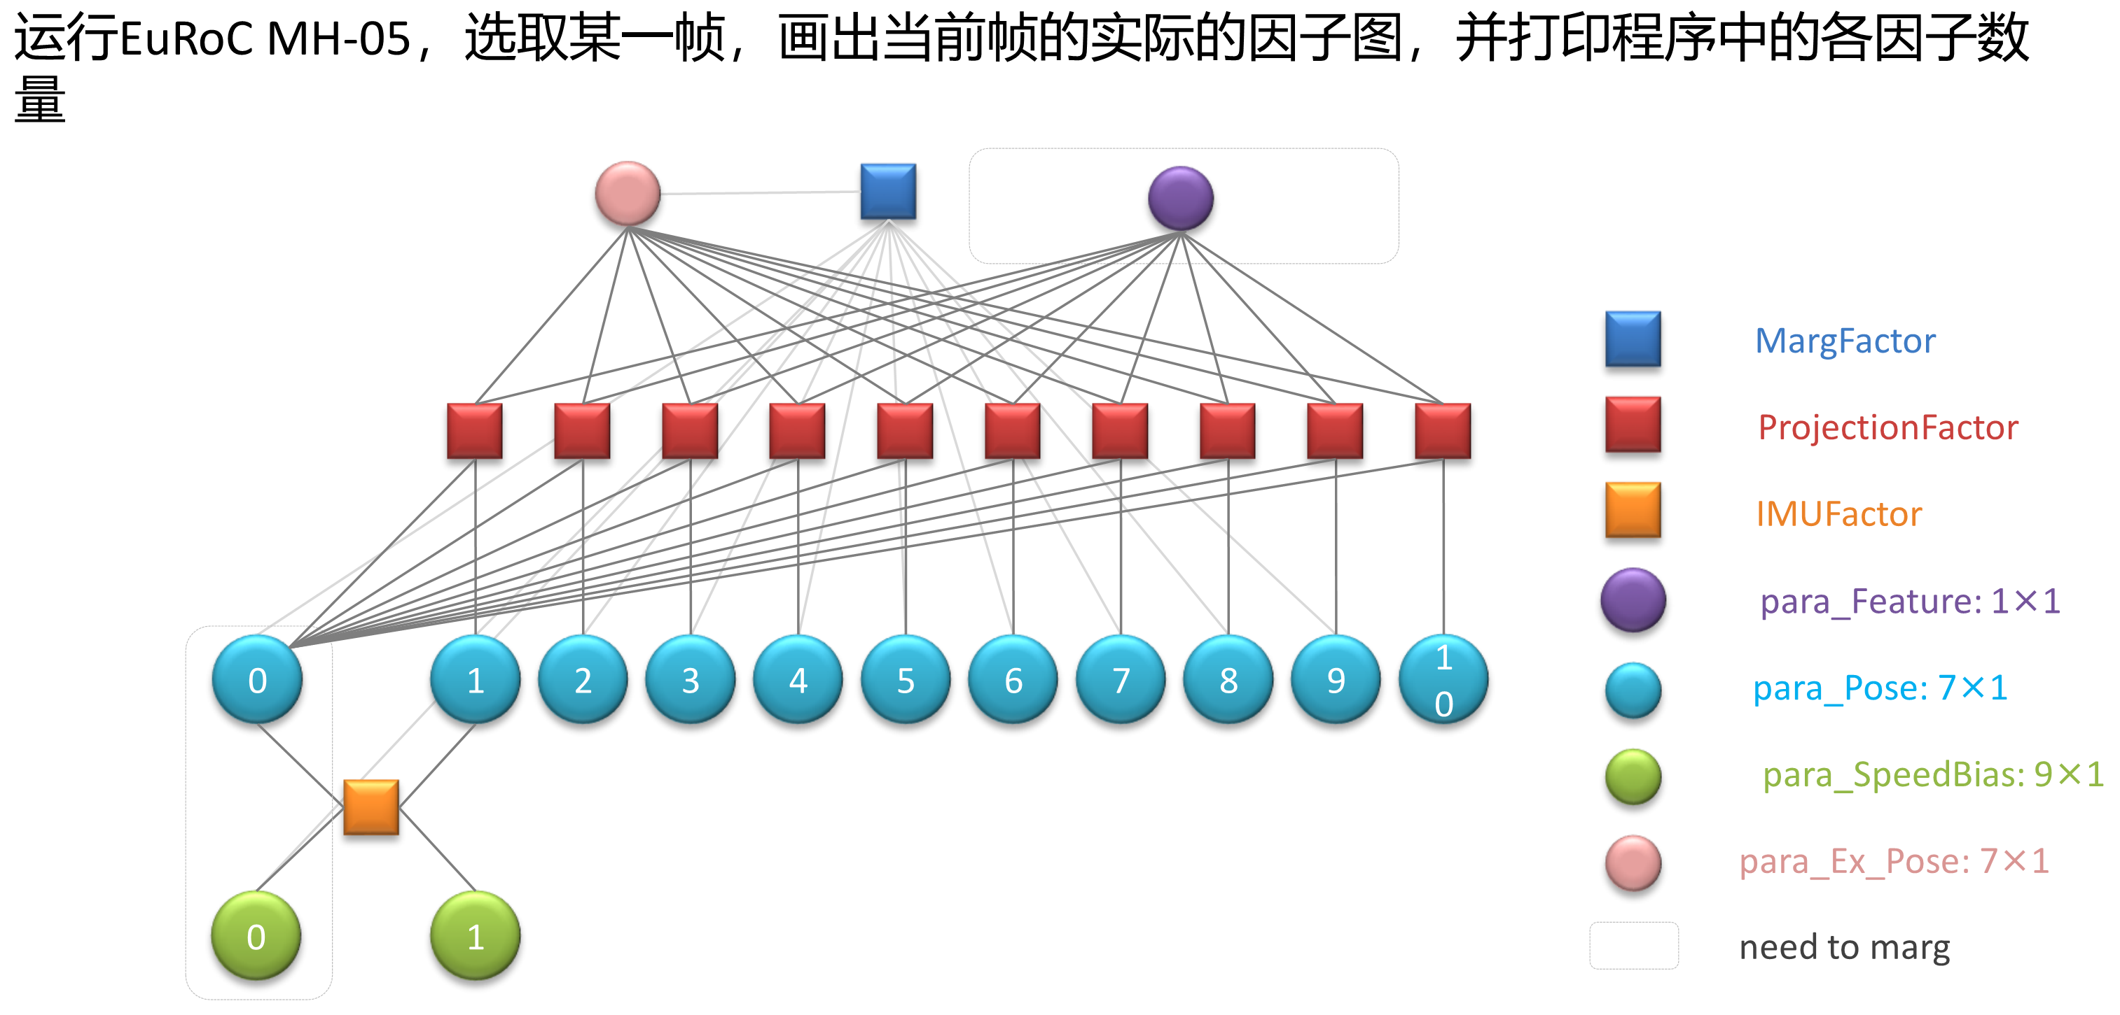

Code
Estimator::problemSolve()中；
// IMU
for (int i = 0; i < WINDOW_SIZE; i++)
{
if(dbg_check_frmNo==i)
{
dbg_IMU_related_frmNo.push_back(j);
}
}
//Visual
for (auto &it_per_id : f_manager.feature)
{
if(dbg_check_frmNo==imu_i)
{
dbg_Visual_related_ft_id.push_back(it_per_id.feature_id);
}
std::vector<int> tFrms;
// 遍历所有的观测
for (auto &it_per_frame : it_per_id.feature_per_frame)
{
if(dbg_check_frmNo==imu_i)
{
//dbg_Visual_related_ft_id.push_back(it_per_id.feature_id);
//dbg_Visual_related_frmNo.push_back(imu_j);
tFrms.push_back(imu_j);
dbg_got=true;
}
}
dbg_Visual_related_frmNo.push_back(tFrms);
}

运行结果
可见：对于IMU：每1帧图像只关联另外1个图像帧（即位姿）；
对于视觉特征，每1帧图像关联另外多个图像帧；
=== imu & visial factor ===0 ===check-times:0;
~~~imu factor ~~~
imu: 1;
^^^visial factor ^^^
vis: ft-id: related-frm: 0; frm: 1, 2, 3,
vis: ft-id: related-frm: 1; frm: 1, 2, 3, 4,
vis: ft-id: related-frm: 2; frm: 1, 2, 3, 4,
vis: ft-id: related-frm: 3; frm: 1, 2, 3, 4, 5, 6,
vis: ft-id: related-frm: 4; frm: 1, 2, 3, 4, 5,
vis: ft-id: related-frm: 5; frm: 1, 2, 3, 4, 5, 6, 7, 8, 9, 10,
vis: ft-id: related-frm: 6; frm: 1, 2, 3, 4, 5, 6, 7, 8, 9, 10,
vis: ft-id: related-frm: 7; frm: 1, 2, 3, 4, 5,
vis: ft-id: related-frm: 8; frm: 1, 2, 3, 4, 5,
vis: ft-id: related-frm: 9; frm: 1, 2, 3, 4, 5,
vis: ft-id: related-frm: 10; frm: 1, 2, 3, 4, 5,
vis: ft-id: related-frm: 11; frm: 1, 2, 3, 4, 5,
vis: ft-id: related-frm: 12; frm: 1, 2, 3, 4, 5, 6, 7, 8,
vis: ft-id: related-frm: 13; frm: 1, 2, 3, 4, 5, 6,
vis: ft-id: related-frm: 14; frm: 1, 2,
vis: ft-id: related-frm: 15; frm: 1, 2, 3, 4, 5, 6,
vis: ft-id: related-frm: 16; frm: 1, 2, 3,
vis: ft-id: related-frm: 17; frm: 1, 2, 3, 4, 5,
vis: ft-id: related-frm: 18; frm: 1, 2, 3, 4, 5, 6, 7, 8, 9, 10,
vis: ft-id: related-frm: 19; frm: 1, 2, 3, 4, 5, 6, 7, 8,
vis: ft-id: related-frm: 20; frm: 1, 2, 3, 4, 5, 6, 7, 8, 9, 10,
vis: ft-id: related-frm: 21; frm: 1, 2, 3, 4,
vis: ft-id: related-frm: 22; frm: 1, 2, 3, 4, 5, 6,
vis: ft-id: related-frm: 23; frm: 1, 2,
vis: ft-id: related-frm: 24; frm: 1, 2, 3, 4, 5, 6,
vis: ft-id: related-frm: 25; frm: 1, 2, 3, 4, 5,
vis: ft-id: related-frm: 26; frm: 1, 2, 3,
vis: ft-id: related-frm: 27; frm: 1, 2, 3, 4,
vis: ft-id: related-frm: 28; frm: 1, 2, 3,
vis: ft-id: related-frm: 29; frm: 1, 2,
vis: ft-id: related-frm: 30; frm: 1, 2, 3, 4, 5, 6, 7,
vis: ft-id: related-frm: 31; frm: 1, 2, 3, 4, 5, 6,
vis: ft-id: related-frm: 32; frm: 1, 2, 3, 4, 5, 6, 7, 8,
vis: ft-id: related-frm: 33; frm: 1, 2, 3, 4, 5, 6,
vis: ft-id: related-frm: 34; frm: 1, 2, 3, 4,
vis: ft-id: related-frm: 35; frm: 1, 2, 3, 4, 5, 6,
vis: ft-id: related-frm: 36; frm: 1, 2, 3, 4, 5, 6,
vis: ft-id: related-frm: 37; frm: 1, 2, 3, 4, 5, 6, 7, 8, 9, 10,
vis: ft-id: related-frm: 38; frm: 1, 2, 3, 4,
vis: ft-id: related-frm: 39; frm: 1, 2, 3,
vis: ft-id: related-frm: 40; frm: 1, 2, 3,
vis: ft-id: related-frm: 41; frm: 1, 2, 3, 4,
vis: ft-id: related-frm: 42; frm: 1, 2, 3, 4,
vis: ft-id: related-frm: 43; frm: 1, 2, 3, 4, 5, 6, 7,
vis: ft-id: related-frm: 44; frm: 1, 2, 3,
vis: ft-id: related-frm: 45; frm: 1, 2, 3, 4, 5,
vis: ft-id: related-frm: 46; frm: 1, 2,
vis: ft-id: related-frm: 47; frm: 1, 2, 3, 4,
vis: ft-id: related-frm: 48; frm: 1, 2, 3, 4,
vis: ft-id: related-frm: 49; frm: 1, 2, 3,
vis: ft-id: related-frm: 50; frm: 1, 2, 3,
vis: ft-id: related-frm: 51; frm: 1, 2, 3, 4, 5, 6, 7, 8, 9, 10,
vis: ft-id: related-frm: 52; frm: 1, 2, 3,
vis: ft-id: related-frm: 53; frm: 1, 2, 3, 4, 5, 6,
vis: ft-id: related-frm: 54; frm: 1, 2, 3, 4,
vis: ft-id: related-frm: 55; frm: 1, 2, 3, 4,
vis: ft-id: related-frm: 56; frm: 1, 2, 3, 4, 5, 6, 7, 8,
vis: ft-id: related-frm: 57; frm: 1, 2, 3, 4, 5,
vis: ft-id: related-frm: 58; frm: 1, 2, 3, 4, 5,
vis: ft-id: related-frm: 59; frm: 1, 2, 3, 4, 5,
vis: ft-id: related-frm: 60; frm: 1, 2, 3, 4, 5, 6, 7, 8,
vis: ft-id: related-frm: 61; frm: 1, 2, 3, 4, 5, 6, 7,
vis: ft-id: related-frm: 62; frm: 1, 2, 3, 4, 5, 6, 7, 8, 9, 10,
vis: ft-id: related-frm: 63; frm: 1, 2, 3,
vis: ft-id: related-frm: 64; frm: 1, 2, 3, 4, 5, 6, 7, 8, 9, 10,
vis: ft-id: related-frm: 65; frm: 1, 2, 3, 4, 5, 6,
vis: ft-id: related-frm: 66; frm: 1, 2, 3, 4, 5, 6,
vis: ft-id: related-frm: 68; frm: 1, 2, 3, 4, 5, 6, 7, 8, 9, 10,
vis: ft-id: related-frm: 69; frm: 1, 2, 3, 4, 5, 6, 7, 8, 9, 10,
vis: ft-id: related-frm: 70; frm: 1, 2, 3, 4,
vis: ft-id: related-frm: 71; frm: 1, 2, 3,
vis: ft-id: related-frm: 72; frm: 1, 2, 3, 4, 5, 6, 7,
vis: ft-id: related-frm: 73; frm: 1, 2, 3, 4, 5, 6, 7, 8, 9, 10,
vis: ft-id: related-frm: 74; frm: 1, 2, 3, 4,
vis: ft-id: related-frm: 75; frm: 1, 2, 3, 4, 5, 6, 7, 8, 9, 10,
vis: ft-id: related-frm: 76; frm: 1, 2, 3, 4, 5, 6, 7, 8, 9, 10,
vis: ft-id: related-frm: 77; frm: 1, 2, 3,
vis: ft-id: related-frm: 78; frm: 1, 2, 3, 4, 5, 6, 7, 8, 9, 10,
vis: ft-id: related-frm: 79; frm: 1, 2, 3, 4,
vis: ft-id: related-frm: 80; frm: 1, 2, 3, 4, 5, 6,
vis: ft-id: related-frm: 81; frm: 1, 2, 3, 4, 5, 6, 7, 8, 9, 10,
vis: ft-id: related-frm: 82; frm: 1, 2, 3, 4, 5, 6, 7, 8, 9, 10,
vis: ft-id: related-frm: 83; frm: 1, 2, 3, 4, 5,
vis: ft-id: related-frm: 84; frm: 1, 2, 3, 4, 5,
vis: ft-id: related-frm: 85; frm: 1, 2, 3, 4, 5, 6, 7, 8, 9, 10,
vis: ft-id: related-frm: 86; frm: 1, 2, 3, 4, 5, 6, 7, 8, 9, 10,
vis: ft-id: related-frm: 87; frm: 1, 2,
vis: ft-id: related-frm: 88; frm: 1, 2, 3, 4, 5, 6, 7,
vis: ft-id: related-frm: 89; frm: 1, 2, 3, 4, 5, 6, 7, 8, 9, 10,
vis: ft-id: related-frm: 90; frm: 1, 2, 3,
vis: ft-id: related-frm: 91; frm: 1, 2, 3, 4, 5,
vis: ft-id: related-frm: 92; frm: 1, 2, 3,
vis: ft-id: related-frm: 93; frm: 1, 2, 3, 4, 5,
vis: ft-id: related-frm: 94; frm: 1, 2, 3,
vis: ft-id: related-frm: 95; frm: 1, 2, 3, 4, 5, 6, 7, 8, 9, 10,
vis: ft-id: related-frm: 96; frm: 1, 2, 3,
vis: ft-id: related-frm: 97; frm: 1, 2, 3,
vis: ft-id: related-frm: 98; frm: 1, 2, 3,
vis: ft-id: related-frm: 99; frm: 1, 2, 3,
vis: ft-id: related-frm: 100; frm: 1, 2, 3, 4, 5, 6,
vis: ft-id: related-frm: 101; frm: 1, 2,
vis: ft-id: related-frm: 102; frm: 1, 2, 3,
vis: ft-id: related-frm: 103; frm: 1, 2, 3, 4, 5, 6, 7, 8, 9, 10,
vis: ft-id: related-frm: 104; frm: 1, 2, 3,
vis: ft-id: related-frm: 105; frm: 1, 2, 3,
vis: ft-id: related-frm: 106; frm: 1, 2, 3,
vis: ft-id: related-frm: 107; frm: 1, 2, 3,
vis: ft-id: related-frm: 108; frm: 1, 2,
vis: ft-id: related-frm: 109; frm: 1, 2, 3,
vis: ft-id: related-frm: 110; frm: 1, 2, 3,
vis: ft-id: related-frm: 111; frm: 1, 2, 3, 4, 5, 6, 7, 8, 9, 10,
vis: ft-id: related-frm: 112; frm: 1, 2, 3,
vis: ft-id: related-frm: 113; frm: 1, 2, 3, 4,
vis: ft-id: related-frm: 114; frm: 1, 2, 3,
vis: ft-id: related-frm: 115; frm: 1, 2,
vis: ft-id: related-frm: 116; frm: 1, 2, 3,
vis: ft-id: related-frm: 117; frm: 1, 2, 3, 4, 5, 6, 7, 8, 9, 10,
vis: ft-id: related-frm: 118; frm: 1, 2,
vis: ft-id: related-frm: 119; frm: 1, 2, 3, 4, 5, 6, 7, 8, 9, 10,
vis: ft-id: related-frm: 120; frm: 1, 2, 3,
vis: ft-id: related-frm: 121; frm: 1, 2, 3,
vis: ft-id: related-frm: 122; frm: 1, 2, 3,
vis: ft-id: related-frm: 123; frm: 1, 2,
vis: ft-id: related-frm: 124; frm: 1, 2, 3,
vis: ft-id: related-frm: 125; frm: 1, 2, 3,
vis: ft-id: related-frm: 126; frm: 1, 2, 3,
vis: ft-id: related-frm: 127; frm: 1, 2,
vis: ft-id: related-frm: 128; frm: 1, 2, 3, 4, 5,
vis: ft-id: related-frm: 129; frm: 1, 2,
vis: ft-id: related-frm: 130; frm: 1, 2,
vis: ft-id: related-frm: 131; frm: 1, 2, 3,
vis: ft-id: related-frm: 132; frm: 1, 2, 3,
vis: ft-id: related-frm: 133; frm: 1, 2,
vis: ft-id: related-frm: 134; frm: 1, 2, 3, 4,
vis: ft-id: related-frm: 135; frm: 1, 2, 3, 4,
vis: ft-id: related-frm: 136; frm: 1, 2, 3, 4,
vis: ft-id: related-frm: 137; frm: 1, 2,
vis: ft-id: related-frm: 138; frm: 1, 2, 3, 4,
vis: ft-id: related-frm: 139; frm: 1, 2,
vis: ft-id: related-frm: 140; frm: 1, 2, 3,
vis: ft-id: related-frm: 141; frm: 1, 2,
vis: ft-id: related-frm: 142; frm: 1, 2, 3,
vis: ft-id: related-frm: 143; frm: 1, 2,
vis: ft-id: related-frm: 144; frm: 1, 2,
vis: ft-id: related-frm: 145; frm: 1, 2, 3, 4, 5,
vis: ft-id: related-frm: 146; frm: 1, 2, 3, 4, 5, 6, 7, 8, 9, 10,
vis: ft-id: related-frm: 147; frm: 1, 2, 3,
vis: ft-id: related-frm: 148; frm: 1, 2, 3, 4,
vis: ft-id: related-frm: 149; frm: 1, 2, 3,
vis: ft-id: related-frm: 150; frm: 1, 2, 3, 4, 5, 6, 7, 8, 9, 10,

观察IMU约束和视觉约束中共有的变量；
在slide-window中，对于某一图像帧（即某个位姿），共有的变量是slide-window的此帧和下一帧的位姿，pose(即P+Q);
对于slide-window，全部的位姿都出现在imu约束和某个视觉约束中；
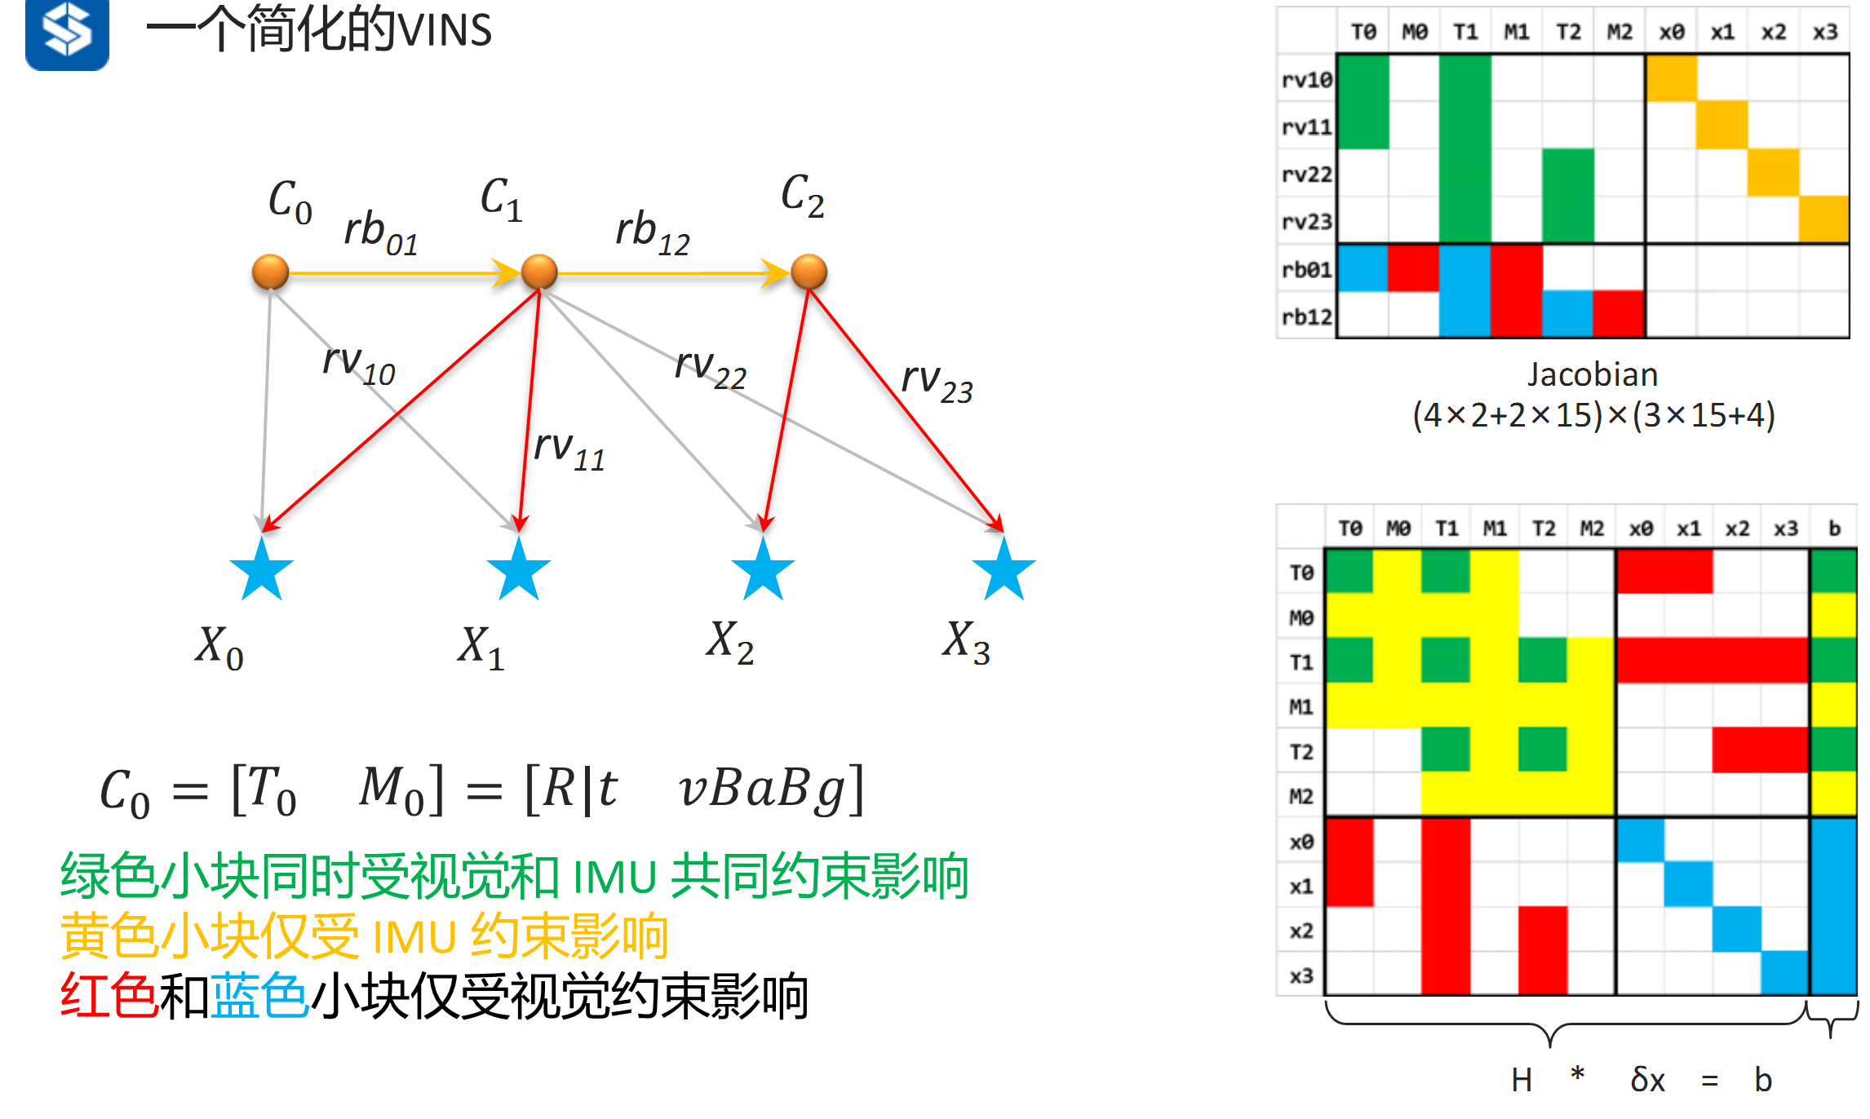

Code
** code: Problem::MakeHessian()中；
std::map<unsigned long, std::shared_ptr<Vertex>> dbg_check_vx;

auto jacobian_i = jacobians[i];
ulong index_i = v_i->OrderingId();
ulong dim_i = v_i->LocalDimension();

if ( dbg_check_vx.find( index_i ) == dbg_check_vx.end() ) {//!!debug-check;
dbg_check_vx.insert( pair<ulong, std::shared_ptr<Vertex>>(index_i, v_i) );//!!
//printf("H-index,dim: %d; %d; type: %s;\n", index_i, dim_i, v_i->TypeInfo().c_str());
}//!!

for(auto & it : dbg_check_vx)//!!debug check;
{
printf("H-index: %d; type: %s;\n", it.first, it.second->TypeInfo().c_str());
}

运行结果
** 运行结果如下，可见有11个pose，多个landmarks; 开始不是0，因为marg;
H-index: 6; type: VertexPose;
H-index: 12; type: VertexSpeedBias;
H-index: 21; type: VertexPose;
H-index: 27; type: VertexSpeedBias;
H-index: 36; type: VertexPose;
H-index: 42; type: VertexSpeedBias;
H-index: 51; type: VertexPose;
H-index: 57; type: VertexSpeedBias;
H-index: 66; type: VertexPose;
H-index: 72; type: VertexSpeedBias;
H-index: 81; type: VertexPose;
H-index: 87; type: VertexSpeedBias;
H-index: 96; type: VertexPose;
H-index: 102; type: VertexSpeedBias;
H-index: 111; type: VertexPose;
H-index: 117; type: VertexSpeedBias;
H-index: 126; type: VertexPose;
H-index: 132; type: VertexSpeedBias;
H-index: 141; type: VertexPose;
H-index: 147; type: VertexSpeedBias;
H-index: 156; type: VertexPose;
H-index: 162; type: VertexSpeedBias;
H-index: 171; type: VertexInverseDepth;
H-index: 172; type: VertexInverseDepth;
。。。
H-index: 375; type: VertexInverseDepth;
H-index: 376; type: VertexInverseDepth;
H-index: 377; type: VertexInverseDepth;
H-index: 378; type: VertexInverseDepth;
H-index: 379; type: VertexInverseDepth;
H-index: 380; type: VertexInverseDepth;
H-index: 381; type: VertexInverseDepth;
H-index: 382; type: VertexInverseDepth;
H-index: 383; type: VertexInverseDepth;

四、MarginalizationInfo中的几个变量
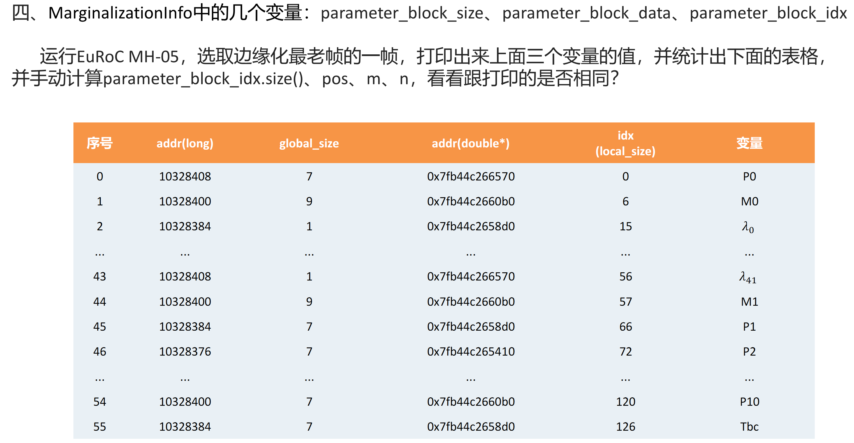

说明
VINS-course修改了原始的VINS,现在观察哪些landmarks被marg掉，以及这些landmarks对应的feat-id和start-frame, frm-num；
对于slide-window为10的情况，start-frm总是从0~10，表示某个feat-id第1次出现在slide-window的第几帧，此外，有个naïve的分析，不是全部的feature点（即landmark）的start-frm都是0，有些feature是在后面的几帧才发现的。

Code
(1)在problem中不能得到f_manager，所以margilization()时不能很容易的知道被marg掉的landmarks对应的feature-id;
(2)程序中，在estimator中观察全部的feature-id, 被marg的是start-frm==0（即第1帧）中的全部landmarks;
(3)在problem的margilization()中观察被marg掉的landmarks，可以发现数目是对应的，但是注意edge.Id()已经和estimator中无法对应了，因为margilation重新设置了AddEdge();

*** void Estimator::problemSolve()
for (auto &it_per_id : f_manager.feature)
{
it_per_id.used_num = it_per_id.feature_per_frame.size();
if (!(it_per_id.used_num >= 2 && it_per_id.start_frame < WINDOW_SIZE - 2))
continue;

++feature_index;

int imu_i = it_per_id.start_frame, imu_j = imu_i - 1;
Vector3d pts_i = it_per_id.feature_per_frame[0].point;

#if 1
//检查每个feat-id的start-frm-No & frm-num，看是不是每个feat都是从0开始；
printf("892 feta-id, start, num: %d; %d; %d;\n",it_per_id.feature_id, it_per_id.start_frame,it_per_id.feature_per_frame.size());
#endif

#if 1
printf("892 edge id; %d; %s;\n",edge->Id(), edge->TypeInfo().c_str() );
#endif

*** Problem::Marginalize()
int num_landmarks_to_be_marged=0;//!!
// std::cout << "\n marg edge 1st id: "<< marg_edges.front()->Id() << " end id: "<<marg_edges.back()->Id()<<std::endl;
for (size_t i = 0; i < marg_edges.size(); ++i) {
// std::cout << "marg edge id: "<< marg_edges[i]->Id() <<std::endl;
#if 1
//printf(" marg edge id: %d; %s;\n", marg_edges[i]->Id(), marg_edges[i]->TypeInfo().c_str());
#endif
auto verticies = marg_edges[i]->Verticies();
for (auto iter : verticies) {
if (IsLandmarkVertex(iter) && margLandmark.find(iter->Id()) == margLandmark.end()) {
iter->SetOrderingId(pose_dim + marg_landmark_size);
margLandmark.insert(make_pair(iter->Id(), iter));
marg_landmark_size += iter->LocalDimension();
++num_landmarks_to_be_marged;//!!
}
}
}
#if 1
printf("num_landmarks_to_be_marged: %d;\n",num_landmarks_to_be_marged);
printf("952 test exit;\n");exit(0);
#endif

结果
可见，第1帧可见到150个landmarks，这150个landmarks被marg掉；
。。。
892 feta-id, start, num: 142; 0; 4;
892 1st edge id; 725; EdgeReprojection;
892 1st edge id; 726; EdgeReprojection;
892 1st edge id; 727; EdgeReprojection;
892 feta-id, start, num: 143; 0; 3;
892 1st edge id; 728; EdgeReprojection;
892 1st edge id; 729; EdgeReprojection;
892 feta-id, start, num: 144; 0; 3;
892 1st edge id; 730; EdgeReprojection;
892 1st edge id; 731; EdgeReprojection;
892 feta-id, start, num: 145; 0; 6;
892 1st edge id; 732; EdgeReprojection;
892 1st edge id; 733; EdgeReprojection;
892 1st edge id; 734; EdgeReprojection;
892 1st edge id; 735; EdgeReprojection;
892 1st edge id; 736; EdgeReprojection;
892 feta-id, start, num: 146; 0; 11;
892 1st edge id; 737; EdgeReprojection;
892 1st edge id; 738; EdgeReprojection;
892 1st edge id; 739; EdgeReprojection;
892 1st edge id; 740; EdgeReprojection;
892 1st edge id; 741; EdgeReprojection;
892 1st edge id; 742; EdgeReprojection;
892 1st edge id; 743; EdgeReprojection;
892 1st edge id; 744; EdgeReprojection;
892 1st edge id; 745; EdgeReprojection;
892 1st edge id; 746; EdgeReprojection;
892 feta-id, start, num: 147; 0; 4;
892 1st edge id; 747; EdgeReprojection;
892 1st edge id; 748; EdgeReprojection;
892 1st edge id; 749; EdgeReprojection;
892 feta-id, start, num: 148; 0; 5;
892 1st edge id; 750; EdgeReprojection;
892 1st edge id; 751; EdgeReprojection;
892 1st edge id; 752; EdgeReprojection;
892 1st edge id; 753; EdgeReprojection;
892 feta-id, start, num: 149; 0; 4;
892 1st edge id; 754; EdgeReprojection;
892 1st edge id; 755; EdgeReprojection;
892 1st edge id; 756; EdgeReprojection;
892 feta-id, start, num: 150; 0; 11;
892 1st edge id; 757; EdgeReprojection;
892 1st edge id; 758; EdgeReprojection;
892 1st edge id; 759; EdgeReprojection;
892 1st edge id; 760; EdgeReprojection;
892 1st edge id; 761; EdgeReprojection;
892 1st edge id; 762; EdgeReprojection;
892 1st edge id; 763; EdgeReprojection;
892 1st edge id; 764; EdgeReprojection;
892 1st edge id; 765; EdgeReprojection;
892 1st edge id; 766; EdgeReprojection;
892 feta-id, start, num: 153; 3; 2;
892 1st edge id; 767; EdgeReprojection;
892 feta-id, start, num: 155; 3; 8;
892 1st edge id; 768; EdgeReprojection;
892 1st edge id; 769; EdgeReprojection;
892 1st edge id; 770; EdgeReprojection;
892 1st edge id; 771; EdgeReprojection;
892 1st edge id; 772; EdgeReprojection;
892 1st edge id; 773; EdgeReprojection;
892 1st edge id; 774; EdgeReprojection;
。。。
to be marged; head: id: 1; type: VertexPose;
num_landmarks_to_be_marged: 150;

五、手动画出来marg最老帧时构建的Hessian矩阵
