Front-end

summary

2.feture-tracking status
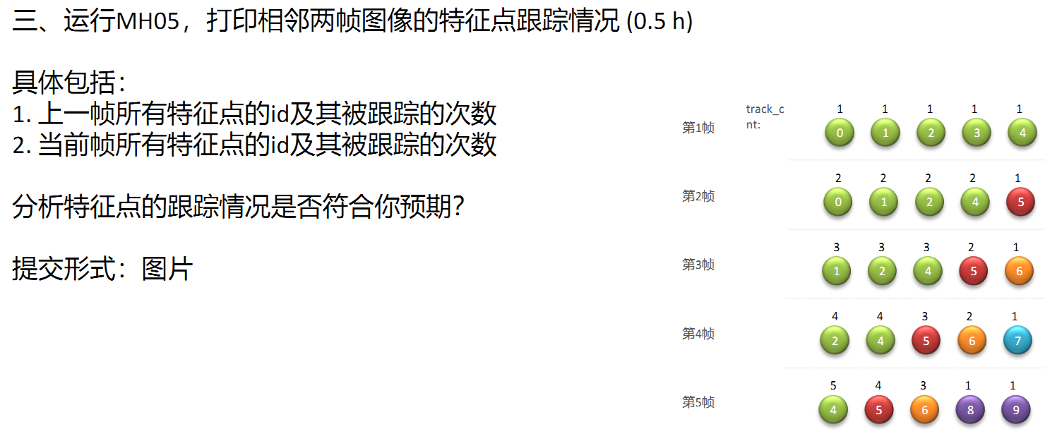

Code: feature_tracker.cpp; readImage();
#define VIO_ANALYSE_NOTE 1
#if VIO_ANALYSE_NOTE==1
bool dbg_check_feature=true;
int missed_pts_num=0;
int solveTimes=GlobalStat::solve_times_;
int last_ft_num=0,crnt_ft_num=0;
if(solveTimes>10)
{
for(int ii=0;ii<cur_pts.size();++ii)
{
int tId=ids[ii];
int tTrackCnt=track_cnt[ii];
++last_ft_num;
printf("153 last: [%d / %d]: %d; %d;\n ",ii,cur_pts.size(),tId,tTrackCnt);
}
}
vector<uchar> status_check;
#endif

运行结果：
No / feat-num; feat-id; track-cnt;
153 last: [0 / 135]: 85; 124;
153 last: [1 / 135]: 119; 124;
153 last: [2 / 135]: 86; 124;
153 last: [3 / 135]: 117; 124;
153 last: [4 / 135]: 75; 124;
153 last: [5 / 135]: 76; 124;
153 last: [6 / 135]: 78; 124;
153 last: [7 / 135]: 111; 124;
153 last: [8 / 135]: 18; 124;
153 last: [9 / 135]: 82; 124;
153 last: [10 / 135]: 81; 124;
153 last: [11 / 135]: 37; 124;
153 last: [12 / 135]: 89; 124;
153 last: [13 / 135]: 95; 124;
153 last: [14 / 135]: 51; 124;
153 last: [15 / 135]: 69; 124;
153 last: [16 / 135]: 103; 124;
153 last: [17 / 135]: 20; 124;
153 last: [18 / 135]: 68; 124;
153 last: [19 / 135]: 73; 124;
153 last: [20 / 135]: 62; 124;
153 last: [21 / 135]: 64; 124;
153 last: [22 / 135]: 150; 122;
153 last: [23 / 135]: 155; 48;
153 last: [24 / 135]: 186; 44;
153 last: [25 / 135]: 176; 44;
153 last: [26 / 135]: 174; 44;
153 last: [27 / 135]: 173; 44;
153 last: [28 / 135]: 213; 44;
153 last: [29 / 135]: 223; 44;
153 last: [30 / 135]: 208; 44;
153 last: [31 / 135]: 202; 44;
153 last: [32 / 135]: 214; 44;
153 last: [33 / 135]: 175; 44;
153 last: [34 / 135]: 183; 44;
153 last: [35 / 135]: 180; 44;
153 last: [36 / 135]: 229; 42;
153 last: [37 / 135]: 231; 42;
153 last: [38 / 135]: 236; 42;
153 last: [39 / 135]: 226; 42;
153 last: [40 / 135]: 230; 42;
153 last: [41 / 135]: 302; 40;
153 last: [42 / 135]: 282; 40;
153 last: [43 / 135]: 289; 40;
153 last: [44 / 135]: 284; 40;
153 last: [45 / 135]: 274; 40;
153 last: [46 / 135]: 285; 40;
153 last: [47 / 135]: 334; 38;
153 last: [48 / 135]: 343; 38;
153 last: [49 / 135]: 331; 38;
153 last: [50 / 135]: 406; 36;
153 last: [51 / 135]: 569; 24;
153 last: [52 / 135]: 596; 22;
153 last: [53 / 135]: 639; 18;
153 last: [54 / 135]: 650; 18;
153 last: [55 / 135]: 655; 16;
153 last: [56 / 135]: 688; 16;
153 last: [57 / 135]: 662; 16;
153 last: [58 / 135]: 658; 16;
153 last: [59 / 135]: 660; 16;
153 last: [60 / 135]: 713; 14;
153 last: [61 / 135]: 715; 14;
153 last: [62 / 135]: 701; 14;
153 last: [63 / 135]: 693; 14;
153 last: [64 / 135]: 764; 12;
153 last: [65 / 135]: 755; 12;
153 last: [66 / 135]: 741; 12;
153 last: [67 / 135]: 740; 12;
153 last: [68 / 135]: 739; 12;
153 last: [69 / 135]: 775; 10;
153 last: [70 / 135]: 784; 10;
153 last: [71 / 135]: 826; 8;
153 last: [72 / 135]: 828; 8;
153 last: [73 / 135]: 820; 8;
153 last: [74 / 135]: 819; 8;
153 last: [75 / 135]: 839; 8;
153 last: [76 / 135]: 895; 4;
153 last: [77 / 135]: 894; 4;
153 last: [78 / 135]: 893; 4;
153 last: [79 / 135]: 890; 4;
153 last: [80 / 135]: 887; 4;
153 last: [81 / 135]: 886; 4;
153 last: [82 / 135]: 884; 4;
153 last: [83 / 135]: 883; 4;
153 last: [84 / 135]: 882; 4;
153 last: [85 / 135]: 881; 4;
153 last: [86 / 135]: 876; 4;
153 last: [87 / 135]: 875; 4;
153 last: [88 / 135]: 872; 4;
153 last: [89 / 135]: 871; 4;
153 last: [90 / 135]: 870; 4;
153 last: [91 / 135]: 869; 4;
153 last: [92 / 135]: 867; 4;
153 last: [93 / 135]: 864; 4;
153 last: [94 / 135]: 862; 4;
153 last: [95 / 135]: 860; 4;
153 last: [96 / 135]: 859; 4;
153 last: [97 / 135]: 858; 4;
153 last: [98 / 135]: 857; 4;
153 last: [99 / 135]: 898; 2;
153 last: [100 / 135]: 899; 2;
153 last: [101 / 135]: 900; 2;
153 last: [102 / 135]: 901; 2;
153 last: [103 / 135]: 902; 2;
153 last: [104 / 135]: 903; 2;
153 last: [105 / 135]: 904; 2;
153 last: [106 / 135]: 906; 2;
153 last: [107 / 135]: 907; 2;
153 last: [108 / 135]: 908; 2;
153 last: [109 / 135]: 909; 2;
153 last: [110 / 135]: 910; 2;
153 last: [111 / 135]: 911; 2;
153 last: [112 / 135]: 912; 2;
153 last: [113 / 135]: 913; 2;
153 last: [114 / 135]: 914; 2;
153 last: [115 / 135]: 915; 2;
153 last: [116 / 135]: 916; 2;
153 last: [117 / 135]: 917; 2;
153 last: [118 / 135]: 919; 2;
153 last: [119 / 135]: 920; 2;
153 last: [120 / 135]: 921; 2;
153 last: [121 / 135]: 925; 2;
153 last: [122 / 135]: 926; 2;
153 last: [123 / 135]: 927; 2;
153 last: [124 / 135]: 930; 2;
153 last: [125 / 135]: 931; 2;
153 last: [126 / 135]: 932; 2;
153 last: [127 / 135]: 934; 2;
153 last: [128 / 135]: 935; 2;
153 last: [129 / 135]: 936; 2;
153 last: [130 / 135]: 938; 2;
153 last: [131 / 135]: 939; 2;
153 last: [132 / 135]: 941; 2;
153 last: [133 / 135]: 942; 2;
153 last: [134 / 135]: 943; 2;

168 crnt: [0 / 128]: 85; 125;
168 crnt: [1 / 128]: 119; 125;
168 crnt: [2 / 128]: 86; 125;
168 crnt: [3 / 128]: 117; 125;
168 crnt: [4 / 128]: 75; 125;
168 crnt: [5 / 128]: 76; 125;
168 crnt: [6 / 128]: 78; 125;
168 crnt: [7 / 128]: 111; 125;
168 crnt: [8 / 128]: 18; 125;
168 crnt: [9 / 128]: 82; 125;
168 crnt: [10 / 128]: 81; 125;
168 crnt: [11 / 128]: 37; 125;
168 crnt: [12 / 128]: 89; 125;
168 crnt: [13 / 128]: 95; 125;
168 crnt: [14 / 128]: 51; 125;
168 crnt: [15 / 128]: 69; 125;
168 crnt: [16 / 128]: 103; 125;
168 crnt: [17 / 128]: 20; 125;
168 crnt: [18 / 128]: 68; 125;
168 crnt: [19 / 128]: 73; 125;
168 crnt: [20 / 128]: 62; 125;
168 crnt: [21 / 128]: 64; 125;
168 crnt: [22 / 128]: 150; 123;
168 crnt: [23 / 128]: 155; 49;
168 crnt: [24 / 128]: 186; 45;
168 crnt: [25 / 128]: 176; 45;
168 crnt: [26 / 128]: 174; 45;
168 crnt: [27 / 128]: 173; 45;
168 crnt: [28 / 128]: 213; 45;
168 crnt: [29 / 128]: 223; 45;
168 crnt: [30 / 128]: 208; 45;
168 crnt: [31 / 128]: 202; 45;
168 crnt: [32 / 128]: 214; 45;
168 crnt: [33 / 128]: 175; 45;
168 crnt: [34 / 128]: 183; 45;
168 crnt: [35 / 128]: 180; 45;
168 crnt: [36 / 128]: 229; 43;
168 crnt: [37 / 128]: 231; 43;
168 crnt: [38 / 128]: 236; 43;
168 crnt: [39 / 128]: 226; 43;
168 crnt: [40 / 128]: 230; 43;
168 crnt: [41 / 128]: 302; 41;
168 crnt: [42 / 128]: 282; 41;
168 crnt: [43 / 128]: 289; 41;
168 crnt: [44 / 128]: 284; 41;
168 crnt: [45 / 128]: 274; 41;
168 crnt: [46 / 128]: 285; 41;
168 crnt: [47 / 128]: 334; 39;
168 crnt: [48 / 128]: 343; 39;
168 crnt: [49 / 128]: 331; 39;
168 crnt: [50 / 128]: 406; 37;
168 crnt: [51 / 128]: 569; 25;
168 crnt: [52 / 128]: 596; 23;
168 crnt: [53 / 128]: 639; 19;
168 crnt: [54 / 128]: 650; 19;
168 crnt: [55 / 128]: 655; 17;
168 crnt: [56 / 128]: 688; 17;
168 crnt: [57 / 128]: 662; 17;
168 crnt: [58 / 128]: 658; 17;
168 crnt: [59 / 128]: 660; 17;
168 crnt: [60 / 128]: 713; 15;
168 crnt: [61 / 128]: 715; 15;
168 crnt: [62 / 128]: 701; 15;
168 crnt: [63 / 128]: 693; 15;
168 crnt: [64 / 128]: 741; 13;
168 crnt: [65 / 128]: 740; 13;
168 crnt: [66 / 128]: 775; 11;
168 crnt: [67 / 128]: 784; 11;
168 crnt: [68 / 128]: 826; 9;
168 crnt: [69 / 128]: 828; 9;
168 crnt: [70 / 128]: 820; 9;
168 crnt: [71 / 128]: 819; 9;
168 crnt: [72 / 128]: 839; 9;
168 crnt: [73 / 128]: 895; 5;
168 crnt: [74 / 128]: 894; 5;
168 crnt: [75 / 128]: 893; 5;
168 crnt: [76 / 128]: 890; 5;
168 crnt: [77 / 128]: 887; 5;
168 crnt: [78 / 128]: 886; 5;
168 crnt: [79 / 128]: 884; 5;
168 crnt: [80 / 128]: 883; 5;
168 crnt: [81 / 128]: 882; 5;
168 crnt: [82 / 128]: 881; 5;
168 crnt: [83 / 128]: 876; 5;
168 crnt: [84 / 128]: 875; 5;
168 crnt: [85 / 128]: 872; 5;
168 crnt: [86 / 128]: 871; 5;
168 crnt: [87 / 128]: 870; 5;
168 crnt: [88 / 128]: 869; 5;
168 crnt: [89 / 128]: 867; 5;
168 crnt: [90 / 128]: 864; 5;
168 crnt: [91 / 128]: 862; 5;
168 crnt: [92 / 128]: 860; 5;
168 crnt: [93 / 128]: 859; 5;
168 crnt: [94 / 128]: 858; 5;
168 crnt: [95 / 128]: 857; 5;
168 crnt: [96 / 128]: 898; 3;
168 crnt: [97 / 128]: 899; 3;
168 crnt: [98 / 128]: 900; 3;
168 crnt: [99 / 128]: 901; 3;
168 crnt: [100 / 128]: 902; 3;
168 crnt: [101 / 128]: 903; 3;
168 crnt: [102 / 128]: 904; 3;
168 crnt: [103 / 128]: 906; 3;
168 crnt: [104 / 128]: 907; 3;
168 crnt: [105 / 128]: 908; 3;
168 crnt: [106 / 128]: 909; 3;
168 crnt: [107 / 128]: 910; 3;
168 crnt: [108 / 128]: 912; 3;
168 crnt: [109 / 128]: 913; 3;
168 crnt: [110 / 128]: 914; 3;
168 crnt: [111 / 128]: 915; 3;
168 crnt: [112 / 128]: 917; 3;
168 crnt: [113 / 128]: 919; 3;
168 crnt: [114 / 128]: 920; 3;
168 crnt: [115 / 128]: 921; 3;
168 crnt: [116 / 128]: 925; 3;
168 crnt: [117 / 128]: 926; 3;
168 crnt: [118 / 128]: 927; 3;
168 crnt: [119 / 128]: 930; 3;
168 crnt: [120 / 128]: 931; 3;
168 crnt: [121 / 128]: 934; 3;
168 crnt: [122 / 128]: 935; 3;
168 crnt: [123 / 128]: 936; 3;
168 crnt: [124 / 128]: 939; 3;
168 crnt: [125 / 128]: 941; 3;
168 crnt: [126 / 128]: 942; 3;
168 crnt: [127 / 128]: 943; 3;
last-num,crnt-num,missed-num: 135, 128, 7; //上一帧的feat-num; 当前帧的feat-num, 未跟踪feat-num;

Jacobian
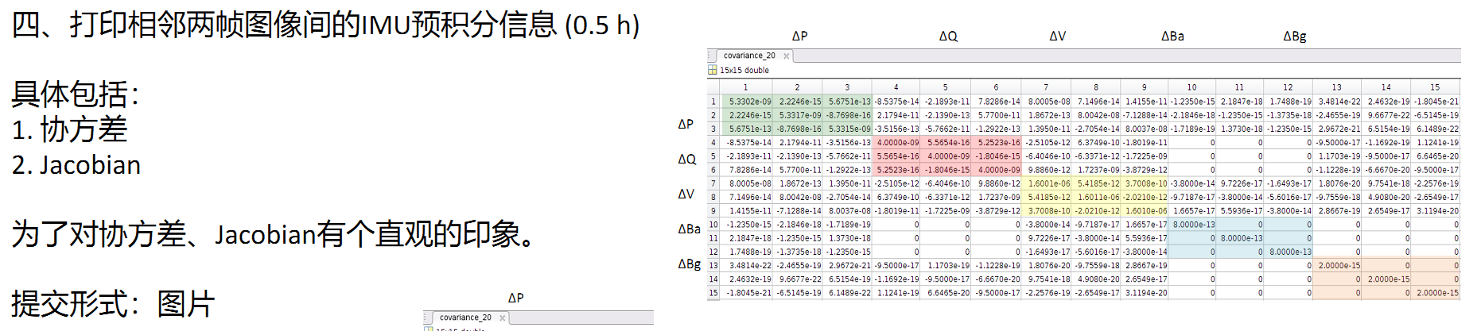
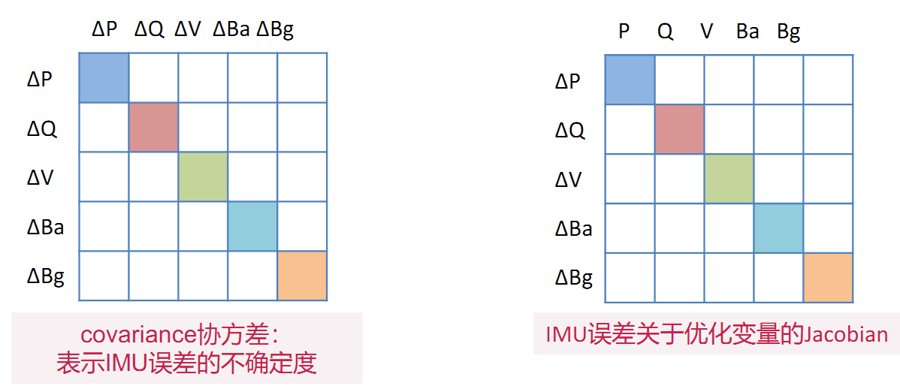
对于1个imu约束，有15个变量；
pre-integration; Estimator::processIMU();
=> integration_base.h; midPointIntegration();
jacobian = F * jacobian;
covariance = F * covariance * F.transpose() + V * noise * V.transpose();

调试code：
std::cout<<jacobian<<std::endl;
printf("======= %d ***== covariance ===***===;rows,cols: %d; %d;\n",
solveTimes,covariance.rows(),covariance.cols());
std::cout<<covariance<<std::endl;
double cov_sum=covariance.sum();
double cov_norm=covariance.norm();

结果：
====== 89 ====== jacobian ====;rows,cols: 15; 15;
1.000000 0.000000 0.000000 0.000000 -1.667068 0.055936 0.910000 0.000000 0.000000 -0.414011 -0.002676 -0.004353 -0.002912 0.506179 -0.020634
0.000000 1.000000 0.000000 1.667078 -0.000006 3.687795 0.000000 0.910000 0.000000 0.002679 -0.414040 -0.000203 -0.495999 -0.002570 -1.127970
0.000000 0.000000 1.000000 -0.055932 -3.687775 0.000006 0.000000 0.000000 0.910000 0.004351 0.000234 -0.414020 0.013932 1.123577 0.000660
0.000000 0.000000 0.000000 0.999886 -0.006684 -0.014806 0.000000 0.000000 0.000000 0.000000 0.000000 0.000000 -0.909989 -0.000130 0.002112
0.000000 0.000000 0.000000 0.006676 0.999984 -0.000553 0.000000 0.000000 0.000000 0.000000 0.000000 0.000000 0.000131 -0.910000 -0.000045
0.000000 0.000000 0.000000 0.014807 0.000449 0.999904 0.000000 0.000000 0.000000 0.000000 0.000000 0.000000 -0.002112 0.000049 -0.909990
0.000000 0.000000 0.000000 0.000001 -3.661449 0.138850 1.000000 0.000000 0.000000 -0.909897 -0.006188 -0.011327 -0.010074 1.664846 -0.069590
0.000000 0.000000 0.000000 3.661477 -0.000017 8.122472 0.000000 1.000000 0.000000 0.006195 -0.909977 -0.000469 -1.625519 -0.008707 -3.720949
0.000000 0.000000 0.000000 -0.138841 -8.122419 0.000016 0.000000 0.000000 1.000000 0.011323 0.000550 -0.909919 0.046300 3.703983 0.002583
0.000000 0.000000 0.000000 0.000000 0.000000 0.000000 0.000000 0.000000 0.000000 1.000000 0.000000 0.000000 0.000000 0.000000 0.000000
0.000000 0.000000 0.000000 0.000000 0.000000 0.000000 0.000000 0.000000 0.000000 0.000000 1.000000 0.000000 0.000000 0.000000 0.000000
0.000000 0.000000 0.000000 0.000000 0.000000 0.000000 0.000000 0.000000 0.000000 0.000000 0.000000 1.000000 0.000000 0.000000 0.000000
0.000000 0.000000 0.000000 0.000000 0.000000 0.000000 0.000000 0.000000 0.000000 0.000000 0.000000 0.000000 1.000000 0.000000 0.000000
0.000000 0.000000 0.000000 0.000000 0.000000 0.000000 0.000000 0.000000 0.000000 0.000000 0.000000 0.000000 0.000000 1.000000 0.000000
0.000000 0.000000 0.000000 0.000000 0.000000 0.000000 0.000000 0.000000 0.000000 0.000000 0.000000 0.000000 0.000000 0.000000 1.000000
======= 89 ***== covariance ===***===;rows,cols: 15; 15;
0.000004 0.000000 0.000000 0.000000 -0.000000 0.000000 0.000007 0.000000 0.000000 -0.000000 -0.000000 -0.000000 -0.000000 0.000000 -0.000000
0.000000 0.000004 -0.000000 0.000000 0.000000 0.000000 0.000000 0.000007 -0.000000 0.000000 -0.000000 -0.000000 -0.000000 -0.000000 -0.000000
0.000000 -0.000000 0.000004 -0.000000 -0.000000 -0.000000 0.000000 -0.000000 0.000007 0.000000 0.000000 -0.000000 0.000000 0.000000 0.000000
0.000000 0.000000 -0.000000 0.000000 -0.000000 -0.000000 0.000000 0.000000 -0.000000 0.000000 0.000000 0.000000 -0.000000 -0.000000 0.000000
-0.000000 0.000000 -0.000000 -0.000000 0.000000 -0.000000 -0.000000 0.000000 -0.000000 0.000000 0.000000 0.000000 0.000000 -0.000000 -0.000000
0.000000 0.000000 -0.000000 -0.000000 -0.000000 0.000000 0.000000 0.000000 -0.000000 0.000000 0.000000 0.000000 -0.000000 0.000000 -0.000000
0.000007 0.000000 0.000000 0.000000 -0.000000 0.000000 0.000015 0.000000 0.000000 -0.000000 -0.000000 -0.000000 -0.000000 0.000000 -0.000000
0.000000 0.000007 -0.000000 0.000000 0.000000 0.000000 0.000000 0.000016 -0.000000 0.000000 -0.000000 -0.000000 -0.000000 -0.000000 -0.000000
0.000000 -0.000000 0.000007 -0.000000 -0.000000 -0.000000 0.000000 -0.000000 0.000015 0.000000 0.000000 -0.000000 0.000000 0.000000 0.000000
-0.000000 0.000000 0.000000 0.000000 0.000000 0.000000 -0.000000 0.000000 0.000000 0.000000 0.000000 0.000000 0.000000 0.000000 0.000000
-0.000000 -0.000000 0.000000 0.000000 0.000000 0.000000 -0.000000 -0.000000 0.000000 0.000000 0.000000 0.000000 0.000000 0.000000 0.000000
-0.000000 -0.000000 -0.000000 0.000000 0.000000 0.000000 -0.000000 -0.000000 -0.000000 0.000000 0.000000 0.000000 0.000000 0.000000 0.000000
-0.000000 -0.000000 0.000000 -0.000000 0.000000 -0.000000 -0.000000 -0.000000 0.000000 0.000000 0.000000 0.000000 0.000000 0.000000 0.000000
0.000000 -0.000000 0.000000 -0.000000 -0.000000 0.000000 0.000000 -0.000000 0.000000 0.000000 0.000000 0.000000 0.000000 0.000000 0.000000
-0.000000 -0.000000 0.000000 0.000000 -0.000000 -0.000000 -0.000000 -0.000000 0.000000 0.000000 0.000000 0.000000 0.000000 0.000000 0.000000

exit in test;0.00010043; 0.00003203; //covariance-sum; covariance-norm();
可见，IMU的协方差很小，数据可信度很大；

3.观察feature-id在连续帧中的发现和消失
（1）显示feature信息；只观察feature-id为5的变化情况；
void FeatureManager::dbg_dsp_feat()
{
bool has_feat_interest=false;
for (auto &it_per_id : feature)
{
it_per_id.feature_id==5;
it_per_id.start_frame;
it_per_id.feature_per_frame.size();
for (auto &it_per_frame : it_per_id.feature_per_frame)
{
Eigen::Vector3d f = it_per_frame.point;
if(it_per_id.feature_id==5)
{
std::cout<<"feat-info {"<<it_per_id.feature_id<<"}"<<it_per_id.start_frame<<";"<<
it_per_id.feature_per_frame.size()<<"; uv_norm: "<<f.transpose()<<std::endl;
has_feat_interest=true;
}
}
//printf("689 {%d}: %.6f;\n",it_per_id.feature_id,it_per_id.estimated_depth);
}
if(! has_feat_interest)
{
printf("exit test;\n");exit(0);
}
}

加在以下函数中：
void Estimator::solveOdometry()
if (solver_flag == NON_LINEAR) {
printf("----before triangle;\n");
f_manager.dbg_dsp_feat();
f_manager.triangulate(Ps, tic, ric);
printf("----before optim;\n");
f_manager.dbg_dsp_feat();
backendOptimization();
printf("----after optim;\n");
f_manager.dbg_dsp_feat(); }
加在以下函数中：slide-windows时将位姿pose基于slide-windows的第一个frame，原来的第1个被移除，原来的第2个变成现在的第1个；
FeatureManager::removeBackShiftDepth()
Eigen::Vector3d pts_i = uv_i * it->estimated_depth;
Eigen::Vector3d w_pts_i = marg_R * pts_i + marg_P;
Eigen::Vector3d pts_j = new_R.transpose() * (w_pts_i - new_P);
double dep_j = pts_j(2);
if(it->feature_id==5) {//!!
printf("removeBackShiftDepth {%d};\n",it->feature_id);
std::cout<<" prev depth: "<<it->estimated_depth<<std::endl;
std::cout<<" slide depth: "<<dep_j<<std::endl;
}
if (dep_j > 0)
it->estimated_depth = dep_j;
- 运行结果，可见第1帧的变化；
----after optim;
feat-info {5}0;3; uv_norm: -0.107142 -0.547047 1.000000
feat-info {5}0;3; uv_norm: -0.101565 -0.559711 1.000000
feat-info {5}0;3; uv_norm: -0.091031 -0.585695 1.000000
removeBackShiftDepth {5};
prev depth: 11.067731
slide depth: 11.020516
1 BackEnd processImage dt: 257.912544 stamp: 1403638524.927830 p_wi: 0.024621 -0.027134 0.435598
----before triangle;
feat-info {5}0;2; uv_norm: -0.101565 -0.559711 1.000000
feat-info {5}0;2; uv_norm: -0.091031 -0.585695 1.000000
in triangulate();
feat-info {5}0;2; uv_norm: -0.101565 -0.559711 1.000000
feat-info {5}0;2; uv_norm: -0.091031 -0.585695 1.000000
----before optim;
feat-info {5}0;2; uv_norm: -0.101565 -0.559711 1.000000
feat-info {5}0;2; uv_norm: -0.091031 -0.585695 1.000000

4.Projection
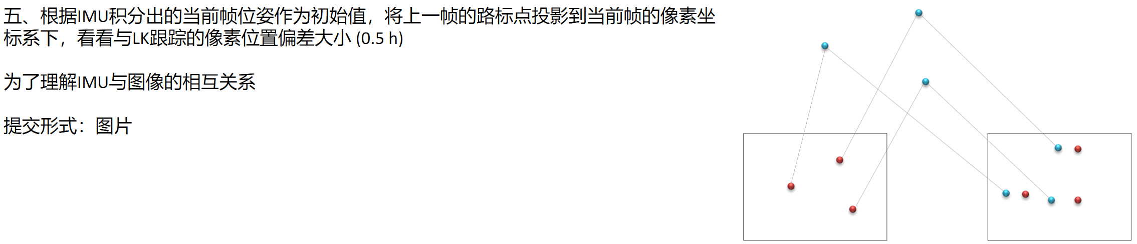
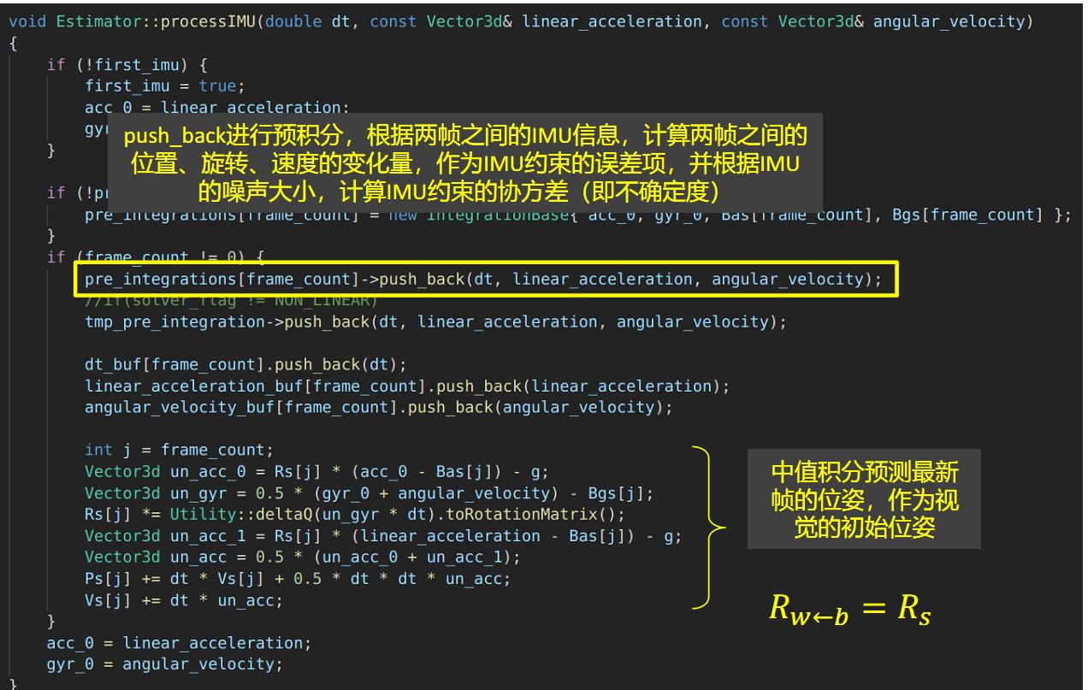
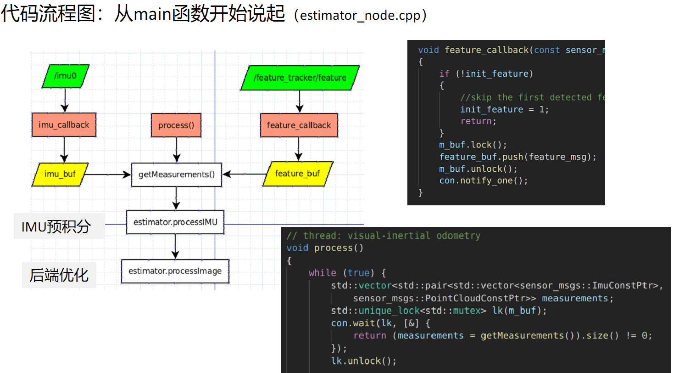
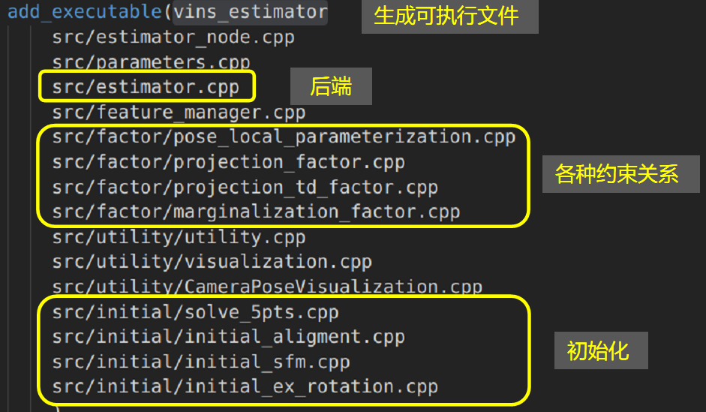

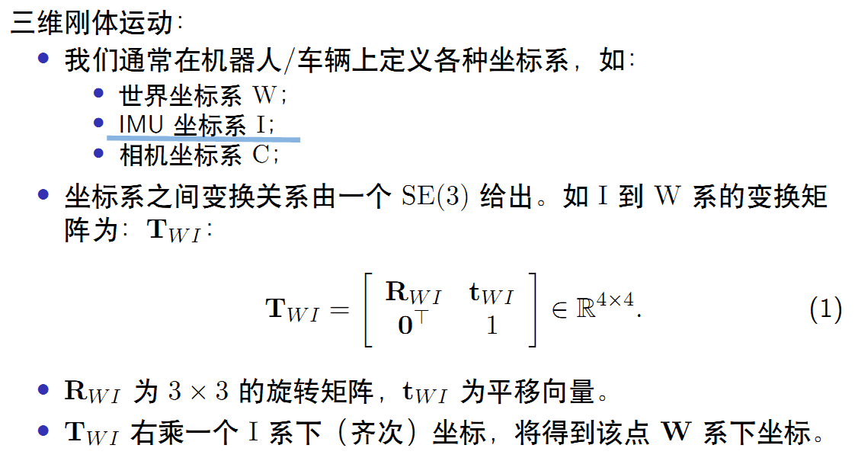

Code
加在此函数中： FeatureManager::triangulate（）；
if(it_per_id.feature_id==5)
{
int imu_i = it_per_id.start_frame, imu_j = imu_i - 1;

Eigen::Vector3d t0 = Ps[imu_i] + Rs[imu_i] * tic[0];
Eigen::Matrix3d R0 = Rs[imu_i] * ric[0];

if(imu_i==imu_j)
{
double use_depth=it_per_id.estimated_depth;
printf("^^^ 1st frm;\n");
landmark_pos(0)=it_per_frame.point[0]*use_depth;//already归一化坐标
landmark_pos(1)=it_per_frame.point[1]*use_depth;//already归一化坐标
landmark_pos(2)= use_depth;//必须匹配归一化坐标;
landmark_pos(3)=1;

std::cout<<"land-mark: "<<landmark_pos.transpose() <<std::endl;
}
Eigen::Vector3d project=P * landmark_pos;

结果
运行结果：可见，计算的投影点和实际uv坐标相差不大；
in triangulate();
feat-info {5}0;11; uv_norm: -0.191051 -0.563088 1
feat-info {5}0;11; uv_norm: -0.19107 -0.563037 1
feat-info {5}0;11; uv_norm: -0.191025 -0.563053 1
feat-info {5}0;11; uv_norm: -0.179143 -0.576903 1
feat-info {5}0;11; uv_norm: -0.171358 -0.563948 1
feat-info {5}0;11; uv_norm: -0.158527 -0.532489 1
feat-info {5}0;11; uv_norm: -0.144847 -0.519034 1
feat-info {5}0;11; uv_norm: -0.135347 -0.527474 1
feat-info {5}0;11; uv_norm: -0.125801 -0.526563 1
feat-info {5}0;11; uv_norm: -0.108016 -0.503108 1
feat-info {5}0;11; uv_norm: -0.0890342 -0.4741 1
^^^^ {5};calc-times:0; start:0; 0,11; 23.977176;dbg:0.000000;
^^^ 1st frm;
land-mark: -4.58085 -13.5013 23.9772 1
~~~ calced-project: -0.191051 -0.563088 23.9772
++ image-project: -0.191051 -0.563088 0.859528
~~~ calced-project: -0.19105 -0.563101 23.977
++ image-project: -0.19107 -0.563037 0.859543
~~~ calced-project: -0.191066 -0.563098 23.977
++ image-project: -0.191025 -0.563053 0.859543
~~~ calced-project: -0.178345 -0.574601 23.9015
++ image-project: -0.179143 -0.576903 0.855949
~~~ calced-project: -0.169248 -0.561816 24.0553
++ image-project: -0.171358 -0.563948 0.861493
~~~ calced-project: -0.156619 -0.529228 24.4119
++ image-project: -0.158527 -0.532489 0.874146
~~~ calced-project: -0.142955 -0.516908 24.5673
++ image-project: -0.144847 -0.519034 0.880322
~~~ calced-project: -0.131308 -0.527197 24.4845
++ image-project: -0.135347 -0.527474 0.878225
~~~ calced-project: -0.121764 -0.526998 24.4946
++ image-project: -0.125801 -0.526563 0.879397
~~~ calced-project: -0.106014 -0.502347 24.7577
++ image-project: -0.108016 -0.503108 0.889184
~~~ calced-project: -0.0878112 -0.47321 25.0666
++ image-project: -0.0890342 -0.4741 0.900683

分析
- triangulate（）中，对于1个特征点，只计算一次三角化，以后只计算投影点，并计算优化；
- Ps表示从开始累计到当前时刻的IMU，
- 也可以在视觉残差部分计算投影的像素坐标；
- 对于1个slide-window，depth基于slide-window的第1帧的位姿；对于各个帧，有一个：bi<-b0的转换，表示计算结果为基于b0的depth；
- 三角化中使用范数归一化的uv坐标(3元素齐次坐标)，uv(2)!=1; 而没有使用/uv(2)，即uv(2)=1;
实际计算2种方法的结果相同；
Eigen::Vector3d f = it_per_frame.point.normalized();//orig, error???计算更稳定??
//Eigen::Vector3d f = it_per_frame.point;//???已是归一化坐标;实际计算landmark-pos和above相同;

