DATA SCIENCE BOOTCAMP · EDA MILESTONE · 20 OCTOBER 2026

The Sentiment Signal
  - Weeks 1 to 3 report
Kevin (yy6074), Kelly (lx2455), Yuwei (yz13019)
Technical EDA work is complete. Role assignments remain proposed. The primary prediction problem and feature set are specified; polarity annotations remain unreviewed. Modeling begins in Week 5. The publisher explicitly identifies the dataset as ChatGPT-generated synthetic content.

Workflow completion
Stage | Workflow item | Status | Evidence or action
Week 1 | Team of 3–4 students | Complete | Kevin yy6074; Kelly lx2455; Yuwei yz13019. Team name confirmed.
Week 1 | Project introduction and objectives | Complete | project_charter.md
Week 1 | Dataset acquisition and initial exploration | Complete | Local source verified; raw inventory; publisher metadata and source hash.
Week 2 | NumPy and Pandas manipulation | Complete | Executed notebook: normalization, duplicate audit, validation, vectorized features, grouped summaries and quantiles.
Week 2 | Feature exploration | Complete | Numeric/text summaries, feature redundancy, constant-feature checks and metadata coverage.
Week 3 | EDA and visualization | Complete | Eight earlier charts plus four new charts; supporting tables and executed outputs.
Week 3 | Relevant feature selection | Complete | Text-only baseline selected; feature_selection.csv explains every candidate field.
Week 3 | Problem statement | Complete as proposed scope | problem_and_features.md defines primary task, target rubric and future evaluation.
Team action | Confirm proposed responsibilities | Pending team decision | Suggested allocation in project_charter.md; no ownership approval assumed.
Before Week 5 | Review and freeze polarity target | Pending human review | Draft lookup and annotation sample provided; no reviewed ground truth claimed.
Week 4 | Mid-program presentation delivery | Scheduled future work | Presentation outline and speaker notes prepared; delivery and instructor feedback remain outstanding.
Week 5 onward | Modeling and hypothesis testing | Future work | No models trained or inferential tests run in Weeks 1–3.

Week 1 project introduction

Team
Member | NetID | Proposed lead responsibility | Proposed cross-review
Kevin | yy6074 | Source inventory, cleaning and reproducibility | Check Kelly’s EDA calculations
Kelly | lx2455 | Feature exploration, charts and EDA interpretation | Check Yuwei’s target rubric
Yuwei | yz13019 | Problem statement, target review and presentation narrative | Check Kevin’s cleaning audit

The roster and team name are confirmed by the user. Role allocations are proposals for the team to confirm. Everyone should explain the whole workflow and share annotation work. A fourth member is not required.

Project introduction
We study a synthetic collection of social media posts to practice sentiment analysis and explore how supplied labels, text features and recorded engagement vary across platforms, locations and time. We aim to build a transparent, reproducible educational workflow and then test a bounded sentiment classifier. Findings concern the simulated sample.

Objectives and research questions
1. Establish dataset structure, provenance and quality. Which formatting issues or duplicate records affect analysis?
2. Describe the emotion-label distribution. Does label support permit reliable evaluation of the original classification task?
3. Explore platform and geographic composition, hashtags and calendar coverage. Which apparent patterns reflect the sample construction?
4. Inspect engagement distributions, feature redundancy and text length. Which fields should inform EDA or a future predictor?
5. Define a text-only polarity classification target with an explicit review process and a leakage-aware evaluation plan.

Scope through Week 3
Data acquisition verification, cleaning, data dictionary, descriptive EDA, visualizations, target proposal and feature selection. Models begin in Week 5. Hypothesis tests begin in Weeks 6–7. No predictive performance, significant effects or causal relationships are claimed at the mid-program stage.

Data and limitations
- One local source: ../sentimentdataset.csv, 732 records and 15 columns. Unit: simulated post. Retained observations: 710.
- Publisher: Kashish Parmar, Kaggle, CC0-1.0. Local source version is identified by its SHA-256 in the audit; no version equivalence is assumed merely from filename.
- The publisher explicitly discloses ChatGPT-generated synthetic content. Original timestamps span 2010–2023, but there is no verified sampling design, timezone or independent annotation protocol.
- Retweets appear for Instagram and Facebook as well as Twitter. Their meanings across platforms are unverified. Likes plus retweets is a count proxy, not an engagement rate.
- Geography labels mix UK and Scotland. They remain as supplied after whitespace normalization. Real-world country rankings, seasonality claims and influencer conclusions are outside scope.

Definition of success at the mid program presentation
All source rows reconcile to retained or audited duplicates; notebook cells execute without errors; every chart states its denominator or unit; each headline claim has a supporting table; selected features have reasons; unreviewed labels and proposed responsibilities remain visibly unconfirmed.

Sources
- Dataset card.
- Publisher metadata, cached in ../initial_analysis/sources/kaggle_metadata.json on 20 October 2026.

Week 2 data manipulation
The executed notebook uses Pandas for inventory, Unicode/whitespace normalization, duplicate detection, datetime validation, grouping and crosstabs. It uses NumPy for stable row provenance, vectorized weekend indicators, interaction transformations, quantiles and outlier flags. The audit identifies every removed record. Valid extreme values remain in the data. Original text retains punctuation, emoji and negation.
The prepared dataset contains 710 posts. Each export field has a documented role; the earlier data dictionary remains available. The notebook independently reproduces the earlier cleaning result and verifies matching record IDs and engagement totals.

Week 3 EDA findings
Cleaning. 732 raw records become 710 after removing 22 full-record duplicates. Zero missing cells and no invalid dates or engagement counts were found.
Label support. 279 raw label values normalize to 191. Eighty-one labels occur once, and 150 labels have fewer than five posts.
Composition. Instagram has 251 retained posts, Twitter 236 and Facebook 223. The top five location labels account for 83.5% of posts. These counts describe synthetic sample composition.
Calendar coverage. The sample spans May 2010 to October 2023. The uneven annual coverage and partial final year limit trend and seasonality interpretations.
Engagement. Pearson correlation between likes and retweets is 0.9985. For 412 of 710 posts, likes equal twice retweets. Recorded counts do not provide an engagement rate.
Text and hashtags. Every retained post has two extracted hashtags. 498 posts (70.1%) contain an exact normalized match between a hashtag and the supplied emotion label. This is a cue-risk diagnostic, not proof of leakage.
Split design. Four repeated-text groups cover eight retained rows. Keep these groups together in later training and evaluation. Paraphrases may still overlap semantically.
Selected baseline. Use post text as the primary predictor. Keep IDs and label-derived values out of predictors. Review the polarity target before Week 5; no models or tests have run.

Visual evidence
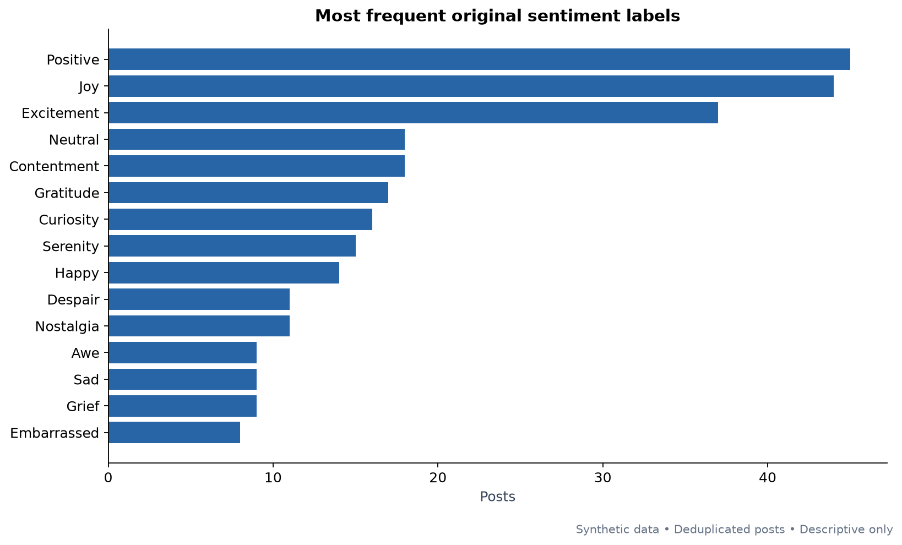
01. Most frequent original emotion labels. Positive is one original label, not all positive-polarity posts.
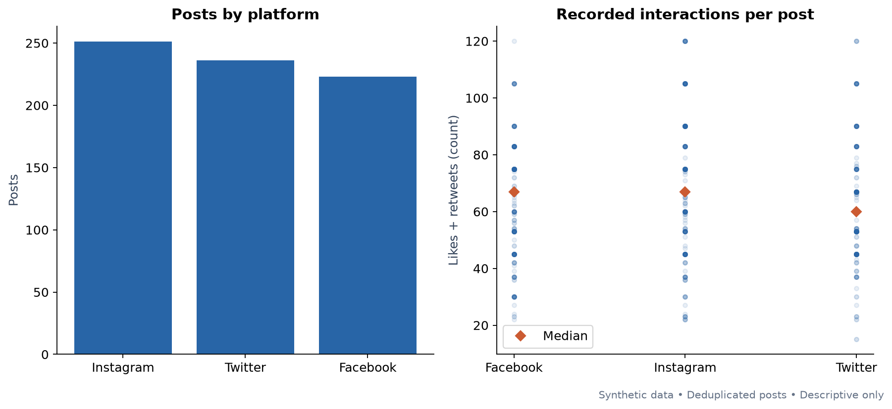
02. Post counts and recorded interactions by platform. Orange diamonds show medians.

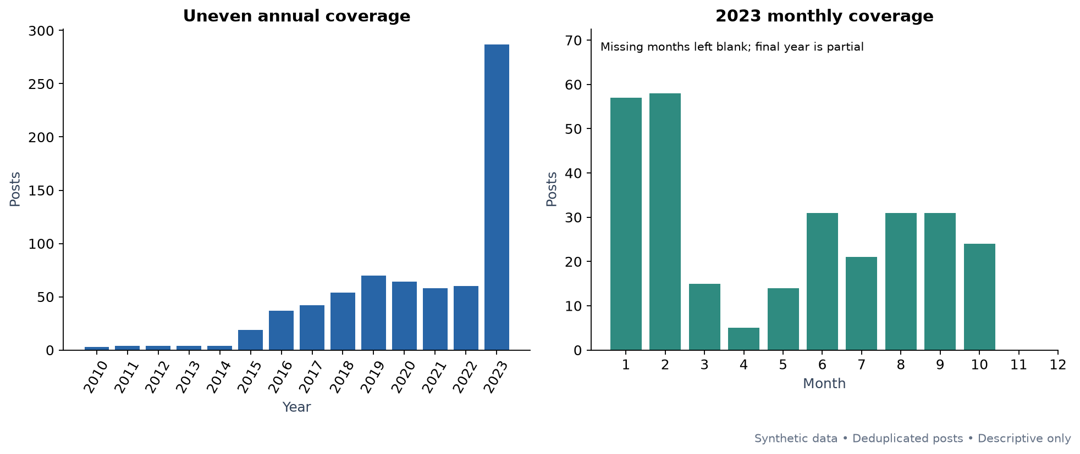
03. Annual and latest-year coverage. Missing months indicate absent sample records.
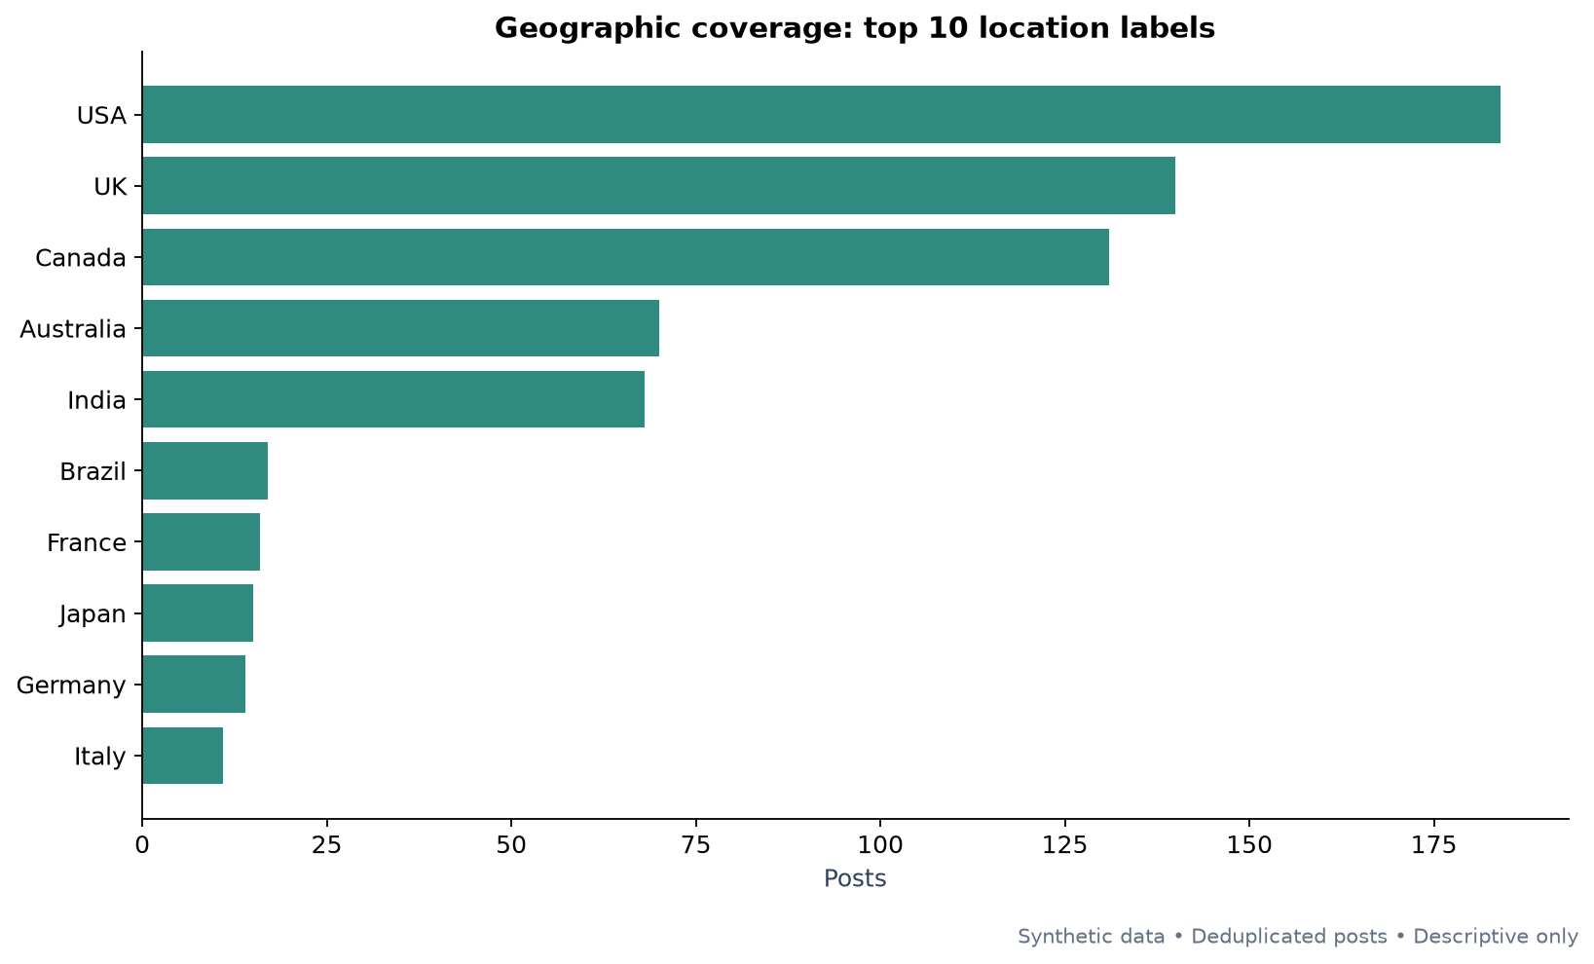
04. Location label concentration. Scotland and UK remain separate source labels.

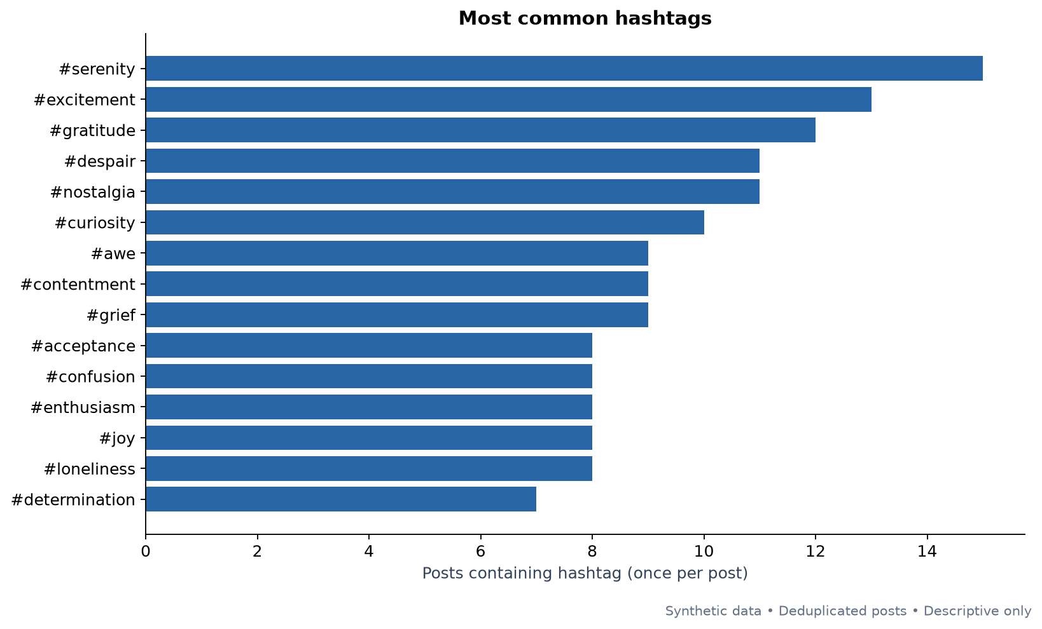
05. Hashtag document frequency, counted at most once per post.
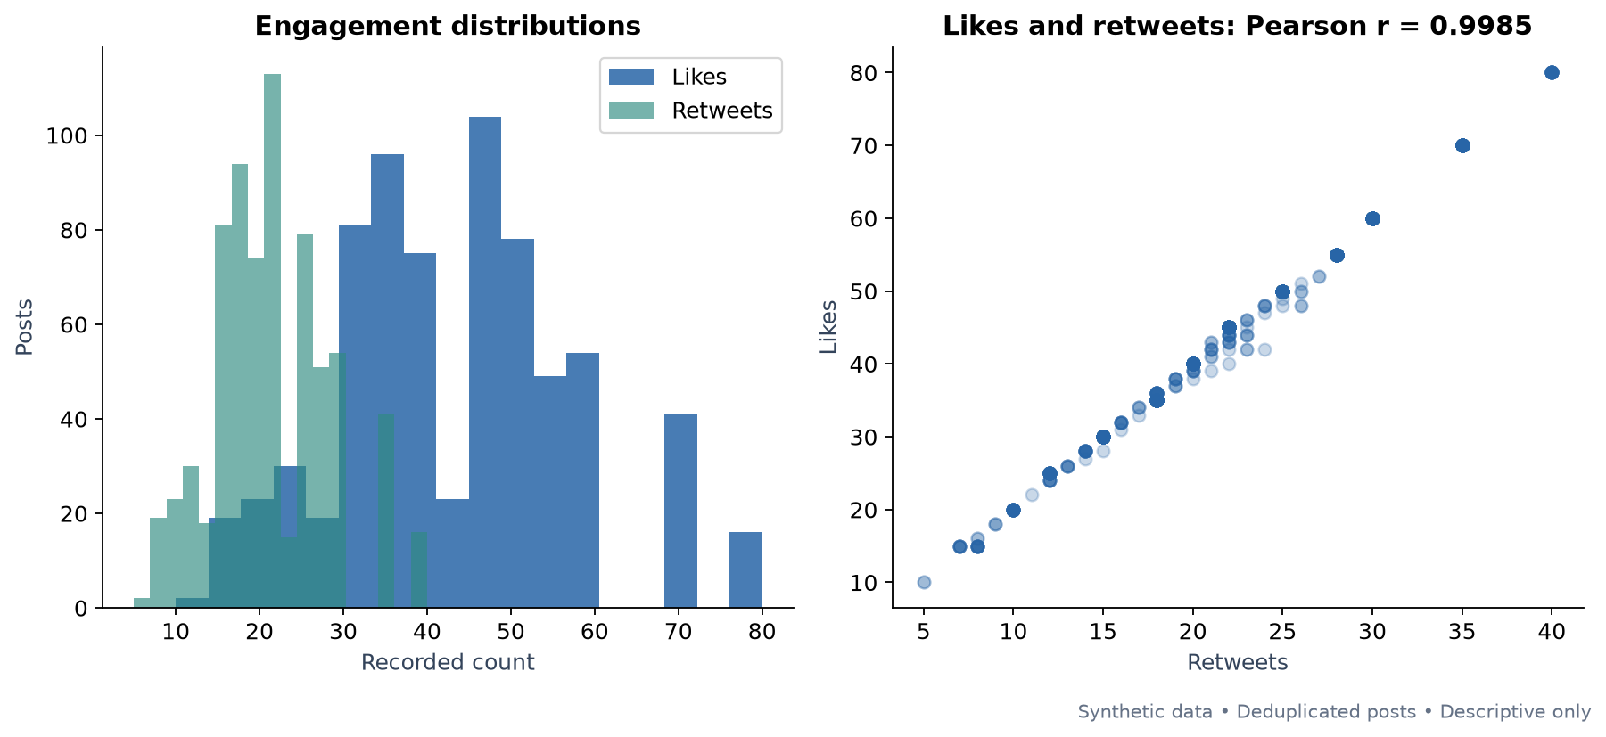
06. Engagement distributions and the near-deterministic relationship between likes and retweets.

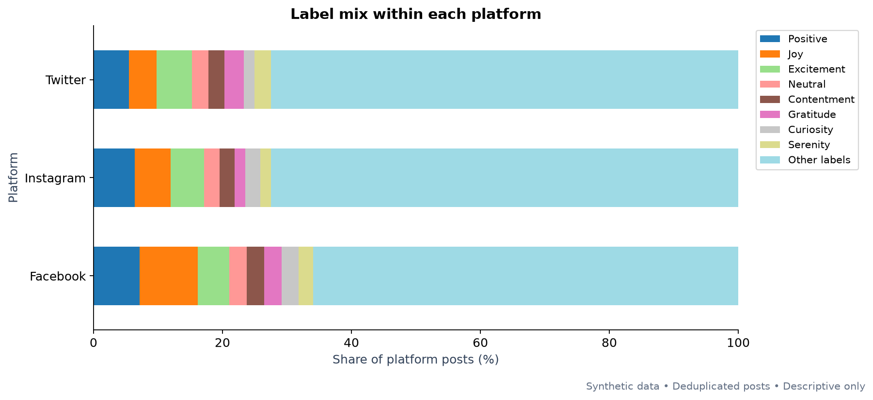
07. Within-platform label shares. Other labels is a display remainder, not a training class.
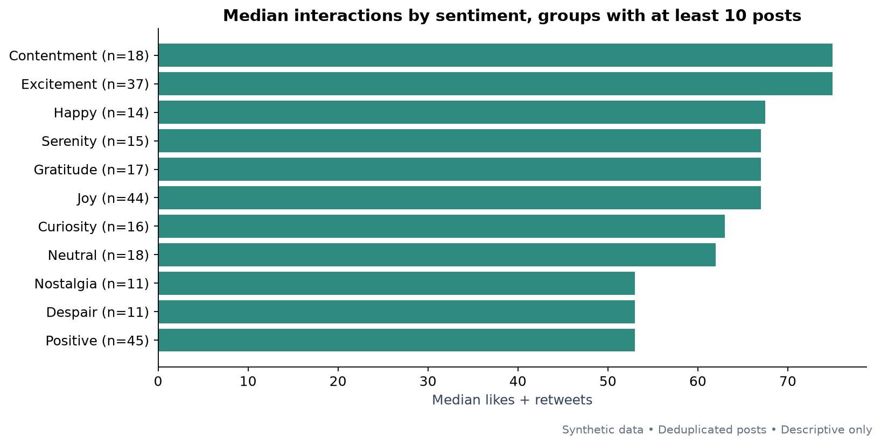
08. Median interactions for original labels with at least 10 posts. Differences are descriptive.

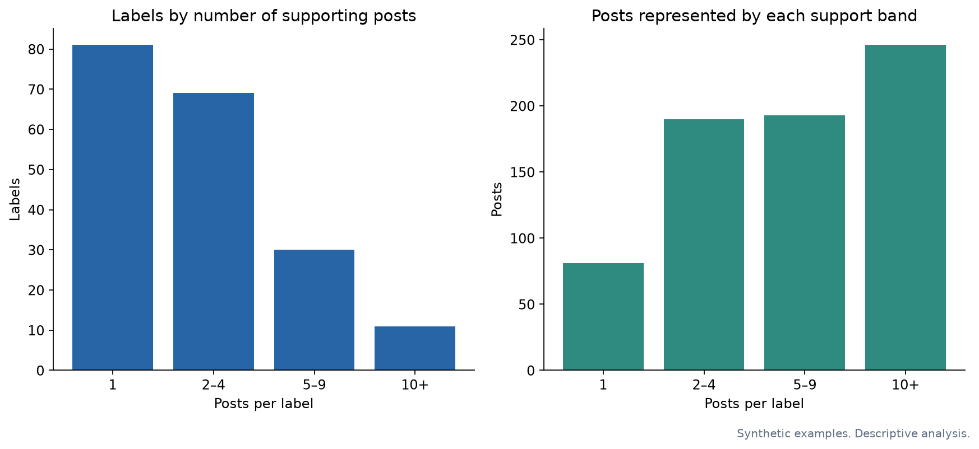
09. Support bands show why the original 191-class task is unsuitable as the primary model plan.
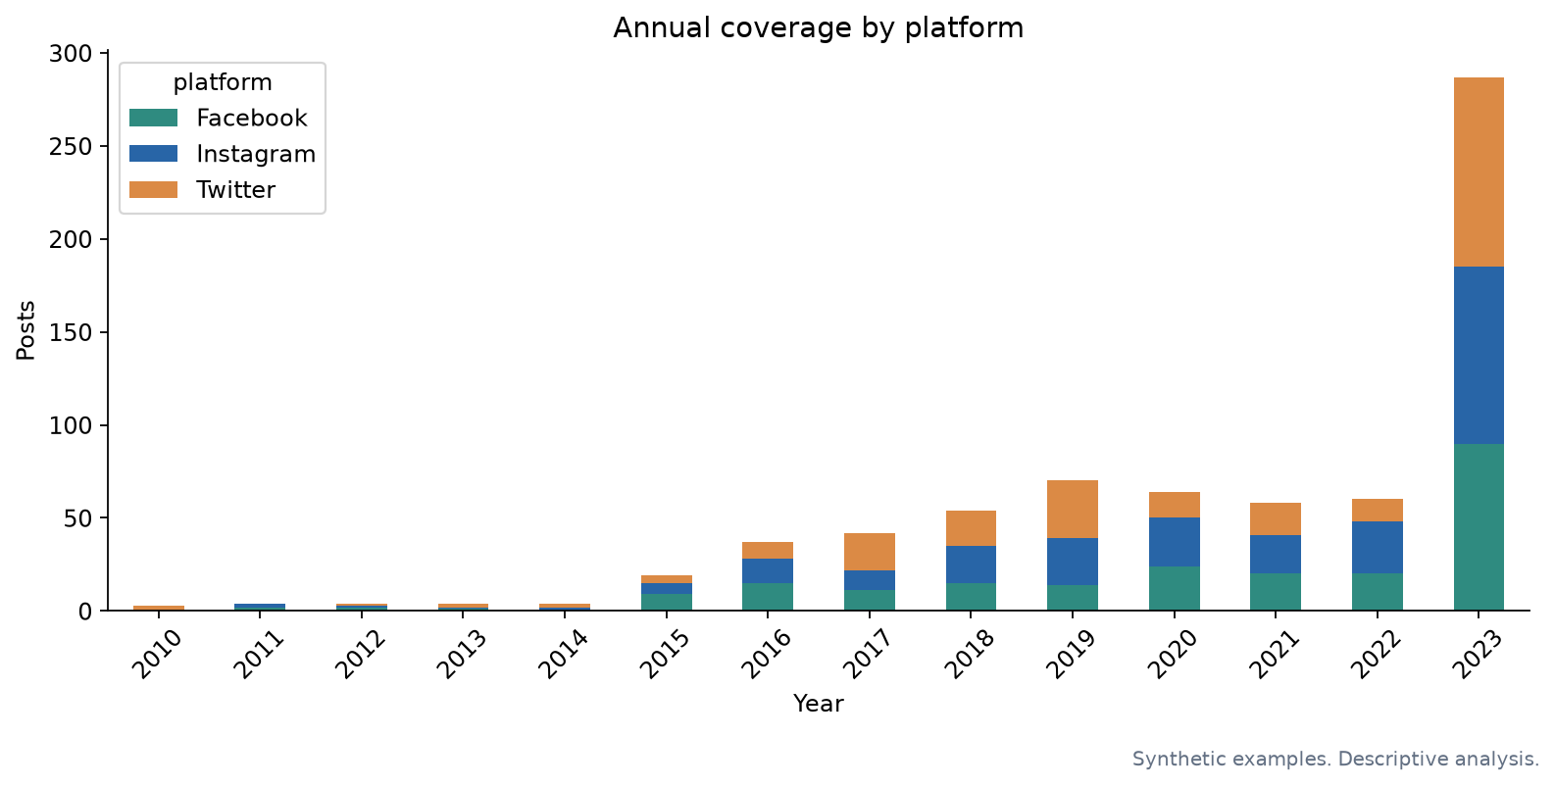
10. Calendar coverage split by platform. Sample volume does not measure actual platform activity.

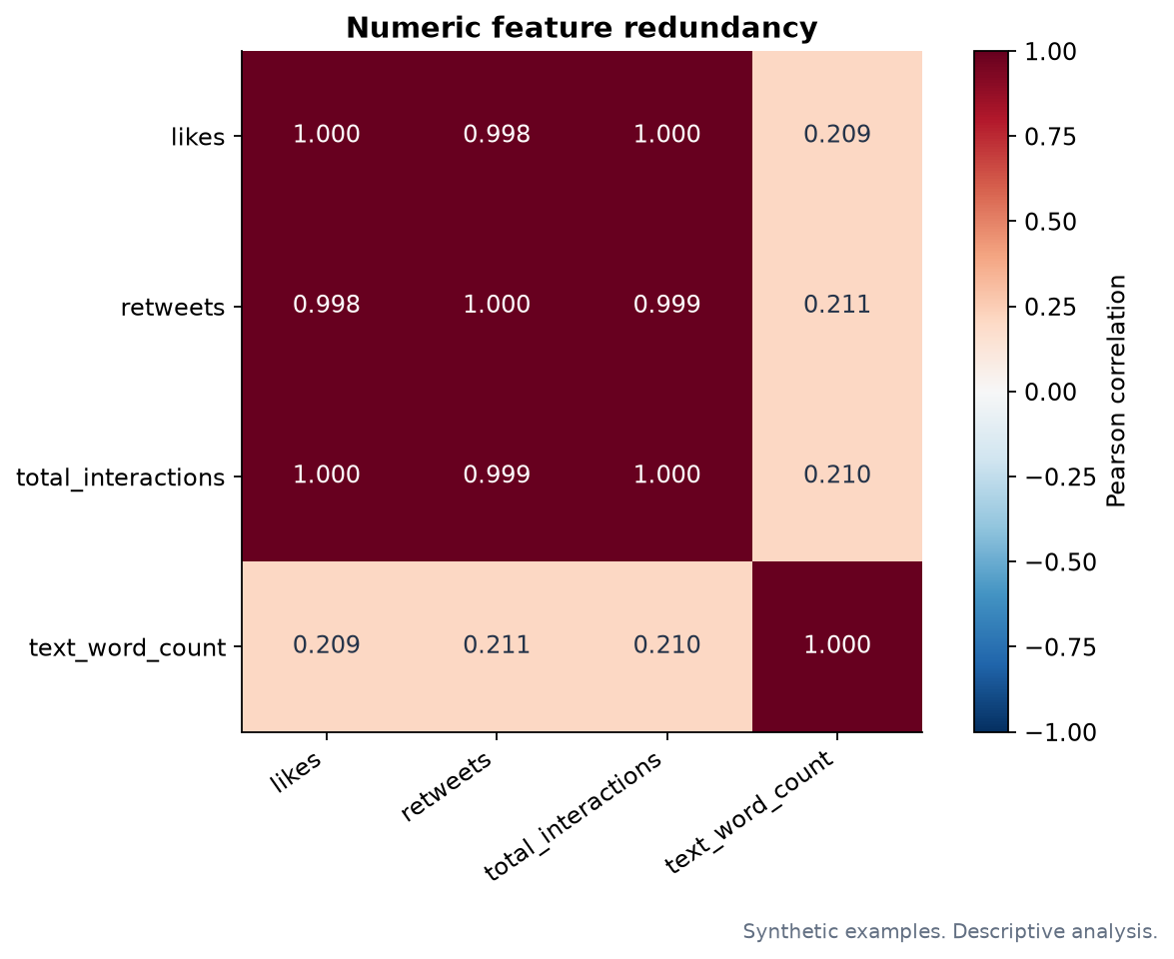
11. Numeric feature redundancy. The constant hashtag count is excluded from correlation calculation.

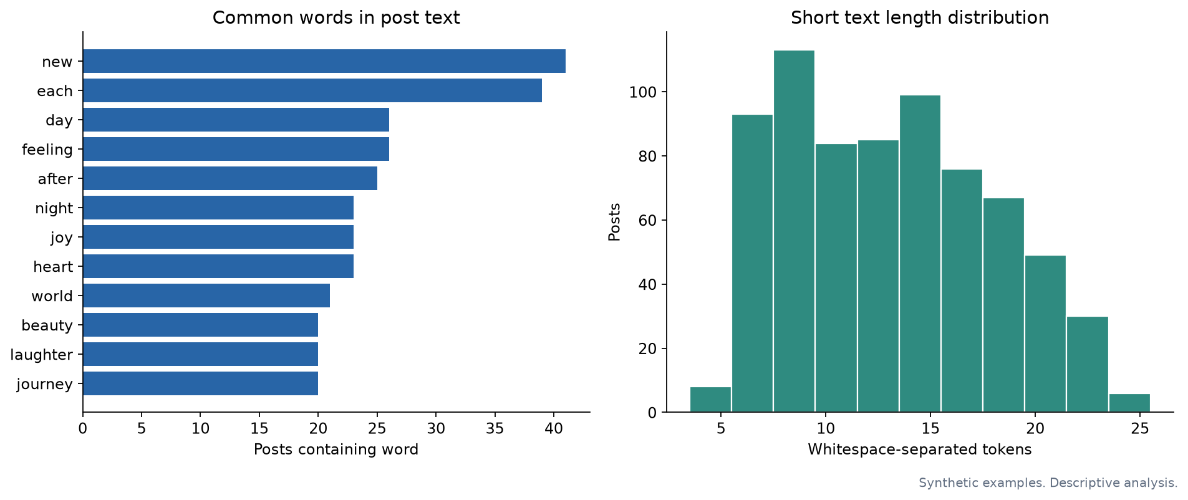
12. Descriptive text document frequencies and whitespace token counts. These displays do not fit a model vocabulary.

Problem statement and relevant features

Selected primary problem
Given the text of a previously unseen simulated social media post, predict a reviewed sentiment polarity label: Positive, Negative or Neutral. Use a reviewed mapping of the publisher’s original labels as a starting point, inspect the post text, and evaluate generalization to held-out text groups from the same synthetic corpus. Use macro-F1 as the primary selection metric and report per-class support and error patterns. The result is an educational classifier for this corpus; external usefulness would require a real independently annotated evaluation dataset.

Why this target
The original 191-label target has 81 singleton labels and many overlapping synonyms or topic-like entries. A model with all labels cannot represent every singleton in both training and evaluation. Coarse polarity gives a manageable primary objective. Original emotion-label EDA remains useful, and a reviewed emotion-family task can be a stretch goal.
The taxonomy choice is a project recommendation. The mapping remains provisional until the team reviews it against the text. We have not created new ground truth or claimed that all emotions have an unambiguous polarity.

Draft target coverage
Proposed group | Posts
Positive | 328
Needs review | 201
Negative | 163
Neutral | 18

All 710 posts remain in the analytical dataset. The draft classifier corpus also retains all rows and explicitly marks review status. Needs review is a review queue, not a fourth training class. No records have been silently discarded for their sentiment label.

Annotation rules
- Positive: the post’s dominant expressed evaluation is favorable, pleased, grateful, hopeful or approving.
- Negative: its dominant expressed evaluation is unfavorable, sad, angry, fearful or dissatisfied.
- Neutral: the text makes no clear positive or negative evaluation. Emotional intensity alone does not define polarity. Calm, numb or indifferent words do not automatically make a post Neutral.
- Mixed or unclear: record Mixed/Unclear during review, inspect context and adjudicate. If it cannot fit the three-class rubric, retain it in EDA and explicitly exclude it from the three-class model with its reason. Report resulting coverage and class balance.
- Preserve negation, emoji and sarcasm cues. Text meaning takes precedence over a broad label lookup. Do not assign Neutral to an unknown label.
Two reviewers independently label the sample worksheet without seeing each other’s decisions. Adjudicate disagreements. Then review every mapping and all associated ambiguous posts; sample review alone does not validate 191 mappings. Inspect the remaining mapped posts for label-text inconsistencies before freezing a target. Save finalized decisions under a new filename so reruns preserve them. Record reviewer names and dates, agreement before adjudication and final inclusion/exclusion reasons. Report agreement only after actual independent reviews.

Selected features
Primary baseline input: text. Derived word/character counts remain EDA and possible later auxiliary features. Apply TF-IDF inside the training pipeline in Week 5.
Split metadata: text_group_id prevents identical normalized text crossing folds. source_record traces rows to input. Neither is a predictor.
Excluded from baseline predictors: original sentiment, draft polarity and target-derived diagnostics; export indices and user IDs; all recorded engagement counts; country/platform/date metadata; separate hashtag fields; constant hashtag count. Reasons for all 30 candidate columns appear in tables/feature_selection.csv.
Hashtag cue diagnostic: 498/710 posts (70.1%) contain a hashtag that exactly matches the normalized supplied label. This is label-cue overlap, not proof of data leakage. Synonyms and semantic cues are not measured. A later robustness comparison should remove hashtags and compare performance, provided remaining text and split definitions stay consistent.

Later modeling plan not executed
1. Freeze reviewed labels and target inclusion rules, then summarize retained coverage.
2. Set aside about 20% of text groups for a final test set, with a fixed seed (6074). Inspect class representation and group overlap. Group splitting need not yield exactly 80/20 rows or perfect stratification. If the smallest class cannot support evaluation, revise the design transparently rather than forcing a misleading score.
3. Use group-aware cross-validation within training only. Choose folds based on the smallest reviewed class. Fit vocabulary/IDF and any balancing within each training fold.
4. Compare a majority-class baseline, TF-IDF plus logistic regression, and TF-IDF plus linear SVM. Consider class weights in training. Avoid synthetic oversampling of text before splitting.
5. Select using macro-F1. Report balanced accuracy, class precision/recall/F1/support and confusion matrix. Use the frozen test set once after model selection.
6. Inspect errors and compare hashtag removal. Document synthetic-origin, sparse-neutral and near-duplicate limitations. Exact-text grouping alone cannot eliminate paraphrase overlap in generated examples.

Field level selection
feature | role | reason
source_record | Identifier. Exclude from predictors | Traceability only; arbitrary identifiers can encourage memorization.
source_index_1 | Identifier. Exclude from predictors | Traceability only; arbitrary identifiers can encourage memorization.
source_index_2 | Identifier. Exclude from predictors | Traceability only; arbitrary identifiers can encourage memorization.
text | Primary text input | Text available at prediction time; fit vectorizer on training folds only.
sentiment | Target or target-derived. Exclude from predictors | Supplied/proposed outcomes or a diagnostic derived from the target.
timestamp | EDA or evaluation breakdown only | Context and quality flags do not enter the initial text-only baseline.
user | Identifier. Exclude from predictors | Traceability only; arbitrary identifiers can encourage memorization.
platform | EDA or evaluation breakdown only | Context and quality flags do not enter the initial text-only baseline.
hashtags | EDA only. Reserve for sensitivity analysis | Explicit sentiment cues may make synthetic labels easy to recover; compare after removing cues.
retweets | EDA only. Exclude from text classifier | Post-publication outcomes; engagement fields are highly redundant.
likes | EDA only. Exclude from text classifier | Post-publication outcomes; engagement fields are highly redundant.
country | EDA or evaluation breakdown only | Context and quality flags do not enter the initial text-only baseline.
year | EDA or evaluation breakdown only | Context and quality flags do not enter the initial text-only baseline.
month | EDA or evaluation breakdown only | Context and quality flags do not enter the initial text-only baseline.
day | EDA or evaluation breakdown only | Context and quality flags do not enter the initial text-only baseline.
hour | EDA or evaluation breakdown only | Context and quality flags do not enter the initial text-only baseline.
text_lower | Candidate text transformation or auxiliary feature | Preserve as EDA features; baseline uses text only to avoid duplicate representations.
text_group_id | Split grouping only | Keep identical normalized text together across training and evaluation.
repeated_text | EDA or evaluation breakdown only | Context and quality flags do not enter the initial text-only baseline.
text_char_count | Candidate text transformation or auxiliary feature | Preserve as EDA features; baseline uses text only to avoid duplicate representations.
text_word_count | Candidate text transformation or auxiliary feature | Preserve as EDA features; baseline uses text only to avoid duplicate representations.
total_interactions | EDA only. Exclude from text classifier | Post-publication outcomes; engagement fields are highly redundant.
year_month | EDA or evaluation breakdown only | Context and quality flags do not enter the initial text-only baseline.
weekday | EDA or evaluation breakdown only | Context and quality flags do not enter the initial text-only baseline.
hashtag_list | EDA only. Reserve for sensitivity analysis | Explicit sentiment cues may make synthetic labels easy to recover; compare after removing cues.
hashtag_count | EDA only. Drop from baseline | Constant at two for all retained posts.
is_weekend | EDA or evaluation breakdown only | Context and quality flags do not enter the initial text-only baseline.
log1p_interactions | EDA only. Exclude from text classifier | Post-publication outcomes; engagement fields are highly redundant.
hashtag_matches_supplied_label | Target or target-derived. Exclude from predictors | Supplied/proposed outcomes or a diagnostic derived from the target.
polarity_draft | Target or target-derived. Exclude from predictors | Supplied/proposed outcomes or a diagnostic derived from the target.

Week 4 presentation preparation
The Sentiment Signal. Kevin (yy6074), Kelly (lx2455), Yuwei (yz13019). Suggested duration: 8–10 minutes, plus questions. Speaking assignments below are proposals.

1 Project and team 45 seconds Kevin
Introduce the team. Explain the goal: build a reproducible sentiment-analysis workflow using a synthetic social media corpus. State immediately that the publisher generated the content with ChatGPT. The intended output is a demonstration classifier and an EDA narrative. No real public-opinion claims.

2 Dataset and provenance 60 seconds Kevin
732 records, 15 columns; unit is a simulated post. Introduce text, supplied emotion labels, timestamps, platform, hashtags, likes/retweets and location. Use the raw inventory and data dictionary. Name the Kaggle source and synthetic disclosure. Note unknown timezone and annotation protocol.

3 Cleaning and audit 60 seconds Kevin
Whitespace inflates labels and platform values. Normalize strings, exclude export indices from record matching, remove 22 repeated records, retain 710 posts. Keep removed-row provenance. All date and engagement checks pass. Explain why identical text with differing metadata remains but gets a split-group flag. Show the normalization log and quality audit.

4 Sentiment support 60 seconds Kelly
Show charts 01 and 09. The cleaned sample has 191 original labels; 81 have only one post. Positive, Joy and Excitement are the largest individual labels. Positive is one label, not the count of all positive emotions. Sparse support and overlapping meanings motivate a reviewed polarity target.

5 Coverage and composition 75 seconds Kelly
Show chart 10 plus 03/04 if time permits. Coverage is uneven across years and locations. The latest year ends in October. Platform counts: Instagram 251, Twitter 236, Facebook 223. Compare sample composition; avoid presenting counts as platform adoption or changes in real public mood. Country labels mix Scotland and UK.

6 Engagement and text features 75 seconds Kelly
Show charts 06, 11 and 12 selectively. Likes and retweets correlate at 0.9985. Every post has two hashtags. Text is short. Hashtags often directly cue a supplied label. Explain the implication: engagement fields are redundant and separate hashtags need sensitivity checks. These are feature observations, not significant or causal effects.

7 Problem statement and selected features 75 seconds Yuwei
Classify previously unseen simulated post text into reviewed Positive/Negative/Neutral polarity. Show the selected feature list: text is the baseline predictor; text_group_id controls splitting; supplied labels are targets; IDs, metadata and engagement are excluded from baseline predictors. Explain that the provided polarity mapping is unreviewed and contains an explicit review queue.

8 Progress next steps and feedback 60 seconds Yuwei
Weeks 1–3 technical work is documented and executable. The next team action is target review, followed by instructor feedback. Week 5 compares simple text classifiers; Weeks 6–7 handle hypothesis tests. Ask whether the polarity target fits the assignment, whether a real-world corpus should support external evaluation, and how the instructor wants ambiguous examples and sparse Neutral handled.

Backup material and questions
- Why remove only 22 rows? Equality uses all substantive fields after normalization, not just text. Four repeated-text groups remain because other metadata differs.
- Why no model scores? The current milestone ends at EDA and target design; training begins in Week 5.
- Why not use 191 labels? Eighty-one singleton categories cannot appear in both training and held-out evaluation.
- Are Instagram posts more engaging? The recorded mean differs descriptively; generated data, differing composition and unverified metric comparability prevent a real-world platform conclusion.
- Is label/hashtag overlap leakage? It is a cue-risk diagnostic. Leakage depends on the prediction setting, feature availability and how labels were created. Group separation and cue-removal comparisons are proposed checks.
- What happens to Mixed/Unclear? Preserve for EDA, adjudicate against text, and explicitly document any final model exclusion.
- Can we claim seasonality? Uneven synthetic coverage and a partial final year prevent a sound real-world seasonal claim.

Rehearsal checklist
Each presenter should explain the source disclosure, duplicate rule and chosen target. Reproduce at least one summary from the notebook. Use only charts that support the spoken point. Keep draft target counts clearly marked as provisional. Reserve 2–3 minutes for instructor feedback and record decisions afterward.

Final week preparation plan
Use relative days because the actual presentation date was not supplied. No calendar dates or reminders have been assumed.
When | Action | Proposed lead | Done when
T−7 to T−6 | Confirm roles and reproduce notebook outputs | Kevin | All cells run; roster and file locations verified
T−6 to T−5 | Independently review annotation sample and inspect ambiguous labels | Kelly and Yuwei | Both reviewer columns completed, disagreements listed
T−5 to T−4 | Adjudicate examples and agree target scope | Entire team | Rubric and inclusion policy documented; remaining uncertainty listed
T−4 to T−3 | Choose 5–6 charts and prepare the presentation using the outline | Kelly, with all members | Every claim has a table or chart and a limitation
T−2 | Rehearse the 8–10 minute narrative | Entire team | All members explain methods and stay within time
T−1 | Freeze the EDA handoff and back up files | Kevin | Notebook, report and presentation materials open on presentation laptop
T | Present and record feedback | Entire team; Yuwei records feedback | Instructor decisions captured, future plan updated

Target review can continue after the mid-program milestone if the team clearly presents its provisional status. It must finish before training a model on the proposed polarity labels.
Feedback log fields: topic; instructor comment; agreed decision; owner; due milestone; status. No feedback has been invented or pre-filled.

Files and reproducibility
Start with weeks_1_3_report.html. It is a self-contained report with the workflow checklist, project scope, findings, all 12 charts and a summary of decisions.
The original source CSV stays in the parent directory. This folder adds to the earlier initial_analysis folder without changing its files.

Main files
- weeks_1_3_analysis.ipynb: executed notebook with source inspection, cleaning, NumPy/Pandas manipulation, EDA, visualizations, draft target and feature selection.
- weeks_1_3_analysis.py: equivalent code cells for a plain Python run. Requires IPython for rich displays, provided by the notebook dependencies.
- project_charter.md: confirmed roster, proposed roles, objectives and scope.
- problem_and_features.md: selected primary question, annotation rules and later evaluation plan.
- workflow_checklist.csv: completed work, pending decisions and future milestones.
- mid_program_presentation_outline.md: eight-part outline, suggested speaker notes and backup Q&A.
- one_week_preparation_plan.md: relative-day rehearsal plan.
- data/posts_prepared.csv: all 710 prepared EDA rows, with added features.
- data/classification_corpus_draft.csv: text, source IDs and draft targets; every row remains unreviewed.
- data/polarity_mapping_proposed.csv: proposed mappings for all 191 original labels. Save reviewed decisions separately.
- data/annotation_review_sample_proposed.csv: up to 20 examples per draft group for independent review. Save a separate reviewed copy.
- tables/feature_selection.csv: feature decisions and reasons.
- tables/feature_dictionary_and_selection.csv: definitions combined with feature decisions.

Reproduce
Install requirements.txt in a virtual environment, open the notebook, select its Python kernel and run all cells from this folder. Alternatively run python weeks_1_3_analysis.py. All rows are read from the original CSV; no network access is required. Rerunning refreshes generated proposed files, so keep human annotations in separately named files. The EDA report is a saved handoff snapshot and must be updated if source data or claims change.
The full archive includes this folder, the earlier analysis and the original CSV in the expected relative layout.
All source-based statements use the local dataset and the saved Kaggle publisher metadata. No new web data was downloaded for this handoff. No model performance, statistical significance, team approval or instructor feedback has been invented.

