Human osteoarthritis reveals context-dependent PIEZO1 expression across chondrocyte-state programmes
Yang Yunze (ORCID: 0009-0003-5907-7037)
Orthopedics and Traumatology, The First Affiliated Hospital of Heilongjiang University of Chinese Medicine, Heilongjiang University of Chinese Medicine, Harbin, Heilongjiang 150060, China
Corresponding author: Yang Yunze, Orthopedics and Traumatology, The First Affiliated Hospital of Heilongjiang University of Chinese Medicine, Heilongjiang University of Chinese Medicine, Harbin, Heilongjiang 150060, China. E-mail: 631652214@qq.com. ORCID: https://orcid.org/0009-0003-5907-7037.
Running title: Context-dependent PIEZO1 across chondrocyte programmes
Manuscript type: Full-length original research article | Main-text word count: 3,905 | Abstract word count: 335

Abstract
Objective. PIEZO1 is a mechanically gated cation channel implicated in cartilage mechanotransduction, but its reported expression in human osteoarthritis (OA) is inconsistent. We tested whether within-joint context is more strongly associated with PIEZO1 expression than case-control status, whether a chondrocyte-programme shift shows cross-dataset concordance under compositional testing, and whether genetically predicted whole-blood PIEZO1 expression influences OA risk under instrumental-variable assumptions.
Design. Seven public transcriptomic datasets were integrated: paired subchondral bone, two synovial cohorts, an inflammation-gradient model, donor-annotated single-cell OA cartilage, paired preserved and affected cartilage, and paired lateral and medial cartilage single-cell profiles. Analyses used donor-paired differential expression, donor-level single-cell inference, programme scoring with compositional sensitivity analyses, reference-internal fully nested validation, external projection support, Mendelian randomization, colocalization and power analyses.
Results. PIEZO1 showed no consistent OA-versus-control main effect. In OA subchondral bone, expression was lower medially (log2 fold change -0.504, P=0.000273, FDR=0.00189), but the disease-by-compartment interaction was not significant (P=0.147; covariate-adjusted P=0.81). Across 10 GSE104782 donors, PIEZO1 correlated weakly and negatively with the hypertrophic-minus-homeostatic axis (mean rho=-0.137, P=0.0035), and the donor-within Q1-Q4 difference was 0.123 (Wilcoxon P=0.0323). The homeostatic-versus-pre-hypertrophic contrast was concordant in 33 paired cartilage donors; GSE152805 supplied three-donor external projection support. Reference-internal fully nested validation exceeded the complete-pipeline permutation null (balanced accuracy 0.595; null 95th percentile 0.172; P=0.001). After excluding HTC, RegC and EC for recall below 0.60, the total medial-higher difference persisted in all three donors, but within-state expression and composition components were concordant in only two. Five whole-blood cis-eQTL instruments gave null primary estimates; conservative 80%-power minimum detectable odds ratios were 1.14, 1.14 and 1.09.
Conclusions. Human OA shows a consistent chondrocyte-programme balance shift across the analysed paired datasets, whereas PIEZO1 transcription is context dependent. The compartment difference has donor-heterogeneous within-state expression and composition contributions. Within the whole-blood instrument model, genetic estimates did not support a moderate-to-large systemic effect and do not evaluate local joint mechanisms.
Keywords: PIEZO1; osteoarthritis; chondrocyte state; compositional data; single-cell RNA sequencing; Mendelian randomization

1 Introduction
Osteoarthritis (OA) affected an estimated 595 million people worldwide in 2020 and is a major cause of pain, loss of mobility and years lived with disability [1,2]. OA is a whole-joint disorder in which articular cartilage, subchondral bone, synovium and periarticular tissues interact. Mechanical context is central to this system: altered joint alignment, injury and repeated loading shape the spatial distribution of tissue damage, while cellular responses depend on loading magnitude, duration and matrix state [2,3]. Medial and lateral regions of the same knee therefore provide a useful paired contrast that reduces inter-individual confounding, although anatomical compartment remains a proxy rather than a direct measurement of force.
PIEZO1 is a mechanically activated, non-selective cation channel identified as a core component of mammalian mechanotransduction [4]. In articular chondrocytes, PIEZO1 and PIEZO2 cooperate to transduce high-strain deformation into calcium signalling [5], and inflammatory signalling can sensitise PIEZO1-mediated responses [6]. More recent work has linked membrane stretch to the activation threshold of PIEZO1 and shown that chondrocyte-specific Piezo1 deletion modifies osteoarthritis-related phenotypes in mice [7,8]. These studies support biological plausibility, but they do not imply that PIEZO1 messenger RNA must change in one direction across all human joint tissues.
Human transcriptomic studies pose four recurring problems. First, case-control comparisons mix anatomical regions, disease severities and cell compositions. Second, single-cell tests can yield very small P values when cells rather than donors are treated as independent units. Third, programme weights obtained by constrained fitting are compositional: because they are rescaled to sum to one, an increase in one programme can arise purely from decreases in the others [23]. Fourth, single-gene expression and cell-state programmes may not travel together across tissues. The seven chondrocyte states described in human OA cartilage provide a reference for separating a continuous homeostatic-to-hypertrophic transition from the behaviour of any one transcript [9]. Independent paired cartilage data can then evaluate cross-dataset programme concordance [10,11].
Observational tissue data also cannot determine whether systemic modulation of PIEZO1 expression alters OA risk. Expression quantitative trait loci (eQTLs) can proxy long-term differences in gene expression for Mendelian randomization (MR), while colocalization tests whether exposure and outcome associations are compatible with a shared causal variant [12-15]. The present causal analysis uses a well-powered whole-blood eQTL resource; a null result bounds the systemic whole-blood instrument model but does not evaluate cartilage- or subchondral-bone-specific mechanisms.
We therefore evaluated four linked questions: whether PIEZO1 is a disease-wide expression marker; whether within-donor joint compartment explains a stronger signal; whether PIEZO1-associated chondrocyte programmes show cross-dataset concordance once compositional constraints are respected; and whether whole-blood expression genetics support a systemic causal effect. The analysis was organised around donor-level and paired-tissue estimates; immune and regulatory extensions were retained as exploratory supplementary analyses.

2 Materials and Methods
Full procedural detail, including normalisation, probe mapping, quality-control thresholds, marker panels, the programme-scoring algorithm and the exposure-effect reconstruction, is given in Supplementary Methods. The summaries below define the inferential unit, the primary test for each question and every decision that could affect interpretation.

2.1 Study design, analysis provenance and reporting
This secondary, discovery-driven reanalysis used public human data. Dataset roles were defined for disease context, paired within-joint comparisons, donor-aware single-cell association, cross-dataset programme concordance and whole-blood expression genetics. Processing, quality control, final sensitivity definitions and eligibility screens for optional evidence are in Supplementary Methods S1-S12. The analysis plan was not preregistered; final-audit additions are identified.

2.2 Data sources
We analysed GSE51588 [32], GSE55235 [33], GSE82107 [34], GSE46750 [35], GSE104782 [9], GSE57218 [10] and GSE152805 [11], together with eQTLGen whole-blood cis-eQTL statistics and FinnGen R12 osteoarthritis outcomes. Dataset identifiers, deposited samples, exclusions, preprocessing and final analysis counts are in Supplementary Tables S1-S4 and Data S1.

2.3 Disease-level and paired compartment analyses
PIEZO1 disease contrasts were estimated within each microarray dataset and were not pooled across platforms. In GSE51588, the primary compartment analysis was donor paired; OA specificity was tested by the moderated disease-by-compartment interaction. Age- and sex-adjusted models were sensitivity analyses because donor-invariant covariates are absorbed by pairing.

2.4 Donor-aware single-cell analysis
GSE104782 cells were assigned to seven published chondrocyte states. The continuous axis was defined as z(mean hypertrophic markers) minus z(mean homeostatic markers), using COL10A1, RUNX2, IBSP, ALPL, MMP13, SPP1 and POSTN for the hypertrophic set and COL2A1, SOX9, ACAN, CHAD and HAPLN1 for the homeostatic set. CRTL1 is a historical alias of HAPLN1 and was not treated as an additional independent marker. PIEZO1 was not included in either set. PIEZO1-axis association was estimated within donor and summarized across ten donors, and Q1/Q4 groups were defined within each donor. Cell-level tests were descriptive; donor-blocked pseudobulk models were used for categorical contrasts with transcriptome-wide correction. The paired Q1-Q4 Wilcoxon signed-rank sensitivity test used the asymptotic normal approximation with continuity correction.

2.5 Programme scoring and compositional sensitivity
State programmes were scored by one final standardized pipeline distinct from the disease-level DEG preprocessing. GSE104782-derived top-100 state markers were fitted after probe-mean aggregation, conditional conversion of log2 bulk expression to the linear scale and gene-wise standardization; no additional quantile normalization was applied. Non-negative L-BFGS-B weights were then closed to sum one. Table S6 reports the raw closed-weight layer, while the zero-handling, centred-log-ratio, additive-log-ratio, pairwise-log-ratio and unclosed gene-set specifications in Table S13 use the same marker construction and authoritative programme preprocessing. The homeostatic-minus-pre-hypertrophic contrast, rather than any isolated coordinate, was the principal cross-dataset comparison.

2.6 Within-state and composition decomposition
Reference-internal validation was fully nested within GSE104782: for each held-out donor, top-100 state markers were reselected and centroids rebuilt from the other nine donors; 1,000 donor-preserving label permutations repeated the complete fold-specific pipeline. Full-reference centroids were then projected onto GEO-supplied sparse matrices from the six GSE152805 cartilage libraries by maximum unconstrained similarity. This external projection support is not external validation because independent gold-standard GSE152805 state labels were unavailable. States with held-out recall below 0.60 were excluded in a final sensitivity analysis without reassigning cells; retained proportions were renormalized before symmetric Kitagawa decomposition. Assignment confidence used the top-1-minus-top-2 margin, and full-state within-state PIEZO1 required at least 50 cells per donor-compartment-state. These estimates address compartmental heterogeneity, not disease causality.

2.7 Mendelian randomization
The three core MR assumptions were relevance (the cis-eQTLs predict whole-blood PIEZO1 expression), independence from exposure-outcome confounders, and exclusion restriction (the variants affect OA only through whole-blood PIEZO1 expression). F statistics assessed relevance; source-study adjustment, the non-overlapping two-sample design, heterogeneity, MR-Egger, leave-one-out, directionality and colocalization probed the other assumptions, which cannot be proven from summary data. Five independent PIEZO1 cis-eQTLs present in all outcomes were analysed. Because eQTLGen supplied Z scores and sample sizes, per-allele effects on standardized expression were reconstructed as beta=Z/sqrt[2f(1-f)N] and SE=1/sqrt[2f(1-f)N], using assessed-allele frequency f; F=Z^2. The primary estimate was inverse-variance weighted with multiplicative random effects; fixed-effect, DerSimonian-Laird, weighted-median and MR-Egger estimates were sensitivity checks. Variants absent from an outcome were excluded. No individual-level missing data were imputed, and no multiplicity adjustment was applied across three correlated OA endpoints.

2.8 Colocalization and power
Colocalization used coloc.abf in the PIEZO1 region and reported posterior probabilities for distinct (H3) and shared (H4) signals separately by outcome. Power boundaries used the primary multiplicative-random-effects standard errors and, separately, the more conservative DerSimonian-Laird standard errors at two-sided alpha=0.05 and 80% power.

2.9 Covariate handling, exploratory analyses and software
Deposited age and sex were included where available; missing covariates were not imputed. The RegC-FC contrast and other unplanned comparisons were labelled exploratory. Analyses were performed in R 4.6.1 and Python 3.12.13. Package versions, explicit model implementations and exact data-to-result links are listed in Supplementary Tables S16 and S17.

3 Results

3.1 PIEZO1 is not a consistent disease-wide OA marker
Across subchondral bone and synovial disease contrasts, PIEZO1 showed no consistent OA-versus-control direction. In GSE51588 the region-adjusted OA main effect was small (log2 fold change -0.109, P=0.500, FDR=0.616) and remained small after adjustment for age and sex (-0.090, P=0.74). Synovial cohorts were discordant or null across probes, single-gene receiver-operating-characteristic areas ranged from 0.55 to 0.81, and PIEZO1 was unrelated to age (Spearman rho=-0.07, P=0.61). These observations do not support PIEZO1 as a uniform disease-wide expression marker or standalone diagnostic marker (Figure 1; Supplementary Table S3).

3.2 Within-joint compartmental heterogeneity is not shown to be OA specific
Within the 20 OA donors in GSE51588, 7,195 of 21,752 tested genes (33.1%) differed between medial and lateral subchondral bone at FDR<0.05. PIEZO1 was lower medially (log2 fold change -0.504, P=0.000273, FDR=0.00189), and the direct donor-paired difference was -0.504 (95% CI -0.746 to -0.261; P=0.000350). The five non-OA donors showed no detectable paired difference (mean -0.140, P=0.35). The primary moderated disease-by-compartment interaction was not significant (effect -0.363, P=0.147, FDR=0.435); the unmoderated donor-delta comparison gave P=0.064 (95% CI -0.752 to 0.025) and is a sensitivity analysis only. Adjustment for the deposited age and sex variables attenuated the interaction further (effect -0.116, P=0.81). The OA medial-lateral contrast is therefore well supported, but these data do not establish that it is OA specific.
Genes higher medially were enriched for skeletal development, extracellular-matrix organisation, proliferation and angiogenesis, whereas genes higher laterally were enriched for lipid-metabolic and immune-related processes, and Hallmark enrichment likewise separated proliferative and matrix programmes from adipogenic and metabolic programmes. These regional programmes were far stronger than the disease main effect for PIEZO1 (Figure 2; Supplementary Tables S3-S4).

3.3 Donor-aware analysis supports a weak association of PIEZO1 with the homeostatic end of a chondrocyte continuum
PIEZO1 was detected in 59.6% of the 1,464 GSE104782 chondrocytes. Descriptively, mean expression was greatest in regulatory and homeostatic cells, but categorical state differences were sensitive to the level of analysis. The cell-level seven-state Kruskal-Wallis test was significant (P=3.9e-6), whereas the donor-level Friedman analysis of states represented in at least eight donors was not (chi-square=1.36, df=5, P=0.929; Kendall W=0.034), and the donor-level HomC-versus-HTC paired difference was not significant (mean 0.042, P=0.49). The donor-blocked pseudobulk subtype omnibus test was F(6, 38.81)=3.252, P=0.0110 and FDR=0.0663, and therefore did not pass transcriptome-wide correction. One pairwise contrast, RegC versus FC, remained significant after correction (log2 fold change 1.799, 95% CI 0.741 to 2.856, FDR=0.029); because the omnibus test was not significant after correction, it is reported as exploratory and supports no main conclusion.
The continuous axis was more consistent across donors. Nine of ten donors showed a negative PIEZO1 correlation with the hypertrophic-minus-homeostatic axis, with a mean donor Spearman correlation of -0.137 (95% CI -0.216 to -0.058; one-sample t P=0.00346). Three donor-level sensitivity tests agreed: Fisher-z one-sample t P=0.00355 (mean z=-0.139), Wilcoxon signed-rank P=0.0108 (median rho=-0.156) and exact sign-test P=0.0215. With Q1 and Q4 defined within donor, PIEZO1 was higher at the homeostatic than hypertrophic end by 0.123 normalized-expression units (paired t P=0.0134; Wilcoxon P=0.0323). The cell-level association (rho=-0.142, P=5.26e-8) reflects 1,464 nested cells, explains 2.0% of variance and is descriptive. These results support a weak donor-consistent continuous state association, not a categorical ranking of all seven states (Figure 3; Supplementary Tables S5 and S20).

3.4 The homeostatic-versus-pre-hypertrophic contrast shows cross-dataset concordance and survives compositional testing
Programme-level integration was secondary, so its evidential hierarchy is stated before the estimates. GSE104782 defines the programmes; GSE57218 provides paired-cartilage cross-dataset concordance; GSE152805 provides external projection support only; and GSE51588 contributes regional discovery and cross-tissue transcriptomic similarity. GSE152805 is not an external validation dataset because independent gold-standard state labels were unavailable.
In GSE57218, preserved-minus-affected differences were positive for the homeostatic programme (0.0298, P=4.4e-5) and negative for the pre-hypertrophic programme (-0.1197, P=1.8e-7), where positive favours preserved tissue. The composite homeostatic-minus-pre-hypertrophic contrast was positive in every analytic layer: 1.3439 as the log-ratio log(HomC/preHTC) (P=2.6e-4) and 0.551 using an unclosed gene-set score carrying no sum-to-one constraint (P=1.2e-9). Centred log-ratio transformation gave homeostatic estimates from 0.177 to 0.193 (P=3.4e-5 to 9.1e-3) and pre-hypertrophic estimates from -0.857 to -1.151 (P=1.6e-6 to 4.2e-4). Under additive log-ratio transformation the pre-hypertrophic programme was negative with all seven reference states (-0.759 to -1.802, P=8.7e-5 to 0.017), whereas the homeostatic programme was reference dependent (-0.458 to 1.344, P=2.6e-4 to 0.91). The isolated homeostatic increase is therefore not compositionally robust and is not claimed; the homeostatic-versus-pre-hypertrophic contrast is robust and is what we report (Figure 4; Supplementary Tables S6 and S13).
The same contrast held in the subchondral-bone discovery dataset, where it is interpreted as cross-tissue transcriptomic resemblance rather than chondrocyte content: 0.6846 as log(HomC/preHTC) (P=8.2e-5) and 0.355 with the unclosed gene-set score (P=7.1e-5). Centred and additive log-ratio results paralleled GSE57218, with the pre-hypertrophic programme negative under every treatment (-0.222 to -1.163) and the homeostatic programme reference dependent (-0.479 to 0.685, P=0.052 to 0.37) and not significant with the unclosed gene-set score (0.057, P=0.35). GSE51588 lateral-up and medial-up signatures transferred to GSE57218 in the expected directions (0.115, P=0.0060 and -0.100, P=0.0140). In GSE152805, five of seven projected programmes had the same direction in all three donors; fibrocartilage and regulatory scores agreed in two. With three donors and no gold-standard query labels, this is external projection support, not independent statistical validation (Figure 4; Supplementary Figure S7).

3.5 PIEZO1 direction is context dependent, with donor-heterogeneous within-state and compositional contributions
PIEZO1 messenger RNA did not show one cross-dataset direction. Preserved cartilage in GSE57218 had lower PIEZO1 than OA-affected cartilage (preserved-minus-affected -0.253, P=0.013), and all three GSE152805 donors had lower mean PIEZO1 laterally than medially (-0.052, -0.147 and -0.073). Both directions oppose the subchondral-bone contrast, where PIEZO1 is higher laterally.
We therefore asked whether the GSE152805 compartment difference was an artefact of cell-state composition. Fully nested leave-one-donor-out validation, with marker selection repeated inside each training fold, gave balanced accuracy 0.595 and macro-F1 0.554, above the complete-pipeline donor-preserving permutation-null 95th percentile of 0.172 (P=0.001). Held-out recall was below 0.60 for HTC, RegC and EC. In the full-state analysis, symmetric within-state components were medial-higher in all three donors. Across donors and reference formulations, within-state shares occurred on both sides of 50%, and the donor 118 interval crossed 50%. In the recall-gated sensitivity retaining FC, HomC, ProC and preHTC without reassigning cells, total lateral-minus-medial differences remained negative in donors 113, 116 and 118 (-0.047, -0.138 and -0.069), but the within-state component was slightly positive in donor 113 (+0.004) and negative in donors 116 and 118 (-0.101 and -0.032); composition components were negative in all three (-0.051, -0.037 and -0.037). The medial PIEZO1 excess therefore persisted overall, but the relative contribution of within-state expression and composition was not uniform across donors (Figure 4; Supplementary Figures S12 and S15; Supplementary Tables S14, S19 and S21).

3.6 Whole-blood expression genetics bound the tested systemic instrument model
Five independent whole-blood cis-eQTL instruments were available for all outcomes (F=32.7-654.6; all F>10). Under the primary multiplicative random-effects model, log odds ratios per standard-deviation higher genetically predicted whole-blood PIEZO1 expression were -0.027 (SE 0.026, P=0.30) for overall OA, -0.032 (SE 0.028, P=0.26) for knee OA and -0.005 (SE 0.032, P=0.87) for hip OA. Fixed-effect P values were 0.166, 0.179 and 0.874; DerSimonian-Laird, weighted-median and MR-Egger slope estimates were also nonsignificant (Figure 5; Supplementary Tables S10-S11).
Heterogeneity was moderate for overall OA (Q=7.14, P=0.129; I2=44.0%), lower for knee OA (Q=5.60, P=0.231; I2=28.5%) and absent for hip OA (Q=3.72, P=0.445; I2=0%). MR-Egger intercepts showed no directional pleiotropy for overall or knee OA but were nominally significant for hip OA (P=0.043). Leave-one-out estimates remained nonsignificant. However, rs56158123 carried 84.7% of IVW weight in every outcome, making the analysis statistically close to a single-instrument Wald ratio; per-SNP results and Steiger checks are reported in Supplementary Tables S10-S11.
Colocalization provided no evidence for a shared causal variant: PP.H4 was 0.072% for overall OA, 0.0042% for knee OA and 0.103% for hip OA. For overall and knee OA, a strong eQTL and separate regional OA signals 897 kb and 471 kb away favoured distinct signals (PP.H3 94.9% and 99.7%). For hip OA, PP.H3=85.5% reflected a dominant eQTL alongside a sub-threshold outcome signal, not two established signals.
Power is reported conservatively because the exposure scale is reconstructed. Using the most conservative variance model, minimum detectable odds ratios at 80% power were 1.14 for overall OA, 1.14 for knee OA and 1.09 for hip OA; under the primary model they were 1.08, 1.08 and 1.09. Power to detect an odds ratio of 1.10 was 55%, 54% and 85% under the conservative model and exceeded 97% for an odds ratio of 1.20 in all three outcomes. Within the whole-blood cis-eQTL instrument model, the estimates did not support a moderate-to-large systemic effect; they neither evaluate nor establish any local cartilage or subchondral-bone mechanism (Figure 5; Supplementary Table S12).

4 Discussion
This analysis separates two quantities that are easily conflated: a consistent cross-dataset shift in chondrocyte-programme balance within human OA joints, and the context-dependent expression of PIEZO1 itself. Paired-cartilage concordance came from GSE57218, external projection support from three GSE152805 donors, and cross-tissue regional similarity from GSE51588. The contrast survived compositional sensitivity testing. By contrast, PIEZO1 transcript abundance was higher laterally in subchondral bone but higher medially or in affected regions in two cartilage datasets. A single directional biomarker claim would discard this context dependence.

Why the programme claim is stated as a contrast
Programme weights obtained by constrained fitting sum to one and therefore behave as compositional data: an apparent increase in one programme can arise from decreases in others rather than from a change in that programme. Testing this directly changed what can be claimed. The pre-hypertrophic programme was robust, remaining negative under every centred log-ratio, additive log-ratio, log-ratio and unclosed gene-set treatment in both datasets. The isolated homeostatic increase was not: its sign depended on which state served as the additive log-ratio reference, and it was not significant with an unclosed gene-set score in GSE51588. We therefore report the homeostatic-versus-pre-hypertrophic contrast, which is stable across all five analytic layers in both datasets. Reporting programme findings as balances rather than as single-programme changes should be the default whenever weights are constrained to sum to one.

Reconciling the discordant PIEZO1 directions
The apparent contradiction resolves once three quantities measured on different axes are separated. The first is the cross-state association: within GSE104782 donors, PIEZO1 declines weakly along a continuous hypertrophic-minus-homeostatic axis. The second is the projected within-state compartment contrast, which was predominantly medial-higher in the full-state analysis but was sensitive to the nested recall gate. The third is the compartment average, which combines within-state expression with cell-state composition. After retaining only states with recall at least 0.60, the total medial-higher direction persisted in all three donors, although donor 113 became composition dominated and its within-state component reversed slightly. These quantities are not mutually exclusive, and their different signs show that PIEZO1 transcript level is not a fixed function of position on the state axis.
Decomposition does not support a single universal mechanism for the cartilage compartment difference. In the full-state analysis, both within-state expression and composition were material. Across donors and reference formulations, within-state shares occurred on both sides of 50%, and the donor 118 interval crossed 50%. After excluding HTC, RegC and EC for nested recall below 0.60, both components aligned with the total difference in donors 116 and 118, whereas donor 113 was composition dominated with a small opposing within-state component. The result is donor-heterogeneous contributions, not a uniformly within-state or uniformly compositional mechanism.
PIEZO1 expression, channel activity and cellular adaptation should also not be treated as interchangeable readouts. PIEZO channels translate high-strain deformation into calcium signalling [5], inflammation alters PIEZO1 abundance and sensitivity [6], and membrane prestress changes the activation threshold [7]. A transcript may therefore rise as an adaptive or pathological response in one matrix context and fall in another, while both tissues participate in a broader state transition. Whether PIEZO1 expression, channel activity and cell-state adaptation are coupled or decoupled is the next experimental question, and answering it requires direct measurement of channel activity, calcium dynamics, local strain and exposure duration in the same samples.

Strength and limits of the genetic evidence
The genetic analysis supplies a boundary rather than mechanistic proof, and its numerical scale depends on reconstructing per-allele eQTLGen effects. Uniform rescaling changes Wald-ratio and standard-error units proportionally but leaves the IVW z statistic, P value and heterogeneity statistics unchanged. Thus the null test is robust, whereas odds-ratio units and minimum detectable effects remain scale dependent. We report primary and conservative variance models with explicit scale-sensitivity bounds. These estimates apply only to the whole-blood instrument model and do not evaluate local joint-tissue mechanisms.
Two caveats qualify this result. The IVW weight is concentrated on rs56158123 at 84.7%, so the analysis is close to a single-instrument Wald ratio; removing that variant leaves the null intact but reverses the sign of the point estimate, so the estimate should be read as close to zero with wide uncertainty rather than as a precise zero. And the MR-Egger intercept was nominally significant for hip OA, warranting caution there despite apparent homogeneity. Whole-blood eQTLs and primarily European-ancestry data limit tissue and ancestry generalisability, and coloc.abf assumes at most one causal variant per trait in the region, worth stating given that distinct eQTL and OA lead variants were identified.

Limitations
All transcriptomic datasets are cross-sectional and were generated on different platforms. The subchondral-bone discovery tissue and cartilage reference are biologically distinct, so programme weights in bone indicate cross-tissue transcriptomic resemblance, not cell fractions. GSE51588 included five non-OA donors and GSE152805 three paired OA donors; the latter offers external projection support rather than independent statistical validation. GSE104782 used deposited processed counts and annotations, whereas GSE152805 used GEO-supplied sparse matrices. No deposited doublet calls or ambient-RNA estimates were available, no additional correction was applied, and residual doublets or ambient RNA remain possible. Programme integration was secondary and discovery driven, not a preregistered primary endpoint. Body-mass index and radiographic grade were unavailable; residual within-donor confounding remains possible. Exploratory immune, transcription-factor, motif and drug-target analyses do not strengthen the central claims.
In conclusion, human OA tissues show a consistent cross-dataset shift in the balance between homeostatic and pre-hypertrophic chondrocyte programmes that is robust to the compositional constraint on programme weights. PIEZO1 is embedded in this biology, but its transcript response is context dependent rather than universally directional. This framework motivates a focused next experiment: paired regional cartilage and subchondral-bone sampling with direct force, PIEZO1 activity and calcium measurements at donor level.

Declarations
Ethics approval and consent to participate. This study was a secondary analysis of lawfully accessed, publicly available, de-identified datasets. It involved no new participant recruitment, intervention, specimen collection or access to identifiable private information. Article 32 of the Measures for Ethical Review of Life Science and Medical Research Involving Humans (National Health Commission, Ministry of Education, Ministry of Science and Technology, and National Administration of Traditional Chinese Medicine of China, 2023) permits exemption from ethics review for research using lawfully obtained public data or anonymized information when the specified conditions are met. Accordingly, no additional institutional ethics committee approval or participant consent was required for this secondary analysis. Ethics approval and informed consent for the original data collection were the responsibility of the original investigators and are reported in the source publications and database records.
Consent for publication. Not applicable; no identifiable individual-level information is presented.
Data availability. GSE51588, GSE55235, GSE82107, GSE46750, GSE104782, GSE57218 and GSE152805 are available from NCBI GEO. eQTLGen whole-blood cis-eQTL summary statistics and FinnGen R12 OA summary statistics are publicly accessible subject to their terms of use. Derived per-donor tables supporting the programme, within-state and MR analyses are listed in Supplementary Table S17 and reproduced by the scripts referenced there.
Code availability. A versioned local Git repository contains the analytical scripts, software versions, derived results and data-to-result manifest used for this revision. Local release v1.2.0 is pinned to commit 315b61d5ca5d038f0e6cce46dec8dd1a81b36232. The repository and DOI-bearing archive are not yet publicly available.
Author contributions. Yang Yunze: Conceptualization; Data curation; Formal analysis; Investigation; Methodology; Project administration; Resources; Software; Supervision; Validation; Visualization; Writing, original draft; Writing, review and editing. Yang Yunze approved the final manuscript and accepts full responsibility for the work.
Funding. This research received no specific grant from any funding agency in the public, commercial, or not-for-profit sectors. Funding for the source datasets and consortia is reported in their original publications and repository records; the author had no role in those awards.
Competing interests. The author declares no competing interests.
Acknowledgements. The author acknowledges the investigators and participants who generated and shared the GEO, eQTLGen, GTEx and FinnGen resources.
Use of generative artificial intelligence. Generative AI tools were used to assist language editing, document structuring and consistency checking. All analyses, numerical values, citations and interpretations were reviewed against source outputs by the author, who retains full responsibility for the manuscript.

References
1. GBD 2021 Osteoarthritis Collaborators. Global, regional, and national burden of osteoarthritis, 1990-2020 and projections to 2050: a systematic analysis for the Global Burden of Disease Study 2021. Lancet Rheumatol. 2023;5:e508-e522. doi:10.1016/S2665-9913(23)00163-7.
2. Martel-Pelletier J, Barr AJ, Cicuttini FM, et al. Osteoarthritis. Nat Rev Dis Primers. 2016;2:16072. doi:10.1038/nrdp.2016.72.
3. Guilak F. Biomechanical factors in osteoarthritis. Best Pract Res Clin Rheumatol. 2011;25:815-823. doi:10.1016/j.berh.2011.11.013.
4. Coste B, Mathur J, Schmidt M, et al. Piezo1 and Piezo2 are essential components of distinct mechanically activated cation channels. Science. 2010;330:55-60. doi:10.1126/science.1193270.
5. Lee W, Leddy HA, Chen Y, et al. Synergy between Piezo1 and Piezo2 channels confers high-strain mechanosensitivity to articular cartilage. Proc Natl Acad Sci USA. 2014;111:E5114-E5122. doi:10.1073/pnas.1414298111.
6. Lee W, Nims RJ, Savadipour A, et al. Inflammatory signaling sensitizes Piezo1 mechanotransduction in articular chondrocytes as a pathogenic feed-forward mechanism in osteoarthritis. Proc Natl Acad Sci USA. 2021;118:e2001611118. doi:10.1073/pnas.2001611118.
7. Savadipour A, Nims RJ, Rashidi N, et al. Membrane stretch as the mechanism of activation of PIEZO1 ion channels in chondrocytes. Proc Natl Acad Sci USA. 2023;120:e2221958120. doi:10.1073/pnas.2221958120.
8. Brylka LJ, Alimy AR, Tschaffon-Muller MEA, et al. Piezo1 expression in chondrocytes controls endochondral ossification and osteoarthritis development. Bone Res. 2024;12:16. doi:10.1038/s41413-024-00315-x.
9. Ji Q, Zheng Y, Zhang G, et al. Single-cell RNA-seq analysis reveals the progression of human osteoarthritis. Ann Rheum Dis. 2019;78:100-110. doi:10.1136/annrheumdis-2017-212863.
10. Ramos YFM, den Hollander W, Bovee JVMG, et al. Genes involved in the osteoarthritis process identified through genome wide expression analysis in articular cartilage: the RAAK study. PLoS One. 2014;9:e103056. doi:10.1371/journal.pone.0103056.
11. Chou CH, Jain V, Gibson J, et al. Synovial cell cross-talk with cartilage plays a major role in the pathogenesis of osteoarthritis. Sci Rep. 2020;10:10868. doi:10.1038/s41598-020-67730-y.
12. Vosa U, Claringbould A, Westra HJ, et al. Large-scale cis- and trans-eQTL analyses identify thousands of genetic loci and polygenic scores that regulate blood gene expression. Nat Genet. 2021;53:1300-1310. doi:10.1038/s41588-021-00913-z.
13. Kurki MI, Karjalainen J, Palta P, et al. FinnGen provides genetic insights from a well-phenotyped isolated population. Nature. 2023;613:508-518. doi:10.1038/s41586-022-05473-8.
14. Skrivankova VW, Richmond RC, Woolf BAR, et al. Strengthening the Reporting of Observational Studies in Epidemiology Using Mendelian Randomization: the STROBE-MR statement. JAMA. 2021;326:1614-1621. doi:10.1001/jama.2021.18236.
15. Giambartolomei C, Vukcevic D, Schadt EE, et al. Bayesian test for colocalisation between pairs of genetic association studies using summary statistics. PLoS Genet. 2014;10:e1004383. doi:10.1371/journal.pgen.1004383.
16. Edgar R, Domrachev M, Lash AE. Gene Expression Omnibus: NCBI gene expression and hybridization array data repository. Nucleic Acids Res. 2002;30:207-210. doi:10.1093/nar/30.1.207.
17. Ritchie ME, Phipson B, Wu D, et al. limma powers differential expression analyses for RNA-sequencing and microarray studies. Nucleic Acids Res. 2015;43:e47. doi:10.1093/nar/gkv007.
18. Subramanian A, Tamayo P, Mootha VK, et al. Gene set enrichment analysis: a knowledge-based approach to interpreting genome-wide expression profiles. Proc Natl Acad Sci USA. 2005;102:15545-15550. doi:10.1073/pnas.0506580102.
19. Liberzon A, Birger C, Thorvaldsdottir H, et al. The Molecular Signatures Database Hallmark gene set collection. Cell Syst. 2015;1:417-425. doi:10.1016/j.cels.2015.12.004.
20. Wu T, Hu E, Xu S, et al. clusterProfiler 4.0: a universal enrichment tool for interpreting omics data. Innovation. 2021;2:100141. doi:10.1016/j.xinn.2021.100141.
21. Hao Y, Hao S, Andersen-Nissen E, et al. Integrated analysis of multimodal single-cell data. Cell. 2021;184:3573-3587.e29. doi:10.1016/j.cell.2021.04.048.
22. Hanzelmann S, Castelo R, Guinney J. GSVA: gene set variation analysis for microarray and RNA-seq data. BMC Bioinformatics. 2013;14:7. doi:10.1186/1471-2105-14-7.
23. Aitchison J. The statistical analysis of compositional data. J R Stat Soc B. 1982;44:139-160. doi:10.1111/j.2517-6161.1982.tb01195.x.
24. Burgess S, Butterworth A, Thompson SG. Mendelian randomization analysis with multiple genetic variants using summarized data. Genet Epidemiol. 2013;37:658-665. doi:10.1002/gepi.21758.
25. Bowden J, Davey Smith G, Haycock PC, Burgess S. Consistent estimation in Mendelian randomization with some invalid instruments using a weighted median estimator. Genet Epidemiol. 2016;40:304-314. doi:10.1002/gepi.21965.
26. Bowden J, Davey Smith G, Burgess S. Mendelian randomization with invalid instruments: effect estimation and bias detection through Egger regression. Int J Epidemiol. 2015;44:512-525. doi:10.1093/ije/dyv080.
27. Hemani G, Tilling K, Davey Smith G. Orienting the causal relationship between imprecisely measured traits using GWAS summary data. PLoS Genet. 2017;13:e1007081. doi:10.1371/journal.pgen.1007081.
28. GTEx Consortium. The GTEx Consortium atlas of genetic regulatory effects across human tissues. Science. 2020;369:1318-1330. doi:10.1126/science.aaz1776.
29. Kitagawa EM. Components of a difference between two rates. J Am Stat Assoc. 1955;50:1168-1194. doi:10.1080/01621459.1955.10501299.
30. DerSimonian R, Laird N. Meta-analysis in clinical trials. Control Clin Trials. 1986;7:177-188. doi:10.1016/0197-2456(86)90046-2.
31. Higgins JPT, Thompson SG, Deeks JJ, Altman DG. Measuring inconsistency in meta-analyses. BMJ. 2003;327:557-560. doi:10.1136/bmj.327.7414.557.
32. Chou CH, Wu CC, Song IW, et al. Genome-wide expression profiles of subchondral bone in osteoarthritis. Arthritis Res Ther. 2013;15:R190. doi:10.1186/ar4380.
33. Woetzel D, Huber R, Kupfer P, et al. Identification of rheumatoid arthritis and osteoarthritis patients by transcriptome-based rule set generation. Arthritis Res Ther. 2014;16:R84. doi:10.1186/ar4526.
34. Broeren MGA, de Vries M, Bennink MB, et al. Functional tissue analysis reveals successful cryopreservation of human osteoarthritic synovium. PLoS One. 2016;11:e0167076. doi:10.1371/journal.pone.0167076.
35. Lambert C, Dubuc JE, Montell E, et al. Gene expression pattern of cells from inflamed and normal areas of osteoarthritis synovial membrane. Arthritis Rheumatol. 2014;66:960-968. doi:10.1002/art.38315.
36. Katsoula G, Arruda AL, Tutino M, et al. Transcriptome analysis in osteoarthritis primary tissues identifies high-confidence effector genes. Nat Commun. 2026;17:8128. doi:10.1038/s41467-026-74993-y.

Figure legends
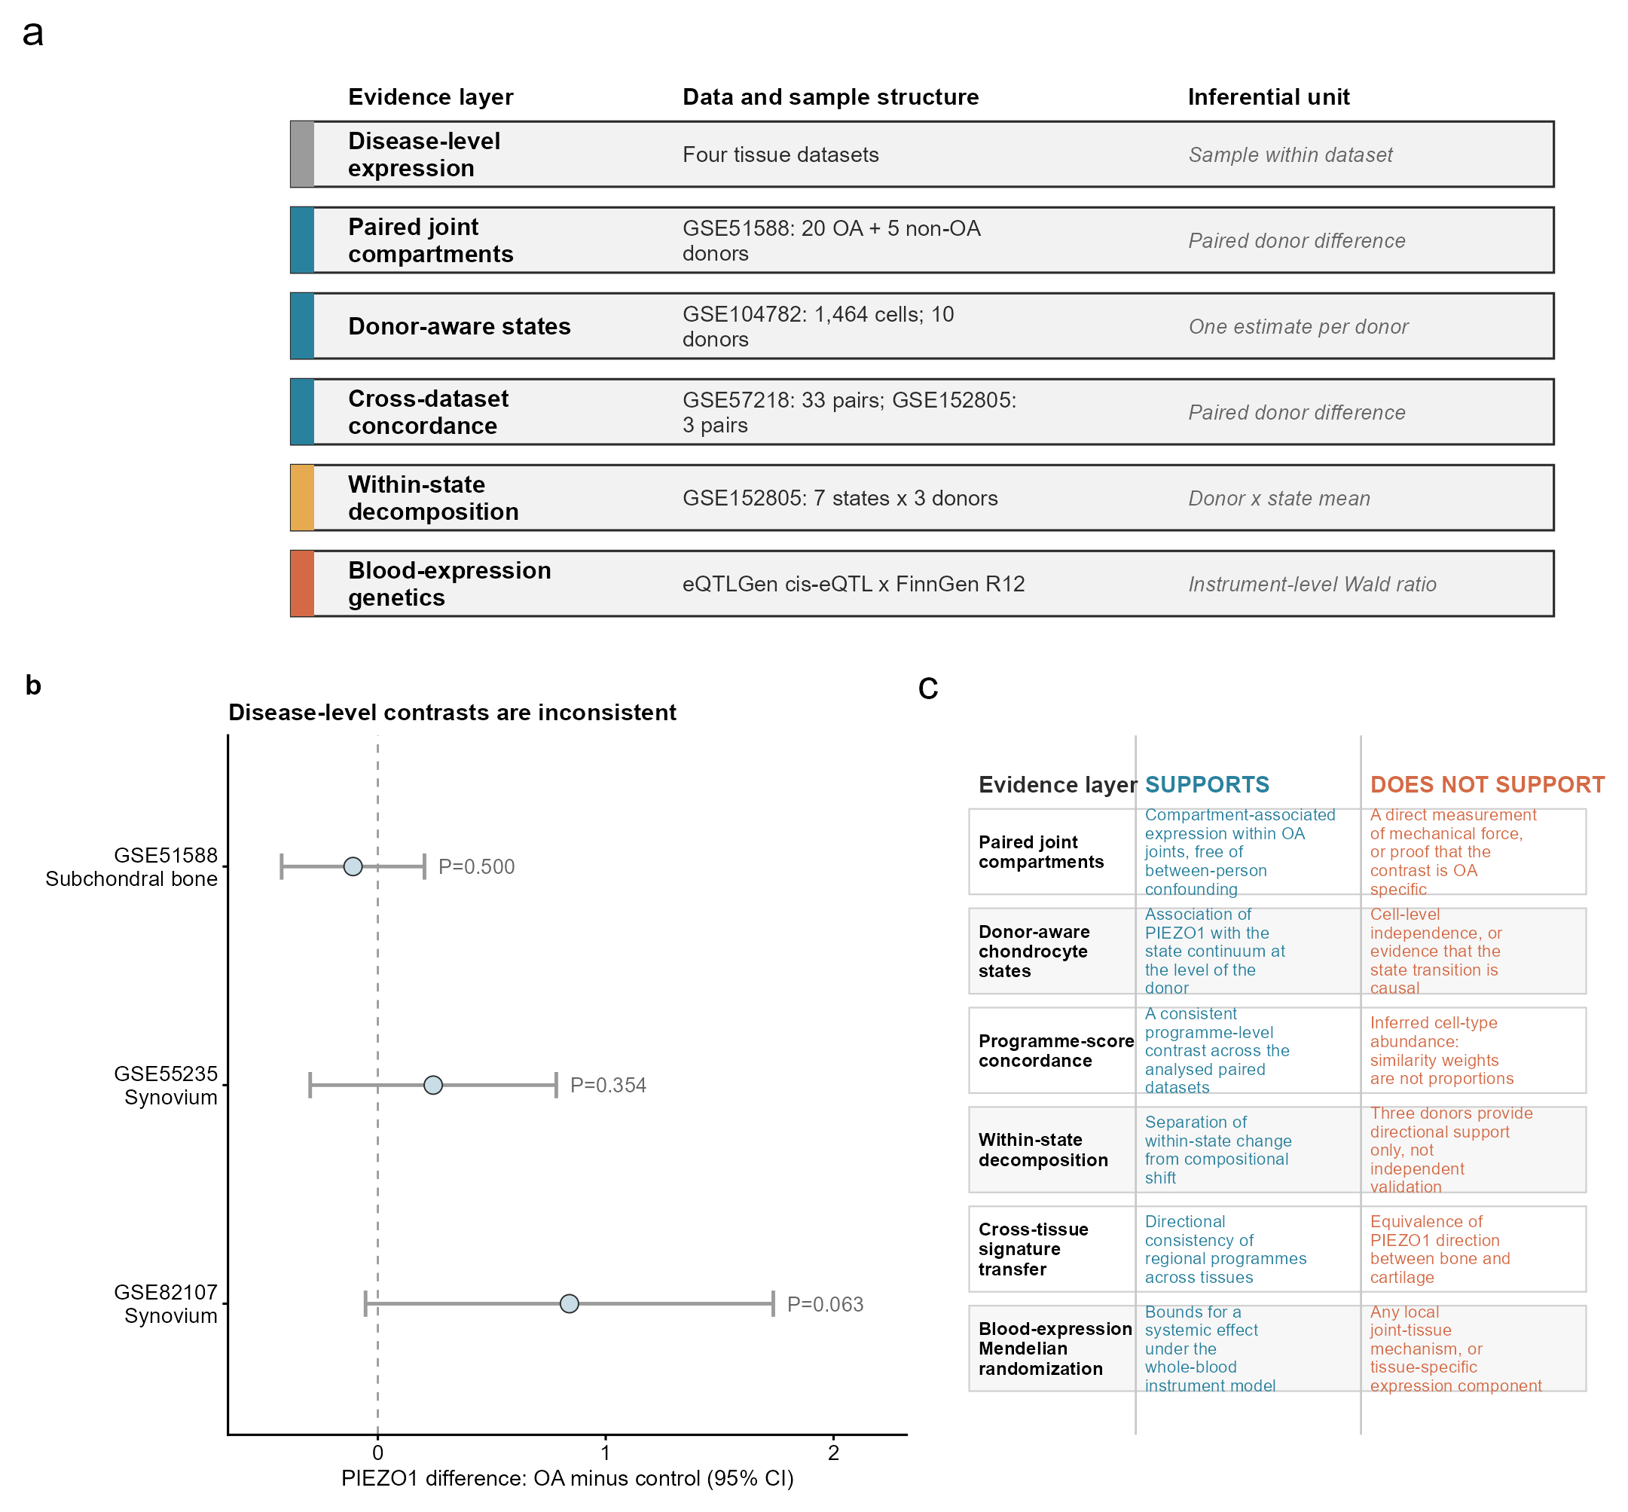
Figure 1. Evidence architecture and disease-level context. (a) Study design separating disease-level expression, paired joint compartments, donor-aware chondrocyte-state analyses, cross-dataset concordance, within-state decomposition and whole-blood expression genetics; the inferential unit of each layer is stated. (b) Dataset-specific PIEZO1 case-minus-control differences with 95% confidence intervals: subchondral bone -0.109 (-0.422 to 0.205; P=0.500), synovium GSE55235 +0.243 (-0.297 to 0.783; P=0.35) and synovium GSE82107 +0.841 (-0.054 to 1.736; P=0.063). Estimates remain on native scales and are not pooled. (c) Interpretation contract. The figure does not support PIEZO1 as a uniform disease-wide or standalone diagnostic marker.
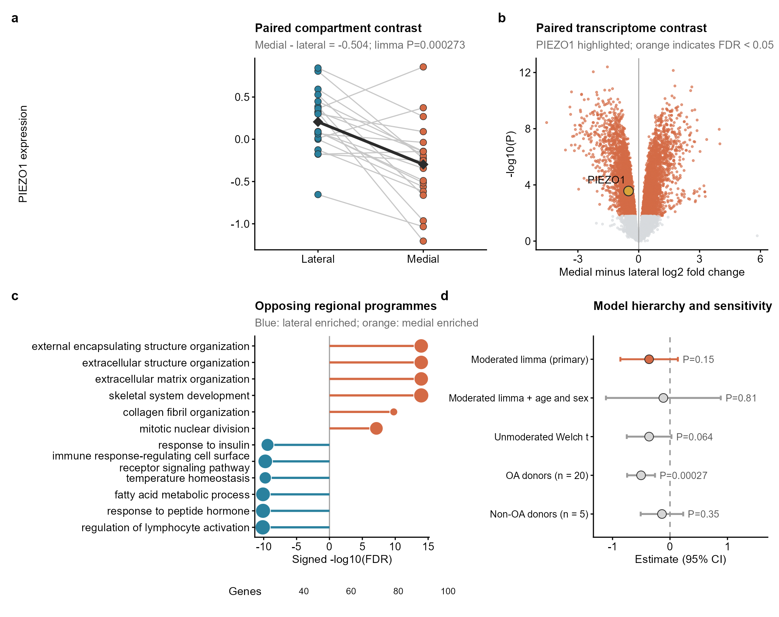
Figure 2. Within-donor compartmental heterogeneity in subchondral bone. (a) Donor-paired PIEZO1 expression in lateral and medial OA subchondral bone (n=20 donors); diamonds show group means and the thick line joins the means. (b) Regional transcriptome contrast for medial minus lateral tissue, with PIEZO1 highlighted. (c) Representative Gene Ontology processes enriched among genes higher laterally or medially; point size denotes gene count; six terms per direction were selected by adjusted P value. (d) PIEZO1 medial-minus-lateral estimates with 95% confidence intervals across five specifications. For OA donors, the descriptive paired estimate was -0.504 (-0.746 to -0.261; n=20), with the primary moderated limma P=0.000273 and FDR=0.00189; the direct paired-test P=0.000350 is reported in Supplementary Table S3. For non-OA donors, the estimate was -0.140 (-0.510 to 0.230; P=0.35; n=5). The moderated disease-by-compartment interaction was primary (-0.363, -0.864 to 0.137; P=0.147; FDR=0.435); unmoderated and covariate-adjusted results were sensitivity analyses.
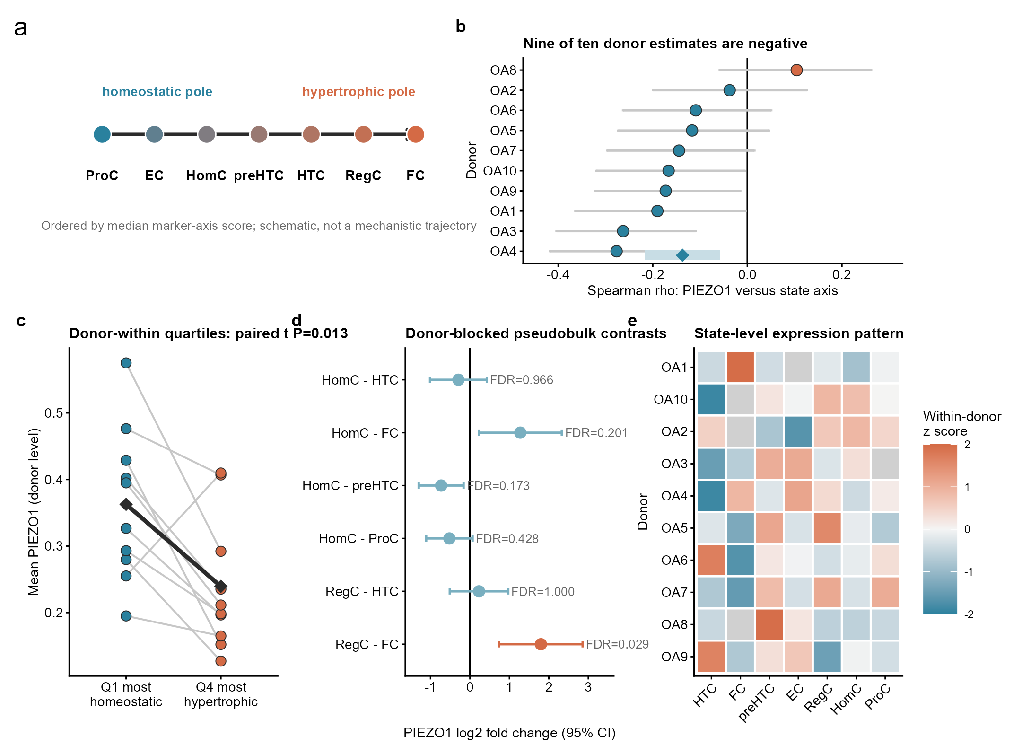
Figure 3. Donor-aware association of PIEZO1 with the chondrocyte-state continuum in GSE104782. (a) Schematic homeostatic-to-hypertrophic state ordering defined by the marker axis; it is not a mechanistic trajectory. (b) Donor-specific Spearman correlations with 95% confidence intervals; nine of ten are negative and the diamond shows the mean. (c) PIEZO1 at donor-within Q1 and Q4 axis quartiles (paired t P=0.0134; Wilcoxon P=0.0323). (d) Donor-blocked pseudobulk contrasts. (e) Within-donor standardized state means. Cell-level P values are descriptive; donor-level summaries carry inference.
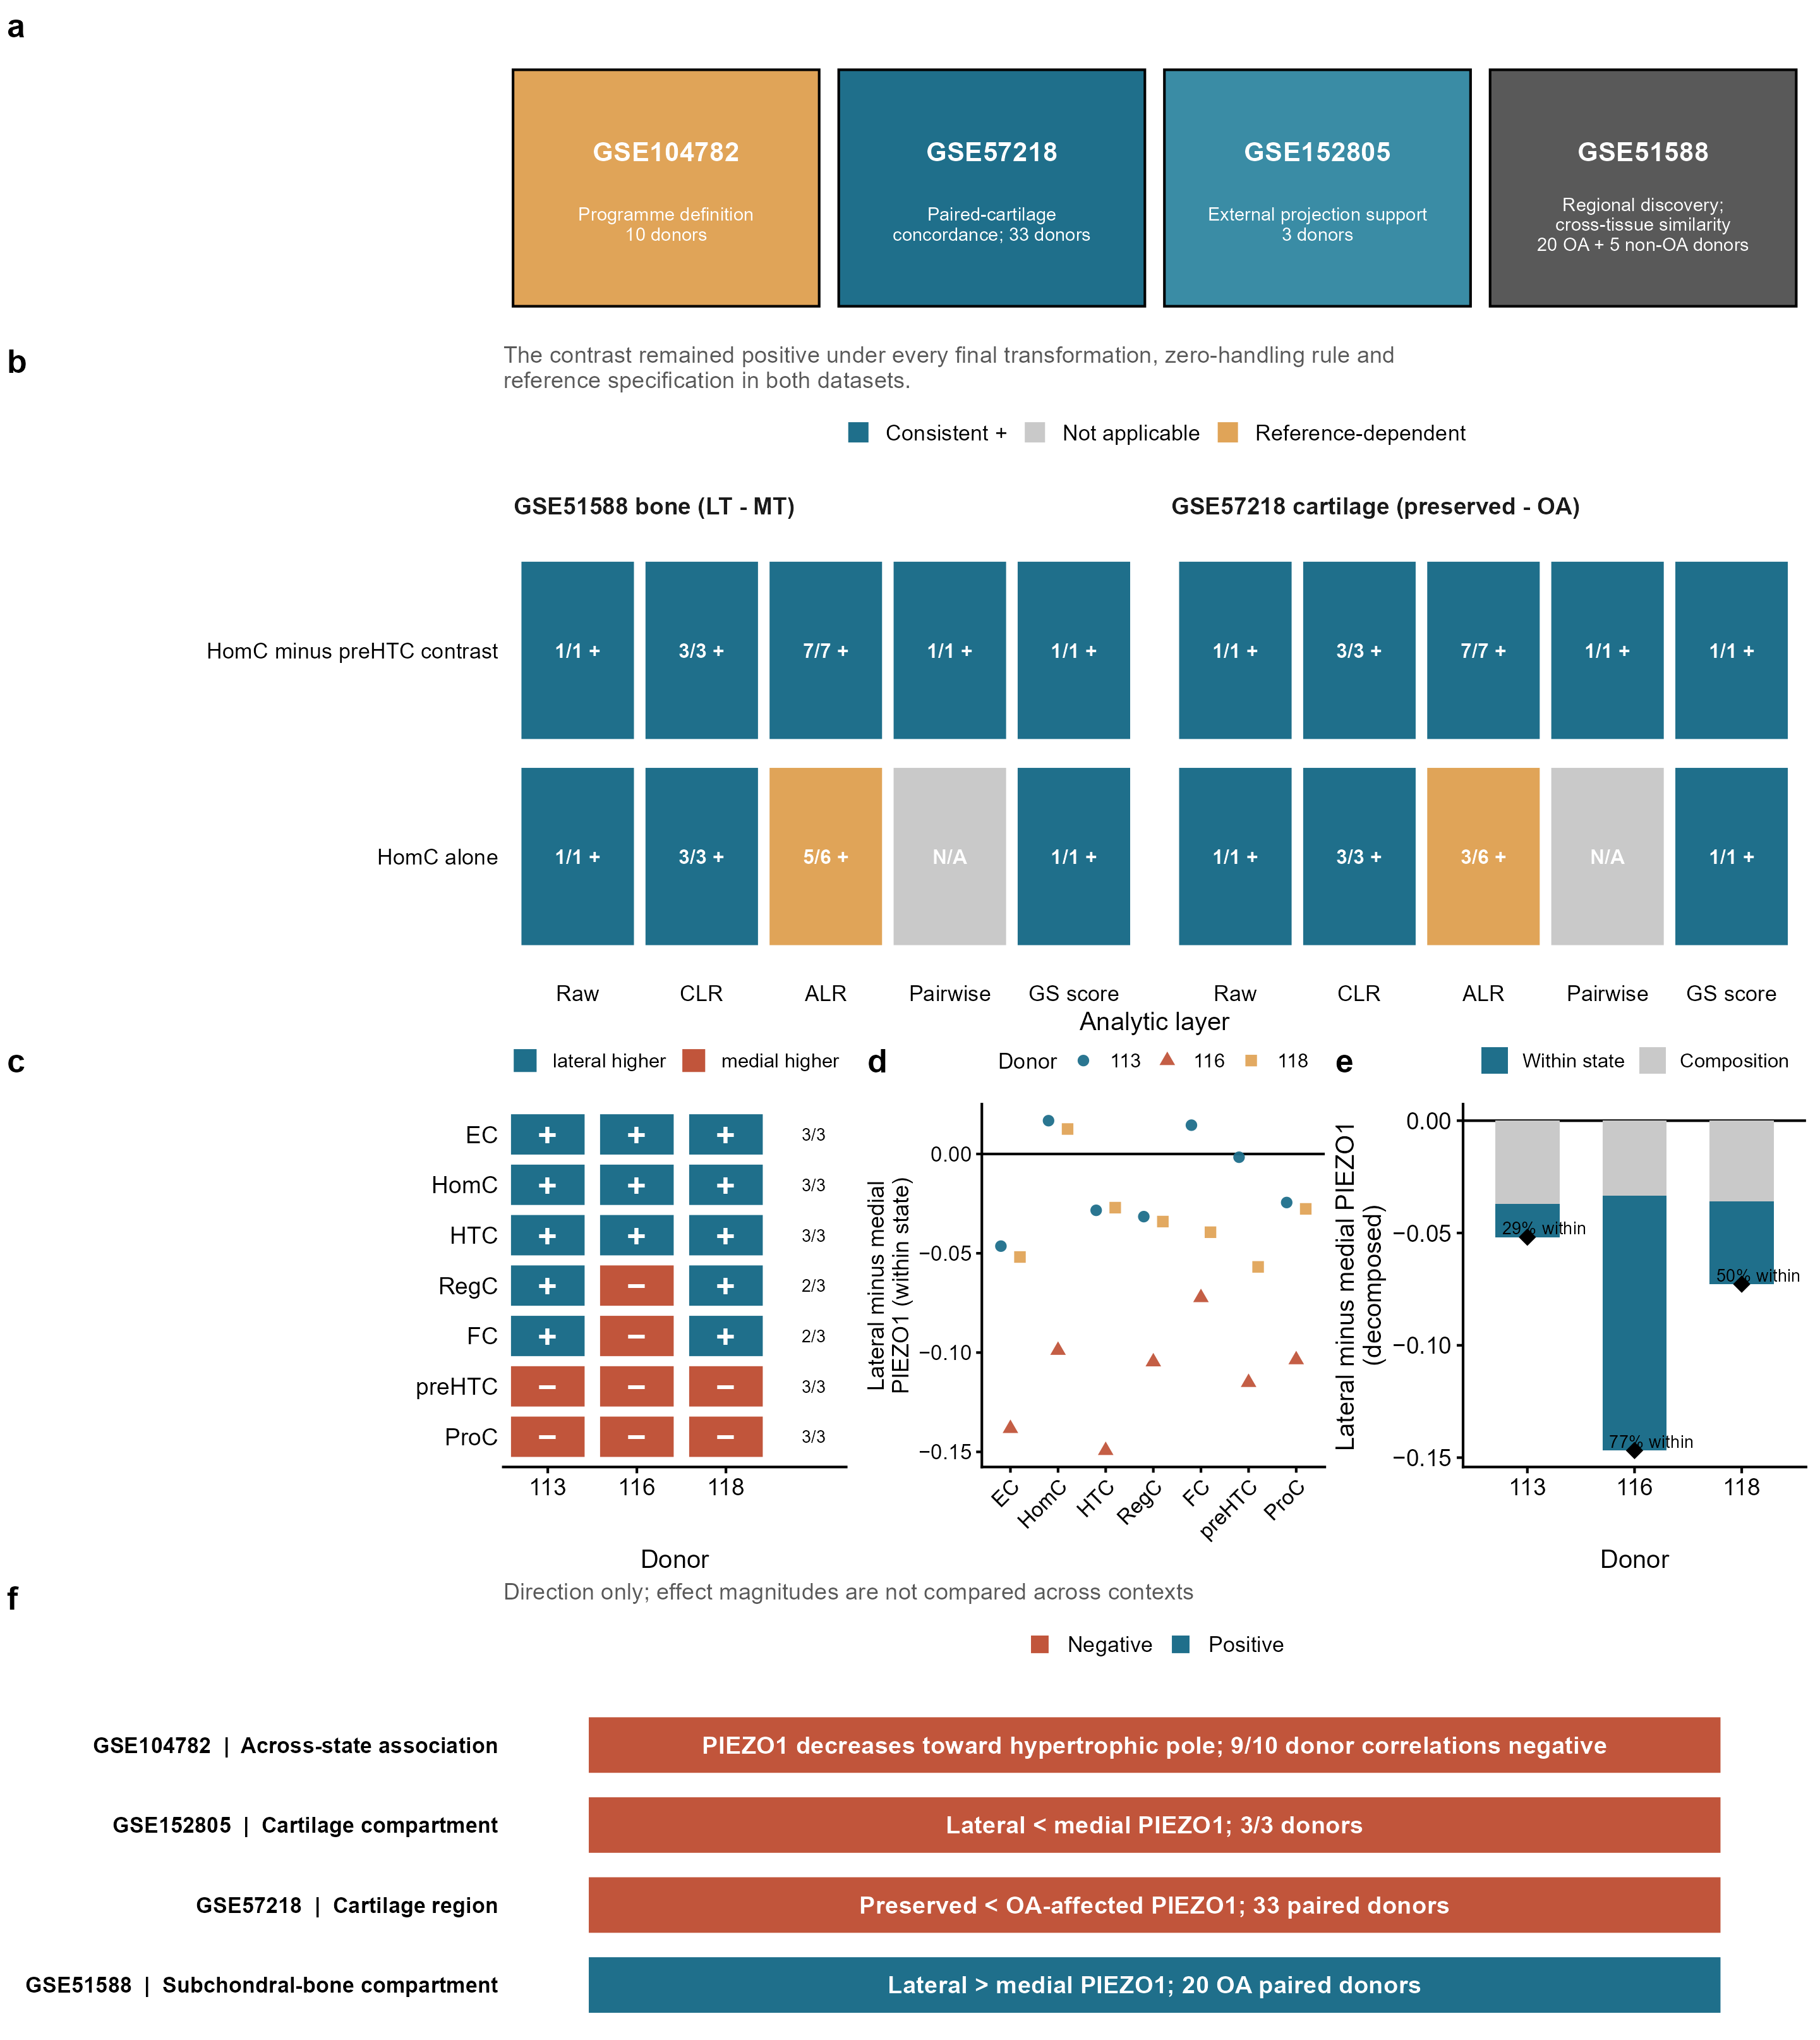
Figure 4. Cross-dataset concordance of the chondrocyte-programme contrast and context-dependent PIEZO1 transcription. (a) Evidence hierarchy: reference definition, paired-cartilage concordance, external projection support and regional discovery. (b) Direction and robustness across raw, centred-log-ratio, additive-log-ratio, pairwise-log-ratio and unclosed gene-set specifications from the same final pipeline. The contrast remained positive under every final transformation, zero-handling rule and reference specification in both datasets; the isolated homeostatic increase was reference dependent. (c) GSE152805 projected programme directions by donor. (d) Full-reference within-state lateral-minus-medial PIEZO1 differences. (e) Full-reference symmetric decomposition into donor-heterogeneous within-state expression and composition components; diamonds mark totals. (f) Dataset-specific PIEZO1 directions. Effect magnitudes are not compared across transformations or datasets; the recall-gated sensitivity is shown in Supplementary Figure S15.
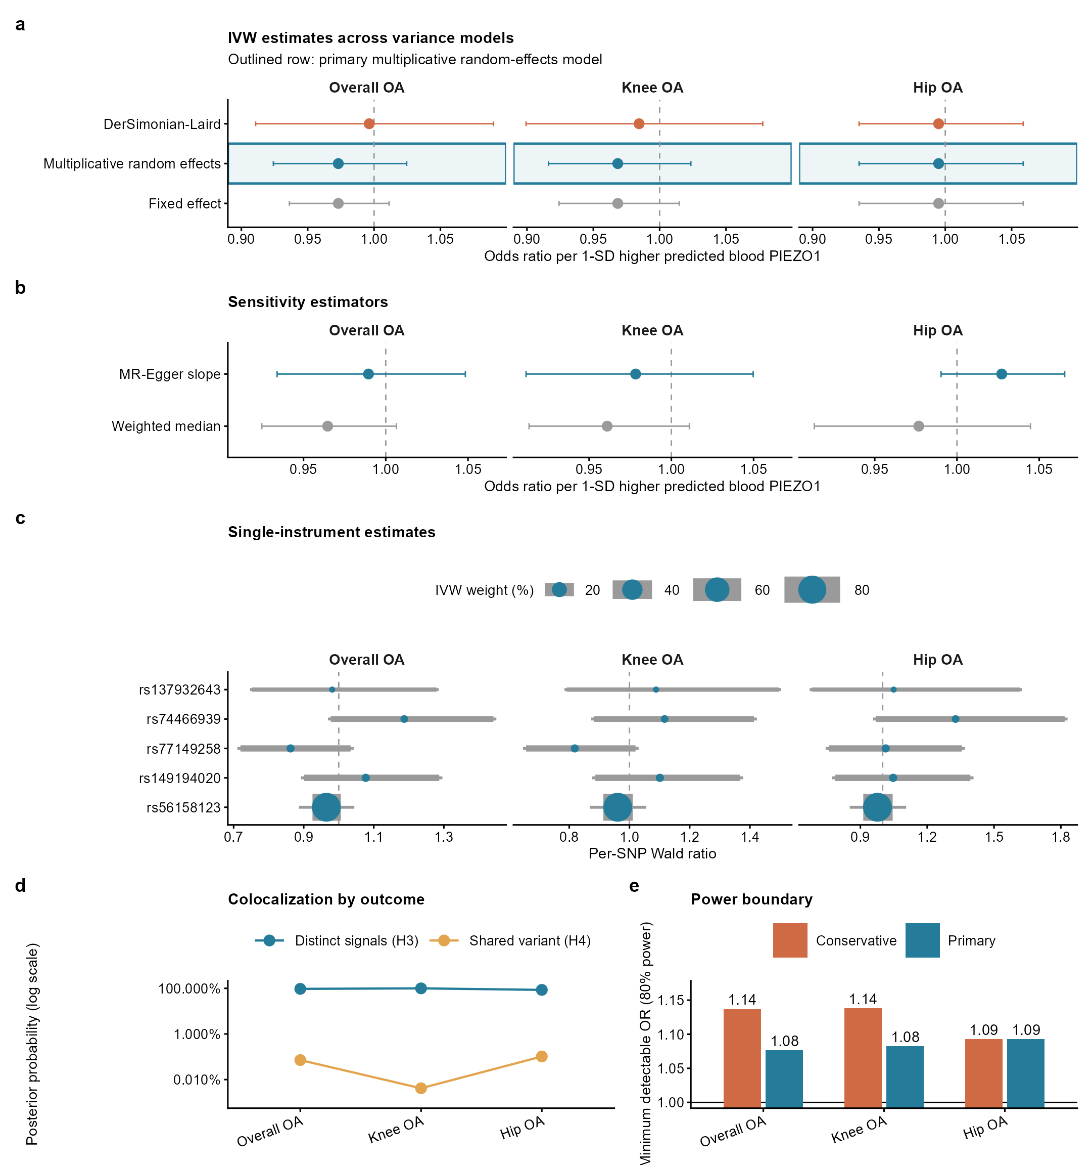
Figure 5. Whole-blood expression genetic evidence. (a) IVW estimates under three variance models; the outline marks the primary multiplicative model. (b) Weighted-median and MR-Egger sensitivity estimates. (c) Per-SNP Wald ratios and IVW weights. (d) Colocalization posterior probabilities for distinct and shared signals. (e) Minimum detectable odds ratios at 80% power. Bars in panels a-c are 95% confidence intervals. Inference is limited to the whole-blood cis-eQTL instrument model and does not evaluate local joint mechanisms.

