Supplementary Methods, Results, Tables and Figure Legends
Human osteoarthritis reveals context-dependent PIEZO1 expression across chondrocyte-state programmes
Yang Yunze (ORCID: 0009-0003-5907-7037)

Supplementary overview
This supplement separates confirmatory, supportive and exploratory analyses. Every numerical statement in the main manuscript is traceable to a stored result file, and the script that produced each result is listed in Supplementary Table S17. Tables S13 and S14 report compositional sensitivity and within-state decomposition; Table S18 records the final eligibility decisions for optional comparator, spatial and joint-tissue genetic extensions.

Terminology and inferential scope
The most consistent signal in osteoarthritis is a shift in the balance between homeostatic and pre-hypertrophic chondrocyte programmes, reported as the homeostatic-minus-pre-hypertrophic contrast rather than as uniform cross-tissue direction of PIEZO1 transcription. Whole-blood expression genetics constrain the size of a systemic effect but cannot evaluate local joint mechanisms. The table below fixes the terms used throughout the manuscript and supplement.
Term | Operational definition | Reporting constraint
Medial compartment | Medial tibial region in GSE51588 and GSE152805 | An anatomical proxy for mechanical context; not a direct force measurement
Lateral compartment | Lateral tibial region | Avoid calling it completely unloaded
Programme similarity / programme score | Relative transcriptomic resemblance to GSE104782 subtype signatures | Not a cell proportion or abundance estimate in subchondral bone
Homeostatic-minus-pre-hypertrophic contrast | Difference between the HomC and preHTC programme scores; equivalently log(HomC/preHTC) | Primary programme statistic; invariant to the additive log-ratio reference
Homeostatic-to-hypertrophic axis | Continuous score: scaled hypertrophic marker mean minus scaled homeostatic marker mean | Primary single-cell inference is donor level
Within-state contrast | Compartment difference computed inside one chondrocyte state | Distinct from composition differences and from the cross-state axis
Directional concordance | Same direction in all donors of a small dataset | With three donors this is external projection support, not independent statistical validation
Systemic PIEZO1 effect | Effect proxied by whole-blood cis-eQTLs | Bounded to the whole-blood instrument model; does not evaluate local cartilage or bone mechanisms
Exploratory | Immune, transcription-factor, motif, PROGENy, transcription-factor MR/TWAS, fine-mapping and druggability analyses | Hypothesis-generating and supplementary only

Supplementary Methods

S1 Dataset-role separation and evidence hierarchy
GSE51588 was the paired regional discovery dataset. GSE104782 defined chondrocyte states and enabled donor-aware analysis. GSE57218 supplied paired-cartilage cross-dataset programme concordance. GSE152805 supplied compartment-matched external projection support and decomposition, not independent validation. Synovial datasets tested disease-wide direction and exploratory immune context. Genetic resources were not treated as tissue-concordance datasets. Subchondral-bone programme weights indicate cross-tissue transcriptomic similarity, not chondrocyte content.

S2 Interaction-model hierarchy
The moderated limma comparison of donor medial-minus-lateral differences between OA and non-OA groups is the primary interaction test because it uses empirical-Bayes variance moderation across genes. The ordinary two-sample t-test on PIEZO1 donor deltas is an unmoderated sensitivity result, and the age- and sex-adjusted moderated model is a covariate sensitivity result. The three P values answer the same biological contrast under different variance models and adjustment sets; only the unadjusted moderated value (P=0.147) is used for the primary claim.

S3 Donor-level single-cell hierarchy
Continuous axis evidence is primary because it supplies one correlation and one quartile contrast per donor. The axis was z(mean hypertrophic markers) minus z(mean homeostatic markers). Hypertrophic markers were COL10A1, RUNX2, IBSP, ALPL, MMP13, SPP1 and POSTN; homeostatic markers were COL2A1, SOX9, ACAN, CHAD and HAPLN1. CRTL1 is a historical alias of HAPLN1 and was not treated as an additional independent marker. PIEZO1 was absent from both sets. Q1 and Q4 were defined within donor. Pseudobulk donor-by-state analysis is supportive and requires at least five cells per donor-state combination. Cell-level P values are descriptive only. No claim of a stable ordering across all seven states is made because the donor-level Friedman test was null. The paired Q1-Q4 Wilcoxon signed-rank sensitivity used the asymptotic normal approximation with continuity correction.

S4 Microarray normalisation, probe mapping and batch handling
The preprocessing described in S4 applies to disease-level and differential-expression analyses. Deposited series matrices were inspected for scale; matrices exceeding the raw-intensity threshold were log2 transformed, while already log2-scale matrices were retained. The authoritative GSE51588 DEG script did not apply additional quantile normalization. Probes were mapped to gene symbols using the platform annotation supplied with each series. Where several probes mapped to one gene, the probe with the highest mean expression was retained for the DEG pipeline. This S4 rule does not define programme scoring, which follows the separate authoritative pipeline in S5. No cross-platform batch correction was applied because inference remained within dataset.

S5 Programme scoring algorithm
For each GSE104782 state, fold changes were computed against the mean of the remaining states and the top 100 genes were retained after requiring mean normalized expression above 0.05, giving 690 unique signature genes. The authoritative final programme pipeline converted the GSE104782 normalized matrix back to the linear scale for centroid construction. Bulk probes were aggregated to gene symbols by their mean, converted from log2 to linear scale when appropriate, and standardized gene-wise across samples; no additional quantile normalization was applied. Non-negative L-BFGS-B weights were fitted and then closed to sum one. Table S6 reports this L0 raw-weight layer, and Table S13 applies all zero-handling, log-ratio and unclosed gene-set sensitivity layers to the same final marker construction and programme preprocessing. For GSE152805, query cells and reference centroids were standardized over frozen genes and assigned by the highest unconstrained similarity projection score; these scores are arbitrary units, not proportions. PIEZO1 was absent from all top-100 marker sets.

S6 Compositional sensitivity: layers and zero handling
Five analytic layers were applied. L0 used the raw sum-to-one weights as reported. L1 applied the centred log-ratio transformation with three zero-handling rules: multiplicative simple replacement at half the minimum non-zero value, and additive pseudocounts of 1e-3 and 1e-2. L2 applied the additive log-ratio transformation with each of the seven states in turn as the reference category. L3 used the single pairwise log-ratio log(HomC/preHTC). L4 used an unclosed gene-set score computed as the mean standardised expression of each state signature in the query sample, with no sum-to-one constraint and therefore no closure. One zero weight occurred in each dataset (1 of 350 weight cells in GSE51588 and 1 of 511 in GSE57218), which is why three zero-handling rules were compared rather than one.
A useful algebraic property governs interpretation. Under the additive log-ratio transformation the individual coordinates depend on the reference state, but the difference between two coordinates does not: log(HomC/ref) - log(preHTC/ref) = log(HomC/preHTC). This is visible in Supplementary Table S13, where the HomC-minus-preHTC difference is 0.6846 in GSE51588 and 1.3439 in GSE57218 for every reference state, while the individual coordinates vary widely and, for the homeostatic programme, change sign. The contrast is therefore the reportable quantity and the individual coordinates are not.

S7 GSE152805 quality control, state assignment and within-state analysis
GSE104782 used the deposited processed count matrix and accompanying cell-quality and clustering annotations. GSE152805 used GEO-supplied matrix.mtx, barcodes.tsv and genes.tsv files for six cartilage libraries; three synovial libraries were excluded before analysis. Cells required at least 200 detected genes, at least 500 counts and mitochondrial fraction below 25%; all 26,228 deposited cartilage barcodes passed, so no library-specific exclusion was introduced. Counts were log-normalized to 10,000 per cell. Deposited doublet calls and ambient-RNA estimates were unavailable; no additional doublet removal or ambient-RNA correction was applied, and the supplied barcode matrices lacked empty droplets for a de novo ambient profile. Residual doublets or ambient RNA therefore remain limitations. Reference-internal validation was fully nested within GSE104782, with fold-specific marker selection and 1,000 complete-pipeline donor-preserving permutations. Full-reference centroids were then projected into GSE152805 as external projection support, not external validation, because no independent gold-standard query-state labels were available. States with held-out recall below 0.60 were excluded only in the final sensitivity analysis without reassigning cells. Full-state within-state PIEZO1 required at least 50 cells per donor-compartment-state; symmetric Kitagawa decomposition and margin-trimming sensitivities followed the stated rules.

S8 Mendelian randomization: exposure reconstruction and validation
The deposited eQTLGen PIEZO1 cis file contains 1,318 variant-gene records with the following fields: Pvalue, SNP, SNPChr, SNPPos, AssessedAllele, OtherAllele, Zscore, Gene, GeneSymbol, GeneChr, GenePos, NrCohorts, NrSamples, FDR and BonferroniP. It contains no per-allele beta, no SE and no effect-allele frequency, so effects could not be taken directly from the exposure file. The exposure and FinnGen R12 outcome samples were treated as non-overlapping. FinnGen registry-derived endpoints were overall OA (M13_ARTHROSIS), knee OA (gonarthrosis) and hip OA (coxarthrosis); case and control counts are reported in Supplementary Table S10. Individual-level participant data and covariates were unavailable to this secondary analysis.
Two reconstructions are possible when only Z and N are available. If the genotype is coded 0/1/2 and the phenotype is standardised, then beta = Z / sqrt(2 f (1 - f) N) and SE = 1 / sqrt(2 f (1 - f) N), which is the per-allele effect in standard-deviation units. If the genotype is also standardised, then beta = Z / sqrt(N) and SE = 1 / sqrt(N), which is the standardised regression coefficient and equals the correlation. Both give the same Z and the same R-squared (Z^2/N), and both give F = (beta/SE)^2 = Z^2, but only the first is expressed in standard-deviation units of expression per allele, which is the unit required for the MR interpretation. We therefore used beta = Z / sqrt(2 f (1 - f) N) with allele frequencies taken from the separate eQTLGen allele-frequency file, that is, from the eQTL sample itself rather than from an external panel.
Two consequences of this choice are worth recording. First, the commonly reported F=Z2 is not circular: for a single-instrument regression the t statistic equals Z and F equals t squared, so F=Z2 is the correct instrument-strength statistic and is independent of the reconstruction. Second, if the reconstructed exposure scale is uniformly rescaled by a common multiplicative factor across all instruments, each Wald ratio and its standard error are rescaled proportionally, leaving the IVW z statistic, its P value and heterogeneity statistics unchanged. This scale sensitivity was verified numerically over common factors from 0.6 to 1.67 (Supplementary Table S11). Only the effect-estimate units and minimum detectable odds ratios depend on the scale assumption.
External comparison used allele-aligned GTEx v8 whole-blood normalized effect sizes. Among 62 variants significant in both resources, the ordinary-least-squares slope of GTEx on the reconstructed eQTLGen effect was 0.412 (95% CI 0.325 to 0.498) and the Pearson correlation was 0.775; all 16 variants with |Z|>=15 agreed in direction. Differences in normalization, ancestry composition, covariate adjustment and effective sample size prevent this comparison from validating equality of the absolute effect scale. It therefore supports directional concordance only. The MR analysis and its stated units use the allele-frequency-based eQTLGen reconstruction defined above, while scale-dependent effect and power quantities are reported with explicit sensitivity bounds.
Six candidate instruments were identified within +/-1 Mb of the PIEZO1 transcription start site at genome-wide significance and pruned against a European linkage-disequilibrium reference. rs61649074 had no matching outcome data and was excluded, leaving five instruments harmonised across all three outcomes. Per-SNP characteristics, exposure effects, standard errors and F statistics are given in Supplementary Table S9.

S9 Variance models and diagnostic statistics
Three inverse-variance-weighting variance models were computed. The fixed-effect model used weights 1/se^2; the multiplicative random-effects model inflated its standard error by sqrt(max(1, Q/df)); and the DerSimonian-Laird model re-estimated tau^2 and refitted with weights 1/(se^2+tau^2). The multiplicative model was designated as the primary final model; the others were retained because variance estimators diverge when one instrument dominates the weights. Cochran Q, heterogeneity P and I-squared came from the fixed-effect fit. MR-Egger, weighted median, leave-one-out and approximate Steiger analyses followed the implementations listed in Table S16.

S10 Colocalization and power
Colocalization used coloc.abf across all 8,790 variants in the PIEZO1 cis region, with FinnGen statistics analysed as case-control outcomes using case fractions. Default priors were p1=p2=1e-4 and p12=1e-5. Posterior probabilities for H0 (no association), H1 (exposure only), H2 (outcome only), H3 (distinct variants) and H4 (shared variant) are reported in Supplementary Table S12 together with the number of variants reaching the regional significance threshold of 5.69e-6 for each trait, the minimum locus P value, the lead variant for each trait and the distance between lead variants. A p12 sensitivity analysis over 1e-6 to 1e-4 changed no posterior probability materially and is reported in the same table. Power used exp[(1.96+0.842) x SE] for the minimum detectable odds ratio at 80% power and two-sided alpha=0.05, and pnorm(log(OR)/SE - 1.96) for achieved power, each computed under all three variance models and across uniform exposure-scale errors from 0.6-fold to 1.67-fold.

S11 Exploratory analyses and evidential limitations
Immune deconvolution, transcription-factor activity, motif enrichment, PROGENy, transcription-factor MR, transcriptome-wide association, fine-mapping and drug-target analyses are retained for transparency but cannot strengthen the central causal claim because donor-level independence, tissue matching, linkage pruning or independent corroboration was incomplete for at least one component.

S12 Final eligibility screening for optional external evidence
A fixed comparator panel comprised PIEZO1, PIEZO2, TRPV4, TRPV2 and TRPA1. Eligible comparison required donor-level estimands across GSE51588, GSE104782, GSE57218 and GSE152805 without result-dependent substitution. Spatial eligibility required human OA cartilage or osteochondral tissue, at least three independent donors, identifiable donor labels, a defined spatial axis and donor-level inference. Joint-tissue QTL eligibility required human joint tissue and PIEZO1 cis-region statistics with effect allele, beta, standard error, ancestry or linkage-disequilibrium information, sample size and method. Failure of an optional screen was recorded as not eligible for primary analysis and did not alter manuscript claims.

Supplementary Results

S1 Disease-level contrasts
The region-adjusted GSE51588 disease effect for PIEZO1 was null and remained null after adjustment for age and sex. Synovial estimates varied across probes and cohorts, reinforcing that tissue and probe context dominate a universal case-control direction. Diagnostic areas under the curve are reported descriptively and are not internally or externally validated prediction models.

S2 Donor-aware chondrocyte analysis
Cell-level subtype and axis tests gave small P values, but donor-level analyses changed the conclusion. The categorical state omnibus was not significant by Friedman test, whereas the continuous axis was negative in nine of ten donors under all four donor-level sensitivity tests. With Q1/Q4 defined within donor, the mean Q1-minus-Q4 PIEZO1 difference was 0.123 normalized-expression units (paired t P=0.0134; Wilcoxon P=0.0323). Pseudobulk provided a nominal omnibus signal that did not survive transcriptome-wide correction; one pairwise contrast, RegC versus FC, survived and remains exploratory because it followed a non-significant omnibus test.

S3 Compositional sensitivity of the programme contrast
Full results across all five analytic layers are given in Supplementary Table S13. The pre-hypertrophic programme was negative, indicating higher values medially or in OA-affected tissue, under every treatment in both datasets. The homeostatic programme was positive under raw and centred log-ratio treatments and under the unclosed gene-set score in GSE57218, but was reference dependent under additive log-ratio transformation in both datasets, changing sign with the reference state, and was not significant with the unclosed gene-set score in GSE51588 (0.057, P=0.35). The homeostatic-minus-pre-hypertrophic contrast was positive in every layer in both datasets, including the unconstrained unclosed gene-set score, and was invariant to the additive log-ratio reference by construction.

S4 Within-state decomposition of the cartilage compartment difference
Within-state results are given in Supplementary Table S14. Reference-internal fully nested leave-one-donor-out validation gave balanced accuracy 0.595 and macro-F1 0.554, above the complete-pipeline donor-preserving permutation-null 95th percentile of 0.172 (P=0.001). HTC, RegC and EC had recall below 0.60 and were excluded only in the final sensitivity. In the full-state analysis, symmetric within-state shares were 28.7%, 77.2% and 50.5%, spanning both sides of 50% across donors and reference formulations. After retaining FC, HomC, ProC and preHTC without reassigning cells, total lateral-minus-medial differences remained negative in all donors (-0.047, -0.138 and -0.069), but donor 113 had a small positive within-state component (+0.004) opposing a negative composition component (-0.051); both components were negative in donors 116 and 118. The result is donor-heterogeneous contributions and does not support a uniform mechanism (Supplementary Tables S19 and S21; Supplementary Figure S15).

S5 Mendelian randomization diagnostics
All five instruments individually exceeded F=32.7 (Supplementary Table S9). Heterogeneity was moderate for overall OA (I^2=44.0%, P=0.129), lower for knee OA (I^2=28.5%, P=0.231) and absent for hip OA (I^2=0%, P=0.445). MR-Egger intercepts gave no evidence of directional pleiotropy for overall or knee OA but were nominally significant for hip OA (P=0.043), which tempers the hip result despite its homogeneity. Leave-one-out estimates all remained non-significant. The IVW weight was concentrated on rs56158123 at 84.7% in every outcome, because that variant combines the largest exposure effect with the most precise outcome estimate; the rs56158123-only Wald ratios agree with the pooled estimates, but the analysis should be read as statistically close to a single-instrument estimate. Removing rs56158123 reversed the sign of the overall-OA point estimate to +0.021 (P=0.78), so the estimate is best described as close to zero with wide uncertainty rather than as a precise zero. Steiger tests favoured the exposure-to-outcome direction for all retained instruments.

S6 Colocalization by outcome
For overall and knee OA the region contains both a strong whole-blood PIEZO1 eQTL and a separate, region-wide significant OA signal, with lead variants 897 kb and 471 kb apart; the posterior therefore favours two distinct signals (H3) rather than a shared variant. For hip OA no variant reached the regional threshold and the minimum locus P value of 6.7e-6 sits just above it, so H3 there reflects a dominant eQTL alongside a sub-threshold outcome signal. In no outcome is PP.H4 above 0.11%, and there is no evidence for hip-specific colocalization.

S7 Covariate sensitivity
Adjusting the disease-by-compartment interaction and the region-adjusted disease main effect for the deposited age and sex variables attenuated both estimates and moved both further from significance. The paired compartment contrast is unchanged by covariate adjustment because donor-invariant covariates are absorbed by the pairing. Body-mass index and radiographic grade were not deposited for any dataset and could not be adjusted for.

S8 Exploratory findings
Immune and regulatory associations were heterogeneous across tissues. Because many were based on cell-level or cross-sectional correlations and the extended transcription-factor genetic analyses lacked consistently clumped, tissue-matched instruments, these findings are suitable for generating mechanistic hypotheses only.

S9 Optional-evidence eligibility decisions
The final comparator assessment covered only two of the four required datasets and omitted two fixed genes, so it was not eligible for primary analysis and could not support a complete channel-specificity claim. GSE254844 provides human OA cartilage Geo-seq profiles across histological zones and weight-bearing regions, but public metadata do not support independent donor-level zone inference. A 2026 OA joint-tissue eQTL resource included several joint tissues, but PIEZO1 was absent from its packaged significant and conditionally independent cis-eQTL tables. No eligible local PIEZO1 instrument was available. These extensions were not eligible for primary analysis; the main narrative remains bounded to donor-level transcriptomics and whole-blood genetics.

Supplementary Tables
Supplementary Table S1. Data sources and analytical roles
Resource | Tissue | Platform | Design | Role
GSE51588 | Subchondral bone | Agilent GPL13497 microarray | 20 OA + 5 non-OA donors; paired medial/lateral | Primary regional discovery; disease and interaction models; cross-tissue programme similarity
GSE55235 | Synovial tissue | Affymetrix GPL96 microarray | 30 deposited: 10 OA + 10 healthy used; 10 RA excluded | Disease-direction and exploratory immune context
GSE82107 | Synovial tissue | Affymetrix GPL570 microarray | 17 deposited: 10 OA + 7 healthy; all used | Disease-direction and exploratory immune context
GSE46750 | Cultured synovial-membrane cells | Agilent GPL10558 microarray | 12 OA donors; paired inflammatory/normal-reactive | Exploratory inflammation gradient
GSE104782 | Articular cartilage chondrocytes | Single-cell RNA-seq | 1,464 cells from 10 OA donors | State reference and donor-aware PIEZO1 inference
GSE57218 | Articular cartilage | Illumina GPL6947 microarray | 33 paired preserved/OA-affected donors | Paired-cartilage cross-dataset programme concordance
GSE152805 | Tibial cartilage | 10x single-cell RNA-seq, GPL20301 | 3 paired lateral/medial OA donors | External projection support; within-state decomposition
eQTLGen | Whole blood | cis-eQTL summary statistics | n=31,684 | MR exposure and colocalization trait 1
GTEx v8 | Whole blood | Normalised effect sizes | n=670 | External directional comparison of reconstructed exposure effects
FinnGen R12 | Population genetics | OA GWAS summary statistics | Overall/knee/hip OA | MR outcomes and colocalization trait 2
Supplementary Table S1A. Sample inclusion, exclusion and pairing audit
Dataset | Deposited | Excluded | Reason | Final analysis | Final donors | Pairs
GSE51588 | 50 arrays | 0 | - | 50 | 25 | 25 medial/lateral
GSE55235 | 30 arrays | 10 RA arrays | RA comparator outside OA-versus-healthy analysis | 20 | 20 | none
GSE82107 | 17 arrays | 0 | - | 17 | 17 | none
GSE46750 | 24 arrays | 0 | - | 24 | 12 | 12 paired conditions
GSE104782 | 34 GSM libraries plus processed matrix | library-level mapping not reconstructed | analysis used published processed OA chondrocytes | 1,464 cells | 10 | none
GSE57218 | 73 arrays | 7 healthy arrays | outside preserved/OA-affected paired contrast | 66 | 33 | 33 preserved/OA-affected
GSE152805 | 9 libraries | 3 synovium libraries | tissue mismatch | 6 cartilage libraries; 26,228 cells | 3 | 3 lateral/medial
Data S1. GSM/sample-to-donor-to-region mapping is supplied separately as Data_S1_GSM_Donor_Region_Mapping.csv.

Supplementary Table S2. Evidence and claim hierarchy
Claim | Status | Decisive evidence | Constraint
PIEZO1 is a universal OA marker | Refuted | Discordant/null disease contrasts; limited AUC | Do not use as title or conclusion
OA subchondral bone has a PIEZO1 compartment contrast | Supported | Paired log2FC -0.504; FDR 0.0019 | Within OA; not proof of load causation
The contrast is OA-specific | Not established | Primary interaction P=0.147; adjusted P=0.81 | Unmoderated P=0.064 cannot replace primary
PIEZO1 follows a continuous homeostatic-to-hypertrophic axis | Supported, small effect | 10 donors, mean rho -0.137; P=0.0035; 9/10 negative | Effect size is modest and the analysis includes ten donors.
All seven states have a stable PIEZO1 ordering | Not supported | Donor Friedman P=0.929 | Keep categorical plot descriptive
The homeostatic-minus-pre-hypertrophic programme contrast is concordant across datasets | Supported within the analysed datasets | Same final pipeline; five analytic layers in two datasets; three-donor external projection support | Cross-dataset concordance, not independent external validation
The isolated homeostatic programme increases | Not claimed | Additive log-ratio reference dependent; P=0.35 with the unclosed score in GSE51588 | Report the contrast, not the single programme
The cartilage compartment effect is purely compositional | Not supported overall; donor heterogeneity | Recall-gated total direction persisted; within-state and composition components were concordant in 2/3 donors | Donor 113 was composition dominated; do not claim a uniform mechanism
PIEZO1 transcript direction is uniform across datasets | Not supported | Bone and cartilage directions differ | Context dependence is central
Blood PIEZO1 expression has a major systemic OA effect | Not supported | MR null across three variance models; PP.H4 <= 0.103% | Local tissue effects unresolved; single-variant weight dominance disclosed

Supplementary Table S3. Key GSE51588 PIEZO1 results
Contrast | Effect | P | FDR | Interpretation
OA medial vs lateral | log2FC -0.5035 | 0.000273 | 0.00189 | Strong paired regional contrast
OA paired donor delta | -0.5035 (95% CI -0.7462 to -0.2609) | 0.000350 | - | Direct donor-paired summary
Non-OA paired donor delta | -0.140 | 0.35 | - | No detectable difference; n=5
Disease main effect, region adjusted | log2FC -0.1088 | 0.4995 | 0.6164 | No uniform OA main effect
Disease x compartment, moderated limma | -0.3634 | 0.1474 | 0.4345 | Primary interaction: not significant
Donor-delta OA vs non-OA, unmoderated t | 95% CI -0.7523 to 0.0254 | 0.0642 | - | Unmoderated sensitivity only

Supplementary Table S4. GSE51588 covariate sensitivity
Model | Contrast | Adjustment | Estimate | P | Note
M1 paired compartment (within OA) | lateral - medial | None (paired within donor) | 0.5035 | 0.00035 | Donor-invariant covariates absorbed by the pairing
M2 primary interaction | delta(MT-LT): OA - non-OA | limma moderated, no covariate | -0.3634 | 0.147 | Primary test reported in the main manuscript
M2 covariate sensitivity | delta(MT-LT): OA - non-OA | limma moderated + age + sex | -0.1157 | 0.814 | Age and sex are deposited; further attenuation
M2 unmoderated sensitivity | delta(MT-LT): OA - non-OA | Two-sample t | -0.3634 | 0.064 | Unmoderated sensitivity only
M2 unmoderated, adjusted | delta(MT-LT): OA - non-OA | Two-sample t + age + sex | -0.1157 | 0.814 | Sensitivity only
M3 disease main effect | OA - non-OA, region adjusted | compartment | -0.1088 | 0.502 | Null result
M3 adjusted | OA - non-OA, region adjusted | compartment + age + sex | -0.0896 | 0.741 | Null result

Supplementary Table S5. Donor-aware GSE104782 inference
Analysis | Unit | Statistic | P | Conclusion
Axis correlation, one-sample t | 10 donors | mean rho -0.137; 95% CI -0.216 to -0.058 | 0.00346 | Weak but donor-consistent trend
Axis correlation, Fisher-z one-sample t | 10 donors | mean z -0.139 | 0.00355 | Concordant sensitivity test
Axis Wilcoxon signed-rank | 10 donors | V=2; median rho -0.156 | 0.0108 | Concordant sensitivity test
Axis sign test | 10 donors | 9/10 negative | 0.0215 | Direction consistency
Q1 homeostatic vs Q4 hypertrophic, paired t | 10 donors | mean difference 0.1232 | 0.0134 | Higher PIEZO1 at the donor-within homeostatic end
Q1 vs Q4, Wilcoxon signed-rank | 10 donors | V=49; median difference 0.1412; asymptotic with continuity correction | 0.0323 | Concordant sensitivity test
Subtype Friedman | 8 donors, 6 subtypes | chi-square 1.357; Kendall W 0.034 | 0.929 | No stable seven-state ordering
HomC vs HTC, donor paired | 10 donors | mean difference 0.0419; dz 0.23 | 0.491 | No donor-level difference
Pseudobulk subtype omnibus | donor x state | F(6, 38.81)=3.252 | 0.0110; FDR 0.0663 | Nominal, not transcriptome-wide significant
Pseudobulk RegC vs FC | donor x state | logFC 1.799; 95% CI 0.741 to 2.856 | 0.0014; FDR 0.0286 | Exploratory; omnibus not significant
Cell-level axis correlation | 1,464 cells | rho -0.142 (2.0% of variance) | 5.26e-8 | Descriptive; cells are not independent inferential units
Cells per donor | 10 donors | 111 to 155 (median 150) | - | No donor exceeds 14% of cells; summaries unweighted

Supplementary Table S6. Cross-dataset programme and transferred-signature concordance from the authoritative final pipeline
Dataset | Comparison | Programme or signature | Difference | P / FDR | Direction
GSE51588 | Lateral - medial | HomC | +0.0356 | P 4.94e-4; FDR 0.00173 | Homeostatic higher laterally
GSE51588 | Lateral - medial | RegC | +0.0446 | P 0.00767; FDR 0.0134 | Regulatory higher laterally
GSE51588 | Lateral - medial | preHTC | -0.0612 | P 3.77e-4; FDR 0.00173 | Pre-hypertrophic higher medially
GSE57218 | Preserved - affected | HomC | +0.0298 | P 4.37e-5; FDR 6.11e-5 | Homeostatic higher preserved
GSE57218 | Preserved - affected | preHTC | -0.1197 | P 1.78e-7; FDR 6.22e-7 | Pre-hypertrophic higher affected
GSE57218 | Preserved - affected | GSE51588 lateral-up signature | +0.1147 | P 0.0060 | Transferred direction concordant
GSE57218 | Preserved - affected | GSE51588 medial-up signature | -0.0997 | P 0.0140 | Transferred direction concordant

Supplementary Table S7. PIEZO1 direction across paired tissues
Dataset / tissue | Contrast | PIEZO1 difference | P | Conclusion
GSE51588 subchondral bone | Lateral - medial | +0.5035 | 0.00035 | Higher laterally
GSE57218 articular cartilage | Preserved - affected | -0.2531 | 0.0128 | Higher in affected cartilage
GSE152805 articular cartilage | Lateral - medial | -0.0519, -0.1468, -0.0728 | 3 donors | Higher medially in every donor; directional concordance

Supplementary Table S8. GSE152805 per-donor programme and PIEZO1 directions (lateral minus medial; programme values in unconstrained similarity-projection score units)
Measure | Donor 113 | Donor 116 | Donor 118 | Direction concordance
HomC programme score | +23.77 | +60.05 | +38.52 | 3/3 lateral higher
EC programme score | +15.70 | +55.93 | +27.69 | 3/3 lateral higher
HTC programme score | +17.03 | +60.93 | +35.97 | 3/3 lateral higher
RegC programme score | +10.05 | -10.71 | +7.46 | 2/3 lateral higher
FC programme score | +0.13 | -62.59 | +2.46 | 2/3 lateral higher
preHTC programme score | -50.97 | -89.42 | -87.98 | 3/3 medial higher
ProC programme score | -15.70 | -14.19 | -24.12 | 3/3 medial higher
PIEZO1 expression | -0.0519 | -0.1468 | -0.0728 | 3/3 medial higher
Note: Programme values are differences in unconstrained similarity-projection score units computed as dot products of gene-wise standardized query profiles and reference centroids. They are arbitrary but reproducible score units and are neither proportions nor percentage points.

Supplementary Table S9. MR instrument characteristics and exposure-effect reconstruction
SNP | Effect allele | Other allele | Z score | N | Allele frequency | beta (SD/allele) | SE | F | In outcome data
rs56158123 | G | C | 25.586 | 17,548 | 0.2238 | 0.3277 | 0.0128 | 654.6 | Yes
rs137932643 | G | A | 9.176 | 10,283 | 0.0184 | 0.4757 | 0.0518 | 84.2 | Yes
rs61649074 | G | A | 7.889 | 4,570 | 0.0209 | 0.5774 | 0.0732 | 62.2 | No
rs149194020 | T | C | -7.225 | 12,075 | 0.0207 | -0.3268 | 0.0452 | 52.2 | Yes
rs74466939 | T | C | -6.100 | 21,985 | 0.1001 | -0.0969 | 0.0159 | 37.2 | Yes
rs77149258 | C | G | -5.720 | 12,860 | 0.0294 | -0.2111 | 0.0369 | 32.7 | Yes

Supplementary Table S10. Primary PIEZO1 MR results (per 1-SD higher genetically predicted blood PIEZO1 expression)
Outcome | Cases / controls | n SNP | IVW fixed-effect beta (SE), P | IVW multiplicative random effects beta (SE), P | IVW DerSimonian-Laird beta (SE), P | Weighted median beta (SE), P
Overall OA | 101,454 / 315,115 | 5 | -0.0273 (0.0197), 0.166 | -0.0273 (0.0263), 0.300 | -0.0037 (0.0458), 0.936 | -0.0359 (0.0216), 0.097
Knee OA | 61,356 / 315,115 | 5 | -0.0321 (0.0239), 0.179 | -0.0321 (0.0282), 0.256 | -0.0156 (0.0462), 0.735 | -0.0398 (0.0259), 0.124
Hip OA | 30,802 / 315,115 | 5 | -0.0050 (0.0317), 0.874 | -0.0050 (0.0317), 0.874 | -0.0050 (0.0317), 0.874 | -0.0235 (0.0323), 0.468

Supplementary Table S11. MR diagnostics, instrument weights and scale invariance
Diagnostic | Overall OA | Knee OA | Hip OA
Cochran's Q (df=4) | 7.14 | 5.60 | 3.72
Heterogeneity P | 0.129 | 0.231 | 0.445
I-squared (%) | 44.0 | 28.5 | 0.0
MR-Egger slope (P) | -0.0105 (0.744) | -0.0220 (0.585) | +0.0268 (0.246)
MR-Egger intercept (P) | -0.0090 (0.342) | -0.0054 (0.617) | -0.0171 (0.043)
IVW weight on rs56158123 (%) | 84.7 | 84.7 | 84.7
rs56158123-only Wald ratio (P) | -0.0359 (0.093) | -0.0398 (0.124) | -0.0235 (0.495)
Leave-one-out range, beta | -0.0355 to +0.0205 | -0.0384 to +0.0107 | -0.0168 to +0.0975
Leave-one-out, all non-significant | Yes | Yes | Yes
Steiger direction correct (all SNPs) | Yes | Yes | Yes
IVW z, exposure scaled x0.6 | -1.386 | -1.345 | -0.158
IVW z, exposure scaled x1.0 | -1.386 | -1.345 | -0.158
IVW z, exposure scaled x1.67 | -1.386 | -1.345 | -0.158

Supplementary Table S12. Colocalization, power and minimum detectable effect
Quantity | Overall OA | Knee OA | Hip OA
Variants in region | 8,790 | 8,790 | 8,790
PP.H0 / PP.H1 / PP.H2 | 1.6e-138 / 0.050 / 3.0e-137 | 9.6e-140 / 0.0030 / 3.2e-137 | 4.6e-138 / 0.144 / 2.7e-137
PP.H3 (distinct signals) | 0.949 | 0.997 | 0.855
PP.H4 (shared signal) | 0.00072 (0.072%) | 0.0000416 (0.0042%) | 0.00103 (0.103%)
Region-wide significant eQTL variants | 919 | 919 | 919
Region-wide significant OA variants | 38 | 78 | 0
Minimum locus P, eQTL | 2.18e-144 | 2.18e-144 | 2.18e-144
Minimum locus P, OA | 1.09e-7 | 3.06e-8 | 6.65e-6
Lead eQTL / lead OA variant | rs56158123 / rs453528 | rs56158123 / rs28481824 | rs56158123 / rs258332
Distance between lead variants | 897 kb | 471 kb | 931 kb
SE: fixed effect | 0.0197 | 0.0239 | 0.0317
SE: multiplicative random effects | 0.0263 | 0.0282 | 0.0317
SE: DerSimonian-Laird | 0.0458 | 0.0462 | 0.0317
MDE odds ratio at 80% power, primary model | 1.08 | 1.08 | 1.09
MDE odds ratio at 80% power, conservative model | 1.14 | 1.14 | 1.09
MDE odds ratio, scale error x0.6 | 1.131 | 1.141 | 1.159
MDE odds ratio, scale error x1.67 | 1.045 | 1.048 | 1.055
Power for odds ratio 1.10, conservative model | 0.548 | 0.542 | 0.853
Power for odds ratio 1.20, conservative model | 0.978 | 0.977 | 1.000
Power for odds ratio 1.50, conservative model | 1.000 | 1.000 | 1.000
p12 prior sensitivity, PP.H4 range over 1e-6 to 1e-4 | < 0.1% | < 0.01% | < 0.2%

Supplementary Table S13. Compositional sensitivity of the programme contrast
Dataset | Layer | HomC delta (P) | preHTC delta (P) | HomC minus preHTC
GSE51588 (lateral - medial) | L0 raw sum-to-one | +0.0356 (4.9e-4) | -0.0612 (3.8e-4) | +0.0968
GSE51588 | L1 CLR, multiplicative replacement | +0.1804 (0.012) | -0.5042 (4.9e-5) | +0.6846
GSE51588 | L1 CLR, pseudocount 1e-3 | +0.1599 (0.050) | -0.5193 (7.2e-6) | +0.6792
GSE51588 | L1 CLR, pseudocount 1e-2 | +0.1768 (0.012) | -0.4578 (2.3e-5) | +0.6346
GSE51588 | L2 ALR, reference EC | +0.1032 (0.375) | -0.5813 (2.1e-5) | +0.6846
GSE51588 | L2 ALR, reference FC | +0.1319 (0.239) | -0.5527 (4.4e-4) | +0.6846
GSE51588 | L2 ALR, reference HTC | +0.3595 (1.6e-3) | -0.3251 (0.011) | +0.6846
GSE51588 | L2 ALR, reference HomC | reference | -0.6846 (8.2e-5) | +0.6846
GSE51588 | L2 ALR, reference preHTC | +0.6846 (8.2e-5) | reference | +0.6846
GSE51588 | L2 ALR, reference ProC | +0.4625 (2.3e-3) | -0.2220 (0.206) | +0.6846
GSE51588 | L2 ALR, reference RegC | -0.4789 (0.052) | -1.1634 (3.3e-4) | +0.6846
GSE51588 | L3 log-ratio log(HomC/preHTC) | - | - | +0.6846 (8.2e-5)
GSE51588 | L4 unclosed gene-set score | +0.0570 (0.350) | -0.2984 (2.4e-4) | +0.3554 (7.1e-5)
GSE57218 (preserved - affected) | L0 raw sum-to-one | +0.0298 (4.4e-5) | -0.1197 (1.8e-7) | +0.1495
GSE57218 | L1 CLR, multiplicative replacement | +0.1931 (9.1e-3) | -1.1508 (4.2e-4) | +1.3439
GSE57218 | L1 CLR, pseudocount 1e-3 | +0.1812 (3.4e-4) | -1.0039 (9.0e-6) | +1.1851
GSE57218 | L1 CLR, pseudocount 1e-2 | +0.1770 (3.4e-5) | -0.8568 (1.6e-6) | +1.0338
GSE57218 | L2 ALR, reference EC | -0.4578 (0.137) | -1.8018 (1.0e-4) | +1.3440
GSE57218 | L2 ALR, reference FC | +0.1074 (0.363) | -1.2365 (3.3e-3) | +1.3439
GSE57218 | L2 ALR, reference HTC | -0.2086 (9.6e-3) | -1.5525 (8.7e-5) | +1.3439
GSE57218 | L2 ALR, reference HomC | reference | -1.3439 (2.6e-4) | +1.3439
GSE57218 | L2 ALR, reference preHTC | +1.3439 (2.6e-4) | reference | +1.3439
GSE57218 | L2 ALR, reference ProC | +0.5853 (1.0e-7) | -0.7586 (0.017) | +1.3439
GSE57218 | L2 ALR, reference RegC | -0.0187 (0.908) | -1.3626 (3.0e-3) | +1.3439
GSE57218 | L3 log-ratio log(HomC/preHTC) | - | - | +1.3439 (2.6e-4)
GSE57218 | L4 unclosed gene-set score | +0.0892 (4.4e-3) | -0.4613 (7.0e-10) | +0.5505 (1.2e-9)

CLR, centred log-ratio; ALR, additive log-ratio. One zero weight occurred in each dataset (1 of 350 weight cells in GSE51588, 1 of 511 in GSE57218). The HomC-minus-preHTC column is identical across all ALR references because log(HomC/ref) - log(preHTC/ref) = log(HomC/preHTC); the individual coordinates are reference dependent and, for HomC, change sign.
Supplementary Table S14. Within-state PIEZO1 and donor-heterogeneous Kitagawa contributions in GSE152805 (lateral minus medial)
State | Donor 113 | Donor 116 | Donor 118 | Mean delta | Donors with medial higher | Cells medial / lateral
Effector (EC) | -0.0464 | -0.1382 | -0.0519 | -0.0788 | 3/3 | 917 / 3,316
Fibrocartilage (FC) | +0.0145 | -0.0723 | -0.0394 | -0.0324 | 2/3 | 1,048 / 805
Homeostatic (HomC) | +0.0168 | -0.0989 | +0.0126 | -0.0232 | 1/3 | 657 / 3,926
Hypertrophic (HTC) | -0.0284 | -0.1493 | -0.0270 | -0.0682 | 3/3 | 998 / 3,563
Pre-hypertrophic (preHTC) | -0.0016 | -0.1151 | -0.0569 | -0.0578 | 3/3 | 6,213 / 1,132
Progenitor (ProC) | -0.0244 | -0.1036 | -0.0276 | -0.0519 | 3/3 | 1,394 / 748
Regulatory (RegC) | -0.0315 | -0.1047 | -0.0340 | -0.0567 | 3/3 | 376 / 1,135

Donor | Overall delta | Symmetric within-state expression component | Symmetric composition component | Symmetric within-state share
113 | -0.0519 | -0.0149 | -0.0370 | 28.7%
116 | -0.1468 | -0.1133 | -0.0335 | 77.2%
118 | -0.0728 | -0.0368 | -0.0360 | 50.5%
Mean | -0.0905 | -0.0550 | -0.0355 | 60.8%

Supplementary Table S15. Covariate audit by dataset
Dataset | n samples | Fields available | Age | Sex | BMI | Radiographic grade | Batch | Donor identifier
GSE51588 | 50 | age, disease, sex, tissue | Yes | Yes | No | No | No | No (inferred from sample titles)
GSE57218 | 73 | age, disease, sex, tissue | Yes | Yes | No | No | No | No (inferred from sample titles)
GSE55235 | 30 | disease, tissue | No | No | No | No | No | No (inferred from sample titles)
GSE82107 | 17 | disease, tissue | No | No | No | No | No | No (inferred from sample titles)
GSE46750 | 24 | disease, donor_id | No | No | No | No | No | Yes
GSE104782 | 1,464 cells | series matrix not available locally | Unknown | Unknown | Unknown | Unknown | Unknown | Yes (published donor labels)
GSE152805 | 26,228 cells | compartment, donor | No | No | No | No | No | Yes

Supplementary Table S16. Software environment
Component | Version | Primary use
R | 4.6.1 | Statistical computing
limma | 3.68.4 | Microarray and pseudobulk models
edgeR | 4.10.1 | Pseudobulk log-CPM
Seurat | 5.5.1 | Single-cell data handling
fgsea | 1.38.0 | Ranked gene-set enrichment
clusterProfiler | 4.20.0 | GO/KEGG enrichment
data.table | 1.18.4 | Data processing
ggplot2 | 4.0.3 | Plotting
patchwork | 1.3.2 | Figure assembly
Matrix | 1.7.5 | Sparse matrices
coloc | 5.2.3 | Colocalization
svglite | 2.2.2 | SVG export
ragg | 1.5.2 | PNG/TIFF export
scales | 1.4.0 | Plot-axis formatting
stats::optim | R 4.6.1 base | Non-negative L-BFGS-B fitting, maxit=3000, followed by closure to sum one
Base-R log transforms | R 4.6.1 base | Explicit CLR/ALR/log-ratio formulae; no external compositional package
Python | 3.12.13 | MR power, GTEx scale validation and document QA
numpy | 2.3.5 | Python numerical checks
pandas | 3.0.1 | Python tabular checks
python-docx | 1.2.0 | DOCX assembly and QA
Pillow | 12.3.0 | Image inspection

Supplementary Table S17. Reproducibility map
Output / claim | Authoritative script | Authoritative result
GSE51588 paired, disease, interaction | scripts/07_deg_paired.R | results/07_DEG_paired_MedialVsLateral_OA.csv; results/07_DEG_interaction.csv; results/07_DEG_disease_OAvsNormal.csv
GSE104782 donor-aware inference | scripts/40_P0_donorlevel_inference.R | results/40_P0_axis_donorlevel_tests.csv; results/40_P0_cell_vs_donor_comparison.csv; results/40_P0_cells_per_donor_subtype.csv; results/40_P0_donor_x_subtype_piezo1.csv; results/40_P0_donorlevel_axis_perdonor.csv; results/40_P0_donorlevel_subtype_omnibus.csv; results/40_P0_donorlevel_subtype_paired.csv; results/40_P0_pseudobulk_piezo1_contrasts.csv; results/40_P0_pseudobulk_piezo1_omnibus.csv
Transferred compartment signatures | scripts/35_replication_gse57218.R (transferred signatures only) | results/35_replication_signatures.csv
Programme scoring and compositional sensitivity (authoritative final pipeline) | scripts/51_P1_compositional_sensitivity.R (authoritative final programme pipeline) | results/51_compositional_sensitivity_full.csv; results/51_compositional_sensitivity_key.csv; results/51_weights_GSE51588.csv; results/51_weights_GSE57218.csv
GSE152805 donor directions | scripts/39_gse152805.R | results/39_gse152805_perdonor.csv; results/39_gse152805_piezo1.csv; results/39_gse152805_programmes.csv
GSE152805 within-state and decomposition | scripts/52_P1_gse152805_within_state.R | results/52_kitagawa_decomposition.csv; results/52_overall_direction.csv; results/52_state_composition.csv; results/52_within_state_per_donor.csv
MR exposure audit, reconstruction and main results | scripts/50_P1_mr_exposure_audit.R; scripts/50b_P1_gtex_scale_validation.py | results/50_instrument_scale_audit.csv; results/50_mr_rerun.csv; results/50_mr_heterogeneity.csv; results/50_mr_ivw_weights.csv; results/50_mr_leave_one_out.csv; results/50_mr_steiger.csv; results/50_mr_scale_invariance.csv; results/50_mr_power.csv; results/50_mr_power_scale_sensitivity.csv; results/50_gtex_scale_validation.csv; results/50_gtex_scale_validation_summary.txt
PIEZO1 colocalization | scripts/11b_coloc_piezo1.R; scripts/41_P0_coloc_PPH3.R | results/11_coloc_PP.csv; results/11_coloc_region_data.csv; results/41_P0_coloc_PPH3_report.csv
MR power | scripts/32_power_primary_mr.py | results/32_power_primary_mr.csv
Covariate audit and sensitivity | scripts/53_P1_covariate_audit.py; scripts/54_P1_gse51588_covariate_sensitivity.R | results/53_covariate_audit_models.csv; results/53_covariate_audit.csv; results/54_covariate_sensitivity.csv
State-transfer validation and confidence trimming | scripts/80_final_execution_nested_validation.R; scripts/83_final_audit_tables.R | 04_Nested_LODO_QC.csv; 04_LODO_confusion_matrix.csv; 04_Nested_LODO_CellPredictions.csv; 04_Nested_LODO_Markers.csv; 04_Nested_LODO_PermutationNull.csv; 05_HighRecall_State_Sensitivity.csv; 05_HighRecall_State_Directions.csv; Figures/Figure_S15_Nested_StateTransfer_Validation.svg
Donor-within continuous-axis quartiles | scripts/71_v10_controlled_validations.R | 03_AxisDefinition.csv; 03_AxisDonor_Q1Q4.csv
Reference-sensitive symmetric decomposition | scripts/71_v10_controlled_validations.R | 02_Decomposition_Sensitivity.csv
Programme-score unit audit | scripts/71_v10_controlled_validations.R | 04_ProgrammeScore_Units.txt
Final execution document transformation | scripts/89_apply_v13_v11_final_sop.py | PIEZO1_OA_Main_Manuscript_V14_Final_SOP_Review.docx; PIEZO1_OA_Supplementary_Materials_V12_Final_SOP_Review.docx; PIEZO1_OA_STROBE-MR_Checklist_Completed_V3.docx
Figure 1 P-value correction | scripts/82_rebuild_figure1_final.R | Figures/Figure1_Final_P0500.svg; Figures/Figure1_Final_P0500.pdf; Figures/Figure1_Final_P0500.png; Figures/Figure1_Final_P0500.tiff
GEO sample-flow audit and Data S1 | scripts/83_final_audit_tables.R | 03_GEO_SampleFlow_Audit.csv; Data_S1_GSM_Donor_Region_Mapping.csv

Supplementary Table S18. Final optional-evidence eligibility audit
Extension | Fixed eligibility | Resource screened | Decision | Reason | Claim consequence
Comparator panel | Five fixed genes; donor-level estimands in four frozen datasets | Fixed comparator assessment plus GSE104782/GSE152805 pipeline | Not eligible for primary analysis | Coverage was limited to GSE51588 and GSE57218 and did not include TRPV2 or TRPA1 | No PIEZO1-specific or shared-channel claim
Spatial validation | Human OA cartilage/osteochondral tissue; >=3 donors; donor ID; spatial axis; donor-level inference | GSE254844 Geo-seq | Not eligible for primary analysis | OA donor profiles are confounded with histological zone in public metadata; capture samples are not independent donors | No independent spatial-validation claim
Joint-tissue genetics | Human joint tissue; PIEZO1 cis summary with allele, beta, SE, LD/ancestry, N and method | OA joint-tissue eQTL map [36] | Not eligible for primary analysis | PIEZO1 is absent from packaged significant and conditionally independent cis-eQTL tables | Whole-blood MR is bounded to its systemic instrument model; it neither evaluates nor establishes local mechanisms
Supplementary Table S19. Reference-internal state-transfer validation and external-projection confidence sensitivity
Metric | Estimate | Permutation null 95th | Interpretation
balanced_accuracy | 0.595 | 0.172 | PASS; complete-pipeline permutation P=0.001
macro_F1 | 0.554 | - | descriptive
recall_ProC | 0.703 | - | PASS (>=0.60)
recall_HomC | 0.821 | - | PASS (>=0.60)
recall_HTC | 0.454 | - | FAIL (<0.60); excluded in sensitivity
recall_RegC | 0.230 | - | FAIL (<0.60); excluded in sensitivity
recall_preHTC | 0.747 | - | PASS (>=0.60)
recall_FC | 0.673 | - | PASS (>=0.60)
recall_EC | 0.535 | - | FAIL (<0.60); excluded in sensitivity
Confidence trimming | 10% and 20% removed within donor x compartment | - | Full-state within-state component remained medial-higher after margin trimming
Recall-gated sensitivity | Retained FC, HomC, ProC and preHTC | - | Total medial-higher direction persisted in 3/3 donors; both components concordant in 2/3
Supplementary Table S20. Continuous-axis definition and donor-within quartile audit
Item | Value | Detail
homeostatic_markers_requested | COL2A1; SOX9; ACAN; CHAD; HAPLN1 | canonical HGNC/NCBI symbols
homeostatic_markers | COL2A1; SOX9; ACAN; CHAD; HAPLN1 | higher values decrease the axis score
homeostatic_alias_resolution | CRTL1 -> HAPLN1 | CRTL1 is a historical alias of HAPLN1 and was not counted as an additional marker
hypertrophic_markers_requested | COL10A1; RUNX2; IBSP; ALPL; MMP13; SPP1; POSTN | full planned marker set before intersection with the expression matrix
hypertrophic_markers | COL10A1; RUNX2; IBSP; ALPL; MMP13; SPP1; POSTN | higher values increase the axis score
hypertrophic_markers_absent |  | requested genes absent from the normalized reference matrix
PIEZO1_in_marker_set | FALSE | target-gene leave-out is unnecessary because PIEZO1 is absent
scaling | cell-level gene-set mean; each set standardized across all reference cells | axis = z(mean hypertrophic markers) - z(mean homeostatic markers)
quartiles | donor-within rank quartiles | Q1 <=25th percentile; Q4 >75th percentile within each donor
cell_level_spearman | rho=-0.141637; P=5.2637e-08 | descriptive cell-level association
donor_paired_Q4_minus_Q1 | mean=-0.123167; paired t P=0.0133911; Wilcoxon P=0.0323129 | n=10 donors
Supplementary Table S21. Symmetric and reference-sensitive Kitagawa decomposition showing donor-heterogeneous contributions
Donor | Low-margin cells removed | Total | Within-state expression | Composition | Lateral-/medial-reference within-state share range | Identity error
113 | 0% | -0.0519 | -0.0149 | -0.0370 | 26.2-31.2% | 0
116 | 0% | -0.1468 | -0.1133 | -0.0335 | 71.9-82.5% | 0
118 | 0% | -0.0728 | -0.0368 | -0.0360 | 36.6-64.4% | 2.8e-17
113 | 10% | -0.0514 | -0.0116 | -0.0398 | 21.8-23.3% | 2.8e-17
116 | 10% | -0.1451 | -0.0992 | -0.0459 | 67.3-69.5% | 0
118 | 10% | -0.0754 | -0.0363 | -0.0391 | 32.7-63.6% | 2.8e-17
113 | 20% | -0.0550 | -0.0091 | -0.0459 | 6.2-26.8% | 6.9e-18
116 | 20% | -0.1487 | -0.1042 | -0.0445 | 69.7-70.5% | 0
118 | 20% | -0.0795 | -0.0321 | -0.0474 | 25.8-55.0% | 2.8e-17
113 | High-recall states only | -0.0469 | +0.0036 | -0.0505 | -20.8 to 5.4% | 2.8e-17
116 | High-recall states only | -0.1382 | -0.1013 | -0.0369 | 72.6 to 74.0% | 2.8e-17
118 | High-recall states only | -0.0694 | -0.0321 | -0.0373 | 22.4 to 70.2% | 2.8e-17

Supplementary Figure Legends
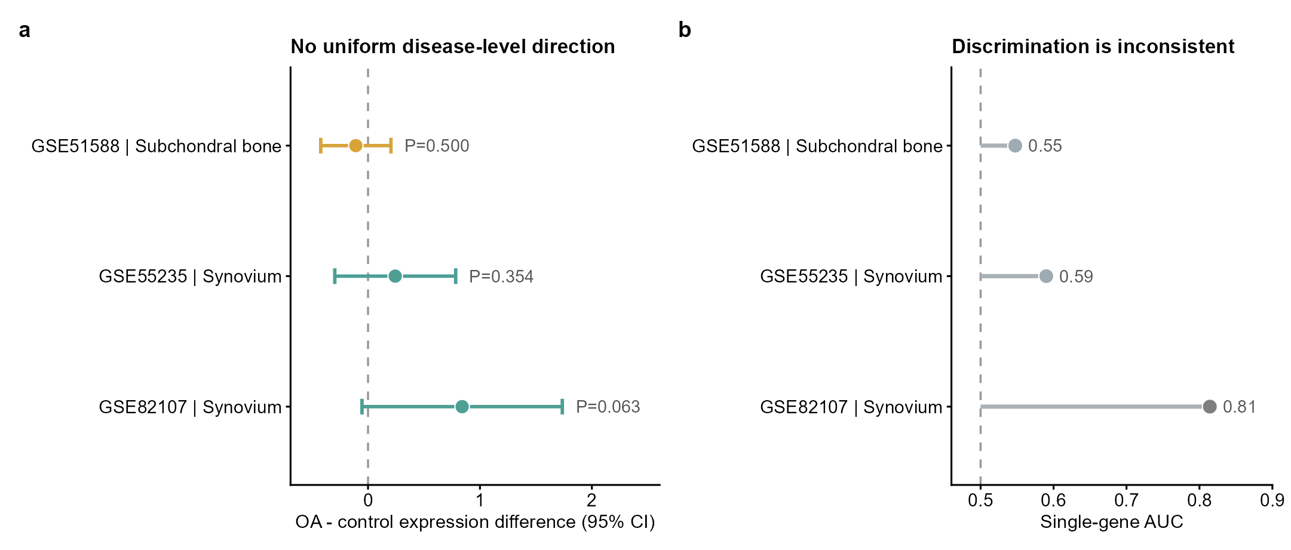
Supplementary Figure S1. Dataset-specific PIEZO1 disease context. (a) OA-versus-control expression differences with 95% confidence intervals. (b) Single-gene areas under the receiver-operating-characteristic curve. Performance is inconsistent across cohorts and is not presented as validation of a diagnostic biomarker.
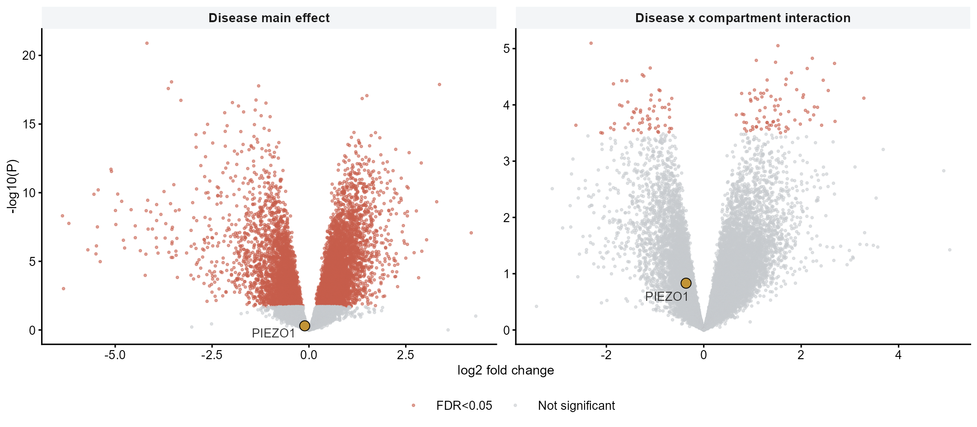
Supplementary Figure S2. GSE51588 disease main-effect and disease-by-compartment interaction volcano plots. PIEZO1 is highlighted. The primary moderated interaction P value for PIEZO1 is 0.147; red points meet transcriptome-wide FDR<0.05.
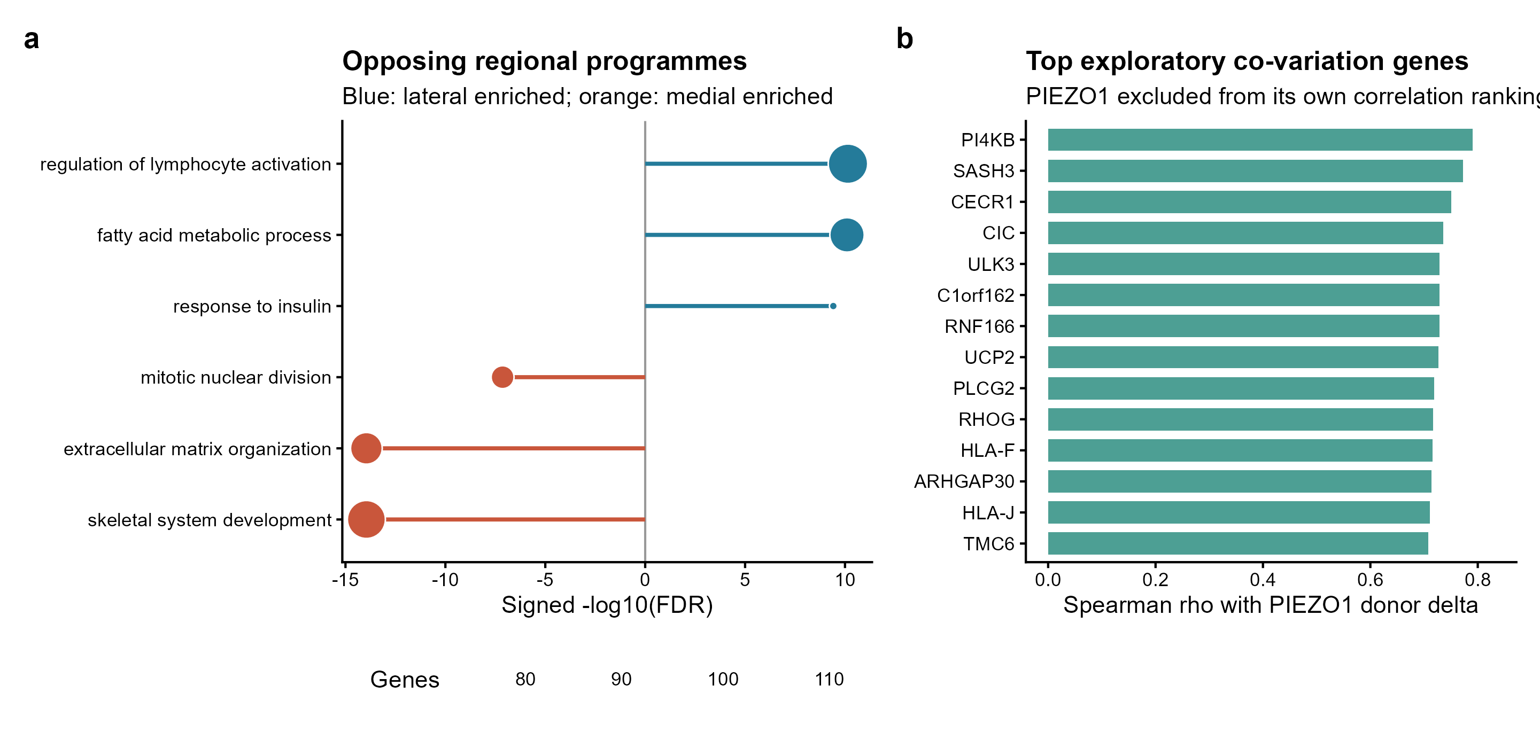
Supplementary Figure S3. Regional enrichment and exploratory co-variation. (a) Representative processes enriched among genes higher laterally or medially. (b) Genes with the largest positive Spearman correlations with the donor-level PIEZO1 medial-minus-lateral difference. PIEZO1 was excluded from its own correlation ranking before reranking. The panel is hypothesis-generating and is not an independently validated network.
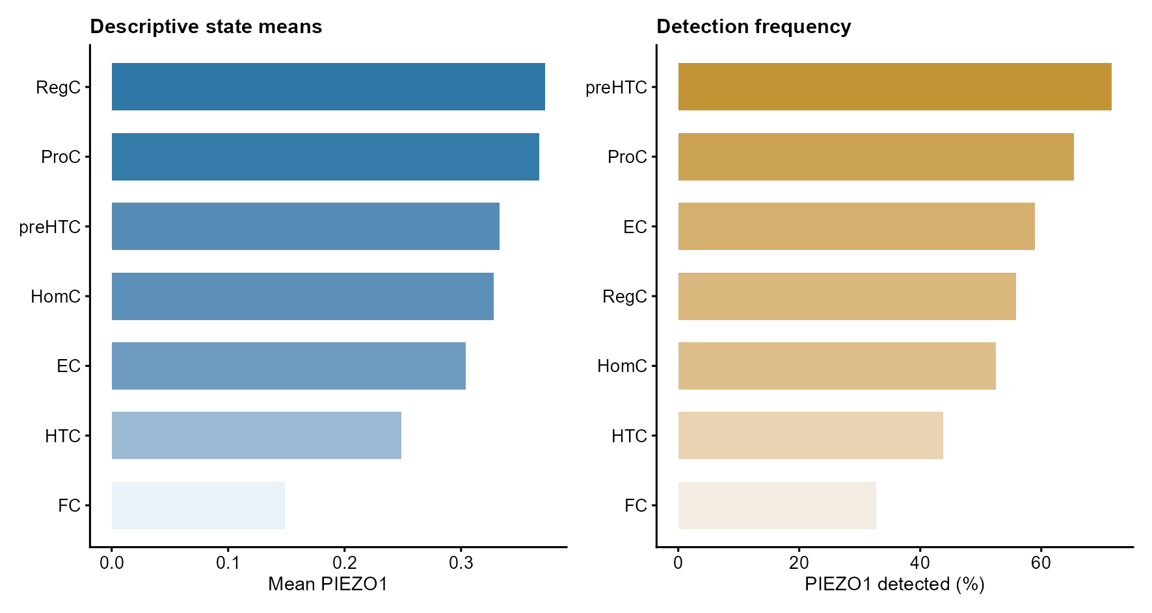
Supplementary Figure S4. Descriptive GSE104782 state summaries. Mean PIEZO1 expression and detection frequency are shown by published chondrocyte state, with cell-level Kruskal-Wallis P values. These cell-level summaries do not replace donor-level inference and should not be read as evidence for a stable ordering of the seven states.
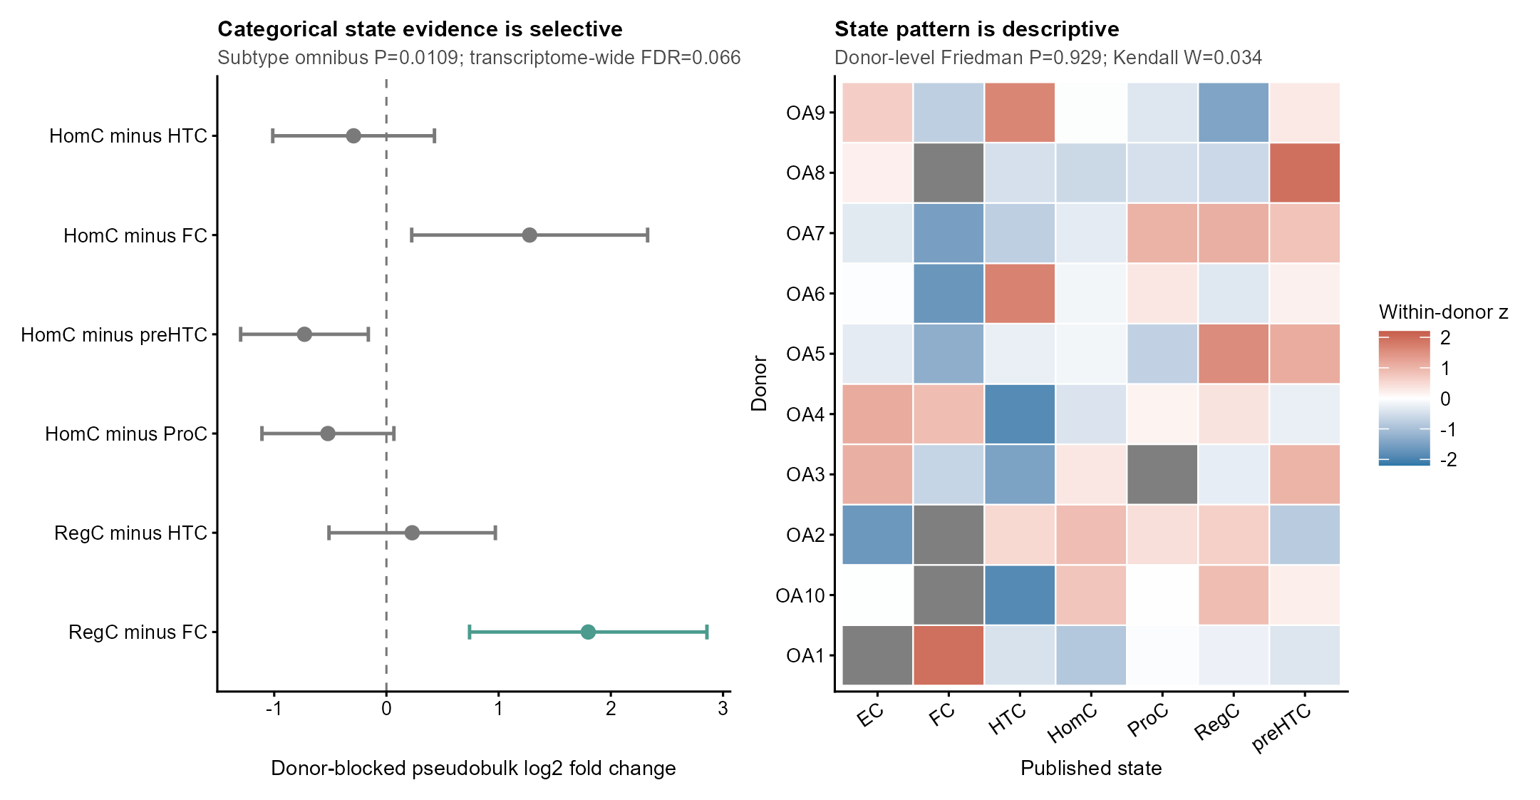
Supplementary Figure S5. Donor-aware state sensitivity analyses. (a) Donor-blocked pseudobulk state contrasts with 95% confidence intervals; the omnibus P value is 0.011 and the transcriptome-wide FDR 0.066, so the RegC-FC contrast is labelled exploratory. (b) Donor-by-state heatmap of within-donor standardized PIEZO1 expression; grey cells indicate unavailable donor-state combinations.
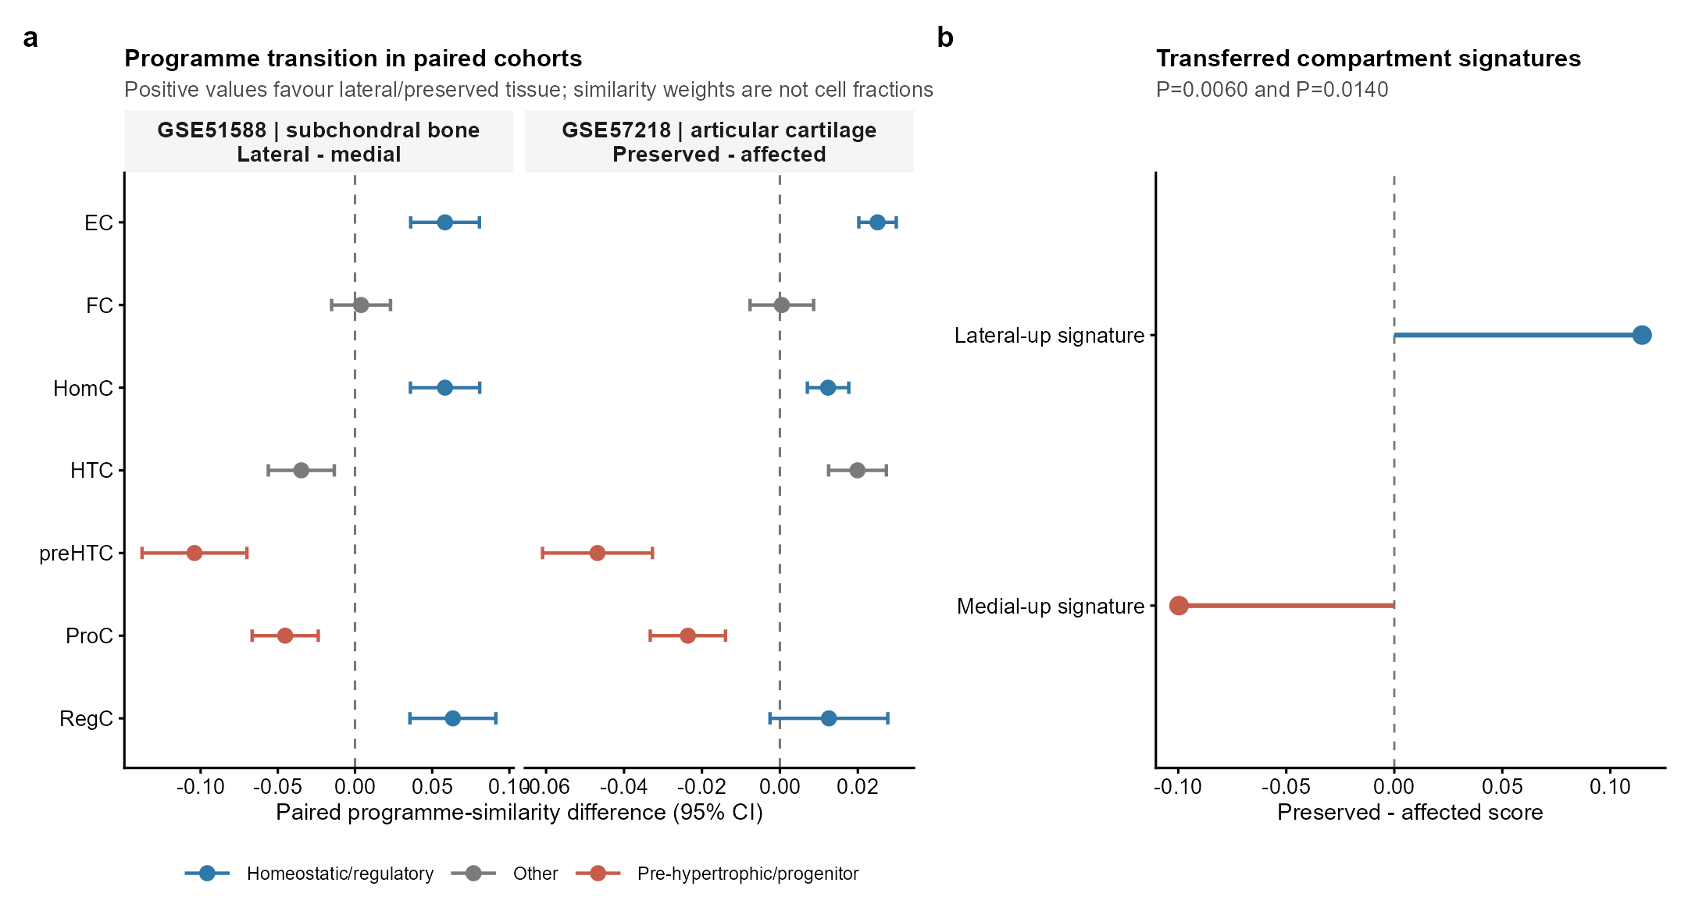
Supplementary Figure S6. Programme and transferred-signature concordance. (a) Full paired programme-similarity estimates for GSE51588 and GSE57218 with 95% confidence intervals. (b) Transfer of lateral-up and medial-up compartment signatures to GSE57218 preserved-minus-affected cartilage scores (P=0.0060 and P=0.0140). Similarity weights are not cell fractions. The authoritative final programme estimates and compositional sensitivity are reported in Tables S6 and S13 and Supplementary Figure S11.
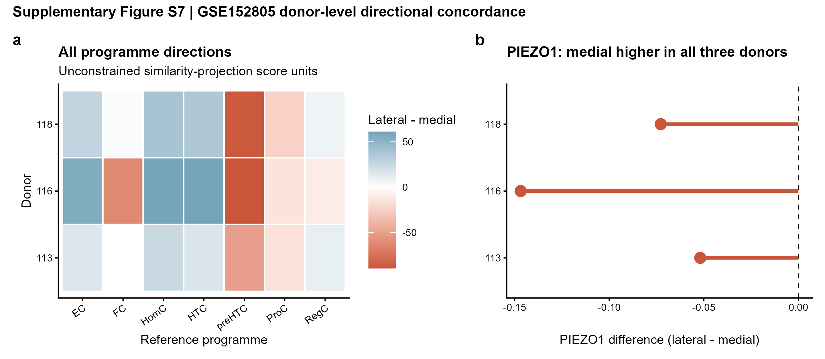
Supplementary Figure S7. GSE152805 donor-level directional concordance. (a) Lateral-minus-medial direction for all seven reference programmes in each donor; programme differences are unconstrained similarity-projection score units, not proportions or percentage points. (b) PIEZO1 was lower laterally in all three donors. Donors are displayed individually and no cell-level inferential P values are used.
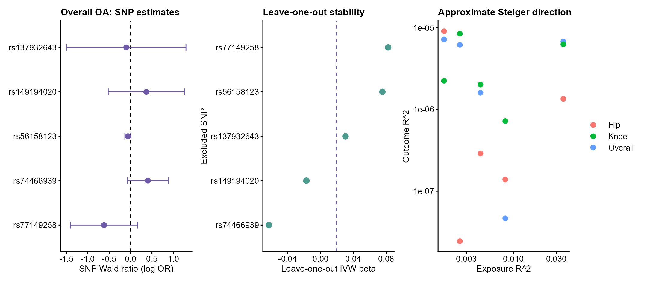
Supplementary Figure S8. Mendelian-randomization sensitivity analyses. Per-SNP Wald ratios with 95% confidence intervals for overall OA, leave-one-out inverse-variance-weighted estimates, IVW weight and approximate Steiger directionality. These analyses use reconstructed whole-blood PIEZO1 cis-eQTL instruments and are bounded to that systemic instrument model; they do not evaluate local joint-tissue mechanisms.
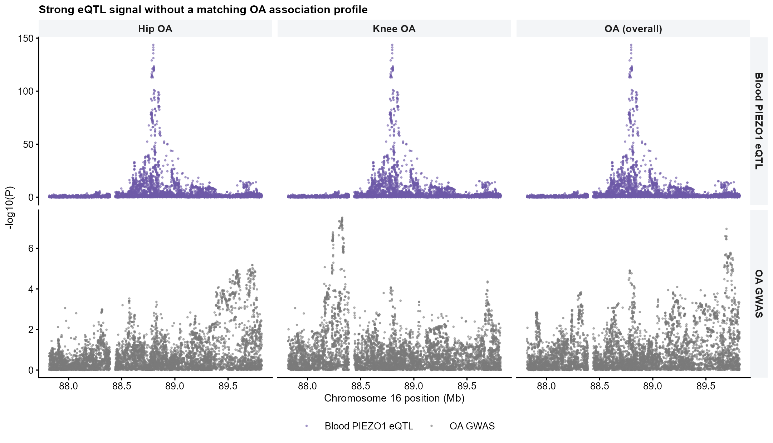
Supplementary Figure S9. Colocalization regional audit. Regional -log10(P) profiles for the whole-blood PIEZO1 eQTL and for overall, knee and hip OA GWAS, with the regional significance threshold of 5.69e-6 marked. Overall and knee OA contain a strong eQTL and a separate, region-wide significant OA signal whose lead variant lies 897 kb and 471 kb away; hip OA contains no variant reaching the regional threshold.
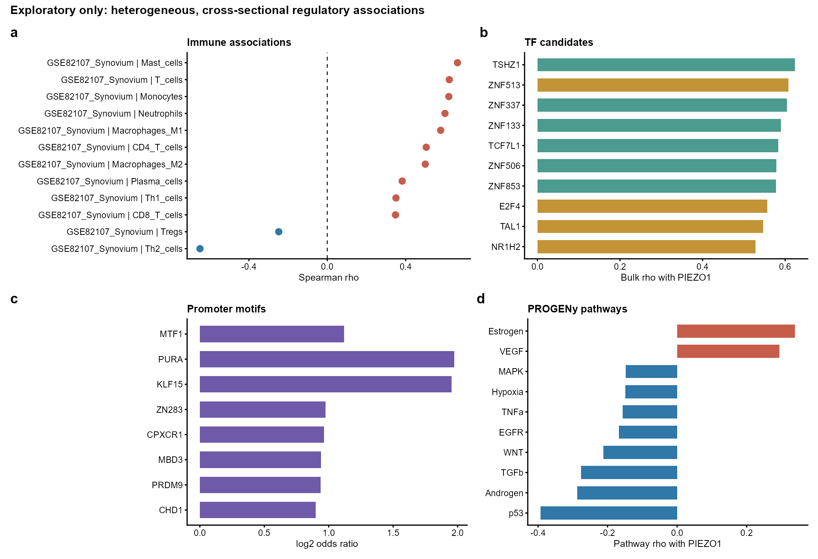
Supplementary Figure S10. Exploratory regulatory context. Cross-sectional immune-cell associations, transcription-factor candidates, promoter-motif enrichment and PROGENy pathway correlations are shown as hypothesis-generating analyses and are not used for causal claims.
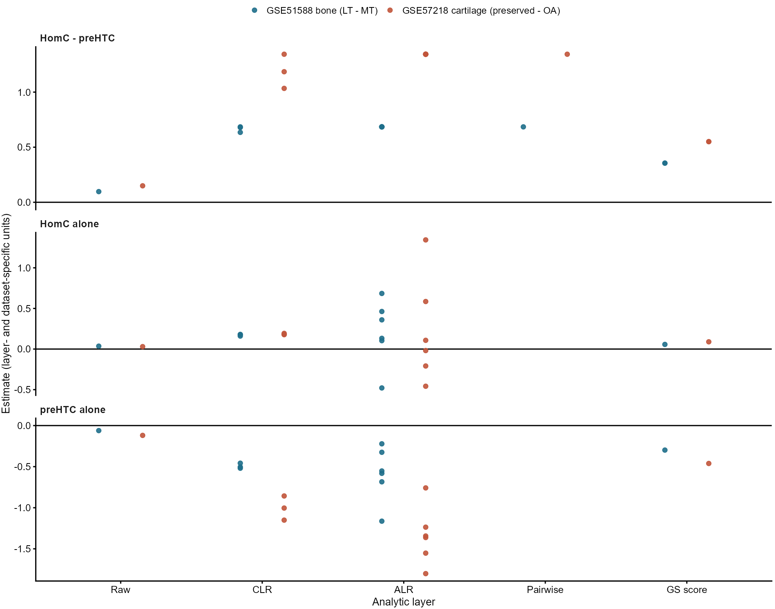
Supplementary Figure S11. Compositional sensitivity of the chondrocyte-programme contrast. The homeostatic-minus-pre-hypertrophic contrast, and the individual homeostatic and pre-hypertrophic programme estimates, are shown across five analytic layers in GSE51588 and GSE57218. The pre-hypertrophic programme is negative under every treatment; the homeostatic programme changes sign with the additive-log-ratio reference and is not significant with the unclosed score in GSE51588; the contrast is stable in every layer. Effect magnitudes are not compared across transformations or datasets; the panels summarize direction and robustness. Numerical values are given in Supplementary Table S13.
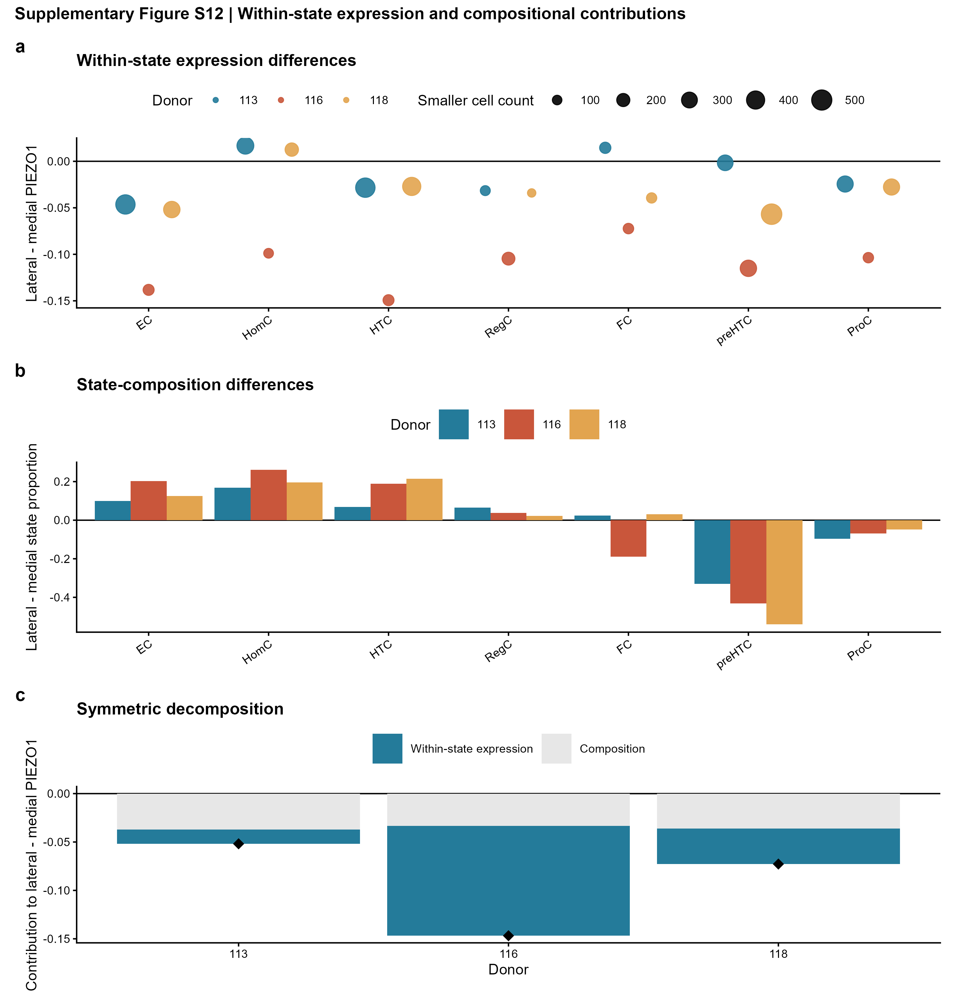
Supplementary Figure S12. Within-state expression and compositional contributions in GSE152805 using full-reference projected states. (a) Lateral-minus-medial PIEZO1 within projected state and donor; symbol area reflects the smaller compartment cell count. (b) Lateral-minus-medial state proportions. (c) Symmetric Kitagawa decomposition into within-state expression and composition components; diamonds mark total differences. Contributions were donor heterogeneous and do not support a uniform mechanism. The recall-gated sensitivity is shown in Supplementary Figure S15 and Supplementary Table S21.
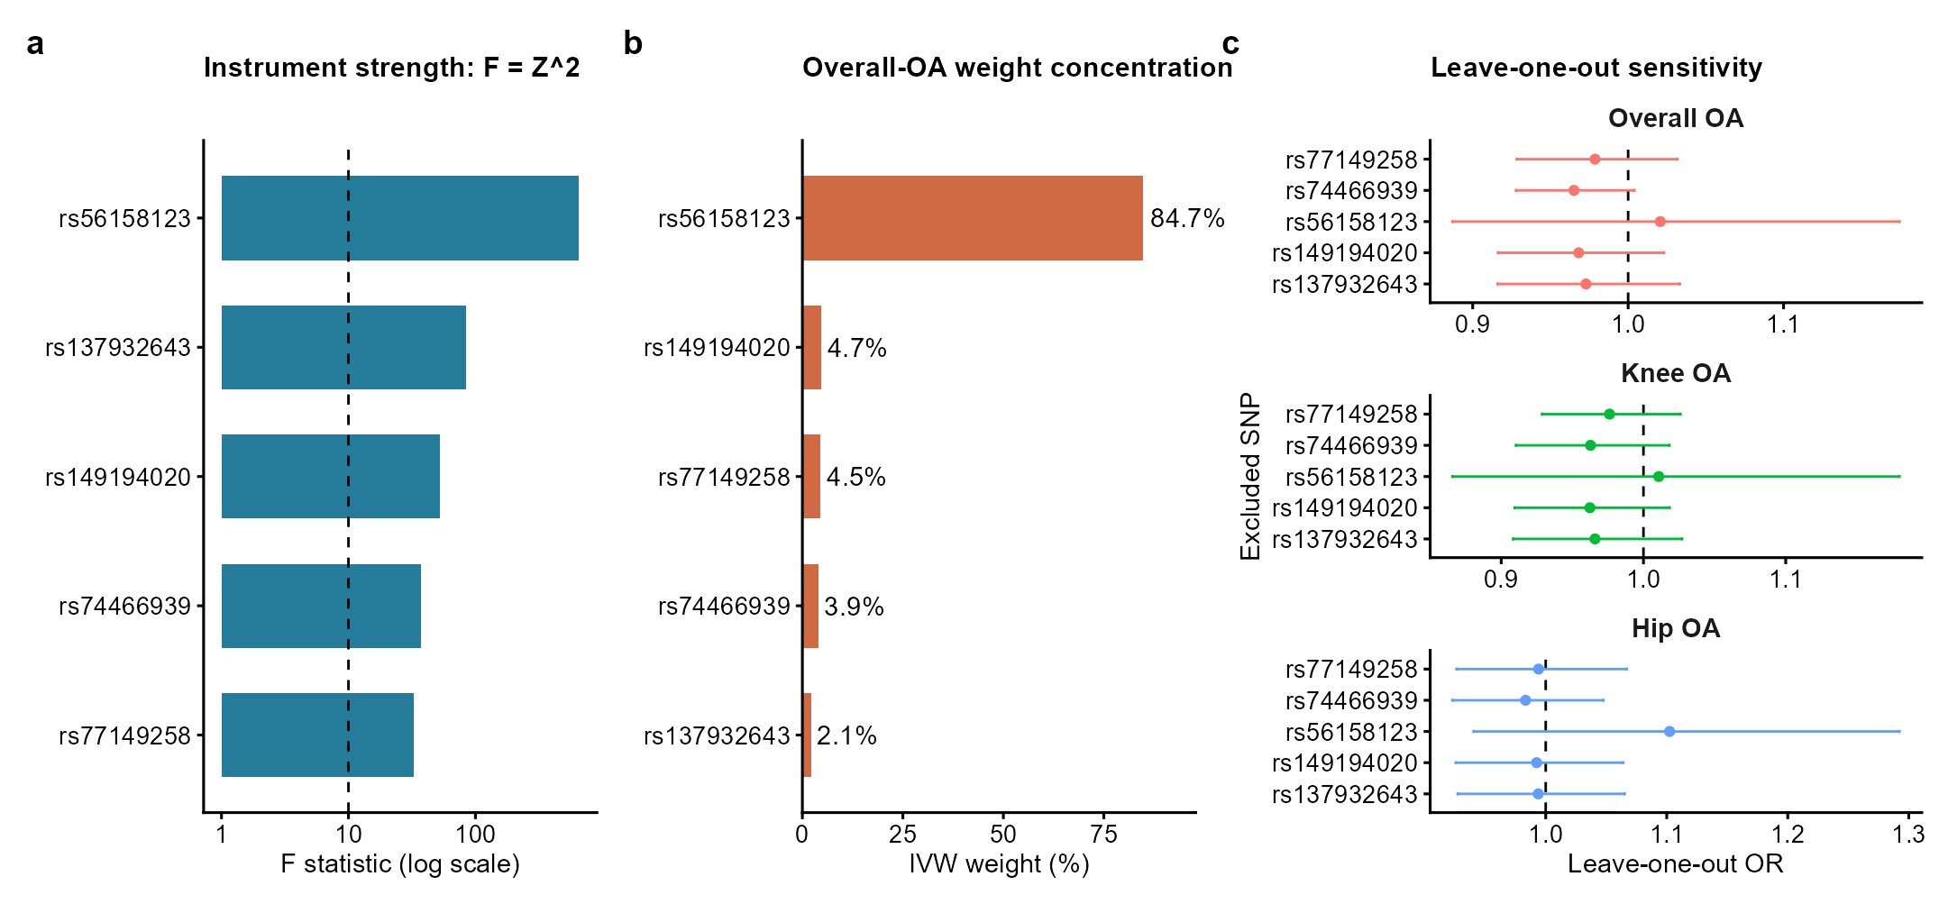
Supplementary Figure S13. Mendelian-randomization instrument-strength and influence diagnostics. (a) Instrument strength uses F=(beta/SE)^2=Z^2; all five retained instruments exceed F=32.7. (b) IVW weight concentration for overall OA; rs56158123 contributes 84.7%. (c) Leave-one-out multiplicative-random-effects estimates for all outcomes. Removing rs56158123 changes the overall-OA estimate to +0.0205 (P=0.775), confirming that the analysis is statistically close to a single-instrument estimate. Numerical values are in Supplementary Tables S9-S11.
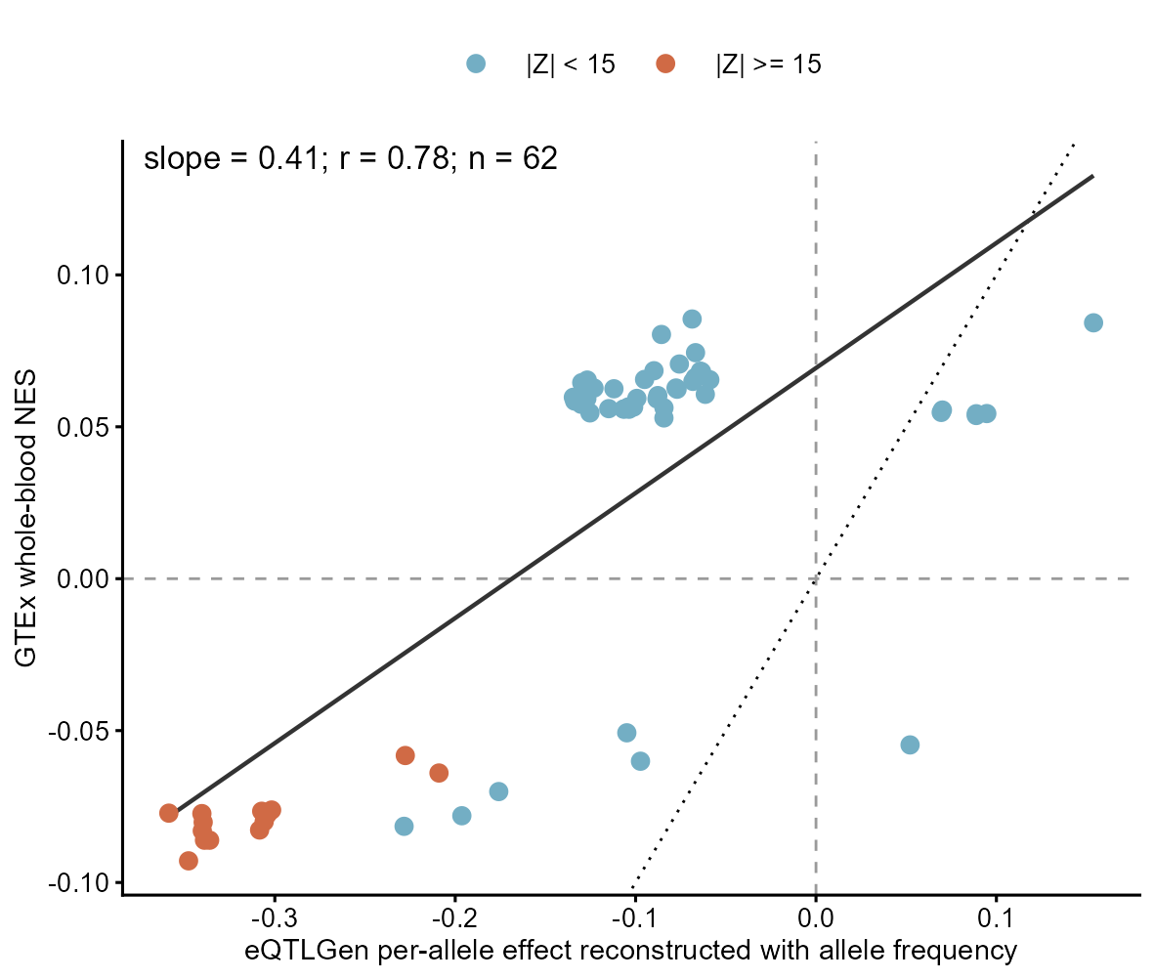
Supplementary Figure S14. Cross-resource comparison of reconstructed exposure effects. eQTLGen per-allele effects reconstructed with assessed-allele frequency are compared with allele-aligned GTEx v8 whole-blood normalized effect sizes for 62 shared significant variants. The OLS slope is 0.412 (95% CI 0.325-0.498; Pearson r=0.775), and all 16 variants with |Z|>=15 agree in direction. Because normalization, ancestry composition, covariate adjustment and effective sample size differ between resources, this comparison supports directional concordance but does not validate equality of the absolute effect scale. The MR inference and its stated units use the eQTLGen reconstruction defined in Supplementary Methods S8.
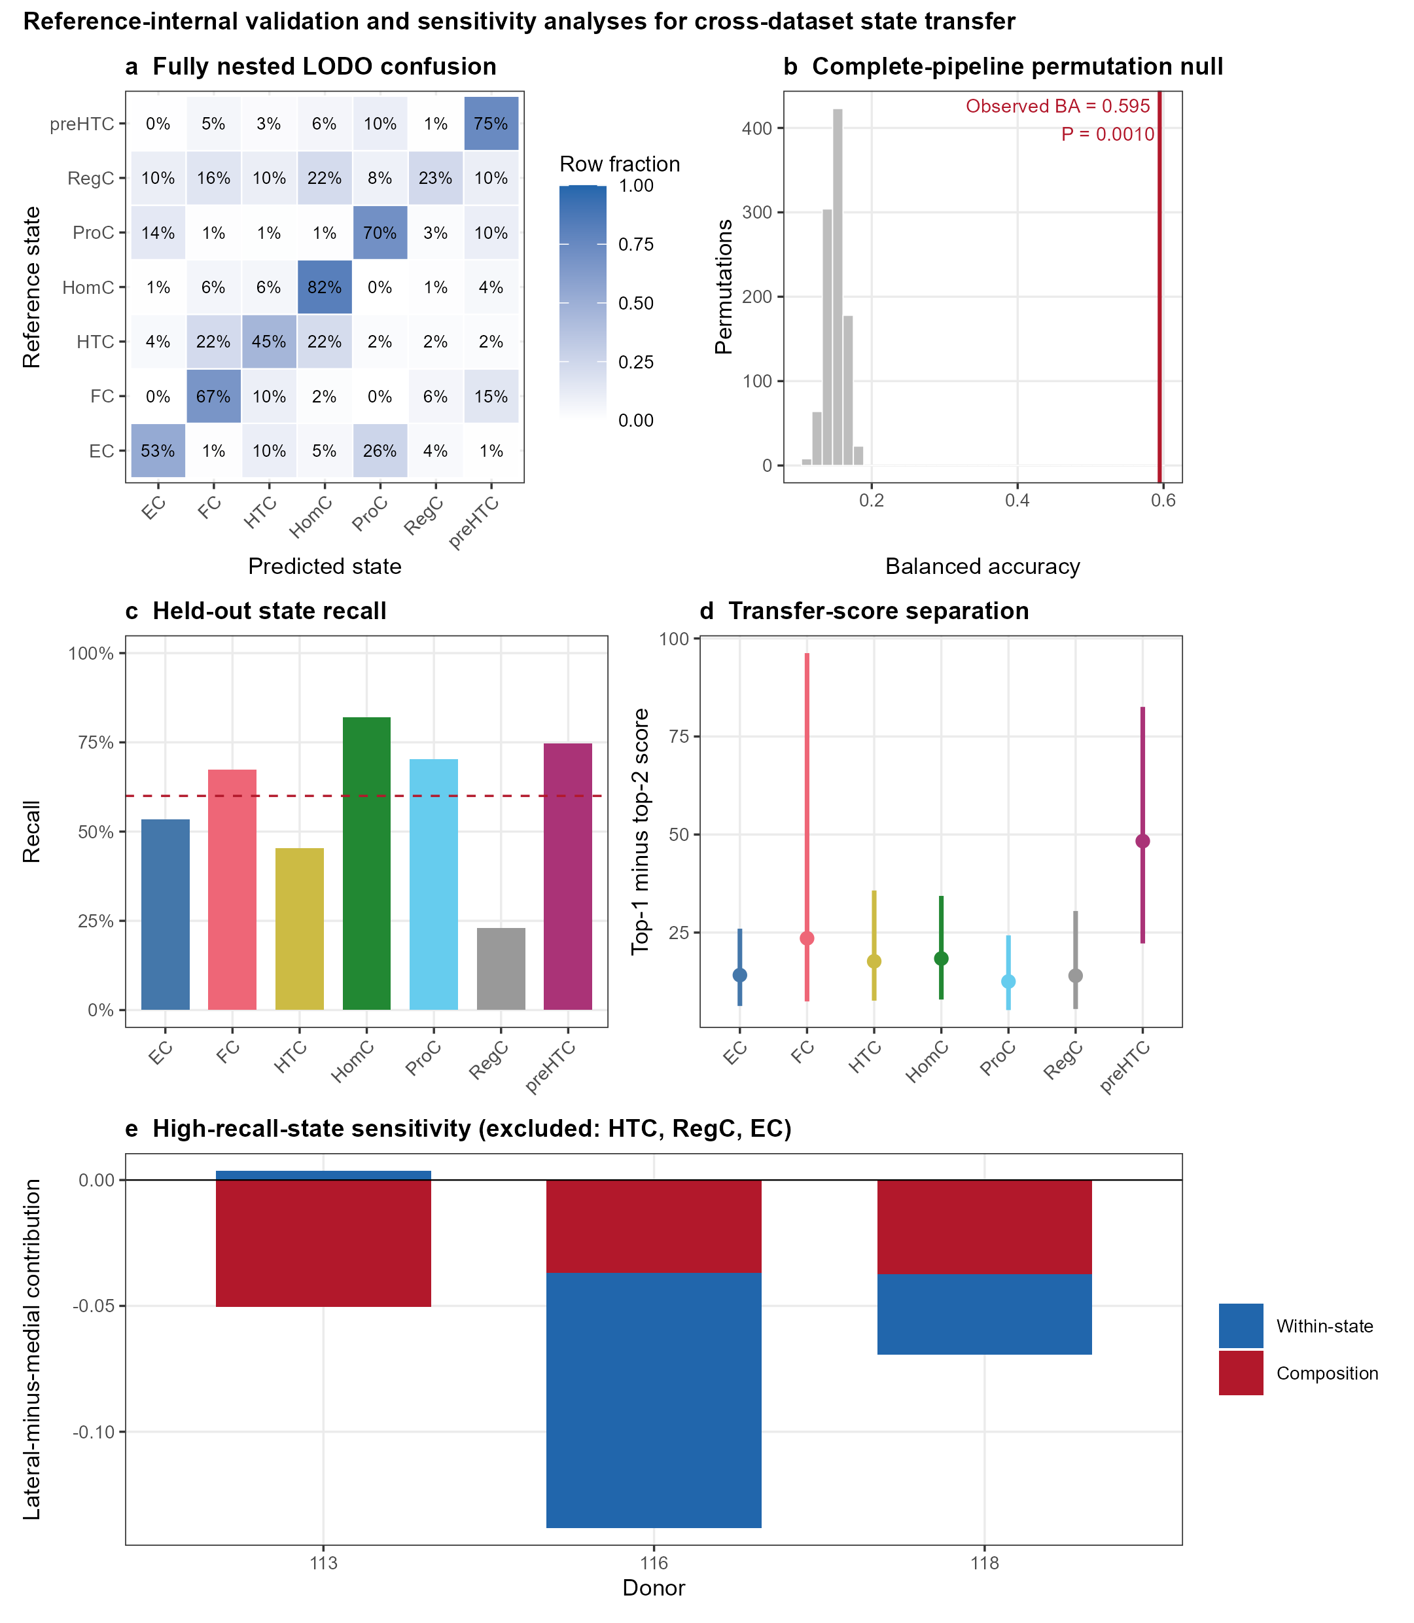
Supplementary Figure S15. Reference-internal fully nested validation and external projection sensitivity analyses. (a) Leave-one-donor-out confusion matrix within GSE104782, with marker selection repeated in each training fold. (b) Observed balanced accuracy against 1,000 donor-preserving complete-pipeline permutations. (c) Held-out recall; the dashed line marks the 0.60 threshold used only in the final sensitivity analysis. (d) GSE152805 projection-score margins, reported as external projection support rather than external validation. (e) Symmetric decomposition after excluding HTC, RegC and EC without reassigning cells. The total medial-higher direction persisted, but donor 113 was composition dominated with a small opposing within-state component.

