题目很简单, 有N个不同的点, 用K条线取连接这些点. 问有多少中连法?  
  
比如N= 3, K = 2, 就有三种连法:  
1-2-3(3-2-1 和这个是一样的)  
2-1-3  
2-3-1

不联通：C( N(N-1)/2, K)

联通 ： C(N, K+1) (K+1)^K-1  
  
应该能推出一个通用公示把,基本是考数学. 楼主我数序奇差, 想不出.  
感觉是图论的东西, 不是简单的排列组合.  
--

<http://www-math.mit.edu/~djk/18.310/18.310F04/counting_trees.html>

<http://stackoverflow.com/questions/3042412/with-n-no-of-nodes-how-many-different-binary-and-binary-search-trees-possib>

This suggests the hypothesis: F(n) = nn-2.

1. Total no of Binary Trees are = 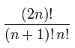
2. Summing over i gives the total number of binary search trees with n nodes. 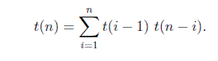

The base case is t(0) = 1 and t(1) = 1, i.e. there is one empty BST and there is one BST with one node. 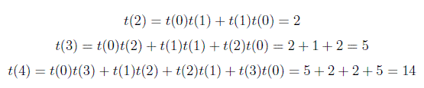

So, In general you can compute total no of Binary Search Trees using above formula. I was asked a question in Google interview related on this formula. Question was how many total no of Binary Search Trees are possible with 6 vertices. So Answer is t(6) = 132