**How does ageing affect brain function similarly and differently between males and females?**

Yuhui Du1, 2*, Zhen Yuan1, Vince D. Calhoun2

1 School of Computer and Information Technology, Shanxi University, Taiyuan, China

2Tri-Institutional Center for Translational Research in Neuroimaging and Data Science, Georgia State University, Georgia Institute of Technology, Emory University, Atlanta, GA, USA

## Abstract

There has been evidence that normal ageing affects human brain function. However, there is no complete picture of what brain function decline is mostly related to ageing, and how ageing affect brain function similarly and differently between males and females . Here, based on resting-state brain functional connectivity of 25582 healthy subjects (13373 females) aged 49-76 years, we propose a large-scale deep learning method followed by an explainable artificial intelligence technique to automatically discover primary brain functional connectivity (FC) relating to the ageing progress, and disclose how similar and different the females and males are in the brain ageing. Using a nested cross-validation scheme, we conducted 4200 deep learning models to classify all paired age groups on the main data for females and males separately, and then extracted the ageing-related gender-common and gender-specific FCs, finally validated the gender-common and gender-specific FCs using additional 21000 classifiers on the independent data. We found that ageing, in general, weaken the absolute functional connectivity strength, specifically, suppress the positive functional connectivity within network and the negative functional connectivity between networks. Interestingly, ageing-related functional connectivity shared by both sexes are mainly within the cognitive control network. Remarkably, females have faster brain decline than males along ageing, and females and males differ greatly in the connectivity between cognitive control, default modal and visual networks. Taken together, our study provides new evidence about how females and males are similar and different in brain ageing.

## Introduction

As the global demographic shift towards an older population, it is greatly needed to understand the effect of ageing on the human brain. Despite the significance of studying the brain ageing mechanism, no work has given a complete picture of how human ageing affects the brain, and no work has provided a potential way about how to slow down the ageing-related brain decline (Gallen, Baniqued et al. 2016, Baniqued, Gallen et al. 2018). Recently, researchers found sex differences in working memory, verbal abilities, and reasoning domains along ageing (Nichols, Wild et al. 2021). Therefore, it is particularly important to disclose how females and males differ in their brain ageing progress, which would be beneficial to proposing gender-specific treatments for slowing down the effects of ageing on the brain.

Some work has found ageing-related changes in specific brain functional networks or systems through comparing young and old adults (Campbell, Grigg et al. 2013, Grady, Sarraf et al. 2016, Ng, Lo et al. 2016, Staffaroni, Brown et al. 2018) using statistical analysis method. There are also a few studies (Meier, Desphande et al. 2012, Sendi, Chun et al. 2020) that utilized machine learning methods to reveal ageing-related functional connectivity that contributed mostly in classifying older and younger age groups to reflect the ageing-related FC. These studies cannot guarantee that the identified features are related to progressive ageing, since sole older and younger groups cannot reflect complex ageing. Moreover, none of them used a large sample to guarantee the reliability of the extracted FC features and validated the ageing-related FC using independent cohorts.

As aging attracted attention globally, revealing changes in brain function across the lifespan was largely concerned. Previous studies have found decline in functional network or connectivity along the ageing. A study (Geerligs, Renken et al. 2015) used graph theory method to investigate the whole-brain functional connectivity and found that brain networks in the elderly showed decreased modularity and decreased local efficiency. Betzel et al (Betzel, Byrge et al. 2014) disclosed that functional connections within resting-state networks weaken in magnitude while connections between resting-state networks tend to increase.       

      

Furthermore, gender difference in the brain has been well acknowledged (Biswal, Mennes et al. 2010, Allen, Erhardt et al. 2011, Filippi, Valsasina et al. 2013). Although some studies already attempted to examine how females and males differ along ageing in brain function (Scheinost, Finn et al. 2015, Goldstone, Mayhew et al. 2016, Zonneveld, Pruim et al. 2019, Stumme, Jockwitz et al. 2020), unfortunately the exsiting findings were all from small sample sizes and were all from statistical analysis methods. It is still controversial that whether significant differences (reflected by small p-values) in statistical analyses can represent the most distinguishing features (add zuoxinian 最近的文章) between groups. To the best of our knowledge, it is largely unknown yet what are the gender-common and gender-unique functional declines in the whole brain during the normal ageing, and going futher how the gender-common functional connectivity changes analogously induces their similar cognitive declines and how the gender-specific functional connectivity changes are diversly associated with their unique cognitive declines.

As aging attracted attention globally, revealing changes in brain function across the lifespan was largely concerned. Previous studies have found decline in functional network or connectivity along the ageing. A study (Geerligs, Renken et al. 2015) used graph theory method to investigate the whole-brain functional connectivity and found that brain networks in the elderly showed decreased modularity and decreased local efficiency. Betzel et al (Betzel, Byrge et al. 2014) disclosed that functional connections within resting-state networks weaken in magnitude while connections between resting-state networks tend to increase.       

      The above ageing-related studies focused on how ageing affected FC in the general population using FC. However, some previous studies showed that females and males could be different in many brain networks (Biswal, Mennes et al. 2010, Allen, Erhardt et al. 2011, Filippi, Valsasina et al. 2013). Many studies tried to explore how females and males age differently and rarely showed any difference (Mowinckel, Espeseth et al. 2012). Tomasi (Tomasi and Volkow 2012) found that females had higher local FC density. A study by Goldstone (Goldstone, Mayhew et al. 2016) examined DMN, DAN, and SN in 20 young (10 males) and 20 old (9 males) adults. They found old adults showed weaker intra-network and greater inter-network than young adults, with only males demonstrated greater FC in ACC-DAN than females. However, they contributed the sex difference to the re-organization of spatial location of RSN nodes, e.g., the position of these nodes changed with older age. Zonneveld et al (Zonneveld, Pruim et al. 2019) found that ageing decreased FC within DMN, ventral attention network (VAN), and SMN but increased FC within VIN. When comparing sex difference, they found males showed higher within-network FC in the FPN, DAN, and SMN, males and females mainly differed between attentional networks (ATN) and SCN. By using graph theory, Stumme et al (Stumme, Jockwitz et al. 2020) investigated how females and males differed based on the FC of 772 participants (421 males). They found that females showed higher within-network FC in DMN and VAN, males showed higher inter-network FC in SMN. Further, they demonstrated that females showed a more segregated network than males and males showed a higher integrated network than females. A study by Scheinost et al (Scheinost, Finn et al. 2015) tried to give more details of ageing trajectories of females and males by using intrinsic connectivity distribution (ICD) and general linear model (GLM) based on 103 female and male participants. In DMN, they found that both females and males showed decreased FC but males deceased faster than females. In FPN, females and males showed divergent trajectories, females showed decreased connectivity with age, while males showed increased connectivity with age, but the change rate of females in lateral parietal was faster than males, the change rate of males in lateral frontal was faster than females. In sensory and subcortical and limbic networks, females and males showed opposite change directions, and the change rate of females was faster than malesDespite these findings, the interaction between the effects of age and gender on the re-organization of resting-state networks is still not fully understood. Comparison or examine-based methods ignored the complex interaction between FC, and their results were more like sex differences rather than how females and males aged differently. On the other hand, investigating aging or how females and males age based on network-level may be too rough and lose the detailed information, since both increased and decreased FC existed wherever within-network or between-network (Campbell, Grigg et al. 2013, Betzel, Byrge et al. 2014, Huang, Hsieh et al. 2015), and thus canceled each influence out. Although using advanced methods, e.g., machine learning, can combine FC linearly or nonlinearly and also find important FC; however, the way of combination is predefined, i.e., handcrafted features. More crucially, when obtaining important FC from the constructed classifier, FC doesn’t like images or language which have very intuitive sense; thus, we must verify the obtained important FC before concluding about it.

Here, we disclose what brain functions in the whole brain are significantly affected by the human normal ageing progress and what are the primary differences between females and males in the brain function decline along the ageing using our large-scale deep learning method. To maximize the reliability, we have employed brain functional connectivity estimated from resting fMRI data of superlarge samples (25582 healthy subjects aged 49-76 years). To guarantee the generalization, we have developed a robust cross-validation classification scheme, which effectively verified that our identified functional connectivity features are reliably relevant to ageing. To overcome the shortcomings of traditional statistical analysis and classification methods in previous studies that often compared a younger group with an older group, we have proposed a large-scale deep learning method to identify the functional connectivity features that are related to progressive ageing by classifying any two groups from seven age groups, using 4200 classifiers on the main data and validating the results using 21000 classifiers on the independent data. In our study, an explainable artificial intelligence technique was used to provide a more intuitive sense from the automatically learned features in deep learning, which benefits mining the most important features in the classification. In this work, we reveal stable ageing-related gender-common and gender-specific brain functional declines, and interestingly they respectively present common and unique relations with the cognitive degradation.. In summary, our finding not only reveals the progressive brain function decline along the ageing, but also would help provide gender-specific treatments for slowing down the effects of ageing on brain.

## Results

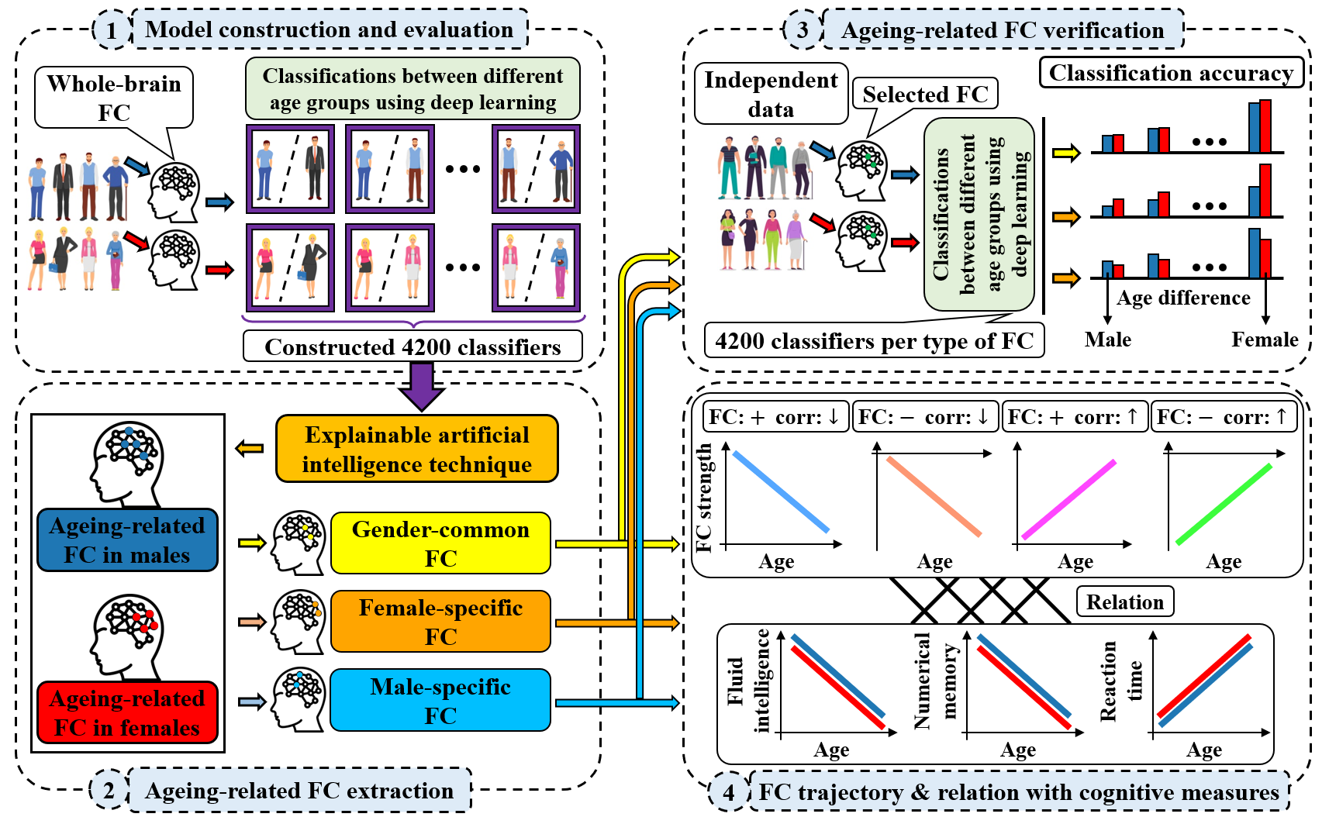

Fig. 1. The pipeline of our study, which identifies and validates ageing-related gender-common and gender-specific functional connectivity (FC) using our proposed large-scale deep learning method. In the procedure, 4200 deep learning models are trained to classify all paired age groups among seven age groups for females and males separately using whole-brain FC as features, and then the gender-common and gender-specific FC features that are most relevant to the progressive ageing are identified using our method based on an explainable artificial intelligence technique, after that, we validate the effectiveness of the gender-common, gender-specific and the combined common and –specific FC features using additional classifications on independent data, and finally, we evaluate the association (Pearson correlation) between each stable gender-common (or gender-specific) FC and the age as well as their correlations with cognitive function related measures (including fluid intelligence, numerical memory and reaction time).

### Brain functional connectivity declines gradually along the normal ageing

We employed the brain FC of 25582 healthy subjects aged between 49 and 76 (including 13373 females and 12209 males) from the UK biobank datasets. The details of the data can be found in the Methods. For each subject, whole-brain 1485 FC features were used for analysis, with each FC reflecting the interaction between two spatial brain functional networks that were estimated from a data-driven independent component analysis method (Hyvarinen 1999, Beckmann and Smith 2004). The analysis pipeline is outlined in Fig. 1. We first applied advanced deep learning to distinguish different age groups for the females and males separately due to the promising applications of deep learning in the neuroscience field in recent years (Ker, Wang et al. 2017, Litjens, Kooi et al. 2017, Liu, Pan et al. 2018, Lundervold and Lundervold 2019, Zhang, Wang et al. 2020), and then identified the FC features that are most relevant to the progressive ageing for females and males respectively using an explainable artificial intelligence technique (Sundararajan, Taly et al. 2017). After that, we extracted the ageing-related gender-common and gender-specific FC features and further validated the effectiveness of the features using additional classifications on independent data. Moreover, we examined how the stable ageing-related gender-common (or gender-specific) FC similarly (or uniquely) changed along the ageing process for females and males, and also evaluated whether the ageing-related gender-common (or gender-specific) FC features show shared (or disparate) relations with cognitive measures

Superior to previous work that often only considered young and old populations, we separated the females (or males) into multiple age groups to perform the classifications, with an aim of capturing the FC features strongly relating to the progressive ageing process. Taking the females for example, all females aged from 49 to 76 years were partitioned into seven age groups, with each age group including four ages of subjects (e.g. the first group includes the subjects aged 49-52 years). As such, 21 classification tasks were conducted across seven groups, and each classification task focused on differentiating one group from another. The subject numbers in the seven groups were well matched via random sampling. For the data of each two groups, we performed the classification via a two-layer ten-fold cross-validation scheme to maximize the reliability. Regarding the inner cross-validation, the main data (i.e. the nine folds from the outer process) were divided into 8: 1: 1 folds as the training, validation, and testing data. The training and validation data were used for the model training and selection, respectively. The trained model was then evaluated using both the test set of the main data and the independent data from the outer cross-validation procedure.

Fig. 2a shows the classification accuracies using females’ data for both the test set of the main data and the independent data. It is evident that the accuracy matrix approximatively presents a symmetric pattern, meaning that the classification accuracy is quite consistent between the test set of the main data and the independent data. Thus, our results support that the trained models had a satisfactory generalization ability that is particularly important to the reliability of the classification. It is also observed that the classification between the group aged 49-52 years and the group aged 73-76 years achieved the highest accuracy (over 89%), and the classification accuracy slowly decreased when the age difference between the two groups in the classification became small. The classification accuracy fell into the lowest value when distinguishing two groups with the fewest age difference (i.e four years), and this phenomenon was still true and the relatively low accuracies from the data with less age differencecan not improve significantly even when increasing the sample size and model complexity (please see the supplementary Fig. S2a and b for the classification results using more data or more hidden layers).

We also performed the classifications for the males using the same framework. Fig. 2b demonstrates a similar pattern to Fig. 2a, again supporting that classification between two groups with more age difference was easier than classifying two groups with less age difference using brain FC as features. Similar to the females’ data, using more samples or more advanced models can not help improve the separability between groups with small age differences (Fig. S2c and d). For a further summary, we regarded the classifications that classified two groups with the same age difference as the similar classification tasks (for example, the classification between the 49-52 age group and the 57-60 age group and the classification between the 53-56 age group and the 61-64 age group were taken as the similar classification tasks, because the age differences both were 8 years), and then averaged their classification accuracies for the test settest set and the independent data, respectively. Our results (see Fig. 2c) show that the classification accuracy reached the highest value when classifying the youngest and oldest age groups (that had a age difference of 24 years) for females (90.11%) and males (85.93%) using the test settest set of the main data, and for females (89.38%) and males (86.28%) using the independent data. In contrast, the classification accuracy was lowest when classifying two groups with the smallest age difference (i.e. 4 years) for females (53.92%) and males (52.92%) using the test settest set of the main data, and for females (53.72%) and males (53.29%) using the independent data. Since the classification accuracy can reflect to what extent two age groups in the classification were different in the brain FC, our finding supports that brain FC declines slowly and gradually along the normal ageing process.

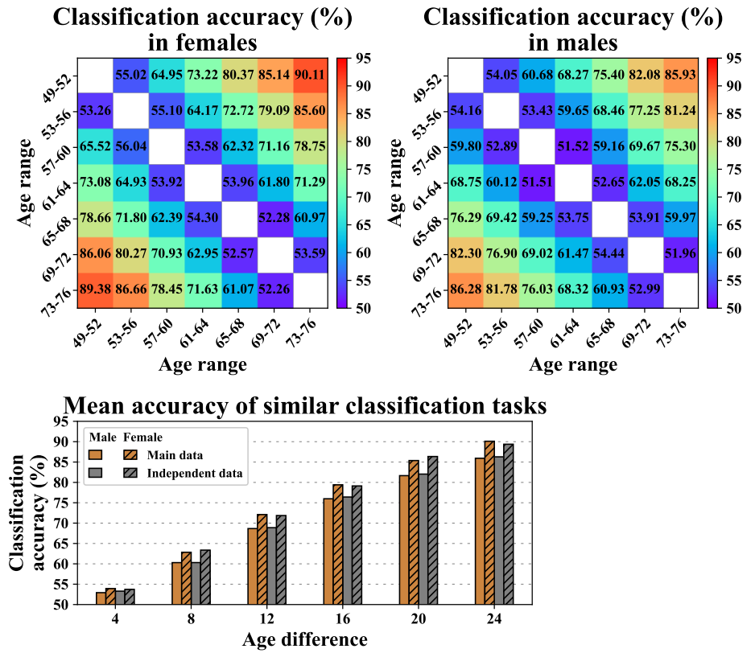

**Fig. 2 Classification accuracy in distinguishing different age groups on the test set of the main data and the independent data.** **a** and **b**: The classification accuracy for the females and the males, respectively. In **a** and **b**, the upper triangular elements include the mean accuracy (across 100 runs) for the test set of the main data, and the lower triangular elements include the mean accuracy (across 100 runs) for the independent data. It is seen that the classification accuracy for the same classification task (e.g. the classification between the 49-52 age group and the 73-76 age group) is very consistent between the test set and independent data. **c**: The mean classification accuracy of similar classification tasks on the test set of the main data and the independent data. Each bar reflects the averaged classification accuracy of similar classification tasks that were defined as those classifying two groups with the same age difference.

### Our method reveals the most important ageing-related gender-common and gender-specific brain functional connectivity

Based on the deep learning models that were well trained to classify different age groups of the females and males separately, we extracted the important FC features that contributed to the deep learning models via an explainable artificial intelligence technique, and then discovered ageing-related gender-common and gender-specific FC features. In our work, the features in the trained deep learning models were automatically mined via a method called integrated gradients (IG) (Sundararajan, Taly et al. 2017).

Since different classification tasks would yield various performances, we only investigated the features for the satisfactory models that achieved higher than 75% classification accuracy on the test set of the main data. Taking the classifications using females’ data for an explanation, given the main data determined (in one run of the outer cross-validation procedure), we computed the features’ importance scores via the IG method for the selected models from all 10 runs in the inner cross-validation and all 21 classification tasks, and then averaged them to obtain a summarized score for each FC feature, next took the absolute value for the summarized score and normalized the features’ scores to reflect the features’ importances in classifying different age groups of the females. As such, we sorted the features and selected the top 300 FC (nearly 20% of all FC) according to the features’ scores for the females and males, separately. Finally, we identified the shared and unique features between the females and males to reflect their common and specific ageing properties. Therefore, the resulting gender-common features include the important FC for the age group classification in both females and males, and the resulting gender-specific (e.g. female-specific) features include the important FC for the age group classification in one gender (e.g. female) but less important in the other (e.g. male).

After successfully extracting the ageing-related gender-common and gender-specific FC features based on the main data (in each outer cross-validation procedure), we carried out the age group classifications again via the same nested 10-fold cross-validation framework using those features of females’ or males’ data. Moreover, we not only tested each of the above-mentioned three types of FC features, but also tested two types of combination FC features. The two types of combination features were the combination of the gender-common and female-specific features and the combination of the gender-common and male-specific features, since we were interested in whether they would outperform the common and specific features alone. We want to emphasize that the classifications on the independent data are fully unbiased, because that the gender-common and gender-specific features were extracted based on the models trained on the main data. Although the reclassifications on the test set of the main data are biased=, we would report them for a comparison with the results on the independent data.

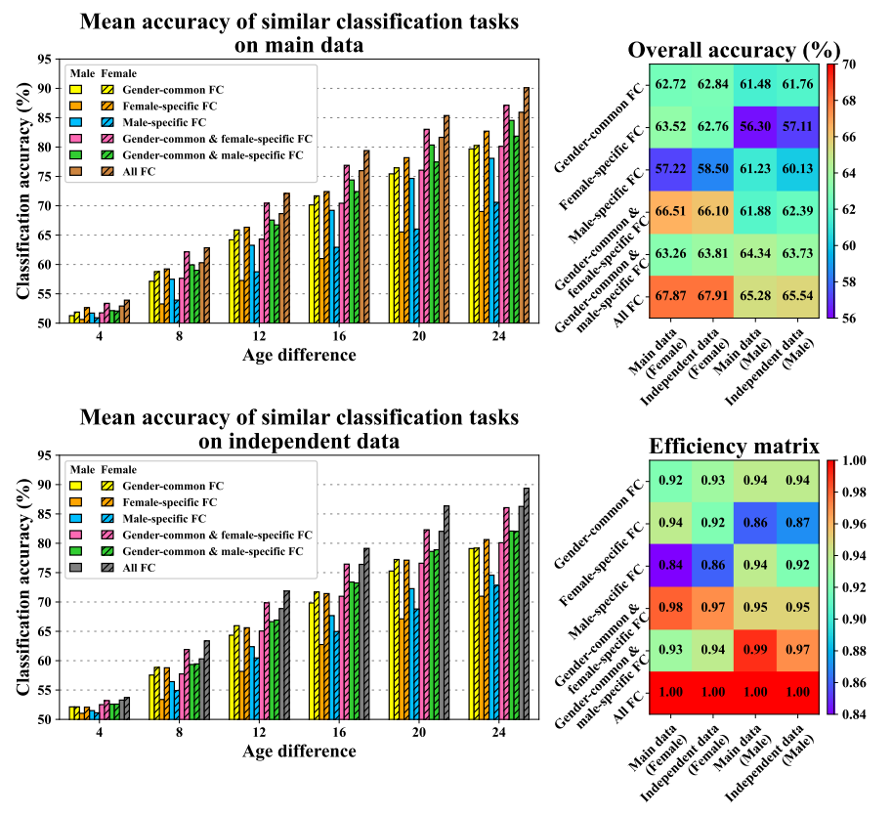

**Fig. 3 Performance of the classifications between seven age groups using different datasets based on varied features.** **a** and **b:** Mean accuracy of similar classification tasks on the test set of the main data and the fully independent data. The used features included the gender-common FC, the female-specific FC, the male-specific FC, the combined gender-common and female-specific FC, and the combined gender-common and male-specific FC. For a comparison, the results using all FC are also shown. **c**: The overall accuracy obtained using each kind of features on different datasets. Here, all accuracies across different classification tasks are averaged to represent the overall accuracy. We include the results for the test set (of the main data) and independent data, and also include the results for the females and males. **d**: The efficiency matrix. An element of the efficiency matrix was calculated as the proportion of the corresponding overall classification accuracy in the overall accuracy using all FC as features.

As for using each of the five types of FC features, we obtained the classification accuracy from classifying any two age groups for the test set of the main data and independent data, separately. The supplementary Fig. S3 and Table S1-S2 includes the detailed classification accuracy results for using each type of features. To facilitate the comparisons across different types of features, we summarized the results by averaging the classification accuracies of similar classification tasks for each type of features. Here, the classifications in which the two age groups had the same age difference were taken as similar classification tasks. Fig. 3a and b show the corresponding results for the test set of the main data and the independent data, respectively, indicating that the results were very consistent between the main data and independent data. Interestingly, regardless of any type of features, the classification accuracy in both females and males gradually increased when the age difference between two groups became large, although the same features were used for the classifications. That means the extracted gender-common and gender-specific FC features can reflect progressive brain function decline along human ageing. Furthermore, the gender-specific features often yielded better classification performance for the related gender than the other gender, supporting the validity of the gender-specificity. For instance, when looking into the classification between the 49-52 age group and the 73-76 age group, the female-specific features obtained higher accuracy for the females (82.71% on the test set of the main data and 80.63% on the independent data) than for the males (69.02% on the test set of the main data and 70.98% on the independent data), while the male-specific features obtained higher accuracy for the males (78.08% on the test set of the main data and 74.57% on the independent data) than for the females (70.59% on the test set of the main data and 72.83% on the independent data). Indeed, the situation is true for all the classification tasks as well as for both the main data and the independent data, as demonstrated in Fig. S3 and Table S1-S2. We also found that the combined use of the gender-common and gender-specific features resulted in a better performance than using the common or specific features alone for both the females and males, which implys that the common features reflect the similar ageing mechanism between females and males and the specific features can reveal more information about how females and males differently change in brain function along the ageing. In order to measure the overall performance of each type of features, we averaged all accuracies across the 21 classification tasks to obtain an overall accuracy. Based on the results (Fig. 3c), another interesting finding is that the extracted FC features worked comparably with all FC features, and using the gender-common and gender-specific features in combination almost yielded an accuracy as high as using all FC features, which means that those features included the most pivotal ageing-related FC. To make it more clear, we assessed the efficiency of each type of feature by computing the proportion of its relevant accuracy in the accuracy obtained from using all FC features. The efficiency matrix is shown in Fig. 3d, which supports that for the females’ data, using the combination of the gender-common and female-specific features yielded the highest efficiency, i.e., 0.98 for the test set of the main data and 0.97 for the independent data; similarly for the males’ data, using the combination of gender-common and male-specific features yielded the highest efficiency, i.e., 0.99 for the test set of the main data and 0.97 for the independent data. The results again confirm the important role of the common and specific features for characterizing brain ageing.

Our deep learning method achieved statisfactory classification performance as deep learning model can automatically mine efficient features that may be better than other straightforword feature selection methods such as correlation-based one. We further validated this point by performing reclassification using the important FC features identified by the IG method and the less important FC features measured by the IG method. Here, both types of feature fell into a similar range of correlation values with the ages. That means the importances of the two types of features were matched using the linear correlation-based feature selection. However, it is evident from Fig. S4 that using important features revealed by the IG method resulted in higher classification accuracies, indicating that our deep learning method is more powerful in disclosing the ageing-related FC.

### Ageing-related gender-common functional connectivity changes consistently in females and males along ageing, primarily including ** functions.

Since using the identified gender-common FCs resulted in similar classification performances between females and males on the independent data in distinguishing different age groups, it is desired to investigate what brain functions commonly decline in females and males and further how they consistently change along the ageing. So, we comprehensively analyzed how similar the ageing-related gender-common FC are between females and males. It should be noted that in the above analyses, we extracted the gender-common and gender-specific FC features based on the main data for each run of the outer cross-validation, and then verified their capability in the classifications using the independent data. So, it is necessary to summarize the stable ageing-related gender-common and gender-specific FC features across different runs. In this work, we identified the FC features that occurred in five of ten cross-validation runs, yielding 95 FCs, 113 FCs, and 101 FCs as the stable gender-common, female-specific, and male-specific FCs, respectively. The detailed information can be seen in Tables S3-S5.

Regarding each of these stable FC features using the females’ or males’ data, we calculated the mean FC strength of the subjects at the initial age (i.e. 49 years) as well as Pearson correlation between the FC strengths at different ages and the ages (from 49 years to 76 years) to measure the changing trends of FC along the ageing. According to the FC strength at the initial age and correlation, in total there are six possible changing patterns (see “Methods” for the definitions). We separately summarized the FC features that belonged to each changing pattern to investigate the similarity and differences between the two genders. Fig. 4a visualizes the changing patterns of the stable gender-common FC features for both the females’ and males’ data. We found that although there are totally six possible changing patterns, there was no FC whose mean FC strength changed its sign (from + to – or from – to +) across all ages that we investigated (i.e., 49 to 76 years). It means that only four changing patterns existed for those important FCs during the aging process. The changing pattern of each stable gender-common and gender-specific FC can be found in Table S3-S5. Interestingly, within the 95 stable gender-common FC features, only three showed different changing patterns between females and males (Fig. 4a). Through conducting paired t-test on the correlations (i.e. the correlation between FC strength and age) for each pattern to test the differences between the males and females, we found that the difference was insignificant for all four changing patterns (please see Fig. 4 for the T-values and p-values). For an intuitional display, we also show the mean correlation across all FCs with the same changing pattern in Fig. 4a, clearly demonstrating that the mean correlation was close between the two genders.

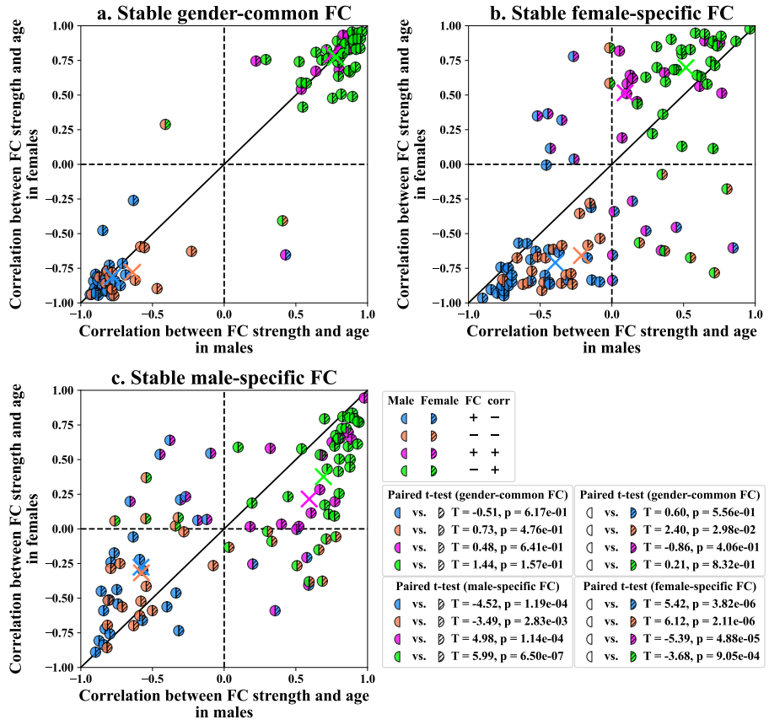

**Fig. 4** Changing patterns of the stable gender-common, female-specific, and male-specific FC features. **a, b,** and **c** include the results of 95 stable gender-common FC features, 113 stable female-specific FC features, and 101 stable male-specific FC features. For each FC, we show its changing pattern using one circle dot, with its x-axis and y-axis are Pearson correlations between the FC strengths at different ages and the ages for males and females and its coloring way in left and right parts denotes its changing pattern in males and females. Although there are six possible patterns defined, only four patterns occurred for these FCs, including pattern 1 (positive FC strength increases along the ageing, denoted by: FC +, corr +), patten 2 (positive FC strength decreases along the ageing but has no sign change of the FC strength, denoted by: FC +, corr -), pattern 3 (negative FC strength increases along the ageing but has no sign change of the FC strength, denoted by: FC -, corr +), and pattern 4 (negative FC strength decreases along the ageing, denoted by: FC -, corr -). In the right-bottom part, we show the T-value and p-value obtained using paired t-test between the males and females on the FC-age correlations for each pattern.

Furthermore, regarding each changing pattern, we display how its associated FCs’ strengths changed with the ageing progress in Fig. 5a. In particular, for the FCs belonging to a pattern, we utilized the FC strengths at each age of females and males so as to show the FC strength distributions at each age using an ellipse (Friendly, Monette et al. 2013). It is observed that for the gender-common FCs, the ellipses tended to move along the diagonal line, suggesting that the changes of FC strengths in females and males were consistent for these stable ageing-related gender-common FCs.

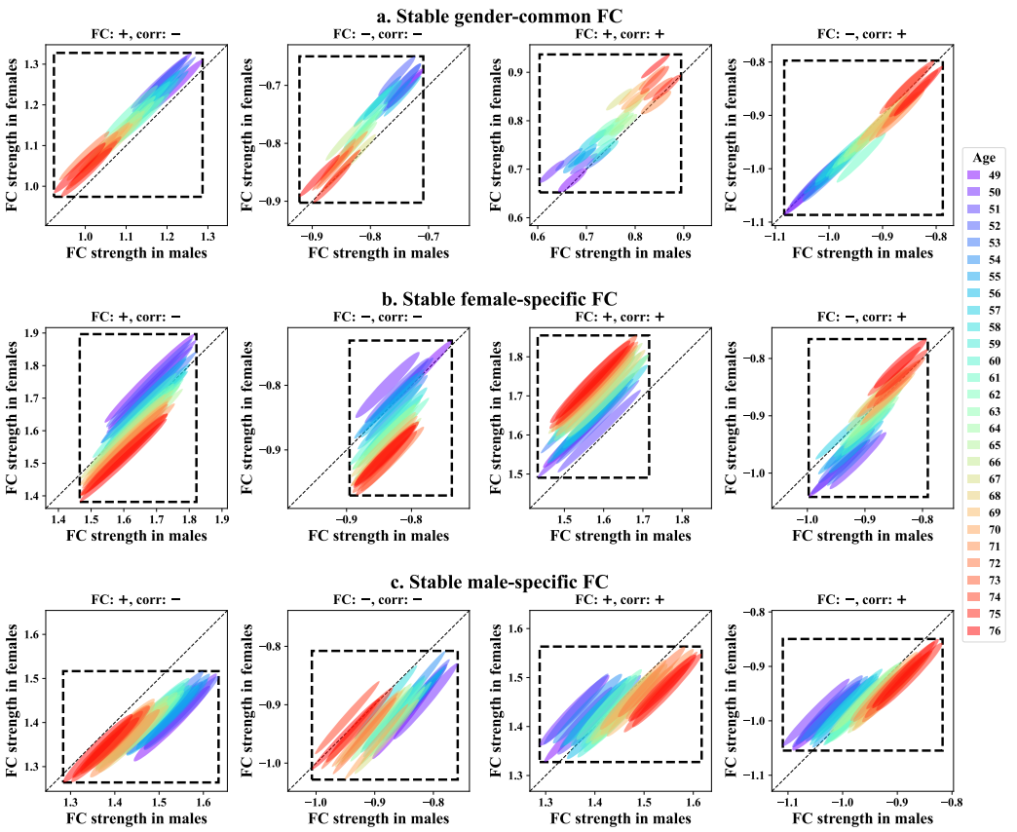

Fig. 5 FC strength change of the stable gender-common, female-specific, and male-specific FC features. **a, b,** and **c** include the results of 95 stable gender-common FC features, 113 stable female-specific FC features, and 101 stable male-specific FC features. For the FC features belonging to a pattern, an ellipse is used to show the strengths of FCs that belonging to the pattern for one specific age. Here, the mean and standard deviation of FC strengths in females and males and the covariance between females and males were used to form each ellipse. The FC strengths of females and males from age 49 to age 76 are represented by ellipses with different colors. For each ellipse, the ratio of the x-axis range to the y-axis range is equal to the ratio of standard deviation in males to standard deviation in females, the coordinate of the center is mean FC in males and females, the semi-minor axis is 1-Pearson correlation between females and males, and the semi-major axis is 1+Pearson correlation between females and male. The dotted box is the minimum box (edges parallel to x-axis or y-axis) which includes all the ellipses.

Since that each FC reflects interaction between two brain functional networks, we further summarized the ageing-related gender-common FCs according to their associated networks. Given all networks were assigned into nine functional domains, some FCs linked the networks from different domains, while others linked the networks within the same domain. So, we display the number of FCs that belonged to each between-domain (e.g CC-DM) and within-domain (e.g CC-CC) in Fig. 6a to investigate what functional domains are mostly relevant to the common ageing. In addition to the number, we also calculated the commonality measure between females and males for each between-domain and within-domain (see Fig. 6b). Considering the stable gender-common FCs were identified under the condition of employing the top n=300 features in the classifications, Fig. 6b reports the commonality results from using n=300 as well as that from combinging different n for maximizing the reliablity. It is observed that Fig. 6a and b resulted in a consistent conclusion that the CC-CC is the most similar for pattern (FC: +, corr: -), and the CC-DM is the most similar for both pattern (FC: -, corr: -) and pattern (FC: -, corr: +). For a further summary, we include the number and percentage of FCs for each changing pattern in Fig. 6a. We found that FCs occupied more percentages for the two patterns of (FC: +, corr: -) and (FC: -, corr: +), compared to the other two patterns of (FC: -, corr: -) and (FC: +, corr: +), which means that FC strengths were primarily suppressed along the ageing. More interestingly, for gender-common FCs, ageing suppressed the pattern (FC: +, corr: -) within domains and the pattern (FC: -, corr: +) between domains.

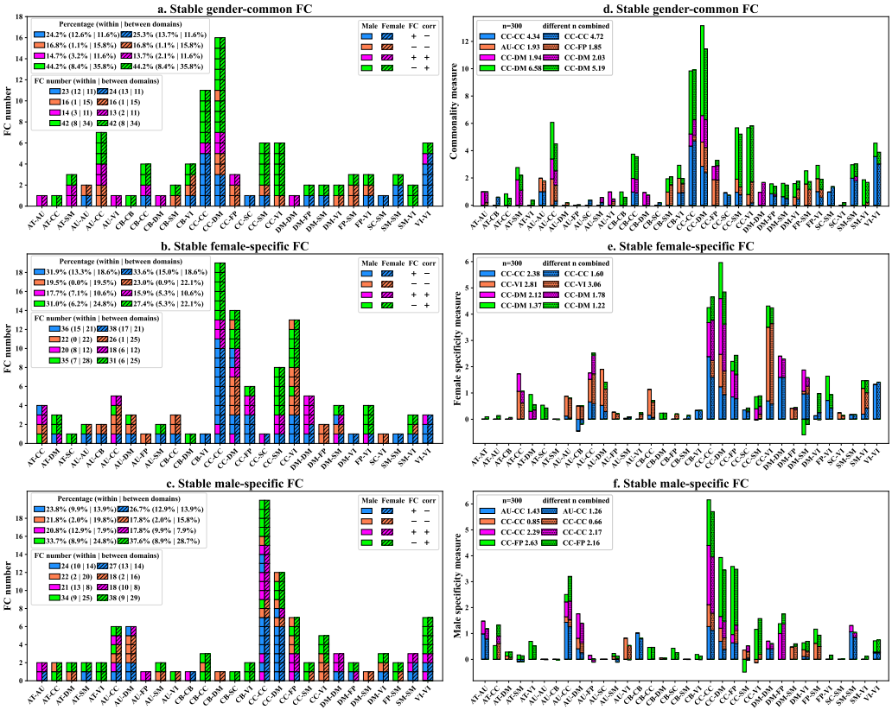

**Fig. 6 Summary of the stable ageing-related gender-common, female-specific, and male-specific FCs according to the network domains that the FC-associated networks belonged to.** The FCs that coincide with the same changing patterns are shown using the same color. a, c, and e: we show the number of FCs belonging to each within-domain or between-domain for the gender-common, female-specific, and male-specific FCs, respectively. In the subfigures of a, c and e, we also list the overall number of FCs (and its percentage) for each changing pattern as well as the results of the within-domains and between-domains. b: the commonality measure between females and males for each between-domain and within-domain. d: the female specificity measure for each between-domain and within-domain. f: the male specificity measure for each between-domain and within-domain. In the subfigures of b, d and f, the measures were computed based on both n=300 and the combination of different n. We also provide the information about which within-domain or between-domain had the highest measure value for both n=300 and the combination of different n.

We further investigated the trajectories of 10 important FCs that were from the 95 stable gender-common FCs and show them in Fig. 7. The 10 FCs had >0.5 absolute FC-age correlations for both genders and had the closer FC-age correlations between the females and males. Eight of the ten FCs were associated with the CC domain, while the other two involved the AU, VI and FP domains..

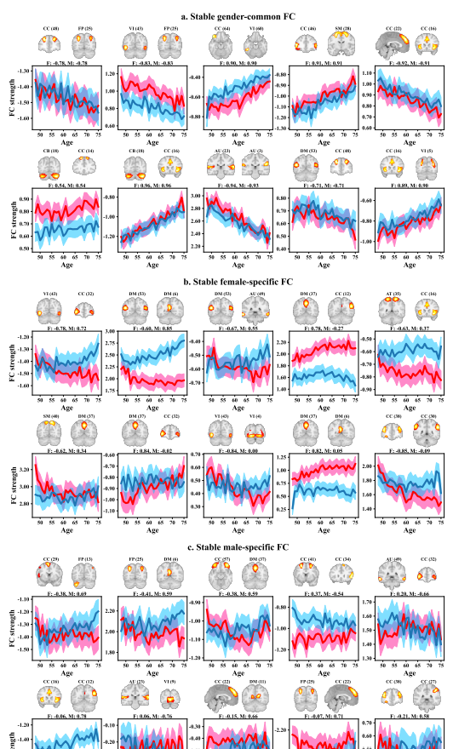

**Fig. 7** The trajectories of **a** the top 10 ageing-related stable gender-common FCs, **b** the top 10 ageing-related stable female-specific FCs, and **c**. the top 10 ageing-related stable male-specific FCs. The stable FCs were sorted by differences in the correlations between the two genders. For the stable gender-common FCs, we took the FCs with the small difference in the correlations as the important stable gender-common FCs. For the gender-specific FCs, we took the FCs with the big difference as the important stable gender-specific FCs. For each FC, we show the trajectory for females (or males) using the mean and standard deviation at each age. For each FC, we also demonstrate two functional networks and its associated domians the FC linked as well as the FC-age correlations in females and males.

### Female-specific FCs show unique changes in females, primarily involving ** function

The paper not only aims to reveal the ageing-related brain functional changes, but also focuses on disclosing how the brain of females and males differently decline along the ageing. Since we already demonstrated that the female-specific FCs were more powerful in distinguishing different age groups in females than in males. It is reasonable to infer the unique ageing parth of females from them. So, similar to the gender-common FC, we show the changing patterns of those 113 female-specific FC features in Fig. 4b. It is seen that for those FCs, while some FCs showed the same changing pattern between females and males, there were also some FCs presenting disparate changing patterns. Regarding the FCs that had the same changing patterns, the correlations tended to show greater absolute values in females than in males, indicating that those FCs changed faster in females than in males along the ageing progression. Among the FCs that showed different changing patterns, most (i.e. eight) FCs presented the pattern of (FC: +, corr:-) in females but the pattern of (FC: +, corr: +) in males, and six FCs presented the pattern of (FC: +, corr:+) in females but the pattern of (FC: +, corr: -) in males,. There were also six FCs showing the pattern of (FC: -, corr: -) in females but the pattern of (FC: -, corr: +) in males, and two FCs showing the pattern of (FC: -, corr: +) in females but the pattern of (FC: -, corr: -) in males (see Table S4 for details). In general, the differences in the correlations between the males and females were all significant (p-value < 0.01, tested by paired t-tests), and the mean correlations were far between the two genders for the four changing patterns (please see Fig. 4 for the T-values and p-values).

Regarding each changing pattern, we also display its associated FCs’ strengths at each age (see Fig. 5b). It seems that regardless of any changing pattern, the ellipses that corresponded to FCs of different ages move more greatly along y-axis than along x-axis, suggesting that the changes of FC strengths were more significant in females than in males for these stable ageing-related female-specific FCs.

Among the stable female-specific FCs (see Fig. 6b) We also found that FCs occupied more percentages for the two patterns of (FC: +, corr: -) and (FC: -, corr: +), compared to the other two patterns of (FC: -, corr: -) and (FC: +, corr: +), which also means that FC strengths were primarily suppressed along the ageing. When considering within and between domains, ageing suppressed the pattern (FC: +, corr: -) within domains for females and males. However, ageing affected the pattern (FC: -, corr: +) and pattern (FC: -, corr: -) between domains fairly for females but suppressed the pattern (FC: -, corr: +) for males. Furthermore, the differencity between females and males when evaluating from the first n=300 and different n combined are consistent also. When considering the most different two-functional network between females and males based on the first n=300 FCs, the CC-CC, CC-VI are the most special for pattern (FC: +, corr: -) and pattern (FC: +, corr: +) respectively, the CC-DM is the most special for both pattern (FC: -, corr: -) and pattern (FC: -, corr: +).

In order to explore what FCs emblem the most uniqueness of females’ brain ageing, from 113 FCs, we identified the top-10 female-specific FCs that had >0.5 absolute FC-age correlations in females and also had bigger gender difference in the FC-age correlations. Fig. 7b demonstrates that these FCs played an important role in females’ brain ageing but not necessarily in males’, and the gender difference in the FC-age relationship was evident. Besides, these FCs primarily involved ** functional domains.

### Male-specific FCs show unique changes in males, primarily involving ** function

We were also interested in disclosing what FCs were more relevant to the ageing of males rather than the ageing of females. Fig. 4c shows the properties of the 101 stable male-specific FCs. Although some FCs of them had a same changing pattern between the two genders, the correlations presented greater absolute values in males than in females, indicating that those FCs changed faster in males along the ageing progression. Among the FCs that showed different changing patterns, most (i.e. nine) FCs had the pattern of (FC: -, corr: -) in females but the pattern of (FC: -, corr: +) in males, and five FCs had the pattern of (FC: -, corr: +) in females but the pattern of (FC: -, corr: -) in males. There were eight FCs presenting the pattern of (FC: +, corr:+) in females but the pattern of (FC: +, corr: -) in males and five FCs presenting the pattern of (FC: +, corr:-) in females but the pattern of (FC: +, corr: +) in males. (see Table S5 for detailsMoreover, their differences in the correlations between genders were significant for all the four patterns (p-value < 0.01, tested by paired t-tests), and the mean correlations were relatively far between males and females for the four changing patterns (see Fig. 4 for the T-values and p-values).

Regarding each changing pattern, we display its associated FCs’ strengths at each age in Fig. 5c. Remarkably, Fig. 5c differs from Fig. 5b. Regardless of any changing pattern, the ellipses that corresponded to FCs of different ages moved more greatly along x-axis than along y-axis, suggesting that the changes of FC strengths were more significant in males than in females for these stable ageing-related male-specific FCs.

Among the stable male-specific FCs (see Fig. 6c), we also found that FCs occupied more percentages for the two patterns of (FC: +, corr: -) and (FC: -, corr: +), compared to the other two patterns of (FC: -, corr: -) and (FC: +, corr: +), which also means that FC strengths were primarily suppressed along the ageing. When considering within and between domains, ageing affected the pattern (FC +, corr +) within domains the most for males and suppressed the pattern (FC +, corr -) within domains for females. However, ageing suppressed the pattern (FC: -, corr: +) between domains for both males and females. Furthermore, the differencity between females and males when evaluating from the first n=300 and different n combined are consistent also. When considering the most different two-functional network between females and males based on the first n=300 FCs, the AU-CC, CC-FP are the most special for pattern (FC: +, corr: -) and pattern (FC: -, corr: +), the CC-CC is the most special for both pattern (FC: -, corr: -) and pattern (FC: +, corr: +).

We further show the trajectories of top-10 stable male-specific FCs in Fig. 7c, by selecting the FCs with strong FC-age relationship (> 0.5 for the absolute FC-age correlation) in males and bigger gender difference of FC-age correlations from 101 FCs.. Fig. 7b demonstrates that these FCs played an important role in females’ brain ageing but not necessarily in males’, and the gender difference in the FC-age relationship was evident. Besides, these FCs primarily involved ** functional domains.

### Association between the ageing-related FC and cognitive function

It is well acknowledged that human’s cognitive functions often decline along the ageing, so we studied the relationship between the change of our identified ageing-related FC and the decline of human coginitive functions. In this work, we involved the fluid intelligence (FI), numeric memory (Yan, Calhoun et al.) and reaction time (RT) as the cognitive measures. Regarding each ageing-related stable gender-common or gender-specific FC, Pearson correlation between the FC strength at different ages and each cognitive measure at different ages (from 49 years to 76 years)was computed. Here, since there are many subjects at each age, we averaged the FC strengths and cognitive measures across the subjects with the same age before the correlation computation. As shown in Fig. 8a, for the stable gender-common FC features, the relationship between the FC strengths and cognitive measures presents a similar trend between females and males. In contrast, for the stable female-specific FC features, the FC decline is more relevant to the decline of all three cognitive functions for females than males (see Fig. 8b). Simiarly, for the stable male-specific FC features, the FC decline is more relevant to decline of all three cognitive functions for males than females (see Fig. 8c). For females and males, we also demonstrate the congnitive measures along different ages to see how these congnitive functions decline along ageing. It is observed in Fig. 8d that FI and NM measures decreased and RT measure increased along ageing for both females and males. Furthermore, females tended to have lower cognitive level than males for all ages, and the decline speed in females was slightly greater than that in males.

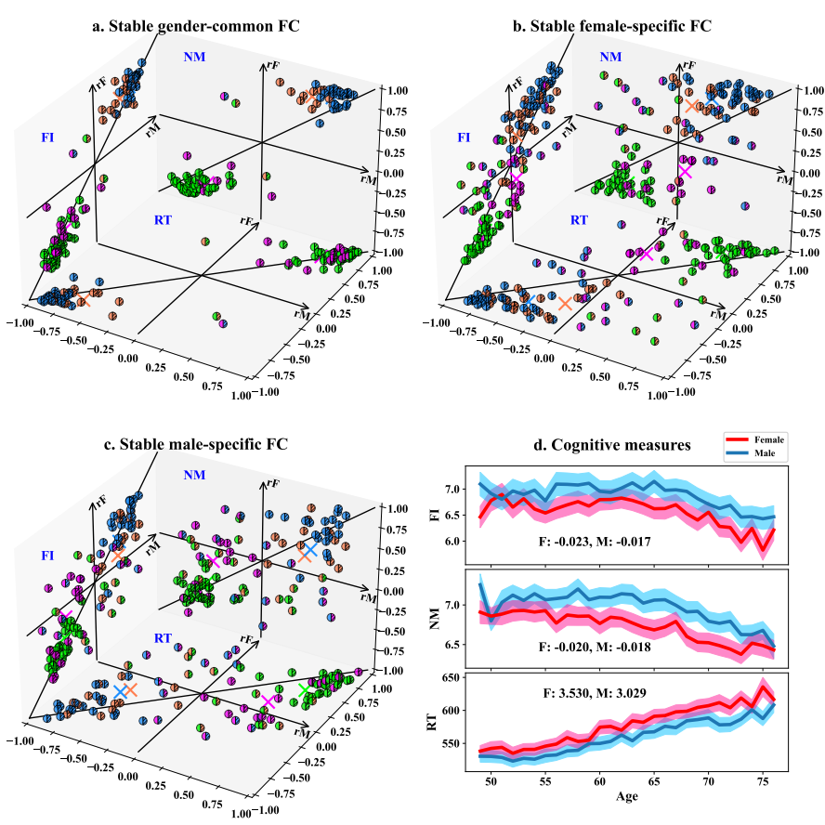

Fig. 8 Association between the stable gender-common, female-specific, and male-specific FC features and human’s cognitive functions measured by the fluid intelligence (FI), numerical memory (Yan, Calhoun et al.) and reaction time (RT). In **a, b** and **c**, each plane displays the correlation values of the FC strengths and one cognitive measure, with the x-axis (rM) representing the correlations computed uing the males’ data and the y-axis (Zonneveld, Pruim et al.) representing the correlations computed using the females’ data. The coloring format of each FC is as same as Fig. 4, in which different colors denoting different FC changing patterns. For FCs corresponding to each pattern, the mean correlation of females and the mean correlation of males are exhibited using a “”. In **d**, we show the the cognitive measures along different ages (49-76 years) for the females and males separately. Regarding each cognitive measure (e.g. FI), we show its mean and standard deviation at each age. Also, we list the gradients after the linear fitting for females (F) and males (M) separately.

### Brain functional ageing is faster in females than male

Another important finding in this work is that brain function decline is faster in females than in males along ageing. The finding was supported from many aspects in the above analyses. First, as shown in Fig. 2a and b, the classification accuracies were always higher in distinguishing two age groups in females than in males when using all whole-brain FC as features. The situation was true for both the testing set of the main data and the independent data. Fig. 2c demonstrates that measured by the mean accuracy of similar classification tasks, using females’ data yielded better performances than using males’ data, as the overall accuracy using females’ data was 67.87% and 67.91% and the overall accuracy using males’ data was 65.28% and 65.54%, for the main testing and the independent data, respectively. Second, even when only using the ageing-related gender-common FC as features, different age groups in the female population were also distinguished more easily compared to the male population (Fig. 3). Third, evidence about faster brain ageing in females also came from the stronger correlations between the FC strengths and ages in females. From Fig. 4, it is seen that for the ageing-related gender-common FCs, their mean correlation with age had slightly greater absolute value in the females than in the males for three of the four changing patterns, which also can be reflected by the paired t-test results. Fourth, the associations between the gender-common FC and the cognitive measures also presented a stronger relationship in females than in males (see Fig. 8a). Indeed, Fig. 8d clearly supports that coginitive function decline along ageing process was faster in females and males. Taken together, our study provide powerful evidence that females tend to have faster brain function decline than males.

## Discussion

In the present study, we proposed a large-scale deep learning method including 4200 classifiers on the main data and 21000 classifiers on the independent data to identify the most stable ageing-related gender-common and gender-specific FCs by investigating the whole-brain FCs using resting-state fMRI of a large sample size (25582 healthy subjects) covering 49 to 76 years ages. The reliability of our findings is guaranteed from many aspects. First, the use of large sample size of fMRI data provided a favorable support for achieving effective classification and exploring reliable ageing-related brain function decline, while previous studies only employed small sizes of subjects (add references) (Meier, Desphande et al. 2012, Campbell, Grigg et al. 2013, Scheinost, Finn et al. 2015, Goldstone, Mayhew et al. 2016, Grady, Sarraf et al. 2016, Ng, Lo et al. 2016, Staffaroni, Brown et al. 2018, Zonneveld, Pruim et al. 2019, Sendi, Chun et al. 2020, Stumme, Jockwitz et al. 2020). Second, the nested cross-validation framework validated the generalization ability of the identified gender-common and gender-specific FCs, as our work yielded a very consisitent classification performance between the test data of main data and the independent data. Third, the advanced explainable artificial intelligence technique automatically interprets the efficient features from the well-trained deep learning models, which ensures that our identified features are most important in ageing. Moreover, our results have shown that a higher classification capability was obtained using them compared to using correlation-based features. Fourth, different from previous work that only considered older and younger two groups, we comphrehensively investigated seven age groups in the classifications, consequently guaranteen the identified features relate to the progressive ageing. Fifth, we investigated the relationship between the FC strengths and cognitive measures, which successfully linked the brain function declines and the cognitive function change along ageing.

Our findings highlights the fact that brain functional connectivity declinces gradually along ageing, because as expected the classification accuracy in distinguishing two age groups coincide with our intuition about brain ageing, that is, the classification accuracy gradually increased along with the increasing age difference. The deep learning model gained the highest classification accuracy when distinguishing the youngest and the oldest groups for both females (about 89%) and males (about 85%). The phenorminon exsited for both the test data of the main data and the independent data using the whole-brain FCs (Fig. 2). Indeed, the trend also was also true for using the gender-common FCs, gender-specific FCs, and the combination of gender-common and gender-specific FCs (Fig. 3).

More importantly, to the best of our knowledge, this is the first study that investigated the relationship between females and males in brain ageing using large sample size and deep learning method. Scientists were interested in how brain ageing (add ref.) (Damoiseaux 2017, Wig 2017, Zuo, He et al. 2017, Edde, Leroux et al. 2021, Jockwitz and Caspers 2021); however, with the limitation of data size, previous studies (add ref.) (Meier, Desphande et al. 2012, Campbell, Grigg et al. 2013, Scheinost, Finn et al. 2015, Goldstone, Mayhew et al. 2016, Grady, Sarraf et al. 2016, Ng, Lo et al. 2016, Staffaroni, Brown et al. 2018, Zonneveld, Pruim et al. 2019, Sendi, Chun et al. 2020, Stumme, Jockwitz et al. 2020) hardly ever used sophisticated methods to investigate brain ageing. Moreover, there is no study that illuminates how females and males commonly and differently progress in whole brain function during ageing. Recently, the UK biobank data with a large sample size provides a great opportunity for using recent advanced methods, e.g., deep learning. In this work, we applied our large-scale deep learning method on 25582 healthy subjects to fully discover the commonality and specificity with respect to brain ageing between females and males, which were further validated using independent cohorts.

Our results demonstrated that the changing patterns in gender-common FC are similar but gender-specific FC are divergent. We further associated the changing patterns with FC changed along with ageing between females and males and found the overall change of gender-common FC in females and males is similar along with ageing; however, the overall change of one gender is always faster than the other in gender-specific FC. It’s worth noting that we didn’t intentionally find the gender-common and gender-specific FC with these properties, we find them by autonomous discovery. Combined with reclassification results, we can interpret the commonality and specificity in a reverse manner. For a batch of FC, if their changing patterns resemble whether females’ or males’, the classification accuracy for differentiating two age groups are both similar and high; thus, they are the gender-common FC features. Coincidentally, we observed that the changing pattern of gender-common FC in females and males are similar also. At the same time, for differentiating two age groups, if their changing patterns of input FC features resemble one gender is more helpful than they resemble the other, then they are gender-specific FC. For these gender-specific FC, we also observed the divergence changing pattern between females and males. For gender-common FC, we can understand the commonality between females and males, because their changing patterns are similar. However, for gender-specific FC, why changing patterns of a batch of FC resemble one gender would more helpful for differentiating any two age groups? Our further analysis suggests that the overall change of FC strength along with ageing is the one reason.

Our new finding of the ageing-related FC suggests that ageing mainly suppressed the FC for both females and males. Compared to previous studies (add ref.), our analysis gave more details, since we divided the ageing-related FC into six changing patterns. However, previous studies only considered the correlation but ignored the sign of FC strength (add ref.). Moreover, some previous studies even only considered the correlation between any two functional domains (add ref.), e.g., took all FCs which belong to the same two-functional domains together and then computed the correlation. Among the gender-common and gender-specific FCs, the first and secondary FCs in terms of FC number which are vulnerable to ageing are FC with decreased absolute strength, e.g., positive FC decreased with ageing and negative FC increased with ageing.

Our analysis of ageing-related FC associated functional domains suggests that ageing mainly decreased the positive FC within domains and increased negative FC between domains for gender-common FC; however, ageing affected gender-specific FC variously. The result of gender-common FC is to some extent similar to previous studies (add ref.), in which ageing decreased FC within domains and increased FC between domains (with the sign of FC ignored). Our new finding of female-specific FC suggests that the specificity for females is ageing equally increased and decreased negative FC between domains in females, meanwhile, for male-specific FC, ageing increased positive within domains in males is the specificity for males.

There are a few shortcomings that could be further investigated in future. In our work, we applied deep learning technique followed by an advance IG feature interpretation method to automatically mine the most discriminative features in classifying different age groups, consequently our identified ageing-related features were superior to the results from linear correlation based feature selection (Fig. S4). To simplify the result summary and comparison between genders (in Fig. 4 and Fig. 7), regarding our identified ageing-related gender-common and gender-specific FCs, we computed the FC-age correlation and ignored more complex nonlinear relationships between FC and age. however, some studies suggested both linear and nonlinear trajectories of FC throughout ageing (Betzel, Byrge et al. 2014, Ng, Lo et al. 2016, Luo, Sui et al. 2020). In future, nonlinear analysis methods can be combinely used for a further exploration. In addition, we used a linear regression method to remove the motion effect from FC measures, a more advanced motion removal method may be useful for a validation.

In summary, we have disclosed the shared and unique ageing path in brain function by developing a reliable large-scale deep learning method on a superlarge sample size for the first time. The identified gender-common FCs presented consistent changing paths between females and males, while the gender-specific FCs showed uniqueness for one gender compared to the other. We also found that females tended to have faster brain ageing than males. More interestingly, our findings coincide with our knowledge of cognitive declines along ageing. We believe our work has left open the potential of exploring new neuroimaging-based treatments for slowing down the brain ageing.

## Methods

### Data

In our study, we employed the resting-state brain FC of 25582 healthy subjects aged between 49 and 76 years (including 13373 females and 12209 males) that were estimated from resting-state fMRI data in the UK Biobank datasets (Miller, Alfaro-Almagro et al. 2016). Specifically, the brain FC data included in the field ID 25753 were used for analyses. Fig. S5 shows a summary of all healthy subjects’ demographic information in field ID 25753. We discarded the subjects who had any mental, neural system and other diseases that could affect the brain function (indicated by the field of 20122-20126, 41202-41205, and 41270-41271). We excluded the subjects with the following diseases diagnosed by ICD-10: malignant neoplasms of eye, brain and other parts of central nervous system, mental and behavioural disorders, diseases of the nervous system, diseases of the eye and adnexa, diseases of the ear and mastoid process, cerebrovascular diseases, congenital malformations of the nervous system, and injuries to the head. Weonly used the data of healthy subjects aged 49-76 years, considering that the subjects at other ages are very few and the selected subjects already can cover middle-aged and old-aged adults. The resting-state fMRI data were first preprocessed by a pipeline developed and run on behalf of UK Biobank. Then, 55 brain functional networks were estimated by a group ICA method (Filippini, MacIntosh et al. 2009, Smith, Miller et al. 2011). After that, a connectivity matrix reflecting the interaction between brain functional networks was obtained for each subject by computing the partial temporal correlation between functional networks’ time series using FSLNets toolbox (http://fsl.fmrib.ox.ac.uk/fsl/fslwiki/FSLNets). L2 regularization was applied to improve the estimates of partial correlation coefficients. Furthermore, the connectivity strengths were Gaussianized from Pearson correlations (r-values) into z-statistics. Because of the symmetricity of the connectivity matrices, only the lower triangular elements of each connectivity matrix were used as the FC measures (size: 1*1485) for investigating ageing-related brain functional changes. It is worth pointing out that we further removed out the effects of head motion from the FC measures by constructing a linear regression model for each FC measure (taken as the dependent variable) with the head motion information as the explanatory variable, because we found that older people tended to have greater head motions during the scanning (Table S9 includes the head motion information).

### Classifying different age groups in females and males using large-scale deep learning models

In this study, we propose a large-scale deep learning method to classify different age groups so as to identify which brain FC features play a key role in the classifications, thus being able to represent the effects of progressive ageing on the brain function decline. We performed the classifications on the females’ and males’ data separately, because we expected to investigate the similarity and difference between genders in brain ageing. For females or males, all subjects aged from 49 to 76 years were partitioned into seven groups, with each group including four ages of subjects. Hence, the seven age groups included the subjects with ages of 49-52, 53-56, 57-60, 61-64, 65-68, 69-72, and 73-76 years. Using whole-brain 1485 FC as possible features, 21 classification tasks were then conducted for distinguishing any age group from another age group within seven age groups, for females and males, respectively. Through the process, we evaluated the performances of different classification tasks, and also identified the most important FC features that contributed greatly to the classifications. Based on those important FC features extracted from the females’ and males’ data separately, we identified the ageing-related gender-common and gender-specific FC features. The overall procedure is outlined in Fig. S6a.

For the data of each two age groups, we performed the classification via a nested ten-fold cross-validation scheme (shown in Fig. S6b) to maximize the reliability. Since the sample sizes of available subjects in the filed ID 25753 are different between the two gendersand across different age groups, we randomly sampled the female (or male) subjects to make the subject number matched and comparable across all age groups in the classification before each outer cross-validation procedure. After the sampling, each age group included 987 subjects, so 6909 females (or males) including seven age groups were used for 21 classification tasks in each outer cross-validation procedure. As for the inner cross-validation, the main data (i.e. the nine folds from the outer process) were divided into 8: 1: 1 as the training, validation, and test set. The training and validation sets were used for the model training and selection respectively. The trained model was then evaluated using both the test set of the main data and the independent data from the outer cross-validation (see Fig. S6c). Because we randomly sampled the subjects before each outer cross-validation procedure, the total data that we used had a large sample size (25582 healthy subjects including 13373 females and 12209 males), which benefited the exploration of reliable classifications and features.

In our study, we adopted a multilayer perceptron (MLP) with two hidden layers and an output layer as the deep learning neural network (DNN) model. The numbers of neurons for the first and second hidden layers were set to 128 and 32, respectively, and the number of neurons for the output layer was 2 for the sake of the two-class (i.e. two age groups) classification. Furthermore, we adopted early stopping, batch normalization (Ioffe and Szegedy 2015) and dropout (Srivastava, Hinton et al. 2014) techniques for avoiding overfitting, and used rectified-linear unit function as the nonlinear transform and chose Adam (Kingma and Ba 2014) as our optimizer. Specifically, the learning rate , the weight of L2 regularization , the dropout probability , and the epoch .

As mentioned above, we separately conducted 21 classification tasks for the females and males’ data, and assessed the classification performance on the test set of the main data and independent data. In total, we trained 4200 classifiers across 100 cross-validation runs, 21 classification tasks and 2 gender groups. Thus, regarding both the test set of the main data and independent data, we obtained the classification accuracy for each classification task (that classified two age groups) using the females’ and males’ data.

It is well known that more samples and more advanced classifier would benefit the improvement of classification performance. Therefore, we made the most use of the subjects to perform the two-class classifications for four age groups (aged 57-60, 61-64, 65-68, and 69-72 years). Other age groups were not involved because their subjects were not enough to get matched. So, 1736 females (or males) were randomly sampled from the original subjects for each age group in each outer cross-validation for the evaluation. In addition, we investigated whether applying a more complex model could improve the classification performance. For this aim, we implemented a 5-layer MLP as the deep learning model to classify any two age groups under the same cross-validation framework.

### Identifying ageing-related gender-common and gender-specific functional connectivity via an explainable artificial intelligence technique

Based on the well-trained deep learning models, one of our primary goals is to disclose the ageing-related gender-common and gender-specific FC. The basic idea is that since we built deep learning models to separate different age groups for the females (or males), we can extract the important features that contributed most to the classifications that achieved a satisfactory performance. Given the important features separately extracted from the classifications using the females and males, we can investigate the common and specific features that should be able to reflect the similarity and uniqueness in the brain ageing between the two genders.

There are many approaches (Springenberg, Dosovitskiy et al. 2014, Binder, Montavon et al. 2016, Shrikumar, Greenside et al. 2017) that can be used to interprete deep learning models. In the study, we utilized a method called integrated gradients (IG) (Sundararajan, Taly et al. 2017) to extract the important features from deep learning models due to its advantage of sensitivity and effectiveness (Sundararajan, Taly et al. 2017, Ancona, Ceolini et al. 2019). The IG method aims to explain the relationship between a model’s output and the inputted features. Given an input data and a target we expect a model to output, IG calculates the inputted features’ importance scores with respect to the target. The importance scores can be positive or negative values. In our work that focused on two-class classification, for one feature, the larger the score’s absolute value was, the more contribution the feature made to the classification.Fig. S6c briefly depicts how we extracted the important ageing-related FC features for the females or males using the IG method. In each run of the outer cross-validation using the females’ (or males’) data, we identified the important features that greatly contributed to classifying each two age groups if only the classification achieved a satisfactory performance (> 75% classification accuracy on the test set), and then evaluated the features’ contributions across different classification tasks to find which FC features were relevant to the progressive ageing. We only investigated the discriminative features for the classifications with high classification accuracy, because that those features worked well in differentiating different age groups and should be able to reflect the brain ageing. In detail, we computed each feature’s importance score by feeding the main data to each well-trained deep learning model using the IG method, and then averaged the importance scores across all 10 inner cross-validation runs and different classification tasks (with > 75% accuracy) for each feature. After that, we took the absolute value of the mean importance score, and then normalized and sorted them across different features to select the top n FC (n=300, nearly 20% of all FC) as the ageing-related FC for the females or males. It is worth pointing out that rather than feeding all data into the trained model to mine the important features, we only used the main data for the feeding, because the processing guarantee the unbias property of the additional classifications on the independent data using the extracted features.

After we extracted the ageing-related FC features for the females and males, respectively, we defined a rule to find what FC features were commonly relevant to the brain ageing in both females and males, and what FC features were uniquely relevant to the brain ageing of females or males.. Here, we denote the importance scores of all FC features as and estimated from the females’ data and males’ data, respectively. As mentioned above, sorted by and separately, we selected the top n FC features for females and males, whose indices form two sets ( and ). Then, we mined the gender-common FC (), female-specific FC (), and male-specific FC according to the equations (1)-(5).

where is the index of the -th FC, and are the importance scores of the -th FC for females and males respectively. In particular, the gender-specific FCs includes FC features that are important for one gender but not for the other. Taking for example, it not only consists of FC features that are included in the top n FCs for females but not in the top n FCs for males ( in equation (1)), but also includes FC features that are included in both the top n FCs for females and males but their score differences between females and males are large ( in equation (1)). Here, and are the thresholds for females and males respectively, that are automatically estimated through equations (4)-(5). For , it is the mean value of the importance score differences of FC involved in .. Once the gender-specific FC features are determined, thegender-common FCswere the remaining FCs in both the first n FCs for females and males.

### Verifying the ageing-related gender-common and gender-specific functional connectivity using independent data

As mentioned above, the ageing-related gender-common and gender-specific FC features were extracted based on the main data in each run of the outer cross-validation. So, it is unbiased to use the independent data to evaluate whether the gender-common features would result in similar classification performances for both genders or not, and whether the gender-specific (e.g. female-specific) features would yield a better ability for this gender (e.g. female) than the other (e.g. male) in distinguishing different age groups. For this goal, we took the gender-common, female-specific, and male-specific FC as the inputs separately to conduct 21 classification tasks using females’ data or males’ data, with an expectation that gender-common FC works similarly well in classifying different age groups for both genders, female-specific FC works better for classifying age groups for females than males, and male-specific FC works better for classifying age groups for males than females. Moreover, we combined the common and specific features for an additional test. That is to say, the gender-common and female-specific FC feature set and the gender-common and male-specific FC feature set were also utilized separately for the 21 classification tasks for the females or males. We wondered if a combination of the gender-common and gender-specific features would yield better performance than using the common or unique features alone. In particular, for a comparison with the classifications using all FC features, we performed a nested cross-validation procedure that had the same data organization as the above-mentioned experiments. Regarding each of five types of feature (gender-common, female-specific, male-specific, the combined gender-common and female-specific, and the cominbed gender-common and male-specific FC) extracted from each run of the outer cross-validation, we conducted classifications (including 10 deep learning models within the inner cross-validation)for classifying each two age groupsand tested its performance on both the test set of the main data and the independent data using females’ or males’ data. Therefore, we trained 21000 classifiers in total (five types of feature * 100 cross-validation runs * 21 classification tasks * two gender groups) and evaluated their classification performance for both the test set of the main data and the independent data.

The IG method extracted important features that contributed greatly to the classification tasks, consequently disclosing the FC features that mostly relate to the ageing. In order to verify this point, we separately conducted the classifications with a same nested cross-validation framework by separately using the important FC features with high importance scores identified by the IG method and the classifications using the less important FC features with low importance scores measured in IG for a comparison. It is worth pointing out that measured by Pearson correlation between FC and age, the two types of features were matched, meaning that they were equally important if using correlation-based feature selection. Taking the classifications using the females’ data for an example, as for the less important FC, we selected the FC features that had high absolute correlations (greater than 0.5) from the last n FCs in females (sorted by the FC importance scores using the IG method); as for the important FC, we chose the FC features from the combination of gender-common and female-specific FCs, with the condition that the selected FC had matched correlations with the less important FC.

### Revealing property of the ageing-related gender-common and gender-specific functional connectivity

It is necessary to summarize the stable ageing-related gender-common or gender-specific FC across different outer cross-validation runs and further reveal how they change similarly or differently along the progressive ageing between the two genders. Therefore, we identified the gender-common and gender-specific FC features that occurred in more than 5 of the 10 outer cross-validation runs as the stable gender-common and gender-specific FC features for a further investigation.

To reflect the changing trend of each stable gender-common and gender-specific FC, we computed its mean FC strength of the subjects at the initial age (i.e. 49 years) as well as Pearson correlation between the FC’s strengths at different ages and the ages for the females or males, respectively. Here, the FC strength at each age was measured by the mean FC strength of all subjects at that age. Furthermore, to explore more details about the FC changing trends, six possible changing patterns were defined according to the mean FC strength at the initial age and Pearson correlation. We then summarized the FC features that coincide with each pattern. The six patterns included positive FC strength increases along the ageing (denoted by: FC +, corr +), positive FC strength decreases along the ageing but has no sign change of the FC strength (denoted by : FC +, corr -), positive FC strength decreases with ageing and has a sign change of the FC strength (denoted by: FC from + to -, corr -), negative FC strength increases along the ageing but has no sign change of the FC strength (denoted by: FC -, corr -), negative FC strength decreases along the ageing (denoted by: FC -, corr -), and negative FC strength increases along the ageing and has a sign change of the FC strength (denoted by : FC from – to +, corr -). After detecting the changing pattern for each FC, we compared it between females and males to see whether the gender-common FC would present more similarity and the gender-specific FC would present more differences in the changing patterns. Due to this reason, we display the changing patterns of each stable gender-common or gender-specific FC in females and males for a better visualization and easier comparison. In addition, regarding each pattern, we performed paired t-test on the FC-age correlations between the males and females to test the differences between genders. Because the two genders could have different patterns for one FC, regarding the gender-common FCs, we conducted two runs of paired t-tests by taking the pattern of females and males as the standard separately, and regarding the gender-specific FC (e.g. female-specfic FC), we performed one run of paired t-test by taking the pattern of this gender (e.g. female) as the standard.

In order to show the changes of each pattern-related FC strengths during the ageing progress in more details, we computed the mean and standard deviation of those FC strengths in females and males separately as well as the covariance of FC strengths between females and males at each age to to demonstrate the distribution of FC strengths at the age using an ellipse. As such, the FC strength changes across different ages can be presented by ellipses with different colors. In this manner, it is covenient to observe the FC strength change of each pattern along the ageing for the gender-common or gender-specific FC.

In addition to the general changing pattern, we were also interested in revealing what primary brain functions are commonly or uniquely influenced during the ageing progress. So, we explored the gender-common and gender-specific FCs by looking into them through their belonging functional domains. Since the 55 functional networks were assigned into nine functional domains, we separately investigated FCs that belonged to each between-domain or within-domain. For each between-domain or within-domain, we computed the number of included FCs for each changing pattern. After that, we comprehensively summarized . Based on the extracted stable gender-common, female-specific, and male-specific FCs by setting , we summarized the number and percentage of FCs for both the between-domains and the within-domains regarding each changing pattern. Moreover, to maximize the reliability of the ageing-related functional domains, we also combined results which estimated by setting .

For the last but not the least, for some important stable gender-common, female-specific, and male-specific FCs, we plotted the FC strength across different ages in females and males separately so as to further specify the related subtle brain networks. Through sorting, we identified ten important FCs from all stable stable gender-common FCs by choosing those with smaller difference of FC-age correlations between females and males among the FCs with > 0.5 absolute FC-age correlations in both genders. From the stable gender-specific FCs (e.g. female-specific FCs), we also selected ten important FCs for investigation, each of which had >0.5 absolute FC-age correlation in this gender (e.g. female) and also had greater difference in FC-age correlation between females and males.

### Exploring association between the ageing-related FC and human cognitive function

Based on the identified stable ageing-related gender-common and gender-specific FC, we were interested in exploring the association between the changes of those FCs and the declines of the human cognitive functions. For the analyses, we included three cognitive measures, i.e. the fluid intelligence (field ID 20016), numeric memory (field 4248), and reaction time (field 20023). A task with thirteen logic/reasoning-type questions with a two-minute time limit were are tested to reflect fluid intelligence in the UK Biobank protocol. In terms of the numeric memory, participants were shown a two-digit number and then asked to recall after a brief pause. This number increased by one until the participant made an error or they reached the maximum of twelve digits. To measure the reaction time, participants completed a timed test of symbol matching. The score on this task was the mean response time in milliseconds across trials which contained matching pairs. Subsequently, regarding each ageing-related stable gender-common or gender-specific FC, we computed Pearson correlation between its FC strength at different ages and each cognitive measure at different ages (from 49 years to 76 years) using females’ data or males’ data. Because there are many subjects at each age, we averaged the FC strengths or cognitive measures for the subjects at the same age before the correlation calculation. Additionally, we were interested in investigating the changes of each congnitive measure for females and males to see how it declines along ageing. So, regarding each cognitive measure, we show its mean and standard deviation at each age, and computed the gradients after the linear fittings of cognitive measures for females and males separately.\

## References:

Allen, E. A., E. B. Erhardt, E. Damaraju, W. Gruner, J. M. Segall, R. F. Silva, M. Havlicek, S. Rachakonda, J. Fries and R. J. F. i. s. n. Kalyanam (2011). "A baseline for the multivariate comparison of resting-state networks." **5**: 2.

Ancona, M., E. Ceolini, C. Öztireli and M. Gross (2019). Gradient-based attribution methods. Explainable AI: Interpreting, Explaining and Visualizing Deep Learning, Springer**:** 169-191.

Baniqued, P. L., C. L. Gallen, M. W. Voss, A. Z. Burzynska, C. N. Wong, G. E. Cooke, K. Duffy, J. Fanning, D. K. Ehlers and E. A. J. F. i. a. n. Salerno (2018). "Brain network modularity predicts exercise-related executive function gains in older adults." **9**: 426.

Beckmann, C. F. and S. M. J. I. t. o. m. i. Smith (2004). "Probabilistic independent component analysis for functional magnetic resonance imaging." **23**(2): 137-152.

Betzel, R. F., L. Byrge, Y. He, J. Goñi, X.-N. Zuo and O. J. N. Sporns (2014). "Changes in structural and functional connectivity among resting-state networks across the human lifespan." **102**: 345-357.

Betzel, R. F., L. Byrge, Y. He, J. Goni, X. N. Zuo and O. Sporns (2014). "Changes in structural and functional connectivity among resting-state networks across the human lifespan." Neuroimage **102 Pt 2**: 345-357.

Binder, A., G. Montavon, S. Lapuschkin, K.-R. Müller and W. Samek (2016). Layer-wise relevance propagation for neural networks with local renormalization layers. International Conference on Artificial Neural Networks, Springer.

Biswal, B. B., M. Mennes, X.-N. Zuo, S. Gohel, C. Kelly, S. M. Smith, C. F. Beckmann, J. S. Adelstein, R. L. Buckner and S. J. P. o. t. N. A. o. S. Colcombe (2010). "Toward discovery science of human brain function." **107**(10): 4734-4739.

Blaes, S. and T. Burwick (2017). "Few-shot learning in deep networks through global prototyping." Neural Networks **94**: 159-172.

Campbell, K., O. Grigg, C. Saverino, N. Churchill and C. J. F. i. a. n. Grady (2013). "Age differences in the intrinsic functional connectivity of default network subsystems." **5**: 73.

Damoiseaux, J. S. J. N. (2017). "Effects of aging on functional and structural brain connectivity." **160**: 32-40.

Edde, M., G. Leroux, E. Altena and S. J. J. o. N. R. Chanraud (2021). "Functional brain connectivity changes across the human life span: From fetal development to old age." **99**(1): 236-262.

Filippi, M., P. Valsasina, P. Misci, A. Falini, G. Comi and M. A. J. H. b. m. Rocca (2013). "The organization of intrinsic brain activity differs between genders: A resting‐state fMRI study in a large cohort of young healthy subjects." **34**(6): 1330-1343.

Filippini, N., B. J. MacIntosh, M. G. Hough, G. M. Goodwin, G. B. Frisoni, S. M. Smith, P. M. Matthews, C. F. Beckmann and C. E. J. P. o. t. N. A. o. S. Mackay (2009). "Distinct patterns of brain activity in young carriers of the APOE-ε4 allele." **106**(17): 7209-7214.

Friendly, M., G. Monette and J. J. S. S. Fox (2013). "Elliptical insights: understanding statistical methods through elliptical geometry." **28**(1): 1-39.

Gallen, C. L., P. L. Baniqued, S. B. Chapman, S. Aslan, M. Keebler, N. Didehbani and M. J. P. o. D’Esposito (2016). "Modular brain network organization predicts response to cognitive training in older adults." **11**(12): e0169015.

Geerligs, L., R. J. Renken, E. Saliasi, N. M. Maurits and M. M. Lorist (2015). "A Brain-Wide Study of Age-Related Changes in Functional Connectivity." Cereb Cortex **25**(7): 1987-1999.

Goldstone, A., S. D. Mayhew, I. Przezdzik, R. S. Wilson, J. R. Hale and A. P. J. F. i. A. N. Bagshaw (2016). "Gender specific re-organization of resting-state networks in older age." **8**: 285.

Grady, C., S. Sarraf, C. Saverino and K. J. N. o. a. Campbell (2016). "Age differences in the functional interactions among the default, frontoparietal control, and dorsal attention networks." **41**: 159-172.

Huang, C. C., W. J. Hsieh, P. L. Lee, L. N. Peng, L. K. Liu, W. J. Lee, J. K. Huang, L. K. Chen, C. P. J. C. N. Lin and Therapeutics (2015). "Age‐related changes in resting‐state networks of a large sample size of healthy elderly." **21**(10): 817-825.

Hyvarinen, A. J. I. t. o. N. N. (1999). "Fast and robust fixed-point algorithms for independent component analysis." **10**(3): 626-634.

Ioffe, S. and C. Szegedy (2015). Batch normalization: Accelerating deep network training by reducing internal covariate shift. International conference on machine learning, PMLR.

Jockwitz, C. and S. J. P. A.-E. J. o. P. Caspers (2021). "Resting-state networks in the course of aging—differential insights from studies across the lifespan vs. amongst the old." 1-11.

Ker, J., L. Wang, J. Rao and T. J. I. A. Lim (2017). "Deep learning applications in medical image analysis." **6**: 9375-9389.

Kingma, D. P. and J. J. a. p. a. Ba (2014). "Adam: A method for stochastic optimization."

Litjens, G., T. Kooi, B. E. Bejnordi, A. A. A. Setio, F. Ciompi, M. Ghafoorian, J. A. Van Der Laak, B. Van Ginneken and C. I. J. M. i. a. Sánchez (2017). "A survey on deep learning in medical image analysis." **42**: 60-88.

Liu, J., Y. Pan, M. Li, Z. Chen, L. Tang, C. Lu, J. J. B. D. M. Wang and Analytics (2018). "Applications of deep learning to MRI images: A survey." **1**(1): 1-18.

Lundervold, A. S. and A. J. Z. f. M. P. Lundervold (2019). "An overview of deep learning in medical imaging focusing on MRI." **29**(2): 102-127.

Luo, N., J. Sui, A. Abrol, D. Lin, J. Chen, V. M. Vergara, Z. Fu, Y. Du, E. Damaraju and Y. J. H. b. m. Xu (2020). "Age‐related structural and functional variations in 5,967 individuals across the adult lifespan." **41**(7): 1725-1737.

Meier, T. B., A. S. Desphande, S. Vergun, V. A. Nair, J. Song, B. B. Biswal, M. E. Meyerand, R. M. Birn and V. J. N. Prabhakaran (2012). "Support vector machine classification and characterization of age-related reorganization of functional brain networks." **60**(1): 601-613.

Miller, K. L., F. Alfaro-Almagro, N. K. Bangerter, D. L. Thomas, E. Yacoub, J. Xu, A. J. Bartsch, S. Jbabdi, S. N. Sotiropoulos and J. L. J. N. n. Andersson (2016). "Multimodal population brain imaging in the UK Biobank prospective epidemiological study." **19**(11): 1523-1536.

Mowinckel, A. M., T. Espeseth and L. T. J. N. Westlye (2012). "Network-specific effects of age and in-scanner subject motion: a resting-state fMRI study of 238 healthy adults." **63**(3): 1364-1373.

Ng, K. K., J. C. Lo, J. K. Lim, M. W. Chee and J. J. N. Zhou (2016). "Reduced functional segregation between the default mode network and the executive control network in healthy older adults: a longitudinal study." **133**: 321-330.

Nichols, E. S., C. J. Wild, A. M. Owen and A. J. B. S. Soddu (2021). "Cognition across the Lifespan: Investigating Age, Sex, and Other Sociodemographic Influences." **11**(4): 51.

Scheinost, D., E. S. Finn, F. Tokoglu, X. Shen, X. Papademetris, M. Hampson and R. T. J. H. b. m. Constable (2015). "Sex differences in normal age trajectories of functional brain networks." **36**(4): 1524-1535.

Schirrmeister, R. T., J. T. Springenberg, L. D. J. Fiederer, M. Glasstetter, K. Eggensperger, M. Tangermann, F. Hutter, W. Burgard and T. Ball (2017). "Deep Learning With Convolutional Neural Networks for EEG Decoding and Visualization." Human Brain Mapping **38**(11): 5391-5420.

Sendi, M. S., J. Y. Chun and V. D. Calhoun (2020). Visualizing functional network connectivity difference between middle adult and older subjects using an explainable machine-learning method. 2020 IEEE 20th International Conference on Bioinformatics and Bioengineering (BIBE), IEEE.

Shrikumar, A., P. Greenside and A. Kundaje (2017). Learning important features through propagating activation differences. International Conference on Machine Learning, PMLR.

Smith, S. M., K. L. Miller, G. Salimi-Khorshidi, M. Webster, C. F. Beckmann, T. E. Nichols, J. D. Ramsey and M. W. J. N. Woolrich (2011). "Network modelling methods for FMRI." **54**(2): 875-891.

Springenberg, J. T., A. Dosovitskiy, T. Brox and M. J. a. p. a. Riedmiller (2014). "Striving for simplicity: The all convolutional net."

Srivastava, N., G. Hinton, A. Krizhevsky, I. Sutskever and R. J. T. j. o. m. l. r. Salakhutdinov (2014). "Dropout: a simple way to prevent neural networks from overfitting." **15**(1): 1929-1958.

Staffaroni, A. M., J. A. Brown, K. B. Casaletto, F. M. Elahi, J. Deng, J. Neuhaus, Y. Cobigo, P. S. Mumford, S. Walters and R. J. J. o. N. Saloner (2018). "The longitudinal trajectory of default mode network connectivity in healthy older adults varies as a function of age and is associated with changes in episodic memory and processing speed." **38**(11): 2809-2817.

Stumme, J., C. Jockwitz, F. Hoffstaedter, K. Amunts and S. J. N. Caspers (2020). "Functional network reorganization in older adults: Graph-theoretical analyses of age, cognition and sex." **214**: 116756.

Sundararajan, M., A. Taly and Q. Yan (2017). Axiomatic attribution for deep networks. International Conference on Machine Learning, PMLR.

Tomasi, D. and N. D. J. H. b. m. Volkow (2012). "Gender differences in brain functional connectivity density." **33**(4): 849-860.

Wig, G. S. J. T. i. c. s. (2017). "Segregated systems of human brain networks." **21**(12): 981-996.

Yan, W., V. Calhoun, M. Song, Y. Cui, H. Yan, S. Liu, L. Fan, N. Zuo, Z. Yang and K. J. E. Xu (2019). "Discriminating schizophrenia using recurrent neural network applied on time courses of multi-site FMRI data." **47**: 543-552.

Zhang, L., M. Wang, M. Liu and D. J. F. i. n. Zhang (2020). "A survey on deep learning for neuroimaging-based brain disorder analysis." **14**.

Zonneveld, H. I., R. H. Pruim, D. Bos, H. A. Vrooman, R. L. Muetzel, A. Hofman, S. A. Rombouts, A. van der Lugt, W. J. Niessen and M. A. J. N. Ikram (2019). "Patterns of functional connectivity in an aging population: The Rotterdam Study." **189**: 432-444.

Zuo, X.-N., Y. He, R. F. Betzel, S. Colcombe, O. Sporns and M. P. J. T. i. c. s. Milham (2017). "Human connectomics across the life span." **21**(1): 32-45.