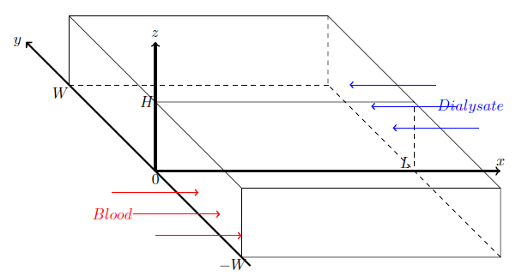

\begin{figure}[htb]

\centering

\begin{tikzpicture}

%\draw[help lines] (-3,0) grid (10,10);

\draw(-2,4)--(2,0)--(8,0)--(8,1.6)--(2,1.6)--(2,0)--(2,1.6)--(-2,5.6)--(-2,4)--(0,2)--(0,3.6)--(6,3.6)--(8,1.6)--(4,5.6)--(-2,5.6);

\draw[dashed] (0,2)--(6,2)--(6,3.6);

\draw[dashed] (8,0)--(4,4)--(4,5.6);

\draw[dashed] (-2,4)--(4,4);

\draw[->, very thick] (2.2,-0.2)--(-3,5);

\node at(-3.2,5) {$y$};

\draw[->,very thick] (0,2)--(8,2);

\node at(8,2.2) {$x$};

\draw[->,very thick] (0,2)--(0,5);

\node at(0,5.2) {$z$};

\node at(0,1.8) {$0$};

\node at(1.8,-0.2) {$-W$};

\node at(-2.2,3.8) {$W$};

\node at(-0.2,3.6) {$H$};

\node at(5.8, 2.2) {$L$};

\draw[->,thick,red] (-1,1.5)--(1,1.5);

\draw[->,thick,red] (-0.5,1)--(1.5,1);

\draw[->,thick,red] (0,0.5)--(2,0.5);

\node[red] at(-1,1) {$Blood$};

\draw[<-,thick,blue] (5.5,3)--(7.5,3);

\draw[<-,thick,blue] (5,3.5)--(7,3.5);

\draw[<-,thick,blue] (4.5,4)--(6.5,4);

\node[blue] at(7.3,3.5) {$Dialysate$};

\end{tikzpicture}

\caption{A simplified rectangular-shaped model: dialysis and blood}\label{fig:box}

\end{figure}

%%%%%%%%%%%%%%%%%%%%%%%%%%%%%%%%%%%%%%%%%%%%%%%%%%%%%%%%%%%%%%%%%%%%%%%%%%%%%%%%%%%%%%%%%%%%%%%%%%%%%%%%%%%%

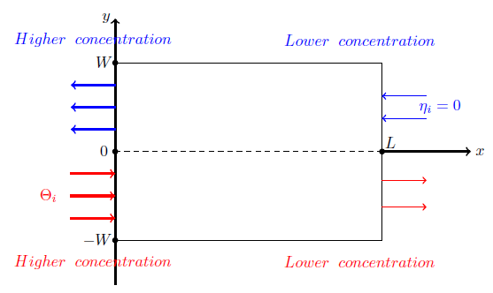

\newcommand{\mycircle}[1]

{\draw[fill=white,line width=1pt] (#1) circle[radius=1mm]}

\newcommand{\mycircleB}[1]

{\draw[fill=black,line width=1pt] (#1) circle[radius=1mm]}

\newcommand{\mycircleC}[1]

{\draw[fill=black,line width=1pt] (#1) circle[radius=0.5mm]};

\begin{figure}[htb]

\centering

\begin{tikzpicture}

%\draw[help lines] (-2,-4) grid (8,5);

\draw(0,2)--(0,-2)--(6,-2)--(6,2)--(0,2);

%\draw[dashed] (0,2)--(6,2)--(6,3.6);

%\draw[dashed] (8,0)--(4,4)--(4,5.6);

%\draw[dashed] (-2,4)--(4,4);

\draw[->, very thick] (0,-3)--(0,3);

\node at(-0.2,3) {$y$};

\draw[->,very thick] (6,0)--(8,0);

\node at(8.2,0) {$x$};

\draw[dashed] (0,0)--(6,0);

\mycircleC{0,0};

\node at(-0.25,0) {$0$};

\node at(-0.25,2) {$W$};

\mycircleC{0,2};

\node at(-0.4,-2) {$-W$};

\mycircleC{0,-2};

\node at(6.2, 0.2) {$L$};

\mycircleC{6,0};

\draw[->,very thick,red] (-1,-0.5)--(0,-0.5);

\draw[->,very thick,red] (-1,-1)--(0,-1);

\draw[->,very thick,red] (-1,-1.5)--(0,-1.5);

\node[red] at(-1.5,-1) {$\Theta_{i}$};

\node[red] at(-0.5,-2.5) {$Higher\hspace{0.2cm} concentration$};

\node[red] at(5.5,-2.5) {$Lower\hspace{0.2cm} concentration$};

\draw[->,thick,red] (6,-0.65)--(7,-0.65);

\draw[->,thick,red] (6,-1.25)--(7,-1.25);

\draw[<-,thick,blue] (6,1.25)--(7,1.25);

\draw[<-,thick,blue] (6,0.75)--(7,0.75);

\node[blue] at(7.3,1) {$\eta_{i}=0$};

\draw[<-, very thick,blue] (-1,1)--(0,1);

\draw[<-, very thick,blue] (-1,1.5)--(0,1.5);

\draw[<-, very thick,blue] (-1,0.5)--(0,0.5);

\node[blue] at(-0.5,2.5) {$Higher\hspace{0.2cm} concentration$};

\node[blue] at(5.5,2.5) {$Lower\hspace{0.2cm} concentration$};

\end{tikzpicture}

\caption{A simplified 2-D model: dialysis and blood}\label{fig:box}

\end{figure}

%%%%%%%%%%%%%%%%%%%%%%%%%%%%%%%%%%%%%%%%%%%%%%%%%%%%%%%%%%%%%%%%%%%%%%%%%%%%%%%%%%%%%%%%%%%%%%%%%%%%%%%%%%%%

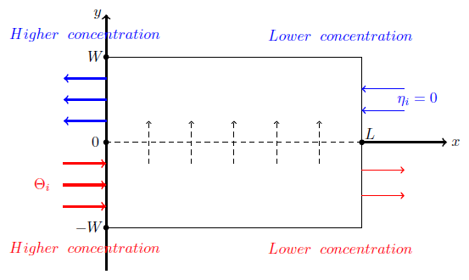

\begin{figure}[htb]

\centering

\begin{tikzpicture}

%\draw[help lines] (-2,-4) grid (8,5);

\draw(0,2)--(0,-2)--(6,-2)--(6,2)--(0,2);

%\draw[dashed] (0,2)--(6,2)--(6,3.6);

%\draw[dashed] (8,0)--(4,4)--(4,5.6);

%\draw[dashed] (-2,4)--(4,4);

\draw[->, very thick] (0,-3)--(0,3);

\node at(-0.2,3) {$y$};

\draw[->,very thick] (6,0)--(8,0);

\node at(8.2,0) {$x$};

\draw[dashed] (0,0)--(6,0);

\mycircleC{0,0};

\node at(-0.25,0) {$0$};

\node at(-0.25,2) {$W$};

\mycircleC{0,2};

\node at(-0.4,-2) {$-W$};

\mycircleC{0,-2};

\node at(6.2, 0.2) {$L$};

\mycircleC{6,0};

\draw[->,very thick,red] (-1,-0.5)--(0,-0.5);

\draw[->,very thick,red] (-1,-1)--(0,-1);

\draw[->,very thick,red] (-1,-1.5)--(0,-1.5);

\node[red] at(-1.5,-1) {$\Theta_{i}$};

\node[red] at(-0.5,-2.5) {$Higher\hspace{0.2cm} concentration$};

\node[red] at(5.5,-2.5) {$Lower\hspace{0.2cm} concentration$};

\draw[->,thick,red] (6,-0.65)--(7,-0.65);

\draw[->,thick,red] (6,-1.25)--(7,-1.25);

\draw[<-,thick,blue] (6,1.25)--(7,1.25);

\draw[<-,thick,blue] (6,0.75)--(7,0.75);

\node[blue] at(7.3,1) {$\eta_{i}=0$};

\draw[<-, very thick,blue] (-1,1)--(0,1);

\draw[<-, very thick,blue] (-1,1.5)--(0,1.5);

\draw[<-, very thick,blue] (-1,0.5)--(0,0.5);

\node[blue] at(-0.5,2.5) {$Higher\hspace{0.2cm} concentration$};

\node[blue] at(5.5,2.5) {$Lower\hspace{0.2cm} concentration$};

\draw[->,dashed] (1,-0.5)--(1,0.5);

\draw[->,dashed] (2,-0.5)--(2,0.5);

\draw[->,dashed] (3,-0.5)--(3,0.5);

\draw[->,dashed] (4,-0.5)--(4,0.5);

\draw[->,dashed] (5,-0.5)--(5,0.5);

\end{tikzpicture}

\caption{A simplified 2-D model: dialysis and blood}\label{fig:box}

\end{figure}

%%%%%%%%%%%%%%%%%%%%%%%%%%%%%%%%%%%%%%%%%%%%%%%%%%%%%%%%%%%%%%%%%

\newcommand{\mycircle}[1]

{\draw[fill=red,line width=1pt] (#1) circle[radius=1cm]}

\newcommand{\mycircleB}[1]

{\draw[fill=white, line width=1pt] (#1) circle[radius=1.1cm]}

\newcommand{\mycircleC}[1]

{\draw[fill=blue,line width=1pt] (#1) circle[radius=2cm]};