https://detail.1688.com/offer/577930153043.html?spm=a2615.7691456.autotrace-offerGeneral.1.36a61408pjld3P

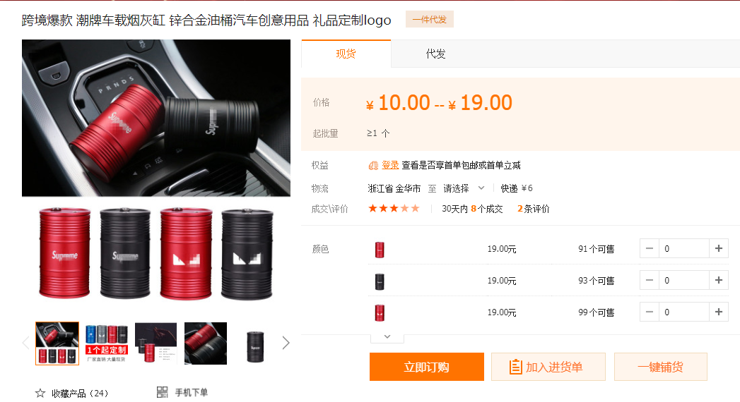
可以印LOGO的烟灰缸

https://detail.1688.com/offer/579087157674.html?spm=b26110380.sw1688.mof001.889.27446c913lyNdc&sk=consign

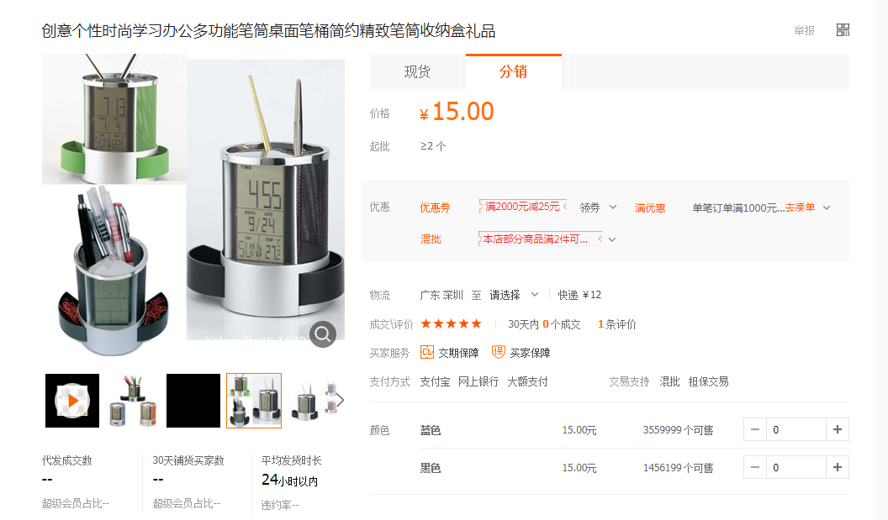
可以印LOGO的笔筒

烟灰缸19元笔筒12.5，印刷版费是200

以下是不能定制LOGO的烟灰缸

https://detail.1688.com/offer/590254627588.html?spm=b26110380.sw1688.mof001.370.49b64e1bcfPtBg

https://detail.1688.com/offer/687416774.html?spm=a261y.7663282.autotrace-offerDetailContext1.5.64fc3737BbhGUZ&sk=

https://detail.1688.com/offer/561058973373.html?spm=a261y.8881078.0.0.45f31b1bkBYzkf

